Research Article

NOVEL RP - HPLC METHOD AND DEVELOPMENT AND VALIDATION FOR ESTIMATION OF PHENTERMINE USING BULK AND PHARMACEUTICAL DOSAGE FORM
Sowmya G
Osmania university of technology, Hyderabad, India. Author email: gandlasowmya810@gmail.com

ABSTRACT
A simple and focused HPLC method is described for phentermine measurement. With a C18 column and a mobile phase made up of 40 volumes of methanol, 40 volumes of acetonitrile, and 20 volumes of water, the chromatographic separation was completed at a wavelength of 263 nm. For Phentermine, the method demonstrated linearity in the 50–150 µg/ml range (r2 = 0.990), and the drug amounts found using this suggested method nearly matched the label claim. It is clear from the previously described testing results and parameters that this newly developed approach for phentermine estimate is simple, accurate, exact, and has a high resolution. Its cost-effectiveness and acceptance are further improved by its shorter retention period. In the near future, this technology can be easily implemented for regular studies in research facilities, industry quality control departments, and accredited testing laboratories.
Keywords: Phentermine, linearity, retention time, drug estimation, HPLC, high resolution.

INTRODUCTION
Phentermine, also recognized as α,α-dimethylphenethylamine, belongs to the substituted amphetamine chemical class and shares pharmacological similarities with amphetamine. Its medical application involves serving as a short-term appetite suppressant and adjunct to exercise and calorie reduction regimens. The IUPAC name for phentermine is 2-methyl-1-Phenylpropan-2-amine. It falls under the category of central nervous system agents, central nervous system stimulants, and centrally acting anti-obesity products.
Phentermine serves as a short-term adjunct in managing exogenous obesity, based on caloric restriction, and exhibits pharmacological activity akin to the prototype drugs of this class, such as amphetamines. Its actions encompass central nervous system stimulation and blood pressure elevation. Phentermine demonstrates a protein binding rate of approximately 96.3%. It is indicated for the treatment and management of obesity.
With a polar mobile phase and a non-polar stationary phase, reverse phase HPLC is the recommended HPLC technique for phentermine analysis. Because they have a stronger attraction for the stationary phase, non-polar molecules are held in solution for longer whereas polar compounds elute first and move more quickly. The aim is to create and certify a new HPLC technique for phentermine in prescription dosage forms.
The procedure entails figuring out how soluble Phentermine is in different solvents and buffers, locating its UV-visible absorption maxima in those solvents and buffers, and choosing the right solvents for the construction of an HPLC technique. Determining the mobile phase and flow rates is necessary for optimization in order to attain the right retention times and resolution. The designed procedure has been validated in compliance with ICH recommendations.
The measurement of phentermine using a straightforward and selective HPLC approach is described. A C18 column and a mobile phase consisting of a blend of 40 volumes of methanol, 40 volumes of acetonitrile, and 20 volumes of water are used to achieve chromatographic separation, which is detected at 263 nm. For Phentermine, the technique is linear in the 50-150 µg/ml range (r2 = 0.990), and the predicted drug amounts are in good agreement with the label claim. Three distinct degrees of recovery studies are used to evaluate the correctness of the suggested methods.
Recovery tests verify that typical pharmaceutical additives do not interfere, and repeatability analysis shows that the procedure is accurate with a percentage RSD of less than 2. The approaches are useful for routine analysis of pharmaceutical dosage forms because the statistical data validates them.
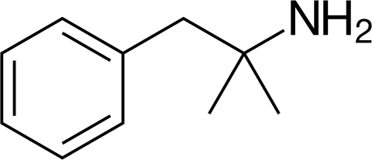
Chemical structure of phentermine13

MATERIAL AND METHODS

Table 1: Instruments used

UV-Visible Spectrophotometer | Nicolet evolution 100
UV-Visible Spectrophotometer software | Vision Pro
HPLC software | Open lab EZ chrome
HPLC | Agilent Technologies
Ultra sonicator | Citizen, Digital Ultrasonic Cleaner
pH meter | Global digital
Electronic balance | Mettler Toledo
Syringe | Hamilton
HPLC Column | Inertsil ODS 3V(150x4.6mm) 4µm

Table 2: Reagents used

Water | HPLC Grade
Methanol | HPLC Grade

Potassium Dihydrogen Phosphate | AR Grade
Acetonitrile | HPLC Grade
Dipotassium hydrogen phosphate | AR Grade
Orthophosphoric acid | HPLC Grade

Table 3: Drugs used

Phentermine (API) | Gift Samples obtained from Chandra labs, Hyd.
Phentermine  Phentermine (Adipex - P 37.5 mg) Tablet dosage form | Obtained from local pharmacy

Mobile Phase:

A mixture of, 40 volumes of Methanol, 40 volumes of methanol and 20 volumes of Water. The mobile phase was sonicated for 10 min to remove gases.

METHOD DEVELOPMENT AND VALIDATION

This study established and validated an analytical method based on HPLC detection for the assay determination of phentermine in pharmaceutical dose form.. Solubility studies and deermination of working wavelength was conducted. Here 5 trails were conducted from which trail 5 was optimized and with optimized chormatographic conditions. Preparation of mixed standard solution was performed and observation was noted down. Assay of standard and sample preparations was performed for 5 preparations in both. The amount of phentermine in taken dosage forms for assay result was found to be 100.9% in both respectively. HPLC method validaton was condcucted for system suitability and system precision, method precision, linearity and range, specificity, accuracy,robustness and intermedite precision (Ruggedness) was performed and validated.

RESULTS AND DISCUSSION

Solubility Studies
These studies are carried out at 25 ⁰ C

Phentermine:
Slightly soluble in water, Freely soluble in Ethanol, and Methanol, Acetonitrile and Phosphate buffer.

Determination of Working Wavelength (λmax) Preparation of standard stock solution of Phentermine

The medication was dissolved in methanol after 10 mg of phentermine were weighed and transferred into a 100 ml volumetric flask. The solution was then diluted 1 ml to 10 ml with methanol to make it up to the required amount.

Results
Using methanol as a blank, a 10-μg/ml solution of the medication was scanned within the 200–400 nm wavelength range using a UV-Visible spectrophotometer to determine the drug's wavelength of maximum absorption (λmax). The final spectra are displayed in Figure 8.3. The absorption curve for Phentermine, which was chosen as the detector wavelength for the HPLC chromatographic process, has distinctive absorption maxima at 263 nm.

METHOD DEVELOPMENT OF PHENTERMINE

Trial - 1
Chromatographic conditions
Mobile phase : Phosphate buffer : ACN Ph : 4.0
Ratio : 37:63
Column : Inertsil ODS 3V (250×4.6× 5µ) wavelength : 230 nm
Flow rate : 1ml/min
    - Preparation of mixed standard solution
    - Measure out 10 milligrams of phentermine exactly and pour it into a 25 milliliter volumetric flask. Mix 25 milliliters of the mobile phase with the phentermine, then adjust the volume to the desired level. Make a solution with 20 µg/ml of phentermine from this prepared stock solution by diluting 1.5 ml of the stock solution with 10 ml of the mobile phase. The chromatogram is recorded using this final solution.
    - Observation:
    - Although the Efficiency was not satisfactory for Phentermine .
    - Theoretical plates for the Phentermine less than 2000.
    - Hence it was not taken for optimization.

Trial- 2
Chromatographic conditions

Mobile phase : KH₂PO₄:Methonol pH : 6.0

Ratio : 55:45
Column : Inertsil ODS 3V (250×4.6 ×5µ) wavelength : 230nm
Flow rate : 1ml/min

Preparation of mixed standard solution

Measure out 10 milligrams of phentermine exactly and put it into a 25 milliliter volumetric flask. Next, dissolve it in 25 milliliters of the mobile phase, then use the mobile phase to adjust the volume to the desired level. Next, dilute 1.5 ml of the stock solution to 10 ml with the mobile phase to yield a Phentermine solution with a concentration of 20 µg/ml from the previously made stock solution. The chromatogram is recorded using this final solution.

Observation:
    - Efficiency was not good.
    - The run time is very more.
    - The peaks of Phentermine showed tailing.
    - Hence it was not taken for optimization.

Trial- 3:
Chromatographic conditions
Mobile phase : phosphate buffer:ACN:Methanol
Ph : 4.0
Ratio : 60:10:30
Column : Inertsil ODS 3V, (250×4.6× 5µ)
Wavelength : 230nm
Flow rate : 1ml/min

Preparation of mixed standard solution

Measure out 10 milligrams of phentermine exactly and put it into a 25 milliliter volumetric flask. Proceed to dissolve it in 25 milliliters of the mobile phase, then use the mobile phase to adjust the volume to the desired level. Next, dilute 1.5 ml of the stock solution to a total volume of 10 ml with the mobile phase to create a Phentermine solution with a concentration of 20 µg/ml. The chromatogram is then recorded using this end solution.

Observation:
    - Asymmetry factor for Phentermine does not meet the system suitability requirements.
    - Efficiency was very less.
    - Hence it was not taken for optimization.

Trial- 4:
Chromatographic conditions

Mobile phase : phosphate buffer:ACN pH : -
Ratio : 20:80
Column : Inertsil ODS , (250×4.6× 5µ) Wavelength : 230 nm Flow rate : 1ml/min

Preparation of mixed standard solution

mg of phentermine, precisely measured, should be added to a 25 ml volumetric flask. Once it has dissolved, use 25 milliliters of the mobile phase to adjust the volume to the desired level. Next, dilute 1.5 ml of the stock solution with the mobile phase to make a total volume of 10 ml. This will yield a Phentermine solution with a concentration of 20 µg/ml. After that, the chromatogram is recorded using this resultant solution.

Observation:
    - Peak Asymmetry factor for Phentermine does not meet the system suitability requirements.
    - Tailing factor is very more.
    - hence it was not taken for optimization.

Trial-5 : (Optimized):
Chromatographic conditions
Mobile pha : Methanol: ACN : WATER pH : -
Ratio : 40:40:20
Column : Inertsil ODS 3V column,C18(250x4.6 ID) 5µm Wavelength : 230nm
Flow rate : 1.0ml/min

Preparation of mixed standard solution
Weigh 10 milligrams of phentermine precisely, then transfer it into a 25 ml volumetric flask. Next, dissolve the phentermine in 25 milliliters of the mobile phase, and then use that same mobile phase to adjust the volume to the desired level. Next, dilute 1.5 ml of the stock solution to a total volume of 10 ml with the mobile phase to generate a Phentermine solution with a concentration of 20 µg/ml. This final mixture is then used to produce a chromatogram.

Observation:
    - All the system suitability requirements were met.
    - The peak Asymmetry factor was less than 2 for both Phentermine
    - The efficiency was more than 2000 Phentermine.
    - Resolution between two peaks >1.5.
    - hence this method was for optimized.

Table 4: Optimized chromatographic conditions

Mobile phase | METHANOL:ACN : WATER(40:40:20)
Ph | -
Column | Inertsil ODS 3V column,C18(150x4.6 ID) 5µm

Flow rate | 1.0 ml/min
Column temperature | Room temperature(20-25ºC)
Sample temperature | Room temperature(20-25ºC)
Wavelength | 230
Injection volume | 20 µl
Run time | 6 min
Retention time | About 2.520 min for Phentermine

Assay
Preparation of samples for Assay Preparation of mixed standard solution
Weigh 10 milligrams of phentermine exactly into a 25 milliliter volumetric flask, dissolve in 25 milliliters of mobile phase, and then top off the flask with more mobile phase. The above stock solution yields 20 µg/ml of phentermine by diluting 0.5 ml to 10 ml with mobile phase. Chromatograms are made using this particular solution.

Sample preparation : weigh accurately 10 Tablets (Adipex - P 37.5 mg) Precisely measure out 10 milligrams of Phentermine into a 25 milliliter volumetric flask, then dissolve it in 25 milliliters of mobile phase to make up the remaining volume. By diluting 0.5ml to 10ml with mobile phase, 20 µg/ml of phentermine is generated from the aforementioned stock solution. Chromatograms are recorded with this solution.

Calculation

The amount of Phentermine present in the formulation by using the formula given below, and results shown in above table:
% Assay = AT × WS × DT × P × AW × 100

Where,
AS: Average peak area due to standard preparation AT: Peak area due to assay preparation
WS: Weight of Phentermine in mg
WT: Weight of sample in assay preparation DT: Dilution of assay preparation
AS DS
WT 100 LC

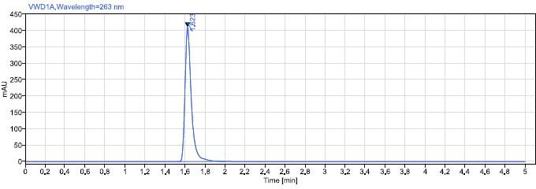
Fig.1.1: Chromatogram of Assay standard preparation-1
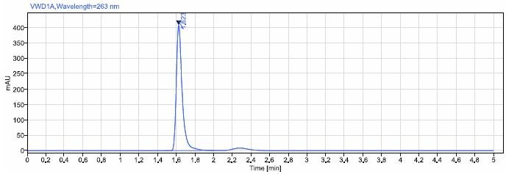
Fig.1.2 : Chromatogram of Assay standard preparation-2

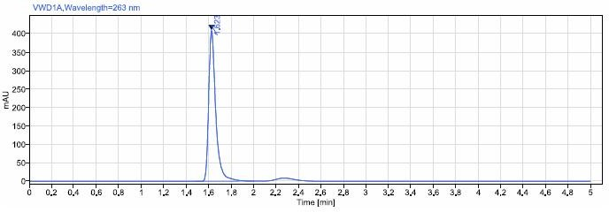
Fig.1.3 : Chromatogram of Assay standard preparation-3

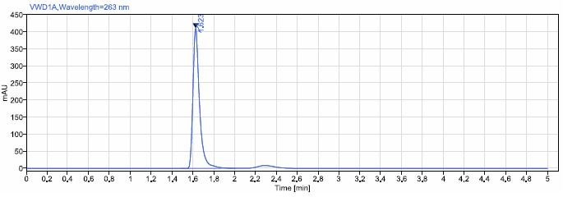
Fig. 1.4: Chromatogram of Assay standard preparation-4

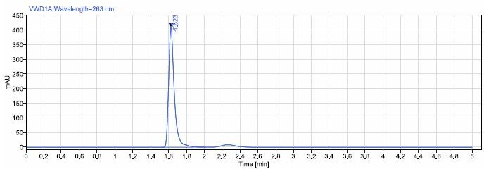
Fig1.5 : Chromatogram of Assay standard preparation-5
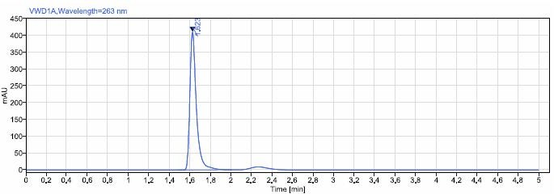
Fig2.1: Chromatogram of Assay sample preparation-1
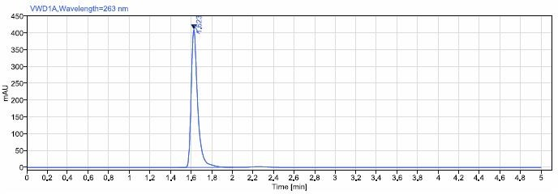
Fig2.2 : Chromatogram of Assay sample preparation-2
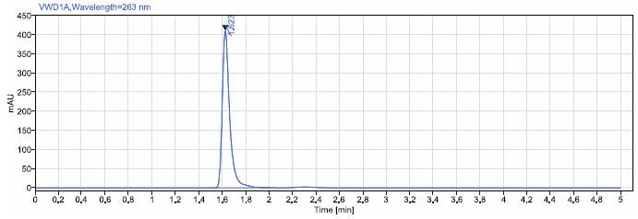
Fig2.3 : Chromatogram of Assay sample preparation-3

Fig2.4 : Chromatogram of Assay sample preparation-4

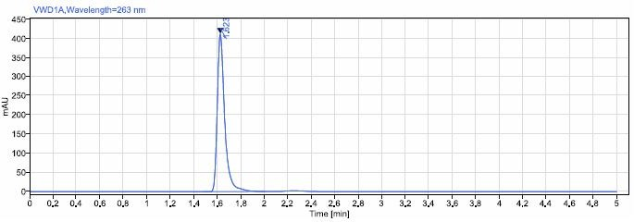
Fig2.5: Chromatogram of Assay sample preparation-5

Table No 5: Assay Results
Phentermine
 | Standard Area | Sample Area
Injection-1 | 1795.43 | 1810.55
Injection-2 | 1793.89 | 1810.74
Injection-3 | 1794.86 | 1810.81
Injection-4 | 1794.23 | 1810.81
Injection-5 | 1794.88 | 1811.4
Average Area | 1794.66 | 1810.86
Standard deviation | 0.60
%RSD | 0.03
Assay(%purity) | 100.90

Observation
The amount of Phentermine present in the taken dosage form was found to be 100.90% respectively.

VALIDATION

HPLC METHOD VALIDATION

System Suitability& System precision

In order to confirm that the analytical system is functioning correctly and capable of providing exact and accurate data, the chromatograms were recorded after six injections of 20µg/mL of PHENTERMINE.
Table 6 : Results for system suitability of PHENTERMINE.

Injection | RT | Peak area | Theoretical plates (TP) | Tailing factor (TF)
1 | 1.622 | 1806.55 | 3700 | 1.53
2 | 1.623 | 1807.57 | 3686 | 1.48
3 | 1.623 | 1808.12 | 3682 | 1.48
4 | 1.623 | 1808.46 | 3682 | 1.48
5 | 1.623 | 1809.14 | 3682 | 1.48
6 | 1.623 | 1809.18 | 3685 | 1.47
Mean | 1.623 | 1808.170 | - | -
SD | 0.00041 | 1.00 | - | -
%RSD | 0.025 | 0.06 | - | -

Acceptance criteria
- Six replicate injections of each standard solution should yield a percentage RSD for the PHENTERMINE retention period Peaks that should not exceed 2.0.

2. The peak area responses of the PHENTERMINE peak from six replicate injections of each standard solution should vary by no more than 2.0%.
3. The PHENTERMINE peaks have a theoretical plate count (N) of at least 2000.
The Tailing factor (TP) for the PHENTERMINE peak is not more than 2.0.

Result

Because the % RSD was determined to be 1.2 and the plate count and tailing factor results were found to be within the limits, the system is appropriate and delivering accurate findings.

Method precision

Method precision was determined by injecting sample solutions of concentration PHENTERMINE (20μg/mL) for six timesare prepared separately.

The chromatograms were recorded and the results were summarized in Table 7
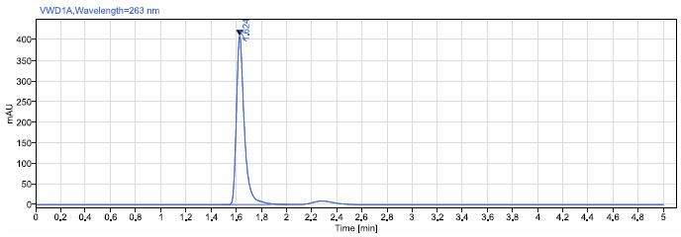

Fig.3.1 : Chromatogram of Method Precision-01
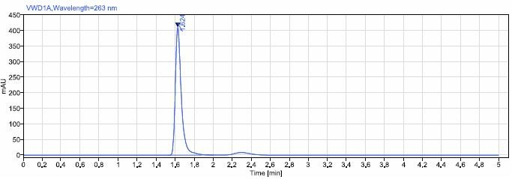

Fig.3.2: Chromatogram of Method Precision-02
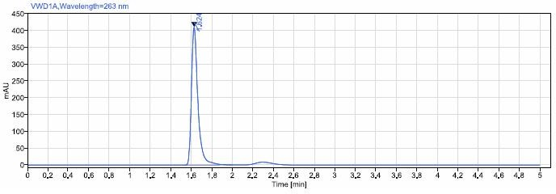

Fig.3.3: Chromatogram of Method Precision-03
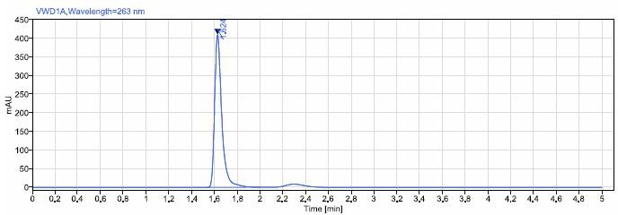

Fig.3.4: Chromatogram of Method Precision-04
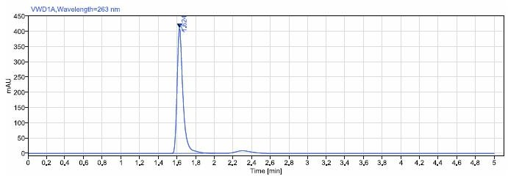

Fig.3.5: Chromatogram of Method Precision-05

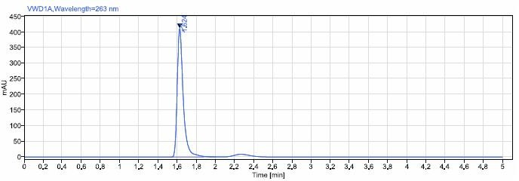

Result
Fig.3.6: Chromatogram of Method Precision-06

Table 7: Method precision results for PHENTERMINE

Phentermine
S.No. | RT | AREA
1 | 1.623 | 1792.8
2 | 1.624 | 1793.47
3 | 1.624 | 1795.84
4 | 1.624 | 1797.36
5 | 1.624 | 1798.51
6 | 1.624 | 1800.08
AVG | 1.6238 | 1796.3433
SD | 0.0004 | 2.86
%RSD | 0.025 | 0.16

The percentage RSD of the assay for the six samples' PHENTERMINE readings was found to be less than 2.0%, which is within the acceptable range. approach is hence exact.

Linearity and range

Preparation of standard stock solution

One hundred milligrams of phentermine were dissolved in one hundred milliliters of diluent to create standard stock solutions. Following that, the solution was filtered through a 0.45-micron syringe filter and Sonicated for five minutes. Additional dilutions were then provided in Table 8.

Table 8 : Linearity Preparations.

Preparations | Volume from standard stock transferred in mL | Volume made up in mL (with mobile phase) | Conc. obtained (µg/mL)
 |  |  | PHENTERMINE
Preparation 1 | 0.5 | 10 | 50
Preparation2 | 0.8 | 10 | 80
Preparation 3 | 1 | 10 | 100
Preparation 4 | 1.2 | 10 | 120
Preparation 5 | 1.5 | 10 | 150

The above prepared PHENTERMINE were in injected into the system and the chromatograms were recorded as given in Fig.

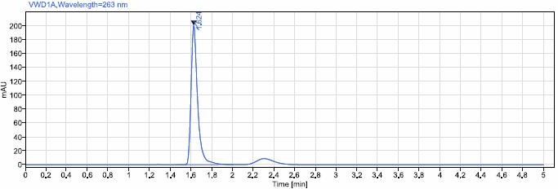

Fig 4.1: Chromatogram of linearity for preparation 1.

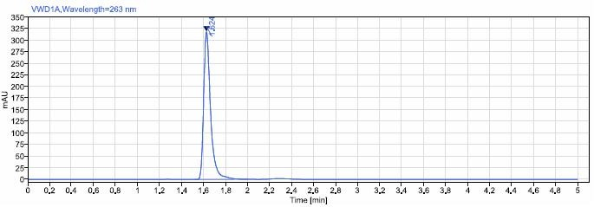

Fig 4.2: Chromatogram of linearity for preparation 2.
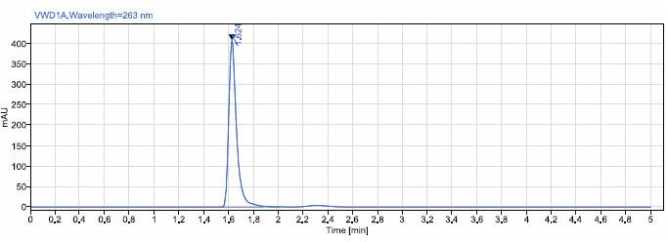

Fig 4.3: Chromatogram of linearity for preparation 3.
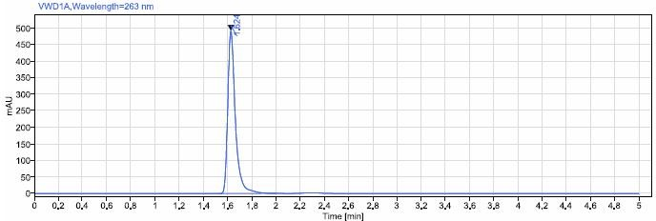

Fig 4.4: Chromatogram of linearity for preparation 4.
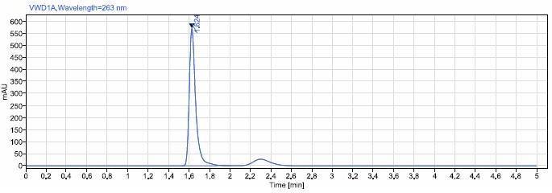

Fig 4.5: Chromatogram of linearity for preparation 5.

PHENTERMINE was plotted on a graph against the solution concentrations and peak regions. When the correlation coefficient R2 for Phentermine was calculated, it was discovered to be 1.00.

Table 10 : Linearity data of PHENTERMINE.

S.No | Concentration (µg/mL) | Area
1 | 50 | 874.8
2 | 80 | 1394.81
3 | 100 | 1784.51
4 | 120 | 2157.39
5 | 150 | 2502.4

Fig 5: Graph for Linearity data of PHENTERMINE.
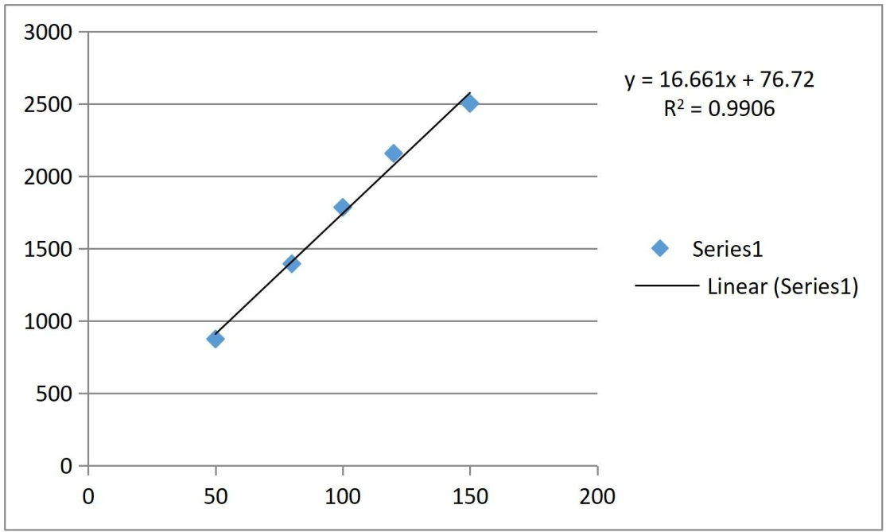

Table 11: Linearity results of PHENTERMINE.

S.N  o | Parameter | PHENTERMINE
1 | Correlation coefficient | 0.990
2 | Slope | 16.66
3 | Intercept | 76.72

Acceptance criteria

Within the given range, the relationship between the concentration (in percentage) and area of phenoltermine should be linear, with a correlation value of at least 0.99.

Result

For the standard preparation, the correlation coefficient for the linear curve produced between concentration vs. area was 0.990.

Specificity

An investigation was carried out to assess and identify any potential interference from blank and placebo samples. This analysis involved the examination of placebo samples, performed in triplicate, with an amount equivalent to the weight of the placebo used in a specific portion of the test preparation, as outlined in the test method. The chromatographic results obtained from the blank and placebo solutions clearly indicated the absence of any peaks at the retention times corresponding to PHENTERMINE.
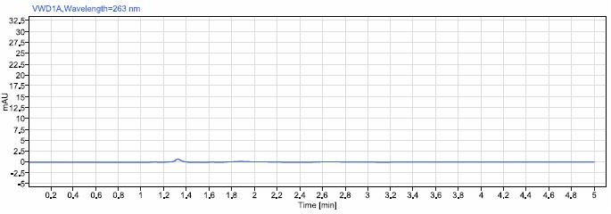

Fig 6.1: Chromatogram of Placebo
Fig 6.2: Chromatogram of Blank

Result

Diluent or excipient peaks were found to not obstruct the PHENTERMINE Peak.

Accuracy

Recovery studies determined the method's accuracy. The formulation (preanalysed sample) was supplemented at 50%, 100%, and 150% with the drug reference standards. Three recovery studies were conducted, and Table 12 displays the percentage recovery and percentage mean recovery for each drug.
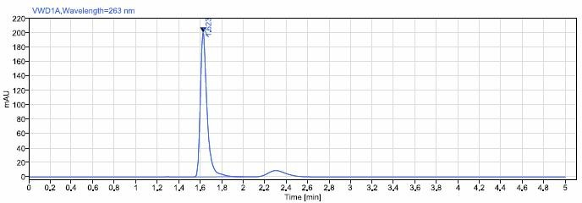

Fig 7.1: Chromatogram of 50% recovery-1
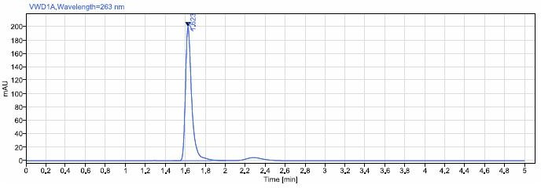

Fig 7.2: Chromatogram of 50% recovery-2
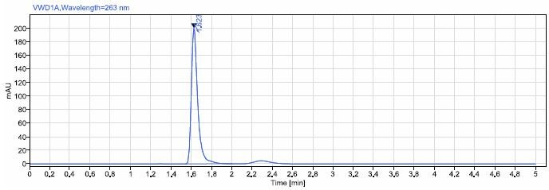

Fig7.3 : Chromatogram of 50% recovery-3
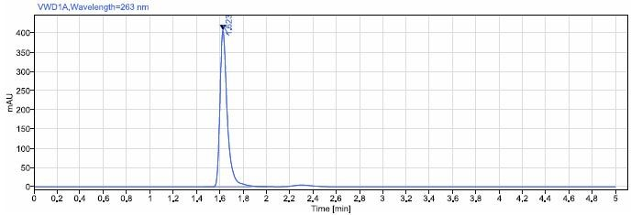

Fig 8.1: Chromatogram of 100% recovery-1
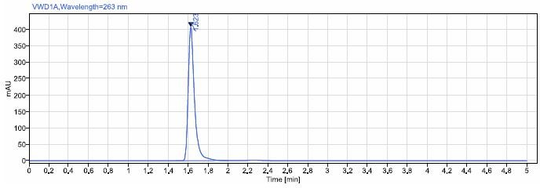

Fig 8.2: Chromatogram of 100% recovery-2

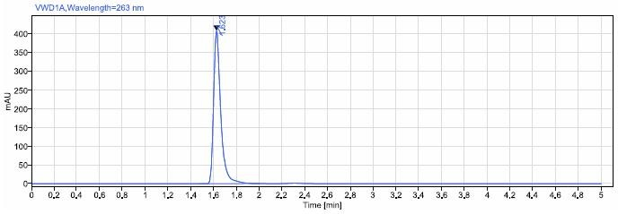

Fig 8.3: Chromatogram of 100% recovery-3

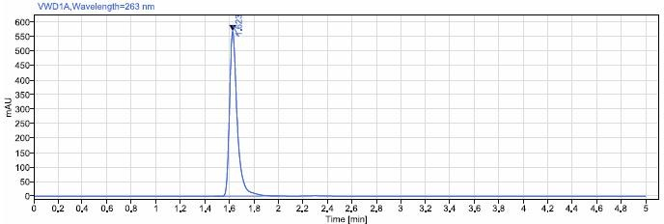

Fig 9.1 : Chromatogram of 150% Recovery-1.
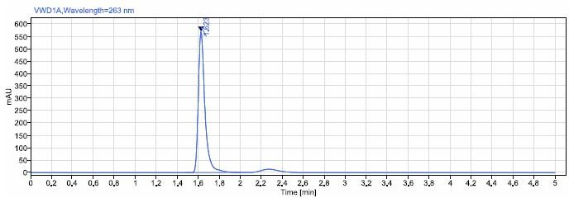

Fig 9.2: Chromatogram of 150% Recovery-2.

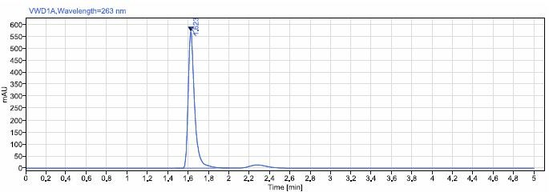

Fig9.3 : Chromatogram of 150% Recovery-3.

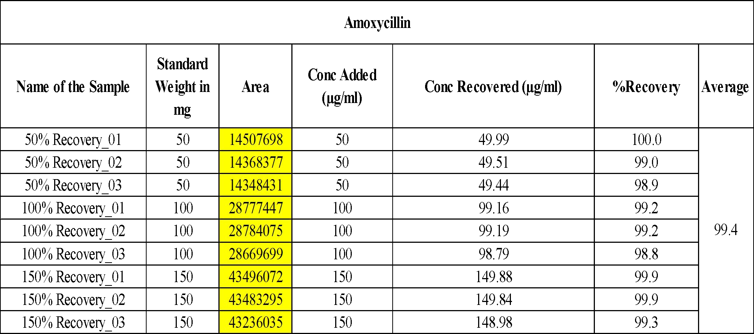

Table 12: Results for Recovery of PHENTERMINE.

Acceptance criteria

The Average % recovery of PHENTERMINE between 98% and 102%.

Result
The percentage mean recovery of PHENTERMINE %

LIMIT OF DETECTION

= 3.3 * (0.6)/76.72
= 0.025µg/ml PHENTERMINE

LOD = 3.3σ
S

Where, σ = the standard deviation of the response
S = the slope of the calibration curve

The slope S may be estimated from the calibration curve of the analyte.

Observation:
The LOD for this method was found to be 0.025µg/ml PHENTERMINE

LIMIT OF QUANTIFICATION (LOQ)

Where

= 10* (0.6)/76.72
= 0.078µg/ml PHENTERMINE

σ = the standard deviation of the response S = the slope of the calibration curve
LOQ = 10σ
S

The slope S may be estimated from the calibration curve of the analyte.

OBSERVATION :
The LOQ for this method was found to be 0.078µg/ml PHENTERMINE

Robustness
It was established if the approach was robust. Table 13 below provides an overview of the outcomes that were attained by purposefully altering the procedure parameters.
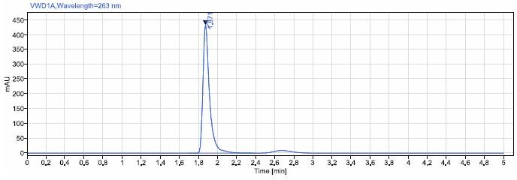

Fig.10.1 : Chromatogram of flow rate at 0.8mL/min.
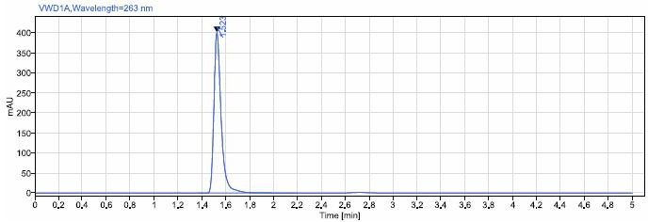

Fig.10.2: Chromatogram of flow rate at 1.2mL/min.
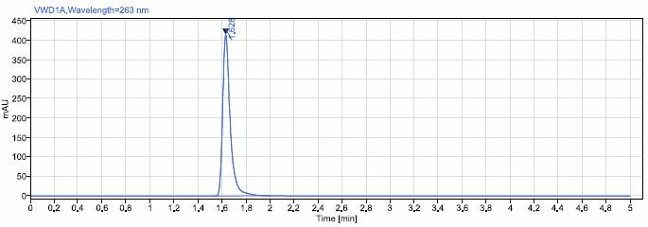

Fig.11.1 : Chromatogram of Temperature at 35°C

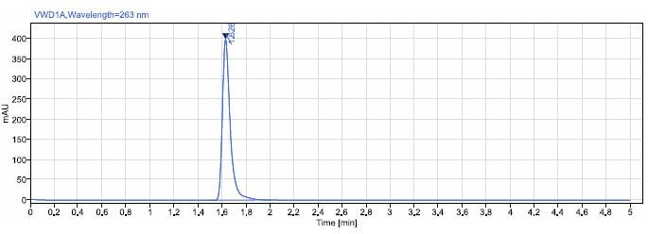

Fig 11.2 : Chromatogram of Temperature at 45°C

Table 13 : Results for Robustness of PHENTERMINE

Chromatographic changes |  | Rt(min) | Tailing Factor | Theoretical Plates | %RSD for Standard areas
Flow rate (mL/min) | 0.4 | 1.871 | 1.63 | 4171 | 0.03
 | 0.6 | 1.523 | 1.43 | 3459 | 0.49
Temperatur  e | 25 | 1.628 | 1.48 | 3786 | 0.05
 | 35 | 1.626 | 1.52 | 3434 | 0.42

Result

The tailing factor was discovered to be within tolerances for slight variations in wavelength and flow rate.

Intermediate Precision (Ruggedness):

Also known as within-laboratory or within-device precision, intermediate precision evaluates the degree of precision under particular circumstances. These prerequisites include repeating measurements on the same or comparable things over an extended period of time using the same measurement technique, equipment, and location.
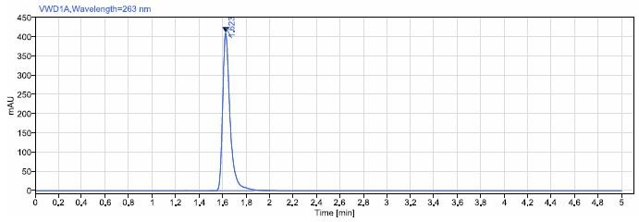

Chromatogram of Analyst-01 standard
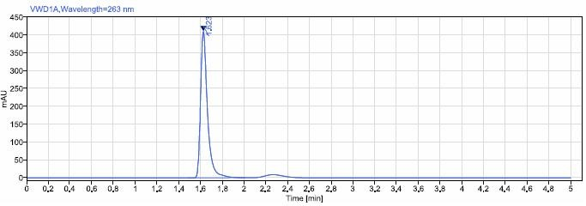

Chromatogram of Analyst-01 sample
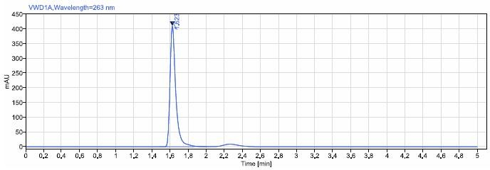
Chromatogram of Analyst-02 standard
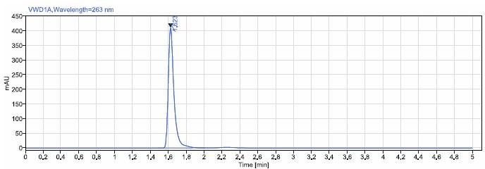

Chromatogram of Analyst-02 sample

Table 14: Ruggedness Results of PHENTERMINE

PHENTERMINE | %Assay
Analyst 01 | 100.22

Analyst 02 | 100.17
%RSD | 0.14

Results:

From the above results % Assay and %RSD obtained acceptance criteria so method is rugged.

CONCLUSION

Based on the above given experimental parameters and outcomes, it was determined that the recently created phentermine estimation method was straightforward, accurate, precise, and had a high resolution. at the near future, the technology can be efficiently utilized for routine analysis at research institutions, approved testing laboratories studies, and quality control departments due to its shorter retention time, which also made it more cost-effective and acceptable.

BIBILOGRAPHY
  - Chatwal, R. G.; Anand, K. S. High performance liquid chromatography. Instrumental methods of chemical analysis, 5thed.; Himalaya publishers: Mumbai, 2010; 2.570-2.629.
  - Sharma, B. K. High performance liquid chromatography. Instrumental methods of chemical analysis, 24th ed.; Goelpublishers: Meerut, 2005; 295 - 300.
  - Dong,W. M. HPLC instrumentation and trends. Modern HPLC for practicing scientists, USA, 2006; 5-10, 78-110.
  - UHPLC solvent properties
www.sanderkok.com/techniques/hplc/eluotropic_series_extended.htm
  - Swartz, M. E.; Ira Krull, S, Analytical method development. Analytical method development and validation, 1st ed.; Marcel Dekker, Inc: New York, 2009; 17-80.
  - Satinder, A.; Dong, M. W. Method development and validation. Pharmaceutical analysis by HPLC, 15th ed.; New York, 2005; 16-70.
  - Snyder, R. L.; Kirkland, J. J.; Glajch, L. J. Getting Started. Practical HPLC Method Development, 2nd ed.; New York, 1997; 30-100.
  - Selection of buffers http://www.sigmaaldrich.com/etc/medialib/docs/Aldrich/General_Information/labbasics_pg144.Par.0001.File.tmp/labbasics_pg144.pd f.
  - ICH, Text on Validation of Analytical Procedures, ICH – Q2A, International Conference on Harmonisation, IFPMA, Geneva, 1995, 2-3, A–1 to A–3.
  - ICH, Validation of Analytical Procedures: Methodology, ICH – Q2B, International Conference on Harmonisation, 1996, 1-3.
  - ICH Guidelines, Q2 (R1) - Validation of Analytical Procedures:Text and Methodology,2005, 1-6.
  - https://en.wikipedia.org/wiki/Phentermine
  - https://www.drugbank.ca/categories/DBCAT001351

