COMPARITIVE ANALYSIS OF OPTICAL PROPERTIES OF CdSe AND CdS ANNEALED THIN FILMS USING SPRAY PYROLYSIS TECHNIQUE

Dr. L.M.Shanware
N.S.Science College, Mulchera , District Gadchiroli.
Email: lshanware@gmail.com

ABSTRACT
A comparative study of CdSe and CdS thin films 0.025 M molar concentration deposited by spray pyrolysis technique were studied .The energy band gaps of these annealed films were found out from reflection spectra. CdS have the direct band gap 2.47 eV and CdSe thin films which has a direct band gap of 1.75eV used in IR optics, polarizers and X-Ray detector .These thin films of semi conducting materials are relevant use in optoelectronic, communicating devices and solar energy .

KEYWORDS: Thin film, optical properties, Energy gap ,Spray pyrolysis,
I. INTRODUCTION

The II-VI compound semiconductor such as CdSe of IV–VI layer structured semiconductor [1].In general they are used as holographic recording, switching photo conducting [2]and photovoltaic materials . which has a direct band gap of 1.75eV[3] is suitable for solar cell and solar control coating and applicable for windows layer[4] Thin films are highly structure sensitive which influence the device performance. Thin films are wide used in optical coating on the lenses to reduce the reflected light from the lenses .In this thin films, cadmium chalcognides have gain more attention due to their band gap which gives maximum efficiency[5] With this it is possible to convert visible light energy directly into electrical ,used in semiconductor photoelectrical and electrolyte hetero-junction system,[6] The efficiency of solar cell is found to improve with the increase in conductivity of the films. The structure is closely related to that of zinc-blende. The binary semiconductors CdS have the direct band gap 2.47 eV [7] Several authors pointed out that CdS could is a n-type window material implemented in hetero-junction solar cells[8] [9].

II.EXPERIMENTAL
CdSe and CdS annealed thin films were deposited by using spray pyrolysis technique[9] on a pre cleaned hot glass as a substrate of molar concentration 0.025M The aqueus solutions are prepared in double distilled water.The source of Cd and S are cadmium chloride -CdCl₂ and thiourea (NH–CS–NH₂) and the source of Cd and Se are cadmium chloride (CdCl₂) and selenium dioxide (Se₂). The aqneus solutions of CdCl₂ and thiourea were taken in the ratio 1:1 in the specially designed sprayer[10]. The specially designed glass spray nozzle was used for thin spray of solution on the hot substrate maintained at 400⁰C with an accuracy ±5⁰C. The special designed glass sprayer was mechanically moved to and fro on hot substrate .Then all the films CdS and CdSe are annealed for 2 hr. at 100⁰C constant temperature. The Experimental setup for spraying is shown in Fig. (1)The distance between the special designed glass sprayer and the glass substrate was about 25–30 cm with air pressure at 12 Kg/cm².[11]
Fig. (1) Experimental setup

III. OPTICAL AND STRUCTURAL PROPERTIES

Absorption spectra of CdS and CdSe are taken in the lab by using ELICO SL 159spectrophotometer in wavelength range 380-1000 nm. Energy band gap Eg and absorption coefficient[12] are used by using the Tauc relation is given by equation 1
$α=\frac{A}{hν}{(hν-E_{g})}^{1/2}$-------------------(1)
Where A is a constant, $hv$ is the photon energy, $Eg$ the band gap and $n$ is an index In this paper $n =\frac{1}{2}$ is chosen for an allowed direct transition. A graph is plotted between $(αhν)$² and $hν$, a straight line tangent to a slope which gives the value of the direct band gap as shown in graph.The sample were annealed because of anneating the samples at 100 ⁰C the crystanality prperties increases[13] From fig 2, found band gap of CdS in the range 2.4 eV [14] and from fig 4, CdSe thin film with a band gap 1.75 eV.[15] From all this data a computer program for calculation is used in lab to calculate the refractive index µ, and absorption 𝛂.[16]

The study of optical properties of the thin films is very important when these are to be used in devises particularly in solar cell. Because the optical properties determine the part of the efficiency of the devices. The refractive index $η$ and extinction coefficient κ were found out from the transmittance data. From fig 3 and Fig 5 it was found that the dependences of refractive index on incident photon energy [17] deposited on glass substrate .The thin film of CdS has significant interest for the efficient use in the solar cells [18-19]. Fig 6 and 7 shows the XRD of CdS and CdSe thin films of annealed samples was used to confirm the crystal structure [20]
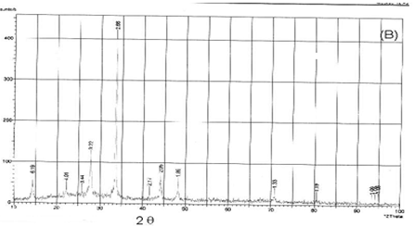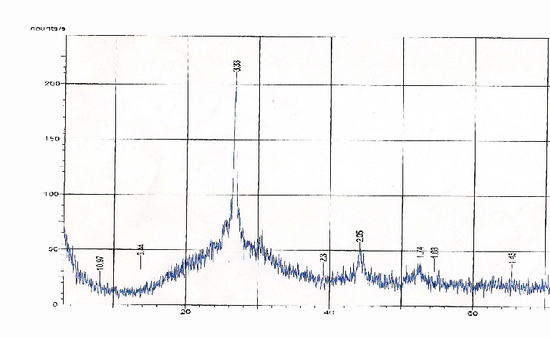
Fig 6 .XRD of CdS thin film Fig 7 .XRD of CdSe thin film

IV.CONCLUSION

Cadmium sulphide is II–VI group and it is almost used material for the heterojunction solar cells. The CdS has nearly the same energy band gapwhich is necessary for maximum conversion efficiency.CdS is stable and low cost thin film . The XRD of these thin films samples are shows crysraline in nature and hence used in solar cell and nano technology.The CdS thin films of 0.025 M molar concentration prepeary by spray pyrolysis method scanned in the visible region the energy gap was found that the band gap for CdS thins films of molar concentration 0.025M are nearly 2.4 eV It was found that the thin films samples prepared by spray pyrolysis method at constant substrate temperature were more stable. CdS thin film can be used as visibly transmitting material and buffer layer in chalcopyrite hetrojunction solar cell. Hence CdS gain more interest for the efficient component of solar cells. The values of energy gap of CdSe are 1.7 eV can be used in IR optics, polarizers and X-Ray detector In summry CdSe is the better window layer material for solar cell and.

REFERENCES
[1] S. S. Siddiqui and C. F. Desai, “Photoconductivity of solid-state-reacted SnSe thin films,” J. Mater. Sci. Lett., vol. 13, no. 7, pp. 512–513, Jan. 1994, doi: 10.1007/BF00540183.
[2] A. A. Faremi et al., “Engineering of window layer cadmium sulphide and zinc sulphide thin films for solar cell applications,” Results Eng., vol. 16, p. 100622, Dec. 2022, doi: 10.1016/j.rineng.2022.100622.
[3] H. H. Gullu, M. Isik, O. Surucu, N. M. Gasanly, and M. Parlak, “Temperature effects on optical characteristics of CdSe thin films,” Mater. Sci. Semicond. Process., vol. 123, p. 105559, Mar. 2021, doi: 10.1016/j.mssp.2020.105559.
[4] S. N. Moger and M. G. Mahesha, “Investigation on copper doped CdSe thin films for photodetector applications,” Micro Nanostructures, vol. 168, p. 207335, Aug. 2022, doi: 10.1016/j.micrna.2022.207335.
[5] Z. Bao et al., “The study of CdSe thin film prepared by pulsed laser deposition for CdSe/CdTe solar cell,” J. Mater. Sci. Mater. Electron., vol. 27, no. 7, pp. 7233–7239, Jul. 2016, doi: 10.1007/s10854-016-4689-9.
[6] C. S. Bagade, V. B. Ghanwat, K. V. Khot, and P. N. Bhosale, “Efficient improvement of photoelectrochemical performance of CdSe thin film deposited via arrested precipitation technique,” Mater. Lett., vol. 164, pp. 52–55, Feb. 2016, doi: 10.1016/j.matlet.2015.10.099.
[7] “Structural and optical properties of cadmium sulfide thin films on flexible polymer substrates by chemical spray pyrolysis technique | SpringerLink.” https://link.springer.com/article/10.1007/s10854-017-6353-4 (accessed Aug. 12, 2023).
[8] M. Dey et al., “Deposition of CdS Thin Film by Thermal Evaporation,” in 2019 International Conference on Electrical, Computer and Communication Engineering (ECCE), Feb. 2019, pp. 1–5. doi: 10.1109/ECACE.2019.8679325.
[9] D. L. M. Shanware, “Comparative Analysis of Optical Properties of Cdo Annealed thin Film deposited by Spray Pyrolysis Method,” Int. J. Chem. Math. PhysicsIJCMP, vol. 7, no. 4, Art. no. 4, Aug. 2023, Accessed: Aug. 10, 2023. [Online]. Available: http://www.journal-repository.theshillonga.com/index.php/ijcmp/article/view/6535
[10] D. L. M. Shanware, D. R. S. Meshram, and D. R. M. Thombre, “Study on Optical Properties of CDS Annealed Thin Films by Spray Pyrolysis,” Int. J. Sci. Res. Sci. Technol., vol. 9, no. 4, pp. 46–48, Apr. 2021, doi: 10.32628/IJSRST219909.
[11] D. L. M. Shanware, “Study of Structural Impact on Annealed CDs Thin Films by Spray Pyrolysis Method,” Int. J. Sci. Res. Sci. Technol., vol. 9, no. 6, pp. 333–336, Oct. 2021, doi: 10.32628/IJSRST219658.
[12] R. M. Thombare, L. M. Shanware, and B. M. Survanshi, “Optical and Electrical properties of CDS thin film of spray pyrolysis as function of annelead effect,” ACTA Cienc. INDICA Phys., vol. 31, no. 3, p. 409, 2005.
[13] M. Vishwas, K. S. Shamala, and S. B. Gandla, “Comparison of optical properties of CdS thin films synthesized by spray pyrolysis and thermal evaporation method,” J. Opt., vol. 51, no. 3, pp. 736–740, Sep. 2022, doi: 10.1007/s12596-022-00887-z.
[14] K. Diwate et al., “Substrate temperature dependent studies on properties of chemical spray pyrolysis deposited CdS thin films for solar cell applications*,” J. Semicond., vol. 38, no. 2, p. 023001, Feb. 2017, doi: 10.1088/1674-4926/38/2/023001.
[15] A. D. Kanwate et al., “CdSe thin films prepared by the homemade and cost effective spray pyrolysis technique,” Ferroelectr. Lett. Sect., vol. 49, no. 4–6, pp. 62–71, Nov. 2022, doi: 10.1080/07315171.2022.2076470.
[16] R. Swanepoel, “Determination of the thickness and optical constants of amorphous silicon,” J. Phys. [E], vol. 16, no. 12, p. 1214, Dec. 1983, doi: 10.1088/0022-3735/16/12/023.
[17] S. Chander and M. S. Dhaka, “Optical and structural constants of CdS thin films grown by electron beam vacuum evaporation for solar cells,” Thin Solid Films, vol. 638, pp. 179–188, Sep. 2017, doi: 10.1016/j.tsf.2017.07.048.
[18] S. M. Ho and T. J. S. Anand, “A Review of Chalcogenide Thin Films for Solar Cell Applications,” Indian J. Sci. Technol., vol. 8, no. 12, Art. no. 12, 2015, Accessed: Aug. 13, 2023. [Online]. Available: http://www.indjst.org
[19] K. Vijayan, S. P. Vijayachamundeeswari, K. Sivaperuman, N. Ahsan, T. Logu, and Y. Okada, “A review on advancements, challenges, and prospective of copper and non-copper based thin-film solar cells using facile spray pyrolysis technique,” Sol. Energy, vol. 234, pp. 81–102, Mar. 2022, doi: 10.1016/j.solener.2022.01.070.
[20] S. Yılmaz, Y. Atasoy, M. Tomakin, and E. Bacaksız, “Comparative studies of CdS, CdS:Al, CdS:Na and CdS:(Al–Na) thin films prepared by spray pyrolysis,” Superlattices Microstruct., vol. 88, pp. 299–307, Dec. 2015, doi: 10.1016/j.spmi.2015.09.021.

