PRODUCT COUNTERFEIT PROTECTION AND TRACKING WITH BLOCKCHAIN TECHNOLOGY

Ms. Swati Bula Patil
Assistant Professor at Department of Information Technology
Vishwakarma Institute of Information Technology, Pune.
Pune, India
swati.patil@viit.ac.in
Mr.Kishor Renukadas Pathak
Assistant Professor at Department of Information Technology
Vishwakarma Institute of Information Technology, Pune.
Pune, India
kishor.pathak@viit.ac.in
Dr..Snehal Rahul Rathi
Assistant Professor at Department of Computer Engineering
Vishwakarma Institute of Information Technology, Pune.
Pune, India
snehal.rathi@viit.ac.in
Dr.Manohar K.Kodmelwar
Assistant Professor at Department of Information Technology
Vishwakarma Institute of Information Technology, Pune.
Pune, India
manohar.kodmelwar @viit.ac.in

Mrs.Sonali Prashant Bhoite
Assistant Professor at Department of Information Technology
Vishwakarma Institute of Information Technology, Pune.
Pune, India
sonali.bhoite@viit.ac.in

Mrs.Shalini Vaibhav Wankhede
Assistant Professor at Department of Information Technology, Pune, India
Vishwakarma Institute of Information Technology, Pune.
shalini.wankhede@viit.ac.in

Mr.Mahesh Ashok Bhandari
Assistant Professor at Department of Information Technology
Vishwakarma Institute of Information Technology, Pune.
Pune, India
mahesh.bhandari@viit.ac.in

Abstract — In recent years, circulation of fake products has devastated the product manufacturing industries. This has an impact on the companies' brand, revenue, and profitability. Blockchain technology is used to identify genuine goods and identify counterfeit goods. This has huge use case in pharmaceutical, electronic and high value deliverables industry. It would be great application for diminishing the fake product flow in market. Blockchain technology is a distributed, decentralized digital ledger that keeps track of transactions in a number of databases in the form of blocks that are related to chains. No block can be changed or hacked because blockchain technology is secure. Customers or consumers can certify the safety of a product without relying on third parties thanks to blockchain technology. Using new technological advancements, Quick Response (QR) codes offer a powerful method in this project to combat the practice of manufacturing phony goods. Integrity of products can be maintained by integrating blockchain technology using QR codes. This system will store the authentic product details and unique codes as blocks. System collects the unique codes using QR codes and matches those codes to entries in the Blockchain database. If the code from QR matches to the codes in the databases the user will be prompted as it is a legitimate product, or else it will alert the user as product is fake.
Keywords — Blockchain, smart contract, supply chain, counterfeit products

Introduction
Blockchain is a system for storing data that makes it challenging or difficult to alter, hack, or defraud the system. The supply chain contains a huge number of products. to verify whether the product is genuine or not. Manufacturers are suffering the worst difficulties and the greatest losses as a result of counterfeit or phony goods. We can utilize blockchain technology to determine whether a product is authentic or not. Blockchain technology aids in addressing the issue of product counterfeiting. Technology based on blockchain is more secure. A chain will be constructed for that product's transactions once it is stored on the network, making it possible to keep all transaction records for both the product and its present owner. In the blockchain, all transaction histories will be kept in ledger with presenting copies in blocks. With the suggested system, each product is given a generated QR cod and token that the end user can scan to learn all there is to know about that product. We can determine whether a product is genuine or not after scanning its QR code. Risk considerations like counterfeiting and duplication are always present when a technology or product is developed globally; these elements can have an impact on the reputation of the organization, its revenue, and the wellbeing of its customers.
A. Blockchain
Blockchain is a digital ledger that is decentralised and used to securely and openly record transactions. Each block of data is connected together in a chain using encryption, and the distributed database is maintained by a network of computers.
Once a block is included in the chain, it cannot be changed or removed. Each block contains a record of several transactions. As a result, the blockchain becomes a tamper- and immutable-proof ledger.
Blockchain technology is most famously employed in cryptocurrencies like Bitcoin, where it is used to record and verify transactions. Supply chain management, voting systems, and digital identity verification are just a few of the numerous more possible uses for the approach.
B. Smart contract
A smart contract is a computer software that automatically carries out a contract's provisions when specific prerequisites are satisfied. It is a self-executing contract since the terms of the agreement between the buyer and seller are directly encoded into lines of code.
Blockchain-based smart contracts enable secure, open execution without the need for middlemen or reliable outside parties. They are made to eliminate the need for human involvement by automating the execution of contractual agreements. A number of uses for smart contracts exist, including supply chain management, property transfers, and financial transactions. A smart contract may be used, for instance, to automate the process of transferring property ownership, making sure that the transaction is safe and transparent and that the contract's requirements are always upheld.

Literature Review
The use of blockchain technology is significant in a number of fields, including finance, healthcare, education, data management, privacy, and security. Due to the potential for misuse, blockchain is also extending its applicability in the telecom and cyber security industries (Taylor et al., 2019).[1]
Additionally, a study by Kamble et al. (2018) used the Technology Readiness Index, the Theory of Planned Behavior, and the Technology Acceptance Model. The purported simplicity of use and effectiveness are barely impacted by insecurity and discomfort. The behavioural intention is influenced by perceived efficacy, attitude, and purported Behavior control. Supply chain experts think that blockchain technology can enable them to maximize benefits in the supply chain with the least amount of work.[2]
In a separate research, Mackey and Nayyar (2017) argued that blockchain technology can promote a trustworthy, secure, responsible, and transparent pharmaceutical supply chain. The identification and prevention of the physical and online sale and distribution of fake pharmaceuticals and medications, on the other hand, will require the use of other technologies, such as machine learning. Governments play a crucial role in integrating these technologies into the legal system. This article offers a thorough analysis and categorization framework for traceability methods used to spot product supply chain fraud. It starts by introducing the concept of traceability and its role in identifying counterfeiting, followed by a review of existing traceability solutions and their application.[3]
The paper then presents a classification framework based on the data source, data capture, data integration, and data analysis stages. It examines various solutions such as RFID, NFC, biometric technologies, databases, web services, and IoT technologies. It also discusses the concept of smart factories and the challenges of data analysis. The paper is an important contribution to the literature on product supply chain counterfeiting, providing a useful tool for researchers and practitioners in the field.[4]
A thorough study and classification of traceability ways to spot counterfeiting in the product supply chain are provided in the article "A Review and Classification Framework of Traceability Approaches for Detecting Product Supply Chain Counterfeiting." It is divided into six categories: physical-based, RFID-based, barcode-based, smartphone-based, holographic-based, and blockchain-based. The paper looks at solutions such as 2D codes, RFID, Near-Field Communication (NFC), and biometric technologies. It also examines various integration techniques, databases, web services, and IoT technologies. Finally, the paper discusses the challenges of data analysis and presents methods for overcoming them. This paper is an important contribution to the literature on product supply chain counterfeiting.[5]
Blockchain technology offers potential solutions to reduce counterfeiting and improve the security and traceability of products. This review of the literature attempts to examine the most recent studies on the use of blockchain technology to detect fake goods. It discusses the current trends and challenges in the counterfeit product market, and the impact of blockchain technology on the sector. Additionally, it assesses various sectoral prioritization strategies suggested in the literature for effective implementation of blockchain technology for counterfeit product identification and prevention.[6]
Research are being undertaken all over the world to take use of the advantages offered by blockchain technology to enhance supply chain performance. The agriculture supply chain includes suppliers, top companies, clients, and distribution partners, just like any other supply chain for consumer goods. The agriculture supply chain is under intense pressure to achieve sustainability from a range of consumer organizations, social and environmental campaigners, agro-based businesses, and legislators. These advantages would aid the agricultural industry in reducing the rising instances of product fraud and adulteration, enhancing sustainability. Blockchain can serve as the digital layer that provides trustworthy information about the provenance and origin of agricultural products.[7]
Examining the obstacles to and facilitators of blockchain technology adoption in a supply chain environment is of interest due to its cutting-edge nature and its potential to improve supply chain management. In a ground breaking study, Casey and Wong (2017) discussed the difficulties involved in the interoperability between different blockchains and the complexity of the rules and regulations that govern contracting and commercial exchange, particularly across national borders. They also highlighted the difficulties associated with the adoption of blockchain technology in international supply chains.[8]
Outside manufacturing companies, the most significant government sectors as well as those in healthcare, retail, finance, media and entertainment, agriculture, law, and fintech start-ups will be affected by blockchain technology's effects on supply chain operations. The use of blockchain's extra functionalities, such as inventory management, demand forecasting, asset monitoring, and intellectual property storage, helps supply chain operations become more agile. Blockchain technology may be used by combining delivery platforms, payment options, and digital contracts that span businesses and interacting with logistics providers and other supply chain partners. Smart contracts are used for enforcement, administration, performance, and payment.[9]
According to ISO 9000:2000, supply chain traceability is the "capacity to trace the history, application, or location of that which is under consideration." The distributed ledger, peer-to-peer communication, transparency, and irreversibility of records are just a few of the characteristics of blockchain technology that make it possible for this BCT application to provide real-time information visibility from a reliable single source of data. By using a smart contract feature to perform digital signatures that minimize the number of validation procedures based on paper-based documentation, digitalization extends beyond supply chain traceability. Single-use apps may be put into use right away, such as using BCT to assist businesses in creating internal databases. The development of localized solutions, which only involve one or a small number of reliable counterparties, helps streamline transactions.[10].
Transparency, validation, automation, and tokenization are the four main characteristics of blockchain technology that improve integration and coordination amongst the participants in a supply chain. Although blockchain provides additional advantages, it might cause problems if a strong business case and criteria are not established. Furthermore, there are drawbacks to blockchain technology, including a slower response time than traditional databases, the inability to alter data once it has been uploaded, and difficulties maintaining public and private keys. Because BCT might lead to data silos, it is crucial to assess if it is necessary before implementing it in an ecosystem. Otherwise, blockchain technology would be useless.[11]
The study proposes a blockchain-based system that can identify counterfeit products by creating a unique digital identity for each product at the point of origin. This identity is then stored on the blockchain and can be traced throughout the supply chain system, allowing stakeholders to verify the authenticity of the product at each stage of the supply chain.[12] A case study of the proposed system, which was implemented in a simulated supply chain environment. The results of the case study showed that the system was effective in identifying counterfeit products and providing real-time information on the product's origin and authenticity.[13]
We also discussed the benefits and challenges of using blockchain technology to combat counterfeit products in the supply chain system. The benefits include increased transparency, security, and traceability, while the challenges include the need for a standardized system and the cost of implementing the technology.[14]
The paper "Smart contract applications within blockchain technology: A systematic mapping study" presents a systematic mapping study of the applications of smart contracts within blockchain technology. It categorizes the applications into six main areas: finance, governance, supply chain management, healthcare, energy, and real estate. The paper provides an overview of each area and highlights the most commonly reported applications. It also discusses the benefits and challenges of using smart contracts, such as increased efficiency, transparency, and security, while the challenges include scalability and the need for technical expertise.[15]

Methodology And proposed sysytem
Because of the enormous range of products available online, the market for counterfeit goods is rapidly growing. So, it is imperative to identify fake items, and blockchain technology is used to accomplish so. Complete Architecture of System is explained in Fig.1. Moreover, a QR code containing the data has been developed. When scanning the QR code, customers or buyers may detect fake items(Fig.[5]). Using blockchain technology, the digital information about the objects will be kept in blocks. The information could be kept on the cloud.
Using blockchain technology, the digital information about the objects will be kept in blocks. The information could be kept on the cloud. Fig.3 shows the complete system diagram of proposed system. Fig.3 explains how both manufacturer and Buyer can use Application and Blockchain Technology.
In Fig.4 comprises of the state chart diagram explaining at level which state an object can have. It is ideally modeling object life cycle. Output is received when user the Verifies the product. This will verify the Authenticity of product. Figure 5 and 6 shows the add and sell product functions managed by admin which will store all the details of product and generate unique token for every product, while Figure 7 shows the gas consumption for the execution of smart contract.

aim and objective
The problem of counterfeit goods has expanded globally in recent years. The existing supply chain contains a large number of counterfeit goods. The survey claims that occurrences of fake products have increased recently. In order for customers or users to identify whether a product is genuine or not, it is critical to have a system in place that enables them to confirm all the product's specs. There is currently no system in place in India to identify fake goods. So, the answer calls for a simple identification system based on QR codes that can help the end-use.
This project was inspired by the poor user experience and issues brought on by counterfeit goods.

Project goals
• To use blockchain technology to design an anti-counterfeit system.
• To use a QR code to safeguard product information.
• Increase the transparency and traceability of the supply chain.
Provide clients security by making data available to them.

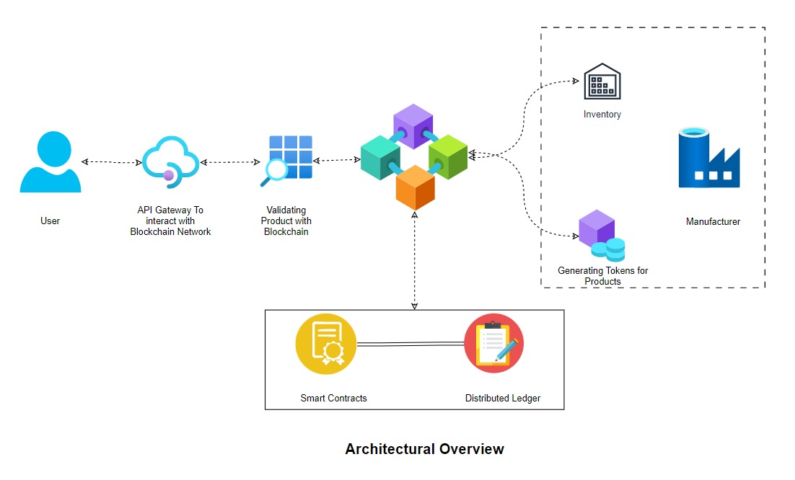

Fig.1 Architectural Overview
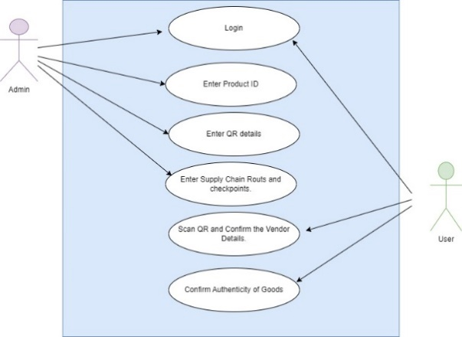
Thus, the recommended method aids the buyer in spotting fake items in the supply chain. Customers may scan the QR codes that have been allocated to products Fig.6 to obtain all the necessary information, including transaction history and the current owner, which the end-user can use to determine if the goods are genuine or not.
Fig.2. Use-Case Diagram
Using a cross-platform application with a QR code scanner, users will be able to scan the QR code of a product to determine whether it is genuine or not. We provide information from a blockchain such as the name of the recently created block, the amount of the product, the hash value that was created, and if the product is corrupted or not.

Actors and roles
- Administrator:
The administrator creates a database of all users and acts as the system's main manager.Fig.2 provide authentication for approvals. He has the ability to both add and remove users. Administrator produces reports and serves as director.

- User:
The user of the system can be anyone. He can use the system as for verifying a product to on their requirement Fig.2.

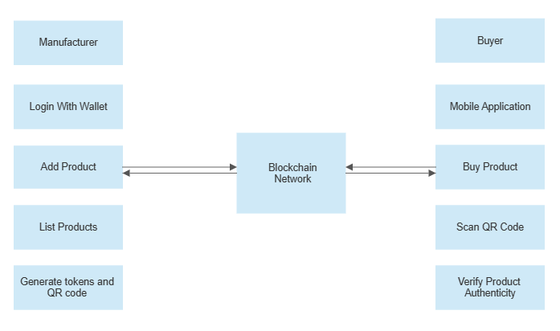
Design and architecture Diagrams
Fig.3 System Diagram

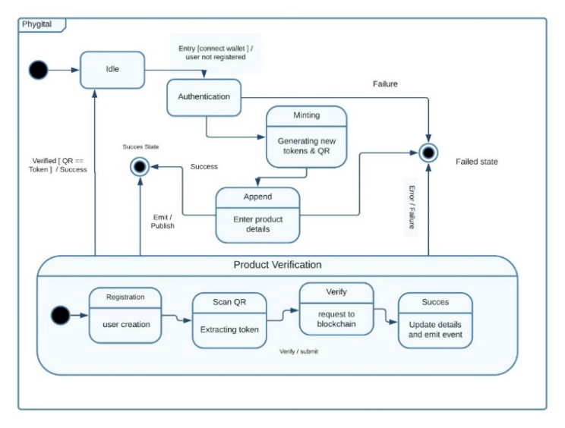
Fig.4 State-Chart Diagram

Fig.5 Verify Product
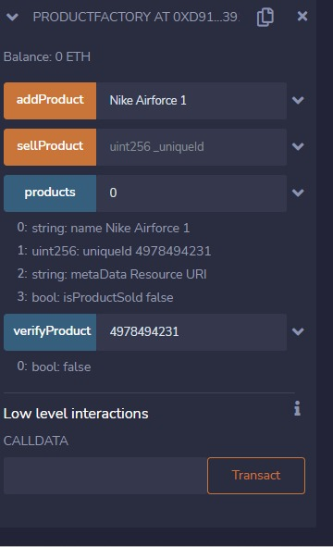
Fig.5 Add Product
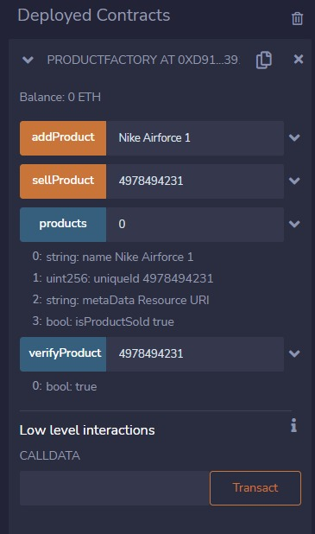
Fig.6 Sell Product
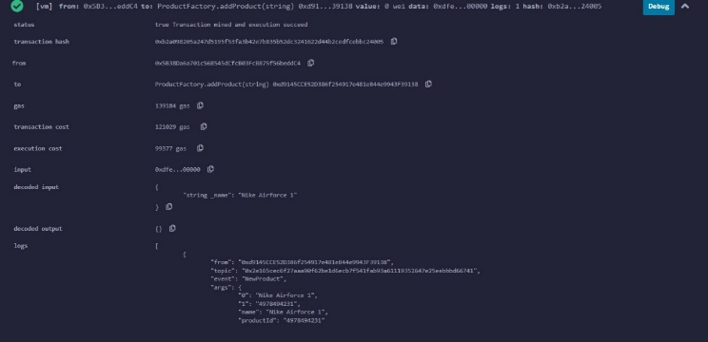
Fig.7 Gas Consumption

conclusion
With the rampant growth of counterfeit products in the market, the unforeseen need of having a way to detect counterfeit products has emerged, which can be met by integrating blockchain technology in the proposed solution.
In addition to this, information regarding the product is encoded into a QR code, which can be scanned by the customers or users so as to verify the authenticity of the product. Digital information gets stored in the form of blocks in blockchain technology, and Firebase Cloud is used to store the data. Therefore, we believe that the proposed system will be functional to overcome the problem of counterfeit products, which is responsible for degrading the user experience.
By employing provenance, a characteristic property of blockchain technology, Customers can scan QR codes assigned to a product and get all the information they need, like transaction history, current owner based on which the end-user can check whether the product is genuine or not. Hence, we believe Phygital stands a good chance to patch the problem of counterfeit product..

References
- Sachin S. Kamble, Angappa Gunasekaran, Rohit Sharma, “Modeling the blockchain enabled traceability in agriculture supply chain”, International Journal of Information Management, Volume 52, June 2020, 101967
- Maher A.N. Agi, Ashish Kumar Jha, “Blockchain technology in the supply chain: An integrated theoretical perspective of organizational adoption”, International Journal of Production Economics, Volume 247, May 2022, 108458
- Dhruman Gohil, Shivangi Viral Thakker, “Blockchain-integrated technologies for solving supply chain challenges”, Modern Supply Chain Research and Applications, 24 May 2021, ISSN: 2631-3871
- Abbas Batwa, Andreas Norrman, “A Framework for Exploring Blockchain Technology in Supply Chain Management”, OSCM Publications, Volume 13, Issue 3, 2020
- Kotha Raj Kumar Reddy, Angappa Gunasekaran, P. Kalpana, V. Raja Sreedharan, S Arvind Kumar, “Developing a blockchain framework for the automotive supply chain: A systematic review”, Computers & Industrial Engineering, Volume 157, July 2021, 107334
- Dnyaneshwar Ghode, Vinod Yadav, Rakesh Jain, Gunjan Soni “Adoption of blockchain in supply chain: an analysis of influencing factors” Journal of Enterprise Information Management, 22 April 2020
- Daniel E. O'Leary “Configuring blockchain architectures for transaction information in blockchain consortiums: The case of accounting and supply chain systems”06 December 2017
- Petri Helo, A.H.M. Shamsuzzoha ,”Real-time supply chain—A blockchain architecture for project deliveries” Robotics and Computer-Integrated Manufacturing Volume 63, June 2020, 101909
- Stefan Tönnissen, Frank Teuteberg “ Analysing the impact of blockchain-technology for operations and supply chain management: An explanatory model drawn from multiple case studies ”International Journal of Information Management Volume 52, June 2020, 101953.
- Fabian Dietrich , Yiwen Ge , Ali Turgut , Louis Louw , Daniel Palm “Review and analysis of blockchain projects in supply chain management”Procedia Computer Science Volume 180, 2021, Pages 724-733
- Nafisa Anjum, Pramit Dutta, “Identifying Counterfeit Products using Blockchain Technology in Supply Chain System”, arXiv:2206.08565v1 [cs.CR] 17 Jun 2022
- Longo Francesco, Nicoletti Letizia, Padovano Antonio, d'Atri Gianfranco, and Marco Forte, "Blockchain-enabled supply chain: An experimental study." Computers & Industrial Engineering, Volume 136, October 2019.
- Shuchih E. Chang, Yichian Chen, “When Blockchain Meets Supply Chain: A Systematic Literature Review on Current Development and Potential Applications”, IEEE Access, Volume 8, March 2020.
- Macrinici Daniel, Cartofeanu Cristian, Shang Gao, "Smart contract applications within blockchain technology: A systematic mapping study." Telematics and Informatics, Volume 35, Issue 8, December 2018.
- Ming K.Lim, Li Yan, Wang Chao, Ming Tseng, "A literature review of blockchain technology applications in supply chains: A comprehensive analysis of themes, methodologies and industries." Computers & Industrial Engineering, Volume 154, April 2021, 107133.

