Tomato Processing

P. B. Sable¹ and S. R. Ghulaxe²
Shri Shivaji Agriculture College, Amravati, M.S., India - 444603

Tomatoes are bountiful crop in India growing in both summer and winter, however those cultivated in winter are superior in quality due to their higher total solids content. Tomatoes are most widely consumed and versatile crop. Botanically being a fruit, but commonly considered as a vegetable. During peak season, 25 per cent of the produce is spoiled due to improper handling. However this losses can be avoided by transforming tomatoes into different value added products by changing their form and colour and other methods are used to increase keeping quality of products. Large quantities of tomatoes are canned or transformed into paste/ puree, juice, sauce and ketchup in the United States of America, Australia and Canada, among various other nations. In India, tomato sauce and ketchup have gained enormous popularity.
Fresh tomatoes are indeed known for their colour, juicy texture and delicious taste. Tomatoes play vital role both for its large consumption and in health related food components. They are good source of vitamins and minerals. Minerals like calcium, magnesium, phosphorous, iron, sodium, potassium and vitamins, especially vitamin C which contributes to their nutritional value. The quality of products is decided by its colour, which is dependent on redness of tomato. The red pigment in tomatoes known as Lycopene, serves as valuable index for measuring the tomato content present in the product. High quality of products can be prepared from tomatoes by.
- Select uniformly ripened, red colour tomatoes.
- Avoid extended heating and cooled the product quickly after cooking.
- Be aware of using either copper or iron utensils at any stage of processing.

Composition of Tomato :
Chemical composition of tomato is influenced by factors such as variety, growing environmental conditions and cultivation practices. It also varies according to stage of maturity. This composition play an extremely important role in determining colour, flavour, nutrient content and texture in both raw and processed tomatoes. As tomatoes mature, total solid content decreases due to conversion of insoluble constituents basically starch and insoluble polysaccharide into simple sugars and soluble polysaccharides.
Tomato is contemplated as a valuable raw material which is used for different processed products. The different value added products prepared from tomato are tomato juice, sauce, ketchup, puree / paste, powder, cocktail, pickle, chutney, soup, tomato chilli sauce, canned tomatoes.
A semi-finished product such as tomato puree prepared on small scale, while tomato paste has gained commercial significance on a larger scale.

Affiliations :-
- Assistant Professor,
Shri Shivaji Agriculture College, Amravati, M. S., India.
- B.Sc. (Hons) Agriculture student.,
Shri Shivaji Agriculture College, Amravati, M.S., India

Address For Correspondence :-
- Dr. P. B. Sable, Assistant Professor, Department of Horticulture,
Shri Shivaji Agriculture College, Amravati, M. S.,
India – 444603 E-Mail –pb_sable@rediffmail.com
Mob. no. -9403063177
1. TOMATO JUICE :-
Tomato juice is the unconcentrated product consisting of the liquid extracted from ripe tomatoes, with a significant amount of pulp. This extraction process can be conducted with or without application of heat and addition of salt.
Tomato juice is the fundamental ingredient used for the preparation of various tomato products such as puree/paste, ketchup, sauce.
Only fully ripe, plant ripened fruit with deep red colours are selected. All green, blemished, under ripen, over ripen or rotten tomatoes are discarded. High quality tomato juice should be deep red colour, possess the characteristic taste and flavour of tomatoes. A good quality juice contain 0.4 per cent acid, 0.5 per cent salt and 0.1 % sugar.

F.P.O. specifications:

Product  (Prepared from any suitable variety) | Minimum total  Soluble solids (%)
Tomato juice | 5

- Home preparation:-
In the home, tomato juice can be made by using 1 liter of juice with 10 g of sugar, 5 g of salt, 1 g of citric acid and 1g of sodium benzoate.
- Extraction method for tomato juice:
Tomato juice can be extracted either by hot pulping or cold pulping methods. On a commercial scale pulping is often accomplished using machines like pulper or continuous spiral press. In the home, a simple method involves straining the tomatoes through a steel sieve for & extraction of juice.

Preparation of tomato juice :-
- Selection of fruits :- Select fully ripe red tomatoes are used for juice making. Discard damage, over ripe or rotten tomatoes.
- Washing :- Tomatoes should be washed thoroughly to remove dirt or contaminants.
- Sorting :- Sort the tomatoes on the basis of size, colour and softness.
- Trimming:- It is an important step to ensure that only high quality tomatoes are used in further processing. Trim away the green portion and stems from top of individual tomato.
- Cutting and chopping:- Cut the tomatoes into 4 to 6 pieces for extraction of pulp.
- Heating :- Heat these pieces at 70-90°C for three to five minutes to soften them.
- Extraction of juice:- Tomato juice can be extracted either by passing through a pulper or continuous spiral press. Pulp can be extracted by passing through pulper. At the time of pulping the juice and pulp passed through a sieve of pulper. The sieves are allowed the fine juice and pulp, while retaining larger pieces such as skin and seeds. The fine juice and pulp pass through one end of pulper and are collected for further processing. Simultaneously skin and seeds are separated through another end of pulper.
- Addition of ingredients:- Add common salt, sugar and citric acid to enhance taste and flavour of the product.
- Homogenization:- Homogenized the mixture to obtain smooth and thick consistency and uniform appearance.
- Heating:- Heat the mixture at 82-88°C for a minute.
- Filling and canning:- Fill the hot juice in pre-sterilized glass bottles or cans The bottles are hermetically sealed using crown cork.
- Sterilization :- Sterilized the filled glass bottles or cans in boiling water (100°C) for 25 to 30 minutes.
- Cooling:- After sterilization, cans are cooled down.
- Storage:- Store the processed tomato juice in cool and dry place.
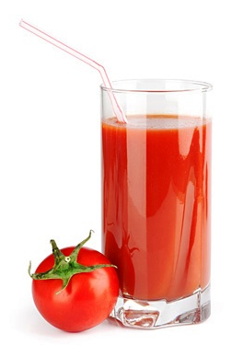

2. TOMATO KETCHUP :-
Tomato ketchup is a commercial product prepared either from fresh tomatoes through the conversion of pulp/ juice or by utilizing tomato puree or tomato paste. Tomato ketchup is prepared from strained tomato juice / pulp along with spices, salt, sugar and vinegar, with or without onion and garlic. It contains minimum 12 per cent tomato solids and total solid content of at least 25 percent.

F.P.O. specifications :-

Product  (Prepared from any suitable variety) | Minimum total  soluble solids (%)
Tomato Ketchup | 25

Recipe:-

Ingredient | Quantity
- Tomato juice  - Sugar  - Salt  - Red Chilli powder  - Onion (Chopped)  - Garlic (Chopped)  - Spices (Cloves (headless), cardamom (large), cumin, blackpepper, cinnamon)  - Acetic acid  - Benzoic acid | 1 Litre  20-30 g  10 g  2 to 3g  35-40g  5-10g  4 g each  2-3 ml  750ppm

Preparation of tomato ketchup :-
- Selection of fruits:- Select uniformly ripe, fresh, well developed colour tomatoes. Entire surface of tomatoes indicating that they are fully mature. Reject all green, damage, infected, over and under ripe fruits.
- Washing :- Tomatoes should be washed thoroughly under running water to eliminate dust and dirt. After washing, surface of tomatoes dry with clean kitchen towel. This helps to remove excess moisture that could lead to bacterial growth.
- Sorting :- Tomatoes are sorted on the basis of colour & softness.
- Cutting:- Sorted tomatoes cut into small pieces and it is helpful for juice extraction.
- Chopping:- Chopped tomatoes are heated at 70-90°C for 3 to 5 minutes. Objective of blanching is to soften tomato pulp, which is helpful for extraction of pulp either by mechanically or sieving, latter straining tomato juice.
- Sugar addition:- About one third of the sugar is added at the beginning of boiling to intensify and fix red colour of tomatoes. However whole sugar is added initially within the pulp, it will require longer span for boiling the pulp which will affect the quality of pulp.
- Salt and sugar content:- Sugar content in ketchup varies from 10-26 percent. Salt should be added at the end of boiling process, otherwise it bleaches the tomato colour. The desired salt content ranges from 1.3 to 1.4 percent.
- Addition of spices:- Spices are placed in muslin cloth in powdered form, using spice bag method. Put the spice bag in boiling mixture and pressed . Squeeze the spice bag and remove after squeezing in pulp.
- Addition of salt and sugar :- Addition of remaining salt and sugar after removal of spice bag. The pulp is cooked with salt and sugar.
- Judging the end point:- Judge the end point by hand refractometer or by measuring stick.
- Addition of vinegar:- Vinegar is essential for the preparation of superior quality ketchup and used for inhibition of microbial growth and spoilage of tomato ketchup. Vinegar is added when the ketchup has thickened sufficiently to prevent volatilization of acid.
Tomato ketchup generally contain 1.25 to 1.5 percent acetic acid. Sometimes, glacical acetic acid is also used in ketchup. It is colourless and cheaper than vinegar.
- Bottling :- The Ketchup should be filled while hot (88°C) into pre-sterilized glass bottles to prevent browning and loss of vitamins at the time of storage. To prevent spoilage of tomato ketchup add 0.025 percent sodium benzoate before bottling.
- Crown corking :- Glass bottles are crown corked by crown corking machine.
- Pasteurization :- Pasteurizing the bottles at 85-90°C for 30 minutes. It provides extra layer of protection against spoilage.
- Cooling :- After processing the cans are cooled rapidly.
- Storage :- Store the tomato ketchup in cool and dry place.

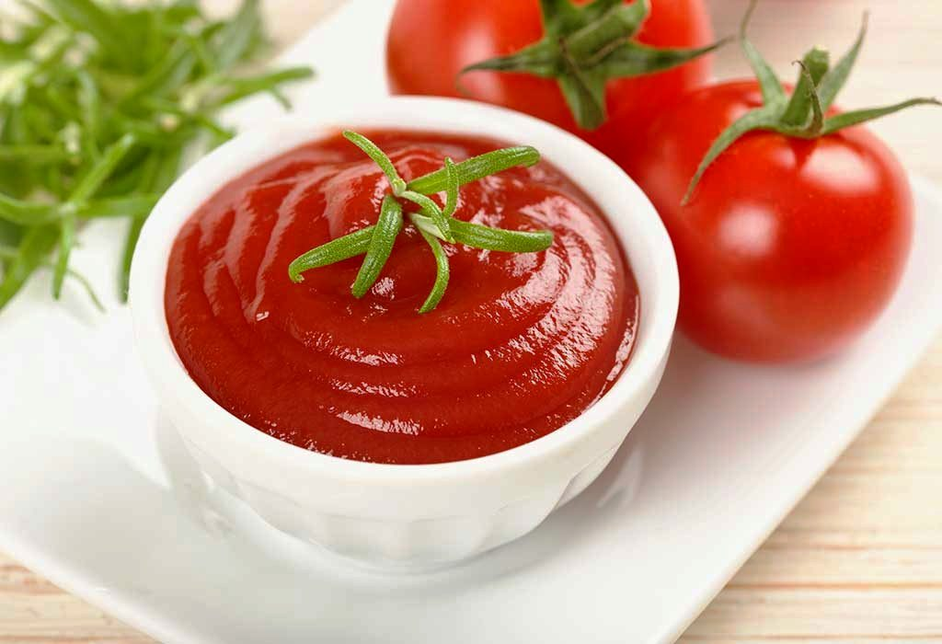

Problem in the preparation of ketchup :-
The main processing problem is that the product turns black at the contact zone with air due to action of iron on tannins in the spices.

Black Neck in tomato ketchup:-
Black ring is formed in the neck of the bottle is called as black neck. This occurs to action of iron with tannins in spices and leads to the formation of ferrous tannate. Ferrous tannate undergo the process of oxidation to form black ferric tannate. Black neck can be prevented by.
- Fill the ketchup at a temperature not less than 85°C.
- Leaving little head space.
- Bottles should be stored in horizontal or inverted position.
- Using plastic lid instead of iron lid.
Discolouration :-
Discolouration could be due to excess squeezing of the spice bag. Another factor is addition of salt too early during cooking process. To prevent discolouration, squeeze the spice bag gently according to the requirement and add salt at the end of cooking.

Precautions :-
- Avoid using copper and iron utensils.
- Before sealing or corking the bottles, leave head space 2cm at the top of the bottle.
- It is best to use the product within one month of opening.
- Avoid addition of chemicals or artificial colour in ketchup.

3. TOMATO SOUP :-
Tomato soup has gained popularity in households. It can be prepared either from tomato pulp or tomato juice. Preparation of tomato soup involves addition of ingredients like cream or butter, spices, starch, etc to achieve the flavour and consistency. These ingredients are added in different proportions on the basis of desired taste.

F.P.O. specifications :-

Product  (Prepared from any suitable variety) | Minimum total  Soluble solids (%)
Tomato Soup | 7

Recipe:-

Ingredient | Quantity
- Tomato juice  - Salt  - Sugar  - Onion (Chopped)  - Garlic (Chopped)  - Arrowroot starch  - Red Chillies  - Cream or butter  - Spices (Cardamom, black pepper, cumin, cinnamon)  - Clove (headless) | 1 Litre  20 g  20 g  20 g  5 g  10 g  20 g  10 g  1g each  5 numbers

Method for processing of tomato soup:-
- Boiling :- The juice is boiled in pans to concentrate its flavour.
- Addition of spices:- Like in tomato ketchup preparation place spices bag in cloth bag and put the spice bag in cooking pan.
- Preparation of paste :- Prepare a smooth paste by mixing arrowroot starch, butter and small amount of juice.
- Addition to concentrated juice:- Add the arrowroot and butter paste to concentrated juice while continuous stirring.
- Boiling :- Keep the mixture boiling while stirring, allowing it to reach desired consistency to prevent coagulation of starch.
- Addition of salt and sugar content:- Towards the end of process, add salt and sugar, boiling for about 2 minutes to dissolve them.
- Removal of spice bag:- Remove the spice bag after squeezing.
- Filling and Sterilization:- Fill the hot soup into cans (plain cans) and process them at 115°C for 40 to 45 minutes.
- Cooling:- Cans are cooled rapidly to maintain quality of product.
- Storage :- Store at ambient temperature.
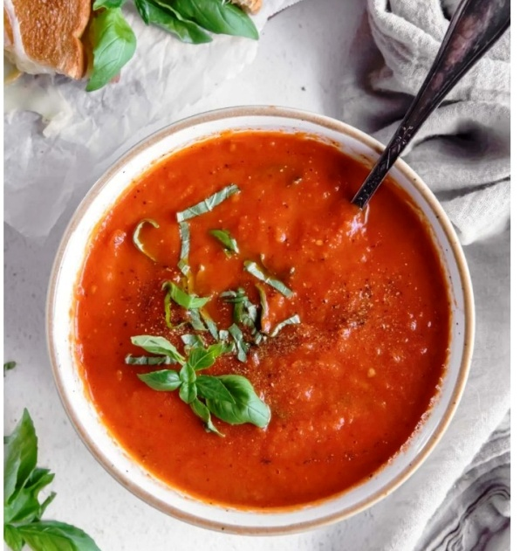

Flow chart for preparation of whey tomato soup :-
Frying of seasoning in oil (Onion, ginger and garlic)

Paneer/ Cheese
Whey

Tomatoes

Cooking under pressure
Add corn flour

Grinding
Gelatinization of Starch
(80-85 ⁰C / 2 min)

Straining

Tomato Pulp

Tomato whey corn flour
Suspension

Add salt and authorized
food colour

Cooking

Whey Soup

4. TOMATO POWDER :-
An indigenous method involves converting tomato juice into a free flowing and highly moisture absorbing powder by using several drying methods. This innovative approach presents an additional preservation method for protecting tomato solids during off-season periods and also offer convenience to consumers.
Tomato juice can be converted to powder through several methods including spray drying, foam mat drying or tray drying methods. For the preparation of tomato powder the process starts with cleaning and washing whole tomatoes and allowing the surface moisture to evaporate. The tomato juice is extracted using a hot pulping method and the pulp free juice is obtained through filtration. After that, the juice is concentrated under vaccum conditions. The concentrated juice is combined with foaming agent, to form foam that undergoes drying through hot air. The resulting tomato powder is cooled and conditioned in a finely processed powdered form.

Spray drying process:-
Select tomatoes with attributes like thick wall, red colour, high solids and high pectin content. These characteristics are ideal for dehydration. Extract juice using hot break method and may subjected to enzymatic treatment to enhance juice recovery, solids and colour pigments. Remove seeds and skin pieces to obtain smooth juice. Concentrate juice using vaccum pans or double effect evaporators to attain desired total solids. Add Maltodextrin (10 DE @1%) and SiO₂ [Silicon dioxide] (@ 1%) to the concentrated juice. This addition improves the colour and reconstitution properties of powder. Atomize the mixture using a high speed atomizer around 25,000 rpm (revolutions per minute). Set inlet temperature at 200°C to get good quality tomato powder. The mixture is sprayed into hot air stream, leading to rapid evaporation and liquid droplets are transformed into fine powder particles. Collect the dried particles from drying chamber and allow it to cool down. Package the cooled powder in suitable container for distribution and storage Tomato powder can also packed under vaccum for extending the keeping quality.

Flow chart for preporation of tomato powder by spray drying process :-

TOMATO JUICE
(Strained)

VACCUM CONCENTRATION
(Vaccum pan or multiple effect evaporators)

TOMATO JUICE CONCENTRATE

ATOMIZATION OF FEED
(25,000 rpm)

SPRAY DRYING
(Inlet air temperature 200⁰C, outlet temperature 70⁰C)

COOLING

STORAGE

Tomato Paste / Puree :-
Tomato pulp devoid of skin or seeds, with or without salt, with a minimum of 9 percent salt free content from tomato solids is known as “medium tomato puree". It can be further concentrated into "heavy tomato puree" with at least 12 per cent solids. If concentration escalates to encompass a minimum of 25 per cent tomato solids is termed as "tomato paste” elevating concentration to 33 per cent or beyond of solid it is called as "concentrated tomato paste”

F.P.O. Specification :-

Product (Prepared from any suitable variety) | Minimum total soluble  Solids (%) | Mould Count
Tomato Puree | 9 | Should not in excess of 60% of field count
Tomato Paste | 25

Based on the degree of concentration tomato paste can be classified as.

Sr. No. | Tomato Paste | % of salt free salts
1. | Light tomato paste | 25-29 %
2. | Medium tomato paste | 29-33%
3. | Heavy tomato paste | Not Less than 33%

Preparation :-
The production of tomato pulp follows similar approach to that of tomato juice extraction. Two methods are available for extraction of pulp.
- Open cooker
- Vaccum pan
In an open cooker, extensive heat exposure can lead to loss of vitamins and the product becomes brown. However vaccum pans help in the preservation of nutrients and significantly reduce browning. Normally, tomato juice can be concentrated to 14-15 % solids in an open cooker. For higher concentration vaccum pan is essential. Also, it provides the advantage of product sterilization. During the cooking process in an open cooker a small amount of butter or edible oil is introduced to prevent issues such as foaming, burning and sticking. If post cooking total solids content of juice exceeds the desired level, adding more juice to lower it. If it's insufficient cooking is extended until the desired concentration is achieved. The end of cooking paste and puree can be judged either with a hand refractometer or by measuring the volume with the assistance of measuring stick.
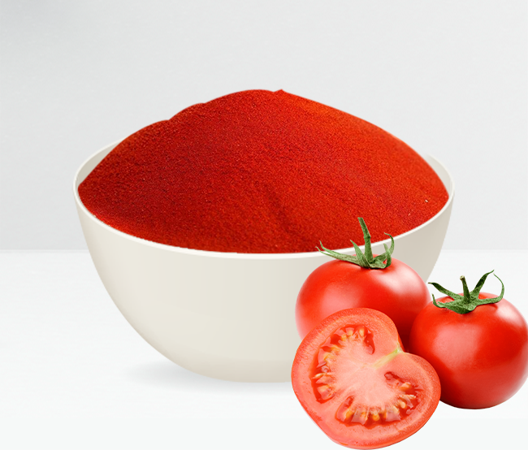

References :
- Fruit and Vegetable Preservation
PRINCIPLES AND PRACTICES
3rd Revised and Enlarged Edition
By R. P. Shrivastava and Sanjeev Kumar
- www.iaritoppers.com
- http://ecoursesonline.iasri.res.in

