Stability Indicating Bio-analytical Method Development and Validation for the Quantification of Apalutamide - Apalutamide D3 by Using Ultra Performance Liquid Chromatography in Human Plasma
D. China Babu*¹, G. Sai Sri Harsha¹, G. Venkateswarlu¹, M. Alagusundaram¹, Shailendra Singh Narwariya¹, SK. Aleesha²
School of Pharmacy, ITM University Gwalior, Madhya Pradesh-474001, India
Narayana Pharmacy College, Nellore, Andhra Pradesh-524002, India
Corresponding Author:
Dr. D. China Babu
Associate Professor,
Dept. of Pharmaceutical Analysis,
ITM University, Gwalior,
Madhya Pradesh, India.

ABSTRACT
A simple, convenient, specific,precise and highly conventional stability indicating ultra performance liquid chromatographic- diode array method was developed for the quantification of Apalutamide in human plasma. The phenomenex Luna (100x4.6x5µ) column was used for apalutamide separation and mobile phase was composed with 5 mM ammonium fumarate and acetonitrile in the ratio of 15:85 v/v and buffer pH 3.5 was adjusted with glacial acetic acid and detected at 345 nm. The Apalutamide-D3 used as internal standard and K2-EDTA used as coagulant.The liquid-liquid extraction process used for extraction of drug from human plasma with tert butyl methyl ether. The retention times of Apalutamide and Apalutamide D3 (ISTD) was 1.48 min & 1.97 min respectively. The assay of the method was validated in human plasma in the concentration range from 307.26-200013.87 pg/ml with the accuracy and precision ranging from 3.86 to 4.87. Recovery studies were found to be 103.79%, 90.93% & 96.83% for HQC, MQC and LQC respectively. The stability of the drug was evaluated in human plasma with different conditions of auto-sampler, freeze-thaw, bench top, short term and long term stability studies were performed. The method was proved as highly sensitive and selective for the quantification of Apalutamide and determined at picogram level. There was no matrix effect observed and proved as a stability indicating method.
Keywords: Apalutamide, Acetonitrile, Di Potassium ethylene diamino tetra acetic acid, High Quality control, Medium Quality control.

INTRODUCTION
Apalutamide (Figure 1) is an anti-androgen. The IUPAC name of the drug is 4-{7-[6-cyano-5-(trifluoromethyl) pyridine-3-yl]-8-oxo-6 sulfanylidine 5,7diazaspiro [3.4] octan-5-yl}-2-fluoro-N-methylbenzamide (Fig.1). It shows the antagonistic effect on androgenic receptors. The drug is under the class of non-steroidal anti-androgen.. It is second generation androgen receptor antagonist [Anjaneyulu Reddy R., et al.2019]. It is developed to inhibit androgen receptor mediate prostate cancer cell proliferation [Vadim Koshkin S et al., 2018]. Apalutamide evaluated in high-risk patients for its activity and safety of non-metastatic castration-resistance prostate cancer to identify it by conducting multicentre phase-2 trials on nm-CRPC patients with a high risk of advancement [Smith MR et al., 2016, Zhou, Z., Hu.X. 2018].The efficacy of the apalutamide was evaluated in men with non-metastatic castration-resistance (nmcr) prostate cancer in the development of metastasis of high risk patients. They were conducted a double-blind, placebo controlled, phase-3 trial of nmcr prostate cancer and a prostate-specific antigen doubling time of 10 months or less in men patients [Smith MR et al., 2018, Small EJ et al., 2018]. The patients were taken apalutamide (240 mg/day) or placebo. The androgen deprivation therapy continued for patients.The prime end point was metastasis free survival [Sandler HM et al.,2016, Rathkopf DE et al.,2017].The efficacy of apalutamide was evaluated with abiraterone acetate and prednisone in patients before or after treatment with progressive metastatic castration resistant prostate cancer [Suresh P Sulochana et al., 2018, Dellis A et al., 2018]. The chemotherpy exposure shows more effective on CRPC [Ranjan RK et al.,2018, Khan Z.G et al.,2016]. Few analytical methods were reported on its related and core molecule of Apalutamide [Sandhya Rani J, et al.,2018, Anjaneyulu Reddy R., et al. 2019, Ashok Zukkala et al. 2019, Chinababu D et al 2021, Sai Uday Kiran, G., Sandhya P. 2020].

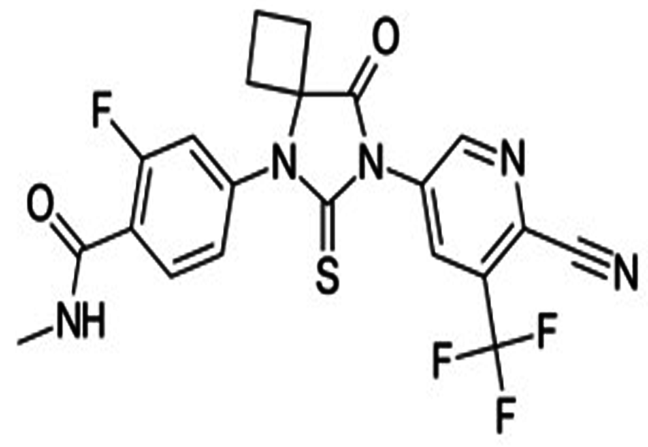

Figure1: Structure of Apalutamide
MATERIALS AND METHODS
Materials & reagents
The apalutamide drug and internal standard of apalutamide D3 were procured from Ajanta Pharma LTD, Mumbai, India. The water used for analysis was prepared from milli-Q water purified system purchased from Millipore, Mumbai, India. The HPLC grade acetonitrile was purchased from Merk, Mumbai, India. Analytical grade of ammonium fumarate, K2-EDTA and tert-butyl methyl ether and glacial acetic acid purchased from SD fine chem, Mumbai, India. The plasma sample was purchased from Santhiram Medical College, Nandyal, AP, India.
Instrumentation
The liquid chromatographic system was Shimadzu UPLC-2010 CHT (Shimadzu, Corporation,Kyoto,Japan) consisting of a quaternary pump, column heater, solvent degasser. The column used for separation was Phenomenex Luna (100 x 4.6mm x 5µ) Waters Corporation, Milford, USA. The column temperature was maintained at ambient and flow rate of the mobile phase was maintained at 1mL/min. The analyte was detected at 345 nm by using a photodiode array detector. The auto sampler temperature was maintained at 15℃ and pressure of the system was maintained at 6000 psi.

Methodology
Statistical analysis
The developed method in UPLC was validated to ensure the stability of the analytical method and consistency of the results. The statistical analysis was performed with one way variance analysis treatments.
Preparation of standard solution
Apalutamide (1mg/ml) and internal standard Apalutamide D3 standard solutions were prepared in 10 ml separate volumetric flask in the mobile phase. Apalutamide D3 internal standard, 0.5 µg/ml solution was prepared by diluting its stock solution with ammonium fumarate: acetonitrile (15:85 v/v). The plasma spiked working standard solutions prepared for Apalutamide in the concentration ranging from 200013.9 pg/ml (STD1) to 307.3 pg/ml (STD 10).
Quality control samples
Quality control samples of the APA were prepared for the qualitative evaluation of calibration curve. Lower limit of quantification (LLOQ), low quality control (LQC), Middle quality control 1 & 2 (MQC 1 & 2) and high quality control (HQC) has been prepared in drug free plasma and solutions were stored at 4℃.
Extraction of APA from plasma
The plasma samples were stored in a freezer at -70℃ and thaw at room temperature before processing. A 200 µl of plasma was transferred to the Ria vials, then 50µl of IS working standard solution 0.5 µg/ml was spiked and vortexed for 10 sec with100µl of 2% formic acid, tert-butyl methyl ether 2.5 ml was added and vortexed again for 10 min. After centrifugation at 3000 RPM for 10 min and transferred the organic layer in to new ria vials and evaporated until dry under a gentle stream of nitrogen gas at 45℃. The residue was reconstituted with 150 µl of the mobile phase and 10 µl aliquots were injected into UPLC system.
Preparation of buffer
Ammonium fumarate was prepared 1M solution from that collected 5 mL and transferred into 1000 mL volumetric flask. The volume was made up to mark with water and obtained 5 mM ammonium fumarate.
Mobile phase
Buffer and acetonitrile was taken in the ratio of 15:85 v/v used as mobile phase.
RESULTS & DISCUSSION
Bio-analytical method validation
The validation was done in accordance with the US-FDA's criteria for the validation of bioanalytical methods [US FDA Bio-analytical validation guidelines 2001, Smith G, 2012, Zakkula A et al., 2019].
Optimised parameters
The separation was obtained with 5 mM ammonium fumarate: acetonitrile in the ratio of 15:85 v/v, buffer pH 3.5 was adjusted with glacial acetic acid and other optimized parameters discussed in Table 1. The standard chromatogram was shown in Figure 2.

Table 1: Optimised parameters of the bio-analytical method
S.No | Parameters | Conditions
1 | Column | Phenomenex Luna (100x4.6x5µ)
2 | Mobile phase | 5mM Ammonium fumarate: acetonitrile (15:85 v/v) and pH 3.5
3 | Column temperature | Ambient
4 | Biological Matrix | Human plasma
6 | Anti-coagulant | K2-EDTA
7 | Flow rate | 1 mL/min
8 | Wavelength | 345 nm
9 | Run time | 3.5 min
10 | Injection volume | 5 µL
11 | Retention time | Apalutamide 1.48 min  Apalutamide D3 1.97min

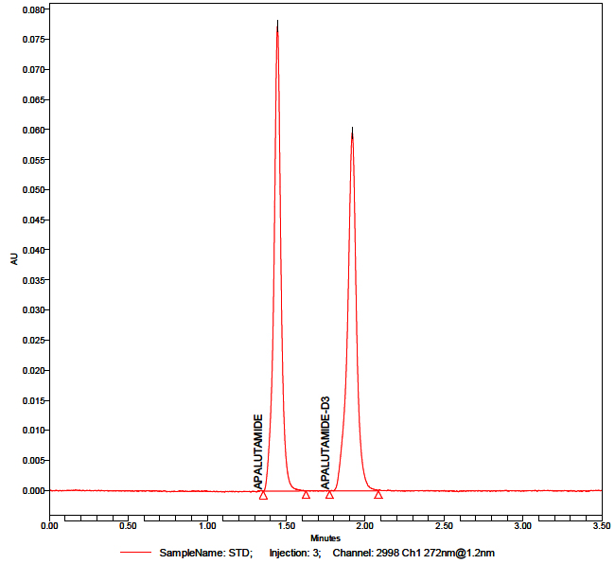
Figure 2: Standard chromatogram of Apalutamide
System Suitability
The system applicability of the current approach was tested by injecting six replicate injections of an aqueous standard mixture equivalent to the calibration curve's MQC concentration. Each day, the validation of the technique began with system appropriateness as the initial step of experiment.
Specificity/ Selectivity
The method specificity was established by viewed the standard blanks of different lots of commercially available human plasma. A different lot of plasma was screened for the specificity of the experiment. Out of ten, seven batches were of intended anticoagulant plasma, one of haemolytic plasma, one of lipidemic plasma and one lot containing heparin as an anticoagulant. The significant interferences were not observed in investigated human plasma lots at the retention times of drug and ISTD (Figure 1). In standard blank samples at the retention time the peak area of the drug was ≤ 20.00% of the peak area of the drug in the extracted LLOQ sample; for ISTD it was considered as ≤ 5.00%. The calibration curve standards and quality controls were prepared from blank matrix of pooled plasma lots.
Linearity and Quality controls
The method's linearity was determined using a ten-point standard curve. For the investigation of linearity from standard plots connected with a ten point standard curve, the weighted least square regression analysis 1/x2 was used. All three calibration curves examined during validation were determined to be linear from standard concentrations ranging from 200013.87 307.26 pg/mL, with a regression coefficient value of 0.999. The peak area ratios of APA/ISTD were shown to have a good linear relationship.
Recovery studies
The analyte was recovered from the plasma samples was studied at different levels of quality controls of LQC, MQC-2 and HQC. The % recovery values of LQC, MQC-2 & HQC were found 96.83%, 93.90% and 88.65% respectively for apalutamide.
Effect of Matrix
The matrix effect of the UPLC approach was evaluated (Table 2) using six different lots of chromatographically screened human plasma. Sample concentrations of apalutamide solution comparable to LQC and HQC were generated and injected in triplicate in each lot of plasma. The mean percentage values for HQC and LQC were discovered to be 102.59% and 102.01%, respectively.
Table 2: Results of Matrix effect proposed UPLC-DAD method
S. No. | QC | HQC (167199.079) | LQC (912.907)
 | Nominal Concentration (pg/mL) | 142119.217– 192278.94* | 730.325 – 1095.48*
 |  | Calculated Concentration (pg/mL) | Calculated Concentration (pg/mL)
Mean |  | 171543.57 | 931.31
SD |  | 7981.61 | 62.20
% CV |  | 4.65 | 6.67
% Mean Accuracy |  | 85.73 | 91.19

Accuracy and Precision
The precision was assessed using % CV at various levels of concentration which correspond to LLOQ, LQC, MQC1, MQC2, and HQC during the validation procedure (Fig.3A-3E). The assay's accuracy was determined by the ratio of the computed mean values of the quality control samples to their respective nominal values, expressed as a percentage. The Within batch and between the batch accuracy and precision was determined and % accuracy values were obtained 90.66%,95,05%,97.56%,98.15% & 93.16% for HQC,MQC-1,MQC-2,LQC & LLOQ. The accepted limits of % accuracy for all QC samples except LLOQ were 85%-115% and 80%-120% for LLOQ. The results were shown in Table 3.
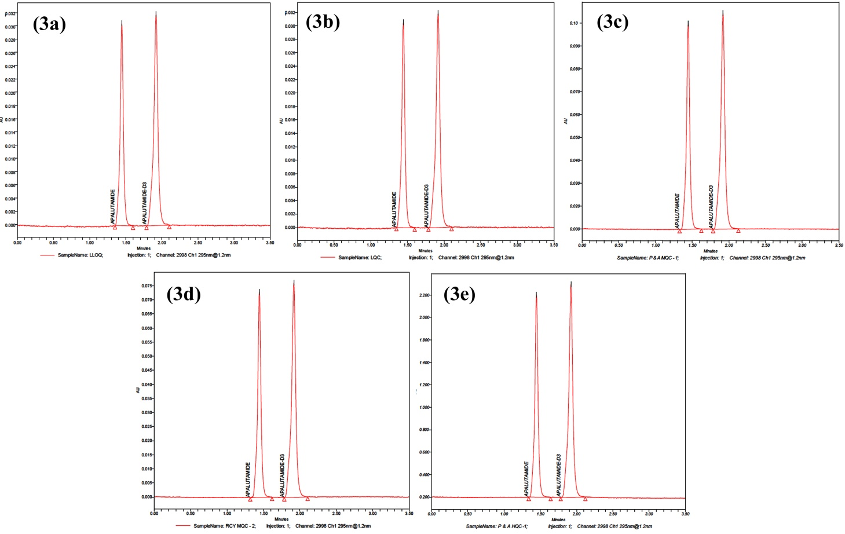
Figure (3a-3e): Representative accuracy & precision chromatograms of LLOQ, LQC, MQC-I, MQC-II & HQC
Table3: Data of Accuracy and Precision for proposed UPLC-DAD method
Nominal Concentration (pg/mL) | HQC  171316.60 | MQC1  102789.96 | MQC2  51394.98 | LQC  868.57 | LLOQ QC  312.687
 | 14561911 – 197014.09* | 87371.47 – 118208.45* | 43685.733 – 59104.2282* | 590.631 – 1042.29* | 250.1496 – 375.224*
Mean | 177297.45 | 110956.96 | 55544.30 | 799.87 | 290.83
SD | 17753.36 | 5449.29 | 2157.49 | 34.64 | 33.95
% CV | 10.01 | 4.91 | 3.8842 | 4.33 | 11.67
% Mean Accuracy  Accuracy | 90.66 | 95.05 | 97.56 | 98.15 | 93.16

$$\% Mean accuracy=\frac{Mean concentration QCs}{Nominal concentration}x 100$$

* The percentage deviation ± 15 % from 100% of nominal concentration for all QC samples except for LLOQ (percentage deviation ± 20 %.
Stability studies
Stability tests were carried out to investigate the stability of apalutamide and its internal standard in human plasma during sample preparation and analysis under various stress situations. The bench top stability of spiked QC samples was tested for duration of 6 hours at room temperature. Short-term stability of QC spiked samples was investigated for a period of 21 hours 40 minutes for the analyte and 21 hours 30 minutes for the ISTD. Long term stock solution and working standard solution stability of the analyte and ISTD were determined after 6 days of storage at 5°C ± 3°C using a standard comparable to HQC & LQC concentration. The freeze-thaw stability of spiked QC samples was assessed after the third freeze-thaw cycle stored at 28°C ± 5°C.

Table 4: Results of stability studies of proposed UPLC-DAD method

Stability | QC Level | Mean Measured concentrations (pg/ml); (n=6) |  | % Change | %CV | % Mean stability
 |  | Comparison sample | Stability sample
Auto sampler | HQC | 176633.75±  25310.24 | 184439.23±  8586.55 | 4.42 | 4.66 | 107.65
 | LQC | 809.72±  38.75 | 757.78±  46.58 | -6.41 | 6.14 | 87.24
Bench top | HQC | 170142.07±  23801.80 | 194207.65 ± 4718.00 | 14.14 | 2.71 | 106.11
 | LQC | 834.96±  37.45 | 780.14±  42.56 | -6.56 | 5.45 | 93.43
Freeze-Thaw | HQC | 185805.57±  5921.49 | 177829.18 ±  4342.64 | -4.29 | 2.44 | 95.70
 | LQC | 772.37  ±  37.96 | 774.91  ±  131.30 | 0.32 | 16.94 | 100.32
Short term | HQC | 166454.76  ±  11787.23 | 194363.99  ±  4718.00 | 16.76 | 2.91 | 108.74
 | LQC | 875.30  ±  22.53 | 853.15  ±  94.42 | -2.53 | 2.12 | 106.62
Long term | HQC | 173236.57  ±  21081.57 | 187812.47  ±  14960.47 | 8.41 | 1.69 | 98.65
 | LQC | 923.78  ±  92.30 | 901.63  ±  57.75 | -2.39 | 3.35 | 109.47

$$\% Change=\frac{Mean stability sample-Mean comparision}{Mean comparision}x 100$$
CONCLUSION
Bio-analytical method of Apalutamide by using UPLC
Apalutamide used for treatment of urinary bladder cancer. The proposed method was performed in human plasma and no analytical method was reported on UPLC and few LC/MS works were reported on this drug.
The bio-analytical method was developed with suitable solvent system, column, nitrogen evaporator, UPLC system, mobile phases, vacuum pump and sonicator. The mobile phase was 5mM ammonium fumarate and acetonitrile in the ratio of 15:85 v/v and pH was adjusted to 3.5 with glacial acetic acid and sample prepared with mobile phase. The λmax was obtained at 345 nm, at this wavelength total analysis was done. The mobile phase flow rate was kept constant at 1 ml/min. The retention times were found to be 1.48 min for APA and 1.97 min for ISTD. The system suitability was performed at each day (6 days) %CV values of APA were found to be 0.58 -1.67 and 0.29-1.68 for ISTD. The linearity concentrations were found to be 200013.87-307.26 pg/mL and R² value was found to be 0.999. The recovery of the sample from the matrix studied at HQC, MQC-2 and LQC level. The % mean recoveries of HQC, MQC-2 and LQC were found to be 88.65%, 93.90%& 96.83% respectively. The precision & accuracy of the method have been conducted on APA at the level of HQC, MQC-1, MQC-2, LQC and LLOQC. The matrix effect was studied at HQC and LQC level and results were found to be 102.59 & 102.01 for HQC & LQC respectively. The % mean accuracy results were found to be 90.66, 90.05, 97.56, 98.15 & 93.16% were found to be HQC, MQC-1, MQC-2, LQC and LLOQC respectively. The acceptance criterion is % mean accuracy for all QC samples except of LLOQ QC should be in the range of 85-115% for LLOQ QC is 80-120%.Differnt stability studies were performed like freeze thaw, bench top, auto sampler, short term and Long term stability studies at HQC and LQC levels. The % mean stability of HQC and LQC obtained as 95.70% & 100.32%, to the bench top % mean stability was found to be 106.11% & 93.43% for HQC and LQC respectively. The auto sampler % mean stability was observed 104.41% & 93.58 for HQC & LQC. The %mean stability was obtained for HQC and LQC 108.74% & 106.62% in short term stability and 98.65% & 109.47% for long term stability. The validation parameters of the bio analytical method passed FDA guidelines.
ACKNOWLEDGEMENT
We heart fully thank to the ITM University ,Gwalior, Madhya Pradesh, India and Ajanta Pharma Ltd for providing Apalutamide API and ISTD.
REFERENCES
Anjaneyulu Reddy, R., et al.2019.A validated stability indicating RP-HPLC method development for anticancer drug Enzalutamide in bulk and pharmaceuticals. Int jour of pharm sci & drug res,85-90.
Ashok Zukkala, et al. 2019. RP-HPLC-UV method for simultaneous Quantification of second generation non-steroidal androgens along with their active metabolites in mice plasma: Application to a pharmacokinetic study. Drug Res, 69: 537-544.
Chinababu, D., Madhusudhana Chetty, C., Mastanamma, SK. 2021. Forced indicating UPLC-DAD method development and validation for estimation of Apalutamide in bulk and in pharmaceutical dosage form. Indian Drugs, 58(09): 73-75.
Dellis, A., Papatsoris, A.G.2018. Apalutamide: The established and emerging roles in the treatments of advanced prostate cancer. Expert Opinion on Investigational Drugs,27(6) :553-559.
Khan, Z.G., et al.2016. Validated RP-HPLC method for Determination of Enzalutamide in Bulk drug and pharmaceutical Dosage form. Indian Drugs, 53(11): 46-50.
Rathkopf, DE., et al.2017. Safety and antitumour activity of apalutamide (ARN-509) in metastatic castration-resistant prostate cancer with and without prior abiraterone acetate and prednisone. Clin Cancer Res, 23: 3544-3551.
Ranjan, RK.,Chandra, A.2018. Apalutamide : a better option for the treatment on non-metastatic castration resistant prostatic carcinoma. Int.J.Basic.Clin.Pharmacol,7(9) :1853-1856.
Sandler, HM., et al.2016. ATLAS:a randomized, double blind, placebo-controlled, phase 3 trial of apalutamide (ARN-509) in patients with high-risk localized or locally advanced prostate cancer receiving primary radiation therapy. J.Clin Oncol ,34: 5087.
Sandhya Rani,J., Devanna,N.2018.Method development and validation of Enzalutamide pure drug substance by using liquid chromatographic technique. Jour of chem pharm sci,1: 5-9.
Small, EJ., et al.2018. MP52 20 patient reported outcomes (PROs) in SPARTAN, a phase 3, double-blind, randomised study of apalutamide (APA) plus androgen deprivation therapy (ADT) Vs placebo plus ADT in men with non-metastatic castration-resistant prostate cancer (nm-CRPC). Journal of Urology, 99: 703-704.
Smith, MR., et al.2016. Phase 2 study of the safety and anti-tumour activity of apalutamide (ARN-509), a potent androgen receptor antagonist, in the high-risk non-metastatic castration-resistant prostate cancer cohort. Eur Urol, 70: 936-970.
Smith, MR., et al.2018.Apalutamide treatment and metastatic- free survival in prostate cancer. N. Engl. J. med, 378: 1408-1418.
Smith, G. 2012. European medicines agency guideline on bio-analytical method validation: what more is there to say?, Bioanalysis, 4(8): 865-868.
Suresh P Sulochana., et al.2018. Validation of an LC-MS/MS method for simultaneous quantitation of enzalutamide, N -desmethylenzulatamide, apalutamide, darolutamide and ORM-15341 in mice plasma and its application to a mice pharmacokinetic study. J. Phar and Biomed Anal,156: 170-180.
US Department of Health and Human Services (2001) Guidance for Industry, Bioanalytical Method Validation, Food and Drug Administration Centre for Drug Evaluation and Research (CDER),Centre for Veterinary Medicine (CVM),BP. Available at: https://www.fda.gov/files/drugs/published/Bioanalytical-Method-Validation-Guidance-for-Industry.pdf
Sai Uday Kiran, G., Sandhya P. 2020. Method development and validation for the analysis of Apalutamide in human plasma by LC-MS/MS. International Journal of Current Research and Review, 14(4): 74-79.
Vadim Koshkin, S.,Eric Small,J.2018. Apalutamide in the treatment of castrate-resistant prostate cancer: evidence from clinical trials. Ther adv in urol, 10(12) :445-454.
Zakkula, A., et al.2019.RP-HPLC UV method for simultaneous quantification of second generation non-steroidal antiandrogens along with their active metabolites in rat plasma: Application to a pharmacokinetic study. Drug Res, 6(10): 537-544.
Zhou, Z., Hu.X. 2018. PCN-153-Cost effectiveness analysis of apalutamide for treatment in non-metastasis castration-resistant prostate cancer. Value in Health, 21(3): S40-S41.

