Artificial Intelligence in Health System
- Debasmia Dubey, Assistant Professor, Department of Medical Research, IMS and SUM Hospital, Siksha ‘O’ Anusandhan Deemed to be University, K8, Kalinga Nagar, Bhubaneswar-751003, Odisha, INDIA Email: debasmitasubey@gmail.com
- Shakti Rath, Associate Professor (Microbiology & Research), Central Research Laboratory, Institute of Dental Sciences, Siksha ‘O’ Anusandhan Deemed to be University, K8, Kalinga Nagar, Bhubaneswar-751003, Odisha, INDIA Email: dr.shaktirath@gmail.com (Corresponding author)
- Debidatta Singh Samanta, Research Scholar, Department of Otorhinolaryngology, IMS and SUM Hospital, Siksha ‘O’ Anusandhan Deemed to be University, K8, Kalinga Nagar, Bhubaneswar-751003, Odisha, INDIA
- Sourav Palai, Research Assistant, Central Research Laboratory, Institute of Dental Sciences, Siksha ‘O’ Anusandhan Deemed to be University, K8, Kalinga Nagar, Bhubaneswar-751003, Odisha, INDIA
- Ayesha Roul, Research Assistant, Central Research Laboratory, Institute of Dental Sciences, Siksha ‘O’ Anusandhan Deemed to be University, K8, Kalinga Nagar, Bhubaneswar-751003, Odisha, INDIA
- Smarita Lenka, Research Scholar, Department of Medical Research, IMS and SUM Hospital, Siksha ‘O’ Anusandhan Deemed to be University, K8, Kalinga Nagar, Bhubaneswar-751003, Odisha, INDIA
- Smrutipragyan Samal, Research Scholar, Department of Medical Research, IMS and SUM Hospital, Siksha ‘O’ Anusandhan Deemed to be University, K8, Kalinga Nagar, Bhubaneswar-751003, Odisha, INDIA
---------------------------------------------------------------------------------------------------
Artificial intelligence (AI) is gaining popularity in modern business and everyday life and is increasingly applied in healthcare settings. AI can help healthcare providers with various clinical tasks, including patient care, administration and many different ways. However, the ways that they support might be pretty diverse. While some articles on AI in healthcare suggest that AI can perform as well as or better than humans at specific tasks, such as diagnosing illness, it will be long before AI replaces people in a wide range of medical vocations. This article reviews the use of AI in different medical settings.
Keywords: Artificial intelligence, Health care systems, Computerized protocols, Machine learning; Advanced robotics, Artificial neural networks, Bioinformatics
----------------------------------------------------------------------------------------------------------------
INTRODUCTION
Artificial intelligence (AI) simulates the human mind in computer systems built to think and act like humans, including learning and problem-solving. Visual perception, decision-making, and communication are all functions that require human intelligence. AI should be able to accomplish these jobs when physicians are questioned about the most critical factors for excellent patient care. Better patient care can be provided depending on the knowledge and experience of the doctor. Typically, this occurs over time, with physicians gaining knowledge and experience while caring for patients and expanding their knowledge in their areas of interest through continued study. Understanding AI and its consequences in medicine hinges on this concept of experience and knowledge. The more experience and data (information analysis) we have, the better we can make knowledge-based decisions. Data can be derived from evidence-based medical sources such as textbooks and peer-reviewed articles. In contrast, experience is gained through patient results and outcomes, such as patient files, lab data, and clinical findings. The human mind's main restriction in acquiring enormous volumes of data is time limits. The integration of knowledge and experience gained over time is required in the learning process. Large volumes of patient data may be accessible, recorded, and stored for processing in the era of silicon chips. The cornerstone of AI is harnessing these massive data banks and changing them to gain experience.¹ Through algorithms, computer software may gather substantially more experience in a much shorter period than human subjects can in their lifetime. A radiologist will examine around 225,000 MRI/CT exams throughout a 40-year career. In contrast, AI can start with this amount and quickly scale up to millions of scans, significantly enhancing accuracy. As a result, the accuracy and speed with which AI reads and diagnoses CTs should be considerably higher than an ordinary human.²
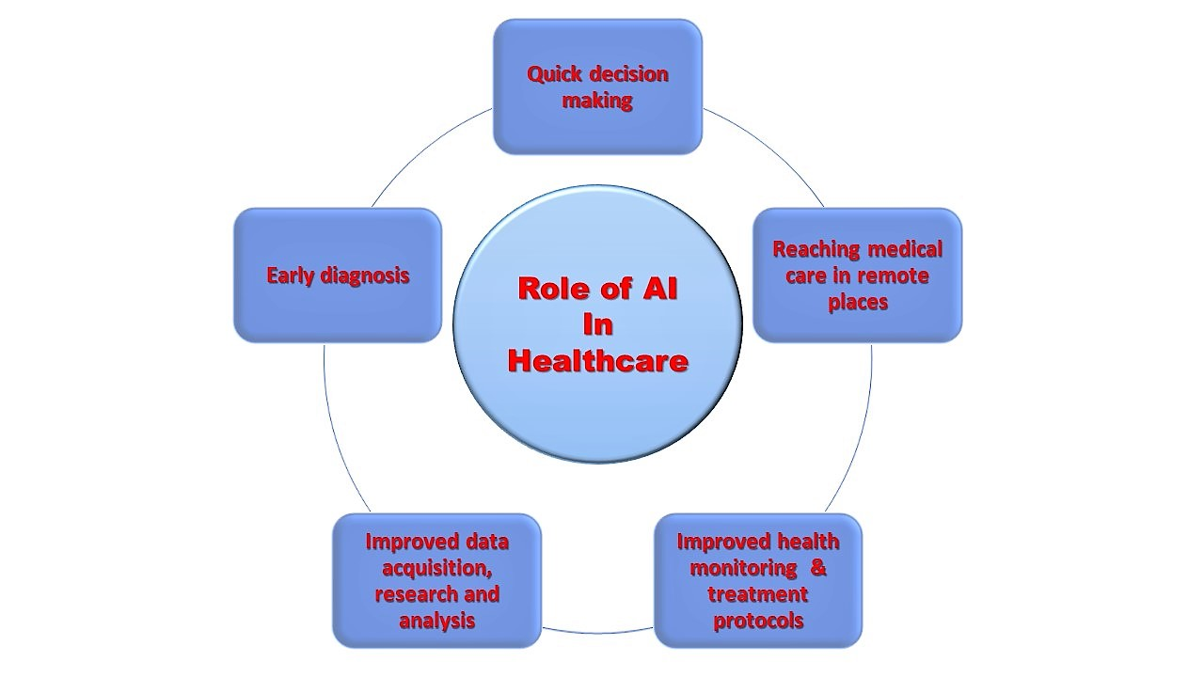
Figure 1. Role of artificial intelligence in the Health care System
ARTIFICIAL INTELLIGENCE AND COMPUTATIONAL PATHOLOGY
Artificial intelligence-based computational pathology is an evolving field that has shown promising results in increased accuracy and obtainability of superior healthcare facilities to patients in many areas of medicine. The primary impediments faced by this field are:
- The global healthcare system needs more resources and skilled pathologists.³
- The increased amount of available data on health, including digitalized images, records of clinical examination, and patient demographic information, is being generated in inpatient care.⁴
- The increase in complications created in management and data integration in different sources to increase patient care;
- Machine learning algorithms must be practised to improve patient care and understand the vast data. ⁵
This technology can process the vast data formed in the whole patient care cycle to improve the disease's pathological diagnosis, classification, and prognosis. The significant advantage of computational pathology is the reduced errors in diagnosis and classification. Cameleon Grand Challenge 2016 (CAMELYON16 challenge) is an internationally known machine-based program that evaluates new automatic cancer detection algorithms in slides stained with hematoxylin and eosin in whole slide imaging (WSI). It has attained inspiring outcomes with a sensitivity of 92.4% in the tumour detection rate. On the contrary, a pathologist can only achieve a sensitivity of 3.2%.⁶ This technician transforms the traditional core function of pathology, ology, including the growing sub-segments like digital pathology, molecular pathology, and informatic pathology.^{7,8} The technique aims to improve the accuracy of diagnosis, optimize patient care, and reduce patient costs with global collaboration.

Digital pathology
The new advancement in brightfield and fluorescent slide scanners has aided in the virtualization and the digitalization of whole glass slides.⁹ Digital pathology comprises digitalized histopathology, immunochemistry, and cytology slides using a computational approach and interpreting, managing, and analyzing the digitalized complete slides with the help of whole slide scanners. The digital data extracted from the falls can be stockpiled in a central cloud-based space, allowing increased accessibility of the information for automated assessment by data algorithm and manual review by a pathologist. This makes artificial intelligence a branch of computational science that can generate and apply algorithms to possible pathologies.¹⁰ Depending on the intelligence grade, it can currently be categorized into two main divisions: weak AI and strong AI. Weak AI is also called narrow artificial intelligence, which can classify the data depending upon a well-recognized model of statistics and has already been proficient in performing explicit tasks.¹¹ On the contrary, strong AI, also called artificial general intelligence (AGI), can create a protocol intelligently and self-reliantly by implementing machine learning on all average data available.

MACHINE LEARNING AND DEEP LEARNING
In artificial intelligence, machine learning is a process that allows the computer system to acquire and progress automatically from a set of data on its own and to resolve the problem without being programmed through the procedure. In artificial general intelligence, machine learning is a progressive field that uses considerable preliminary data and training to figure out and interpret the algorithms statistically and later act on the derived data.¹² Currently, many machine learning-dependent approaches have been established and verified in pathology to contribute to diagnosis based on the morphological patterns like cells of cancer, division of the cell, their nuclei, blood vessels, and their ducts, etc.¹³
Deep or structured learning is a branch of machine learning dependent on artificial neural networks (ANNs), which formulates a statistical model derived from input training data. Deep neural networks provide architectures for deep learning.¹⁴ Artificial neural networks resemble a complex biological neural network of the human brain as they can evaluate whether the prediction or the interpretation is correct.¹⁵
Artificial neural networks are composed of 3 layers of artificial neurons, named “nodes”, and include an input layer, multiple hidden layers, and an output layer. In ANNs, these synthetic neuronal layers are linked to one another, and the asset of their link is called "weights". These links are assessed using statistics, along with the help of a cluster of algorithms, K-nearest neighbour, supporting vector machines, and logical regressions.¹⁶ The output event-related artificial neurons, their concurrent connections, and “weight” require proper training and practice in massive data set qualifications to attain the optimal algorithm for a particular task (Figure 1). A subdivision of deep multilayer neural networks is convolutional neural networks explicitly designed for visual images.
By adjusting the image either through flattening or removing and reducing, convolutional kernels perform a pre-procedure treatment that permits processing, analyzing, and classification of the digital images, or a section of an image, into an identified group with the help of computer vision as well as machine vision models.¹⁶
Role of computational pathology
Computational pathology is essential in medical research and addressing clinical queries arising during practice.¹⁷ To attain this aim, a group of professionals from multiple areas of specialization is required to contribute to these projects. Computational pathology, together with data scientists like statisticians and bio-informaticians, for designing algorithms, an architect and an engineer for creating a physical environment and maintaining hardware (Figure 2). In this project, the pathologists play an essential role in introducing a question related to the medical field and its clinical implications to the team of developers and initiating the downstream industrial development.¹⁸ In computational pathology, the pathologist requires solid clinical knowledge, experience, statistical analysis, and data mining information to form a bridge between clinical medicine and artificial intelligence.

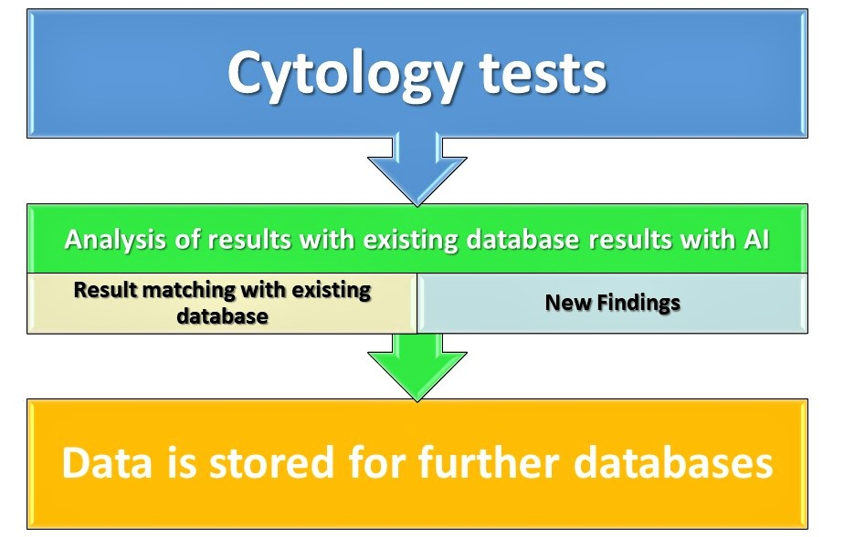
Figure 2. Role of AI in Cytology

AI AND CYTOLOGY
Using convolutional neural networks, Martin et al., in a study, classified images of cervical cytology into five different categories based on diagnosis, which include malignancies or intraepithelial lesions, atypical squamous cells of undetermined significance, low-grade squamous intraepithelial lesion, atypical squamous cells with low grade squamous intraepithelial lesions and high grade squamous intraepithelial lesions, and precisions of 56%, 36%, 72%, 17%, and 86% were achieved, that suggested that convolutional neural networks have the capability of learning cytological features.¹⁹ In the global pathology service model, local laboratories are represented by “L” in small green circles, where the slides are scanned. A centralized scanning centre (SC) can also scan the falls.
A central cloud laboratory system that can store extensive data and computational power will integrate the data, analyze it and keep the whole slide imaging data and the other medically related data and cytopathological studies. In one of the studies, a morphometric algorithm and semantic segmentation network based on VISUAL GEOMETRIC GROUP (VGG-19) was used by the authors to classify whole-slide images of urine cytology according to Paris System for Urine Cytopathology and attained an a77% sensitivity with a 30% rate of false-positive and 0.8 area under the curve.²⁰
AI AND RADIOLOGY
In this new era of medicine, artificial intelligence has gained acceptance and popularity, with broad implications in the areas of radiology, because of this extraordinary progress in tasks of image identification, where significant growth has been seen in recent years in the accumulation of sufficient digital data and significant computational power along with availability. Artificial intelligence and its skills have been driven to the fronts of medicine. There is increased accessibility to radiographical examinations, increased work pressure on radiologists and a lack of trained and experienced radiologists. The current capabilities of artificial intelligence include automatic detection of diseases of the lungs, liver, cardiovascular, and bones. For example, vertebral fractures can be automatically detected using an algorithm on chest and abdomen CT scans. Using a convolutional neural network, images of segments and sagittal sections of the spinal column can be extracted, and the presence of vertebral fracture is predicted.²¹ Likewise, on non-contrast chest CT scans, calcium can be detected in the coronary arteries with similar algorithms that can predict cardiovascular events and mortality.^{22,23} Furthermore, an algorithm identical to dual-energy X-ray absorptiometry score is present that calculates the bone mineral density and hence can detect osteoporosis.²⁴
The use of deep learning in diagnosis has shown good performance in specific areas like the detection of metastatic lymph nodes as well as the detection of mammography malignancies.^{25, 26} Laukamp et al., in their study, applied a multiparametric deep learning model to MRIs in cases of meningiomas for the recognition as well as segmentation and compared it with manual segmentation. In the same study of 249 preoperative MRI glioma cases, based on the brain tumour image segmentation benchmark, the program analyzed 55 cases out of 56 more accurately than that manual reading by two radiologists.²⁷

AI AND ONCOLOGY
Artificial intelligence has better results than human readings in breast cancer diagnosis. In a study, Somashekhar et al. suggested that machine learning is a reliable tool for diagnosing cancer.²⁸ Watson was found to have a concordance rate of 93% in a double-blinded validation study with a professional multidisciplinary tumour board on recommendations concerning breast cancer treatment. Bernard et al. conducted a study using 129 training slide sets, 49 with metastatic lymph nodes and 80 without. The algorithms achieved better diagnostic performance when all these slides were compared with 11 pathologies.²⁹ Furthermore, the assessment time required by the pathologists was 30 hours for the entire 129 slides, whereas, for algorithms, the running time was presumed almost negligible.
In lung cancer cases, the detection using artificial intelligence algorithms proved more effective when compared to human readings. Yu et al. demonstrated the precision of artificial intelligence in pathological diagnosis by using 2186 stained histopathological whole-slide images of lung adenocarcinoma and squamous cell carcinoma.³⁰ The conclusion drawn from the study is that for an inpatient with cancer of the lungs, the prognosis can be predicted accurately with artificial intelligence, and thereby, patient care can be improved via oncological treatment determination.
Artificial intelligence has shown some promising results in dermatology, as the diagnosis and classification of skin lesions are based primarily on visual imaging. A single convolutional neural network was used by Esteva et al. in a study in which trained forms of images were used alone with disease tags and pixels as inputs and classifying them in various skin lesions. Its performance was tested using a 129,450 clinical images data set compared to 21 board-qualified professional dermatologists based on biopsy-proven clinical images. Images were grouped into 2, representing the most commonly occurring cancer and those with the highest mortality rate, like malignant melanomas versus benign nevi and keratinocyte carcinomas versus benign seborrheic keratosis. Artificial intelligence was concordant with the professionals in all cases across both tasks, demonstrating that artificial intelligence is more capable than professional dermatologists.³¹

AI AND CARDIOLOGY
In many areas of cardiology, the application of machine learning and artificial intelligence has resulted in faster interpretation and diagnosis. Readings of the ECG have been interpreted automatically; cardiac functions can be measured automatically with an echocardiogram, cardiac perfusion can be determined automatically with SPECT, and coronary vessel calcifications can be resolved with CT angiography.
Cardiac MRI can perform automatic segmentation and measurement of perfusion and blood flow.³² Early detection of heart failure via artificial intelligence in electronic medical records has effectively reduced mortality. This is because of the capability of artificial intelligence to accomplish a longitudinal data assessment to detect the patterns and determine the prognosticators for heart failure.³³ When AI is included in the process of deciding to access the interventional procedures that should be carried out in patients with angina, either a percutaneous cardiac intervention or a coronary artery bypass grafting (CABG), artificial intelligence gives a better predictive value by evaluating the electronic medical records of the patient and hence, reducing the mortality.³⁴
AI AND GASTROENTEROLOGY
In gastroenterology, the diagnosis and treatment depend on images from the stomach, duodenum, and colon endoscopy. A key factor for patient care is the early detection of cancers, and screening regimens are implemented worldwide. An AI-based system was developed to improve the clinical examination process, which is short and accomplished many times daily.³⁵ A computer-aided diagnosis system like the CADe system identifies the abnormal findings and highlights the abnormality on the screen, alerting the endoscopist. After detecting an anomaly and shifting to a narrow-band imaging view, a real-time diagnosis can be suggested with defined endoscopic images with the help of the CADx system. The CADe system showed a 94% detection rate in cases of colon polyps.³⁶ Furthermore, the CADx system proved to be able to distinguish early gastric cancer and cancer of the colon in the endoscope. The CADx system demonstrated a precision of 96.3% in the early diagnosis of gastric cancer with a specificity and sensitivity of 95% and 96%, respectively.³⁷
AI AND OPHTHALMOLOGY
For the early diagnosis of diabetic retinopathy, artificial intelligence and deep learning have been proven to be very effective. In comparing with seven board-certified ophthalmologists, Gulshan et al. used two sets of validation data, i.e., 9963 and 1748 images, and found an increased specificity and sensitivity rate of deep learning. From this study, one may conclude that, in ophthalmology, deep understanding has significant potential in diabetic retinopathy and macular oedema detection from images of the retina; however, there is a need for further studies.³⁸

AI AND SURGERY
Robotic-assisted surgery is an example of computer sciences that have already arrived in the operating room but are not connected with artificial intelligence. Although the technology available enhances the vision of an operating surgeon with the help of 3D cameras and near infra-red imaging and also increases mechanical skills like intuitive instrument articulation, elimination of tremors, and movement scaling, it has failed to interpret it into better results in terms of the improved health status of the patient. Therefore, when it comes to artificial intelligence incorporated in operating rooms, the expectations are high regarding outcomes. In the operating rooms, AI can be included in several forms: in supportive anaesthesia, 39 to achieve better time management and patient safety, the workflow in the operating room should be improved,⁴⁰ in addition to monitored instrumentation in surgery. In surgery, OR.NET is an emerging technology in the operating rooms to establish a standard interface that can permit communication between devices to enhance workflow and the patient's safety.

AI IN COVID - 19
Telemedicine and computer-aided medicine entered the markets in many countries during the COVID-19 outbreak. The high risk of transmission, systemic risks, and social seclusion were some of the unexpected challenges for traditional medicine. However, AI was an evolving technology in medical imaging that actively contributed to fighting COVID-19. Unlike conventional medicine, which profoundly relies on human resources, more efficient and more accurate imaging solutions were provided by artificial intelligence. Applying AI-based computer-aided treatment and the clinical data from electronic health records and individuals can quickly give social data to control this public health emergency more safely, reducing the clinical risks of spreading through human-to-human interactions.⁴¹ A dedicated imaging platform of lungs and segmentation of infectious regions, clinical evaluation, and diagnosis, with pioneering basics and clinical research, are some of the recent AI-empowered utilization in COVID-19. AI-empowered contactless imaging workflows and AI-aided image segmentations are some commercially available products developed and successfully integrated AI in the battle against COVID-19 and validate the competence of the technology. ⁴¹

CLOUD-BASED AI
Cloud-based AI is a new concept that provides customers access to continuously updated algorithms as a fee-for-service. This concept has an additional advantage by allowing interoperability, as this service is available regardless of hardware. To contribute to several medical applications, many companies have developed many cloud-based artificial bits of intelligence platforms. Companies like Zebra Medical Vision Ltd, Arterys Inc. (San Francisco, CA, USA), and VIDA Diagnostics Inc. (Coralville, IA, USA) offer cloud-based AI services to support the investigation of lung diseases, imaging processing of heart, liver imaging, and bone health.

CONCLUSION
Machine learning isn't meant to replace human doctors but to assist or augment medical treatment. The number of radiological scans is increasing, but the number of radiologists is decreasing. Assistance in this area can minimize the time between exams and results due to faster readings and a 24/7 operating capability. Furthermore, human factors such as fatigue or other environmental conditions do not affect AI software, which could lead it to slow down or lose accuracy. Because of the expanding workload and labour shortage, pathology may benefit from incorporating AI into the workflow. Analyzing the morphology and measuring quantitative tasks such as the number of mitoses per high power field can be accomplished. However, it is critical to emphasize that AI will not replace human physicians in medicine or surgery, contrary to popular belief.
On the contrary, AI-enhanced medical systems will aid in optimizing workflow and providing more consistent care. The road to AI is still long and winding, with numerous difficulties to be addressed, such as FDA approvals, ethical issues surrounding data sharing, and public perceptions of AI. AI in medicine should be viewed as a decision-making tool, with humans making the final choice.

Financial support and sponsorship: Nil.
Conflicts of interest: There are no conflicts of interest.

References
- A.Turing. Computing machinery and intelligence. Mind 1950, 49, 433–460.
- H. Yokota, M. Goto, C. Bamba, M. Kiba, K. Yamada. Reading efficiency can be improved by minor modifications of assigned duties, a pilot study on a small team of general radiologists. Japanese Journal of Radiology 2017, 35(5), 262-268.
- M. R. George, K. A. Johnson, D. A. Gratzinger, M. D. Brissette, C. B. McCloskey, R. M. Conran, et al. Will I need to move to get my first job? Geographic relocation and other trends in the pathology job market. Archives of Pathology & Laboratory Medicine 2020,144, 427–34.
- Goldenberg SL, Nir G, Salcudean SE. A new era: artificial intelligence and machine learning in prostate cancer. Nat Rev Urol. 2019; 16:391–403.
- Parwani AV. Next-generation diagnostic pathology: use of digital pathology and artificial intelligence tools to augment a pathological diagnosis. DiagnPathol. 2019; 14:138.
- Liu Y, Gadepalli K, Norouzi M, Dahl GH, Kohlberger T, Boyko A, et al. Detecting cancer metastases on gigapixel pathology images. arXiv. 2017. https://arxiv.org/abs/1703.02442.
- McAlpine ED, Michelow P. The cytopathologist’s role in developing and evaluating artificial intelligence in cytopathology practice. Cytopathology. 2020; 31:385–92.
- Huss R, Coupland SE. Software-assisted decision support in digital histopathology. J Pathol. 2020; 250:685–92.
- Hou L, Samaras D, Kurc TM, Gao Y, Davis JE, Saltz JH. Patch-based convolutional neural network for whole slide tissue image classification. Proc IEEE ComputSocConfComput Vis Pattern Recognit. 2016; 2016:2424–33.
- Chang HY, Jung CK, Woo JI, Lee S, Cho J, Kim SW, et al. Artificial intelligence in pathology. J PatholTransl Med. 2019; 53:1–12.
- Tizhoosh HR, Pantanowitz L. Artificial intelligence and digital pathology: challenges and opportunities. J Pathol Inform. 2018; 14:38.
- Komura D, Ishikawa S. Machine learning methods for histopathological image analysis. ComputStructBiotechnol J. 2018; 9:34–42.
- Komura D, Ishikawa S. Machine learning approaches for pathologic diagnosis. Virchows Arch. 2019; 475:131–8.
- Levine AB, Schlosser C, Grewal J, Coope R, Jones SJM, Yip S. Rise of the machines: advances in deep learning for cancer diagnosis. Trends Cancer. 2019; 5:157–69.
- Ching T, Himmelstein DS, Beaulieu-Jones BK, Kalinin AA, Do BT, Way GP, et al. Opportunities and obstacles for deep learning in biology and medicine. J R Soc Interface. 2018; 15:20170387.
- Rashidi HH, Tran NK, Betts EV, Howell LP, Green R. Artificial intelligence and machine learning in pathology: the present landscape of supervised methods. Acad Pathol.2019;6:2374289519873088.
- Kulkarni S, Seneviratne N, Baig MS, Khan AHA. Artificial intelligence in medicine: where are we now? AcadRadiol. 2020; 27:62–70.
- Jha S, Topol EJ. Adapting to artificial intelligence: radiologists and pathologists as information specialists. JAMA. 2016; 316:2353–4.
- Martin V, Kim TH, Kwon M, Kuko M, Pourhomayoun M, Martin S. A more comprehensive cervical cell classification using convolutional neural network. J Am SocCytopathol. 2018. HTTPS:// doi.org/10.1016/j.jasc.2018.06.156.
- Vaickus LJ, Suriawinata AA, Wei JW, Liu X. Automating the Paris System for urine cytopathology-A hybrid deep-learning and morphometric approach. Cancer Cytopathol. 2019; 127:98–115.
- Bar A, Wolf L, Amitai O, et al. Compression fractures detection on CT. Med Imaging. 2017;10134: 10134.
- Detrano R, Guerci A, Carr JJ, et al. Coronary calcium as a predictor of coronary events in four racial or ethnic groups. New Engl J Med. 2008; 358:1336–1345.
- Shadmi R, Mazo V, Bregman-Amitai O, et al. Fully convolutional deep-learning-based system for coronary calcium score prediction from non-contrast chest CT. Washington, DC: 2018 IEEE 15th International Symposium on Biomedical Imaging (ISBI 2018); 2018. p. 24–28. doi: 10.1109/ISBI.2018. 8363515
- Bergman Amitai O, Bar A, Toledano E, et al. Computing DEXA score from CT using Deep segmentation networks cascade. www.zebra-med.com/ research-publications/computing-dexa-score-from-causing- deep-segmentation-networks-cascade/
- Teare P FM, Benzaquen O, Toledano E, Elnekave E.Malignancy detection on mammography using dual deep convolutional neural networks and genetically discovered false-colour input enhancement. J DigitImaging.2017;30:499–505.
- Bejnordi BE, Veta M, van Diest PJ, et al. Diagnostic assessment of deep learning algorithms for detection of lymph node metastasis in women with breast cancer. JAMA 2017; 318:2199–2210.
- Laukamp KR, Thiele F, Shakirin G, et al. Fully automated detection and segmentation of meningiomas using deep learning on routine multiparametric MRI. Eur Radiol. 2018;29:124–132.
- Somashekhar SP, Sep_ulveda MJ, Puglielli S, et al. Watson for oncology and breast cancer treatment recommendations: agreement with an expert multidisciplinary tumour board. Ann Oncol. 2018; 29:1–6.
- Yu KH, Zhang C, Berry GI, et al. Predicting non-small cell lung cancer prognosis by fully automated microscopic pathology image features. Nat Commun. 2016; 7:12474.
- Esteva A, Kuprel B, Novoa RA, et al. Dermatologist level classification of skin cancer with deep neural networks. Nature 2017; 542:115–118.
- Slomka PJ, Dey D, Sitek A, et al. Cardiac imaging: working towards fully-automated machine analysis & interpretation. Expert Rev Med Devices. 2017;14: 197–212.
- Choi E, Schuetz A, Stewart WF, et al. Using recurrent neural network models for early detection of heart failure. J Am MEd Inform Assoc. 2017; 24:351–370.
- Buzeav IV, Plechev V, Nikolaeva IE, et al. Artificial intelligence: neural network model as the multidisciplinary team member in clinical decision support to avoid medical mistakes. Chronic Dis Transl Med. 2016; 2:166–172.
- Karkanis S, Magoulas G, Theofanous N. Image recognition and neuronal networks: intelligent systems for the improvement of imaging information. Min InvasTher Allied Technol. 2000; 9:225–230.
- Misawa M, Kudo SE, Mori Y, et al. Artificial intelligence-assisted polyp detection for colonoscopy initial experience. Gastroenterology 2018; 154:2027–2029.
- Kanesaka T, Lee T, Uedo N, et al. Computer-aided diagnosis for identifying early gastric cancers in magnifying narrow-band images. GastrointestEndosc. 2017; 87:1339–1344.
- Gulshan V, Peng L, Voram M, et al. Development and validation of a deep learning algorithm for detection of diabetic retinopathy in retinal fundus photographs. JAMA 2016; 316:2402–2410.
- Goudra BG, Singh PM, Chandrasekhara V. SEDASYS (VR), airway, oxygenation, and ventilation: anticipating and managing the challenges. Dig Dis Sci. 2014; 59:920–927.
- Arney D, Goldman J. Towards a safe and secure medical internet of things. 2016. Available from: www.mdpnp.org.
- Rockstroh M, Franke S, Hofer M, et al. OR.NET: multiperspective qualitative evaluation of an integrated operating room based on IEEE 11073 SDC. Int J CARS. 2017;12:1461–1469.
- Niazi MKK, Parwani AV, Gurcan MN. Digital pathology and artificial intelligence. Lancet Oncol. 2019;20:e253–61.

