GROUNDWATER EXPLORATION IN FRACTURED CHARNOCKITE FORMATION FOR IRRIGATION AT ALANGULAM, TAMILNADU, INDIA
* Antony Alosanai Promilton A^{1,2}, Antony Ravindran A¹, Mohamed Afzal J¹, S.Muthusamy¹, Abinaya R¹
¹PG and Research Department of Geology, V.O.Chidambaram College, Thoothukudi, Tamilnadu, India.
²(Reg.No: 19212232221033) Research scholar Manonmaniam Sundaranar university, Tirunelveli, Tamilnadu, India
³Department of Geology, University of Madras, Guindy Campus Chennai, India-600025

ABSTRACT
The present study focuses on subsurface geology as well as Groundwater present at deeper depth in hard rock terrain. The AMT-Audio Magneto-telluric method is adopted for the groundwater exploration. The equal interval depth of 5m upto 300m depth is scanned by ADMT-300S instrument. The 2D image generated as output from the collected data using Aidu Prospecting software showing resistivity variations in the study area demarcating the subsurface geology and fractures present. The low, medium and high resistivity values are indicated as fractures, water zone and hard rock formation. The bore well was drilled in 2 locations, which are utilized for comparing the subsurface lithology and fracture zone present along with AMT data for confirmation. Moreover the study area has deeper aquifer in all locations with considerable amount of water present in it for irrigation purpose.

Keywords: Groundwater, AMT, Resistivity, Deeper Aquifer.

INTRODUCTION
Groundwater is a vital natural resource that plays a central role in sustaining life and supporting ecosystems. It serves as a reliable source of freshwater, especially in regions where surface water is scarce or subject to seasonal fluctuations. Groundwater is essential for agricultural irrigation, industrial processes, and meeting domestic water needs. Additionally, it maintains stream flow during dry periods, ensuring the survival of aquatic habitats and biodiversity (Gleeson et al., 2012). Moreover, in many arid and semi-arid areas, groundwater acts as a natural buffer against droughts and provides resilience in times of water scarcity. The sustainable management and protection of groundwater resources are of utmost importance to ensure water security, economic stability, and environmental well-being for present and future generations.The world is facing an escalating groundwater crisis, characterized by the overexploitation and depletion of aquifers at an unsustainable rate. Rapid population growth, urbanization, and agricultural demands are exerting immense pressure on groundwater reserves (Narasimhan, 2015). Climate change exacerbates the crisis by altering precipitation patterns, causing more frequent and severe droughts, and affecting groundwater recharge rates. The depletion of groundwater has severe consequences, including land subsidence, saltwater intrusion in coastal areas, and the drying up of rivers and wetlands. The global groundwater crisis demands urgent action in the form of innovative exploration techniques and sustainable water management practices.
Geophysical methods are invaluable tools for exploring and characterizing subsurface structures, providing crucial insights into the presence and distribution of groundwater. The Audio Magnetotelluric (AMT) sounding technique is well-suited for the detection of subsurface targets, including groundwater reservoirs at depths of a few hundred meters. Its applicability is especially noteworthy for deep explorations when the natural electromagnetic field is strong enough to generate data suitable for interpretation, making it potentially more advantageous than the DC sounding method (Bernard et al., 1990). The method proves efficient and cost-effective for investigating considerable depths with dense space sampling, but its sensitivity to surface and urban noises is influenced by the level of urbanization in the study area (Agyemang, 2020). The application of AMT geophysical technique, we can successfully identify zones with promising groundwater resources and potential aquifers (Agyemang, 2022).
The AMT method was used for identifying the fault structure present in the Area of Mount Kubing, Belitung, where distinct fault features present are explained (Sanjaya, 2023). The mitigation dredging of sea beds a geotechnical work for harbour construction process was employed using the AMT method (Antony Ravindran, 2020). The identification of Sub marine groundwater discharge, a highly important one in the coastal region was carried on Manapad, Tiruchendur and Uvari regions using AMT method (Jeyapaul, 2020, Vinoth Kingston, 2021 and Antony Ravindran, 2022). The groundwater characteristic studies on Thamirabarani river sub basin was carried out using AMT method (A, 2022). The employing of AMT method is low cost and more effective that other methods.
The main objective of this research article is to comprehensively explore and assess the effectiveness of the Audio Magnetotelluric (AMT) geophysical technique for groundwater exploration in the Alangulam region, situated in Tirunelveli, India. This study aims to investigate the subsurface resistivity structure to identify potential aquifer zones and assess the availability of groundwater resources suitable for irrigation purposes. By conducting a detailed AMT survey, acquiring high-quality data, and utilizing advanced data processing and interpretation techniques, the research seeks to contribute valuable insights into the hydrogeological conditions of the study area. The findings will provide valuable guidance for sustainable water resource management and optimized utilization for irrigation needs, benefiting agricultural practices and ensuring long-term water security in the region.
Study Area
The Alangulam region, situated in the district of Tenkasi, Tamil Nadu, India, falls under a tropical climate characterized by hot and dry summers, where temperatures often soar to 35-40°C. The monsoon season, typically Northeast monsoon, accounts for the majority of the areas annual rainfall, averaging around 800-1000 mm. The hydrogeology of the region is influenced by a diverse geological setting, comprising alluvial deposits, sedimentary rocks, and Precambrian crystalline rocks. The subsurface geology of Alangulam is complex, with varying degrees of weathered zones, fractures, and fault systems that significantly impact groundwater storage and movement. These geological features play a crucial role in the distribution and movement of groundwater within the aquifers. Notably, the presence of extensive fracture networks and fault systems contributes to the regions hydrogeological dynamics, providing potential pathways for groundwater recharge and discharge. The study area exhibits a varied geological composition, ranging from deep Red soil and fertile black cotton soils to weathered and hard granitic gneiss followed by charnockite basement rocks, which have implications for the hydrogeological properties and groundwater distribution in the region. The study area has elevation range from 76m to 150m above mean sea level shown in Fig.1.
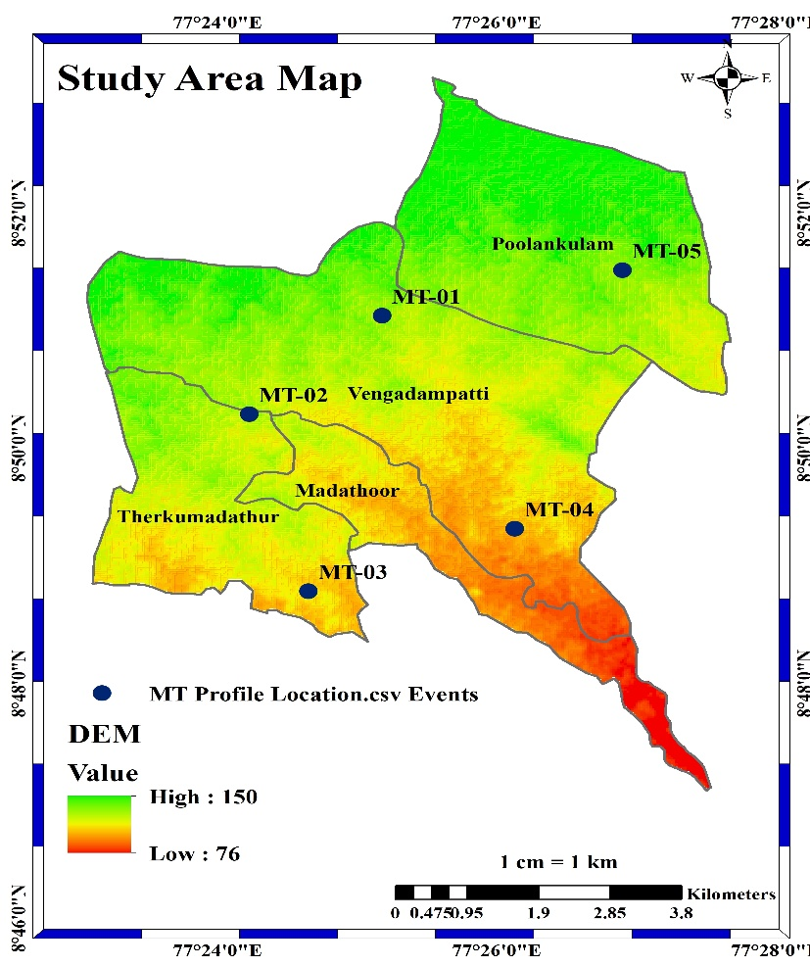
Fig 1. Study Area map.

Materials and Method
The geophysical technique utilized in this study was the Audio Magnetotelluric method (AMT). As described by Bernard et al., (1990), AMT is a passive-surface geophysical technique that harnesses the Earth's natural electromagnetic fields to explore the electrical resistivity structure of the subsurface, spanning depths from tens of meters to several hundred meters. Measurements of natural variations in the Earths magnetic and electric fields were conducted at each specific field location. This method proves highly effective for studying intricate geological settings, as it is sensitive to both vertical and horizontal resistivity variations. For optimal results, high-resolution shallow subsurface characterization is achieved with closely spaced field locations, while the resolution diminishes with increased depth and wider spacing between measurement points. AMT's versatility is evident in its capability to discern the subsurfaces dimensional characteristics, whether one, two, or three-dimensional, and its exploration depth can range from approximately 300 meters to several hundred meters below the ground based on the instrument used for investigation.
The ADMT-300S is a sophisticated and advanced geophysical instrument used in groundwater exploration and subsurface imaging in the study area. It is a specialized variant of the Audio Magnetotelluric (AMT) method, designed for acquiring high-quality AMT data The ADMT-300S is particularly renowned for its ability to investigate great depths, making it well-suited for identifying deep groundwater reservoirs and geological structures at depths ranging from tens to hundreds of meters. With its non-intrusive nature, the ADMT-300S offers an environmentally friendly and cost-effective solution for understanding subsurface resistivity variations and contributing essential insights into groundwater potential and distribution in the Alangulam region. This makes it a valuable tool for supporting sustainable water resource management and irrigation purposes in the area.
In the field, MN electrodes were systematically positioned at either 10m or 20m intervals along the data collection direction. The electrodes were arranged in pairs with an equidistance of 10m or 20m between them. After completing measurements at each point, both M and N electrodes were relocated to new positions for the next data collection. This continuous data acquisition was conducted with a spacing of 10m/20m between MN electrodes at 5m depth intervals. A total of five profile lines, varying in length from minimum to maximum, were recorded. Subsequently, the collected field data underwent processing and inversion using AIDU 2.3.6 mobile software, resulting in the generation of a 2D profile map representing the subsurface resistivity model. Upon completing data collection through its distinct built-in computing functions, the instrument is equipped to generate curve graphs and profile maps effortlessly with a single press. These profile maps offer a clear depiction of the geological structure, enabling swift identification of valuable elements such as ore bodies, hollows, and aquifers.
Result and Discussion
The AMT profilings were carried out in five villages namely, Koviloothu, Therku Madathoor, Madathoor, Pandarakulam and Keela-Pavoor.
Koviloothu Profile
The profile was carried out in a coconut farmland in Koviloothu village. The profile length was extended upto 35m with 5m interval, depth of investigation is 300m. The profile has three distinct fractures at different depths such as 45m, 165m and 225m. The top layer consist of clay with calcrete formation with resistivity value of 0.0070 ohm-m. The next layer consist of weathered gneissic formation with resistivity value of 0.0065 ohm-m. The next fractured layer with low water detected at the depth of 165m with resistivity 0.0025 ohm-m in a fractured charnockite base rock. Then highly fractured charnockite rock at the depth of 225m was identified with good fresh water bearing formation of resistivity value 0.0025 ohm-m. The area also has Intrusive dyke formation on the profile length of 18-22m at the depth from 60 -300m. The bore hole was constructed in this profile location, the well has good yield at the deeper aquifer of depth 225m where pebbles of fractured charnockite was observed while drilling.
Therku Madathoor AMT Profile
The profile was carried out in a Lemon/Mango farmland in Therku Madathoor village. The profile length was extended upto 140m with 20m interval, depth of investigation is 300m. The profile has three fractures at depths of 30m, 45m and 210m. The top layer consist of soil with calcrete formation present in it with resistivity value of 0.0089 ohm-m. The next layer consist of weathered gneissic formation with resistivity value of 0.0069 ohm-m. The two fractured layer at the depth of 30m and 45m with low water detected with resistivity 0.0025 ohm-m in a fractured charnockite base rock. Then highly fractured charnockite rock at the depth of 225m was identified with good fresh water bearing formation of resistivity value 0.0059 ohm-m. The area also has Intrusive dyke formation which is “Tectonically Sheared” is clearly shown in the AMT profile. The deeper aquifer at 210m was identified with resistivity value 0.0039 ohm-m having good yield capacity. The bore hole was drilled by the farmland owners in this location.
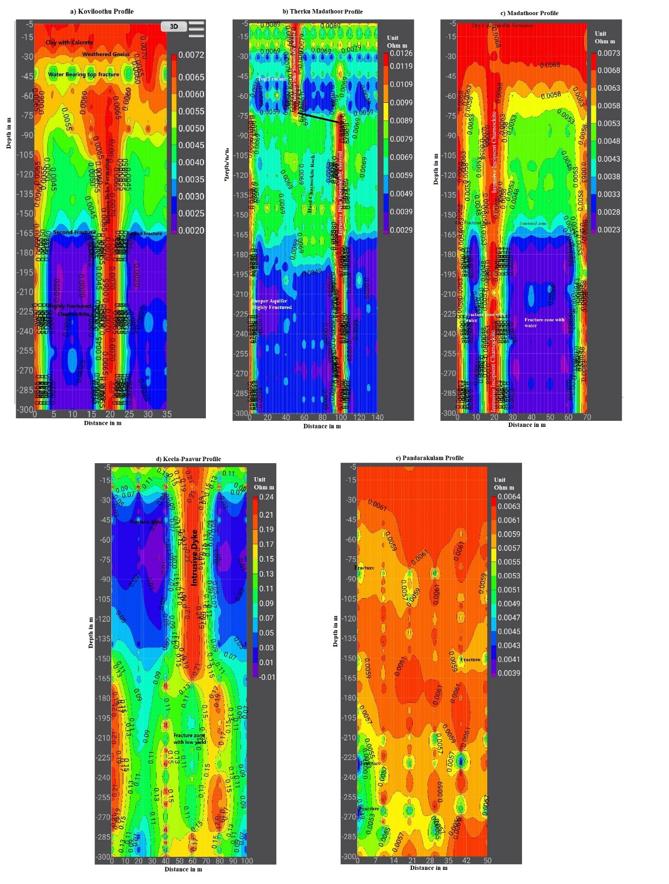
Fig 2. AMT Profiles: a) Koviloothu, b) Therkumadathoor c) Madathoor, d) Keela-Paavur and e) Pandarakulam.
Madathoor AMT Profile
The profile was carried out in a Coconut farmland in Madathoor village. The open well with water present at 10mdepth was observed. The profile length was extended upto 70m with 10m interval, depth of investigation is 300m. The profile has three fractures at depths of 155m and 225m. The top layer consist of dry calc-granulite formation. The intrusive “Incipient Charnockite” was clearly seen dividing the area into two halves with resistivity value 0.0068 ohm-m. The fractured layer at the depth of 155m with moisture content seen with resistivity value of 0.0023 ohm-m. The deeper aquifer with adequate water supply is seen at the depth of 225m with resistivity value of 0.0028 ohm-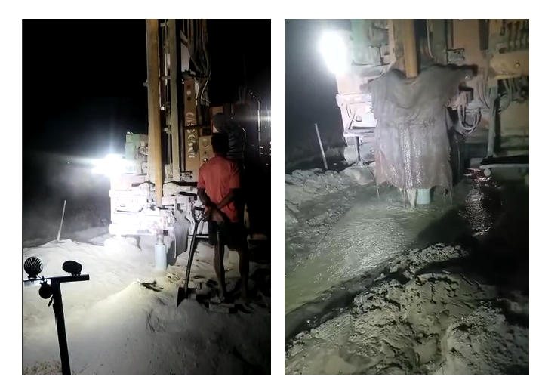
Fig 3. Bore hole drilled in Koviloothu village farm showing Charnockite hard rock formation grinded as powder and deeper aquifer consisting water at deeper depth.

Pandarakulam Profile
The AMT profile covers the length of 50m with 7m interval and 300m depth. The area has different fracture present but the adequate amount of water is seen only at deeper depth. The top fracture zone was at 30m depth which is totally dry. The formation includes the top layer consisting calcrete/clay rich sediments followed by fractured and hard gneiss rock, at deeper depth charnockite base rock presents. The fractured layers are at depths of 90m, 150m, 225m and 270m. The depths of 90m and 150m consists of moisture content with resistivity values of 0.0053 ohm-m. The deeper depth aquifers at 225m and 270m consist of adequate amount of groundwater with resistivity value of 0.0049 ohm-m.
Keela-Pavoor AMT Profile
The profile was carried out in a farmland of Keela-Pavoor village. The profile extends about 100m length with 10m interval of 300m depth. The top layer consists of calcareous material with resistivity value of 0.05 0hm-m to 0.07 ohm-m. The first fractured layer observed at the depth of 45m on Aplite rock with low resistivity value of 0.01 to 0.05 ohm-m. The formation beneath 45m is found to be hard and lack moisture content. The deeper aquifer with low yield was identified at the depth of 210m on fractured charnockite formation with resistivity value of 0.09 ohm-m.

Conclusion
A geophysical investigation of groundwater for agricultural purposes has been made by interpreting audio-magnetotelluric (AMT) data collected with a ADMT-300S in the Alangulam area. This study contributes into the better understanding of the near subsurface formation present in the study area. It puts in evidence of many dyke formations in the area where one farming land has sufficient supply of groundwater, whereas the nearby farming land has very low or no groundwater supply for irrigation purposes. This is due to the Dyke formation acting as barrier or check dam not passing the water to the other side. The study area consist of mostly deeper aquifers containing water in it, the shallow aquifers lack groundwater due to over usage from past and current usage and also due to less rainfall in the region. Among the five profiles the Koviloothu and Therkumadathoor profiles results good yielding deeper aquifers, whereas other profile have aquifers with limited usage. The bore hole was constructed in the Koviloothu and Therkumadathoor area, the deeper aquifer has good supply of water was noted. The study tells the dropping of groundwater level which should be kept in mind and carry out natural or artificial methods of groundwater recharge for the future concerns.

Acknowledgments
The First author expresses his sincere thanks to Shri. A.P.C.V. Chockalingam, Secretary and our Principal Dr. C. Veerabhahu, V.O.Chidambaram College, Thoothukudi. Dr. P. Siva Subramanian, Professor and Head, PG and Research Department of Geology, V.O.Chidambaram College, Thoothukudi extended the help.

Reference
A, A. R., & S, R. A. (2022). Assessment of groundwater study using geophysical and geochemistry mapping in Thamirabarani sub-basin, Karunkulam area, Southern India. Arabian Journal of Geosciences, 15(3). https://doi.org/10.1007/s12517-021-09357-5
Agyemang, V. O. (2020). Application of magnetotelluric geophysical technique in delineation of zones of high groundwater potential for borehole drilling in five communities in the Agona East District, Ghana. Applied Water Science, 10(6). https://doi.org/10.1007/s13201-020-01214-2
Agyemang, V. O. (2022). Groundwater exploration by magnetotelluric method within the birimian rocks of mankessim, Ghana. Applied Water Science, 12(3). https://doi.org/10.1007/s13201-022-01576-9
Antony Ravindran, A., Vinoth Kingston, J., & Hepzibah Premshiya, K. (2020). Mitigation Dredging in Seabed Geotechnical Engineering Study Using Marine 2D ERI and Textural Characteristics in Thengapattanam Harbour, South India. Geotechnical and Geological Engineering, 39(2), 897–907. https://doi.org/10.1007/s10706-020-01530-z
Antony Ravindran, A., & Antony Alosanai Promilton, A. (2022). Geophysical and geochemical prospecting for submarine groundwater discharge in a karst leaky aquifer from Valliyur Hills to Uvari Beach. Modeling Earth Systems and Environment, 8(4), 4909–4921. https://doi.org/10.1007/s40808-022-01412-8
Bernard, J., Vachette, C., & Valla, P. (1990). Deep groundwater survey with audio‐magnetotelluric soundings. SEG Technical Program Expanded Abstracts 1990. https://doi.org/10.1190/1.1890253
Gleeson, T., Wada, Y., Bierkens, M. F. P., & van Beek, L. P. H. (2012). Water balance of global aquifers revealed by groundwater footprint. Nature, 488(7410), 197–200. https://doi.org/10.1038/nature11295
Jeyapaul, V. K., Antony Jebamalai, A. R., Selvam, R. A., Sudarsanan Krishnaveni, A., & Antony Johnson, A. A. P. (2020). A case study of freshwater discharge in porous calcarenite formation in coastal terrace at Manapad, South India. Carbonates and Evaporites, 35(4). https://doi.org/10.1007/s13146-020-00641-1
Narasimhan, T. N. (2010). On Adapting to Global Groundwater Crisis. Ground Water, 48(3), 354–357. https://doi.org/10.1111/j.1745-6584.2010.00695_4.x
Sanjaya, E., Nafian, M., Suwondo, S., Fadillah, M. H., & Shafa, D. (2023). The Identification of the Existence of a Fault Structure on Gravity and Audio Magnetotulleric Data in the Area of Mount Kubing, Belitung. Jurnal Penelitian Fisika Dan Aplikasinya (JPFA), 13(1), 81–94. https://doi.org/10.26740/jpfa.v13n1.p81-94
Vinoth Kingston, J., Antony Ravindran, A., Richard Abishek, S., Aswin, S. K., & Antony Alosanai Promilton, A. (2021). Integrated geophysical and geochemical assessment of submarine groundwater discharge in coastal terrace of Tiruchendur, Southern India. Applied Water Science, 12(1). https://doi.org/10.1007/s13201-021-01553-8

