Basic Extraction and Fractionation Procedures for Experimental Purposes of Medicinal plants
Ria Bhar¹*, Amit Gamit²

¹Department of Biotechnology, School of Life Science and Biotechnology, Adamas University, Kolkata, India.
²ICAR-IVRI, ERS, Kolkata-700037

*Corresponding Author
Address for Correspondence:
E-mail addresses: bhar.riya89@gmail.com (R.Bhar)

Abstract:
The first and most important step in producing high-quality research results is the preparation of medicinal plants for experimentation. Before moving further with the desired biological testing, it entails the extraction and assessment of the quality and amount of bioactive elements. This study's main goal was to assess the various approaches utilized in our routine research to prepare and screen medicinal plants. Although the extracts, bioactive fractions, or chemicals made from medicinal plants are used for many things, regardless of the biological testing they are meant for, the processes used to make them are typically the same. The choice of an adequate solvent, extraction techniques, phytochemical screening procedures, fractionation techniques, and identification techniques are the key steps in getting excellent bioactive molecules. The specifics of these techniques and the precise path taken totally depend on the research design. Polar solvents (such as water and alcohols), intermediate polar solvents (such as acetone and dichloromethane), and nonpolar solvents (such as n-hexane, ether, and chloroform) are frequently used in the extraction of medicinal plants. Maceration, digestion, decoction, infusion, percolation, Soxhlet extraction, superficial extraction, ultrasound-assisted extraction, and microwave-assisted extraction are all examples of extraction techniques. By using different chromatographic techniques, including paper chromatography, thin-layer chromatography, gas chromatography, and high-performance liquid chromatography, phytochemical compounds can be fractionated and purified. Finally, compounds are identified using a variety of identification methods, including nuclear magnetic resonance spectroscopy, infrared spectroscopy, ultraviolet spectroscopy, and mass spectroscopy. In order to direct young researchers and help them become more focused, the various approaches outlined above might be categorized and discussed in accordance with the anticipated biological testing.
Introduction:
It is possible to prepare medicinal plants for experimentation or to extract and process them for use directly as herbal or conventional medicine. The idea of preparing a medicinal plant for experimental uses entails the timely and appropriate gathering of the plant, expert authentication, suitable drying, and grinding. When necessary, the bioactive ingredient is then extracted, fractionated, and isolated. It also includes figuring out how much and what kind of bioactive chemicals are present (1, 2, 3, 4, 5). Because of its natural origin, accessibility in local communities, affordability, ease of administration, and potentially less bothersome nature, plants are currently gaining favour on a global scale as a source of medicine. Additionally, herbal remedies could be a helpful alternative to conventional therapy in cases of severe side effects and drug resistance. The process of extracting medicinal plants involves separating active plant components or secondary metabolites including alkaloids, flavonoids, terpenes, saponins, steroids, and glycosides from inert or inactive components using the right solvent and accepted extraction techniques. Plant products with high levels of phenolic and flavonoid chemicals have been shown to have antioxidant characteristics and are therefore utilized to treat age-related illnesses like Alzheimer's disease, Parkinsonism, anxiety, and depression.[25] The type of plant material, the solvent being used, its pH, the temperature, and the solvent to sample ratio all play a role in selecting the best extraction technique. It also relies on how the finished products are going to be used.[12345] The objective of this study was to evaluate various extraction solvents, procedures, fractionation, and purification techniques as well as phytochemical screening and identification of bioactive chemicals in medicinal plants.

Isolation of plant materials by extraction:
Using a mechanical grinder, coarse powder was created from the dried barks. 20 grams of dry powder were extracted using a magnetic starring machine in 200 ml of organic solvents at 50–60°C, including acetone and methanol. For 48 hours, the extractions went on as usual. The extracts were removed from the solvents using a rotary evaporator, and the resulting crude extracts were kept in sterile amber-colored vials kept at 4°C in a refrigerator until further investigation.
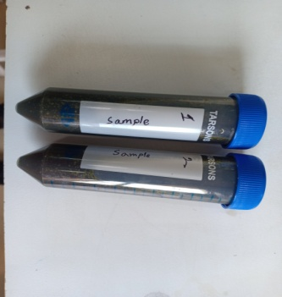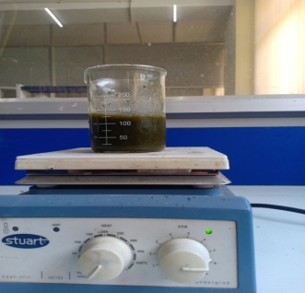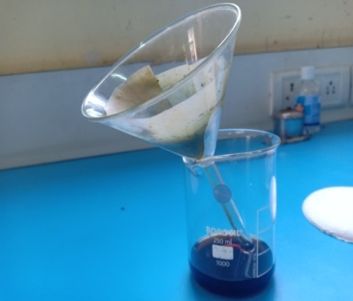
Figure 1: Plant dry Extract Figure 2: Mixed by magnetic Figure 3: Filtration
starring machine
Separation by Fractional Distillation:
A mixture of solids in a liquid can be extracted using the separation process of distillation. In essence, it involves heating the liquid to create vapours, which are then condensed to produce the liquid again. The distillate is the liquid that is produced when performing vapour condensation. A solution is created when two miscible liquids, such as ethanol and water, are combined. Liquids that are immiscible do not mix well. Take oil and water as an example. A binary mixture of liquids is any two liquids that are miscible with one another in all possible ratios. With enough of a difference in boiling points (B.P.), this method is used to separate the components of a mixture of two miscible liquids that may be heated without decomposing. When heated, a volatile liquid evaporates, but it can be recovered by condensing its vapours when cooled (https://www.geeksforgeeks.org/separation-by-fractional-distillation/).

Fractional Distillation:
To separate miscible liquids that are naturally volatile, fractional distillation is performed. These liquids' boiling points are reasonably near. To mimic the separation, fractionating column equipment is employed. Since the vapour is partially condensed and then returned as a liquid, it is sometimes referred to as rectification. It consists essentially of vaporizing a liquid combination to produce a mixture of elements, which is then followed by the extraction of the desired constituent in its purest form.

Fractionating Column:
A fractionating column that is inserted between the distillation flask and the condenser distinguishes the equipment used in this procedure from that for basic distillation. A tube filled with glass beads serves as a straightforward fractionating column. The beads act as a surface for the vapours to repeatedly cool and condense.
The partial condensation of the vapour takes place in a fractionating column during the distillation of the liquid mixture.
Vapour from the still that is moving up the column interacts with condensing vapour that is returning to the still. As a result, the more volatile component becomes more enriched in the vapour(1,9).

Separating Funnel:
A device known as a separating funnel is used in the process for separating two immiscible liquids. It is a unique kind of funnel with a stop-cock in the stem that controls whether liquid flows into or out of it. The different densities of the composing liquids determine whether two immiscible liquids can be separated by a separating funnel. The lighter liquid remains as an upper layer while the heavier liquid sinks to the bottom.
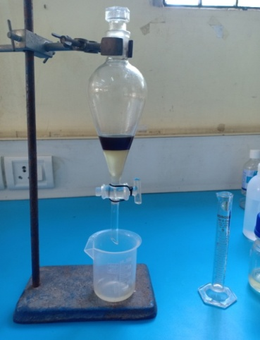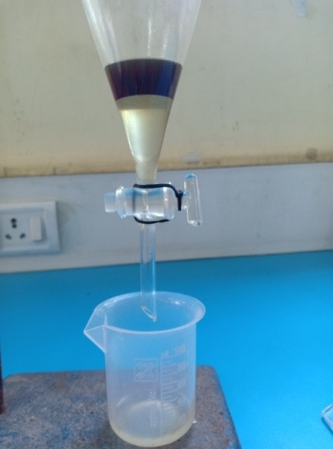
Figure 4: Separating funnel Figure 5: Separated between two immiscible liquid phases
The components of a combination are separated between two immiscible liquid phases using a separating funnel. Aqueous phase makes up one phase, and an organic solvent makes up the other. The different densities of the liquids provide the basis for this separation. The lower layer is made up of the denser liquid, whereas the top layer is made up of the denser liquid.
The liquid with the lower density floats to the top when the combination is poured into a separating funnel, and when the tap is opened, the liquid with the higher density begins to flow into the container through the separating funnel. Then, just as the liquid with the lower density begins to pour through, the tap is shut. The two immiscible liquids can then be separated by draining the liquid with the lower density that is still in the separating funnel into a new container(1,5,9).
Application:
The following mixes can be separated using fractional distillation:
- Acetone and water
- Chloroform and benzene
- Separation of gases of air
Applications of Separating Funnel:
- Separating a mixture of water and kerosene
- Separating a mixture of petrol and water
- Groundnut oil or mustard oil from water
- Mercury, carbon disulphide, chloroform, benzene from water
Table 1: Difference between Simple Distillation and Fractional Distillation:
Simple Distillation | Fractional Distillation
To separate mixtures of miscible liquids with sufficiently substantial differences between their boiling points, simple distillation is utilized. | When there is little variation between the boiling points, fractional distillation is used.
It comprises of a condenser, two flasks, and a simple equipment. | It is made up of more complicated machinery with a fractionating column.
Example: To purify seawater | Example: Crude oil refining
Separation by Evaporation:
Evaporation is the process of removing a solid from water that has been dissolved in it. The application is based on the observation that liquids evaporate more readily than solids do. The solid substance is removed during evaporation and is left as a residue. It is a method of vaporization where the liquid transforms into the gaseous phase and leaves behind surface residue. Up until the point of equilibrium, evaporation continues. A liquid will, however, continue to vaporize in an enclosed environment until air saturation is reached. Practically speaking, just a small portion of all molecules have the thermal energy needed to vaporize (https://www.geeksforgeeks.org/separation-by-fractional-distillation/).
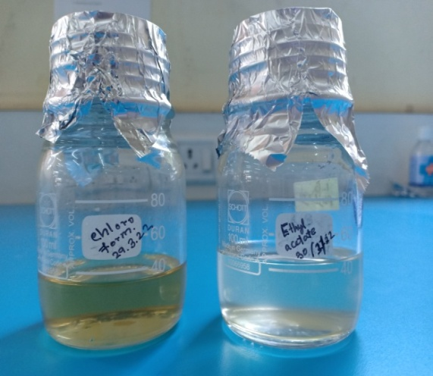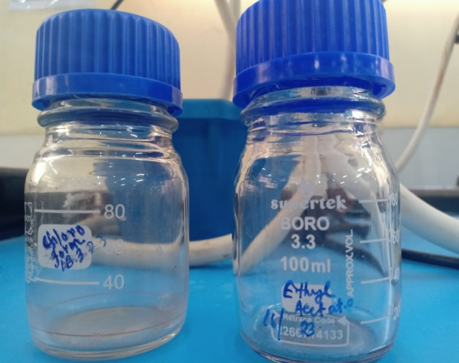
Figure 6: Mixture of a solid dissolves Figure 7: Only solid remains
in a liquid

Conclusion:
Many studies on medicinal plants have been conducted, either to look into and support a claim of biological activity or to replicate its historic medical use based on ethnomedical survey. Successfully extracted, fractionated, and isolated chemicals from numerous therapeutic plants. Additionally, the produced compounds were examined for biological or pharmacological action, and they were typically found to be active. However, the precision in solvent selection, method selection and execution, phytochemical screening, fractionation, and identification techniques determine the rate of success and the veracity of these findings. Finally, appropriate comprehension and application of these strategies are essential. Periodic improvement and adjustment of these techniques will speed up the study process and enhance the final product.
Reference:
1. Ingle KP, Deshmukh AG, Padole DA, Dudhare MS, Moharil MP, Khelurkar VC. Phytochemicals: Extraction methods, identification, and detection of bioactive compounds from plant extracts J Pharmacogn Phytochem. 2017;6:32–6.

2. Azwanida NN. A review on the extraction methods use in medicinal plants, principle, strength, and limitation Med Aromat Plants. 2015;4:196.

3. Pandey A, Tripathi S. Concept of standardization, extraction, and pre-phytochemical screening strategies for herbal drug J Pharmacogn Phytochem. 2014;2:115–9.

4. Doughari JHVenketeshwer R. Phytochemicals: Extraction methods, basic structures, and mode of action as potential chemotherapeutic agents, phytochemicals––a global perspective of their role in nutrition and health A Global Perspective of Their Role in Nutrition and Health.2012.

5. Sasidharan S, Chen Y, Saravanan D, Sundram KM, Yoga Latha L. Extraction, isolation and characterization of bioactive compounds from plants’ extracts Afr J Tradit Complement Altern Med. 2011;8:1–10.

6. Rungsung W, Ratha KK, Dutta S, Dixit AK, Hazra J. Secondary metabolites of plants in drugs discovery World J Pharm Res. 2015;4:604–13.

7. Sofowora A. The present status of knowledge of the plants used in traditional medicine in western Africa: A medical approach and a chemical evaluation J Ethnopharmacol. 1980;2:109–18.

8. Rimando AM, Olofsdotter M, Dayan FE, Duke SO. Searching for rice allelochemicals: An example of bioassay-guided isolation Agron J. 2001;93: 16–20.

9. Das K, Tiwari RK, Shrivastava DK. Techniques for evaluation of medicinal plant products as antimicrobial agents: Current methods and future trends J Med Plants Res. 2010; 4: 104–11.

10. Altemimi A, Lakhssassi N, Baharlouei A, Watson DG, Lightfoot DA. Phytochemicals: Extraction, isolation, and identification of bioactive compounds from plant extracts Plants. 2017;6 :42.

11. Majekodunmi SO. Review of extraction of medicinal plants for pharmaceutical research MRJMMS. 2015; 3: 521–7.

12. Tiwari P, Kumar B, Kaur M, Kaur G, Kaur H. Phytochemical screening and extraction: A review Int Pharm Sci. 2011;1:98–106.

13. Cowan MM. Plant products as antimicrobial agents Clin Microbiol Rev. 1999; 12: 564–82.

14. Bhan M. Ionic liquids as green solvents in herbal extraction Int J Adv Res Dev. 2017; 2: 10–2.

