**Reverse Phase High Performance Liquid Chromatographic Method and Method Validation of Silymarin by Using Single Mobile Phase**

Tirthankar Choudhury

Professor, ITM University, School of Pharmacy,

Gwalior- 474011, M.P, India

E-mail: - tirtha29a@gmail.com

**ABSTRACT**

In the pharmaceutical sector, the computerization of technique development and validation is helpful in drug analysis. This article describes the development, validation, and use of a straightforward, sensitive, and accurate high-performance liquid chromatographic (HPLC) technique for the measurement of silymarin using UV detection at 284 nm. Silymarin tablets (two brands) were acquired from Allen Laboratories Ltd. (ADSYL) and from the market. Ahmedabad, Gujarat (ASIL PLUS) and Alpic Biotech Limited, respectively. On a Hypersil ODS C18 reversed-phase column, the compounds were effectively separated using a mobile phase made up of methanol and water (95:5 v/v at a flow rate of 1.0 ml/min). For Silymarin, the linearity ranges were 50- 200 µg/ ml. Silymarin has limits of quantitation (LOQ) of 9.61 µg/ml and limits of detection (LOD) of 3.155 µg/ml. The work demonstrated that Silymarin can be determined using a single mobile phase utilising reversed-phase liquid chromatography, which is sensitive and selective.

**Keywords:** Silymarin, ODS column, and RP-HPLC.

**1. INTRODUCTION**

The process of proving analytical processes is appropriate for their intended purpose is known as methods validation. The planned and organised gathering of validation data to support the analytical processes is the first step in the technique’s validation process. [1, 2]. The review chemist assesses the validation information and analytical methods. A validation technique is one that shows a process can consistently produce a product that satisfies the set product specification while operating under controlled conditions. In the pharmaceutical sector, validation studies are a crucial component of GMP and GLP and must be carried out in line with established standards. A written report should be created and kept that summarises the recorded findings and recommendations. Guidelines are provided by the ICH, USFDA, and European Union (European Medical Evaluation Agency) for adhering the principles started for GMP, GLP requirements. [3,4,5]

Silymarin is used to treat liver and gallbladder problems, protect the liver against mushroom poisoning and alcohol consumption, and treat liver and gallbladder issues. It is a (2R,3R) chemical.-3,5,7-trihydroxy-2-[(2R,3R)-3-(4-hydroxy-3-methoxyphenyl)-2-(hydroxymethyl)2.3.3 dihydrobenzo[1,4]dioxin-6-ylchroman-4-one. Silymarin, a flavonoid with the chemical formula C25H22O102, is an antioxidant. Although it is extremely insoluble in water, it is easily soluble in 95% ethanol. It is a crystalline powder that is yellowish white. [6,7,8]

The literature review found that developed methods were used to biological fluids and buffer solutions. More challenges develop when using buffer solutions and biological fluids because,

i) In huge volumes of blood, urine, or tissues, a little amount of drug or its metabolite is often present.

ii) Endogenous pigments can cause certain analytical errors if the circumstances are not well controlled.

iii) Drugs may bind to proteins, which results in slow recovery.

iv) Buffer solutions should always be created from scratch.

v) Measuring medication plasma levels from patients is a difficult procedure. These tests needed a sizable amount of plasma sample for each patient.

vi) TDM (Therapeutic Drug Monitoring) - Prospective clinical investigations evaluating the therapeutic applicability of this technique have produced conflicting findings, highlighting the necessity to take many factors into account while undertaking TDM.

While there is no need to manufacture methanol-water from scratch because the recovery rate is so high.We intended to reduce the time and expense of the tests by developing a single, straightforward, quick, reliable, and affordable approach that is employed for silymarin by RP-HPLC in individual pharmaceuticals.

**2. MATERIALS AND METHODS**

**2.1. Chemicals and Reagents**

Chemicals and Standards Sd. Fine Pvt. Ltd. (Mumbai, India) provided HPLC-grade methanol, while Universal Labortories Pvt. Ltd. (Mumbai, India) provided triple-distilled water. The market was stocked with silymarin pills (ADSYL, Allen Laboratories Ltd., and ASIL PLUS, Alpic Biotech Limited, Ahmedabad, Gujarat).

**2.2. Instrumentation**

A Shimadzu Corporation, Switzerland, HPLC apparatus from the LC-10AT VP series, which includes a UV-Visible detector, manual injector with a 20-l loop, and Hypersil ODS C18 column (250 mm X 4.6 mm i.d., 5 m particle sizes), was utilised.

**2.3. Chromatographic condition**

Base deactivated silyl bonded Hypersil C18 reversed phase column (250 mm x 4.6 mm i.d., 5 µl) was used for the chromatography. Methanol and water were the mobile phase in a 95:5 (v/v) ratio. There was a 1 ml/min flow. During the analysis, the column was maintained at 25.0 0.10 _C; the injection volume was 20 l, and the detection wavelength was 284 nm.

**Table 1. Condition applied**

|  |
| --- |
| Column Mode : C18 RP-HPLC |
| Detector : UV – Visible |
| Type of Analysis : Peak area and peak height |
| Detection Limit : 284 nm |
| Flow Rate : 1.0 ml/min |
| Run Time : 10 min |
| Injection volume : 20 µl |

**2.4. Solution Preparation**

Silymarin (100 mg) was weighed in a 100-ml volumetric flask, dissolved in methanol, and diluted to volume with the same solvent of these solutions. 1 ml was then further diluted to 100 ml with mobile phase to create the stock and working standard solutions for Silymarin.

**2.5. Stock and working standard solution**

Silymarin (100 mg) was weighed in a 100-ml volumetric flask, dissolved in 95 ml of methanol, and then diluted to a volume of 100 ml using the same solvent. To create working standard solutions containing silymarin (10 g/ml) from these solutions, 1 ml was further diluted to 100 ml with mobile phase.

**2.6. Preparation of internal standard solution**

Silymarin standard, accurately weighed at 100 mg, was taken in to 100 ml volumetric flasks, mixed with 60 ml of methanol in each, and then sonicated for 30 minutes to obtain 1 mg/ml (1000 µg/ml) standard stock solution.

**2.7. Preparation of the sample solutions**

In a mortar and pestle, the twenty tablets (ADSYL 140 mg and ASIL PLUS 140 mg) were precisely weighed and finely ground. A 100 mg equivalent was taken in a volumetric flask of 100 ml from the powder. This was sonicated for 30 minutes with internal shaking after being dissolved in 60 ml of methanol. Finally, 100 ml of mobile phase were added to the volume to produce a clear solution containing 1 mg/ml. Centrifuging the aforementioned solution at 3000 rpm for 5 minutes.

**3. RESULTS AND DISCUSSION**

**3.1. Method Validation**

There were numerous mobile phase compositions tested in order to optimise the HPLC parameters. To improve reproducibility and repeatability, a mobile phase made up of methanol and water (95:5 v/v) led to a successful separation and peak symmetry for silymarin. Based on the peak area, quantification was accomplished using UV detection at 284 nm. It was discovered that the peaks had better resolution and a distinct base line separation (Fig. 2). Silymarin has limits of detection (LOD) of 3.155 g/ml and limits of quantitation (LOQ) of 9.61 g/ml. The work demonstrated that Silymarin can be determined using a single mobile phase utilising reversed-phase liquid chromatography, which is sensitive and selective.

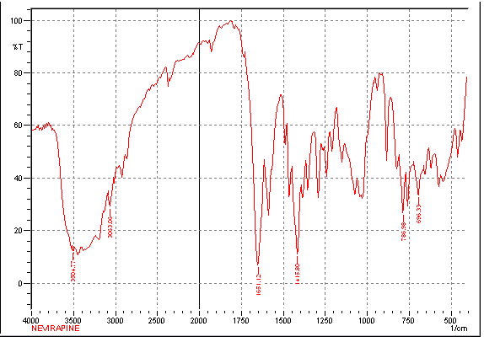

**Fig.:-1 IR Spectrum for Sylimarin**

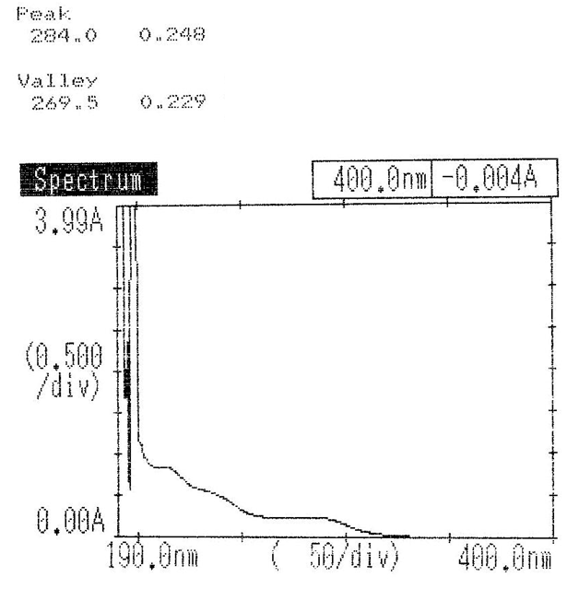

**Fig.:-2 UV Scan for Sylimarin (λmax= 284 nm)**

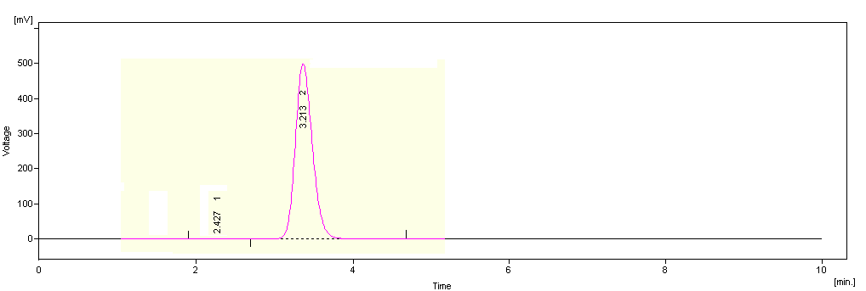

**Fig. 3 Peak area and peak height Silymarin (Pure drug)**

**3.2. Specificity (Selectivity)**

By contrasting the chromatograms produced from samples and the equivalent placebo, the selectivity of the RP-HPLC technique was evaluated. While the active ingredients are easily soluble in methanol or the mobile phase, tablet additives are essentially insoluble in these media. The tablet ingredients had no effect on the results.

**3.3. Linearity**

Analysis of standard plots connected to the nine-point standard calibration curve was used to establish the linearity of the procedure. Regression analysis of the calibration standard and the measurement of the drug concentration were both used to compute the analytes' concentrations using a straightforward linear equation. The calibration standards' peak area ratio values correlated with the medicines.

Each sample's peak area was plotted against its relative Silymarin concentration, and it was discovered that this relationship was linear between 25 and 200 g/ml. Regression analysis was used to generate the linear equation Y= 15.67x + 3.2132 with an R2 = 0.9999. The data from the measures' least squares linear regression fit are shown in the table. By analysing standard plots connected to an eight-point standard calibration curve, the linearity of the procedure was confirmed.

**Fig. 3 Standard calibration curve of Silymarin (Pure drug)**

**3.4. Accuracy**

The conventional addition approach was used to conduct the recovery studies. For Silymarin (Brand 1 and Brand 2), the percent ages of the recoveries were 99.703% and 100.186%, respectively, and the outcomes are displayed in (Table 2). The technique recovered well.

**Table 2. Recovery studies (For accuracy)**

|  |  |  |
| --- | --- | --- |
| Labeled claim 75mg | Amount added (mg) | % Recovery |
| Brand 1  (ADSYL) | 10  20  30 | 99.38  100.12  99.1 |
| Brand 2  (ASIL PLUS) | 10  20  30 | 100.25  99.85  100.06 |

*Mean of five determinations.

**3.5. Precision**

**3.5.1. System precision**

When the method is used repeatedly to do multiple sampling of a homogeneous sample, the accuracy of an analytical method is measured by the degree of agreement among the individual test findings. The relative standard deviation (% RSD) or percentage coefficient of variation (% CV) were used to calculate the accuracy.

Repeatability is the application of the analytical technique over a brief period of time (within a single day) in a laboratory, using the same analytes with the same tools. By injecting three different concentrations of the same standard medication three times on the same day, repeatability was tested. The repeatability test for the technique was successful since the RSD was less than 2%.

**Table 3. Intraday precision of Silymarin by the proposed RP- HPLC method**

|  |  |  |  |
| --- | --- | --- | --- |
| Conc. Silymarin (μg/ml) | Mean area (n= 3) | Standard deviation | %RSD (n= 3) |
| 50 | 740.666 | 10.689 | 1.43 |
| 100 | 1557.629 | 25.568 | 1.641 |
| 200 | 3179.414 | 39.857 | 1.253 |

**3.5.2. Intermediate precision**

Participate in the assessment of analytical variance when a method is used within a laboratory, such as on various days (inter-day). By injecting three distinct standard concentrations in triplicate on three separate days, intermediate accuracy was examined. Since the RSD was less than 1.5%, the approach passed the test for intermediate accuracy.

**Table 4. Inter- Day precision of Silymarin by the proposed RP- HPLC Method**

|  |  |  |  |
| --- | --- | --- | --- |
| **Conc. of Silymarin**  **(μg/mL)** | **Mean area (n= 9)** | **Standard deviation** | **%RSD (n= 9)** |
| 50 | 782.0973 | 4.093 | 0.523 |
| 100 | 1557.834 | 22.003 | 1.412 |
| 200 | 3144.218 | 44.302 | 1.409 |



**Fig4: Intraday- graph of Silymarin Fig 5: Inter day- graph of Silymarin**

**3.6. Ruggedness**

The technique graph was tested on a different analyte with a different batch of chemicals. The results did not vary significantly. These investigations demonstrated the method's rugged.



**Fig. 6 Analyst-1 Silymarin Fig. 7 Analyst -2 Silymarin**

**Table 5. Analyst-1 for Silymarin**

|  |  |  |  |
| --- | --- | --- | --- |
| **Concentration** | **Peak area (mV.s)\*** | **SD** | **%RSD\*** |
| 100 | 1595.588 | 4.005 | 0.251 |
| 150 | 2277.222 | 25.512 | 1.120 |
| 200 | 3067.112 | 29.163 | 0.950 |

*Average of three values

**Table 6. Analyst-2 for Silymarin**

|  |  |  |  |
| --- | --- | --- | --- |
| **Concentration** | **Peak area (mV.s)\*** | **SD** | **%RSD\*** |
| 100 | 1615.169 | 4.216 | 0.261 |
| 150 | 2362.835 | 25.541 | 1.080 |
| 200 | 3094.138 | 10.674 | 0.344 |

*Average of three values

**3.7. Robustness**

By intentionally making tiny but purposeful changes to the flow rate, mobile phase, and temperature, the method's robustness was examined. At three distinct concentrations and temperatures (ranging from (±1˚C to ±5˚C), the effects of flow rate modification (±1 ml/min) were investigated. At three different concentrations, the impact of varying the mobile phase ratio was also investigated. The following Tables provide the findings.

**Table 7. Effect of variations in the flow rate of (-1.0 ml/min) for Silymarin**

|  |  |  |  |  |
| --- | --- | --- | --- | --- |
| Concentration | Retention Time* | Peak area (mV.s)* | SD | %RSD |
| 50 | 3.547 | 779.509 | 1.971 | 0.252 |
| 100 | 3.543 | 1486.747 | 11.066 | 0.747 |
| 200 | 3.557 | 2718.083 | 22.777 | 0.837 |

*Average of three values

**3.7.1. System suitability test**

Using this approach, the relative standard deviation (% RSD) for Silymarin was determined to be 1.03. The entire set of outcomes fell inside the permitted range. Chromatographic procedures often include system suitability studies to ensure that the system's resolution and repeatability are sufficient for the analysis to be carried out. All of the criteria for system appropriateness had values that fell within acceptable bounds.

**Table 8. System suitability test for Silymarin**

|  |  |
| --- | --- |
| Parameters | Values |
| Retention Time | 3.22 |
| HETP(mm) | 0.009 |
| Tailing factor | 1.113 |
| Theoretical plates/m | 110099.84 |
| LOD(μg/ml) | 3.155 |
| LOQ(μg/ml) | 9.61 |

**3.7.2. Regression analysis**

Silymarin regression statistics for intraday and interday are shown in Table 9. With a regression value of 0.9999, the method's linearity was shown in the concentration range of 50-200 µg/ml, indicating its acceptability for analysis.

**Table 9. Silymarin regression statistics**

|  |  |  |
| --- | --- | --- |
| **Concentration range(μg/ml)** | **Regression equation** | **Regression coefficient (R2)** |
| 50-200 | Y=15.97X – 28.18 | R2=0.999 |
| 50-200 | Y=15.81X-25.98 | R2=0.999 |

**3.7.3. Assay of the tablet dosage form**

Silymarin in pharmaceutical items was effectively identified using the suggested validated approach. The findings for silymarin were equivalent to the levels that were labelled (Table 2).

**4. DISCUSSION**

In relation to the foregoing, the liquid chromatographic technique was explained, and the outcomes were provided. Limits of detection (LOD) were determined to be 3.155 µg/ml, limits of quantitation (LOQ) were 9.61 µg/ml, and recovery rates for ADSYL and ASIL PLUSPLUS, respectively, were 99.703% and 100.186%, with a regression coefficient of 0.9999 (Intraday & Inter-day). So, the technique was demonstrating its validity. The regression coefficient (r2) value of 0.999 was obtained from the standard calibration curve using the concentration of 50-200 µg/ml (Y=15.97X - 28.18, Y=15.81X-25.98).

**5. CONCLUSION**

For the study of silymarin in pharmaceutical formulations, a high-performance liquid chromatographic approach has been developed that is straightforward, dependable, repeatable, and affordable. The disclosed approach may be utilised to analyse silymarin in tablet or other pharmaceutical formulations both qualitatively and quantitatively. The obtained limits of detection (LOD) were 3.155 µg/ml and 9.61 µsg/ml for the limits of quantitation (LOQ).

**ACKNOWLEDGEMENTS**

The author acknowledges ITM University's School of Pharmacy (SOP), Gwalior, for providing the resources necessary to conduct the research.

**REFERENCES**

1. Virtanen, R. Radioimmunoassay for Tricyclic Anti-depressants, Scand. J. Clin. Lab. Invest. (1980) 40: 191-197.
2. Barry M, Mulcahy F, Merry C, Gibbons S, Back, D.Clin. Pharmacokinet. (1999) 36: 289.
3. .Malaty L I, Kupper, J J.Drug Saf. (1999)20: 147.
4. Jajaray A, Alexander J, Price C, Daly D, Pav J, Hatoxx S KeirnsJ.Pharm.Res.(1995)9: 334.
5. Anbazhagan S, Indumathy N, Shanmugapandiyan P Sridhar, S K.J. PharmBiomed Anal.(2005) 39: 801.
6. Avolio D A, Siccardi M, Sciandra M, Lorena B, Bonora S, Trentini L, Perri, G D. J.Chromatographia.

(2007)859: 234.

7. Ramachandran G, Hemanthkumar A K, Kumaraswami V, Swaminathan, S. J.Chromatographia.(2006)

843: 339.

8. Fan B, Stewart, J T.J. Pharm. Biomed. Anal. (2002)28: 903.

9. Dailly E, Raffi F, Jolliet, P.J. Chromatogr. B.(2004)813: 335.

10. Rezk N L, Richard R, Tidwell, Kashuba, A D M.J.Chromatogr.B.(2002)774: 79.

11. Marzolini C, Beguin A, Telenti A, Schreyer A, Buclin T, Biollaz J, Decostered L

A.J.Chromatogr.B.(2002)774: 127.

12. Little B B, Bawdon R E, Christmas J T, Sobhi S, Gilstrap L, Gynecol, A J O.J. Chromatogr. B, (1989)

732: 161.

13. Mistri H N, Jangid A G, Pudage A, Gomes N, Sanyal M, Shrivastav, P. J.Chromatogr.B.(2007) 853: 320.

14. Hollanders R M F, Kolmer E B, Burger D M, Wuis E W, Koopmans P P, Hekster, Y A. J.Chromatogr.B.(2000) 744: 65.

15. Yavuz, B; Bilensoy, E; Şumnu, M, Analytical method validation for HPLC Assay of Oral Anticancer drug

Exemestane. Fabad Journal of Pharmaceutical Sciences. 2007; 32:15-22.

16. Persini S, Broutin F,Cicioni P,Stefanini P,Benedetti MS. Determination of the new aromatase inhibitor

exemestane in biological fluid by automated high-performance liquid chromatography followed by

radioimmunoassay. European Journal of Pharmaceutical Sciences. 1996;4(6):331-340.

17. Konda B, Tiwari RN, Fegade H. Development and validation of stability indicating method for the

determination of exemestane by reverse phase high performance liquid chromatography. J Chromatogr

Sci. 2011;49(8):634-9. DOI: 10.1093/chrsci/49.8.634. PMID: 21859539.

18. Mukthinuthalapati MA, Bukkapatnam V. A Novel Validated StabilityIndicating RP-HPLC Method

for the Determination of Exemestane (Steroidal Aromatase Inhibitor). J Bioequiv Availab. 2015;7:288-

292. doi:10.4172/jbb.1000256.

19. Per E. Lonning, Jurgen Geisler, Lars E. Krag, Bjørn Erikstein, Yngve Bremnes, Anne I. Hagen Ellen

Schlichting, Ernst A. Lien, Erik S. Ofjord, Jolanda Paolini, Anna Polli, and Giorgio Massimini. Effects

of Exemestane Administered for 2 Years Versus Placebo on Bone Mineral Density, Bone Biomarkers,

and Plasma Lipids in Patients with Surgically Resected Early Breast Cancer. Journal of Clinical

Oncology. 2005;23(22):5126-5137. DOI:10.1200/JCO.2005.07.097.

20. Cenacchi V, Barattè S, Cicioni P, Frigerio E, Long J, James C. LC-MS-MS determination of exemestane

in human plasma with heated nebulizer interface following solid-phase extraction in the 96 well plate

format. J Pharm Biomed Anal. 2000;22(3):451-60. DOI: 10.1016/s0731-7085(00)00235-1. PMID:

10766362.