The Future of Healthcare in the Metaverse
ABSTRACT
Rapid advances in digitization and automation have fueled rapid growth in the healthcare sector, creating new models that create new channels for cheaper treatment, enhanced patient experience, and expand access to healthcare. Metaverse is an emerging technology, which is the confluence of several assistive technologies such as Artificial Intelligence, Virtual Reality, Augmented Reality, the Internet of Things (IoT), Robots, Quantum Computing, etc. through which new avenues can be explored for the delivery of quality healthcare services. However, in an industry where patient data is essential and is held to the highest levels of security, there is no guarantee that it will remain intact. Therefore, this article aims to explore the use of the Metaverse in the healthcare industry as well as its current state, challenges, issues, and prospects. Problems in adapting Metaverse for healthcare practices are also identified with plausible solutions.
KEYWORDS: Healthcare, Metaverse, Emerging Technology, Future Trends
INTRODUCTION
The Metaverse has been the focus of industry and science in recent years. The term "Metaverse" was first introduced by Neal Stephenson in the 1992 ' science fiction novel Snow Crash, which is about an alternative and immersive virtual reality. The Metaverse is a virtual environment that combines physical and digital reality. It is an internet-based three-dimensional (3D) virtual world in which people go about their daily activities with avatars that represent their "real" or imaginary identity (Petrigna & Musumeci, 2022). In short, the virtual space has become a real world of alternative life, where digital avatars or profiles participate in social activities and virtual cultural events, but also conduct economic life.
Metaverse service applications in the healthcare industry have been launched and have become an increasingly promising and important area (Lee, 2022) and are expected to be worth $800 billion by 2024 (Marr B. 2022). They have the potential to revolutionize digital healthcare, access, education, and patient outcomes (Chen & Zhang, 2022). Artificial intelligence technology has shown its potential during the pandemic by predicting the emergence of coronavirus disease 2019 (COVID-19) and helping identify sites for vaccine trials. Radically changing social interactions, social distancing rules, mandatory lockdowns, and quarantines during the pandemic has been the key driver that has accelerated the technological mediation of communication on an unprecedented scale. (Thomason, 2021). The post-pandemic era has brought about major fundamental changes in the healthcare sector. For example, current-generation consumers have started to actively participate in healthcare decision-making, and then embrace virtual healthcare systems and associated digital innovations. Experts predict it will be more intuitive than current computer systems. A simple example: instead of locating a document in drives and folders, attaching it to an email, and then sending it to a colleague, the user can instead browse through stacks of documents on a virtual desktop, select a document and send it directly to the avatar of a colleague for review. The Metaverse, with its immersive, customizable, and secure features, plays an important role in the future of healthcare. Through individualized, predictive, and empathetic engagement models, technology can help deliver hyper-personalized, data-driven care that can lead to early disease detection and tailored interventions that lead to better outcomes (Wiederhold & Riva, 2022). Metaverse has the potential to solve problems in various areas by changing the way devices and users communicate with modern technologies. (Chengoden et al., 2016). However, in the absence of robust national and global healthcare governance and accountability mechanisms, digital healthcare ecosystems are at risk of breaches of physician confidentiality and privacy, leading to the sharing and exploitation/re-use of data by companies or governments' overall scope and limitations of patient consent. (Curtis & Brolan, 2023). As consumers of healthcare services are increasingly willing to share their sensitive data, the need has developed for organizations to ensure interoperability between organizations and maintain consumer trust by being trustworthy, transparent, and empathetic in their operations. The issues and challenges brought by a simulated, interoperable virtual environment that is supposed to remotely view pertinent, sensitive information can bring vulnerabilities due to the shared platform experience. In addition, outside factors such as body sensor networks and smart devices can bring a plethora of risks to the healthcare system. Identifying the possible risks and vulnerabilities can bring potential hardening measures for an increase in trustworthiness and utilization (Mejia & Rawat, 2022). However significant challenges remain and addressing these challenges will pave the way for the future of healthcare.
This paper thus provides a detailed study on the significance of the Metaverse in resolving the issues of the healthcare domain by considering features of the Metaverse, existing applications, and challenges in realizing the full potential of the Metaverse in the healthcare sector
METAVERSE FRAMEWORK AND BUILDING BLOCK TECHNOLOGIES
The Metaverse is an interdisciplinary ecosystem created by integrating various other technologies at various levels all through the architecture. It's a 3D version of today's internet. In the Metaverse environment, different components interact between the physical and virtual worlds. Among these, users are one of the key elements. The user can interact with virtual worlds using certain devices such as AR/VR glasses or head-mounted displays (HMDs). With these devices, users can interact virtually and perform various tasks. IoT networks, Virtual Service Providers (VSPs), and Physical Service Providers (PSPs) are also some of the key elements used for the interaction between the real and virtual world. Data is collected in the real world via the IoT and sensor networks and used to create digital twins. Virtual Service Provider (VSP) and Physical Service Provider (PSP) help manage virtual and real Metaverse environments.

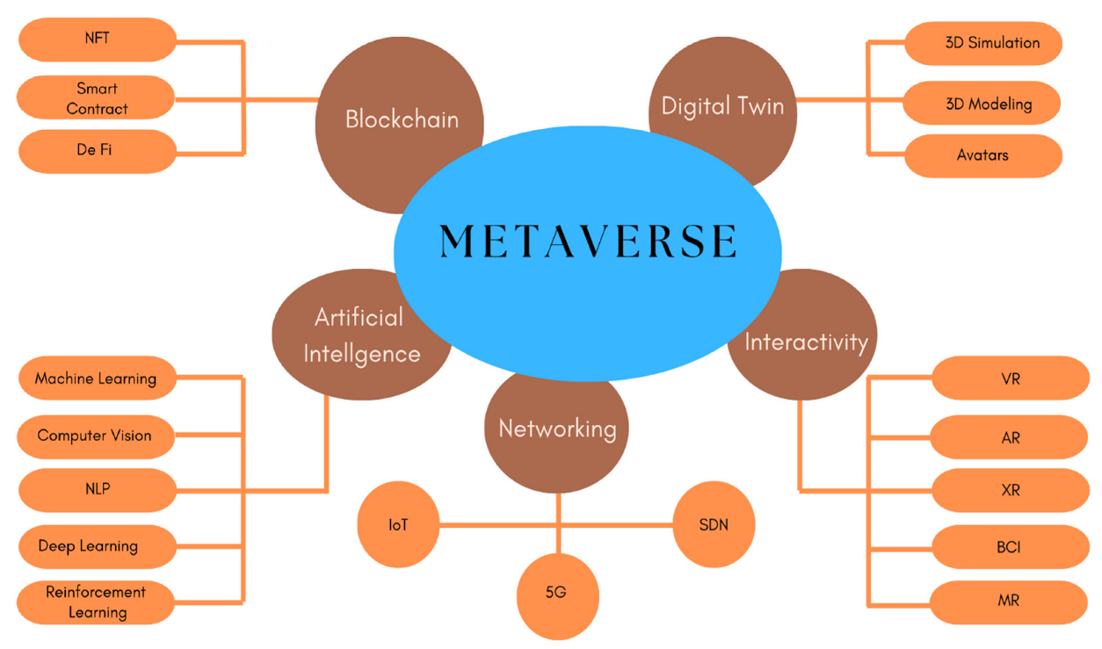
Fig 1 Building Blocks Technologies for Metaverse
Source: (Ali et al., 2023)

2.1 Block Chain
Blockchain is a type of DLT that logs transactions using an immutable cryptographic signature called a hash. That is , when a single block in the chain is modified, it is immediately evident that it has been modified. If the hackers want to break into the blockchain system, they would have to change every block in the chain on all distributed copies of the chain. Non-fungible tokens and cryptocurrencies on the blockchain facilitate the creation, ownership, and use of decentralised digital assets. The Metaverse concept would be incomplete without blockchain, as centralized data storage raises several issues related to data security, privacy, and transparency. Blockchain will make the Metaverse a decentralized digital asset that can function on any platform and on a global scale (Bamakan et al., 2022). The blockchain-enabled Metaverse will provide physicians with accurate patient data so they can make more accurate decisions. Blockchain prevents this sensitive information from being altered or manipulated by attackers. However, there are also some limitations to the Metaverse-backed healthcare blockchain. Adopting this technology poses challenges due to its huge resource requirements and cost. This technology is completely unrestricted and unregulated, putting patients at risk. The complexity of the technology will make it difficult for end users or patients to adapt. Because all data must be stored on every node connected to the chain, a blockchain-enabled Metaverse can be very slow (Yaqoob et al., 2022) Small hospital networks cannot use this technology due to excessive power consumption and complexity.
2.2 Digital Twin
Digital twin coined in the year 1991 in the book Mirror Worlds by David Gelernter is a virtual representation that acts as the digital counterpart of a physical object or process in real-time (Moyne et al., 2020). Digital Twins are the result of the continuous evolution of product design and engineering processes. It is a digital representation of an object, process, or service that exists in the real world. It can be a digital copy of a physical thing like machinery, medical equipment, or even larger objects like skyscrapers or even entire cities. On the other hand, the Metaverse technology represents a virtual world where everything and everyone interacts like in the real world. Digital twins are the building blocks of the Metaverse as they create a digital copy of every object in the Metaverse (Han et al., 2023)
Operating strategies, staffing, and models of care can be explored by establishing a digital twin of the entire hospital in the Metaverse to identify needs (Alazab et al., 2022). In scenarios such as bed shortages, the transmission of pathogens, doctor scheduling, or the availability of operating rooms, these virtual Metaverse models can be helpful. Patient care, costs, and staff productivity can be improved with Metaverse using digital twins, to provide a risk-free environment. The Metaverse, with support for digital twins, will also help create custom artificial organs. A Metaverse supporting digital twins can also help create custom artificial organs. A Metaverse supporting digital twins can also help brain and heart surgeons to virtually simulate surgical procedures before performing complex operations in the real world. (Chengoden et al., 2016).

2.3 Artificial Intelligence
AI, also known as artificial intelligence, focuses on developing and managing technologies that can learn to make decisions for themselves and perform tasks on behalf of humans. (Gupta et al., 2021). Artificial Intelligence will help strengthen the infrastructure of the Metaverse, improve immersive 3D experiences, and improve the integrated service of the virtual world. AI technology will also help improve the quality of the Metaverse’s service and ecosystem. With the help of artificial intelligence, health data from patients are analyzed/ diagnosed. Metaverse uses artificial intelligence to support physicians with high-quality 3D images and patient scans needed for procedures. AI can help provide physicians with critical information that can help prioritize critically ill patients minimize potential errors in electronic health record analysis, and provide more accurate diagnoses (Huynh-The et al., undated 2022).

2.4 Networking
2.4.1 The Internet of Things (IoT) offers a variety of technologies such as sensors,
wireless networks and nanotechnologies to connect and communicate between a large number of devices such as smartphones, smartwatches, medical devices, etc. (Aghdam et al., 2021). The IoT, along with other technologies, is changing people's lives by making things easier and thereby improving the quality of life. It is widely used in healthcare facilities that serve patients and doctors. Patients can be monitored remotely using various types of IoT devices thereby improving the quality of healthcare services and reducing costs. (Mistry et al., 2020). This technology is also an integral part of the Metaverse ecosystem. The possibilities of the Metaverse are expanded through the integration of IoT technologies. These devices will be encouraged to capture and track the physical state of objects, which will help virtual service providers synchronize the digital twins.
2.4.2 Edge/Cloud Computing is a new computing concept in which operations are performed at the edge of the network. This technology aims to bring IT services closer to the origin of the data (Satyanarayanan, 2017). With the development of the Internet of Things (IoT) and edge devices, the volume of data is increasing every day and therefore, it faces several challenges such as power consumption, privacy and security, and latency in real-time operations. To address these challenges, the concept of edge computing was introduced, which is a new mode of computing closer to the edge of network devices with increased security and privacy, data optimization, and real-time activities
2.5 Interactivity
2.5.1 Virtual Reality (VR) provides a simulated experience for users using a head-mounted display (HMD) or VR glasses (Dicelli & Yayla, 2022). It allows users to immerse themselves in a 3D digital world through software and hardware components. In addition, it offers advanced technical capabilities and seamless immersion, giving users the freedom of the moment in the virtual world (McGill et al., 2016). Although VR technology isn't a new concept, it gained a lot of attention after the release of the Metaverse. In
the healthcare sector, VR technology is used in surgery, physical therapy, stress, and pain reduction, cognitive rehabilitation, etc. (Alizadehsalehi et al., 2020).
2.5.2 Extended Reality (XR) is an umbrella term for Virtual Reality, AR, and Mixed Reality (MR). It includes all connected virtual and real environments. The term extended reality was first used in history in 1960 (Alizadehsalehi et al., 2020). Subsequently, the technology is used in almost all industries like healthcare, education, manufacturing, mining, etc. (Logeswaran et al., 2021).
2.5.3 Augmented Reality (AR) has transformed the outlook of the world. The users’ real‑world views are strengthened by augmented reality (AR) with digital overlays that blend artificial objects. Users' real-world views are enhanced by augmented reality (AR) in the digital world to enrich them with digital overlays connecting man-made objects. Doctors and surgeons use augmented reality for surgeries, which enlarges the part of the body they need surgery on and helps them during the procedure (Fida et al., 2018). Google Glass, Microsoft Hololens and Magic leap, are some of the most popular AR Devices.
3. APPLICATIONS IN HEALTHCARE SECTOR
Considering the revolutionary role that the Metaverse could play in healthcare, four key applications around medical imaging were identified as examples of Medical technology and AI (MeTAI): Virtual benchmarking, raw data sharing, advanced regulatory science, and medical intervention with the meta version. While there are precursors to these applications, their new facets are exciting in scope, scale, depth, and integration mechanisms. Metaverse adopters would be represented by avatars (their digital twins) via which they could interact across multiple virtual spaces with cross-platform user accounts. Avatars represent us, reproducing many objects that surround us such as medical imaging equipment, and can cover different disciplines (Wang et al., 2022). Phantoms with known geometries and material compositions are utilized to reproducibly and precisely characterize ability of a medical imaging system to reliably produce accurate images. Today, a variety of commercial phantoms come in with a range of shapes, materials, and uses. Three-dimensional reconstruction technologies would form a key part in the development of the metaverse especially in order to provide real-time data via communication channels between digital twins (DTs) and their real-world counterparts.
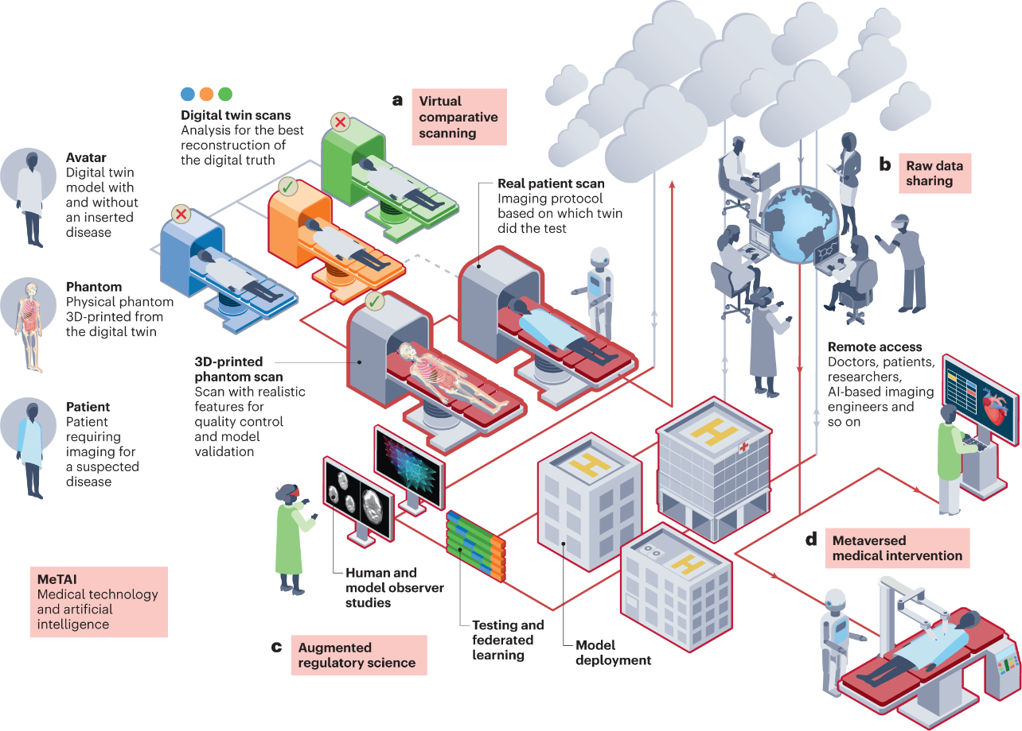
Fig 2 A Metaverse of ‘medical technology and AI’ (MeTAI) Healthcare Applications
Source: (Wang et al., 2022)

4. CHALLENGES
The healthcare industry has been slow in accepting, promoting, and implementing emerging information technology. Every time a new technology is introduced, the technology's impact on patients will be assessed carefully. The challenges may involve multiple aspects, such as technology (interoperability, portability, and stakeholder customization), human factors (skills, resistance, distrust, and cyber-attacks), legislation, and regulation.
In the future, the problems and challenges facing the Health Metaverse include:
4.1 Existing online platforms require additional upgrades
The global COVID-19 pandemic has fundamentally fuelled the development of digital and mobile health, but the authority and effectiveness of these platforms are still worth exploring. Doctors and medical institutions are now participating in the Metaverse but not everyone should be able to create their own diagnostic and treatment standards, as regular users may lack the clinical knowledge of the Metaverse. Existing online platforms are not yet able to integrate medical knowledge into the decision-making processes of platform users.

4.2 Gamification and entertainment of health services
The gamification of reputable healthcare services sometimes creates a medical ethics crisis. Its social consequences can be severe, even threatening the lives and health of patients. Many people still assume Metaverse is a platform for fast and engaging game-based learning, but this understanding is dangerous (Getchell, Oliver, Miller, & Allison, 2010). We can't just let gaming companies or social media companies create, define, and maintain the essential content of the Health Metaverse. For example, Roblox is a VR platform compatible with virtual worlds, casual games, and user-generated content, and is very similar to the Metaverse concept (Bhugaonkar et al., 2022). However, the entertainment features of the platform are not suited to Health Metaverse. It still needs to be reformed and monitored. The health Metaverse is based on user-generated content, which must be professional and credible to avoid misinformation. Similar to existing strategies for assessing the effectiveness of the online health community, we need to explore a post-diagnosis virtual three-dimensional assessment mechanism with physicians and patients in one-to-one or one-to-many interactions in the Metaverse.
4.3 Concerns about user privacy, security, and personalization.
Promising applications of the health Metaverse are essentially changing the way medical practice is done. When constructing the Metaverse, however, the protection of users' privacy as well as physical and psychological safety must be taken into account at an early stage. A Metaverse with tightly connected devices and people are bound to have significant security vulnerabilities, raising the question of what surveillance measures can provide adequate moral containment (Blobel, 2020; Kim et al., 2019). Health Metaverse's technology stack also demonstrates the risks and difficulties of maintaining a system that cannot be compromised by hackers. Such risks threaten the personalized nature of the doctor-patient relationship.
4.4 Censorship and regulation Issues.
Metaverse is now mainly promoted by some tech giants like Facebook, Microsoft, etc. When the Metaverse is complete, people will inevitably accept all kinds of censorship and fall prey to all kinds of commercial interests. Metaverse's business model design aligns more with platform owners, thereby undermining other competitors, which is often not conducive to platform sustainability (Zhou, Leenders & Cong, 2018). The Metaverse was originally conceived as a place where people deal with reality without experiencing it, trying to create a world that replaces the real world. Metaverse relies on its technology and tremendous user benefits to lead the global expansion of its Metaverse platform, raising concerns about data security, sovereignty, privacy, and ethics. These issues are particularly evident in the health Metaverse, which contains massive multimodal and sensitive health and medical data. As with eHealth communities, related technologies in the healthcare Metaverse will gradually evolve into a safe, reliable, and patient-centric environment to effectively meet patient needs. However, the social price to be paid in this process deserves to be considered in the future
5. DISCUSSION
The results indicate that the literature on the subject is limited to a few reviews, literature, and editorials. The research included is new and the Metaverse has been used for various purposes that will require further research in the near future. Despite these limitations, Metaverse can be used to prevent and treat clinical conditions; it is feasible in an education and training environment and researchers can use this tool to accelerate research and manage larger global studies. Deploying Metaverse using virtual reality and augmented reality in the healthcare sector has proven essential in improving the efficiency of the medical community in terms of patient services, medical education, and distance learning.
6. CONCLUSION AND FUTURE DIRECTIONS
The healthcare industry is a highly regulated system that provides comprehensive care to its patients. Some of the challenges in aligning healthcare with the Metaverse are maintaining a sense of privacy and trust, interoperability of cloud data information systems, and the lack of scalable technology for sustainable environmental medicine. However, the prospects for this area look very promising. Advancements in the Metaverse will open up new possibilities in healthcare, introducing innovations and improvements in this area. The quality of care could be greatly improved if the Metaverse were successfully integrated into healthcare and education.
REFERENCES
Aghdam, Z. N., Rahmani, A. M., & Hosseinzadeh, M. (2021). The Role of the Internet of Things in Healthcare: Future Trends and Challenges. Computer Methods and Programs in Biomedicine, 199, 105903. https://doi.org/10.1016/j.cmpb.2020.105903
Ali, S., Abdullah, Armand, T. P. T., Athar, A., Hussain, A., Ali, M., Yaseen, M., Joo, M. Il, & Kim, H. C. (2023). Metaverse in Healthcare Integrated with Explainable AI and Blockchain: Enabling Immersiveness, Ensuring Trust, and Providing Patient Data Security. Sensors, 23(2), 1–17. https://doi.org/10.3390/s23020565
Bamakan, S. M. H., Nezhadsistani, N., Bodaghi, O., & Qu, Q. (2022). Patents and intellectual property assets as non-fungible tokens; key technologies and challenges. Scientific Reports, 12(1), 1–13. https://doi.org/10.1038/s41598-022-05920-6
Bhugaonkar, K., Bhugaonkar, R., & Masne, N. (2022). The Trend of Metaverse and Augmented & Virtual Reality Extending to the Healthcare System. Cureus, 14(9). https://doi.org/10.7759/cureus.29071
Blobel, B. (2020, September). Application of industry 4.0 concept to health care. In pHealth 2020: Proceedings of the 17th International Conference on Wearable Micro and Nano Technologies for Personalized Health (Vol. 273, p. 23). IOS Press.
Chen, D., & Zhang, R. (2022). Exploring Research Trends of Emerging Technologies in Health Metaverse: A Bibliometric Analysis. SSRN Electronic Journal. https://doi.org/10.2139/ssrn.3998068
Chengoden, R., Victor, N., Huynh-the, T., Yenduri, G., Hjhaveri, R., Member, S., Alazab, M., Bhattacharya, S., Hegde, P., Kumar Reddy Maddikunta, P., Maddikunta, reddy, & Reddy Gadekallu, T. (2016). Metaverse for Healthcare: A Survey on Potential Applications, Challenges and Future Directions. IEEE Access, 4(November 2022), 1–28.
Curtis, C., & Brolan, C. E. (2023). Health care in the metaverse. Medical Journal of Australia, 218(1), 46. https://doi.org/10.5694/mja2.51793
Mejia, J. M. R., & Rawat, D. B. (2022). Recent Advances in a Medical Domain Metaverse: Status, Challenges, and Perspective. International Conference on Ubiquitous and Future Networks, ICUFN, 2022-July, 357–362. https://doi.org/10.1109/ICUFN55119.2022.9829645
Moyne, J., Qamsane, Y., Balta, E. C., Kovalenko, I., Faris, J., Barton, K., & Tilbury, D. M. (2020). A Requirements Driven Digital Twin Framework: Specification and Opportunities. IEEE Access, 8, 107781–107801. https://doi.org/10.1109/ACCESS.2020.3000437
Thomason, J. (2021). Journal of Metaverse MetaHealth-How will the Metaverse Change Health Care? Journal of Metaverse, 1(1), 13–16. https://www.influencive.com/flickplays-3d-social-media-platform-
Wang, G., Badal, A., Jia, X., Maltz, J. S., Mueller, K., Myers, K. J., Niu, C., Vannier, M., Yan, P., Yu, Z., & Zeng, R. (2022). Development of metaverse for intelligent healthcare. Nature Machine Intelligence, 4(11), 922–929. https://doi.org/10.1038/s42256-022-00549-6
Wiederhold, B. K., & Riva, G. (2022). Me t a v e r s e C r e a t e s. June.
Yaqoob, I., Salah, K., Jayaraman, R., & Al-Hammadi, Y. (2022). Blockchain for healthcare data management: opportunities, challenges, and future recommendations. Neural Computing and Applications, 34(14), 11475–11490. https://doi.org/10.1007/S00521-020-05519-W/METRICS

