Covid-19 Detection Neural Networks

Prof.PRIYANKA M R Prof Veena Dhavalgi
Assistant Professor, Dept of ISE, Assistant Professor, Dept of ISE,
Sapthagiri College of Engg, Sapthagiri College of Engg,
Bengaluru-560057,Karnataka(India). Bengaluru-560057,Karnataka(India).
Email: priyankamr@sapthagiri.edu.in Email: veenadhavalgi@sapthagiri.edu.in

Abstract: The novel coronavirus 2019 (COVID- 2019), which first appeared in Wuhan city of China in December 2019, spread rapidly around the world and became a pandemic. It has caused a devastating effect on both daily lives, public health, and the global economy. It is critical to detect the positive cases as early as possible so as to prevent the further spread of this epidemic and to quickly treat affected patients. The need for auxiliary diagnostic tools has increased as there are no accurate automated toolkits available. Recent findings obtained using radiology imaging techniques suggest that such images contain salient information about the COVID-19 virus. Application of advanced artificial intelligence (AI) techniques coupled with radiological imaging can be helpful for the accurate detection of this disease, and can also be assistive to overcome the problem of a lack of specialized physicians in remote villages. In this study, a new model for automatic COVID-19 detection using raw chest X-ray images is presented. The proposed model is developed to provide accurate diagnostics for binary classification (COVID vs. No- Findings) and multi-class classification (COVID vs. No-Findings vs. Pneumonia). Our model produced a classification accuracy of 98.08% for binary classes and 87.02% for multiclass cases. The DarkNet model was used in our study as a classifier for the you only look once (YOLO) real time object detection system. We implemented 17 convolutional layers and introduced different filtering on each layer. Our model (available at can be employed to assist radiologists in validating their initial screening, and can also be employed via cloud to immediately screen patients.

Introduction
COVID-19 pandemic is the most widely pandemic in the 21st century and is caused by the SARS-COV2 virus. The COVID-19 spreads between people mainly through direct contact or air droplet. Currently, there are 179 million infected people with more than 3 million deaths worldwide. The number continuously increases. The most common symptoms of COVID-19 are fever, weakness, cough and diarrhea. More than half of patient report shortness of breathes with few developing acute respiratory distress syndrome. The disease is estimated has the mortality rate around 3.4%, however, the number could vary among countries or areas. The COVID-19 pandemic is not only a health crisis but also affecting societies and economies at their core. The pandemic has major impact in many aspects of human life such as in education, tourism, energy (especially oil and gas), transportation, manufacture, healthcare, politics as well as economics. Many efforts have been made to deal with the pandemic such as reducing the spread of the diseases, improving the disease detection methods, as well as accelerate the availability of COVID-19 vaccine. There is increased demand for testing, diagnosis, and treatment due to the massive cases of COVID-19. The definitive test for COVID-19 diagnosis is reverse transcription polymerase chain reaction (RT-PCR). Using the technique, the test samples need to be processed in the lab. With a very large number of samples, and each sample waits its turn to be processed; it may take several days to obtain the result. Due to the low RT-PCR sensitivity of 60%–70%, even if negative results are obtained, symptoms can be detected by examining radiological images of patients. It is stated that CT is a sensitive method to detect COVID-19 pneumonia, and can be considered as a screening tool with RT-PRC. CT

findings are observed over a long interval after the onset of symptoms, and patients usually have a normal CT in the first 0–2 days. In a study on lung CT of patients who survived COVID-19 pneumonia, the most significant lung disease is observed ten days after the onset of symptoms. An alternative test for the diagnosis of COVID-19 is using chest X-ray radiography. It is a fast, effective, and affordable test that identifies the possible COVID-19-related pneumonia stated that there are differences of X-ray and CT scan result before and after experiencing COVID-19 symptoms. These reveal that the results of CT scans and X-rays can be used to determine whether a person infected by SARS-COV2 virus or not. In response to the pandemic outbreak, many researchers from various backgrounds actively participate in finding effective diagnostic mechanism and vaccination for its treatment. The researchers’ domain not only limited to the medical and biotechnology fields but also involves researcher from other fields such as data science, machine learning and deep learning. An example of deep learning approach to detect COVID-19 is based on the X-ray or CT scan images. The use of X-ray images is based on the fact that once the corona virus enters the respiratory tract; it will affect the lungs of the person and causing pneumonia. In this case, the lungs become filled with fluid, get inflamed and develop patches called "Ground-Glass Opacity" (GGO). Therefore, it is possible to detect COVID-19 based on the chest X-ray of infected people. X-ray machine is well known for scanning various human organs. Commonly, the interpretation of X-ray images is performed by expert radiologists. The advanced development of deep learning, especially Convolutional Neural Network (CNN), enable the interpretation of X- ray images conducted automatically by system. A good system is a system that can be relied on and has high accuracy to minimize misdiagnosis. It is also important to consider common disorders so that they do not lead to misdiagnoses.

Related Works:
In reference 1, The proposed model is based on 14 layers of convolutional neural network with a modified spatial pyramid pooling module. The multiscale ability of the proposed network allows it to identify the COVID- 19 disease for various severity levels. According to the performance results, the proposed SPP-COVID-Net achieves the best mean accuracy of 0.946 with the lowest standard deviation among the training folds accuracy. It comprises of just 862,331 total number of parameters, which uses less than 4 Megabytes memory storage. The model is suitable to be implemented for fast screening purposes so that better-targeted diagnoses can be performed to optimize the test time and cost.
In reference 2, the deep studying based totally methodology is usually recommended for the detection of COVID-19 infected patients using X-ray images. The help vector gadget classifies the corona affected X-ray images from others through usage of the deep features. The technique is useful for the clinical practitioners for early detection of COVID-19 infected patients. The suggested system of multi-level thresholding plus SVM presented high accuracy in classification of the infected lung. All images were of the same size and stored in JPEG format with 512 * 512 pixels. The average sensitivity, specificity, and accuracy of the lung classification using the proposed model results were 95.76%, 99.7%, and 97.48%, respectively.

In reference 3, DCNN based model Inception V3 with transfer learning have been proposed for the detection of coronavirus pneumonia infected patients using chest X-ray radiographs and gives a classification accuracy of more than 98% (training accuracy of 97% and validation accuracy of 93%). The results demonstrate that transfer learning proved to be effective, showed robust performance and easily deployable approach for COVID-19 detection.

In another attempt, the authors in [5] have worked on the same issue in a different way. The model here is trained using 120 X-ray images (60 COVID-19 and 60 normal) and 339 CT scan images (192 COVID- 19 and 147 normal) [5]. The dataset is divided into two categories: 50% to train the CNN and remaining 50% to validate the model 3 times in each epoch [5]. The testing of the model was done on a total of 67 images comprising both X-ray and CT scan images. The proposed model here consists of a CNN with one convolution layer which is followed by a Batch Norm layer followed by ReLU activation [5]. The fully connected layer is followed by a SoftMax layer which outputs ‘0’ or ‘1’. The concepts of transfer learning have also been implemented here and the pretrained model Alex Net has been used which has been trained on over a few million images on ImageNet and in the range of 1000 classes [5]. The last layer of the Alex Net has been replaced to obtain binary results [5]. The comparisons in the results show that the proposed CNN performs better than the Alex Net in case of CT scans with an accuracy of 94.1% as compared to 82% for the Alex Net

Methodology
The invention of the CNN in 1994 by Yann LeCun is what propelled the field of Artificial Intelligence and Deep learning to its former glory. The first neural network named LeNet5 had a very less validation accuracy of 42% since then we have come a long way in this field. Nowadays almost all giant technology firms

rely on CNN for more efficient performance. The data training in our CNN model has to satisfy following constraints:

- There should be no missing values in our dataset.

- The dataset must distinctly be divided into training and testing sets, either the training or the testing set shouldn’t contain any irrelevant data out of our model domain in case of an image dataset all the images must be of the same size, one uneven distribution of image size in our dataset can decrease the efficiency of our neural network.

- The images should be converted into black and white format before feeding it into the convolution layer because reading images in RGB would involve a 3-D NumPy matrix which will reduce the execution time of our model by a considerable amount.

- Any kind of corrupted or blurred images should also be trimmed from the database before feeding it into the neural network. Now we have learned the data pre- processing rules, let us dive right into the working of the convolutional neural network.
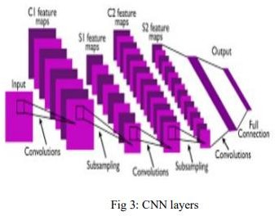

The Algorithms\Layer Used in our model are:

Convolution layer:

This layer involves scanning the whole image for patterns and formulating it in the form of a 3x3 matrix. This convolved feature matrix of the image is known as Kernel. Each value in the kernel is known as weight vector

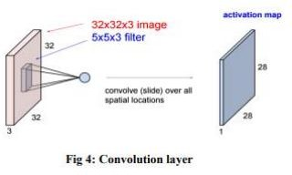

Pooling layer:
After the convolution comes to the pooling here the image matrix is broken down into the sets of 4 rectangular segments which are non-overlapping. There are two types of pooling, Max pooling and average pooling. Max pooling gives the maximum value in the relative matrix region which is taken. Average pooling gives the average value in the relative matrix region. The main advantage of the pooling layer is that it increases computer performance and decreases over-fitting chances.

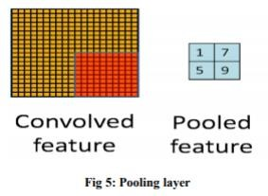

Activation layer:
It the part of the Convolutional Neural Networks where the values are Normalized that is, they are fitted in a certain range. The used convolutional function is ReLU which allows only the positive values and then rejects the negative values. It is the function of low computational cost.

Fully connected layer:
Here the features are compared with the features of the test image and associate similar features with the specified label. Generally, labels are encoded in the form of numbers for the computational ease, they will be later converted into their respective strings.

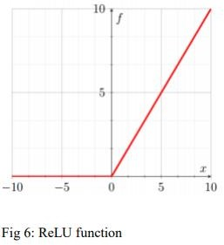

Proposed Model
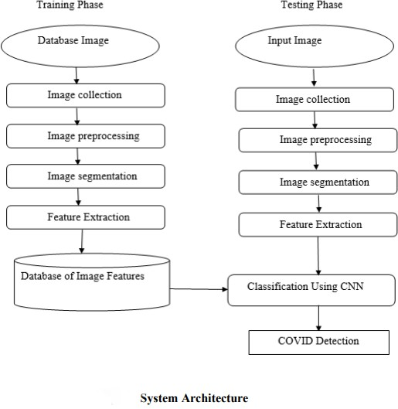
The system design mainly consists of:
- Image Collection
- Image Pre-processing
- Image Segmentation
- Feature Extraction
- Training
- Classification

Image Collection:
Input to proposed system is Classification of X-Ray Scan images, CT images are images taken . It is kind of magnifier used to take pictures of CT Images.

Image Pre-processing:
Goal of pre-processing is an improvement of image data that reduces unwanted distortions and enhances some image features important for further image processing. Image pre-processing involves three main things
a) Gray scale conversion b) Noise removal c) Image enhancement.

Grayscale conversion
Grayscale image contains only brightness information. Each pixel value in grayscale image corresponds to an amount or quantity of light. The brightness graduation can be differentiated in grayscale image. Grayscale image measures only light intensity 8 bit image will have brightness variation from 0 to 255 where ‘0’ represents black and ‘255’ represents white. In grayscale conversion colour image is converted into grayscale image. Grayscale images are more easy and more faster to process than coloured images. All image processing technique are applied on grayscale image. In our proposed system X Ray image is converted into grayscale image.

Noise Removal:
The objective of noise removal is to detect and remove unwanted noise from digital image. The difficulty is in deciding which features of an image are real and which are caused by noise. Noise is random variations in pixel values. In our proposed system we are using median filter to remove unwanted noise. Median filter is nonlinear filter, it leaves edges invariant. Median filter is implemented by sliding window of odd length. Each sample value is sorted by magnitude, the centre most value is median of sample within the window, is a filter output.

Image Enhancement:
The objective of image enhancement is to process an image to increase visibility of feature of interest. Here contrast enhancement is used to get better quality result.

Image Segmentation:
The next step after image pre-processing was to segment the Lung area from the surrounding X-Ray Images. A black and white image was produced with its contrast adjusted to provide better segmentation.

Feature Extraction:
Feature extraction plays an important role in extracting information present in given image. Here we are using GLCM for texture image analysis. GLCM is used to capture spatial dependency between image pixels. GLCM works on Gray level image matrix to capture most common feature such as contrast, entropy, energy, homogeneity, correlation, ASM, cluster-shade. Contrast

∑𝑖 ∑𝑗 (𝑖 − 𝑗) 2 𝐶(𝑖,𝑗) Energy ∑𝑖 ∑𝑗𝐶 2 (𝑖,𝑗) Homogeneity
∑𝑖 ∑𝑗 𝐶(𝑖,𝑗) 1+|𝑖−𝑗| The purpose of feature extraction (glcm) is to suppressed the original image data set by measuring certain values or features that helps to classify different images from one another.

Training:
Create training dataset from images of known Cancer types. Train classifiers on the created training dataset. Create testing dataset in temporary folder. Predict results from the test cases. Plot classifiers graphs. Add feature- sets to test case file, to make image Processing models accurately.

Classification:
The binary classifier which makes use of the hyper-plane which is also called as the decision boundary between two of the classes is called as Convolution Neural Network. Some of the problems are pattern recognition like texture classification make use of CNN. Mapping of non-linear input data to the linear data provides good classification in high dimensional space in CNN. The marginal distance is maximized between different classes by CNN. Different Kernels are used to divide the classes. SVM is basically binary classifier which determines hyper plane in dividing two classes. The boundary is

 | Precision | Recall | F1-  score | Support cases
Normal | 0.96 | 0.91 | 0.93 | 864
Other Pneumonia | 0.96 | 0.96 | 0.96 | 1554
COVID19 | 0.73 | 0.98 | 0.84 | 126
Accuracy | --- | --- | 0.95 | 2544
Macro avg | 0.88 | 0.95 | 0.91 | 2544
Weighted avg | 0.95 | 0.94 | 0.94 | 2544

To further evaluate the performance of our model in detecting the COVID19 infected cases using chest X-ray images, we place both normal and community-acquired pneumonia images into the negative class and COVID-

maximized between the hyper plane and two classes. The samples that are nearest to the margin will be selected in determining the hyper plane are called support vectors.

Experimental Results
First, based on three confusion matrices, the overall 3- class classification accuracy levels are 93.9 % (796/848), 94.7 % (803/848), and 94.9 % (805/848), respectively. The difference is approximately 1%. Then, based on the confusion matrix of the combined data, we compute the precision, recall rate, F1-score, and prediction accuracy of the new transfer learning VGG16 based CNN model, as shown in Table 3 . Among 2544 testing cases, 2404 are correctly detected and classified into 3 classes. The overall accuracy is 94.5 % (2404/2544) with 95 % confidence interval of [0.93, 0.96]. In addition, the computed Cohen’s kappa coefficient is 0.89, which confirms the reliability of the proposed approach to train this new deep transfer learning model to do this classification task.

Table 3
Classification report of the proposed method.
19 infected pneumonia cases into the positive class. Combining the data in the confusion matrix, as shown in, the model yields 98.4 % detection sensitivity (124/126) and 98.0 % specificity (2371/2418). The overall accuracy is 98.1 % (2495/2544).
Next, Table 4 shows and compares confusion matrixes generated by four models trained and tested using different input images and three data subsets generated from the data partition, as well as overall classification accuracy and 95 % confidence intervals. The results indicate that without using the data augmentation technique, the model accuracy on data of the testing subset drops to 82.3 % with the kappa score of 0.71. Without applying image pre-processing and directly feeding the original chest X-ray images into the VGG16 based CNN model (“simple model”), classification accuracy is 88.0 % with a Cohen’s kappa score of 0.75. Using image filtering and pseudo colour images without removing the majority part of diaphragm regions, the “filter-based model” yields 91.2 % accuracy and a Cohen’s kappa score of 0.83. All three models yield lower classification accuracy than the proposed model involving data augmentation technique and two steps of image pre-processing.

Table 4
Confusion matrix of four CNN models on X-ray Images. 95 % confidence interval (CI) for the accuracy is shown in the last column.

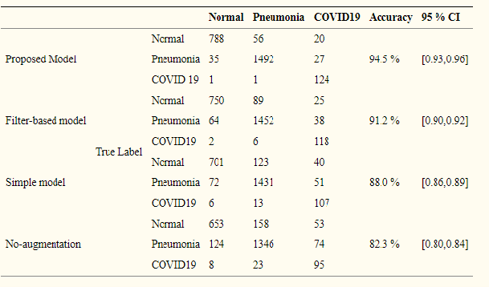
Study results demonstrate that this transfer learning approach can yield higher performance with the overall accuracy of 94.5 % (2404/2544) in the classification of 3 classes and 98.1 % (2495/2544) in classifying cases with and without COVID-19 infection, as well as the high robustness with a Cohen’s kappa score of 0.89.

CONCLUSION
In this study, we proposed and investigated several new approaches to develop a transfer deep learning CNN model to detect and classify COVID-19 cases using chest X-ray images. Study results demonstrate the added value of performing image preprocessing to generate better input image data to build deep learning models.
We are almost certain that it is possible for the proposed CNN model shows the equivalent of the highest score for the accuracy of a specialized chest radiologist, represents a very effective examination tool for the rapid diagnosis of many infectious diseases such as the Covid-19 epidemic that do not require the introduction of a radiologist or physical examinations. The aim of this work is to evaluate the ability of the proposed CNN algorithm to discriminate between healthy and covid. It can be concluded that the system gave very encouraging results. the used texture and color features enhanced the performance of our system and gave high recognition accuracy. This accuracy proves that the texture features are very useful as recognition features for diagnosis of covid.
The system can be also used for detecting Pneumonia diseases by choosing the proper training sets.
In future studies, we recommend addressing other topics such as outbreak escalates, as well as trying to explore different approaches to Convolutional Neural Networks, including deep learning models and improved interpretation of CNN models.
REFERENCES

[1]. A Lightweight Deep Learning Model for COVID- 19 Detection, Siti Raihanah Abdani ; Mohd Asyraf Zulkifley ; Nuraisyah Hani Zulkifley

[2]. Automatic X-ray COVID-19 Lung Image Classification System based on Multi- Level Thresholding and Support Vector Machine, Aboul Ella Hassanien, Hassan Aboul-Ella.

[3]. Classification of COVID-19 from Chest X-ray images using Deep Convolutional Neural Networks,
Sohaib Asif, Yi Wenhui*, Hou Jin, Yi Tao, Si Jinhai

[4]. A Deep Neural Network to Distinguish COVID-19 from other Chest Diseases Using X-ray Images,
Saleh Albahli

[5]. Halgurd S. Maghdid, Aras T. Asaad, Kayhan Zrar Ghafoor, Ali Safaa Sadiq, Muhammad Khurram Khan, “Diagnosing COVID-19 Pneumonia from X- ray and CT images using deep learning and transfer learning algorithms, ” arXiv:2004.00038.

[6]. Kong W., Agarwal P.P. Chest imaging appearance of COVID-19 infection. Radiology: Cardiothoracic Imaging. 2020;2(1)

[7]. Singhal T. A review of coronavirus disease-2019 (COVID-19) Indian J. Pediatr. 2020;87:281–286.

[8]. Zu Z.Y., Jiang M.D., Xu P.P., Chen W., Ni Q.Q., Lu
G.M., Zhang L.J. Coronavirus disease 2019 (COVID-19): a perspective from China. Radiology. 2020 doi: 10.1148/radiol.2020200490.

[9]. Kanne J.P., Little B.P., Chung J.H., Elicker B.M., Ketai L.H. Essentials for radiologists on COVID- 19: an update—radiology scientific expert panel. Radiology. 2020 doi: 10.1148/radiol.2020200527.

