Dynamics of Interaction of One Prey and Two Competing Predators with Population Heterogeneity

Dr.Raveendra Babu* and Imtiyaz Ahmad Wani**
* Prestige Institute of Management and Research, Gwalior 474020, India
** School Mathematics and Allied Sciences, Jiwaji University, Gwalior 474011, India
raveendra96@rediffmail.com

Abstract: A mathematical model of two predators competing for a single prey system incorporating population heterogeneity has been proposed and analyzed by extending the system of coupled logistic equations for three species system. The local stability analysis of all the equilibria has been carried out. It is observed that equilibrium points are globally stable in Varies 2-D planes. Through analytical results, it is observed that the interior equilibrium of one prey and two competing predators in prey dependent case is always unstable. At the end, discussed the dynamical behavior of a three species interaction with the help of some numerical examples by using MATLAB to support the analytical presentations.

Keywords: Three species, Equilibria, Jacobian matrix.

1.1 Introduction:
In ecological-mathematical modelling, extremely the most imperative branch is of predator-prey type models. Among the important themes for mathematical and ecological modelling, the key theme is the relationship between prey and predator and it will remain continue to be a principal theme due to its universal existence and importance [41]. Interactions between predators and prey are often sophisticated behavioral games in which the decisions of each player are influenced by the decisions of the other. Both players play to maximize their own physical fitness or survival [1].
Lotka-Volterra model is the initial predator prey system. Since then a number of improvements have been suggested to the primary model, including adding the predator saturation term, a prey which is self-competition term, a predator competition term and by taking distinct functional types etc.. [2]. These two species predator-prey models are the simplest form of mathematical models where there is interaction between a single prey and predator. While there is a principle in the ecosystem that models can be extended to multiple prey predator species systems [3].
A lot of research work has been done in the past in which authors studied extensively the extinction and co-existence of interacting species. The exploitation of a single resource by multiple competitors has received much attention and many authors have attempted to describe these situations mathematically [4-10]. Particularly, Hsu [6] initiated and examined a model containing a prey and two competing predators. The author has been observed in analysis that interference will affect the prey predator system. The authors Freedman and waltman [4] have considered food webs and studied in three levels, which are comprising of a single prey and two competing predators, and also two competing prey species affected by single predator. Cushing [11] has considered one prey population and two predator population system and initiated with a way that two predators which are competing feeding on one prey the resource of renewable and system is in the time of periodic. Dubey and Dass [12] investigated a Gauss- type mathematical model in which two predator populations competing with interference for a finite prey species. Dubey and Upadhyay [13] have also described a model in which one prey and two predator system considering ratio predator dependent rate growth.
Reddy and Ramacharyulu [14] carried out the stability analysis of the system by considering two predator populations which are competing for one prey.
In the comparison of considering the influence of different type of conditions for predator-prey system a little research work has been done for the systems in which the population heterogeneity is being considered. Models incorporating heterogeneity are frequently used to describe the movement of population among patches. The interacting population is obviously very interesting thing to consider for the dynamics of the ecological system is influencing by the migration or dispersal of prey and predator [3].
Considering the above things, mainly in this chapter, an interacting prey predator model which is comprising of two predators and a single renewable resource prey in patchy habitat is proposed and analysed by extending the Kuno’s competitive equations for the three species ecosystem. Our projected mathematical system is carefully defined and the predators of the model in the condition by competition for exploiting the prey species. It’s noted that the outcomes of the system consisting of two predator populations and one prey population which is dependent function is closely known [6,12, 13]. In this particular chapter mainly to study the changes or dynamics of the qualitative ways of the system by incorporating the population heterogeneity.
1.2 Background:
Competition is an interaction of ecological systems which happens when two or more prey predator species depend on the same limited resource. Direct competition is exceptionally rare in nature; when two species compete, mostly one will dislocate the other, or they will adapt to utilize different resources and consequently avoid competition$[15]$. Another ecological process related to competition is crowding, that is the habitat are densely populated than the normal. Therefore, the crowding effect is equivalent to the spatial heterogeneity or population heterogeneity, which emerges due to the number of processes inclusive of genetics, dispersal and resource availability$[16, 17]$. This process is exhibited to the effect of competitive procedure like an exclusion of various interacting prey predator species and coexistence$[18]$. Intra-specific means the crowding effect denoted by $m^{*}$ as defined by Lloyd, which means that the average count of other animals per species of their own habitat per patch$[19]$, and which is expressed as given below:
$$m^{*}=\frac{\sum_{q=1}^{n}{{N_{q}}^{2}}}{\sum_{q=1}^{n}{N_{q}}}-1 (1)$$
$${or m}^{*}+1=\frac{\sum_{q=1}^{n}{{N_{q}}^{2}}}{\sum_{q=1}^{n}{N_{q}}} (2)$$
where $N_{q}$ denotes the count of animals at $q^{th}$ patch of species$[19, 20]$.
A patch is any discrete part of a population formed on either width or area. Patches explained on the basis of an area are just the sections across the geographical lines of a population’s habitat whereas the patches explained on the foundation of area are simply the number of individuals forming ecologically a meaningful unit. Patches based on size are ecologically more meaningful than the patches based on area as the area based patch in an animal zone containing no animal in it has ecologically no meaning. Under this approach, a patch may be defined as a small group of animals which do not interact with the animals of other groups except the animals of their own group in an ecologically meaningful way$[21]$.
Iwao derived a simple linear model to express the connection between the average crowding $(m^{*})$ and the average density of individuals $(m)$ per patch of habitat $[19, 22]$as
$$m^{*}=a+bm (3)$$
Although equation $\left(3\right)$ is represents a linear regression likewise it could be regarded while the linear functional connection$[23]$. A distinctive property of Iwao’s model is, when population is allocated according to the Poisson, uniform or negative binomial distribution its parameters $a$ (intercept) and $b$ (slope) have been shown to acquire particular values $\left(see Table1\right)$ $[18, 22].$
Table 1:
The values of $a$ & $b$ for the population of different spatial distributions$[18, 22].$
Distribution $a$ $b$
Uniform distribution $-1$ $1$
Poisson (Random) distribution $0$ $1$
Negative binomial distribution $0$ $>1$
Contagious distribution $>0$ $>1$
Regular (underdispersed) distribution $-1$ $0-1$
Besides intra-specific mean crowding Lloyd also explained an inter-specific mean crowding denoted by $m_{ij}^{*}$ means the average count of animals of habitat $i$ per animal of other animals $j [19, 24]$and is calculated by the formulae
$$m_{ji}^{*}=\frac{\sum_{q=1}^{n}{N_{jq}N_{iq}}}{\sum_{q=1}^{n}{N_{jq}}} (4)$$
where $N_{iq}$ and $N_{jq}$ are the number of animals of the $i^{th}$ and $j^{th}$ species in the $q^{th}$ patch of habitat. This index is required whenever we have a need to extend the model dealing with the interaction of single species to multiple species.
The logistic equation is mostly used for the betterment of an exponentially expressing growth the species$[25-27]$. However, it is also well recognized that the growth of logistic equation acts impractical in different circumstances. The expression of growth of logistic equation of population $N$ individuals usually appears in the form
$$\dot{N}=rN\left(1-\frac{N}{K}\right) (5)$$
here $\dot{N}$ represents the first derivative of species number or area with the time, $r$ represents the intrinsic growth or generative rate of the given population and K represents the environment carrying capacity$[18,28,29]$. Carrying capacity is referred as the maximum size of population that the environment can support$[27]$. In many situations this form of the above logistic expression yields biologically absurd outcomes. The most remarkable limitation of $(5)$ is that even if the generative rate is fatalistic, that means which occurs in the situation when the early value is more than $K$ (Levin’s paradox) the population still increases indefinitely$[28-30]$. Another model of the constraints of expression $(5)$ is presumes that the particulars will be uniformly distributed in the given environment$[18]$. The possibility will overcome at first limitation, Levin’s paradox, for utilize the Verhulst’s logistic expression$[28,29]$,
$$\dot{N}=rN-hN^{2} (6)$$where $h$ denotes the positive constant which is expressing the intrinsic limitations of population or species growth $[28]$. Kuno$\left(1991a\right)\left[31\right]$used logistic equation which is the foundation of mathematical design to solve the absurd presumption of the species which are distributed homogeneously.
To extend the logistic model given in equation$(6)$ for simulating the competing result of one species upon another, Water’s et al., in$2015$used the structure of coupled logistic which are in growth expressions. The given system explains the population or species growth for competing species:
$$\begin{aligned}{\dot{N}}_{1}=r_{1}N_{1}-h_{1}N_{1}\left(N_{1}+α_{12}N_{2}\right) \\ \\ {\dot{N}}_{2}=r_{2}N_{2}-h_{2}N_{2}(N_{2}+α_{21}N_{1})\end{aligned} (7)$$
where $N_{1}$ and $N_{2}$ are two respective species and parameters $α_{ij}$ represents the competitive effect of the $j^{th}$ species on the $i^{th} [21]$.
Water’s et al. $\left(2015\right)$then derived the predator-prey case for the model $(7)$ by reversing the sign of $α_{21}$ as
$$\begin{aligned}{\dot{N}}_{1}=r_{1}N_{1}-h_{1}N_{1}\left(N_{1}+α_{12}N_{2}\right) \\ \\ {\dot{N}}_{2}=r_{2}N_{2}-h_{2}N_{2}(N_{2}-α_{21}N_{1})\end{aligned} (8)$$
Where, $N_{1}$ and $N_{2}$ represents the species or population density of prey and predators respectively $[21]$.
1.3 Extension to three dimensions:
To generalize the model $(7)$ to three dimensions it is necessary to model the competitive interactions of particular species by adding the term$α_{ij}$, that shows the effect of $j^{th}$ populations on the intrinsic reproductive rate of the $i^{th}$ species. Thus the resulting model describes the growth of population for three competing population is
$$\begin{aligned}{\dot{N}}_{1}=r_{1}N_{1}-h_{1}N_{1}\left(N_{1}+α_{12}N_{2}+α_{13}N_{3}\right) \\ \\ {\dot{N}}_{2}=r_{2}N_{2}-h_{2}N_{2}\left(N_{2}+α_{21}N_{2}+α_{23}N_{3}\right) \\ \\ {\dot{N}}_{3}=r_{3}N_{3}-h_{3}N_{3}\left(N_{3}+α_{31}N_{1}+α_{32}N_{2}\right).\end{aligned} (9)$$
Now we obtain a predator-prey example of $(9)$ by considering population heterogeneity in the tri trophic ecosystem consisting of both predators competing for the single prey to investigate whether it will facilitate the existence of stable equilibrium in this case or not.

1.4 Extension of predator-prey example:
To describe prey - predator system (9), $N_{1}$ represents the amount of prey common to two predators $N_{2}$ and $N_{3}$ which are competing with each other and by reversing the sign’s of $α_{21}$ and $α_{31}$ so that $\begin{aligned}\begin{aligned}{\dot{N}}_{1}=r_{1}N_{1}-h_{1}N_{1}\left(N_{1}+α_{12}N_{2}+α_{13}N_{3}\right) \\ \\ {\dot{N}}_{2}=r_{2}N_{2}-h_{2}N_{2}\left(N_{2}-α_{21}N_{2}+α_{23}N_{3}\right) \\ \\ {\dot{N}}_{3}=r_{3}N_{3}-h_{3}N_{3}\left(N_{3}-α_{31}N_{1}+α_{32}N_{2}\right).\end{aligned} \\ \end{aligned} (10)$
If the predators are taken as a function of prey only, subscripts of $r$ & $h$ will be needless because these parameters apply to prey only. Therefore by removing the $r$ and $h$ for predators & rewriting the logistic growth only to prey species, but keeping predator species to increase entirely like an expression of prey species yields
${\dot{N}}_{1}=r N_{1}-h N_{1}( N_{1}+α_{12}N_{2} +α_{13}N_{3})$
${\dot{N}}_{2}=α_{21} N_{1}N_{2} -α_{23}N_{2} N_{3}$ (11)
${\dot{N}}_{3}=α_{31} N_{1}N_{3}-α_{32}N_{2} N_{3}.$
If we consider the death rates for the predators $N_{2}$ and $N_{3}$ as $υ$ and $μ$ respectively then the resulting equations become
${\dot{N}}_{1}=r N_{1}-h N_{1}( N_{1}+α_{12}N_{2} +α_{13}N_{3})$
${\dot{N}}_{2}=α_{21} N_{1}N_{2} -α_{23}N_{2} N_{3}-υN_{2}$ (12)
${\dot{N}}_{3}=α_{31} N_{1}N_{3}-α_{32}N_{2} N_{3}-μN_{3}.$
In (12) assumed that prey & predators both are homogeneously distributed. So the predator prey system given in $(12)$ could be extended to a patchy species like
${\dot{N}}_{1}=\sum_{q=1}^{n}{\left(r{N_{1}}_{q}-h{N_{1}}_{q}\left({N_{1}}_{q}+α_{12}{N_{2}}_{q}+α_{13}{N_{3}}_{q}\right)\right) }$
${\dot{N}}_{2}=\sum_{q=1}^{n}{\left(α_{21}{N_{1}}_{q}{N_{2}}_{q}-α_{23}{N_{2}}_{q}{N_{3}}_{q}-υ{N_{2}}_{q}\right)}$
${\dot{N}}_{3}=\sum_{q=1}^{n}{(α_{31}{N_{1}}_{q}{N_{3}}_{q}-α_{32}{N_{2}}_{q}{N_{3}}_{q}-μ{N_{3}}_{q})}. (13)$
where ${N_{1}}_{q} ,{N_{2}}_{q} and {N_{3}}_{q}$ are the density of prey & two species of predators at $q^{th}$ of n patches. While dividing equation $(13)$ by $\sum_{q=1}^{n}{{N_{1}}_{q}} ,\sum_{q=1}^{n}{{N_{2}}_{q}} and \sum_{q=1}^{n}{{N_{3}}_{q}}$ yields
$\frac{1}{\sum_{q=1}^{n}{{N_{1}}_{q}} \sum_{q=1}^{n}{{N_{2}}_{q}}}\frac{{\dot{N}}_{1}}{\sum_{q=1}^{n}{{N_{3}}_{q}}}=\frac{r}{\sum_{q=1}^{n}{{N_{2}}_{q}} \sum_{q=1}^{n}{{N_{3}}_{q}}}-$ $\frac{1}{\sum_{q=1}^{n}{{N_{2}}_{q}} \sum_{q=1}^{n}{{N_{3}}_{q}}}\frac{h\sum_{q=1}^{n}{{N_{1}}_{q}^{2}}}{\sum_{q=1}^{n}{{N_{1}}_{q}}}-$
$\frac{1}{\sum_{q=1}^{n}{{N_{2}}_{q}} \sum_{q=1}^{n}{{N_{3}}_{q}}}\frac{hα_{12}\sum_{q=1}^{n}{{N_{1}}_{q}{N_{2}}_{q}}}{\sum_{q=1}^{n}{{N_{1}}_{q}}}-\frac{1}{\sum_{q=1}^{n}{{N_{2}}_{q}} \sum_{q=1}^{n}{{N_{3}}_{q}}}\frac{hα_{13\sum_{q=1}^{n}{{N_{1}}_{q}{N_{3}}_{q}}}}{\sum_{q=1}^{n}{{N_{1}}_{q}}}$
$\frac{1}{\sum_{q=1}^{n}{{N_{1}}_{q}} \sum_{q=1}^{n}{{N_{2}}_{q}}}\frac{{\dot{N}}_{2}}{\sum_{q=1}^{n}{{N_{3}}_{q}}}=\frac{1}{\sum_{q=1}^{n}{{N_{1}}_{q}\sum_{q=1}^{n}{{N_{3}}_{q}}}}\frac{α_{21}\sum_{q=1}^{n}{{N_{1}}_{q}{N_{2}}_{q}}}{\sum_{q=1}^{n}{{N_{2}}_{q}}}$ $-\frac{1}{\sum_{q=1}^{n}{{N_{1}}_{q}\sum_{q=1}^{n}{{N_{3}}_{q}}}}\frac{α_{23}\sum_{q=1}^{n}{{N_{2}}_{q}{N_{3}}_{q}}}{\sum_{q=1}^{n}{{N_{2}}_{q}}}-\frac{υ}{\sum_{q=1}^{n}{{N_{1}}_{q}\sum_{q=1}^{n}{{N_{3}}_{q}}}}$
$\frac{1}{\sum_{q=1}^{n}{{N_{1}}_{q}} \sum_{q=1}^{n}{{N_{2}}_{q}}}\frac{{\dot{N}}_{3}}{\sum_{q=1}^{n}{{N_{3}}_{q}}}=\frac{1}{\sum_{q=1}^{n}{{N_{1}}_{q}\sum_{q=1}^{n}{{N_{2}}_{q}}}}\frac{α_{31}\sum_{q=1}^{n}{{N_{1}}_{q}{N_{3}}_{q}}}{\sum_{q=1}^{n}{{N_{3}}_{q}}}$
$-\frac{1}{\sum_{q=1}^{n}{{N_{1}}_{q}\sum_{q=1}^{n}{{N_{2}}_{q}}}}\frac{α_{32}\sum_{q=1}^{n}{{N_{2}}_{q}{N_{3}}_{q}}}{\sum_{q=1}^{n}{{N_{3}}_{q}}}-\frac{μ}{\sum_{q=1}^{n}{{N_{1}}_{q}\sum_{q=1}^{n}{{N_{2}}_{q}}}} .$
(14)
In above equation $(14)$ ${\sum_{q=1}^{n}{N_{i_{q}}N_{j_{q}}}}/{\sum_{q=1}^{n}{N_{i_{q}}}}$ is the inter-certain mean packed of the $j^{th}$ species upon the $i^{th}$,$m_{ij}^{*}$, and ${ \sum_{q=1}^{n}{{N_{1}}_{q}^{2}}}/{\sum_{q=1}^{n}{{N_{1}}_{q}=m_{1}^{*}+1}}$, where $m_{1}^{*}$ represents the intra specific crowding effect for prey species, showing heterogeneity effect upon its rate of reproduction. By (14) of $m_{1}^{*}$ & $m_{ij}^{*}$, we get
$\frac{1}{\sum_{q=1}^{n}{{N_{1}}_{q}} \sum_{q=1}^{n}{{N_{2}}_{q}}}\frac{{\dot{N}}_{1}}{\sum_{q=1}^{n}{{N_{3}}_{q}}}= \frac{r}{\sum_{q=1}^{n}{{N_{2}}_{q}} \sum_{q=1}^{n}{{N_{3}}_{q}}}-\frac{h(m_{1}^{*}+1)}{\sum_{q=1}^{n}{{N_{2}}_{q}} \sum_{q=1}^{n}{{N_{3}}_{q}}}$ $- \frac{hα_{12}m_{12}^{*}}{\sum_{q=1}^{n}{{N_{2}}_{q}} \sum_{q=1}^{n}{{N_{3}}_{q}}}-\frac{hα_{13}m_{13}^{*}}{\sum_{q=1}^{n}{{N_{2}}_{q}} \sum_{q=1}^{n}{{N_{3}}_{q}}}$
S$\frac{1}{\sum_{q=1}^{n}{{N_{1}}_{q}} \sum_{q=1}^{n}{{N_{2}}_{q}}}\frac{{\dot{N}}_{2}}{\sum_{q=1}^{n}{{N_{3}}_{q}}}=\frac{α_{21}m_{21}^{*}}{\sum_{q=1}^{n}{{N_{1}}_{q}\sum_{q=1}^{n}{{N_{3}}_{q}}}}-\frac{α_{23}m_{23}^{*}}{\sum_{q=1}^{n}{{N_{1}}_{q}\sum_{q=1}^{n}{{N_{3}}_{q}}}}-\frac{υ}{\sum_{q=1}^{n}{{N_{1}}_{q}\sum_{q=1}^{n}{{N_{3}}_{q}}}}$ $\frac{1}{\sum_{q=1}^{n}{{N_{1}}_{q}} \sum_{q=1}^{n}{{N_{2}}_{q}}}\frac{{\dot{N}}_{3}}{\sum_{q=1}^{n}{{N_{3}}_{q}}} =\frac{α_{31}m_{31}^{*}}{\sum_{q=1}^{n}{{N_{1}}_{q}\sum_{q=1}^{n}{{N_{2}}_{q}}}}-\frac{α_{32}m_{32}^{*}}{\sum_{q=1}^{n}{{N_{1}}_{q}\sum_{q=1}^{n}{{N_{2}}_{q}}}}-\frac{µ}{\sum_{q=1}^{n}{{N_{1}}_{q}\sum_{q=1}^{n}{{N_{2}}_{q}}}}.$
(15)
Using the relationship $m_{1}^{*}+1=a+bm_{1}+1$ and by multiplying the above equation on both sides by $\sum_{q=1}^{n}{{N_{1}}_{q} ,} \sum_{q=1}^{n}{{N_{2}}_{q}}$ and $\sum_{q=1}^{n}{{N_{3}}_{q}}$ , we obtain
${\dot{N}}_{1}=r\sum_{q=1}^{n}{{N_{1}}_{q}}-h\left(a+bm_{1}+1\right)\sum_{q=1}^{n}{{N_{1}}_{q}}- hα_{12}m_{12}^{*}\sum_{q=1}^{n}{{N_{1}}_{q}}$
$-hα_{13}m_{13}^{*}\sum_{q=1}^{n}{{N_{1}}_{q}}$
${\dot{N}}_{2}=$ $α_{21}m_{21}^{*}\sum_{q=1}^{n}{{N_{2}}_{q}}-α_{23}m_{23}^{*}\sum_{q=1}^{n}{{N_{2}}_{q}}-υ\sum_{q=1}^{n}{{N_{2}}_{q}}$ (16)
${\dot{N}}_{3}=$ $α_{31}m_{31}^{*}\sum_{q=1}^{n}{{N_{3}}_{q}}-α_{32}m_{32}^{*}\sum_{q=1}^{n}{{N_{3}}_{q}}-µ\sum_{q=1}^{n}{{N_{3}}_{q}}$.
When $n=1 , m_{1}=N_{1 } and m_{ij}^{*}=N_{j },$we get
${\dot{N}}_{1}=rN_{1}-hN_{1}\left(a+bN_{1}+1\right)- hα_{12}N_{1}N_{2}- hα_{13}N_{1}N_{3}$
${\dot{N}}_{2}=α_{21}N_{1}N_{2}-α_{23}N_{2}N_{3}-υN_{2}$ (17)
${\dot{N}}_{3}=$ $α_{31}N_{1}N_{3}-α_{32}N_{2}N_{3}-μN_{3}$.
With the conditions of initial are:
$N_{1}\left(0\right)greater than 0, N_{2}\left(0\right)greater than 0 and N_{3}\left(0\right) greater than 0$.
1.5 Boundedness of the Model:
Lemma: The solutions (17) institute the $R_{+}^{3}$ are bounded.
Proof. Let $W=N_{1}+\frac{hα_{12}}{α_{21}}N_{2}+\frac{hα_{13}}{α_{31}}N_{3} (18)$
The time derivative along a solution (17) is
$$\dot{W}=N_{1}[r-h\left(a+bN_{1}+1\right)- hα_{12}N_{2}- hα_{13}N_{3}]$$
$+\frac{hα_{12}}{α_{21}}N_{2}[α_{21}N_{1}-α_{23}N_{3}-υ]$
$+\frac{hα_{13}}{α_{31}}N_{3}\left[α_{31}N_{1}-α_{32}N_{2}-μ\right].$
For $η>0,$
$$\dot{W}+ηW≤N_{1}[r+η-h\left(a+bN_{1}+1\right)]$$
$+\frac{hα_{12}}{α_{21}}N_{2}\left[η-ν-\frac{α_{13}α_{32}α_{21}}{α_{12}α_{31}}\right] (19)$
$+\frac{hα_{13}}{α_{31}}N_{3}\left[η-µ-\frac{α_{12}α_{23}α_{31}}{α_{13}α_{21}}\right].$

Now, if we choose:
$$η<min\left[ν+\frac{α_{13}α_{32}α_{21}}{α_{12}α_{31}}, µ+\frac{α_{12}α_{23}α_{31}}{α_{13}α_{21}}\right]$$
then the right side of equation (19) is bounded for all ($N_{1},$ $N_{2},$ $N_{3}$)$∈R_{+}^{3}$. Thus we define a $θ>0$ with $\dot{W}+ηW<θ$.
By applying the differential inequality theorem, we get:
$$0≤W\left(N_{1}, N_{2}, N_{3}\right)≤\frac{θ}{η}+\frac{W\left(N_{1}(0), N_{2}(0), N_{3}(0)\right)}{e^{ηt}} (20)$$
and for $t→∞:$
$$0≤W≤\frac{θ}{η} .$$
So we have:
$$B=\left[\left(N_{1}, N_{2}, N_{3}\right)∈{\overline{R}}_{+}^{3}: W≤θ/η+m for any m>0\right]$$
1.6 Equilibria Analysis:
It could be checked that the model has five positive equilibria, which are$E_{0}(0, 0, 0)$,$E_{1}\left({\tilde{N}}_{1},0,0\right), E_{2}\left({\overline{N}}_{1},{\overline{N}}_{2},0\right),$ $E_{3}({\overset{̿}{N}}_{1},0,{\overset{̿}{N}}_{3})$
$and E_{4}\left( N_{1}^{*}, N_{2}^{*}, N_{3}^{*}\right)$given by ${\dot{N}}_{i}=0, i=1 , 2 , 3$. The point ${ E}_{0}\left(0, 0, 0\right)$ clearly exists. Now will discuss $E_{1}\left({\tilde{N}}_{1}, 0, 0\right),$ $E_{2}\left({\overline{N}}_{1},{\overline{N}}_{2} , 0\right),E_{3}\left({\overset{̿}{N}}_{1}, 0, {\overset{̿}{N}}_{3}\right)$ and $E_{4}\left(N_{1}^{*}, N_{2}^{*}, N_{3}^{*}\right)$ equilibria as follows:
(i) For$E_{1}\left({\tilde{N}}_{1}, 0, 0\right)$:
Here ${\tilde{N}}_{1}$ is a positive value from the following expression
$$r-h\left(a+bN_{1}+1\right)=0 (21)$$
Solving $\left(18\right),$we get
${\tilde{N}}_{1}=\frac{\frac{r}{h} - (a+1)}{b},$ This equilibrium state would exist only if $\frac{r}{h}- (a+1)>0$.
(ii) Existence of$E_{2}\left({\overline{N}}_{1}, {\overline{N}}_{2}, 0\right)$:
Here ${\overline{N}}_{1} and {\overline{N}}_{2}$are having non negative solutions by these two algebraic expressions:
$$r-h\left(a+bN_{1}+1\right)- hα_{12}N_{2}=0 (22)$$
$$α_{21}N_{1}-υ=0 (23)$$
Solving above two algebraic equations, we get
${\overline{N}}_{1}=\frac{ν}{α_{21}} and$ ${\overline{N}}_{2}=\frac{α_{21}\frac{r}{h} - α_{21}a- α_{21}-νb}{α_{12}α_{21}}.$
This point exists only if $α_{21}\frac{r}{h} - α_{21}a- α_{21}-νb>0$.
(iii) Existence of$E_{3}\left({\overset{̿}{N}}_{1}, 0, {\overset{̿}{N}}_{3}\right)$:
Here ${\overset{̿}{N}}_{1} and {\overset{̿}{N}}_{3}$are non-negative results from these algebraic expressions
$$r-h\left(a+bN_{1}+1\right)- hα_{13}N_{3}=0 (24)$$
$$α_{31}N_{1}-µ=0 (25)$$
Solving above two algebraic equations, we get
${\overset{̿}{N}}_{1}=\frac{µ}{α_{31}} and$ ${\overset{̿}{N}}_{3}=\frac{α_{31}\frac{r}{h} - α_{31}a- α_{31}- μb}{α_{13}α_{31}}$
This equilibrium state would exist only if $α_{31}\frac{r}{h} - α_{31}a- α_{31}- μb>0$.
(iv) Existence of$E_{3}\left(N_{1}^{*},N_{2}^{*} ,N_{3}^{*}\right)$:
Here $N_{1}^{*}, N_{2}^{*} and N_{3}^{*}$are non-negative solutions by these algebraic equations
$r-h\left(a+bN_{1}+1\right)- hα_{12}N_{2}- hα_{13}N_{3}=0 (26)$
$α_{21}N_{1}-α_{23}N_{3}-υ=0 (27)$
$α_{31}N_{1}-α_{32}N_{2}-μ=0 (28)$ Solving above three algebraic equations, we get
$N_{1}^{*}=\frac{α_{23}α_{32}\left(\frac{r}{h} -\left(a+1\right)\right) + α_{13}α_{32}ν + α_{12}α_{23}µ}{α_{23}α_{32}b + α_{12}α_{23}α_{31 }+ α_{13}α_{21}α_{32}};$
$N_{2}^{*}=\frac{α_{23}α_{31}\left(\frac{r}{h} -\left(a+1\right)\right) + α_{13}α_{31}ν- µ(α_{23}b + α_{13}α_{21})}{α_{23}α_{32}b + α_{12}α_{23}α_{31 }+ α_{13}α_{21}α_{32}};$
$N_{3}^{*}=\frac{α_{21}α_{32}\left(\frac{r}{h} -\left(a+1\right)\right) - ν\left(α_{32}b + α_{12}α_{31}\right)+ α_{12}α_{21} µ}{α_{23}α_{32}b + α_{12}α_{23}α_{31 }+ α_{13}α_{21}α_{32}}$.
This equilibrium state would exist only if
$α_{23}α_{32}\left(\frac{r}{h} -\left(a+1\right)\right) + α_{13}α_{32}ν + α_{12}α_{23}µ>0$,
$α_{23}α_{31}\left(\frac{r}{h} -\left(a+1\right)\right) + α_{13}α_{31}ν- µ(α_{23}b + α_{13}α_{21})>0$
and $α_{21}α_{32}\left(\frac{r}{h} -\left(a+1\right)\right) - ν\left(α_{32}b + α_{12}α_{31}\right)+ α_{12}α_{21} µ>0$.
1.7 Stability Analysis:
The Jacobian of system (17) denoted by A is constructed as
Let ${\dot{N}}_{1}=F\left(N_{1} , N_{2} ,N_{3}\right),$
${\dot{N}}_{2}=G\left(N_{1} , N_{2} ,N_{3}\right),$
${\dot{N}}_{3}=H\left(N_{1} , N_{2} ,N_{3}\right).$
then,
$A=\left( \begin{matrix}\begin{matrix}\frac{∂F}{∂N_{1}} & \frac{∂F}{∂N_{2}}\end{matrix} & \frac{∂F}{∂N_{3}} \\ \begin{matrix}\begin{matrix}\frac{∂G}{∂N_{1}} \\ \frac{∂H}{∂N_{1}}\end{matrix} & \begin{matrix}\frac{∂G}{∂N_{2}} \\ \frac{∂H}{∂N_{2}}\end{matrix}\end{matrix} & \begin{matrix}\frac{∂G}{∂N_{3}} \\ \frac{∂H}{∂N_{3}}\end{matrix}\end{matrix} \right)$
Therefore,
$A=$ $\left[ \begin{matrix}\begin{matrix}O11 \\ α_{21}N_{2}\end{matrix} & \begin{matrix}-hα_{12}N_{1}\begin{matrix} & \end{matrix} -hα_{13}N_{1} \\ \begin{matrix}α_{21}N_{1}-α_{23}N_{3}-ν & -α_{23}N_{2}\end{matrix}\end{matrix} \\ α_{31}N_{3} & \begin{matrix} & -α_{32}N_{3} α_{31}N_{1}-α_{32}N_{2}-µ\end{matrix}\end{matrix}\right]$ (29)
Here, $r-h\left(a+1\right)-2bhN_{1}-hα_{12}N_{2}-hα_{13}N_{3}$= O₁₁
The characteristic equation is
$$det\left[A-λI\right]=0 (30)$$
The equilibrium point will be stable only when the results of (30) are negative if they are real or have negative real parts if they are complex.

(i) Stability analysis of fully washed out equilibrium point ($E_{0}$):
The Jacobian matrix (29) evaluated at $E_{0}(0, 0, 0)$ is
$$A_{\left(0, 0, 0\right)}=\left[\begin{matrix}r-h(a+1) & 0 & 0 \\ 0 & -ν & 0 \\ 0 & 0 & -µ\end{matrix}\right]$$
The characteristic equation corresponding to $A_{\left(0, 0, 0\right)}$ is
$\left(r-h\left(a+1\right)-λ\right)\left[\left(-ν-λ\right)\left( -µ-λ\right)\right]=0 (31)$
Therefore, the three eigen-values are:
$λ_{1}=r-h\left(a+1\right),$ $λ_{2}=-ν$ and$λ_{3}=-µ$.
Clearly, $λ_{2}$ $<0$ and $λ_{3}<0$
For stability $λ_{1}$should also be less than zero
$λ_{1}<0$ if $r<h(a+1)$
Thus the equilibrium state is stable only if
$r<h\left(a+1\right) (32)$
Or, $\frac{r}{h}<a+1$, otherwise unstable.
(ii) Stability analysis of prey $(N_{1})$ only surviving equilibrium state $(E_{1})$:
The Jacobian matrix (29) processed at $E_{1}({\tilde{N}}_{1}, 0, 0)$ is
$A_{\left({\tilde{N}}_{1}, 0, 0\right)}=\left[\begin{matrix}h(a+1)-r & -hα_{12}\left(\frac{\frac{r}{h} - \left(a+1\right)}{b}\right) & -hα_{13}\left(\frac{\frac{r}{h} - \left(a+1\right)}{b}\right) \\ 0 & α_{21}\left(\frac{\frac{r}{h} - \left(a+1\right)}{b}\right)-ν & 0 \\ 0 & 0 & α_{31}\left(\frac{\frac{r}{h} - \left(a+1\right)}{b}\right)-µ\end{matrix}\right]$
The characteristic equation corresponding to$A_{\left({\tilde{N}}_{1}, 0, 0\right)}$ is
$\left[h(a+1)-r-λ\right]\left\{{[α}_{21}\left(\frac{\frac{r}{h} - \left(a+1\right)}{b}\right)-ν-λ][ α_{31}\left(\frac{\frac{r}{h} - \left(a+1\right)}{b}\right)-µ-λ]\right\}=0$
(33)
Therefore, the eigen-values are
$λ_{1}=h\left(a+1\right)-r,$ $λ_{2}=α_{21}\left(\frac{\frac{r}{h} -\left(a+1\right)}{b}\right)-ν$ and$λ_{3}=α_{31}\left(\frac{\frac{r}{h} -\left(a+1\right)}{b}\right)-µ$.
For stability it is necessary that all the three eigen-values must be negative. For $λ_{1}<0, { λ}_{2} <0 and λ_{3}<0$ it is necessary that
- $r>h\left(a+1\right) (34)$
or $\frac{r}{h}>a+1$
- $ν>α_{21}\left(\frac{\frac{r}{h} -\left(a+1\right)}{b}\right) (35)$
or $ν>α_{21}{\tilde{N}}_{1}$
- $µ>α_{31}\left(\frac{\frac{r}{h} -\left(a+1\right)}{b}\right) (36)$
or $µ>α_{31}{\tilde{N}}_{1}$
If all these three results hold, then the point will be a stable node, or else it will be a saddle point.
(iii) Stability analysis of predator ($N_{3})$washed out equilibrium state ($E_{2})$:
The Jacobian matrix (29) evaluated at $E_{2}({\overline{N}}_{1}, {\overline{N}}_{2}, 0)$ is
$$A_{\left({\overline{N}}_{1}, {\overline{N}}_{2}, 0\right)}= \left[\begin{matrix}-\frac{hνb}{α_{21}} & -\frac{α_{12}hν}{α_{21}} & -\frac{α_{13}hν}{α_{21}} \\ O22 & 0 & -\frac{α_{23}}{α_{12}}\left(\frac{r}{h} - \left(a+1\right)-\frac{νb}{α_{21}}\right) \\ 0 & 0 & \frac{α_{31}ν}{α_{21}}-\frac{α_{32}}{α_{12}}\left(\frac{r}{h} - \left(a+1\right)-\frac{νb}{α_{21}}\right)-µ\end{matrix}\right]$$
Where O22=$\frac{α_{21}}{α_{12}}\left(\frac{r}{h} - \left(a+1\right)-\frac{νb}{α_{21}}\right).$
The characteristic equation corresponding to $A_{\left({\overline{N}}_{1}, {\overline{N}}_{2}, 0\right)}$ is
$\left[\frac{α_{31}ν}{α_{21}}-\frac{α_{32}}{α_{12}}\left(\frac{r}{h} - \left(a+1\right)-\frac{νb}{α_{21}}\right)-µ-λ\right]\left\{λ^{2}+\frac{hνb}{α_{21}}λ +hν\left(\frac{r}{h} - \left(a+1\right)- \frac{νb}{α_{21}}\right)\right\}=0 (37)$
One eigen-value of $A_{\left({\overline{N}}_{1}, {\overline{N}}_{2}, 0\right)},$ is $α_{31}{\overline{N}}_{1}-α_{32}{\overline{N}}_{2}-µ$, & the rest of two eigen values can be get from the following expression:
$λ^{2}+hb{\overline{N}}_{1}λ+α_{12}hν{\overline{N}}_{2}=0$ (38)
whose sum of roots is $-hb{\overline{N}}_{1},$ negative & product is $α_{12}hν{\overline{N}}_{2}$ positive.
Thus, the roots of (35) are real and negative or complex conjugates having negative real parts. So, the equilibrium point is asymptotically stable only if
$$\frac{α_{31}ν}{α_{21}}<\frac{α_{32}}{α_{12}}\left(\frac{r}{h} - \left(a+1\right)-\frac{νb}{α_{21}}\right)+µ (39)$$
or, $α_{31}{\overline{N}}_{1}<α_{32}{\overline{N}}_{2}+µ,$ otherwise unstable.
(iv) Stability analysis of predator ($N_{2}$) washed out equilibrium state $\left(E_{3}\right)$:
(29) processed at $E_{3}({\overset{̿}{N}}_{1},0,{\overset{̿}{N}}_{3})$ is
$$A_{\left({\overset{̿}{N}}_{1}, 0, {\overset{̿}{N}}_{3}\right)}= \left[\begin{matrix}-\frac{hµb}{α_{31}} & -\frac{α_{12}hµ}{α_{31}} & -\frac{α_{13}hµ}{α_{31}} \\ 0 & \frac{α_{21}µ}{α_{31}}-\frac{α_{23}}{α_{13}}\left(\frac{r}{h} - \left(a+1\right)-\frac{µb}{α_{31}}\right)-ν & 0 \\ O33 & -\frac{α_{32}}{α_{13}}\left(\frac{r}{h} - \left(a+1\right)-\frac{µb}{α_{31}}\right) & 0\end{matrix}\right]$$
O33=$\frac{α_{31}}{α_{13}}\left(\frac{r}{h} - \left(a+1\right)\right)--\frac{µb}{α_{13}}.$
The characteristic polynomial corresponding to $A_{\left({\overset{̿}{N}}_{1}, 0, {\overset{̿}{N}}_{3}\right)}$ is
$-\left[\frac{α_{21}µ}{α_{31}}-\frac{α_{23}}{α_{13}}\left(\frac{r}{h} - \left(a+1\right)-\frac{µb}{α_{31}}\right)-ν-λ\right]\left\{λ^{2}+\frac{hµb}{α_{31}}λ+hµ\left(\frac{r}{h} - \left(a+1\right)- \frac{µb}{α_{31}}\right)\right\}=0 (40)$ One eigen-value is $α_{21}{\overset{̿}{N}}_{1}-α_{23}{\overset{̿}{N}}_{3}-ν$ and other both values can be evaluated from the following expression:
$λ^{2}+hb{\overset{̿}{N}}_{1}λ+α_{13}hµ{\overset{̿}{N}}_{3}=0$(41)
whose sum of roots is $-hb{\overset{̿}{N}}_{1}$ is negative and its product of roots is $α_{13}hµ{\overset{̿}{N}}_{1}$ positive.
Thus, the roots of equation (38) are real & negative or complex conjugates having negative real parts. So, the equilibrium state is asymptotically stable only if
$$\frac{α_{21}µ}{α_{31}}<\frac{α_{23}}{α_{13}}\left(\frac{r}{h} - \left(a+1\right)-\frac{µb}{α_{31}}\right)+ν (42)$$
or $α_{21}{\overset{̿}{N}}_{1}<α_{23}{\overset{̿}{N}}_{3}+ν,$ otherwise unstable.
(v) Stability analysis of co-existing state ($E_{4})$:
The Jacobian matrix (29) evaluated at $E_{4}(N_{1}^{*}, N_{2}^{*}, N_{3}^{*})$ is
$A_{\left(N_{1}^{*}, N_{2}^{*}, N_{3}^{*}\right)}=\left[\begin{matrix}-hb{\overline{N}}_{1} & -h{α_{12}\overline{N}}_{1} & -hα_{13}{\overline{N}}_{1} \\ α_{21}{\overline{N}}_{2} & 0 & -α_{23}{\overline{N}}_{2} \\ α_{31}{\overline{N}}_{3} & {-α}_{32}{\overline{N}}_{3} & 0\end{matrix}\right]$
The characteristic equation corresponding to $A_{\left(N_{1}^{*}, N_{2}^{*}, N_{3}^{*}\right)}$ is
$λ^{3}+ hb{\overline{N}}_{1}λ^{2}$+$\left[h\left(α_{12}α_{21}N_{1}^{*}N_{2}^{*}+α_{13}α_{31}N_{1}^{*}N_{3}^{*}\right)-α_{23}α_{32}N_{2}^{*}N_{3}^{*}\right] λ- hN_{1}^{*}N_{2}^{*}N_{3}^{*}\left(α_{23}α_{32}b+α_{12}α_{23}α_{31}+α_{13}α_{21}α_{32}\right)=0$
or, ${ λ}^{3}+b_{1}λ^{2}+b_{2}λ+b_{3}=0$(43)
where $b_{1}=hbN_{1}^{*} ,$
$b_{2}=h\left(α_{12}α_{21}N_{1}^{*}N_{2}^{*}+α_{13}α_{31}N_{1}^{*}N_{3}^{*}\right)-α_{23}α_{32}N_{2}^{*}N_{3}^{*}$
and $b_{3}=-hN_{1}^{*}N_{2}^{*}N_{3}^{*}\left(α_{23}α_{32}b+α_{12}α_{23}α_{31}+α_{13}α_{21}α_{32}\right).$
According to Routh-Herwitz’s criteria,$E_{4}(N_{1}^{*}, N_{2}^{*}, N_{3}^{*})$ is locally asymptotically stable when it holds the given rules
$b_{1}>0,$
$b_{3}>0$ (44)
and $b_{1}b_{2}>b_{3.}$
Since$b_{3}<0$, so it does not satisfy all the above three conditions of equation (44). Hence we can conclude that $E_{4}(N_{1}^{*}, N_{2}^{*}, N_{3}^{*})$is unstable saddle point.
Therefore, it is concluded that the point (E₄) is always unstable as mentioned in the theorem 3.4 of Hsu [6].
1.7 The Global stability of equilibria:
Here, we prove the global stability by using 2-D planes.
Theorem 1: The point $(E_{2})$ is globally asymptotically stable in $N_{1}-N_{2}$ plane.
Proof. Assume $H\left(N_{1},N_{2}\right)=\frac{1}{N_{1}N_{2}}$
It is obvious that $H\left(N_{1},N_{2}\right)>0$if $N_{1}>0$ and $N_{2}>0$.
Now, we denote
$$F_{1}\left(N_{1},N_{2}\right)= r N_{1}-h N_{1}( a+bN_{1}+1)-hα_{12}N_{1}N_{2}.$$
$F_{2}\left(N_{1},N_{2}\right)=α_{21} N_{1}N_{2} -νN_{2}.$
$$∆\left(N_{1},N_{2}\right)=\frac{∂}{∂N_{1}}\left(F_{1}H\right)+\frac{∂}{∂N_{2}}\left(F_{2}H\right).$$Then,
$∆\left(N_{1},N_{2}\right)=\frac{∂}{∂N_{1}}\left[ \frac{r-h\left(a+bN_{1}+1\right)}{N_{2}}-hα_{12}\right]+\frac{∂}{∂N_{2}}\left[α_{21}-\frac{ν}{N_{1}}\right].$
= $-\frac{hb}{N_{2}}$.
Thus, $∆\left(N_{1},N_{2}\right)<0$for all $N_{2}>0$. Hence by the Bendixson-Dulac rule, there will be no periodic orbit in the non-negative quadrant of $N_{1}-N_{2}$ plane.
This completes the proof.
Theorem 2: $(E_{3})$ is globally asymptotically stable in $N_{1}-N_{3}$ plane.
Proof. Let $H\left(N_{1},N_{3}\right)=\frac{1}{N_{1}N_{3}}$
It is obvious that $H\left(N_{1},N_{3}\right)>0$if $N_{1}>0$ and $N_{3}>0$.
Now, we denote
$$F_{1}\left(N_{1},N_{3}\right)= r N_{1}-h N_{1}\left( a+bN_{1}+1\right)-hα_{13}N_{1}N_{3}.$$
$F_{2}\left(N_{1},N_{3}\right)=α_{31} N_{1}N_{3} -µ N_{3}.$
$$∆\left(N_{1},N_{3}\right)=\frac{∂}{∂N_{1}}\left(F_{1}H\right)+\frac{∂}{∂N_{3}}\left(F_{2}H\right).$$Then,
$∆\left(N_{1},N_{3}\right)=\frac{∂}{∂N_{1}}\left[ \frac{r-h\left(a+bN_{1}+1\right)}{N_{3}}-hα_{13}\right]+\frac{∂}{∂N_{2}}\left[α_{31}-\frac{µ}{N_{1}}\right].$
= $-\frac{hb}{N_{3}}$.
Thus, $∆\left(N_{1},N_{3}\right)<0$for all $N_{3}>0$. Hence by the criterion of Bendixson-Dulac, there will be no periodic orbit in the non-negative quadrant of $N_{1}-N_{3}$ plane.
This completes the proof.
Remark: For the similar manner, observed at $(E_{4})$ is stable which is globally asymptotically in $N_{1}-N_{2}$ and $N_{1}-N_{3}$ planes.
1.8 The Numerical Simulation of the Model:
In numerical section, we discuss the dynamical behavior of a tri species interaction comprising of one prey and two competing predators incorporating population heterogeneity with the help of some numerical examples by using the MATLAB.
1.8.1. Uniformly distributed case: In this case the values of $a and b$are
$a=-1$and $b=1$
We select the following certain values for $E_{1}:$
$r=2$, $h=0.3$, $a_{12}=0.32$, $a_{13}=0.45$; $a_{21}=0.34$ $a_{23}=0.55$, $ν=8$; $a_{31}=0.62$, $a_{32}=0.72$, $µ=5$;
It is observed that the point $\left(6.6667, 0, 0\right)$is stable which is of locally asymptotically (see Fig. 1(a) and Fig. 1(b)).
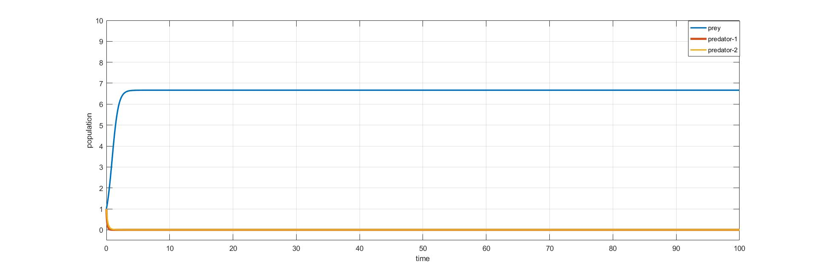
Fig.1(a): Time graph around $E_{1}=\left(6.6667, 0, 0\right)$ showing the stability behavior.
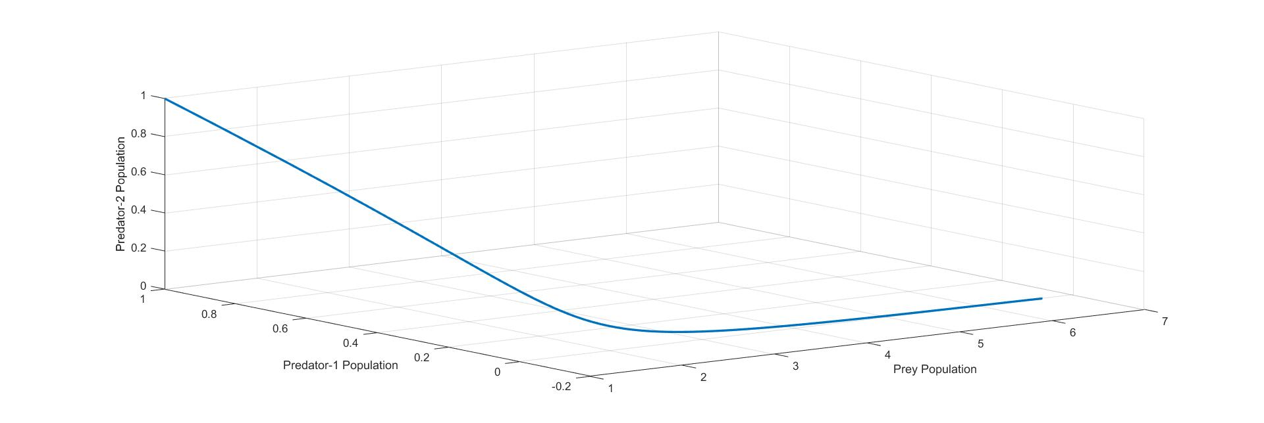
Fig.1(b): Phase graph around the equilibrium point $E_{1}=\left(6.6667, 0, 0\right)$ showing the stability role.
Now we select the following values for $E_{2}:$
$r=5$, $h=0.6$, $a_{12}=0.92$, $a_{13}=0.85$; $a_{21}=0.55$, $a_{23}=0.23$, $ν=3$; $a_{31}=0.32$, $a_{32}=0.62$, $µ=4$;
It is observed that $E_{2}=\left(5.4545, 3.1291, 0\right)$is locally asymptotically stable (see Fig. 2(a) and Fig. 2(b)).
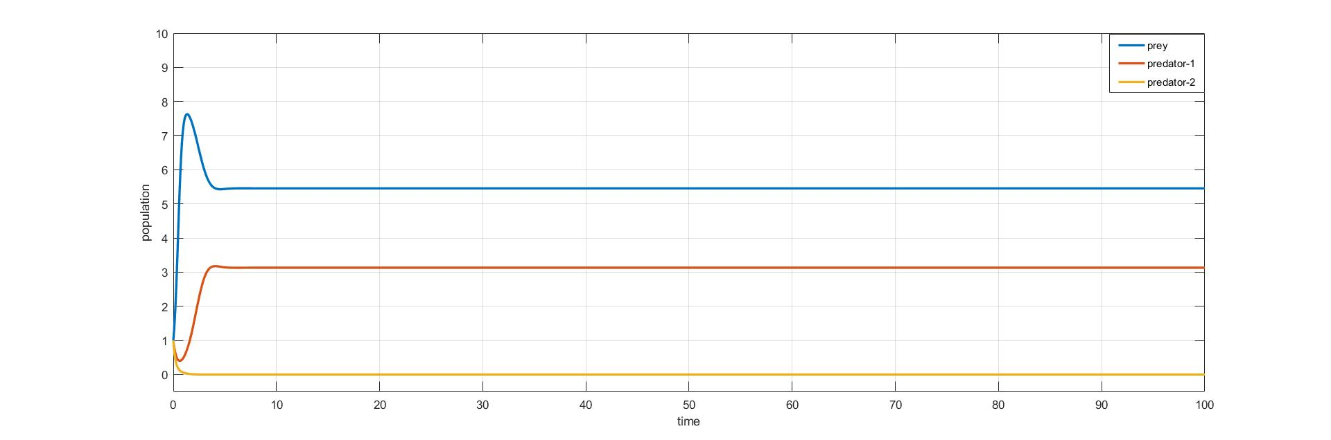
Fig.2(a): Time graph around the equilibrium point $E_{2}=\left(5.4545, 3.1291, 0\right)$ showing the stability behavior.
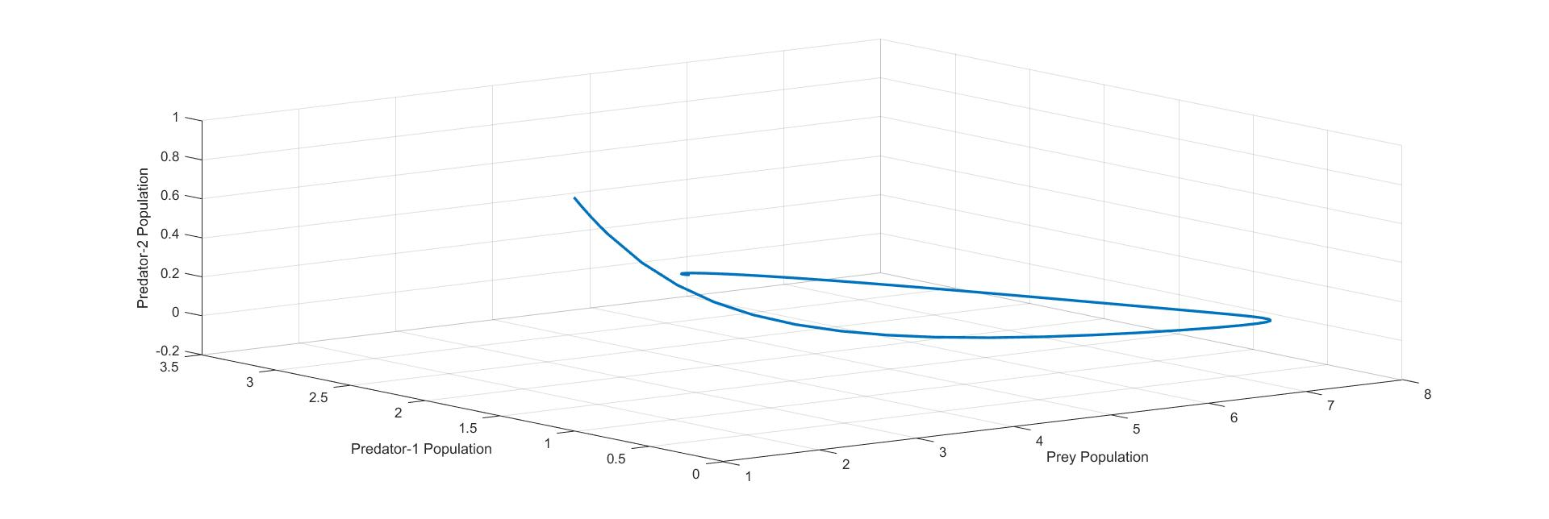
Fig.2(b): Phase graph around the equilibrium point $E_{2}=\left(5.4545, 3.1291, 0\right)$.
Now we select the parameter values for $E_{3}:$
$r=3$, $h=0.32$, $a_{12}=0.24$, $a_{13}=0.35$; $a_{21}=0.35$, $a_{23}=0.65$, $ν=6$; $a_{31}=0.54$, $a_{32}=0.42$, $µ=4$;
It is found that under the above set of parameters the equilibrium $E_{3}=\left(7.4074, 0, 5.6217\right)$is locally asymptotically stable (see Fig. 3(a) and Fig. 3(b)).
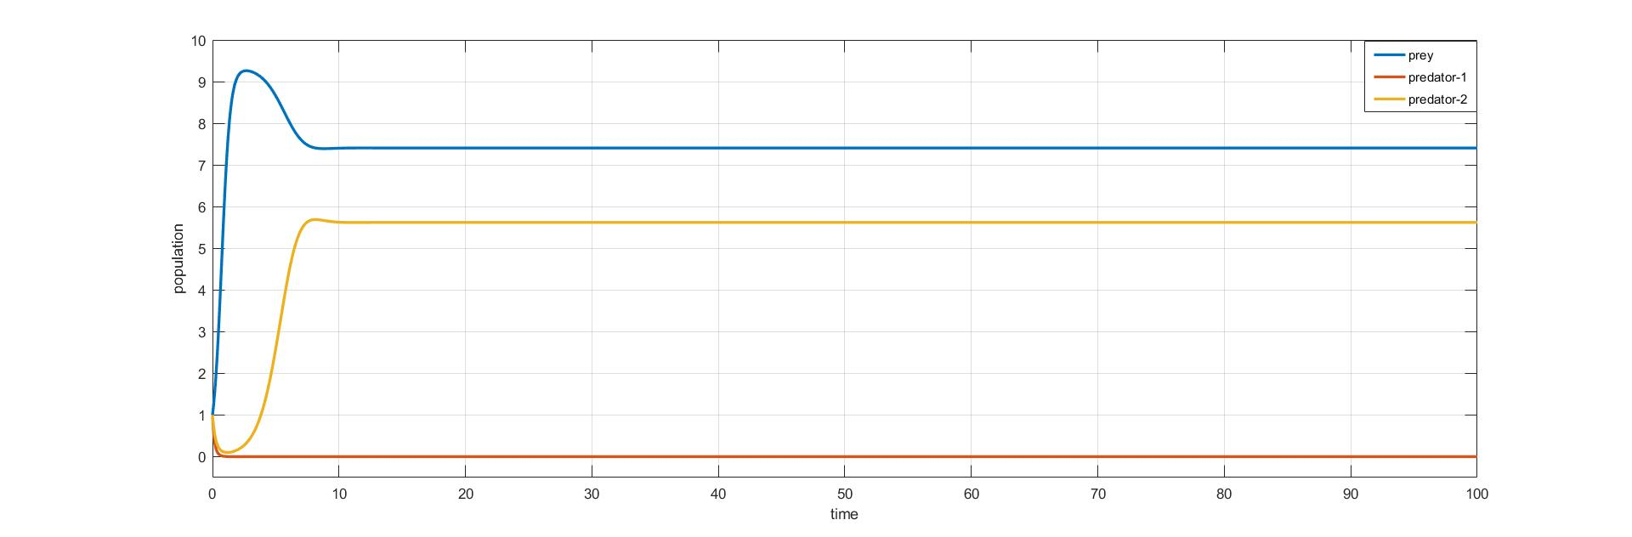
Fig.3(a): Time graph around the equilibrium point $E_{3}=\left(7.4074, 0, 5.6217\right)$ showing the stability behavior.
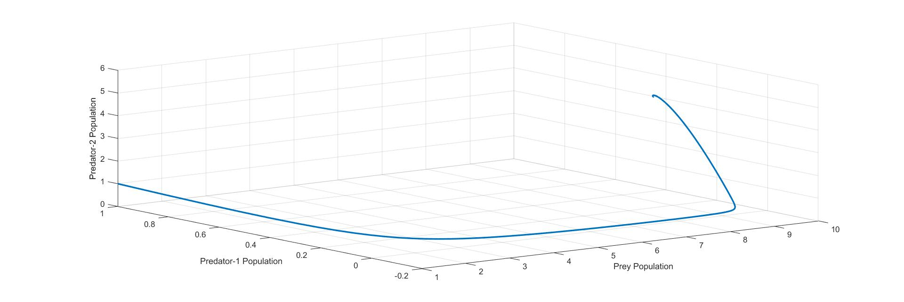
Fig.3(b): Phase graph around the equilibrium point $E_{3}=\left(7.4074, 0, 5.6217\right)$ showing the stability behavior.
1.8.2. Poisson (Randomly) distributed case: In this case the values of $a and b$are
$a=0$and $b=1$
We select these values for $E_{1}:$
$r=4$, $h=0.3$, $a_{12}=0.72$, $a_{13}=0.55$; $a_{21}=0.21$, $a_{23}=0.85$, $ν=7$; $a_{31}=0.13$, $a_{32}=0.72$, $µ=6$;
It is observed that $E_{1}=\left(12.3333, 0, 0\right)$is locally asymptotically stable (see Fig. 4(a) and Fig. 4(b)).
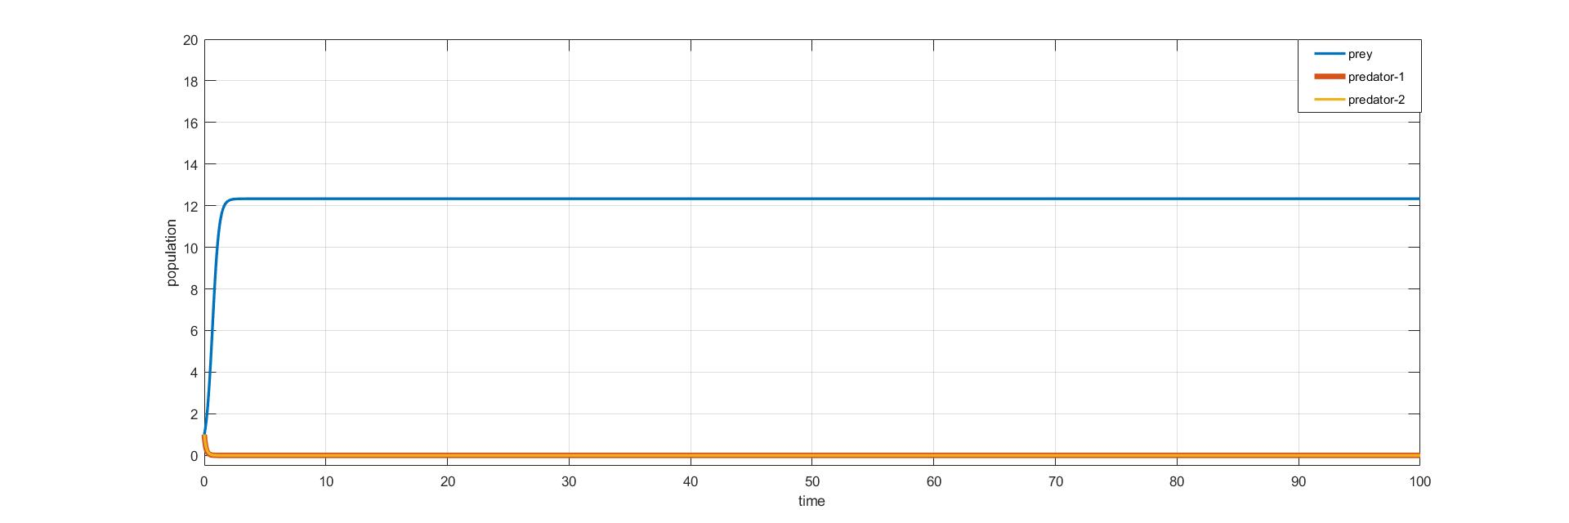
Fig.4(a): Time graph for $E_{1}=\left(12.3333, 0, 0\right)$ explaining the stability.
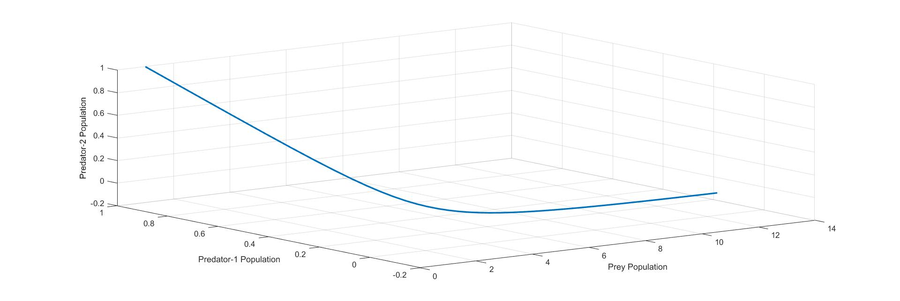
Fig.4(b): Phase graph around the equilibrium point $E_{1}=\left(12.3333, 0, 0\right)$.
Now we select some values for $E_{2}:$
$r=5$, $h=0.3$, $a_{12}=0.32$, $a_{13}=0.25$; $a_{21}=0.3$, $a_{23}=0.1$, $ν=4$; $a_{31}=0.2$, $a_{32}=0.42$, $µ=5$;
It is seen that $\left(13.3333, 7.2917, 0\right)$is locally asymptotically stable (see Fig. 5(a) and Fig. 5(b)).
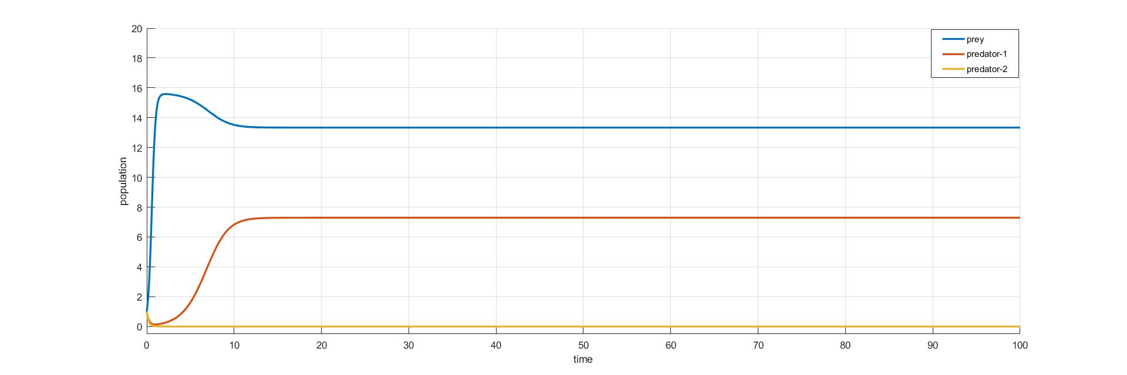
Fig.5(a): Time series graph around the equilibrium point $E_{2}=\left(13.3333, 7.2917, 0\right)$ showing the stability behavior.
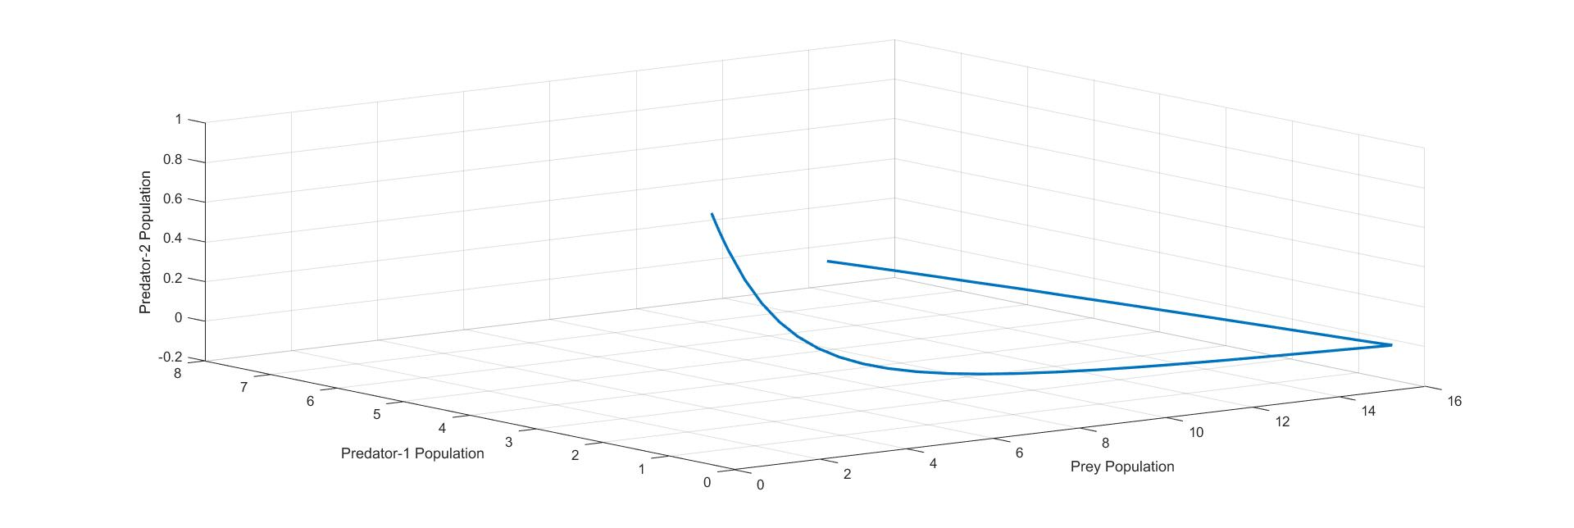
Fig.5(b): Phase graph around the equilibrium point $E_{2}=\left(13.3333, 7.2917, 0\right)$.

Finally select some values for $E_{3}:$
$r=4$, $h=0.2$, $a_{12}=0.4$, $a_{13}=0.45$; $a_{21}=0.25$, $a_{23}=0.45$, $ν=7$; $a_{31}=0.35$, $a_{32}=0.32$, $µ=5$;
It is seen that $E_{3}=$ $\left(14.2857, 0, 10.4762\right)$is locally asymptotically stable (see Fig. 6(a) and Fig. 6(b)).

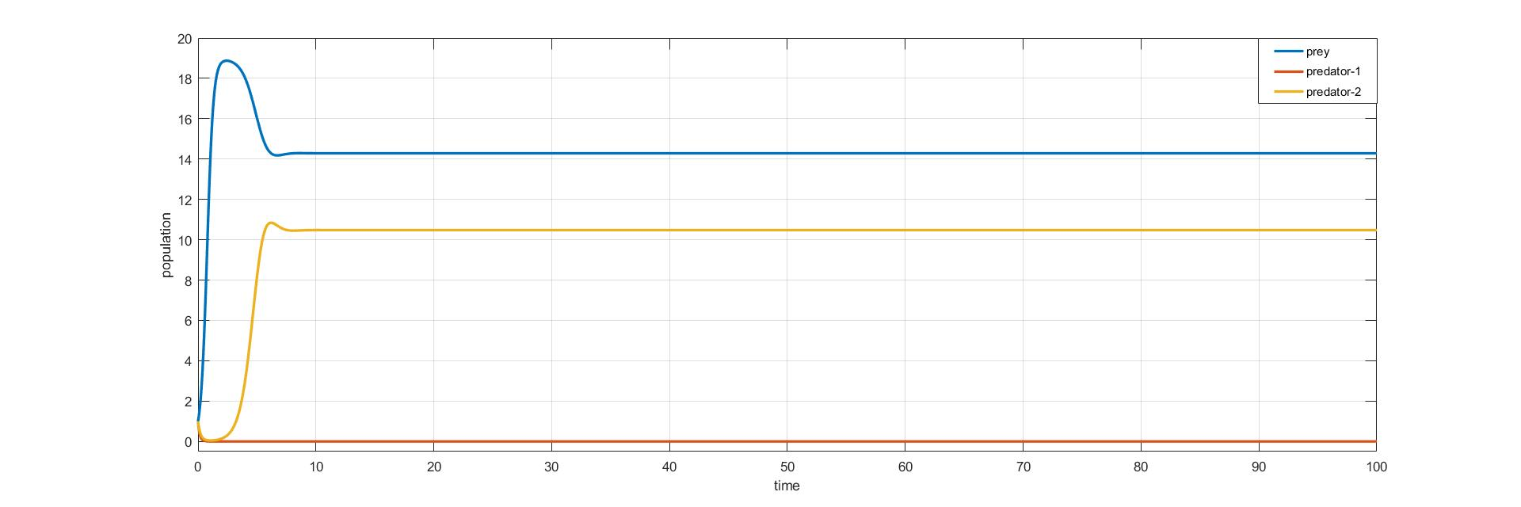
Fig.6(a): Time series graph around the equilibrium point $E_{3}=\left(14.2857, 0, 10.4762\right)$ showing the stability behavior.
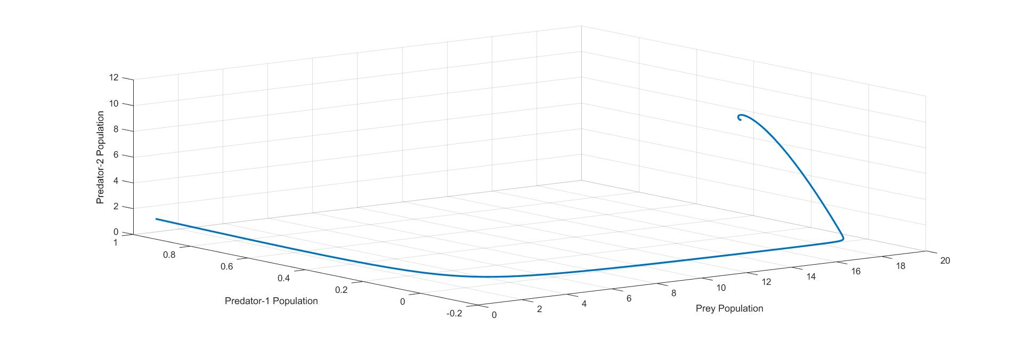
Fig.6(b): Phase graph for $E_{3}=\left(14.2857, 0, 10.4762\right)$.

1.9 Conclusion:
A mathematical model of prey predator, that is two predators competing for a single prey system considering population heterogeneity has been proposed and analysed by extending the system of coupled logistic equations for three species system. The stability examination of all the equilibria has been discussed at locally. It is seen that the equilibrium points are globally stable in varies 2-D planes. From the stability of${ E}_{1}$, only prey will survive and predators will tend to vanish under the conditions (34), (35) and (36). For$E_{2}$, it is seen that only the prey$N_{1}$and predator $N_{2}$ will survive and the population of the predator $N_{3}$may die out under the condition (39). However from the point$E_{3}$, only the prey$N_{1}$and predator $N_{3}$ will survive and the population of the predator $N_{2}$may die out under the condition (42). From theorem 3.4 of Hsu [6] it is identified that the species in prey dependent case is every time unstable. Indeed, from ${ E}_{4}$, it is observed ${ E}_{4}$is an unstable saddle point with two dimensional stable manifolds. At the end, discussed the emphatic behavior of all the species interaction with the help of some numerical examples by using MATLAB to carry the analytical presentations.

References
- Vijayan, S., Kotler, B.P., Abramsky, Z. “A predator equalizes rate of capture of a schooling prey in a patchy environment”, Behavioural Processes, 2017.
- C.Ji, et al. “Dynamical behaviour of a one predator and two independent prey’s system with stochastic perturbations”, Physica A, 2018.
- Y. Gao., S.Q. Liu. “Global Stability for a Predator-Prey Model with Dispersal among Patches”, Abstract and Applied Analysis, 2014.
- Freedman H.I., Waltman P. “Persistence in models of three interacting predator prey populations”, Math. Biosci., 68, 213–231, 1984.
- Harrison G.W. “Global stability of predator-prey interactions”, J. Math. Boil., 8, 159–171, 1979.
- Hsu S.B. “On a resource based ecological competition model with interference”, J. Math. Biol., 12, 45–52, 1981.
- Mitra D., Mukherjee D., Roy A.B. “Permanent coexistence in a resource-based competition system”, Ecol. Model., 60, 77–85, 1992.
- Ghosh, B., Oksana L. Zhdanova, Binandita Barman, Efim Ya. Frisman, “Dynamics of stage-structure predator-prey systems under density-dependent effect and mortality”, Ecological Complexity, 41, 2020.
- Diz-Pita, E., and M. Victoria Otero-Espinar, “Predator–Prey Models: A Review of Some Recent Advances”, Mathematics, 1783, 9, 2021.
- Das, D., Pallav Bora, Sonjoy Mondal, Saponjeet Borah, Priyanku Gogoi, “An Analysis of a Two Predator One Prey Model with Predator Advantage”, Journal of Pharmaceutical Negative Results, 13(5), 2022.
- Cushing J.M. “Periodic two-predator one-prey interactions and the time sharing of a resource niche”, SIAM J. Appl. Math., 44(2), 392–410, 1984.
- Dubey B., Das B. “Modelling the interaction of two predators competing for a prey in a diffusive system”, Ind. J. Pure Appl. Math., 31(7), 823–837, 2000.
- B. Dubey., R.K. Upadhyay. “Persistence and Extinction of One-Prey and Two-Predators System”, Nonlinear Analysis: Modelling and Control, Vol. 9, No. 4, 307–329, 2004.
- K. Shiva Reddy., N. Ch. Pattabhi Ramacharyulu. “A Three Species Ecosystem Comprising of Two Predators competing for a Prey”. Advances in Applied Science Research, 2 (3), 208-218, 2011.
- J. Bulaevsky, “Interactions Facts about Food Chains”, Arcytech, 2000.
- Clobert, J., Le Galliard, J.-F., Cote, J., Meylan, S., Massot, M. “Informed dispersal, heterogeneity in animal dispersal syndromes and the dynamics of spatially structured populations”. Ecol. Lett. 12 (3), 197–209, 2009.
- Pickett, S.T., Cadenasso, M.L. “Landscape ecology: spatial heterogeneity in ecological systems”. Science 269, 331–334, 1995.
- Kuno, E. “Aggregation pattern of individuals and the outcomes of competition within and between species: differential equation models”. Res. Popul. Ecol. 30, 69–82, 1988.
- Lloyd, M. “Mean crowding”. J. Anim. Ecol. 36, 1–30, 1967.
- Hanski, I. “Coexistence of competitors in patchy environment with and without predation”. Oikos 37 (3), 306$-$312, 1981.
- E.K. Waters, H.S. Sidhu, L.A. Sidhu, G.N. Mercer, “Extended Lotka–Volterra equations incorporating population heterogeneity: Derivation and analysis of the predator–prey case”, Ecological Modelling 297, 187$-$195, 2015.
- Iwao, S. “A new regression method for analyzing the aggregation pattern of animal populations”. Res. Popul. Ecol. 10, 1–20, 1968.
- Waters, E.K., Furlong, M.J., Benke, K.K., Grove, J.R., Hamilton, A.J. “Iwao’s patchiness regression through the origin: biological importance and efficiency of sampling applications”. Popul. Ecol. 56, 393–399, 2014.
- Iwao, S. “Analysis of spatial association between two species based on the interspecies mean crowding”. Res. Popul. Ecol. 18 (2), 243–260, 1977.
- J.D. Murray. “Mathematical Biology I. An introduction”, 3rd ed. Springer Verlag, New York, NY, 2002.
- Allman, E.S., Rhodes, J.A. “Mathematical Models in Biology: An Introduction”. Cambridge University Press, Cambridge, UK, 2004.
- Zill, D., Wright, W. “Advanced Engineering Mathematics”. Jones & Bartlett Learning, Sudbury, Massachusetts 2009.
- Gabriel, J.-P., Saucy, F., Bersier, L.-F. “Paradoxes in the logistic equation?”. Ecol.Modell. 185, 147–151, 2005.
- Kuno, E. “Some strange properties of the logistic equation defined with r and K: inherent defects or artifacts?” Res. Popul. Ecol. 33, 33–39, 1991b.
- Mallet, J. “The struggle for existence: how the notion of carrying capacity, K, obscures the links between demography, Darwinian evolution, and speciation”. Evol. Ecol. Res., 14, 625–627, 2012.
- Kuno, E. “Sampling and analysis of insect populations”, Annu. Rev. Entomol., 36, 285–304, 1991a.

