Recent Advances in Plant Wastes Based Natural Dyes For Textiles
Shahid Adeel¹, Nimra Amin¹, Fatima Batool², Meral Ozomay³, Somayeh Mirnezhad⁴, Mozhgan Hosseinnezhad⁵,
¹Department of Applied Chemistry, Government College University, Faisalabad, 3800, Faisalabad Pakistan
²Department of Botany, Division of Science and Technology, University of Education, Lahore, Lahore Pakistan
³ Department of Textile Engineering, Marmara University Istanbul, Turkey
⁴Department of Carpet, University Of Sistan And Baluchestan, Zahedan, Iran
⁵ Department of Organic Colorants, Institutes for Color Science and Technology, Tehran, Iran,
Corresponding Author: shahidadeelapplierdchemsit@gmail.com (Shahidn Adeel)

1.1 Introduction
Natural dyes are colorants derived from plants, invertebrates, or minerals. The majority of natural dyes are vegetable dyes from plant sources such as roots, berries, bark, leaves, and wood and other biological sources such as fungi [1]. Natural dyes are derived from naturally occurring sources such as plants, animals, etc. Sources of natural dyes are given below in Fig. 1.1
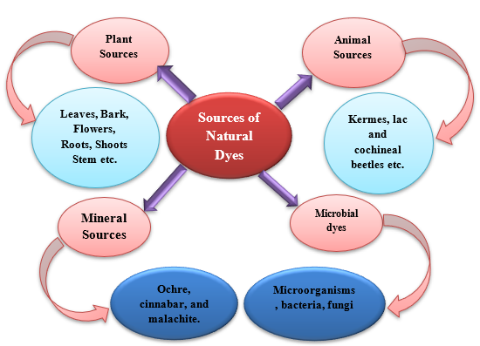
FIGURE 1.1 flow sheet diagrams of sources of natural dyes

1.2 Plant based natural dyes Plant sources include roots, stems, leaves, etc. (Fig. 1.2).
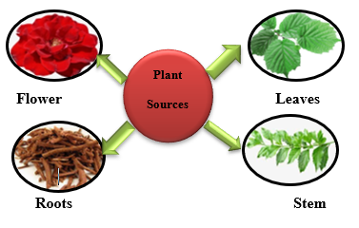
FIGURE 1.2 Flow sheet diagrams of plant sources in natural dye
1.3 Animal sources of Natural dyes
Animal sources included kermes, cochineal, lac, etc. (Figure 1.3)
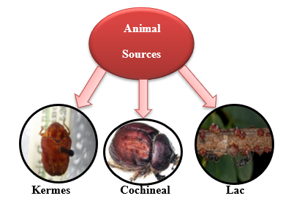
Figure 1.3 Flow sheet of animal sources in natural dyes
1.4 Natural dyes based on mineral sources
Mineral sources include ochre, cinnabar, and malachite (Figure 1.5).
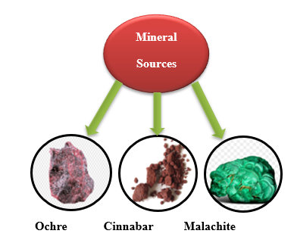
Figure 1.4 Flowsheet diagram of mineral sources in natural dye
1.5 Natural dyes based on microbial sources
Microbial dyes include fungal, algal, bacterial, lichens, etc. (Fig. 1.5)
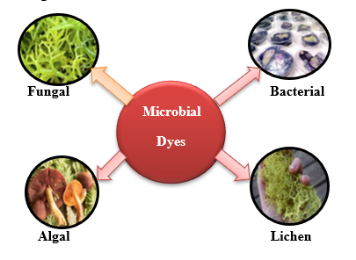
Figure 1.5 Flowsheet diagram of microbial dyes in natural dyes
1.6 Classification of natural dyes
Classification of natural dyes based on sources, structure, color, and applications (Fig. 1.6)
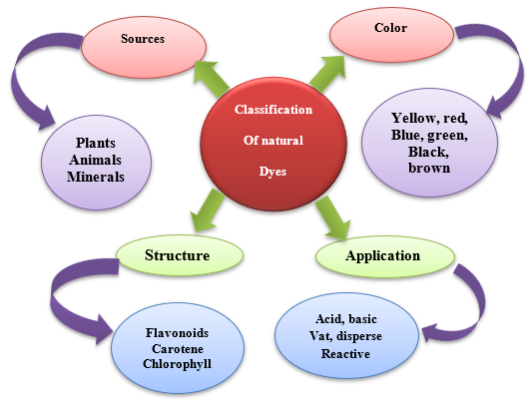
Figure 1.6 Flowsheet diagram of classification of natural dyes
1.7 Applications of natural dyes
It includes agriculture, textile coloration, pH indicator, Food coloration,
Cosmetics, Paint, UV protection, dye-synthesized cell, agriculture, etc. (Fig. 1.7)
Here is the flow sheet diagram:
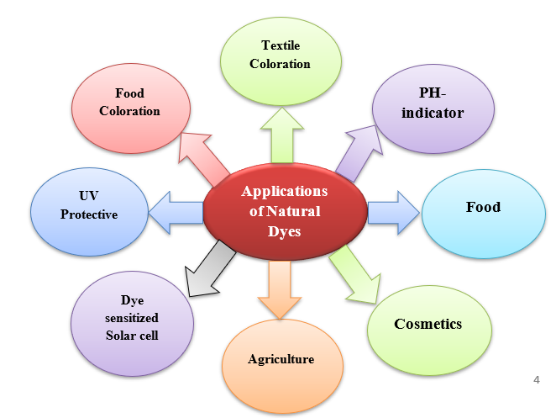
Figure 1.7 Flowsheet diagram of an application of natural dyes

1.8 Natural dyes extraction methods
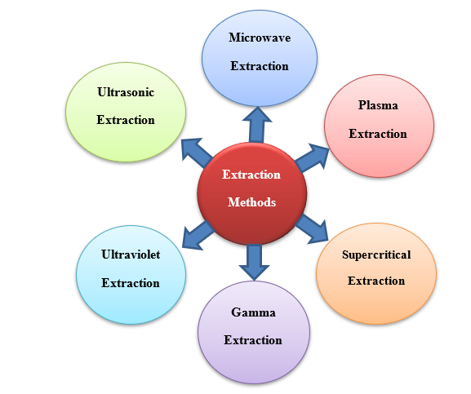
FIGURE 1.8 Flowsheet diagram of extraction methods of natural dyes
1.9 Microwave extraction
Natural dye posed a greener approach to the increased climate destruction caused by synthetic materials. But the extraction of natural dyes through the conventional has not been cost and time-effective, labour-intensive, and less green [2]. Advanced extraction methods were employed to overcome this problem, such as microwave-assisted extraction, ultrasonic extraction, plasma treatment, etc. [3]. Arain et al., (2019) carried out dyeing of polyester fabric with henna dye using a microwave extraction method. They used lemon as a bio-mordant to give the process an eco-friendly approach. They compared microwave-assisted extraction with the conventional extraction method. They analysed the coloring properties with SEM, WAXD (wide-angle X-ray diffraction), and ATR-FTIR and examined the structural changes induced by the microwave method [4]. They concluded that using the microwave technique improved the fixation and color characteristics of the dyeing with clearly reduced mordanting and dyeing time up to 60-65%.
Microwaves heat the molecules of any object by a dual mechanism of ionic.
Conduction and dipole rotation. Microwaves are nonionising electromagnetic waves positioned between the X-ray and infrared rays in the electromagnetic spectrum with a frequency between 300MHz and 300GHz. The two types of oscillating perpendicular fields that generate microwaves are the electric field and the magnetic field. A microwave is a modern approach used for the extraction and dying of textile fabric with fewer intakes of energy, time, and labour. Radiations increase the movement of dye material to the solvent and result in a significant mass transfer [5,6]. Microwave radiation (MW) provides levelled heating to the substrate and adds to the value of the color of natural fabrics via a unique mechanism.
Fu et al. (2019) described the mechanism of microwave radiation during the extraction of natural colorants and its influence on fabric modification. They experimented with investigating the microwave dyeing of the fabric at 2.45GHz & employed microwave drying at 700W and 300W to analyse the fabric’s tangential strength loss caused by microwave treatment. They additionally estimated the association between drying efficiency and the fabric characteristics imposed by it [7].
Zuber et al. (2019) observed that the current work aims to extract tannin from neem bark under the influence of MW radiation for coloring silk fabric that has been chemically and biologically mordanted. Several media have been used to extract the colorant (tannin), and dyeing variables have been improved. Extracts from bio-mordants like turmeric, henna, pomegranate, and acacia have been used under specific circumstances to make the process more environmentally friendly and sustainable. When used to dye silk at 75°C for 65 minutes, it was discovered that MW radiation for 2 minutes applied to an acidified methanolic extract with a pH of 2 derived from 6 grams of powder produced good color strength by using Glauber's salt (3g/100 mL) as the strenuous negotiator. It is determined that MW treatment has improved the color properties under low circumstances and the tannin extraction from neem bark [8].
Adeel et al. (2020a) investigated that textile dyeing is gained popularity due to the resurgence of natural colorants and their eco-friendly behavior. They extracted dye from safflower in different media under microwave treatment for up to 6 min for fabric dyeing. They irradiated to encapsulate the colorant in an acidic medium, yielding excellent colour onto silk fabric when dyed under lower conditions. Again, in their studies, eco-friendly bio-mordant, i.e. extract of turmeric, gave high colour strength with new shades. They concluded that the fastness rating reveals that the mordant fabric dyed at reduced condition has given well to excellent fastness ratings under the influence of Mw treatment [9].
Adeel et al. (2020b) investigated the impact of the resurgence of ecological plant-based dyes on global community demands in every industry. Their research aimed to see if cinnamon bark could be used as a natural yellow colourant for silk dyeing. The yellow dye was extracted in various mediums and microwaved for up to 6 minutes. The results revealed that dyeing irradiated cloth at 35 °C for 45 minutes with an irradiated extract with a pH of 3 and 1g of salt as a levelling agent produced good results. As sustainable chemical mordants, salt of Al& Fe, as well as extracts of Acacia, Pine Nut Hulls, Pomegranate, and Turmeric as sustainable bio-mordants, had provided not only new hues but also improved fastness properties. Finally, employing bio-mordants, the microwave treatment not only enhanced the color extraction yield from cinnamon bark but also made the process more sustainable [10].
Amin et al., (2020) explored natural colorants from cochineal insects extracted with the help of a microwave to dye bio-mordanted silk. The natural colorant from cochineal was extracted utilising acidic, methanolic, and acidified methanol solubilised medium while microwave irradiating for 1-6 minutes. Bio-mordants have been used under ideal circumstances to make the procedure more environmentally friendly and long-lasting. It has been discovered that applying an acid-solubilized extract with a pH of 4 for 55 minutes at 55°C while using 5 g of Glauber's salt per 100 mL as an exhausting agent has produced silk fabrics with excellent color strength. Compared to commonly used chemical mordants, bio-mordants have great colour depth and outstanding ratings for fastness qualities, according to suggested ISO standards for colourfastness. MW treatment has been discovered to enhance the color features of bio-mordanted silk fabric and the dyeing performance of colorants isolated from cochineal in an acid-solubilized medium [11].
Gala et al., (2020) observed that Various parameters, including microwave power, material-to-solvent ratios, heating duration, and amount of extract, were analyzed based on the performance of the extraction process as well as the pigment component of the section, in addition to comparing how long each procedure, Soxhlet, and reflux, takes. Microwave extraction yielded the highest yield under optimal conditions, including 30 minutes of extraction time, 600 W of microwave power, and a material-to-solvent ratio of 0.02 g/mL. In contrast, reflux and soxhlet extraction yielded the highest yield only after 120 and 720 minutes of extraction, respectively [12,13].
Karadag et al. (2020) observed that Microwave irradiation and traditional dyeing procedures were used to colour organic cotton garments with different plants. Different techniques were used to examine the colored textiles. RP-HPLC-PAD was used to investigate coloring chemicals in dye extractions. The colored textiles' coloristic and color fastness capabilities were tested and compared. The materials colored using microwave and traditional dyeing processes showed no signs of harm. They concluded that microwave treatment is cost and time effective [14].
Marsin et al. (2020) utilised the Blue pea flower (BPF) as a source of natural anthocyanin colorant for food and cosmetic coloring. Because natural dyes are unstable, they must be encased. Microwave-assisted encapsulation could help the BPF colorant keep its color during storage. When the microwave-assisted encapsulation procedure was performed using 40 % MD at 770 W for 10 mins, a TAC of 27.03 mg/L, a color parameter index b* value of 9, a water activity of 0.4941, and an encapsulation efficiency of 73.24 % were produced. The blue BPF colorant can be converted into various pigments by adjusting the pH. This study's findings can be utilised as a guide for creating BPF colorant powder using the microwave-assisted approach in the future [15].
Sarfarazi et al. (2020) discovered the use of an anthocyanin-based natural dye from the petals of Saffron through a microwave-assisted extraction method. They utilised optimum conditions for extraction, which were temperature (35‒75°C), time (5‒15 min), and solvent-to-sample ratio of (10:1‒100:1). They analysed the processing conditions through the response surface method. They concluded that the main variable in extraction was solvent to sample ratio i.e 77.5 ml/g as microwave treatment broke the cell wall and extract the dye, so the microwave-assisted method was a fast, modern method [16].
Adeel et al. (2021a) the coloring behavior of laccaic acid, a source of natural red dye derived from lac insects, which has been investigated in this work for the dyeing of wool fabric while being heated in a microwave. The extract was made in an acidic medium, stimulated for up to 7 minutes using microwave energy, and then utilised to color fabrics. Environmentally friendly green mordants, such as acacia and turmeric extracts, were combined with chemical mordants for comparative tests to create new hues. According to the results, when used for 65 minutes at 75°C on uniradiated fabric, an extract prepared in an acidic medium after exposure for 5 minutes had a strong color. The evaluation of fastness attributes demonstrates that, under ideal circumstances, the bio-anchors have provided good ratings. It is implied that this environmentally friendly instrument has improved the sustainability of the natural coloration process while also increasing the coloring output of lac-derived natural anthraquinone dye [17].
Adeel et al., (2021b) studied that natural products have always been appreciated due to the awareness of environmental standards for global health by using green technologies in their isolation and extraction. For the current study, microwave radiations have been used as a green extraction tool to explore the natural coloring potency of Arjun bark for the dyeing of cotton fabrics. For isolation of natural dye from Arjun bark in different media for Mw irradiation, up to 1-6 min has been given and used to dye cotton fabric. They evaluated an increase in color yield (K/S) with 5 min of microwave energy when a 50 mL extract of acidified methanol was used to dye onto cotton fabric for 75 min. At 55 °C. They concluded that Mw energy has an excellent ability to isolate colorant from Arjun bark for dyeing of cotton fabric under reduced optimal dyeing conditions [18].
Arain et al. (2021) studied the eco-friendly dyeing process in which the conventional mordanting method was compared with the modern approach such as microwave treatment used in natural henna dyeing and lemon as a source of bio-mordant used on polyester fabric. They studied that the surface and structural changes induced by microwave henna dyeing and lemon mordanting of polyester fabric were analyzed using SEM, FTIR, and XRD techniques. They found that up to 60-65% of mordanting and dyeing time was reduced by using microwave treatment and improved fixation and color characteristics of the fabric. Hence they concluded that to produce natural garments and products which are safe to use and avoid the risk of health problems, bio-mordants in natural dyeing and microwave treatment could industrially be used [19].
Sharma et al., (2021) examined various process parameters; microwave-assisted extraction was used in this investigation; betacyanin and betaxanthine were extracted from inedible leaves. Several variables were explored, including microwave intensity, temperature, and time. A microwave extraction process lasting 15 minutes at 90 degrees Celsius and 450 watts of electricity yielded the highest betacyanin recovery (72.85 mg/g dry weight). Extraction from the green material using a 205 W microwave at 62 C for 15 minutes yielded the greatest concentration of betaxanthin (41.35 mg/g dw). Water was used as the solvent in green extraction since it is the most effective solvent for these compounds [20].
Ticha et al. (2021) investigated that Juglans Regia L bark can be used as a natural dye for textile application. As a result, a microwave was used to extract a bio-dye, and numerous factors were investigated, including microwave power, pH, and time. Coloured extracts were then utilised to dye wool garments. Colorimetric coordinates (L, a, b) and color strength (K/S) were utilized to evaluate the dyeing process's quality. The dye-fastnesses were also investigated. Finally, Infrared spectral analysis was used to characterize the wool samples [21].
Wang et al., (2021) observed that the following ethanol volume fractions and extraction times were used in the dyeing of wool fiber with walnut green peel pigment using microwave-assisted processes and extraction techniques: 60% ethanol, 1 min, 24:1 liquid-material ratio, and 450 W microwave power, while the optimal mordant fixation procedure was: 3 minutes mordant fixation time, 270 W microwave power, 7% mordant fixing agent, 22 g/L reducing agent dosage. As a result of the experiments, it was found that the use of microwave-assisted extraction of pigments increased the extraction efficiency by a great deal [22].
Akram et al. (2022) worked to use microwave radiation to extract a natural brown colorant from Ficus religiosa for cotton dyeing. Before and during MW treatment for up to 6 minutes, the dye was separated into aqueous and acidic conditions. The dye variables have been optimized to create new hues with good fastness properties, and 1–5g/100 mL of environmentally friendly chemical and biological mordants have been utilized. It has been discovered that after being microwaved for 4 minutes, irradiated aqueous extract (RE) with 3g/100mL of salt produced a high color yield on cotton fabric (RS). Materials with good color properties have been developed using 2% aluminium, 2% iron, and 3% tannic acid as a pre-chemical mordant, and 4% aluminium, 5% iron, and 2% tannic acid as a post-chemical mordant. When utilized as a post-bio-mordant, 3% of Kikar and 4% of pomegranate, as opposed to 2% of acacia and 4% of pomegranate extracts, have created good color attributes. MW treatment provides excellent long-term efficacy for separating dyes from peepal bark powder for cotton dyeing [23].
Gala et al. (2022) found that the microwave-assisted extraction method for extracting natural colors from plants is more successful because of the shorter processing time and the use of fewer solvents. This study aims to use Response Surface Methodology to optimise the effects of extraction time, microwave power, and feed/solvent (F/S) ratio on microwave-assisted extraction yields using a Face-centered Composite Design (FCCD). A face-Centered Composite Design was used to reduce the number of tests. The findings indicated that the maximum yield of the extraction utilizing the FCCD design is 3.67% when the microwave power is 650 W, the F/S ratio is 0.0564 g/mL, and the extraction period is 50 minutes. And the p-values for the model and lack of fit are significant and not significant, respectively [24].
Habib et al. (2022a) demonstrated that the current project aims to extract a natural reddish-brown colorant from peepal using M.W. radiation for silk dyeing. Both the fabric and the extract underwent M.W. treatments for 1, 2, 3, 4, and 5 minutes to assess variations in colour intensity. The colorant was separated in an acidic and aqueous environment. The dye parameters have been adjusted to create sustainable hues with good fastness, and 1.0–5.0 g/100 mL of eco-friendly chemical and biological mordants have been utilized. Materials with good color properties have been created using 3% aluminium, 4% iron, and 2% tannic acid (T.A.) as a pre-chemical mordant and 4% aluminium, 4% iron, and 3% tannic acid as a post-chemical mordant. As post-bio-mordant, acacia, turmeric, and pomegranate extracts exhibit better color properties than acacia, 3 percent turmeric, and 4 percent pomegranate extracts. M.W. treatment provides remarkable long-term efficacy for isolating colorants from peepal bark to dye silk [25].
Habib et al. (2022b) evaluated the current study to evaluate the coloring performance of a natural yellowish colorant based on wild turmeric when used to dye wool using microwave (MW) treatments. Up to 10 minutes of MW treatment have been applied to extracts and fabrics. SEM and FTIR have each been used to examine the external morphology and variations in the chemical composition of the cloth before and after radiation. Acacia extract (1.5%), pomegranate (2%), and pistachio extracts (1.5%) were shown to exhibit high-strength colorfast shades with the application of bio-mordants. Still, acacia extract (1%), pomegranate (1%), and pistachio extracts (2%) had the opposite effect. Moderately, salts of aluminium (1.5%), iron (1%), and tannic acid (2.0%) before dyeing have produced the best results, while salts of aluminium (1%), iron (1.5%), and tannic acid (1.5%) have made excellent yields after dyeing. It has been discovered that pomegranate extract (1.5%) and salt of iron (1.5%) used as post-bio-mordants have extraordinary color strength. Likely, the naturally protective MW treatment has outperformed wool cloth's varying potency of colorants. By including bio-mordants, the tactic has become more sustainable [26].
Naveed et al. (2022) performed that natural colors are now widely utilized since they are safer for the environment, less deadly, and do not harm human health. The cotton fabric and the combined powder (pomegranate rind and turmeric root) used in this investigation were exposed to radiation for 1 to 5 minutes. The optimal exposure duration for improving the dyeing behavior of cellulosic cloth is 3 minutes. Good color strength was seen when dyeing fabric at 65°C for 40 minutes in a pH=6 dyeing bath. The ideal ratio of pre-mordant (4% Cu) and post-mordant (8 percent chromium) was used to increase color fastness. It has been found that employing a mixture of irradiated pomegranate rind and turmeric root powder in aqueous solubilization and microwaves improved irradiated cotton's color strength and fastness capabilities [27].
Yameen et al. (2022) explained the present experiments; the cotton fabric was bio-dyed utilizing microwave irradiation methods employing flowers of the haar singhar. For this purpose, fabrics and liquid extracts were subjected to the microwave for 5 minutes under varied circumstances. The untreated, undyed, and irradiated textile samples and the extract were all identified by FTIR. All colored cotton fabrics were subjected to the CIE-color space system to estimate color synchronization and color strength using the Spectra flash SF600 and to assess colorfastness attributes using ISO standard protocols for light, dry and wet rubbing and washing fastness. Using 4g of powdered haar singhar forward extract and 1.5g/100 mL of salt solution, cotton fabric was colored for 30 minutes at 60°C. After being heated in the microwave for four minutes, the aqueous extract offered excellent color strength for obtaining acceptable hues. Al (K/S=4.8205) is a chemical mordant that produces excellent results, while pistachio (K/S=3.6342) is a bio-mordant that produces excellent results [28].
1.10 Ultrasonic extraction
The application of Ultrasonic has become an exciting new area of study in Chemistry as well as in the food and pharmaceutical industries. The conventional methods usually take a long extraction time and have low performance. In addition, many natural products are thrombolytic and degrade during thermal heating. Increased extraction resulted from the use of ultrasound in less time with lower temperatures. The mechanical impact of its ability to speed up the extraction of active plant compounds is ultrasound, contained within the matrix body, due to cell wall disruption and thus increased mass transfer. Ultrasound-supported extraction (UAE) has recently been introduced. This is used for the extraction of pharmaceutically active substances, Polysaccharides, Hydrocarbon saturated, Cellulose, Flavonoids Fatty acid, Esters, and Steroids from plant material. Isolating and purifying compounds from the crude extract of plants by classical techniques are both expensive and time-consuming.
Zuber et al., (2019) studied the isolation of natural dye from neem bark, containing tannin as a coloring component. For the isolation of the tannin, they used the ultrasonic extraction method and applied it to the silk fabric. They used chemicals and bio-mordant for improvement in shades. They used a methanolic extract of pH=5 and ultrasonic treatment for 30min and obtained the highest color strength of the dye with irradiated fabric for 65min at 75ºC. They concluded that the use of mordants improved the color fastness properties and the ultrasonic method increased the extraction yield [29].
Ali et al., (2019) investigated that the Our study was designed to examine whether the dyeing behavior of wool fibers had been affected by pre-treatment with chitosan and then dyed with rhubarb as a natural dye by conventional (Con) or ultrasonic (US) methods using chitosan as a pre-treatment. Dye extraction and dyeing were studied to find out how to dye content, temperature, time, and pH impacted the results. Chitosan-pretreated wool fibers had significantly higher color strength (K/S) and overall color fastness values than untreated wool fibers. As a result, pre-treated wool fibers can be dyed using ultrasonic technology at lower temperatures than they would be dyed using conventional methods [30].
Amutha et al., (2020) studied that in addition to being eco-friendly and non-hazardous, natural dyes are also sustainable. Metal mordants, on the other hand, such as copper, chromium, tin, and zinc, may be hazardous to ecosystems if used in excess. Natural colors derived from the plants Terminalia arjuna and Thispesia popilnea are used to color silk, cotton, and nylon. This study used ultrasonic bath dyeing, which utilizes significantly less energy than standard water bath dyeing. Ultrasonic dyeing uses less fuel than typical water-bath dyeing and produces less waste [31].
El-Khatib et al. (2020) studied that We pre-treated wool and silk fibers with neem oil using low-cost procedures including microwave heating and ultrasonic energy before dyeing them with natural colors like chlorophyll, saffron red, and yellow. According to the study, the color fastness of the dyes varied from excellent to good, depending on the method employed to remove the dye (microwave or ultrasonic). It was found that pretreated samples inhibited bacteria and fungi more than the fibers that had not been treated. This effect was in place at a higher percentage for the pretreated fibers [6].
Helmy et al. (2020) investigated that there is no doubt that ultrasonic power or microwaves are promising technologies for helping extraction processes compared to traditional heating techniques. Since plant tissues are composed of cellulose, starches, and pectins, readily available enzymes like cellulase, amylase, and pectinase have been used to break down these materials. This has permitted the extraction of colorant particles in a cost-effective manner. The use of ultrasonic and enzymes for textile treatment has also been investigated. It has been reported that combining ultrasound and enzyme treatment increased extraction yield marginally while decreasing treatment time and temperature [32].
Patil et al. (2021) reported that pitaya peels are discarded as garbage while processing. They found that the flesh and peel are a potential source of color for food dye and colorant. They investigated that Dragon fruit peel consists of betacyanin pigment (0.15 %) and pectin (10.8 %) was high in the peel. Moreover, they also revealed that the rapid ultrasonication-microwave treatment provided high amounts of total saturated (10.39 ± 0.15%) and monounsaturated fatty acids (76.55 ± 0.19%) which is a characteristic feature of high-quality biodiesel. Hence, they concluded that ultrasonication-microwave treatment is a promising rapid technique to extract lipids from wet biomass [33].
Qadariyah et al. (2019) investigated the extraction of Natural Ultrasound-assisted Process Dyes from Henna Leaves (Lawsonia Inermis L.) Henna leaves are one of the natural sources of dye that has Lawsone, a peculiar orange-colored substance [34]. Ultrasound-assisted extraction is one method of extraction that is planned to be developed in this research. Ultrasound-assisted extraction with highly efficient energy is an easy, secure, and eco-friendly process. The results of the ratio of feed to solvent, time, temperature, and types of solvent were studied. The highest yield from the extraction of Henna leaves was observed to be 17.96 percent, obtained at pH 1 with 10 minutes of extraction time, 0.02 feed/solvent ratio, and solvent. The ultrasound-aided method was found to be more effective and efficient than the soxhletation method based on both qualitative and quantitative studies of the extracted color [35].
Amesimeku et al. (2021) examined that in the study of this research, using a combination of ultrasonic and microwave irradiation; we investigated the dyeability of meta-aramid fabric with Basic Rhodamine Red, given that aramid fibers are relatively hard to dye due to their highly crystalline structure and compactness. Several factors influence dyeing properties, including temperatures, times, dye concentrations, liquor ratios, and carriers. Using a spectrophotometer, K/S values were used to determine the resulting color strength of each dye mixture [36].
Arifeen et al. (2021) observed that natural dyes, in particular, are expected to become more and more popular due to their non-toxic and biodegradable qualities. In the current study, juglone was used as a reddish-brown natural dye under US radiation as a green and eco-friendly method to increase the dyeability of walnut bark. Under optimum conditions, four bio-mordants, including Kikar bark, turmeric, henna, pomegranate, Fe, Al, and tannic acid, were also employed to produce the new colors. According to research, 3% turmeric extract as a pre-bio-mordant and 5% acacia extract as a post-bio-mordant grew good color qualities compared to their synthetic counterparts. It has been established that using ecologically friendly ultrasonic treatment to extract the reddish-brown color from walnut bark has improved the color ratings of the reddish-brown dye and provided value to the natural dyeing process [37].
Aryanti et al. (2021) observed that saponin was extracted and characterized from lerak (Sapindus rarak DC.), a natural surfactant, and its potential to solubilize reactive dyes and its ability to be solubilized in water. The most saponin was produced (27.87 mg saponin/100 mg feed) after ultrasonic treatment of the green material. The yield of the extract was essentially doubled when 40 minutes of extraction at 30 degrees Celsius were combined with a solvent/solute ratio of 10 mL/g. The output from the maceration-based extraction was roughly doubled as well. UAE results demonstrated that extraction time was improved, the temperature was lowered, and the amount of solvent required was lower when compared with maceration extraction (ME) [38].
Baig et al., (2021) reported the extraction of the natural dye from the flower of different indigenous plants. They used these dyes for the dyeing of the cotton fabric by the application of the ultrasonic method for the extraction of the marigold dye. They found that the light yellow color produced by the dyes fabric at optimized conditions produces a more stable color. They concluded that as compared to the conventional extraction methods, ultrasonic extraction is more efficient in terms of energy consumption, salt concentration, and reduction in dissolved solid contents [39].
Bemcha et al. (2021) found dye's color intensity and durability on wool fabric treated with Ratanjot root using both conventional and ultrasonic dyeing procedures. The percentage of dye absorption increased from traditional heating procedures to 12.31% when ultrasonic waves were used to dye wool using the natural dye Ratanjot (Onosma echioides), exhibiting significant benefits over conventional heating methods. Ultrasonic heating outperformed more standard heating technologies in tests testing fastness grade. Furthermore, the material colored with ultrasonic waves produced a richer hue with good color intensity in just 75 minutes at a lower temperature of 60°C [40].
Lei et al. (2021) studied that this paper aims to present response surface approaches to find the best ultrasonic-assisted extraction (UAE) settings for recovering the most naturally colored pomegranate rind. We determined that by employing ideal conditions for extracting pomegranate peel dyes, we could reach a yield of 17.1 percent (PRD). The dyes derived from pomegranate rind were 17.2 percent, which was quite close to the 17.1 percent predicted. Under optimum UAE conditions, Fourier Transform-infrared and ultraviolet-visible absorption spectroscopy revealed that PRD experienced no significant structural changes. And those ultrasonic-assisted treatments could improve the antioxidant properties of natural pomegranate dyes by achieving a higher level of antioxidant content [41].
Sadeghi-Kiakhani et al. (2021) observed those Colorants from Hawthorn fruits were extracted using ultrasound-assisted extraction (UAE) as well as a variety of different solvents (including methanol, acetone, ethanol, water, and a combination of ethanol and water). When a mixture of water and ethanol was employed for conventional UAE procedures, synergistic dye extraction efficiency was attained; this discovery led to the selection of W1/4E as the optimal mixture. The response surface approach is one of the most successful ways of establishing the ideal extraction parameters (including, but not limited to, the temperature and time of the extraction process, as well as the initial pH of the fruit powder) (RSM) [42].
Hosseinnezhad et al. (2022) observed the choice of plant-based dyes and mordants was made in this study as the key strategy to limit the pollution caused by the dyeing process. The color and mordants were removed from the US medium to achieve maximum performance with the least pollution. The extraction efficiencies of madder, reseda, and walnut husk from water using US radiation were 23%, 33%, and 36%, respectively. The mineral mordant, Fe (ferrous) salt, was used as the mineral sarcastic, and the pre-mordanting process was applied to compare the results. FTIR analytical methods were used to evaluate the resulting extracts and the variations in the fibers. The amount of K/S (color strength) increases with the dye concentration, according to the study of the samples that had been dyed. Using ISO norms, the colorfastness characteristics of each piece were examined. The colored yarns had good, moderate, and excellent wash, light, and fastness, respectively [43].
1.10 Plasma Extraction
Plasma extraction was achieved by applying a blood drop to a membrane stack through which plasma was drawn by capillary action. During plasma migration to a collection disc at the bottom of the membrane stack, blood cells were removed by a combination of adsorption and filtration.
Haji (2020a) studies employed a D-optimal design to analyze plasma with natural dye. According to treated dyeing parameters of plasma coloration technology, but fabric modification has also raised color strength and fastness. He increased plasma treatment time to get a high dye yield from euchromatin and cotton pods. Overall, his investigation using oxygen plasma reduces this fabric treatment as well, as the modification is functional, safe, and reliable for natural dyes [44].
Haji (2020b) improved cellulosic and proteinaceous fabric dyeing with oxygen plasma and chitosan solution. He dyed treated and untreated fabric with walnut dye, an acidic reactive dye. His studies recommended that using plasma-treated salt is unnecessary for the exhaustion of dyes. He responds that the fastness properties of fabric after plasma have also been improved [45].
Haji and Naebe (2020c) explained the role of plasma treatment for surface modification of cellulosic, proteinaceous fabrics, and polymeric fabrics. Their experiments observed that the low yield of natural dyes, their sorption behavior onto fabric, and their colorfastness could be improved if the process was treated with plasma. Not only will the natural dyeing of fabric, synthetic or natural, be safe, but also the result will be excellent. He recommended that the combination of cleaner plasma and natural dyeing will open new doors for research to make the coloration process more safe, reliable, and sustainable for the globe [46].
Haji and payvandy (2020d) used cold plasma-treated wool before dyes modification. They optimized many factors such as oxygen plasma rate, power, and time using statistical tools such as ANM and ANFIS. According to their work, oxygen plasma can potentially improve the dyeing behavior of fabric. Still, the process can be cost, energy, and time effective using statistical design. ANFIS, as a statistical design method, can be improved with RSM and AMN to get a high color yield of natural dyes onto fabrics [47].
Naebe et al. (2021) observed plasma's role in textiles' anti-microbial finishes. According to their review under the pandemic scenario, it has become vital to search for such tools that should be safe and act as anti-microbial. It is necessary to prevent the fabric from microbes in textiles, so it is imperative to use plasma for anti-microbial finishes. They recommended that plasma application in materials as an anti-microbial finish technique should be welcomed because this ecofriendly treatment has the potential to produce a sustainable environment and healthy life [48].

References
[1] Adeel S, Anjum F, Zuber M, Hussan M, Amin N, Ozomay M. Sustainable extraction of colorant from harmal seeds (Peganum harmala) for dyeing of bio-mordanted wool fabric. Sustainability. 2022;14(19):12226.
[2] Adeel S, Rehman FU, Amin A, Amin N, Batool F, Hassan A, Ozomay, M. Sustainable exploration of coffee extracts (Coffea arabica l.) for dyeing of microwave-treated bio-mordanted cotton fabric. Pig. Resin Technol. 2022; 10.1108/PRT-02-2022-0024/full/html
[3] Hayat T, Adeel S, Batool F, Amin N, Ahmad T, Ozomay M. Waste black tea leaves (Camellia sinensis) as a sustainable source of tannin natural colorant for bio-treated silk dyeing. Environ. Sci. Pollut. Res. 2022;29(16):24035-24048.
[4] Arain RA, Ahmad F, Khatri Z. Peerzada MH. Microwave assisted henna organic dyeing of polyester fabric: a green, economical and energy proficient substitute. Nat. Prod. Res. 2021;32(2):1-4.
[5] Karabegović IT, Stojičević SS, Veličković DT, Nikolić NČ, Lazić ML. (2013). Optimization of microwave-assisted extraction and characterization of phenolic compounds in cherry laurel (Prunus laurocerasus) leaves. Sepra. Purif. Technol. 2013;120:429-436.
[6] El-Khatib EM, Ali NF, El-Mohamedy RSR. Enhancing dyeing of wool fibers with colorant pigment extracted from green algae. J. Chem. Pharm. Res. 2016;8(2):614-619.
[7] Fu W, Deng J, Li X. (2019). Microwave drying of fabrics. J. Micro. Power Electromagn. Energy. 2019;53(1):12-23.
[8] Zuber M, Adeel S, Rehman FU, Anjum F, Muneer M, Abdullah M, Zia KM. (2019). Influence of microwave radiation on dyeing of bio-mordanted silk fabric using neem bark (Azadirachta indica)-based tannin natural dye. J. Nat. Fibers. 2019;17(10):1410-1422.
[9] Adeel S, Naseer K, Javed S, Mahmmod S, Tang RC, Amin N, Naz S. Microwave-assisted improvement in dyeing behavior of chemical and bio-mordanted silk fabric using safflower (Carthamus tinctorius L) extract. J. Nat. Fibers. 2020a;17(1):55-65.
[10] Adeel S, Habib N, Arif S, Rehman FU, Azeem M, Batool F, Amin N. (2020b). Microwave-assisted eco-dyeing of bio mordanted silk fabric using cinnamon bark (Cinnamomum Verum) based yellow natural dye. Sustain. Chem. Pharm. 17:100306.
[11] Amin N, Rehman FU, Adeel S, Ahamd T, Muneer M, Haji A. Sustainable application of cochineal-based anthraquinone dye for the coloration of bio-mordanted silk fabric. Environ. Sci. Pollut. Res. 2020;27(7): 6851-6860.
[12] Gala S, Sumarno S, Mahfud M. Comparison of microwave and conventional extraction methods for natural dyes in wood waste of mahogany (Swietenia mahagoni). J. App. Eng. Sci. 2020;18(4):618-623.
[13] Hayat T, Adeel S, Batool F, Amin N, Ahmad T, Ozomay M. (2022). Waste black tea leaves (Camelia sinensis) as a sustainable source of tannin natural colorant for bio-treated silk dyeing. Environ. Sci. Pollut. Res. 2022;29(16):24035-24048.
[14] Karadag R. (2022). Cotton dyeing with cochineal by just-in-time extraction, mordanting, dyeing, and fixing methods in the textile industry. J. Nat. Fibers, 1-11.
[15] Marsin AM, Jusoh YMM, Abang DN, Zaidel ZH, Yusof AHM, Muhamad II. Microwave-assisted encapsulation of blue pea flower (Clitoria ternatea) colorant: maltodextrin concentration, power, and time. Chem. Eng. 2020;78:199-204.
[16] Sarfarazi M, Jafari SM, Rajabzadeh G, Galanakis CM. Evaluation of microwave-assisted extraction technology for separation of bioactive components of saffron (Crocus sativus L.). Ind. Crops Prod. 2020;145:111978.
[17] Adeel S, Rehman F, Pervaiz M, Hussaan M, Amin N, Majeed A, Rehman H. Microwave assisted green isolation of laccaic acid from lac insect (Kerria lacca) for wool dyeing. Prog. Color Color. Coat. 2021;14(4):293-299.
[18] Adeel S, Rehman FU, Khosa MK, Rajab S, Zia KM, Zuber M, Batool, F. Eco-friendly isolation of colorant from arjun bark for dyeing of bio-mordanted cotton fabric: Short title: Dyeing of bio-mordanted cotton with arjun bark colorant. J. Nat. Fibers. 2022;19(12):4684-4695.
[19] Arain RA, Ahmad F, Khatri Z, Peerzada MH. (2021). Microwave-assisted henna organic dyeing of polyester fabric: a green, economical and energy proficient substitute. Nat. Prod. Res. 2021;35(2):327-330.
[20] Sharma A, Mazumdar B, Keshav A. Valorization of unsalable amaranthus tricolour leaves by microwave-assisted extraction of betacyanin and betaxanthin. Biomass Convers. Bioref. 2021;1-17. https://doi.org/10.1007/s13399-020-01267-y
[21] Ticha MB, Slama N, Dhouibi N, Boudokhane C, Dhaouadi H. (2021). Bark residues recovery of juglans regia. l for the dyeing of wool fabrics: development of microwave-assisted extraction and dyeing processes. J. Nat. Fibers, 2021;19(13):5282-5296.
[22] Wang X, Yi F, Zhang W, Guo X. (2021). Optimization of the application of walnut green peel pigment in wool fiber dying and fixing process under microwave-assisted condition. J. Nat. Fibers, 2021;19(13):4854-4867.
[23] Akram W, Adeel S, Amin N, Habib N, Inayat A, Mirnezhad S. (2022). Impact of MW rays on extraction and application of Ficus religiosa bark based natural colourant for cotton dyeing. J. Eng. Fiber. Fabric. 17:1-17.https://doi.org/10.1177/15589250221078927
[24] Gala S, Sumarno S, Mahfud M. Optimization of microwave-assisted extraction of natural dyes from jackfruit wood (Artocarpus heterophyllus Lamk) by response surface methodology. Eng. App. Sci. Res. 2022;49(1):29-35.
[25] Habib N, Akram W, Adeel S, Amin N, Hosseinnezhad M. Environmental-friendly extraction of Peepal (Ficus Religiosa) bark-based reddish-brown tannin natural dye for silk coloration. Environ. Sci. Pollut. Res. 2022;29(23):35048-35060.
[26] Habib N, Ali A, Adeel S, Aftab M, Inayat A. Assessment of wild turmeric–based eco-friendly yellow natural bio-colorant for dyeing of wool fabric. Environ. Sci. Pollut. Res. 2022;1-12.
[27] Naveed R, Bhatti IA, Adeel S, Ashar A, Sohail I, Khan MUH, Nazir A. Microwave assisted extraction and dyeing of cotton fabric with mixed natural dye from pomegranate rind (Punica granatum L.) and turmeric rhizome (Curcuma longa L.). J. Nat. Fibers, 2022;19(1):248-255.
[28] Yameen M, Adeel S, Nasreen H, Ghaffar A, Ahmad T, Inayat A. Sustainable eco-friendly extraction of yellow natural dye from haar singhar (Nyctanthes arbor-tritis) for bio coloration of cotton fabric. Environ. Sci. Pollut Res. 2022
[29] Zuber M, Adeel S, Rehman FU, Anjum F, Muneer M, Abdullah M, Zia KM. (2019). Influence of microwave radiation on dyeing of bio-mordanted silk fabric using neem bark (Azadirachta indica)-based tannin natural dye. J Nat. Fiber. 2020:17(10):1410-1422.
[30] Ali N, Elkatibe E, Elmohamedy R, Nassar S, Elshemy N. Dyeing properties of wool fibers dyed with rhubarb as natural dye via ultrasonic and conventional methods. Egypt. J. Chem. 2019;62(1):119-130.
[31] Amutha K. Sudhapriya N. Dyeing of textiles with natural dyes extracted from Terminalia arjuna and Thespesia populnea fruits. Ind. Crop. Prod. 2020;148:112303.
[32] El-Khatib EM, Ali NF, El-Mohamedy RSR. Influence of Neem oil pretreatment on the dyeing and antimicrobial properties of wool and silk fibers with some natural dyes. Arab. J. Chem. 2020;13(1):1094-1104.
[33] Helmy HM. Extraction approaches of natural dyes for textile coloration. J. Text. Color. Polym. Sci. 2020;17(2):65-76.
[34] Patil PU, Lande SB, Nagalkar VJ, Nikam SB, Wakchaure GC. Grading and sorting technique of dragon fruits using machine learning algorithms. J. Agri. Food Res. 2021;4: 100118. https://doi.org/10.1016/j.jafr.2021.100118
[35] Qadariyah L, Azizah N, Syafa’Atullah AQ, Bhuana DS, Mahfud M. The extraction of natural dyes from Henna leaves (Lawsonia inermis L.) by ultrasound-assisted method. In IOP Conference Series: Mater. Sci. Eng. 2019;543(1):012082). IOP Publishing.
[36] Amesimeku J, Fan L, Jakpa W, Wang, C. Dyeing properties of meta-aramid fabric dyed with basic dye using ultrasonic-microwave irradiation. J. Clean. Prod. 2021;285:124844.
[37] Arifeen WU, Rehman FU, Adeel S, Zuber M, Ahmad MN, Ahmad T. Environmental friendly extraction of walnut bark-based juglone natural colorant for dyeing studies of wool fabric. Environ. Sci. Pollu. Res. 2021;28(36):49958-49966.
[38] Aryanti N, Nafiunisa, Kusworo TD, Wardhani DH. Dye solubilization ability of plant derived surfactant from Sapindus rarak DC. extracted with the assistance of ultrasonic waves. Environ. Technol. Innov.2021;22:101450.
[39] Baig U, Khatri A, Ali S, Sanbhal N, Ishaque F, Junejo N. Ultrasound-assisted dyeing of cotton fabric with natural dye extracted from marigold flower. J. Text. Inst. 2021;112(5):801-808.
[40] Bemcha ORD, Bains S, Grewal S. Ultrasonic dyeing of wool fabric with aqueous extract of Ratanjot (Onosma echioides) natural dye. Environ. Conserv. J. 2021;22(1&2):79-86.
[41] Lei T, Pan Y, Zhang B, Liu R, Pan Y. Optimisation of ultrasonic‐assisted extraction of natural dyes from pomegranate rind using response surface methodology and its characterisation. Color. Technol. 2021;137(3):259-271.
[42] Sadeghi-Kiakhani M, Tehrani-Bagha AR, Safapour S, Eshaghloo-Galugahi S, Etezad SM. Ultrasound-assisted extraction of natural dyes from Hawthorn fruits for dyeing polyamide fabric and study its fastness, antimicrobial, and antioxidant properties. Environ. Develop. Sustain. 2021;23(6):9163-9180.
[43] Hosseinnezhad M, Gharanjig K, Adeel S, Rouhani S, Imani H, Razani N. The effect of ultrasound on environmentally extraction and dyeing of wool yarns. J. Eng. Fibers Fabric. 2021;18(1).
[44] Haji A. Application of D‐optimal design in the analysis and modelling of dyeing of plasma‐treated wool with three natural dyes. Color. Technol. 2020a;136(2):137-146.
[45] Haji A. Plasma activation and chitosan attachment on cotton and wool for improvement of dyeability and fastness properties. Pig. Resin Technol. 2020b;49(6):483-489.
[46] Haji A, Naebe M. Cleaner dyeing of textiles using plasma treatment and natural dyes: A review. J. Clean. Prod. 2020c;265:121866.
[47] Haji A, Payvandy P. Application of ANN and ANFIS in prediction of color strength of plasma-treated wool yarns dyed with a natural colorant. Pig. Resin Technol. 2020;49(3):171-180.
[48] Naebe M, Haque ANMA, Haji A. (2021). Plasma-assisted antimicrobial finishing of textiles: A review. Eng. 2021;12(4):145-163.

