PRECISION MEDICINE: TYPES AND APPROACHES THAT CAN BE APPLIED IN HEALTHCARE

Rafiya yashfeen¹, Humera sadaf¹, Jyothsna kaluwala¹, Harshitha Rathod, Nahiya Fathima, and Ayesha Siddiqua.

¹Jyothishmati Institute of Pharmaceutical Sciences, Thimmapur, Karimnagar, Telangana-India, 505001.

INTRODUCTION

Precision medicine, also referred to as personalized medicine, it is a method of diagnosing and treating diseases that takes into account variability in genetics, environment, and lifestyle. It aims to provide targeted and customized healthcare interventions based on a person's unique characteristics, thereby improving patient outcomes and minimizing adverse effects.
Traditionally, medical treatments have been developed based on the average response of a population. However, individuals can differ significantly in how they respond to treatments due to genetic variations and other factors. Precision medicine seeks to address this variability by tailoring medical interventions to the specific needs of each patient.
The use of genomic data is one of the essential elements of precision medicine. The ability to quickly and economically evaluate an individual's genetic make-up has been made possible by developments in DNA sequencing technologies. This information can help identify genetic mutations or variations that may be associated with certain diseases or influence drug responses.
By analyzing a person's genetic profile, doctors can gain insights into their risk for developing certain diseases, predict how they may respond to different treatments, and identify potential targets for therapies. This information can guide treatment decisions, allowing healthcare providers to select the most appropriate interventions for each patient.
Precision medicine also considers other factors beyond genetics, such as environmental and lifestyle influences. It recognizes that a person's surroundings, behaviors, and personal choices can impact their health and response to treatments. By integrating these factors into the healthcare decision-making process, precision medicine aims to create a more comprehensive and individualized approach to patient care.
. Precision medicine offers multiple opportunities. It may result in more precise diagnosis, better treatment results, and lower medical expenses. Treatments can be personalized to those who will benefit from them the most, reducing the need for unnecessary procedures and the adverse effects that come with them. Additionally, research in precision medicine advances our awareness of diseases and their underlying techniques, opening the door for the creation of novel and more efficient treatments.
It's important to note that precision medicine is a rapidly evolving field, and its widespread implementation still faces some challenges. These include the availability and cost of genomic testing, data privacy concerns, and the need for robust evidence to support the efficacy and safety of personalized interventions. However, with continued advancements in technology, increased collaboration among researchers and healthcare professionals, and ongoing efforts to address these challenges, precision medicine holds great promise for the future of healthcare.

APPROACHES TO PRECISION MEDICINE:

Precision medicine encompasses various types and approaches that can be applied in healthcare. Here are some key types of precision medicine:

- Genomics-Based Precision Medicine:. This category focuses on using genomic information, such as DNA sequencing, to gain an understanding of how a person's genetic composition effects their health and reaction to therapies. It includes identifying genetic variations linked to diseases and using this knowledge to drive tailored therapy decisions.
- Pharmacogenomics: Pharmacogenomics aims to predict how they respond to medications based on a person's genetic profile. By analyzing genetic variations that affect drug metabolism, efficacy, or adverse reactions, healthcare providers can tailor medication choices and dosages to increase their effects and to decrease adverse reactions.
- Molecular Profiling: Molecular profiling involves analyzing the molecular characteristics of a patient's disease, such as genetic mutations, gene expression patterns, or protein markers. This information helps guide treatment decisions by identifying targeted therapies or predicting treatment responses.
- Imaging-Based Precision Medicine:. A patient's anatomy, physiology, and development of illness can all be carefully studied using imaging techniques like MRI, CT scans, or PET scans. Imaging-based precision medicine utilizes these imaging modalities to guide treatment planning and monitor treatment response in a personalized manner.
- Digital Health and Wearables: The integration of digital health technologies and wearable devices enables constant monitoring of health parameters, such as heart rate, activity levels, or sleep patterns. These data can be used to personalize healthcare interventions, monitor treatment efficacy, and facilitate early detection of health issues.
- Data Analytics and Artificial Intelligence: Precision medicine leverages data analytics and artificial intelligence (AI) techniques to analyze large datasets, including genomic data, electronic health records, and clinical trial data. AI algorithms can identify patterns, correlations, and predictive models that aid in disease diagnosis, treatment selection, and patient outcome prediction.
- Preventive Precision Medicine: Precision medicine is not limited to disease treatment but also emphasizes disease prevention. By combining genetic and environmental data, individuals can receive personalized risk assessments and interventions to minimize the chances of developing specific diseases.

These types of precision medicine often overlap and complement each other, as they aim to provide targeted and personalised treatment for individuals based on their characteristics. The integration of these approaches holds great potential for improving patient outcomes and advancing healthcare.

- GENOMICS BASED PRECISION MEDICINE

GENOMICS :

Genomics is the study of an organism's total or part of genetic or epigenetic sequence information, with the aim of understanding the form and function of these sequences and downstream biological products. Genomics in health investigates the molecular mechanisms of disease and the interactions between molecular data, medical care, and environmental factors.
Genomics is defined as the study of genes and their functions, and related techniques It has the possibility to provide novel approaches to the prevention and management of several diseases in the future..
Genome-based precision medicine, often referred to as personalized medicine or genomic medicine, involves tailoring medical interventions to an individual's distinct genetic composition. it is an approach to medical care that takes into account an individual's unique genetic makeup. or specific genetic characteristics to inform choices regarding disease prevention, diagnosis, and treatment. The individual's genetic data can offer valuable understandings of their vulnerability to particular illnesses, their reactions to specific therapies, and their overall health risks
Genomic-based precision medicine works on the concept of GENOMIC SEQUENCING

GENOMIC SEQUENCING :

Genomic sequencing is a laboratory process that involves determining. the arrangement of nucleotide bases (adenine, cytosine, guanine, and thymine) in the genome of an individual DNA molecule .There are different levels of genomic sequencing.

WHOLE-GENOME SEQUENCING:
Whole-genome sequencing (WGS) is a method for examining complete genomes. Genomic data has proved critical in discovering inherited illnesses, explaining cancer mutations, and tracking pandemics of diseases.

WGS works by these four main steps:

- DNA shearing: Scientists begin by slicing the DNA, which is made up of millions of bases (A's, C's, T's, and G's), into bits sufficient in size for the DNA sequencing device to read.
- DNA bar coding: Scientists add tiny fragments of DNA tags, or bar codes, to figure out which fragment of sheared DNA matches to which bacteria. This is identical to how a bar code at a grocery shop identifies a product.
- DNA sequencing: Multiple bacteria's bar-coded DNA is mixed and inserted into a DNA sequencing device . The sequencer recognizes the A, C, T, and G bases that comprise each bacterial sequence and recognises which base belongs to particular bacteria.
- Data analysis:. Computer analysis techniques are used by scientists to analyze sequences from different microorganisms and detect variations. The number of changes between the bacteria can tell scientists how closely linked they are and how likely they are part of the same epidemic.

WHOLE EXOME SEQUENCING (WES):

WES is a popular next-generation sequencing (NGS) technology that involves sequencing the genome's protein-coding regions .The human exome accounts for less than 2% of the genome but contains 85% of previously identified disease-related variants1, making this technology an affordable alternative to WGS.
It Offers a less expensive alternative to WGS (4-5 Gb of sequencing each exome to 90 Gb for the entire human genome). When compared to whole-genome techniques, results in a smaller, simpler to organize data collection for more rapid data analysis.
- Main three Steps involved in WES :

- Library preparation: Extracted DNA fragment corresponding to exons region of genes are enhanced using target capture techniques. These fragments are then amplified and prepared into a sequencing library
- Sequencing: the constructed library undergoes high technologies and produces millions of short DNA sequences simultaneously
- Data analysis: The obtained reads are matched against a reference genome which functions as a blueprint for comparing the individual sequence .by making comparisons, variations like single nucleotide changes, insertions, deletions, and other forms of mutations.

TARGETED GENE SEQUENCING :

Targeted next generation sequencing concentrates on precise genomic areas of interest. This approach is useful for investigating genes in specific pathways or for performing follow-up research (targeted resequencing) after WGS. It is more rapid and more affordable than WGS, and it enables more detailed sequencing. Targeted sequencing is an extremely sensitive and powerful tool for finding variations and changes, including uncommon mutations.
. Additional advantages of targeted NGS compared to WGS include:
• Smaller datasets requiring less computational resources
• More scalable (can handle more samples/sequencing run)
• More appropriate for industrial applications where cost and speed are critical
methods for targeted gene sequencing:
target enrichment and amplicon generation.

- Target Enrichment: The hybridization to biotinylated probes extracts regions of interest, which are then isolated by magnetic pulldown. Based on the experimental design, target enrichment covers 20 kb-62 Mb areas.
- Amplicon sequencing : Employing highly sequenced oligo pools, the areas of interest will be amplified and purified. Depending on the library preparation kit, this approach allows scientists to sequence from a few genes to hundreds of genes in just one run.
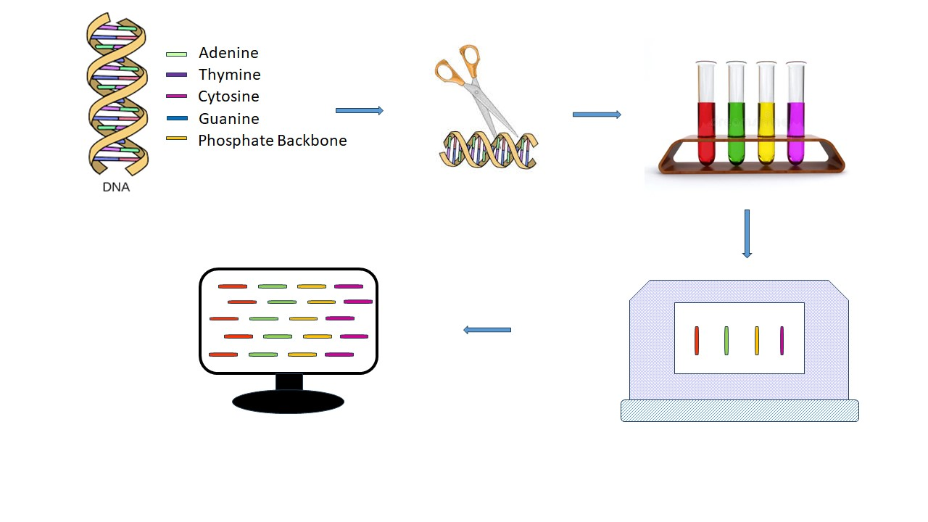
FIGURE 1. WHOLE GENOME SEQUENCING

APPLICATIONS OF GENOME SEQUENCING IN PRECISION MEDICINE :

Drug Development :

Drug development has been accelerated up by the use of genomics. Different conceptual frameworks and methodologies support target prioritizing, tractability, identification, and prediction of consequences from pharmaceutical modifications. It offers in-depth comprehension of illness and drug disruption at the tissue and a single cell stage and has the ability to use CRISPR technology to screen for an absence of function or activation of genes across the entire genome..the information provided by genome sequencing on specific drug receptors and targets and specific biomarkers dicovery create more effective and targeted personalised treatments.

Disease Risk Assessment :

It can detect genetic variations linked to a elevated likelihood of developing specific illnesses .this data empowers health care professionals to evaluate an individuals susceptibility to disorders such as heart diseases , diabetes and particular typesof cancers. Individual with agreater risk can then be offered customised preventive approaches and screenings.

Targeted Therapeis :

Targeted therapy using genomics in precision medicine involves developing and applying treatments that are specifically tailored to person on basis of characteristics of molecular and genome. This approach aims to address the underlying causes of diseases by targeting specific genetic mutations, altered pathways, or molecular abnormalities. Targeted therapy Using genomics works by performing genetic analysis, treatment design and personalised treatment .It is applied in different neurological , cardiovascular ,cancer and hereditary diseases.

CHALLENGES ASSOCIATED IMPLEMENTING GENOMICS IN PRECISION MEDICINE:

Data Interpretation And Security:

Genomic data is very complex and huge which requires advanced computational and bioinformatics tools to accurately interpret and analyse the information. Genetic variations translation into insights is challenging. It is highly sensitive and personal. Protecting data from unauthorised access is the main concern.

Ethical And Privacy Considerations:

The use of genetic information raises ethical concerns related to data ownership, consent , misuse of data for other purposes.

Cost And Accessibilty:

It is highly expensive process which cannot be affordable to all the population. High cost makes it inaccessible foe majority individuals.

Clinical Validation:

All genetic markers and genetic sequences may not have clear clinical significance. Validation of particular genetic sequence and its therapy (treatment options ) requires rigorous research and practice and evidence.

- PHARMACOGENOMICS BASED PRECISION MEDICINE:

PHARMACOGENOMICS:

Pharmacogenomics is a branch of research that studies the association between polymorphisms in genes and pharmacological response. It may be possible to base treatment choices on genetics when a mutation in a gene is linked to a patient's particular drug response, such as changing the dosage or selecting a different medication. Similar to how they evaluate gene variants linked to diseases, scientists evaluate gene variants affecting an individual's reaction to drugs. This area integrates the study of genes and their roles with the science of pharmaceuticals to create effective, secure medications that may be provided depending on a person's genetic profile.
Many drugs that are currently available are “one size fits all,” but they don't work the same way for everyone. It can be difficult to predict who will benefit from a medication, who will not respond at all, and who will experience negative side effects (called adverse drug reactions). Genetic differences will be used to predict whether a medication will be effective for a particular person and which dose will help prevent adverse drug reactions. [8]
Pharmacogenomics plays a crucial role within the framework of precision medicine. Precision medicine seeks to deliver tailored healthcare solutions by considering an individual's genetic, environmental, and lifestyle elements[9]. Pharmacogenomics is important in two ways in precision medicine.
a) It directs pharmaceutical companies' drug discovery and development efforts.
b) It assists medical professionals in selecting the appropriate drug for patients based on their genetic background, preventing adverse drug reactions, and maximizing drug efficacy by prescribing the appropriate dose. The components of pharmacogenomics are :

PHARMACOKINETICS AND PHARMACODYNAMICS :

Drug Transporters:

Drug transporters are enzymes found in cell membranes that play an important role in drug and other chemical transfer into and out of cells. These transporters play important roles in a variety of biological processes, including the absorption and distribution of drugs, their metabolism, and excretion. Individuals' responses to drugs can be influenced by genetic variations in drug transporter genes.[10].
Transporters are proteins within membranes found across the body who balance the influx of critical nutrients and ions as well as the excretion of cell debris, toxins, and medications Transporters in the liver, colon, kidney, and blood-brain barrier (BBB) are particularly important in drug development and application. Multiple transporters combine to move endogenous and foreign chemicals inside and outside of cells. Transporters and drug-metabolizing enzymes combine in specific organs, such as the liver and intestine, to regulate drug pharmacokinetics .Transporters are essential for drug disposal, efficacy in therapy, adverse drug responses, and drug-drug interactions Several genes and environmental variables could influence transporter expression variation. Determining the role of genetic polymorphism in transporter expression and phenotypes may help doctors prescribe medication regimens to patients according to genetic variables. There are two elementary transporter superfamilies which are essential in drug disposal. Solute carrier transporters (SLCs) are an assortment of both active and passive carriers which depend on chemical and/or electrical gradients to move solutes. They are a broad and diverse category of protein molecules which assist multiple solutes traverse cell membranes. These transporters are vital for the passage of nutrients, ions, metabolites, and medicines via cell membranes in numerous organs and tissue layers around the body. SLC22 (Organic Cation and Anion Transporter) Family: Transporters in this family mediate the uptake and efflux of organic cations and anions. Here are several examples:
• OCT1 (SLC22A1): Mediates the absorption of different organic cations in the liver, including certain medicines.
• OCT2 (SLC22A2): Involved in organic cation absorption in the kidney and medication elimination.
• OAT1 (SLC22A6) and OAT3 (SLC22A8): These proteins aid in the renal production of organic anions and have a role in drug excretion.
- Family SLC47 (Multidrug and Toxin Extrusion):

- • Transporters in this family mediate the efflux of cationic medicines and other substances. Here are several examples:

- • MATE1 (SLC47A1) and MATE2-K (SLC47A2): These proteins are found in the kidneys and aid in the elimination of cationic medicines and poisons.

- a) Peptide Transporter SLC15 Family:
- • Peptide transporters are involved in the absorption of peptides and peptide-like medicines. Here are several examples:

- • PEPT1 (SLC15A1): A protein found in the intestines that regulates the absorption of di- and tripeptides, including certain medicines.

- • PEPT2 (SLC15A2): A protein found in the kidneys that aids in the absorption of peptides and peptide-like medicines.

- Family SLC16 (Monocarboxylate Transporter):

- • Monocarboxylate transporters help to transport monocarboxylates such lactate, pyruvate, and some medicines. Here are several examples:
- • MCT1 (SLC16A1): Found in a variety of tissues, including the intestines, MCT1 plays a role in monocarboxylate absorption.

- • MCT2 (SLC16A7): Lactate transporter found in the brain and other organs.SLC29 (Equilibrative Nucleoside Transporter) Family:
- Equilibrative nucleoside transporters are responsible for the transport of nucleosides and nucleoside analogs. Examples include:
- ENT1 (SLC29A1) and ENT2 (SLC29A2): Facilitate the cellular uptake of nucleosides and nucleoside-based drugs.
- SLC6 (Neurotransmitter Transporter) Family:
- This family includes neurotransmitter transporters that regulate the reuptake of neurotransmitters in the nervous system. Examples include:
- SERT (SLC6A4): Serotonin transporter, responsible for the reuptake of serotonin.
- NET (SLC6A2): Norepinephrine transporter, involved in the reuptake of norepinephrine.
- DAT (SLC6A3): Dopamine transporter, responsible for the reuptake of dopamine.
• ATP-binding cassette (ABC) transporters, a class of ATP-dependent primary active transporters. These transporters use ATP (adenosine triphosphate) hydrolysis energy to pump substrates against their concentration gradient, hence contributing to a variety of physiological functions.
Types of ABC Transporters:

They are of two main classes of ABC transporters based on their direction of transport:
- Uptake ABC Transporters: These transporters move substrates into cells. Examples include:
- ABCG2 (BCRP): Involved in xenobiotic and drug efflux, found in tissues like the intestines and blood-brain barrier.
- • ABCB1 (MDR1, P-gp): Mediates drug efflux from cells and can be discovered in a number of tissues, including the gastrointestinal tract and the blood-brain barrier.
- ABCC1 (MRP1): Mediates cellular efflux of various substrates, including some drugs.
- Efflux ABC Transporters: These transporters pump substrates out of cells. Examples include:
- ABCA1: Involved in cholesterol efflux from cells and HDL biogenesis.
- ABCG1: Mediates cholesterol and phospholipid efflux, contributing to lipid metabolism.

Effect of polymorphisms in genes encoding drug transporters :

Drug transporters are responsible for the transfer of all medicines and their active or inactive metabolites into and out of cells. As a result, mutations in drug transporter genes can alter absorption, distribution, and excretion rates, as well as the safety and efficacy of the medications delivered. There are 49 genes in the ABC transporter superfamily of drug transporters, which are split into seven subfamilies ranging from ABCA to ABCG. Figure 3 summarizes the effect of certain major polymorphisms on the drug transport abilities of various ABC transporters. Furthermore, the SLC superfamily contains 360 genes that have been divided into 46 subfamilies. Members of the organic anion transporter (OAT), organic anion transporting polypeptide (OATP), and organic cation transporter (OCT) subfamilies are especially important in drug disposal. Furthermore, polymorphisms in genes encoding SLC superfamily members SLCO, SLC22, and SLC47 have important roles in altering drug transport capabilities of the corresponding transporters. ABC transporter stands for ATP-binding cassette transporter; MDR1 stands for multidrug resistance protein 1; BCRP stands for breast cancer resistance protein; and MRP stands for multidrug resistance-associated protein .The effects of genetic polymorphisms on the transport activities of various allele variations of SLC transporters, including SLCO and SLC47 (A) and SLC22 (B). SLC stands for solute carrier; SLCO stands for solute carrier organic anion; OCT stands for organic cation transporter; OCTN stands for organic cation transporter new; OAT stands for organic anion transporter; MATE1 stands for multidrug and toxin extrusion protein 1; and URAT stands for urate transporter.
Pharmacogenomics in the absorption of drugs

The transport of a drug from its place of administration into the bloodstream is referred to as absorption. It's a complicated process involving numerous membrane-bound drug transporters, including P-glycoprotein (MDR1) and multidrug resistance (MDR) transporters encoded by the ABC genes. The ABCB1 gene, which codes for P-gp, contains more than 50 SNPs that vary in frequency depending on ethnicity. These mechanisms have an impact on the drug's ultimate bioavailability. The fraction of a medicine that reaches the bloodstream or the site of action after administration is referred to as bioavailability.
Pharmacogenomics in the distribution of drugs
Following delivery, the drug is dispersed into all of the body compartments and tissues that it is physically and chemically capable of entering. The medicine is spread into an imaginary volume known as the volume of distribution (Vd), which is primarily determined by physiological characteristics such as BMI and fat deposits. Vd may be dependent on PGx for distribution to certain bodily compartments such as the brain via the blood-brain barrier and breast milk, both of which rely on transporter genes such as ABC. Drug resistance can occur from overexpression of these genes. Polymorphisms in the genes ABCB1 and SLCO1B1 have also been linked to drug distribution.
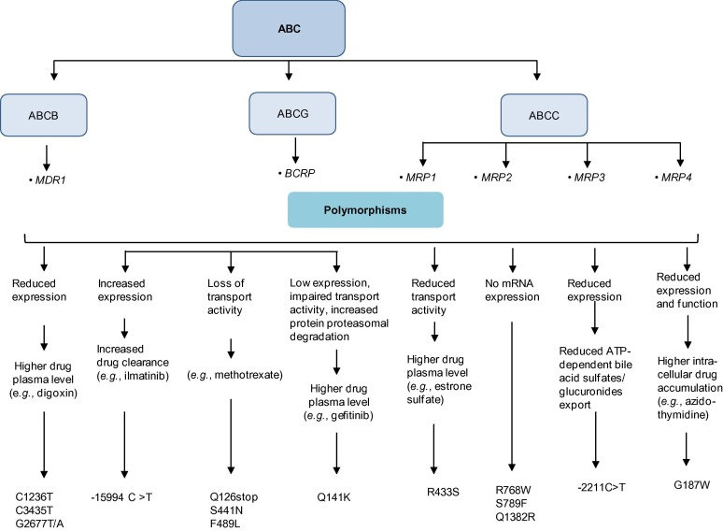
FIGURE 2. EFFECT OF POLYMORPHISMS IN GENES ENCODING DRUG TRANSPORTERS-ABC
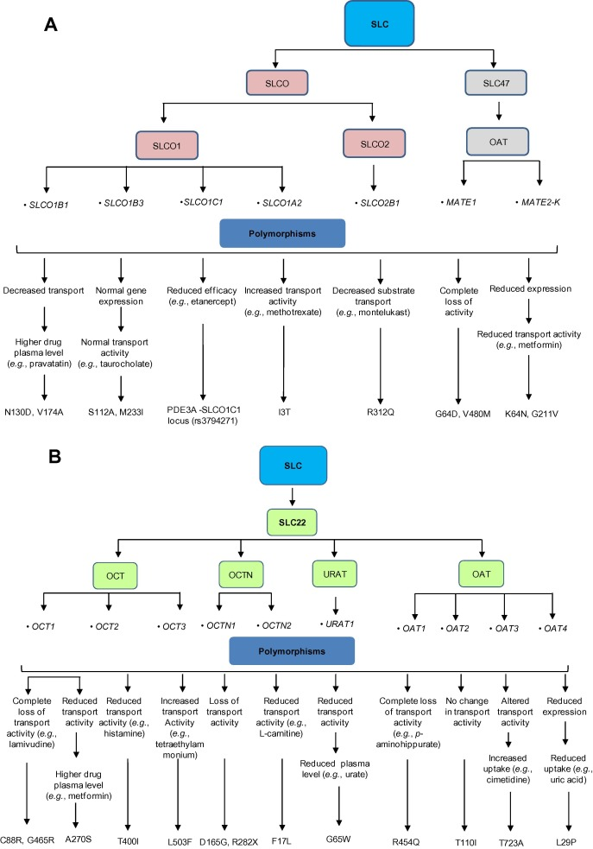
FIGURE 3. EFFECT OF POLYMORPHISMS IN GENES ENCODING DRUG TRANSPORTERS-A AND B SLC

Pharmacogenomics in metabolism of drugs:

Drug metabolism is the metabolic breakdown of drugs, usually through specialized enzymatic systems. Most drug metabolism occurs in the liver and intestine. Drug metabolism is divided into three phases

Phase I metabolism involves:

Oxidation (via cytochrome P450), reduction, and hydrolysis reactions. Conversion of a parent drug to more polar (water soluble) active metabolites by unmasking or inserting a polar functional group (-OH, -SH, -NH2).
Drugs metabolized via phase I reactions have longer half-lives.

Phase II metabolism involves:

Glucuronidation , acetylation, and sulfation reactions. “Conjugation reactions” that increase water solubility of a drug with a polar moiety glucuronate, acetate, and sulfate. Conversion of a parent drug to more polar (water soluble) inactive metabolites by conjugation of subgroups to -OH, -SH, -NH2 functional groups in the drug. Drugs metabolized via phase II reactions that are excreted via the kidney.Patients deficient in acetylation capacity (slow acetylators) may have prolonged or toxic responses to normal doses of certain drugs because of decreased rates of metabolism.

Phase III metabolism involves:

Further modification of the conjugated drug and excretion.
- A detoxification process and transportation of the conjugates against a concentration gradient out of the cell into the interstitial space between cells.
- The conjugated drug entering the capillary system and then the main bloodstream, and filtration by the kidneys.
- Excretion: excretion describes how drugs leave the body, whether by urine, bile, or, in some cases, exhalation.
- Hepatic Elimination: Transporters in the liver play a significant role in the elimination of drugs from the body. They actively transport drugs from the blood into the bile for excretion into the intestines or directly into the urine. Variations in hepatic drug transporters can affect the rate of drug elimination.
- Renal Elimination: Transporters in the kidneys are responsible for the excretion of drugs into the urine. Genetic variations in renal transporters can impact drug clearance and the risk of drug accumulation.

Pharmacodynamics :

Pharmacodynamics is a branch of pharmacology that focuses on how drugs interact with their target molecules and produce their effects within the body. It deals with understanding the relationship between drug concentration and its effects on the body's physiological processes. Pharmacodynamics encompasses various aspects, including drug-receptor interactions, cellular responses, and the overall impact on the body.
Disorders that affect pharmacodynamic responses include genetic mutations, thyrotoxicosis, malnutrition, myasthenia gravis, Parkinson disease, and some forms of insulin-resistant diabetes mellitus. These disorders can change receptor binding, alter the level of binding proteins, or decrease receptor sensitivity. Aging tends to affect pharmacodynamic responses through alterations in receptor binding or in postreceptor response sensitivity (see table Effect of Aging on Drug Response).Pharmacodynamic drug–drug interactions result in competition for receptor binding sites or alter postreceptor response.

GENETIC VARIATIONS :

The Human Genome Project (HGP), which finished in April 2003, found that humans had around 20,500 genes, with 99.5 percent of the genes being identical.6 The remaining 0.5 percent are variants that determine an individual's eye color, blood group, susceptibility to certain diseases, and so on. The single nucleotide polymorphism (SNP, pronounced "snip") is the most prevalent type of DNA sequence variation observed in the human genome. Deletions, insertions, tandem repeats, inversions, and copy number variations (CNV) are examples of structural variants (SV). The human genome has around 11 million SNPs, with one per 1,300 base pairs. SNPs function as biological markers, determining an individual's reaction to medications, vulnerability to environmental influences such as pollutants, and so on. [11].

Individual genetic differences can influence almost every element of an illness and its treatment. Genetic variants can have an impact on disease management in the following ways:

The frequency of illness occurrence

The possibility of illness progression or recurrence

The drug or drug class most likely to prove beneficial

The recommended therapeutic dosage

The form and magnitude of favorable treatment response
The possibility of medication toxicity
Genetic variations relevant to drug development include:
- Genes relevant to the drug’s pharmacokinetics (absorption, distribution, metabolism [including formation of active metabolites], and excretion)
- Genes that code for intended or unintended drug targets and other pathways related to the drug’s pharmacologic effect
- Genes that can predispose to toxicities such as immune reactions
- Genes that influence disease susceptibility or progression.

All of these genetic factors can affect the benefit-risk drug profile

Genetic polymorphisms in drug transporters and phase-1 drug-metabolizing enzymes can vary the pharmacokinetic and pharmacokinetic characteristics of administered medicines, their metabolites, or both at the target site, resulting in drug response variability. In theory, differences in a single base (SNPs) or sets of closely related SNPs (haplotypes) in genes participating in the pharmacokinetic and pharmacodynamic processes at any point could impact an individual's overall drug response. Mutations in gene coding areas may affect gene expression or protein structure, resulting in variations in protein amount and quality. In the case of enzymes, such mutations affect both the protein function as well as the rate and kinetic constants.. Drug responses may differ due to changes in drug-receptor or drug-enzyme interactions caused by structural changes in enzymes or receptors. Polymorphisms in drug transport genes can change the pharmacokinetic properties of a drug and, as a result, its plasma concentration as well as concentrations in target tissues.
Variations in drug response:

Individuals differ greatly in their clinical responses to medications provided, and the outcomes, which might be inherited or acquired, are always patient-specific. Because most medications are only effective in 25%-60% of patients, such interindividual variance is sometimes a barrier to optimizing a dosing regimen. Many people are unable to fully respond to and benefit from the first pharmacological treatment that is offered. For example, an average of 38%, 40%, 43%, 50%, and 75% of patients with depression, asthma, diabetes, arthritis, and cancer do not respond to early therapy, correspondingly.
Contributing factors in interindividual drug responses:

Individual-specific pharmaceutical response can be linked to a variety of multifaceted and complex factors, including the unique genetic composition (mutations such as SNPs, gene deletions, and duplications). These genetic factors, as well as physiological conditions (age, gender, body size, and ethnicity), environmental influences (toxin exposure, diet, and smoking), and pathological factors (liver and renal function, diabetes, and obesity), can all influence drug responses, either alone or in combination.
Cytochrome p450:
Cytochrome P450 (CYP), a broad and diversified heme-containing enzyme superfamily, participates in the oxidative metabolism of structurally diverse compounds such as medicines, chemicals, and fatty acids. For the first time, genetic variation in the genes encoding CYP members was discovered in CYP2D6. The CYP2D6 gene, which has nine exons and eight introns and is located on chromosome 22q13.1, is highly polymorphic (GenBank accession No. NM 000106.5).. More than 100 CYP2D6 genetic variations have been identified, the result of point mutations, duplications, insertions or deletions of single or multiple nucleotides, and even whole-gene deletion. Individuals with various CYP2D6 allelic variants have been classified as poor metabolizers (PMs), intermediate metabolizers (IMs), extensive metabolizers (EMs), and ultrarapid metabolizers (UMs) based on the metabolic nature of the drugs and their level of involvement in drug metabolism. Despite accounting for only 2%-4% of all CYPs in the liver, CYP2D6 actively metabolizes around 20%-25% of all medications taken. CYP2D6 metabolizes tricyclic antidepressants, serotonin reuptake inhibitors, antiarrhythmics, neuroleptics, and -blockers.
The most polymorphism is seen in drug metabolism genes, particularly the cytochrome (CYP) 450 genes. These constitute 80 percent of the FDA's existing pharmacogenomics medication labeling requirements. CYP 450 genes are composed of 49 genes and one pseudogene. There are multiple CYP450 isoforms. Isoforms are CYP enzyme variations that have developed from a single gene. Families and subfamilies of CYP isoforms exist. CYP families are gene families with at least 40% sequence homology. A subfamily's members must share at least 55% of their sequences.. Only a few dozen enzymes from the 1, 2, and 3 CYP-families are responsible for the majority of drug and xenobiotic metabolism.
Genetic variations in drug metabolism genes result in a variety of phenotypes:
Under Dosed Ultra Rapid Metabolizer: Inadequate Efficacy
Expected Response for a Normal Extensive Metabolizer
Adverse Drug Reaction: Poor Metabolizer - Overdose

CYP3A4/5: 36%; CYP2A6, CYP2B6: 3%; CYP2E1: 4%; CYP2C19: 8%; CYP1A2: 11%; CYP2C8/9: 16%; CYP2D6: 19%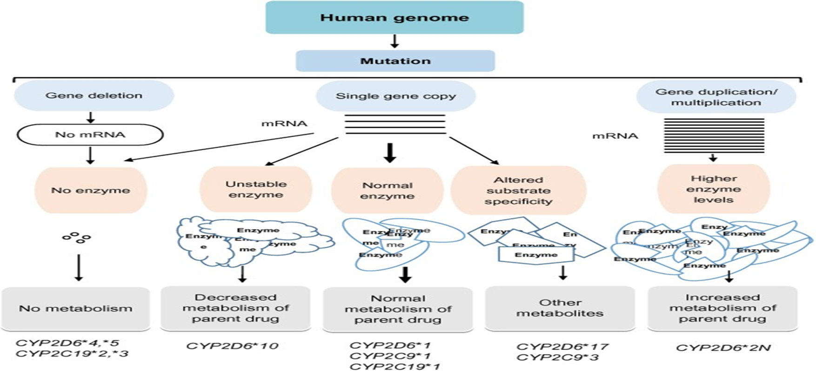
FIGURE 4. INFLUENCE OF GENETIC POLYMORPHISMS IN THE CYPS.

Influence of genetic polymorphisms of drug-metabolizing enzymes or transporters on drug–drug interactions :

Due to drug-drug interactions, the effects of one drug are affected by the coadministered medication, which may be attributable to the altered pharmacokinetic or pharmacodynamic features of the coadministered drug. Drug-metabolizing and transporter gene polymorphisms are a major risk factor for drug-drug interactions and varying interindividual drug responses [12]. These polymorphisms can result in lower amounts of a drug-metabolizing enzyme in a person, which can result in severe adverse drug responses when combined with enzyme inhibitors [13]. CYP2C9, CYP2C19, and CYP2D6 are involved in the metabolism of about 40% of commonly used medicines. Different CYP allelic variations have a substantial impact on an individual's vulnerability to drug-drug interactions and drug-metabolizing capacity. diverse medicines have diverse interactions with the CYP metabolic machinery[14].
Some medicines are preferentially metabolized by CYP enzymes; for example, metoprolol is largely metabolized by CYP2D6, but other pharmaceuticals, such as warfarin, may be metabolized by many CYPs, including CYP2D6, CYP3A4, and CYP1A2. Polymorphisms associated with differential expression of drug metabolizing and transporter genes will eventually change the therapeutic effects of medications supplied. When a drug is metabolized by more than one CYP metabolic pathway and the administered drug operates by blocking or activating CYPs, genetic polymorphisms may divert drug metabolism via alternative CYP pathways. This may result in drug-drug interactions. Antifungal voriconazole, for example, is actively metabolized by CYP3A4 and CYP2C19, but ritonavir dramatically inhibits CYP3A4 while increasing CYP2C19 metabolic activity.[15].
When CYP2C19 PM patients were given voriconazole with ritonavir, the AUC of voriconazole increased by up to 461%, since the patients were unable to metabolize voriconazole due to decreased CYP2C19 and CYP3A4 activity. In another situation, the antiplatelet activity of clopidogrel was lowered when combined with proton pump inhibitors such as esomeprazole and omeprazole due to CYP2C19 inhibition, but an increased activity of clopidogrel was expected when combined with rifampicin and aspirin. Clopidogrel is a prodrug that requires in vivo oxidative activation by CYP1A2, CYP2B6, and CYP2C19 to exert antiplatelet action. Due to the highly complex pharmacokinetics of clopidogrel, genetic variants in CYP2C19, CYP1A2, 2B6*6, and CYP3A5*3 were discovered to be related with the varying degree of drug-drug interactions.
Drug transporter gene mutations also contribute to drug-drug interactions and severe medication responses. OATP1B1 and ABCG2 actively transport HMGCR inhibitors such as atorvastatin, rosuvastatin, and pravastatin. Concurrent administration of cyclosporine (a powerful inhibitor of OATP1B1 and ABCG2) with statins such as rosuvastatin and pitavastatin results in increased statin plasma levels, leading to rhabdomyolysis. Because digoxin is potently removed by MDR1, coadministration with verapamil, clarithromycin, or talinolol, which block MDR1 transport activity, results in higher plasma levels due to lower renal clearance.
Drug Safety:

According to the Food and Drug Administration, major side effects from pharmaceutical medications affect 2 million people in the United States each year and may result in 100,000 fatalities. The annual cost of adverse drug reactions (ADRs) is estimated to be $136 billion. ADRs are classified into two types. One type is caused by medication overuse, such as taking too much of a medicine or taking the prescription too frequently or for too long. The second type involves the strange, atypical effects of numerous medications.. The term "idiosyncratic" refers to adverse effects that are not connected to drug dose and are regarded to be unpredictable. Many idiosyncratic effects, according to scientists, are caused by individual variation encoded in the DNA. Thus, genetic diversity in genes encoding drug-metabolizing enzymes, drug receptors, and drug transporters has been linked to individual differences in therapeutic efficacy and toxicity. Genetics is also at the root of hypersensitive reactions in people who are allergic to specific medications, such as penicillin, in which the body mounts a rapid, aggressive immune response that can produce not just a rash, but also difficulty breathing and swelling to the point of cardiovascular collapse.
Predicting significant adverse drug reactions (ADRs) is a top priority for pharmacogenomic research. For example, the enzyme CYP2D6, which is part of a class of drug-metabolizing enzymes found in the liver, degrades and terminates the activity of certain antidepressants, antiarrhythmics, and antipsychotics. More than 70 variant alleles have been identified by molecular cloning and characterisation investigations of the gene that codes for this enzyme (Meyer, 2000). These alleles have one or more point mutations, only a subset of which influence enzyme activity; nevertheless, several of these alleles have gene deletions and duplications, which can result in higher enzyme activity. Individuals who are homozygous or heterozygous for wild-type or normal activity enzymes (75%-85% of the population) are referred to as extensive metabolizers; intermediate (10%-15%) or poor (5%-10%) metabolizers are carriers of two alleles that reduce enzyme activity (Ingelman-Sundberg, 1999); and ultrarapid metabolizers (1%-10%) are carriers of duplicated genes. DNA chip microarrays can detect the most common alleles, allowing most patients to be allocated to a specific phenotypic group.

TABLE 1. EXAMPLES OF SOME DRUGS WITH GENETIC POLYMORPHISMS THAT IN?LUENCE DRUG EFFECTS IN HUMANS.
S.No. | Drug | Variable clinical effect | Genes with associated variants | Possible mechanism
1 | Azathioprine and mercaptopurine | Increased hematopoietic toxicity  reduced therapeutic effect at standard doses | TPMT | Hypofunctional alleles  Wild types alleles
2 | Irinotecan | Increased hematopoietic toxicity | UGT1A1 | decreased expression due to regulatory polymorphism
3 | Fluorouracil | Increased toxicity | DPD | abrogration of enzymatic activity due to exonic mutation
4 | Antidepressants  And beta blockers | increased toxicity  Decreased activity | CYP206 | hypofunctional alleles  Gene Duplication
5 | Codeine | decreased analgesia |  | hypofunctional alleles
6 | Omeprazole | peptic ulcer response | CYP2C19 | hypofunctional alleles
7 | Warfarin | increased anticoagulant effects  Reduced anticoagulant effects | CYP2C9  VKORC1 | coding region variants causing reduced S-warfarin clearance  variant haplotypes in regulatory regions to variable expression
8 | HIV protease inhibitors  Digoxin | decreased CD4 response in HIV infected Patients, decreased digoxin bioavailability | ABCB1 | altered P- glycoprotein function
9 | Abacavir | immunologic reactions | HLA variants | altered immunologic response
10 | Beta1 antagonists | decreased cardiovascular response | Beta1 adrenergic receptor | altered receptor function /number
11 | Beta2 antagonists | decreased bronchodilation | Beta2 adrenergic receptor | altered receptor function/ number
12 | Diuretics | blood pressure lowering | adducin | altered cytoskeletal function by adducin variants
13 | QT-prolonging drugs | drug inducing arrhythmia | ion channels  (HERG, KvLQT1, Mink, MiRP1) | exposure of subclinical reduction in repolarizing currents by drugs
14 | HMG-CoA reductase  Inhibitors | Low-density lipoprotein cholesterol lowering | HMGCR | altered HMG-CoA reductase activity

- MOLECULAR PROFILING BASED PRECISION MEDICINE:

MOLECULAR PROFILING:

It is a study that involves the examination of an organism's molecules such as DNA, RNA, and proteins. It aids in comprehending their unique structure, function, and interactions. There have been various technological developments, one of which has the ability to look into the tumor and identify the precise genes that cause any mutations or errors.It is employed in a variety of applications, including medicine, genetic variants, and mutation in biological processes[16].
Molecular based precision medicine is an approach to medical treatment and health care which looks into individual molecular profile for prevention, diagnosis and treatment strategies. It involves in examining the individuals genetic, genomic- proteomic and other molecules information to make more targeted and personalized medical decisions. This type of medicine are used to increase the therapeutic outcomes, reduce adverse effects and improve overall patients quality of life. Specially in the cases like cancer treatment and rare genetic disorder[17].

TYPES OF MOLECULAR PROFILING:

- Genomic profiling:

It is the study of how all of a person's genes interact with one another and with the environment. It can examine a large number of genes to discover substitutions, insertions, and detectors.. Genetics and genomics are two different terms, as the genetics refers to the study of single genes and how do they involving in passing down the specific traits from parents to off springs. Where as the genomics is individuals gene interaction among people and environment. Molecular profiling is a type of genomic test that checks the abnormal gene changes.

- Transcriptomic profiling:

- This is a transcriptome study that is used to comprehend the entire collection of ribonucleic acid (RNA) in a cell, including transcription, expression, functions, location, and destruction. It also reads the 5'-3' end sequences of transcripts and their parent genes, as well as splicing patterns and alterations. Transcriptomics encompasses all transcript types, including messenger RNAs (mRNAs), microRNAs (miRNAs), and several types of long non-coding RNAs (Inc RNAs). Transcriptomics is a modern technique for studying the expression of numerous transcripts under various physiological or pathological situations.

- Proteomic profiling:

It is the study the accurate measurement of abundance of proteins and phosphoproteins from multi sample. This method is used to understand the protein expression; modifications, interactions and functions in various biological processes and disease mechanism. This proteonic profiling can be accomplished by various methods such as mass spectrometry, two dimensional, gel electrophoresis, liquid chromatography, protein microarrays, short gun proteomics, top-down and bottom up proteomics. It is applied in identification of bio makers to diagnose the type of disease and measure the disease status and to measure a response to a treatment.

- Metabolomic profiling:

Metabolomics is a word used to describe the analysis of numerous small molecule metabolites in biological samples such as blood, saliva, and Metabolomics are the additions to the genomics, transcriptomics and proteomics. This study is done in various techniques to analyze the small molecules which can be intermediate or the end products of various cellular processes, which include:
  - Untargeted metabolomics: in which all the detachable metabolites are analyzed within a sample and allows a view of metabolite pathways and potential biomarkers. It usually involves comparison of the metabolite of control and test groups to identify the differences between their metabolite profiles. This is done in three steps: profiling, compound identification and interpretation.
  - Targeted metabolomics: it is study to takeout large number of targeted panels of selected groups of metabolites using mass spectroscopy. It mainly focuses on the qualification of specific set of metabolites which is suitable for studying specific pathways or compounds. These may include metabolites of lipids, COOH, organic acids and drug mertabolites.

- Lipidomics:

It is the study of total number of lipid content in a cell or an organ. Lipids play major role in energy storage, cell signaling and membrane structureMass spectrometry, liquid chromatography, and gas chromatography mass spectrometry are used to identify distinct groups of lipids such as fatty acids, phospholipids, and sterols. They are classed as follows:
Shortgun lipidomics:This is the untargeted metabolomics involves the direct analysis of lipid extracts using mass spectroscopy.
- Targeted lipidomics: This is the targeted which concentrates on the specific lipid classes or subclasses.
- Liquid chromatography- mass spectrometry lipidomics: This is done by utilizing liquid chromatography along with mass spectrometry to separate and analyze the lipid species based upon their mass to charge ratios.
- Gas-chromatography-mass spectrometry: This method is done by contains gas chromatography with mass spectrometry to analyze volatile and thermally stable lipid molecules such as fatty acids.
- High resolution mass spectroscopy:This method is done with enhanced mass accuracy and resolution, which improves the identification and quantification of lipid species.

- Epigenomic profiling:

- It is a science that involves the investigation of epigenetic markers in eukaryotic cells. It investigates DNA modifications and related proteins that influence gene expression without changing the DNA sequences. By regulating gene expression, this mechanism modifies local genome activity without affecting the underlying DNA sequences. This approach employs four primary mechanisms:
- i. The methylation of DNA.
- ii. Histone alterations.
- Compaction of chromatin.
- iv. Organization of nuclear weapons.
- The direct chemical addition of a methyl group to specific nucleotides in DNA is known as DNA methylation. Histone tail domains undergo a range of chemical changes; detection of this method is done using antibodies particularly designed to bind modified histone tails for immunoprecipitation with varying levels of resolution. Glycomic profiling:
Glycomic profiling can identify an entire set of N and O- glycons present in different range of biological material. It analyzes the entire set of glycons which are complex sugars present in a sample including secretions, cell lines, tissues and organs. Profiling of glycomic changes in a cell or organism can be used to provide overview on glycome, total glycosylation pattern of glycoprotein, glycolipids. N-glycomic and O- glycomic profiling are two common types of analysis.
There a certain types which include:
- Mass spectrometry:This method involves analyzing the mass to charge ratios of glycon ions which allows the identification and quantification of different glycon structures
- Liquid chromatography: This method profiling separates based on their size, charge or hydrophobicity. This method can be used along with the mass, spectrometry for aquarate glycan characterization.
- Lection microassays: lectins are the proteins that bind to specific glycan structure. This is a novel technique for analyzing glycans and glycoproteins that use a large panel of lectins immobilized on a well-defined substrate. Based on lectin binding patterns, this approach determines the glycan profiles of materials.
- iv. Matrix aided laser desorption / ionization (MALDI) imaging mass spectroscopy: This technology is utilized to investigate glycan distributions inside tissue sections for spatial visualization. This is accomplished by mass spectrometry, which allows for the fast profiling of various biomolecular species from biofluids and tissues. It also examines lipidomics, genotyping, microorganism identification, and metabolomics.
- Phosphoproteomic profiling:

It is the study to identify the phosphorylation events in proteins. This method is used to analyze the phosphorylated proteins, which have proteins that have phosphate groups attached to specific aminoacid, such as tyrosine, serine. This identify the A wide range of biological activities are involved, including signal transduction, cell cycle control, and protein-protein interactions. This takes place in many methods as:
- Sample preparation: cells and tissues are lysed to extract proteins. Phosphorylated proteins are identified by using immobilized metal affinity chromatography (IMAC).
- Protein digestion: The protein sample is digested into peptides using proteolyte enzyme like trypsin after that this produces a mixture of peptides, source of which contain phosphirylated residues.
- Phosphopeptide enrichment: This obtained phospho peptide are further enriched from the peptide mixtures by the method like titanium oxide chromatography.
- Mass spectrometry: Now, this enriched phospho peptides are analyzed using mass spectroscopy. Mass spectrometry data are processed and searched against protein databases to identify phosphorylated peptides. Analysis of the data involves identifying enriched phosphorylated peptides, pathway analysis and exploring biological functions.

- Methylomic profiling:

This is the study identifying DNA methylation patterns in a genome. This provides the understanding into gene expression regulation, biological, process and diseases. They are several types to study DNA methylation such as :
- Whole genome bisulphite sequencing ( WGBS): this method gives a complete view f DNA methylation by sequencing the entire genome after converting the unmethylated cytosines to uracils through bisulphite treatment.
- Targeted bisulphite sequencing: in this type, specific genomic regions of interest are amplified and sequence to analyze their methylation patterns.
- Methylation array: This is done by using micro array technology, which examines the methylation state of specific CPG sites across the genome, allowing for high throughput. These arrays include probes that hybridize with specific DNA regions.
- Bisulphite sequencing is the gold standard method for determining DNA methylation. When DNA is treated with bisulphite, unmethylated cytosines are converted to uracils, while methylated cytosines stay intact.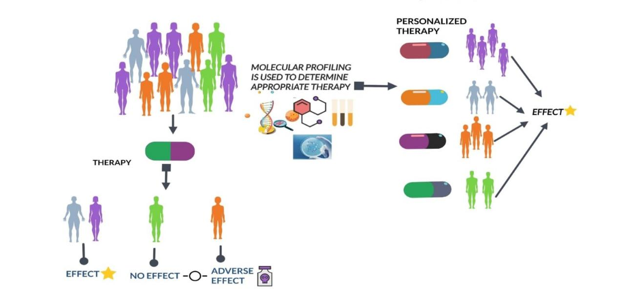
FIGURE 5. MOLECULAR PROFILING FOR APPROPRIATE THERAPY.

APPLICATIONS OF MOLECULAR PROFILING:

These have wide range of applications in research and medicine.
Cancer research and diagnosis: Molecular profiling can identify specific genetic mutations, gene expressions associated with different type of cancer. This information can aid in early diagnosis, prognosis prediction[18].
Drug discovery and development: Profiling molecular pathways and gene expression can identify potential dug targets and biomakers for drug response. This speeds up novel medicinal agent discovery and development.
Personalized medicine: Molecular profiling allows for medical treatment to individual patients depending on their genetics, which aids in enhancing therapeutic efficacy and safety
Genomic research: Molecular profiling helps in researchers to study the structures, function and variation of genomes which leads to evolution and genetic diseases.
Neuroscience: profiling techniques can provide information regarding gene expression patterns in the brain which helps to understand the neurological disorders and brain development of every individual.
Infectious disease research: This profiling can identify pathogen specific genes, proteins and immune responses which helps in the development of diagnostic tests and vaccines.
Forensic science: This profiling techniques like DNA fingerprinting are used for identifying individuals in criminal investigation and paternity tests[17].

- IMAGING BASED PRECISION MEDICINE:

Imaging-based precision medicine is a term used to define a medical strategy that combines advanced imaging technology in order to customize a patient's diagnosis, treatment, and management regimens. To learn in-depth information about a patient's anatomy, physiology, and molecular characteristics. It includes a variety of imaging techniques, such as magnetic resonance imaging (MRI), computed tomography (CT), positron emission tomography (PET), single-photon emission computed tomography (SPECT), and others.

Key components include:
- Personalised Treatment Selection: Clinicians can identify particular aspects of a disease that may respond better to particular drugs by analysing imaging data. Imaging, for instance, might direct the choice of targeted drugs in oncology based on the presence specific molecular markers.
- Diagnosis and classification: Precision imaging methods may give comprehensive knowledge into the kind and severity of diseases. For instance, depending on their metabolic activity, MRI and PET scans can assist physicians differentiate between various tumour types, allowing more precise diagnosis.
- Treatment monitoring : Apatient's response to treatment over time is possible through imaging. A treatment's efficiency or the need for modifications can be determined by changes in tumour size, metabolic activity, or other characteristics.
- Interventions with a Minimal Invasiveness: Imaging-guided techniques, such as image-guided biopsies or minimally invasive procedures, allow for precise targeting of diseased tissues having a Minimal Invasiveness while minimising harm to healthy surrounding tissue.
- Predicting Disease Progression: The risk of illness development can be predicted using longitudinal imaging data, which can also assist guide therapy choices. Brain imaging, for instance, helps monitor the development of amyloid plaques over time in conditions like Alzheimer's and other neurodegenerative disorders.
- Risk assessment and prevention: Imaging can assist in detecting early disease symptoms in people who are at risk, providing early intervention and preventative measures.
- Research and Drug Development: Imaging plays a crucial role in preclinical and clinical research, helping researchers develop new treatments, study disease mechanisms, and evaluate treatment efficacy.

TYPES OF IMAGING PRECISION MEDICINE

- Molecular Imaging: It is the monitoring and analysis of internal body molecular processes. Monitoring particular molecules or chemicals, such as glucose metabolism, oxygen consumption, or specific receptors related to diseases, is done using techniques like PET and SPECT.
- Functional Imaging: physiological mechanisms are captured using functional imaging techniques. Examples include dynamic contrast-enhanced MRI (DCE-MRI), which analyses blood flow patterns in tumours to track treatment response, and functional MRI , which estimate differences in blood flow to evaluate brain activity.
- Image-Guided interventions: Interventions that apply real-time imaging to guide them during medical operations are known as image-guided interventions. Examples include image-guided radiation therapy, which precisely targets tumours while minimising damage to adjacent tissue, and image-guided surgery, where preoperative images help doctors in navigating throughout procedures.
- Multi-Modal Imaging: This method integrates data from many imaging modalities (such as MRI, PET, and CT) to provide a more thorough and precise evaluation of a patient's condition. Combining several image types can help with treatment planning and diagnosis
- Pharmacokinetic imaging: uses imaging techniques to monitor how medicines are metabolised and distributed throughout the body. It can be used to predict drug reactions, assess therapy effectiveness, and optimise drug dose.
- Radiomics and Imaging Biomarkers: Radiomics is the process of defining tissue characteristics and disease traits by extracting quantitative data from medical pictures. These data can be utilized to create imaging biomarkers, which are quantifiable measurements that offer details on the presence, prognosis, and effectiveness of a disease. Radiomics and imaging biomarkers aid in the selection of a specific course of treatment.
- Theranostic Imaging: Theranostics combines focused therapy with diagnostic imaging. In this method, specific illness markers are identified using imaging techniques, and then specific medicines are administered right to those signs. For example, radioactive isotopes can be joined to molecules that bind to cancer cells, allowing the combination of therapy and diagnosis in a single step.
- Quantitative imaging: Measurement of physical characteristics from medical images, such as tumour size, density, blood flow, and more, is known as quantitative imaging. This information can be used to evaluate the course of a disease, how well a patient is responding to treatment, and their general health.
- Predictive imaging: Using imaging data, predictive imaging seeks to predict how diseases will develop and how treatments will work. Complex imaging information can be analyzed using machine learning and AI approaches to create predictive models, helping clinicians determines the most beneficial action.
- Imaging in Personalized Drug Development: To decide the effectiveness and safety of new drugs, medical imaging is also employed in drug development. Imaging may provide details about a drug's interactions with the body and its primary goal, enabling researchers to create more specialised treatment plans.

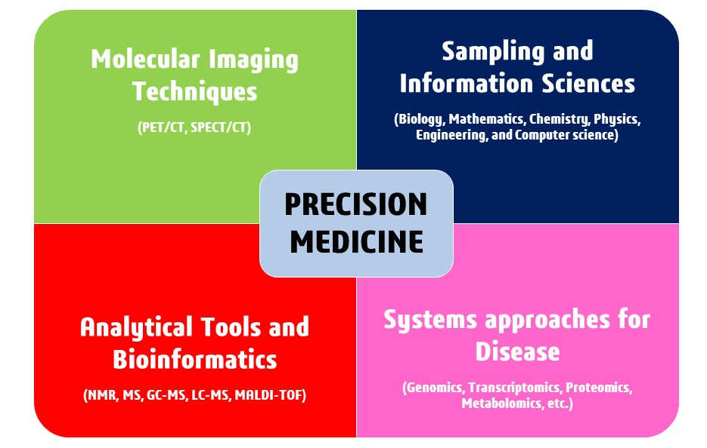
FIGURE 6. IMAGING BASED PRECISION MEDICINE

APPLICATIONS OF IMAGING BASED PRECISION MEDICINE:

Cancer diagnosis and treatment: The size, location, and features of tumors can be precisely determined by techniques like MRI, CT scans, and PET scans. With the help of this data, oncologists can choose the most effective course of action, be it surgery, radiation therapy, chemotherapy, or targeted therapies.
Neurological disorders: imaging methods such as functional MRI and diffusion tensor imaging may help in the diagnosis and understanding of disorders of the nervous system such as multiple sclerosis, Parkinson's disease, and Alzheimer's disease. These methods allow early diagnosis and specific treatment plans by monitoring alterations in brain structure and function over time.
Cardiovascular Medicine: Echocardiography, cardiac MRI, and coronary angiography are imaging modalities that are essential for diagnosing and managing heart diseases. They offer thorough insights on how the heart works, how blood flows, and how the blood vessels are doing, helping physicians make decisions about how to manage problems like heart failure, coronary artery disease, and arrhythmias.
Orthopaedics and musculoskeletal disorders: Imaging-based precision medicine helps in the diagnosis and treatment of soft tissue injuries , joint function, and bone density by orthopaedic specialists. For disorders including fractures, osteoarthritis, and sports-related injuries, methods like MRI and X-rays help with diagnosis and therapy planning
Personalized Radiation Therapy: In cancer treatment, precision medicine involves targeting radiation therapy based on the specific characteristics of a tumor. Advanced imaging techniques assist in accurately locating tumors and surrounding healthy tissues, enabling radiation oncologists to deliver higher doses to the tumor while minimizing damage to healthy tissue.
Minimally Invasive treatments: Real-time imaging is used to direct catheters, needles, or other tools to the precise site of a problem during image-guided treatments, including minimally invasive operations and interventional radiology. This improves the precision and safety of treatments, lowering patient risk and speeding up recovery.
Pharmacogenemics: Imaging can be useful in pharmacogenomic research, which examines how a person's genetic composition affects how well they respond to drugs. It is possible to create customised treatment programmes by combining genetic and imaging data to anticipate how patients will react to particular medications.
Trauma Care: Imaging technology like CT scans and X-rays are essential in both of these fields. They enable quick and precise injury evaluation, assisting healthcare professionals in making decisions about patient treatment more quickly.
Preventive healthcare:can result from early disease identification and risk assessment using imaging. As an illustration, coronary calcium scoring with CT scans can determine a person's risk of developing heart disease even before any symptoms show up.
Longitudinal Monitoring: Repeated imaging throughout time helps monitor the development of the disease and the success of treatment. This is helpful for diseases like cancer, where routine scans can track the effectiveness of treatment on the tumour.
Pediatric imaging: To reduce radiation exposure and ensure correct diagnosis, children frequently need specialized imaging procedures. Adapting imaging methods for pediatric patients while maintaining diagnostic accuracy is made possible by precision medicine methods.

- DIGITAL HEALTH AND WEARABLES IN PRECISION MEDICINE:

Precision medicine has witnessed considerable developments, with digital health and wearables playing a critical part in providing tailored therapy and care based on a patient's genetic profile. unique attributes, environment, lifestyle, and genetics, and through the data collected by these devices, they can help improve the quality of care for patients, medical treatments and interventions, early detection of the disease, which leads to more effective and efficient healthcare outcomes[21]. Here’s how they contribute in the precision field.

- Data collection and monitoring: by gathering and analysing large amounts of patient data, we can gain insights into individual characteristics and plan their treatment accordingly to approach an understanding why individuals and populations have different disease experiences. Furthermore aims to integrate various types of data including genetic information, health behaviours and environmental exposures to develop more effective and targeted strategies for improvements.
- Clinical data: plays a crucial role by providing valuable intuition into personal characteristics, including molecular biomarkers and behavioural patterns individuals. It has a wide range of information of patient’s health which consists of patient medical history , physical examination, diagnostics test , imaging studies, and treatment response. This data provides a clear picture of patient’s health status which helps us in making precised decisions for better patient outcome. It also aids in identifying disease pattern, symptoms and abnormalities along with genetic and molecular information which can differentiate the sub types of the disease. This also takes information from various laboratory tests such as blood tests, urine tests, or tumor markers about the organ function. It relies on clinical trial data which includes information on treatment effectiveness, side effects, and patient outcomes observed during controlled studies.
- Biomarkers data: are measurable indicators that helps to predict disease states, or response to treatments. They can be genetic, molecular, diagnostic, prognostic, predictive, monitoring.
- Genetic biomarkers: such as mutationsSNPs, or single nucleotide polymorphisms, are used to detect specific genetic changes linked to illness risk.
- Molecular biomarkers: such as proteins, RNA are used to provide insights into the underlying molecular changes associated with diseases.
- Diagnostic biomarkers: diagnose disease by identifying specific molecular or genetic condition of the disease.
- Prognostic biomarkers: this guides about likely course of a disease, which includes its aggressiveness, likelihood of recurrence, or progression.
- Predictive biomarkers: it demonstrates the likelihood of response to a specific and effective therapies for individual patient.
- Monitoring biomarkers: enables us to monitor therapy response, disease progression and make necessary adjustments.
- Omics data: focuses on the molecular complexities of diseases and designs personalised treatment strategies. This includes biological components such as genes, proteins, metabolites, and more. It enhances treatment selection and minimizes adverse effects, ultimately leading to improved patient outcomes.
- Health monitoring devices: development of health monitoring devices can be used at the point of care or even in comfort of one’s own home which gains access to tools that seamlessly integrate into their daily lives, allowing for continuous health monitoring and earlier identification of potential health issues. It monitors therapeutically important characteristics such heart rate variability, skin temperature, blood glucose levels, sleep quality, activity levels, environmental influences, and electrodermal activities. Continuous glucose monitoring sensors for diabetes, activity trackers for obesity, and smartwatches for cardiovascular health are a few examples of changeable devices. This devices collects data that is essential to personalise treatment plans and monitor patients for Complications could arise. Overall, it opens up new possibilities by enabling continuous, non-invasive monitoring of a person's health status..
- Electronic health record (EHRs): are digitized copies of clinical and demographic information such as a patient's medical history, laboratory and diagnostic test results, prescriptions, allergies, and more.
- Healthcare professionals can use EHRs to:
- Identify populations at risk: Identifies individuals with genetic predispositions, populations at risk of developing specific diseases and for managing targeted interventions.
- Monitor treatment response: Tracks a patient’s treatment progress over time, adjusts treatment plans to meet individual needs, and identifies any adverse effects that may require further assessment.
- Support medical research: provides vast amount of data to identify patterns and trends, test new therapies and develop new treatment strategies, ultimately leading to better out comes.
- Patient reported data: By matching clinical phenotypic data from patients, this data assists medical practitioners in accurately classifying and diagnosing diseases. Furthermore, it allows for the administration of customized preventative and treatment measures, ensuring that patients receive the relevant therapies at the right time. The incorporation of electronic patient reported outcomes into daily routine care demonstrated various advantages, including a greater understanding of patients' experiences, concerns, treatment goals, and the accuracy of patients' health information.

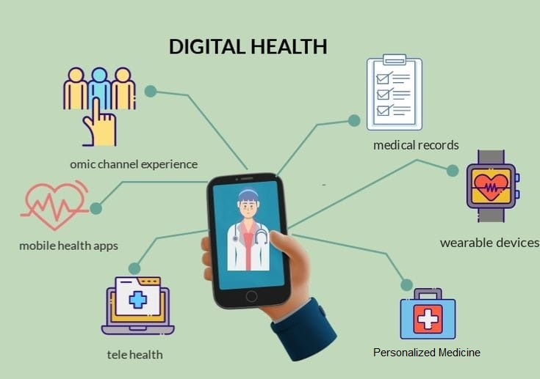
FIGURE 7. DIGITAL HEALTH

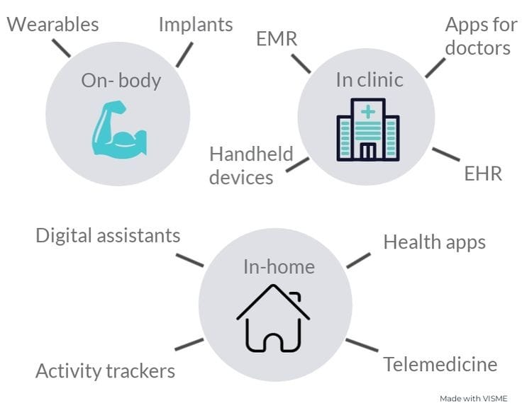
FIGURE 8. WEARABLES

APPLICATIONS OF DIGITAL HEALTHCARE AND WEARABLES

In digital healthcare the use of genomic sequencing combined with wearable sensors can be used for cancer treatments, by analyzing a patient’s genomic profile along with real-time physiological data from wearables, we can tailor treatments based on individual characteristics and monitor response rates more accurately and for early disease detection. Another application is remote monitoring using wearable devices for chronic disease management, better decision-making for dosing or adjustments in therapy in patient’s with other conditions such as diabetes, hypertension. Smartwatches now also offer additional features like electrocardiogram recording, blood pressure recording, blood glucose recording, and etc for more comprehensive, accurate health monitoring[22].

- DATA ANALYTICS & ARTIFICIAL INTELLIGENCE (DA & AI):

DA & AI Precision medicine seeks to adapt therapies to individual patients based on genetic, environmental, and lifestyle factors..
The DA & AI contributions are :
- Personalized Treatment: It includes tailoring medical care and the interventions to the exact characteristics of each individual patient. This strategy considers aspects such as:
- Genomic Information: Genetic data is a key component of personalized treatment .It identifies genetic mutations and variations that may affect drug responses . This helps in selective treatment that are having better efficacy and minimum adverse effect.
- Targeted therapies: with patient genetic information& molecular profile,with this the physician can choose the specially target the underlying mechanisms of a disease . This increases the likelihood of successful treatment with minimizing unnecessary side effects.
- Drug selection: It involves selections of medications based on patient’s genetic and metabolic traits . This helps to avoid the drugs that may be harmful / ineffective and helps to identifies those that are likely to work well for individual patient.
- Dosage Optimization: genetic information can influence how an individual metabolizes drugs. It determine the most appropriate dosage for each patient ,avoiding over/under dose .
- Early detection and prevention :personalized treatment allows for early detection of diseases and preventive measures and interventions to reduce the risk .
- Individualized care plans : the plan includes patient’s unique characteristics,medical historyand preferences.
- Monitorinig & adaptation:monitoring patients using sensors ,wearable devices,digital health tools. This data helps doctors to track treatment progress &adjustment needed.
- Patient engagement : patients are actively involved in treatment decisions. This leads to higher treatment adherence and better outcomes.
- Challenges: implementing personalized treatment collections,analysis privacy concers ,data security must also be addressed.

  - Genomic analysis: AI can analyze genomic data to identify genetic mutations &variationsthat may contribute to diseases.
- Sequencing Genomes:It starts with sequencing a persons entire genome or specific genes of interest.This involves determining the order of DNA bases (adenine,thymine,cytosine,and guanine) in their DNA.
- Genetic variations: It identifies genetic variations,such as single nucleotide polymorphisms(SNPS)or structural variations,that may be associated with disease risk,drug metabolism,and treatment responses.
- Disease Risk Assessment:By comparing an individuals genetic variants to known associations,genomic analysis .This help in early detection &preventive strategies.
- Targeted Therapies:genomic analysis can reveal specific genetic mutations driving diseases like cancer.
- Clinical decision support : provides clinlicals with eaddition information when making treatment decisions & informed care plans .
- Pharmacogenomics:predicts how a patient will respond to medications based on their genetic profile.
- Cancer genomics:genomic analysis of tumor tissue identifies genetic alterations that contribute to cancer development.
- Rare disease diagnosis:helps to diagnosis rare genetic disorders by identifying specific mutations responsible for condition.
- Data integration : genomic data is integrated with other health data such as medical history & environmental factors , to create a comprehensive picture .
- Research Advancenments:aggregating & analysis large scale genemoic data across populations help researches, novel disease associations potential therapeutic targets[23].

  - Predictive Diagnostics : It involves data sources, including genetic information, medical history and life style factors to predicts an individual’s risk of specific disease.
- Data collection: Genetic information, family medical history, environmental exposures, biomarker assays, and lifestyle habits are all included.
- Risk assessment: advanced algorithms analyse the collected data to assess an individual’s risk of certain disease .
- Early detection : to identify the disease risk before symptoms manifest detecting diseases at early stages leads to better outcomes &effective treatment.
- Customized screening: based on individual risk ,health care providers can recommend targeted screening test or monitoring protocols to detect disease .
- Preventive strategies: Predictive diagnostics enable the health care professionals to plan preventive strategies it includes life style modifications medication , interventions to reduce risk factors.

  - Drug Discovery: Involves identifying &developing medications that are tailored to the specific genetic , molecular, biological characteristics of individual patient. Aim is to increase the effectiveness of treatments with reducing side effects. It includes:
- Genomic analysis: Genetic & molecular data obtained through techinques like genomics sequencing to identify specific targets .
- Target identification:researchers pinpoint genes,proteins,pathways that are implicated in the disease.
- Biomarker discovery:which are specific molecular indicators of disease progression are identified to guide drug development& slelection.
- Rational drug designs :based on the identified targets &biomarkers drugs are designed to interact with the specific molecular mechanism.
- High-throughput screening:compounds are tested against the disease targets to identify potential drug.
- Preclinical testing:drug candidates undergo rigours testing in cell culture ,animal models to assess safety,efficacy,potential side effects.
- Clinical trials :drug that pass preclinical testing move on to clinical trials,which are often designed to target patient with specific genetic characteristics.
- Patient stratification: considers patient diversity with treatment to different genetic/molecular subgroup for maximum effectiveness.
- Data integration:involves genetic,molecular ,clinical,other data to make informed decisions at every stage.
- Iterative process:it involves refining compounds based on trial results&improving disease mechanisms.
- Faster development: This approaches can lead to faster drug development,and approvalswith high response rates.
- Challenges: Includes reliable disease targets ,addressing drug resistance ,ensuring drugs are accesscible to patients.

  - Clinical Trials: It involves tailoring Each patient receives individualized medical therapy.These trials seek to identify the best successful treatments based on genetic, molecular, and other relevant data. By identifying the right treatments for specific patients groups ,precision medicine can improve outcomes and reduce adverse effects.

  - Treatment monitoring: Involves closely tracking a patient’sresponse to personalized treatment plan.Includes regular assessment of biomarkers,genetic changes .Monitoring allows providers to adjust treatments as needed,ensuring to choose interventions remain effective and minimally harmful.

  - Population health insights: It involves the data from large groups of individuals to identify patterns , trends, genetic variations that can impact health outcomes.By studying diverse populations ,reserachers can uncover genetic factors that contribute to disease response to treatments ,overall health disparities.the helath insights help refine the precision medicine approaches making them more effective and different demographic groups.

  - Ethical considerations: It involves the isssues like privacy, data security,consents,equitable access to treatments, balancing personalized care with potential misuse of genetic information and ensuring diverse populations benefit are important aspects to address.
FIGURE 9. ARTIFICIAL INTELLIGENCE IN PRECISION MEDICINE

- PREVENTIVE PRECISION MEDICINE (PPM):

Preventive precision medicine (PPM) refers to advancement of technologies and personalized data to predict and prevent the disease before they occur
These are healthcare strategies based on a person's genetic and molecular characteristics. This strategy incorporates interventions such as genetic testing, environmental monitoring, health screening, immunization, early detection, lifestyle modification, targeted therapies, and education.
Genetic testing

In precision medicine, genetic testing techniques are used to analyze an individual's genetic makeup and find any genetic variants or mutations that may be connected with certain diseases or ailments. This information can help healthcare providers tailor treatment plans, intervention and susceptibility of disease the specific needs of each patient. Genetic testing measures can include various techniques such as DNA sequencing, gene expression profiling, and chromosomal analysis.

Environmental monitoring

Environmental monitoring in preventive precision medicine involves tracking an individual’s exposure to external factors that can influence health outcomes. These factors can include air and water quality, diet, exercise habits, occupation, and even social determinants of health. The goal is to understand how these environmental factors interact with an individual’s genetic and molecular makeup to impact their health and disease susceptibility.
Various sensors, wearable devices, and data collection methods are used to gather information about an individual’s environment. For example, air quality sensors can measure pollutants, Wearable fitness trackers, on the other hand, can monitor physical activity and sleeping habits.
Health screening

Health screening in preventive precision medicine aims to shift healthcare from a reactive to a proactive model .It involves the systematic and personalized assessment of an individual's health to detect potential diseases or risk factors at an early stage.

Immunization

Based on genetic information, healthcare professionals can select vaccines that are likely to be most effective for the individual. Genetic markers can help determine the most appropriate timing for vaccinations to ensure the best immune response and also predict an individual's likelihood of responding well to specific vaccines, helping prioritize vaccinations for diseased person.
By integrating genetic information into immunization strategies, preventive precision medicine aims to enhance the individualized effectiveness of vaccines, reduce the risk of adverse reactions, and contribute to more informed decision-making for both individuals and public health initiatives.

Early detection

Early detection involves the identification of initial signs of diseases or health risks before symptoms manifest. This approach relies on an individual's genetic and molecular data to pinpoint potential disease predispositions and employs targeted screenings, biomarker assessments, and personalized risk stratification to catch conditions at their inception. By intervening promptly, tailored treatments can be implemented, leading to more effective disease management and improved overall outcomes. This proactive approach not only benefits individuals but also contributes to broader insights into disease patterns and informs public health strategies.

Lifestyle adjustment

This approach tailors recommendations for nutrition, physical activity, sleep, stress management, and other lifestyle aspects depending on an individual's genetic susceptibilities. By aligning lifestyle choices with genetic insights, the aim is to mitigate the risk of diseases associated with specific genetic markers and promote long-term well-being. This proactive strategy empowers individuals to make informed choices, enhances disease prevention, and contributes to a broader understanding of effective preventive measures.
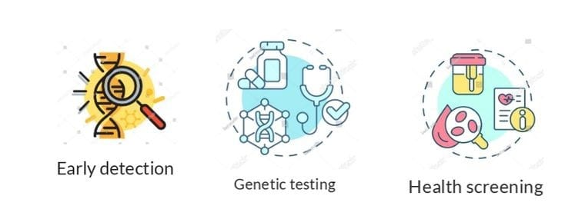
FIGURE 10. PRECISION PREVENTIVE MEDICINE
Targeted therapies

- It entails tailoring medical treatments to an individual's genetic and molecular make-up. This procedure seeks to reduce illness risks and improve overall health by:
- i. Genetic Analysis: The examination of a person's genetic and molecular data to find particular variations or anomalies that may contribute to illness vulnerability.
- Tailored Treatment: Selecting treatments, such as medications or interventions, based on the individual's genetic characteristics, targeting underlying factors that contribute to disease risk.
- Reduced Side Effects: By pinpointing the most appropriate treatments, the potential for adverse reactions and unnecessary side effects can be minimized.
- Early Action: Implementing these therapies at an early stage can prevent disease progression or lessen its impact.
- Continuous Monitoring: Regularly assessing the individual's response to treatment allows for adjustments if needed.
- Personalization: Treatment plans are uniquely tailored to the individual's genetic composition, maximizing their effectiveness.
- Informing Guidelines: Aggregating data on the success of targeted therapies can inform the development of broader medical guidelines and treatments
- Enhanced Outcomes: Targeted therapies contribute to improved disease management, ultimately reducing the burden of illness and promoting overall well-being[24].

Education

It is a process that involves individuals to make well-informed decisions concerning their health and disease prevention. Genetic Literacy, interpreting results, assessing risks, lifestyle changes, Personalized guidelines, ethical Awareness and professional understanding are the key components.
By providing education about genetic information, preventive precision medicine empowers individuals to actively engage in their health management, make informed choices, and collaborate effectively with healthcare providers in shaping personalized strategies for disease prevention. These approaches collectively aim to individualize healthcare strategies, leading to improved disease prevention and overall well-being management

REFERENCES

1. Akhoon N (2021) Precision Medicine: A New Paradigm in Therapeutics. Int J Prev Med 12:12. https://doi.org/10.4103/ijpvm.IJPVM_375_19
2. Naithani N, Sinha S, Misra P, et al (2021) Precision medicine: Concept and tools. Med J Armed Forces India 77:249–257. https://doi.org/10.1016/j.mjafi.2021.06.021
3. Lu CY, Terry V, Thomas DM (2023) Precision medicine: affording the successes of science. npj Precis Oncol 7:3. https://doi.org/10.1038/s41698-022-00343-y
4. Strianese O, Rizzo F, Ciccarelli M, et al (2020) Precision and Personalized Medicine: How Genomic Approach Improves the Management of Cardiovascular and Neurodegenerative Disease. Genes (Basel) 11:747. https://doi.org/10.3390/genes11070747
5. Burian AN, Zhao W, Lo T, Thurtle‐Schmidt DM (2021) Genome sequencing guide: An introductory toolbox to whole‐genome analysis methods. Biochem Mol Biol Educ 49:815–825. https://doi.org/10.1002/bmb.21561
6. Morash M, Mitchell H, Beltran H, et al (2018) The Role of Next-Generation Sequencing in Precision Medicine: A Review of Outcomes in Oncology. J Pers Med 8:30. https://doi.org/10.3390/jpm8030030
7. Ross JP, Dion PA, Rouleau GA (2020) Exome sequencing in genetic disease: recent advances and considerations. F1000Research 9:336. https://doi.org/10.12688/f1000research.19444.1
8. Lam YWF (2019) Principles of Pharmacogenomics :
9. Chandra R (2023) The role of pharmacogenomics in precision medicine. 1–13
10. Sakaeda T, Nakamura T, Okumura K (2004) Pharmacogenetics of Drug Transporters and Its Impact on the Pharmacotherapy. Curr Top Med Chem 4:1383–1396
11. Mini E, Nobili S (2009) Pharmacogenetics: implementing personalized medicine. Clin Cases Miner Bone Metab 6:17–24
12. Geick A, Eichelbaum M, Burk O (2001) Nuclear Receptor Response Elements Mediate Induction of Intestinal MDR1 by Rifampin. J Biol Chem 276:14581–14587. https://doi.org/10.1074/jbc.M010173200
13. Muller C, Bailly JD, Jaffrezou JP, et al (1994) [Pharmacological control of P-glycoprotein expression]. Bull Cancer 81:386–91
14. Sukhai M, Piquette-Miller M (2000) Regulation of the multidrug resistance genes by stress signals. J Pharm Pharm Sci 3:268–80
15. Ahmed S, Zhou Z, Zhou J, Chen S (2016) Pharmacogenomics of Drug Metabolizing Enzymes and Transporters : Relevance to Precision Medicine. Genomics Proteomics Bioinformatics 14:298–313. https://doi.org/10.1016/j.gpb.2016.03.008
16. Gambardella V, Lombardi P, Carbonell-Asins JA, et al (2021) Molecular profiling of advanced solid tumours. The impact of experimental molecular-matched therapies on cancer patient outcomes in early-phase trials: the MAST study. Br J Cancer 125:1261–1269. https://doi.org/10.1038/s41416-021-01502-x
17. Zhang Q, Fu Q, Bai X, Liang T (2020) Molecular Profiling–Based Precision Medicine in Cancer: A Review of Current Evidence and Challenges. Front Oncol 10:1–9. https://doi.org/10.3389/fonc.2020.532403
18. Malone ER, Oliva M, Sabatini PJB, et al (2020) Molecular profiling for precision cancer therapies. Genome Med 12:8. https://doi.org/10.1186/s13073-019-0703-1
19. Society E (2015) Medical imaging in personalised medicine: a white paper of the research committee of the European Society of Radiology (ESR). Insights Imaging 6:141–155. https://doi.org/10.1007/s13244-015-0394-0
20. Shaw A, Seban R, Besson FL, et al (2022) Editorial: Breakthrough in Imaging-Guided Precision Medicine in Oncology. Front Oncol 12:10–13. https://doi.org/10.3389/fonc.2022.908561
21. Giansanti D (2023) Precision Medicine 2.0: How Digital Health and AI Are Changing the Game. J Pers Med 13:1057. https://doi.org/10.3390/jpm13071057
22. Kasoju N, Remya NS, Sasi R, et al (2023) Digital health: trends, opportunities and challenges in medical devices, pharma and bio-technology. CSI Trans ICT 11:11–30. https://doi.org/10.1007/s40012-023-00380-3
23. Fröhlich H, Balling R, Beerenwinkel N, et al (2018) From hype to reality: data science enabling personalized medicine. BMC Med 16:150. https://doi.org/10.1186/s12916-018-1122-7
24. Golubnitschaja O, Kinkorova J, Costigliola V (2014) Predictive, Preventive and Personalised Medicine as the hardcore of ‘Horizon 2020’: EPMA position paper. EPMA J 5:6. https://doi.org/10.1186/1878-5085-5-6

