World Bread Map

Zeynep ÇINAR
Department of Hotel, Restaurant and Catering Services
Karamanoglu Mehmetbey University
Karaman, Turkiye
zeynepcinar@kmu.edu.tr

Hülya Yaman, Ph.D.
Department of Food Processing,
University of Bolu Abant Izzet Baysal
Bolu, Turkiye
hulyayaman@ibu.edu.tr
Sevtap YAVUZ
Department of Gastronomy and Culinary Arts
Bolu Abant İzzet Baysal University
Bolu, Turkiye
sevtapyvz@gmail.com

ABSTRACT

While ancient civilizations consumed mixtures of water and various seeds, the progress of humanity has led to a widespread array of ingredients and improved production techniques for bread-making. The utilization of fire marked a shift to settled living and agriculture. Cultivating wheat and milling it into flour introduced the concept of bread. The revolutionary discovery of yeast transformed traditional bread, allowing the creation and consumption of soft, fluffy, and substantial loaves. Over time, diverse types of bread have emerged, influenced by distinct cultures, geographical locations, religions, dietary preferences, climates, and ways of life.
Originating in Mesopotamia, bread embarked on a journey of diversification and enrichment as it traversed through different countries and societies, ultimately resulting in the abundance of bread varieties in today's global culinary landscape.

Keywords: bread, global bread varieties, culinary culture, local breads, traditional bread

- INTRODUCTION

Humanity mixed various seeds with water to create a slurry and then cooked them on hot stones, thus marking the inception of the first bread [1]. The discovery of fire around 800,000 years ago [2] necessitated communal living, as fire management required people to be together. With fire's discovery, settled societies turned to agriculture in their newfound regions, refining wild grains for consumption. These grains gradually evolved into flour, giving rise to the concept of bread [3]. The notions of leavened bread, bakeries, and baking emerged in ancient Egypt, diffusing throughout Mesopotamia, Greece, Ancient Rome, and Europe, eventually becoming a global staple [4].
Throughout history, these changes in bread-making have impacted cooking techniques. While slurry breads were baked on heated stones, the concept of ovens developed with leavened breads. The growing human population heightened food demand over time, leading to the professionalization of baking. Consequently, nourishing and economical bread became a fundamental sustenance [1].
This study delves into the historical evolution of bread, offering insights into contemporary global bread characteristics and types. The research encompasses American bread, British bread, Scandinavian bread, Spanish bread, French bread, Italian bread, German bread, Eastern European and Russian bread, Middle Eastern and African bread, Indian bread, Far East country bread, Australian bread, and last Turkish bread.

II. THE JOURNEY OF BREAD

The story of bread reaches far back into antiquity. Through the cultivation and milling of grains, the discovery of yeast, and the evolution of baking techniques, humanity has arrived at the cherished and globally consumed form of bread.
For millennia, grains have provided a significant portion of the energy required for human survival. Thus, cereal varieties represent one of the most pivotal food sources in human food culture history [5]. Barley marked the first grain cultivated in history, while wheat, extensively used in bread production, entered the scene much later. The diversity of wheat encompasses approximately thirty thousand varieties. Among these are ancient wheat species like einkorn, gernik, and kavuzlu, encased in a tough husk that requires removal through heat. This process, termed 'threshing,' historically involved animal-driven machinery or manual beating. The separated wheat was subsequently crushed between stones to yield flour. Though these procedures remained manual until 800 BC, animal-powered methods gained prevalence afterward. The flours derived from these processes were typically coarse, and the heat employed therein inadvertently damaged the gluten protein responsible for bread leavening. Consequently, early breads emerged flat and dense.
Around 7000 BC, a strain of wheat with a weaker husk emerged, ushering in a transformative change. This evolution halted the inadvertent heating process, allowing for the production of high-gluten flours [6].
The oldest remains of wheat have been discovered in present-day Palestine territories. It is believed that wheat spread from Palestine to Mesopotamia and then onwards to Egypt, Cyprus, and Crete. When suitable cultivation conditions for wheat were found, it began to be manufactured abundantly, marking the beginning of wheat's global dissemination. There are numerous years between wheat cultivation and bread production [7]. The origins of bread, which consist of flour, water, and salt in their simplest form and were produced in ovens in nearly every neighborhood in the past, can be traced back to ancient times.
According to the prevailing belief, ancient people observed pores forming in soaked cracked wheat that was left alone, and they perceived that its flavor was enhanced when they cooked this porous structure on hot stones. With the discovery of fire and advancements in agriculture in Mesopotamia, as well as the refinement of wheat, the flour usage obtained from wheat and barley emerged for bread-making, replacing seeds. The concepts of bakeries and baking first appeared in Ancient Egypt, where leavened bread was also initially produced. This practice then spread to Greece and Ancient Rome before extending throughout Europe.
While barley-based brown bread was consumed earlier, in the 15th century, the nobility began producing and consuming white bread as a symbol of distinction. In 1780, the inception of commercial baker's yeast in the Netherlands marked the onset of the modern bread production process. Over time, white bread became a representative status and prosperity, resulting in widespread adoption. Today, it remains as fundamental food item accessible to everyone due to its cost-effectiveness.
As bread spread across Europe and later to every corner of the globe, it adapted to the unique characteristics of each nation's culture, including culture, geography, climate, and lifestyle. Wars, famines, religious beliefs, and societal food cultures contributed to the diversity of bread types. Today, breads with similar or entirely distinct structures are produced and consumed worldwide [1, 3, 4, 8, 9].
Furthermore, bread symbolizes unity and solidarity. The provenance of the English word "company," which currently signifies companionship, friendship, or a group, comes from a Latin word that means "those who eat bread together." A similar expression exists in Turkish society, known as "sharing the same bread," which signifies friendship [7, 10].
Additionally, bread holds religious significance in Islam and other divines, commanding respect in nearly every society. In Turkish culture, it is considered a gift from Allah and is referred to as 'nan-ı aziz,' or 'sacred bread,' in Ottoman terms [10]. In Turkish and other cultures, bread carries spiritual value alongside its role as a nutritional resource.

- VARIETIES OF WORLD BREADS

It would be unjust to perceive bread as a mere amalgamation of flour, water, and salt, disregarding the rich culinary diversity of societies. The Italian focaccia embodies the abundance of the Mediterranean climate, while the French brioche stands as a testament to the French ardor for butter. Today, a global stage showcases an array of locally crafted traditional breads from numerous countries, including Mexico's tortilla, Italy's ciabatta, France's iconic 'baguette,' and India's 'chapatis.' Bread, in this sense, transcends borders and social classes [10].
Since the dawn of humanity, societies have dictated what, how, and when to consume. Among the pivotal determinants, geography holds a paramount role. Countries limited by geographical constraints from cultivating specific ingredients could only access new products brought by the discovery of America in the late 15th century, thanks to figures like Columbus. Geography also played a crucial part in shaping essential aspects such as the main components of bread and the conditions of its preparation. For instance, the choice between wheat and rye flour for bread production often hinges on European geography. The cultivation of rye, particularly in the frigid conditions of Northern Europe and Russia, has led to its prevalence there. Meanwhile, in Southern and Central Europe, wheat takes precedence in bread production [3,10,11,12]. In the Far East, where rice serves as the staple food, the spectrum of bread crafted from wheat flour tends to be narrower compared to other regions.

A. Bread Varieties of Americas
With the arrival of European colonists to the continent, a fusion of eating and drinking customs between the indigenous populations and the colonial nations took place, resulting in a diverse culinary culture. The African slaves brought by colonial powers and the encounters with Arab and Jewish communities played a significant role in shaping this amalgamated culinary culture. While terms like 'hamburger,' 'potato,' and 'steak' might be the first to come to mind in relation to American cuisine, this blended culinary culture, born from the coexistence of various traditions, has introduced numerous culinary practices from this continent to the global stage. A prominent example is the fast food movement. Moreover, the United States leads the global bread marketing, with sourdough bread disseminated worldwide [13,14]. Although classic American breads are often characterized by sweetness, richness, and whiteness, exceptions like the "San Francisco Sourdough" exist, displaying more distinctive qualities [15].
Bagel; One of the bagel's two distinctive traits is its method of boiling before baking, while the other lies in its strong association with Jewish culture. A specialty originating over 400 years ago in Poland, the bagel gained broader recognition when Polish bagel artisans transplanted their craft to New York in the early 1900s. By the 1950s, the bagel had firmly established itself as a quintessential New York dish, featuring prominently in American breakfasts and achieving worldwide popularity [16].
Burger Bun; It is a type of bread invented by Walter Anderson in 1916. It is the most consumed fast food bread around the world. After the fermented dough is shaped, egg white is spread on a bun and cooked by sprinkling on sesame seeds [15]
Pullman Loaf; The Pullman loaf, named after the Pullman company that devised baking pans for its distinctive square shape, is America's most widely produced bread. Known as "Pain de mie" in French cuisine, it has found a place in French culinary culture. While the French often employ it for toasting, its thickness and shape make it a preferred choice for crafting the classic French sandwich "croque-monsieur." Rich oils used in its preparation lend it an extended freshness. Though typically mass-produced and sold pre-sliced in markets, it can also be easily prepared at home [15,17].
Graham Bread; Sylvester Graham developed this high-fiber toast bread in the 19th century by incorporating a significant amount of bran and molasses to support leavening. Amidst an era marked by the pervasive use of additives in baked goods, Graham's Bread reponded as an advocate for wholesome eating. Intriguingly, this bread was also historically used as dog food due to its additive-free nature, unlike other bread types deemed unfit for canine consumption [15,18].
Swirl Bread; As the name implies, swirl bread involves rolling out bread dough like thick phyllo pastry, filling it with various ingredients, rolling it into a log, and baking it in molds [15].
Beer Bread; Also known as "Irish Guinness Bread," beer bread is leavened using beer, resulting in a subtly sweet flavor [15,19].
Yankee Cornbread; This bread type is regarding with North American cornbread, a staple food [15].
San Francisco Sourdough; San Francisco sourdough bread holds a unique distinction as the world's first transported yeast. In 1858, the Boudin family brought yeast from France to San Francisco, where the local air and water influenced its development, giving it a distinctive character. This thick, intensely sour-sweet bread is highly popular and often used in soups. Its unique properties set it apart, as the original yeast's distinguishable attributes do not exist in other foods.
Hoagie Roll; The "Hoagie Roll," beloved in the United States, is a long roll-shaped bread traditionally used for crafting a variety of sandwiches. These rolls boast a soft interior and a slightly crustier exterior. Typically, it is made from flour, milk, oil, egg, yeast, salt, and sugar, and variations also incorporate sesame seeds [20].
Frybread; Named the official state bread of South Dakota in 2005, frybread is a flatbread fried in lard. Rooted in Native American Navajo tradition, this bread originated during captivity and famine terms for the Native people [20].
Bolillo; "Bolillo" is a Mexican bread reminiscent of a French baget, created using a similar dough. Its name translates to "small stick," referencing the rolling pin used in production. It has believed that this bread was influenced by French bread during Mexico's French intervention period (1861-1867) [20].
Tortilla; "Tortilla" is a foundational bread in Mexican culture, with thousands of years of history. The first tortilla was crafted from maize, a staple in indigenous cultures [20].
Casabe; Derived from cassava flour, obtained from the cassava plant indigenous to northern South America, "Casabe" is a traditional Venezuelan flatbread known for its thin and crispy texture [21].
Bammy; A traditional Jamaican flatbread, "Bammy," is made from cassava flour. In conventional production, the dough is immersed in coconut milk before being fried or steamed. Often purchased from local vendors, it is commonly enjoyed for breakfast or alongside fish dishes [21].
Banana Bread; "Banana Bread" gained prominence in American cookbooks during the 1930s because of favor trends in baking soda and baking powder. Some food historians suggest it emerged during the Great Depression when resourceful women sought to repurpose overripe bananas. National Banana Bread Day is observed on February 23 every year [16].

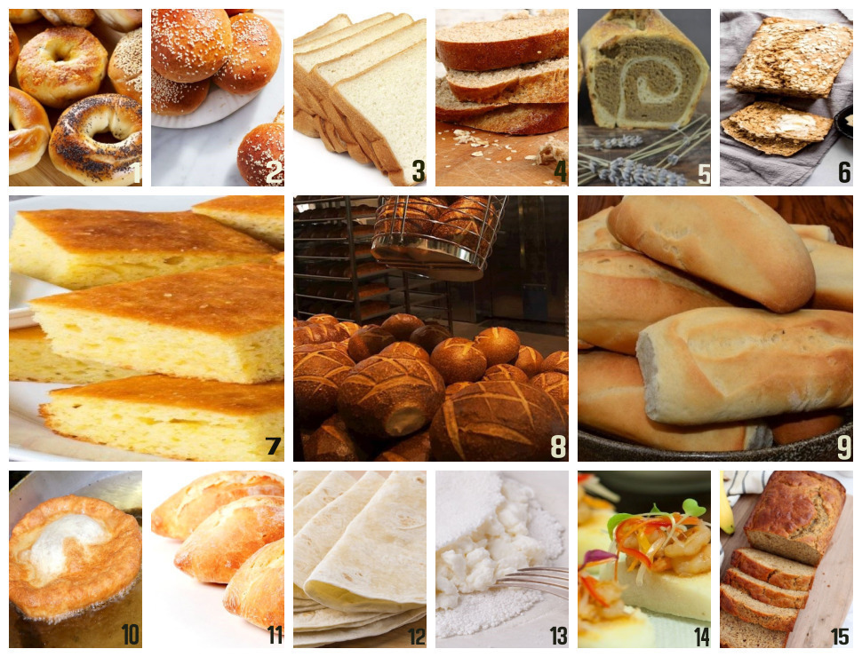

Figure 1: America’s breads; (1) Bagel [22], (2) Burger Bun [23], (3) Pullman Loaf [17], (4) Graham Bread [18], (5) Swirl Bread (taken by authors), (6) Beer Bread [19], (7) Yankee Cornbread [24], (8) San Francisco Sourdough [25], (9) Hoagie Roll [20], (10) Frybread [20], (11) Bolillo [20], (12) Tortilla [20], (13) Casabe [21], (14) Bammy [21], (15) Banana Bread [16].

Apart from the ones mentioned, other bread types belonging to the American continent are as follows; “Basic White Bread” (basic white bread), “Brown and Whole-Wheat Bread” (whole wheat flour black bread), “Tomato/sun Dried Tomato Bread” (dried tomato bread), “Dill Bread” (dill bread), “Chocolate Bread” (chocolate bread), “Triticale Bread” (bread produced with triticale flour, which is a hybrid of wheat and rye), “Oatmeal Bread” (oat bread), “Lemon Bread” (lemon bread), “Cheddar Cheese Bread” ( cheddar cheese bread), “Rye Bread” (rye bread), “Zucchini Bread” (pumpkin bread), “Cranberry Nut Bread” (blueberry and hazelnut bread), “Arepa” (usually Venezuela, Colombia, Panama, Puerto Rico and Round disc-shaped cornbread consumed in the Dominican Republic), “Marraqueta” (the most popular type of bread consumed in Chile), “Pan de Queso” (Colombian round bread with cheese), “Chipa” (casava (cassava) Paraguayan bread made with flour, lard and anise), “Pan de Bono” (Colombian bread served with hot chocolate), “Bollo” (traditional Colombian bun wrapped in corn leaves), “Pan de Huevo” ( Chilean egg roll), “Pan de Yuca” (a type of bread popular in Colombia and Ecuador, consisting of cassava (cassava) flour, cheese and egg), “Pan Amasado” (Chilean small, round and flat bread white bread loaf), “Pepperoni Roll” (pepperoni rolls served with West Virginia marinara sauce), and “Texas Toast” (large sliced bread used with roast pork and garlic or used in fondues and chicken sandwiches)[15,20,21].

B. English Breads
England, the largest and central nation within the United Kingdom, is situated in Western Europe on the Island of Great Britain. Its imperial nature led to the transference of various products from most countries into British culinary culture. British cuisine, shaped by Roman influence in ancient times and French influence during the Middle Ages, is often described as multicultural [27]. Traditional English breads frequently feature sweet and rich flavors.
Anadama Bread; One of England's renowned bread is "anadama." This bread has an intriguing story: Once upon a time, a woman named Anna lived in England. She was very lazy, spending her days enjoying tea at five o'clock and neglecting her cooking duties for her husband. Every evening, she would serve bread made from molasses and cornmeal to her fisherman husband. Fed up with this routine, her husband finally burst out in frustration, exclaiming, "Anna damn her!" This phrase gave rise to the name "anadama" for the molasses and corn flour bread. Typically enjoyed warm with butter and cinnamon, this sweet bread has endured through time [12,28].
English Muffins; "English Muffins" are round bread rolls measuring around 10 cm in diameter and 3.8 cm in height. They can be manufactured by using yeast or sometimes sourdough [29]. These muffins are typically sliced horizontally and toasted before serving. They share similarities with Anatolian bazlama in terms of preparation and cooking techniques. Commonly consumed for breakfast, they are preferred to eat with hollandaise sauce, fried pork ham, and poached eggs.
Scone; An essential part of English tea time, "scone" comes in numerous variations across Scotland and England. Baking soda or baking powder is added for swelling instead of yeast. Possessing a texture that falls between cake and cookie, scones are a form of sweet pastry. They are commonly preferred to eat with butter, strawberry jam, fresh Devonshire cream, whipped cream, or a lemon cream known as lemon curd [30,31]. There are also grilled variations of scones that may include ingredients like cranberries, hazelnuts, chocolate chips, and dates [32].
Yorkshire Pudding; These hollow breads are a customary accompaniment to roast beef (or whole oven-roasted chicken), a well-known Christmas dish in Britain. When there is no yeast, baking soda, or baking powder in the kitchen, eggs are used as the primary swelling agent. Thus, after adding eggs, they incorporate one at a time to keep the air within the mixture. Yorkshire pudding is served alongside roast beef or chicken, often with a savory gravy sauce [33].
Hot Cross Bun; These are round buns with raisins typically consumed for breakfast or tea drinking time in Britain island. Traditionally baked for Good Friday, they are believed to offer protection from misfortune and calamities throughout the coming year. Their name comes from the cross made with a soft decorative paste [16].

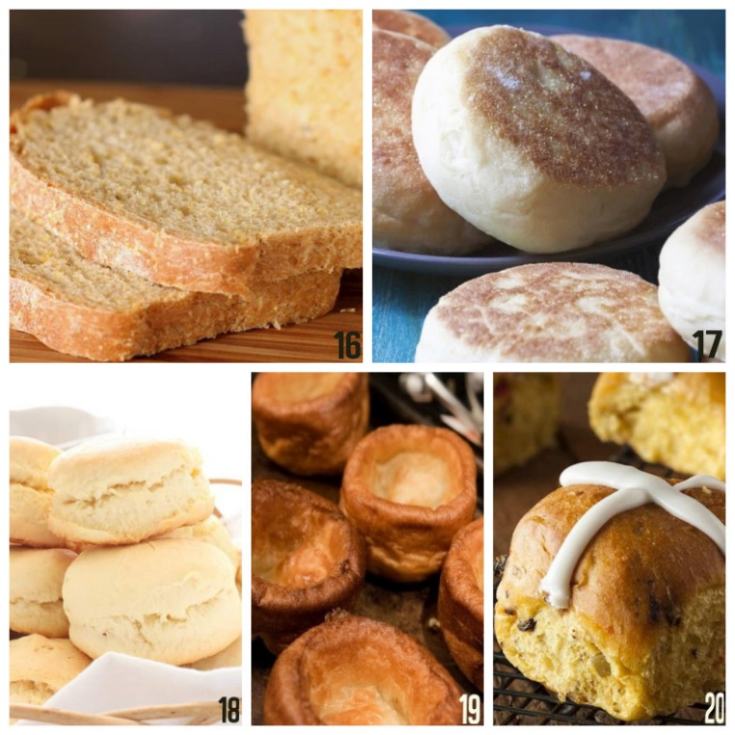

Figure 2: English breads; (16) Anadama Bread [34], (17) English Muffin [35], (18) Scone [32], (19) Yorkshire Pudding [36], (20) Hot Cross Bun [37].

Except as stated, “Barm Cake” (white round bread used to serve the famous British dish “fish&chips”), “Dorset Knop” (English rusk or biscuit), “Kentish Huffkins” (a type of hole-in-the-middle bread), “Stottie Cake” (a bread with a hole in the middle) A soft, dense and delicious bread characterized by an indentation) and “Hawkshead Wig” (round bread with cumin seeds in the dough) are other types of bread belonging to the British culinary culture.

C. Scandinavian Breads
In Scandinavian countries, where culinary culture is affected by the abundance of fishery products due to the extensive coastal lines, a predominant consumption of poultry and pork can be observed. The cold weather conditions give rise to dishes that are typically oily, starchy, and sweet. Game meats also find wide usage. Rooted in a history dating back to the Vikings [38], the culture in Scandinavian countries is a blend of hunting, urban life, travel, and immigration. The cold climate has fostered the production and consumption of multi-grain bread to provide lasting fullness and warmth.
Rögbröd "Rögbröd" is a hearty and flavorful Danish rye bread due to the plenty of grain species. It often boasts a brown hue and elongated rectangular shape. The bread is crafted with rye flour, whole or broken rye grains, sunflower seeds, pumpkin seeds, and flax seeds ingredients. Distinguished by its lack of liquid or solid fat, "Rögbröd" is rich in whole grains and dietary fiber. This bread gained popularity first in Denmark, then spread to Finland, Russia, Iceland, Estonia, Germany, and Latvia. Typically, it is thinly sliced, buttered, and enjoyed with toppings like smoked fish, shrimp, boiled egg, liver pâté, cucumber, or mayonnaise [15, 16, 39].
Tresse Bread (Zopf); "Zopf," meaning "braided" in German, refers to the bread's distinctive braided shape. It's a soft, thinly crusted Swedish bread with a sweet touch, enriched with milk and butter in the dough. Traditionally made on weekends, "zopf" is savored with butter and fruit jams. Legend has it that this bread originated in the mid-15th century. Women used to bury their braided hair alongside their deceased husbands; later, they began to bury this cooked braided bread symbolically [40].
Vörtbröd (Vörtlimpa); "Vörtbröd" is a Scandinavian rye bread with a sweet profile. It's flavored with spices and orange peel, then grilled in a unique lidded container. It pairs well with various jams and cream cheese.
Kavring; "Kavring" is Swedish rye bread infused with fennel, cumin seeds, and molasses syrup. Traditionally enjoyed with gravlax, pickled herring, Christmas ham, pickles, or boiled eggs during the Midsommar Festival, Easter, or Christmas [41].

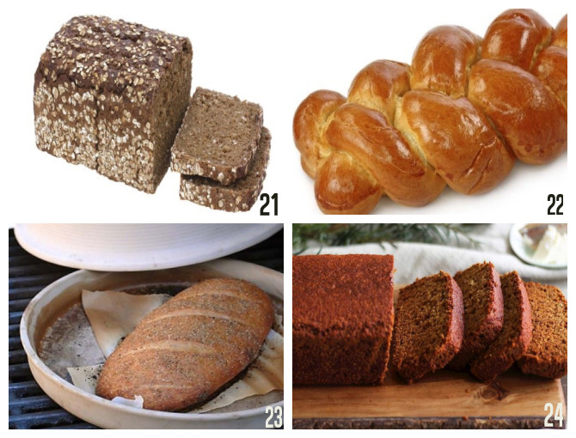

Figure 3: Scandinavian breads; (21) Rogbröd [39], (22) Tresse Bread (Zopf) [40], (23) Vörtbröd (Vörtlimpa) [42], (24) Kavring [41] .

Other than those specified; “Julekage” (Christmas bread with fruit), “Fasterlavnsboiller” (apple cinnamon bread produced at Carnivals), “Smorrebrod” (rye bread with butter), “Cardamom Bread” (Swedish bread with cinnamon and cardamom), “Caraway Bread” (cumin and soda bread) ), “St. Lucia Buns” (S-shaped bread made for Saint Lucia, decorated with raisins), “Knackerbrod” (leaf breadcrumbs or rusks made from rye flour), “Rieska” (Finnish flatbread), “Chleb Zwykly na Zakwasie ” (Polish rye bread with sugar), “Cherni Hleb” (traditional Russian black bread), “Borondinsky” (traditional Russian black rye bread), “Lefse” (a Norwegian flatbread-like bread), “Hönökaka” (herring) perforated Swedish bread served with bread, “Tünnbröd” (thin Swedish bread with a long shelf life), “Lompe” (a traditional Norwegian flatbread using potatoes), “Flatbröd” (traditional Norwegian unleavened flatbread), “Gáhkku” (Swedish flat bread consumed with salted and smoked reindeer meat, butter or cheese) and “Mjukkaka” (round Swedish bread usually baked in a brick oven) are various types of bread from Scandinavian countries [15,43].

D. Spanish Breads
Spanish culinary culture is known for its significant impact on global cuisines, blending influences from the East and West due to its proximity to the sea and the variety of local products around the country [44]. Staples of Spanish cuisine include olive oil, seafood, tomatoes, garlic, and bread. Bread is a constant companion to many Spanish dishes, and even a simple combination of bread and extra virgin olive oil on the table can suffice for a satisfying meal for the Spaniards.
Pan de Aceite "Pan de Aceite," often served as an appetizer alongside extra virgin olive oil, is made from leavened dough and baked on trays. It shares similarities with the well-known Italian 'focaccia' in point of view production technique and appearance.
Hornazo / Hornazo de Salamanca "Hornazo," also regarding the Spanish Easter Pie, is created by enclosing a mixture of various vegetables or deli products within the leavened dough and baking it. Traditional fillings include boiled eggs and chorizo (Spanish sausage) [45].
Pan Gallego "Pan Gallego" is a distinctive sourdough bread specific to the Galicia region of Spain [46]. It features a firm and crunchy outer crust while maintaining a soft interior. It's typically baked in elongated or round shapes.
Pan de Cea Created by kneading 'masa madre,' a pre-fermented yeast dough, into an elastic and robust dough, "Pan de Cea" is baked in special wood-fired ovens with granite bases. These ovens contribute to the bread's distinct characteristics [47].
Pan de Barra Found throughout Spain, "Pan de Barra" is the most popular bread for crafting bocadillos, foundational in Spanish cuisine. While similar to a French baguette, it often boasts a hard and dry texture [48].

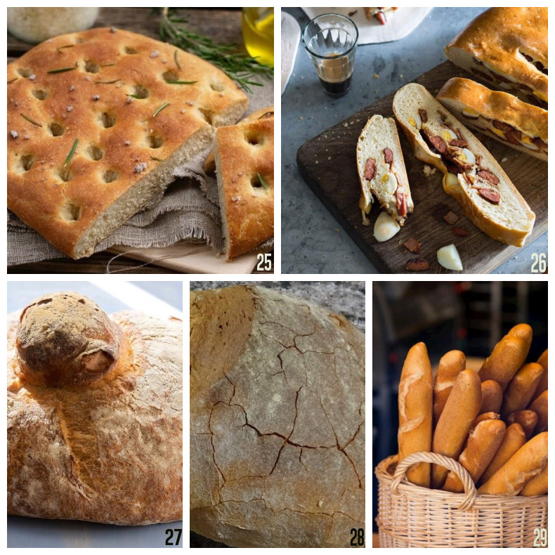

Figure 4: Spanish breads; (25) Pan de Aceite [49], (26) Hornazo [50], (27) Pan Gallego [46], (28) Pan de Cea [47], (29) Pan de Barra [48] .

Other than those specified, “Pan de Espania” (the sponge cake that forms the basis of classical pastry), “Pan Cateto” (rustic village bread from the Andalusia region), “Ensaimada” (marmalade bun made of yeast and sugar dough), “Pan Quemado” (sweet pastry with lots of eggs and sugar) ), “Gofio” (a bread made with roasted grain flour), “Pasqua Coca” (Easter bun) and “Majorcan Potato Buns” (potato mini buns) are other types of Spanish cuisine culture.

E. French Breads
In France, the diversity of food is greatly affected by the country's geographical location, which encompasses a range of climates from continental to mountainous, as well as its proximity to seas and oceans [51]. Bread has not only taken a place as a staple in French culture but has also become a symbol of social class distinction. Historically, bread consumed by peasants and nobles differed, but this distinction has largely faded away today. French breads are now produced and enjoyed around the world [52].
Baguette; The "Baguette" is a beloved French bread with global popularity. It is known and characterized by its long, thin shape, crisp outer crust, and soft interior. Due to its shape, it's sometimes referred to as "cane bread" [15,52]. During World War II, food shortages led to poor-quality bread due to low-quality flour. This situation prompted French millers and bakers to form a union over time. The endeavor for unification and quality improvement, starting in the 1980s, culminated in 1993 with the settlement of rules and enactment for traditional French bread, including the baguette, through official regulations. This law defined the weight, content, length, and thickness of an authentic French baguette, leading to the baguette as we know it today [16]. It's used in sandwiches, croutons, and bruschetta throughout France commonly.
Fougasse; "Fougasse" is a bread made during Christmas in the Provence region of France. It incorporates ingredients such as bacon pieces, caramelized onions, fresh spices (thyme, rosemary, basil, fennel), and lavenders from the renowned lavender gardens of the region. The bread is shaped to resemble a leaf and is often enjoyed with olive oil [15,52].
Tordu of Pain; This bread, hailing from the Limousin region of France, is now known worldwide. It's baked in a twisted shape, and its name is derived from an auger shape [15,52].
Brioche "Brioche" is a renowned French bread possessing leavened and sweet bread features, and its dough contains ample butter and eggs. It's often baked in small molds [1,52]. The name "brioche" has been used since the 15th century. After the 19th century, with the advent of commercial yeast in bread-making, which supplanted traditional pre-ferments, changes occurred in the recipes, adapting them to the new yeast [16].
Pain de Campagne; "Pain de Campagne" translates to "country bread," often in the form of a big round loaf (miche). It's a sourdough village bread crafted by white wheat and rye flour admixture. Traditionally, it weighs between 1.5 kilograms and 5 kilograms. Given its hearty nature, it's highly satisfying [15,16,52].

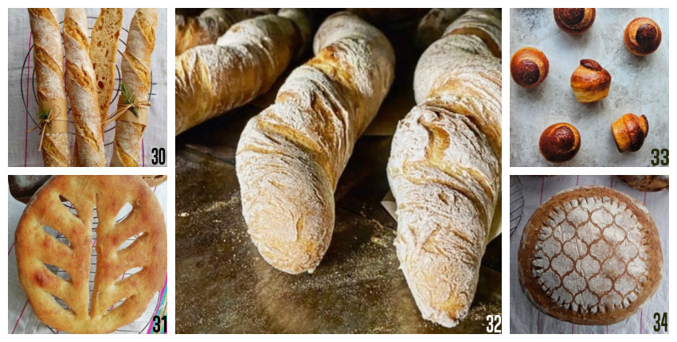
Figure 5: French breads; (30) Baguette (taken by authors), (31) Fougasse (taken by authors), (32) Pain Tordu [53], (33) Brioche [16], (29) Pain de Campagne (taken by authors).

Other than those specified; “Vienna Rolls” (a type of tiny bread known as a French product, as it was originally prepared by Austrian masters for the 1867 Paris Fair), “Croissants” (world-famous, French national bun), “Epi” (wheat ear-shaped baguette), “Pain Aux Noix” (whole wheat bread with walnuts), “Pain de Mie” (French toast bread), “Pain de Seigle” (rye bread, also called black bread), “Pain Polka” (round sourdough bread made to depict the polka dance on bread) bread), “Pain Battu Au Fromage” (bread with cheese inside and on), “Pain Allemand Aux Fruits” (fruit bread made at Christmas), “Pain Au Levain” (traditional sourdough bread), “Boule De Meule” (The traditional loaf of bread produced in large weights is famous for its 4 square-shaped scratches), “Pain de Provence” (spicy, liqueur and lavender bread), “Cereale” (whole grain bread) and “Couronne” (round bagel made to represent the king's crown) shaped bread) are other types of bread belonging to the French culinary culture [15].

F. Italian Breads
In Italy, the concept of large families and abundant meals is ingrained in the culture. Bread holds a significant place in Italian culinary traditions, with each region boasting its own unique types of bread. Italy is renowned for several popular breads that are recognized worldwide, including "focaccia," "ciabatta," "stromboli," "schiacciata con l'uva," "pane di ramerino," and "grissini" [12].
Focaccia; "Focaccia" is a tray-baked bread with a shape derived from the baking tray it's cooked on, usually rectangular. It's often considered the precursor to Italian pizza due to its abundant toppings. A defining characteristic of "focaccia," originating from the Genoa region, is its generous use of olive oil. The bread has a soft and spongy texture. While the ingredients varies by region, common ones include caramelized onions, black olives, fresh herbs (rosemary, mountain thyme), sun-dried tomatoes, and mushrooms. After baking, olive oil is rubbed onto the surface to enhance flavor and shine, followed by a sprinkle of Maldon salt and fresh herbs before serving [1,52,54].
Ciabatta; "Ciabatta" is often regarded as "Italian slipper bread" and is made in the Genoa and Bologna regions. This yeast-based dough, made with white wheat flour, is exceptionally soft due to its high water content. The name "ciabatta," meaning "slipper" in Italian, comes from its shape resembling slippers during the shaping process. When baked, it results in a large, airy bread with a crispy crust. It's commonly used for sandwiches and accompaniment to other meals [12,16,52].
Stromboli; Named after the island of Stromboli, this bread is filled with Italian cheeses, meats, and vegetables before being rolled and baked. It's a hearty and flavorful bread that resembles a pizza roll due to its abundant fillings [52].
Schiacciata Con L'uva; This special bread hails from the Tuscan region, known for its association with the Renaissance and wine. It's made using grapes harvested during the grape harvest season. The yeast dough, prepared from white wheat flour, is adorned with grapes from the previous harvest. The result is a traditional sweet bread that beautifully marries the flavors of old and new grape harvests [52].
Grissini; Originating from the Turin region, the north of Italy, "grissini" have gained international recognition. These breadsticks are made from white wheat flour dough and shaped into thin, elongated sticks. The sticks are brushed with egg yolk and then baked after being coated with sesame seeds or fresh herbs, as desired. With their crispy texture, "grissini" are commonly served alongside soups in many restaurants. Variations of these breadsticks are found in ovens worldwide. They are now produced industrially and available for purchase in markets [1, 16, 52].

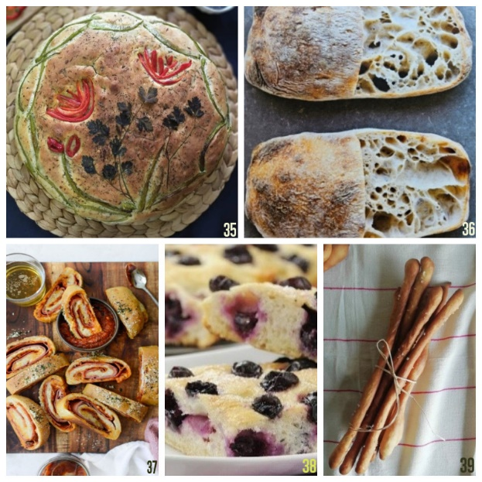

Figure 6: Italian breads; (35) Focaccia (taken by authors), (36) Ciabatta [16], (37) Stromboli [55], (38) Schiacciata Con L'uva [56], (39) Grissini (taken by authors).

G. German Breads
Germany boasts an impressive array of breads, with nearly 500 distinct types generally consumed for breakfast. Rye is an essential ingredient in German bread making, and the country has a distinctive approach to sourdough due to the dominance of pure culture production technology. The influence of Polish bakers living in Germany has also played a role in bread-making traditional shapes [15].
Pumpernichel; "Pumpernichel," also known as "schwarzbrot" or black bread, is a rye flour bread originating from the Westphalia region of Germany. In its traditional form, cracked or whole rye and rye flour are boiled for several hours to soften the bread. The unique aspect of its preparation involves baking at low temperatures in special stone kilns. The bread is first steamed at 200 degrees and then at 100 degrees for 16-24 hours, allowing the ingredients' proteins to caramelize, creating a distinctive taste, aroma, and texture. The dark bread color is formed due to the rye flour and the Maillard reaction occurring during the extended baking process [16,57].
Vollkornbrot; "Vollkornbrot" translates to whole grain bread in German. According to German bread standards, it must be sourdough-based and consist of at least 90% rye flour. This bread incorporates sunflower seeds, sea salt, yeast, rye flour, and sour, without wheat. Its sharp taste and satisfying nature make it a staple in Austria, Switzerland, and Germany. Rye is favored in these regions due to its digestibility and higher nutritional value than wheat [16].
Bretzel (Pretzel); The beloved "Bretzel" or "Pretzel" originated in Germany and has become an iconic symbol of bakeries and guilds since the 12th century, with popularity extending globally. This salty snack, resembling a sailor's knot, can be enjoyed at any time of day. The traditional shape is maintained worldwide, adding to its recognizable appeal [16].
Brötchen; "Brötchen" is the general term for small breads in Germany. The dough is often enriched with milk, cream, and butter. Typically consumed during breakfast or used for sandwiches, "Brötchen" offers a versatile and convenient bread option [1].

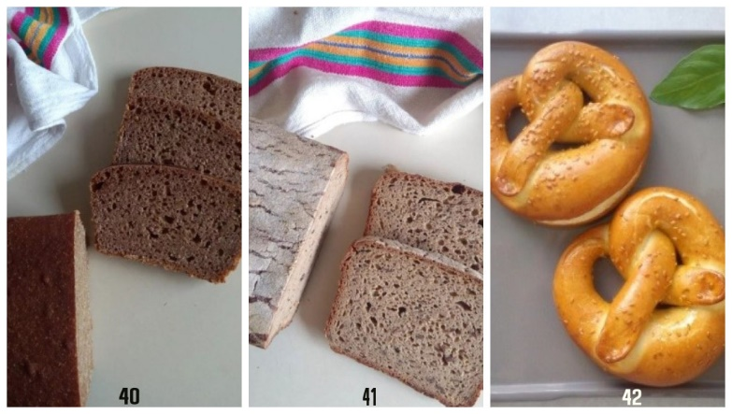

Figure 6: German breads; (40) Pumpernichel (taken by authors), (41) Vollkornbrot (taken by authors), [16], (42) Bretzel (taken by authors).

H. Eastern European and Russian Breads
Eastern European breads, which include countries like Russia, Belarus, Armenia, Estonia, Georgia, Kazakhstan, Latvia, Lithuania, Moldova, Ukraine, and more, often share similarities in recipes and ingredients. Here are some notable Eastern European breads:
Borodinsky Bread; "Borodinsky Bread" is a renowned Russian bread that has gained global popularity. It is healthy and delicious with its intense rye flavor and sourdough base. The bread contains roasted rye (solot), cumin, molasses, and coriander. Coriander usage as a grain on the bread is a nod to its historical origin, as it represents shrapnel pieces from its historical context [58].
Estonian Rye; "Estonian Rye" is a traditional brown bread made from rye flour, reflecting Estonia's long history of rye production. The bread, baked from yeast dough, boasts a uniform and filling interior, showcasing the region's traditional agricultural product [59].
Russian Braided Bread; "Russian Braided Bread" involves applying various fillings into yeast dough made from white wheat flour. The dough is cut lengthwise and shaped into braided patterns, creating visually striking bread. Variations include fillings like pesto sauce, cinnamon, or chocolate, offering flavor and aesthetic appeal [60].
Kolach; "Kolach" is a soft, sweet bread hailing from Ukraine. It holds significance during Christmas, often enjoyed with or without fillings. The bread has become a cherished part of Ukrainian culinary traditions [61].
Kulich; "Kulich" is a private Eastern European bread associated with Easter celebrations. Made from leavened dough with white wheat flour, it features a sweet and raisin-filled interior. Ingredients like citrus juice or peel, vanilla, rum, ginger, and saffron enhance its flavor. Widely consumed in countries like Ukraine, Russia, Georgia, Bulgaria, Romania, Serbia, and Slovakia, the bread is taken to church on Easter morning and later shared among family members [62].
Babka;"Babka" is an Eastern European bread of Polish origin, commonly enjoyed by Jews in the region and recognized worldwide. It is prepared with leavened dough in layers and is often filled with chocolate and sometimes fruit nuts, giving it a distinctive twist. The bread's popularity extends beyond its place of origin [16].

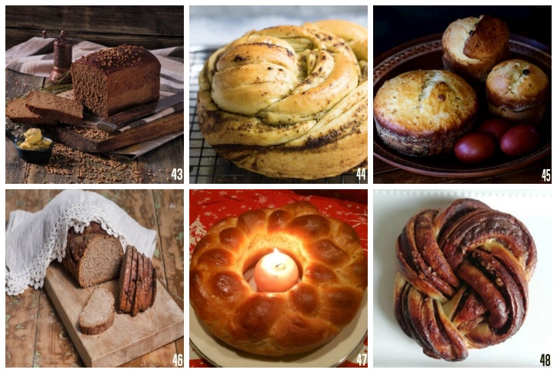

Figure 7: Eastern European and Russian Breads; (43) Borodinsky Bread [58], (44) Estonian Rye [59], (45) Russian Braidad Bread [60], (46) Kolach [63], (47) Kulich [62], (48) Babka (taken by authors).
- Middle Eastern and African Breads
Bread plays a significant role in Middle Eastern and African cuisines, influenced by their food culture of juicy and oily dishes, appetizers, and hand-eating habits. Many of the breads produced in these regions are flatbreads that offer convenience for enjoying meals. Here are some notable Middle Eastern and African breads:
Lavash; "Lavash" is a flatbread commonly enjoyed in African countries and the Middle East, particularly in Iran and Turkey. The term "lavash" is often used to refer to various types of flatbreads. Originating in the Middle East, lavash has gained popularity worldwide. The dough is rolled out thinly and oval-shaped before being baked in specialized ovens called tandoors [1,52,64].
Nan-e Barbari; "Nan-e Barbari" is the traditional bread of Iran. The dough, made from white wheat flour and yeast, is prepared in a thick and oval shape then baked. Its surface is often decorated with sesame, black cumin, or poppy seeds. This bread is commonly eaten for breakfast with cheese and fresh herbs [52,64].
Pita; "Pita" is a type of bread originating from Turkey and is also prevalent in other Muslim Middle Eastern countries, especially during Ramadan. The dough, containing white wheat flour and yeast, is shaped into a thick, round form and topped with sesame and black cumin seeds [1,15,16,52].
Pita Bread; "Pita Bread" is believed to be one of the oldest types of bread in the world, dating back to around 2500 BC in the Middle East. It is an excellent accompaniment to dishes like steak, lamb, falafel, kebabs, or chicken. Traditionally, it is served with hummus, tzatziki sauce, or tabbouleh [65].

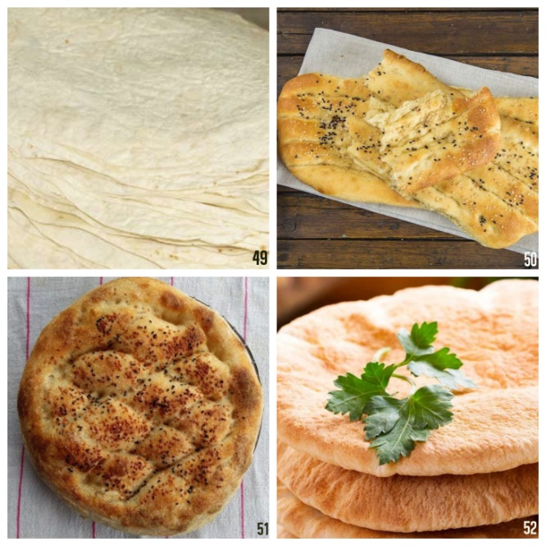
Figure 8: Middle Eastern and African Breads; (49) Lavash (taken by authors), (50) Nan-e Barbari [66], (51) Pide (taken by authors), (52) Pita Bread [65].

J. Indian Breads
Indian cuisine boasts a rich variety of breads complementing diverse spicy and flavorful dishes. Here are some notable Indian breads:
Naan; Naan" is a popular type of flatbread often enjoyed alongside spicy traditional Indian dishes. The dough taste is enhanced with ground coriander seeds, red pepper powder, and garlic seasoning before being cooked in a tandoor (clay oven) or on a metal sheet. It is often brushed with "ghee," a clarified butter used in Indian cuisine, and can be paired with "dal," a spiced lentil dish that is a staple in vegetarian Indian cuisine [33,67].
Pappadam; "Pappadam" is a crispy bread made from various flours, such as lentils, chickpeas, rice, or corn flour, and prepared using corn flour and fried in coconut oil. Traditional methods involve communal production, where Indian women work together. The dough is rolled into small round pieces, sun-dried on mats, and then fried for consumption. Industrially produced pappadams are often sold in frozen form and ready for baking at home [33,68].
Chapati; "Chapati" is an unleavened flatbread commonly enjoyed in India. It is often referred to as the "Indian lavash." Cooked on both sides, it is a staple accompaniment to spicy Indian dishes. The name "chapati" comes from the Hindi word "chapat," which means to slap, reflecting the traditional method of shaping the dough by swiping it between one's palms [69]. It has a slightly firmer texture compared to Anatolian lavash.

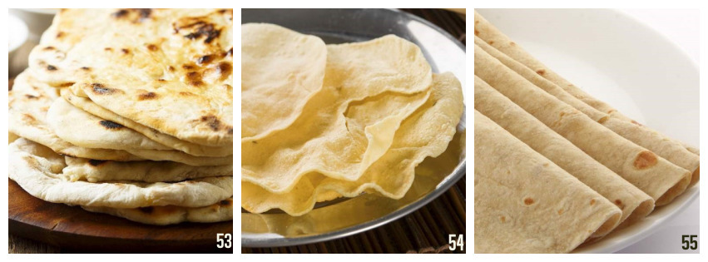
Figure 9: Indian Breads; (53) Naan [70], (54) Pappadam [71], (55) Chapati [69].

K. Far East Countries and Australian Breads
In Far East countries, rice is the staple food, and wheat flour bread is not as common as in these regions. Rice, obtained by cooking rice to a mushy consistency, is an indispensable part of every meal, including breakfast. In Japan, rice is equivalent to wheat bread in Western cultures. While terms like 'bread is ready' and 'finish your bread' are commonly used in Anatolia, similar expressions such as 'the rice is ready' and 'finish your rice' are used in Far East countries, emphasizing the significance of rice, similarly in bread [33]. Consequently, bread varieties made from wheat flour are not as numerous in Far East countries.
Hokkaido (Japanese bread); Hokkaido is a milk bread originating from Japan. It stands out due to including a roux known as "TangZhong." This roux is created by thickening specific proportions of flour and water through heating. The resulting texture and softness set this bread apart.
Melonpan (Melon Bread); Melonpan is a sweet bread unique to Japan. It involves two doughs: the first is leavened dough made from white flour, while the second is a mixture of butter and sugar with added flour, creating a cream-like consistency. Small meringue-like forms are made from the leavened dough, while the other dough is rolled into thin circles and coated with granulated sugar.
Mantou; "Mantou" is a plain Chinese bun commonly steamed and consumed in northern China. Similar to the role of bread in Western cultures, mantou is a staple food for the Chinese. Typically, unfilled, it holds significant importance in Chinese cuisine.
Damper; "Damper" is a traditional bread from Australia cooked on campfire embers, historically. It is an unleavened bread made from flour, water, salt, and baking powder. Originally associated with outdoor cooking, it was a widespread food for explorers and settlers. Today, damper dough is baked in ovens, and bread is served with soups, meat dishes, jams, and butter, or even used as a sandwich bread with various ingredients added [73].

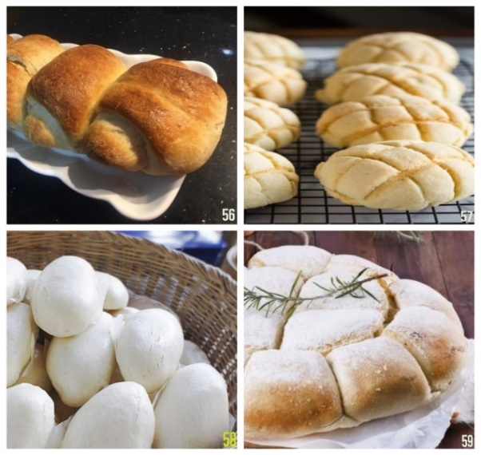
Figure 10: Far East Countries and Australian Breads; (56) Hokkaido (taken by authors), (57) Melonpan [74], (58) Mantou [72], (59) Damper Bread [73].

L. Turkish Breads
Bread, a fundamental element of Anatolian cuisine, holds profound respect among the people. From a young age, children are taught that bread is sacred and revered; the tradition dictates that if a piece of bread is seen on the ground, it should be picked up, kissed, and placed on a high surface. Numerous Turkish proverbs and idioms mirror the significance and esteem accorded to bread. Even today, swearing an oath is done by invoking bread, as in the phrase "let the bread hit the Quran," aligning it with the holy book. Expressions like 'earning one's bread,' 'bread money,' and 'fighting for bread' connote profitability, while 'losing one's bread' signifies losing one's revenues of livelihood. In Turkish culture, eating is symbolized as 'eating bread' [75], and when meals are ready, mothers beckon their households by calling out, 'We are going to eat bread, come on, gather around.'
Similarly, due to the belief that wasting bread is a sin, plenty of recipes have been devised by reusing stale or dry bread throughout history. Dishes such as tires, dried bread chopped and soaked in broth, bread-based desserts soaked in syrup, and bread dipped in baked egg on span for breakfast the exemplify the creative utilization of leftover bread.
Turkey boasts a diverse array of region-specific bread varieties. Despite variations in ingredients, production techniques, and baking methods, the predominance of these bread types is crafted using sourdough. Initiatives are underway to officially document these bread types, preserving their authenticity and passing them down to future generations. The Turkish Trademark and Patent Office has registered specific bread types and granted geographical indications, as listed in Table 1[76], alongside their respective cities and ingredients.

Table 1. Geographically Marked Breads in Turkiye [76]

Bread Type | City | Name of Origin/  Sign of Origin | Content | Appearance
Malatya Sour Bread | Malatya | Sign of Origin | Wheat flour, dry yeast, sourdough, salt, water. | 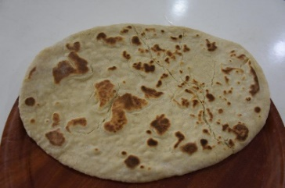
Polat Kınalı Bread | Malatya | Sign of Origin | Whole wheat flour, dry yeast, salt, water, milk, egg, butter, sunflower oil, black cumin, whole wheat flour, sesame, baking soda. | 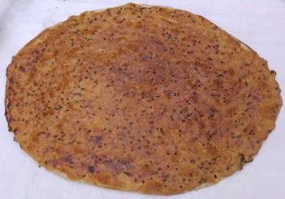
Rize Baston Bread | Rize | Sign of Origin | Bread flour, fresh yeast, salt, water. | 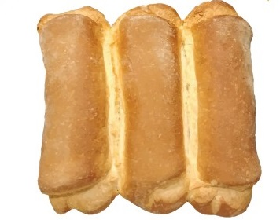
Çankırı Yoka (Thin) Bread Amulet | Çankırı | Sign of Origin | Yoka (thin bread made with wheat flour, water and salt, baked on a sheet metal), Kupecik Cheese, roasted and dried minced meat, butter. | 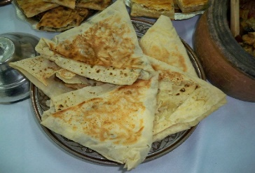
Afyonkarahisar Potato Bread | Afyonkarahisar | Name of Origin | Wheat flour, water, salt, sourdough, boiled potatoes. | 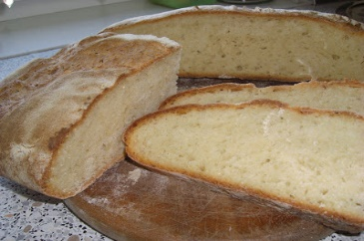
Afyon Övmesi | Afyonkarahisar | Sign of Origin | Wheat flour, fresh yeast, potatoes, water, salt, yellow poppy paste, baking soda, granulated sugar, sunflower oil. | 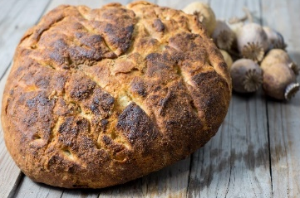
Alaşehir Bread | Manisa | Sign of Origin | Wheat flour, water, salt, sourdough (prepared with grape juice), sesame. | 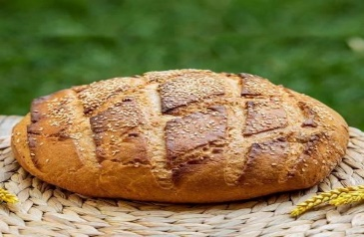
Antep Kübban Bread | Gaziantep | Sign of Origin | Wheat flour or whole wheat flour, salt, water, baker's yeast. | 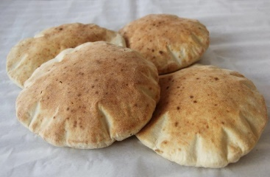
Bartın Çöven Bread | Bartın | Sign of Origin | Wheat flour, corn flour, wheat bran, sourdough, fresh yeast, salt, water. | 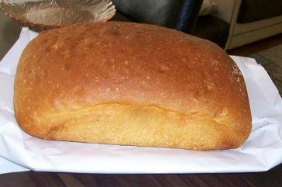
Bolu Potato Bread | Bolu | Sign of Origin | Wheat flour and/or whole wheat flour, water, boiled potatoes, sourdough, fresh yeast. Optionally, black cumin, poppy, etc. can be added to it. | 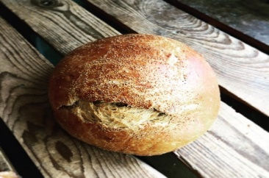
Cihanbeyli Gömeç Bread | Konya | Sign of Origin | Germ-79 type wheat flour, sourdough, rock salt, water. | 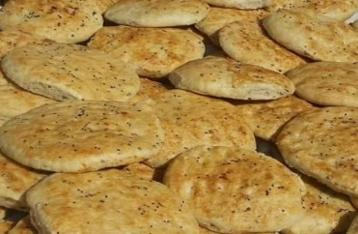
Elmadağ Tandour Bread | Ankara | Name of Origin | Bread, similar in shape to a baguette, baked in a tandoor using wheat flour, flour, water, salt and yeast. | 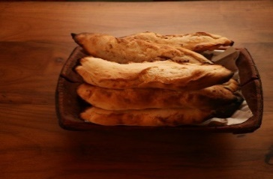
Emet Bread | Kütahya | Sign of Origin | Wheat flour, sourdough prepared from chickpeas, water and salt. | 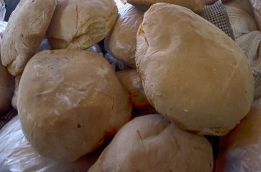
Erzurum Lavash Bread | Erzurum | Sign of Origin | Flat bread, which is consumed with the famous Erzurum Cağ Kebab, consists of bread wheat flour, water and salt. | 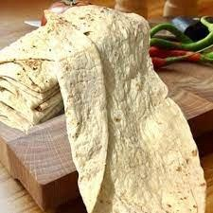
Gelveri Bread | Aksaray | Sign of Origin | Bread flour, sourdough or fresh yeast, water, salt. | 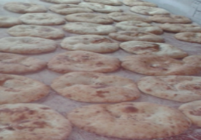
Gümüşhane Bread | Gümüşhane | Sign of Origin | Bread made with wheat flour, sourdough, fresh yeast and water is baked over wood fire in local stone ovens. | 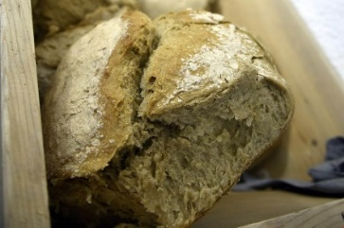
Hopa Anchovy Bread | Artvin | Sign of Origin | It consists of pickled anchovies, cornmeal and various vegetables (tomatoes, leeks, chard, parsley). It is served with garnishes such as cucumbers, radishes or onions. | 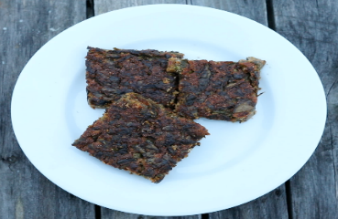
Kalecik Bread | Ankara | Sign of Origin | Wheat flour, sourdough, fresh yeast, water, salt. | 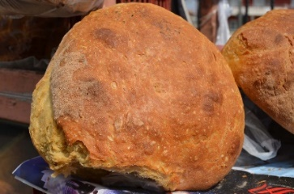
Konya Tandoori Bread | Konya | Sign of Origin | Bread prepared with wheat flour, sourdough (prepared with yoghurt, water and flour), water and salt is baked in the tandoor. | 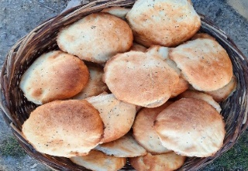
Kürtün Araköy Bread | Gümüşhane | Sign of Origin | It is produced using a century-old sourdough, weighs approximately 4.5 kg and is cooked over a wood fire in 4 hours. | 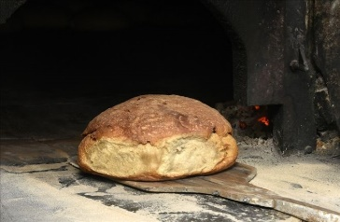
Malatya Bilik Bread | Malatya | Sign of Origin | Wheat flour, sourdough or dry yeast, butter, sunflower oil, salt, water, milk. For Topping: Black cumin seeds, sesame seeds, eggs, mulberry molasses and water. | 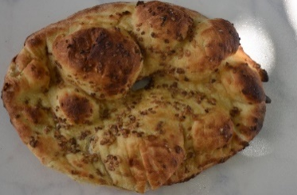
Malatya Pita Bread | Malatya | Sign of Origin | It is prepared using wheat flour, water, salt and fresh yeast then cooked in stone-based ovens. | 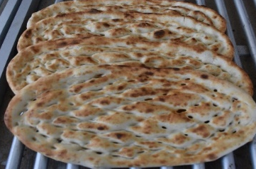
Malatya Tandour Bread | Malatya | Sign of Origin | Wheat flour, fresh yeast, water, salt. For the topping: black cumin and sesame | 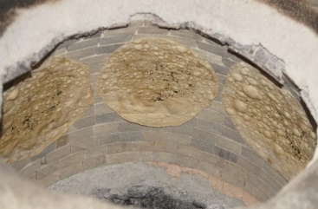
Malatya Fatty Bread | Malatya | Sign of Origin | Wheat flour, fresh yeast, water, salt, butter, egg yolk, sesame, black cumin. | 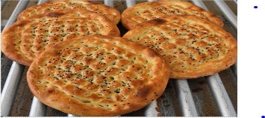
Mamak Celebrated Sourdough Bread | Ankara | Sign of Origin | Wheat flour, whole wheat flour, water, salt, sour  yeast and dry yeast. | 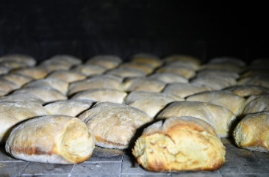
Mesudiye Dried Bread / Mesudiye Golith | Ordu | Sign of Origin | Wheat flour, dry yeast, salt and water. | 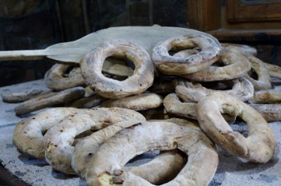
Midyat Tandoori Bread | Mardin | Sign of Origin | Flour, water, fresh yeast and salt obtained from wheat of the Sorgül (Soruk) variety. | 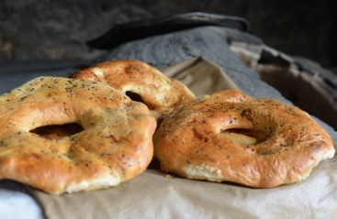
Siirt Dry Bread | Siirt | Sign of Origin | Whole wheat flour, rock salt, fresh yeast, margarine, water, olive oil  For the above:  whole wheat flour, egg, sesame. | 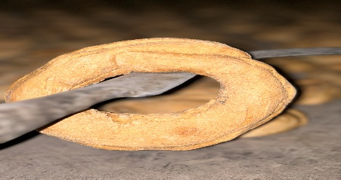
Söke Sweet Yeast Bread | Aydın | Sign of Origin | Wheat flour, flour, water, chickpeas, sweet yeast (formed by fermenting cracked chickpeas by soaking them in water for 8 hours). | 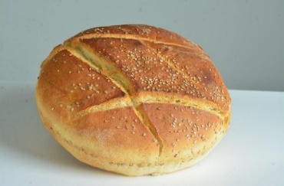
Tokat Bread | Tokat | Sign of Origin | Whole wheat flour, sourdough yeast, water and salt. | 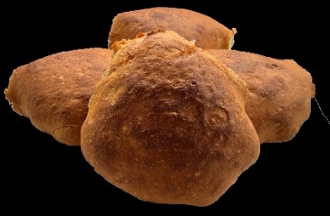
Vakfıkebir Bread | Trabzon | Sign of Origin | Wheat flour, sourdough, water, salt. | 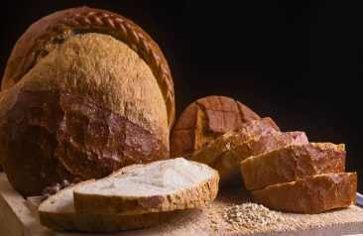
Zara Sheet Bread | Sivas | Sign of Origin | Wheat flour, cottage cheese or whey, rock salt, fresh yeast  Inner mix:  boiled potatoes, parsley, cottage cheese | 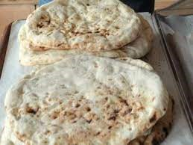
Çavuşlu Bread | Giresun | Sign of Origin | Wheat flour, sourdough, salt, water. | 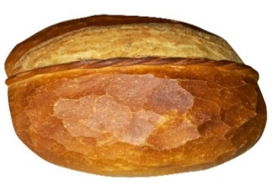
Ödemiş Chickpea Bread | İzmir | Sign of Origin | Wheat flour, chickpea sourdough, salt, water, olive oil. | 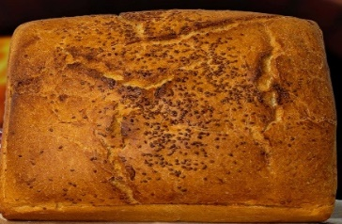
Şanlıurfa Open Bread | Şanlıurfa | Sign of Origin | Wheat flour, sourdough, salt, water.
Şanlıurfa Tırnaklı Bread | Şanlıurfa | Sign of Origin | Wheat flour, water, salt, fresh yeast. It got this name because it was shaped with fingers. | 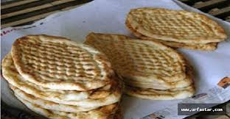

The bread types in the table are local, and some traditional Turkish breads not included in the table will be listed below. Pita and lavash are introduced under the subtitle of Middle Eastern Breads, and flatbread, gobit bread, phyllo, corn bread, a loaf of bread, and simit are listed below.
Bazlama; Bazlama is made from a dough consisting of wheat flour, fresh yeast, water, and salt. The dough is shaped, decorated, and allowed to rest. It is then rolled out to a round shape and cooked on a metal sheet. Typically, bazlama is enjoyed while still hot and butter spread. It can also be filled with cheese and tomatoes, making it a versatile bread suitable for toasting [77].
Gobit Bread; Gobit bread is crafted from yeast dough and takes on a thin, round, and slightly puffed form. Resembling pita bread is generally used for making Turkish döner kebabs [78].
Phyllo Dough (Yufka); Phyllo dough, inherited from Central Asia by the Turks, is created by baking and drying unleavened dough on sheet metal. Before preparing the meal, Phyllo Dough should be soaked to soften. It is commonly consumed during sahur (pre-dawn meal) in Ramadan, often filled with boiled eggs, cheese, tomatoes, and diverse greens to make traditional Turkish food, börek. Phyllo dough is known for its high satiating quality [79].
Cornbread; Cornbread is made by mixing maize flour, commonly obtained from maize grown in the Black Sea region, with various components like milk, cream, salt, and water. It is preferred by celiac patients because it contains gluten. Cornbread is often consumed by breaking it into pieces and mixing it with yogurt [80].
Loaf Bread; Loaf bread is the most commonly consumed bread species in daily life in Turkey because of its affordability and easy accessibility. Known as "white bread" or "market bread," it serves as a staple for many [81].
Simit; Simit is often obtained by shaping yeast dough, dipping it in water and molasses mixture, and then coating it with sesame seeds. It's a popular street food in Turkiye and commonly enjoyed by locals [82].

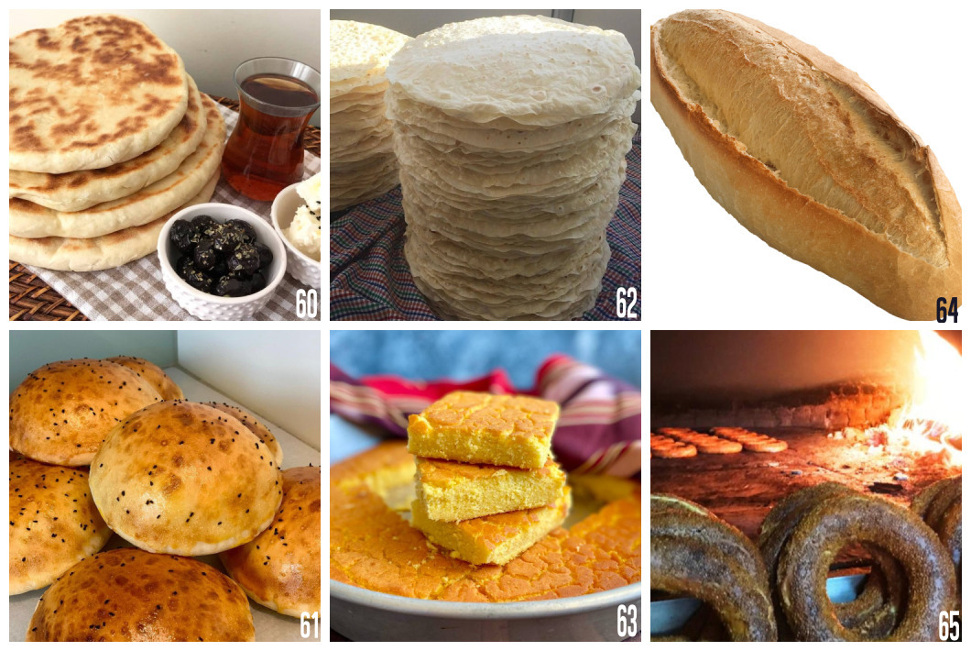

Figure 11: Turkish Breads; (60) Bazlama [77], (61) Gobit Bread [78], (62) Yufka [79], (63) Cornbread [80], (64) Loaf of Bread [81], (65) Bagel [82].

- CONCLUSION

Bread is one of the indispensables of the human race and forms the basis of nutrition and culinary culture. Throughout this study, we've delved into the intricate tapestry of bread—a product shaped by factors like time, culture, lifestyle, religion, dietary habits, geographical nuances, climate, and vegetation. This intricate interplay has led to a remarkable array of bread varieties that vary significantly from country to country and region. The diversity of bread has flourished and thrived thanks to these multifaceted influences, culminating in its status as one of the most widely consumed staple foods in the world today.

REFERENCES

[1] Çilingiroğlu Shipman, D. “Ekmek Bir Tutkudur”. İstanbul: Boyut Yayıncılık ve Ticaret A.Ş.2012.
[2] Armesto, F. F. “Yemek İçin Yaşamak-Yiyeceklerle Dünya Tarihi”. İletişim Yayınları, İstanbul. 2007
[3] Standage, T.” İnsanlığın Yeme Tarihi”. (G. Çakır, Çev.) Maya Kitap.2016.
[4] Şahin, E. “Gerçek Ekmek”. İstanbul: Hayy Kitap.2012.
[5] Sarıoğlan, M. ve Sezen, T. S. “Makarna Hazırlama ve Sosları”, Mutfak Sanatı Kavramlar, İlkeler ve Uygulamalar”, S. Şengül, M. Sarıışık, O. Türkay ve Ş. Ulema (Derleyen), Detay Yayıncılık, Ankara,2020,s 249-266.
[6] Civitello, L. “Mutfak &Kültür (İnsanın BeslenmeTarihi)”, Z.N. Nahya ve S. Örnek(Çvr), Bilim ve Sanat Yayınları, Ankara, 2019.
[7] Belge, M. “Tarih Boyunca Yemek Kültürü “, İletişim Yayınları, İstanbul, 2001.
[8] Özen, M. “Ekmek, Ekmek Üretimi ve TSE’den Belgeli Ekmek Üreticileri”. Standard Ekonomik ve Teknik Dergi. ISSN: 1300-8366 Ağustos,2013, (52) 615, s56-60.
[9] Kocaman, B. ve Acar-Tek, N. “Ekmek, Bira, Şarap ve Yoğurdun Orijinleri ve Tarihsel Süreçleri”, Bes. Diy. Derg. 2016:44(3):272-279.
[10] Özdemir Yaman, Z. “Temel Seviye Ekmekçilik, Profesyonel Teknik ve Reçeteler”. Ankara: Detay Yayıncılık.2019.
[11] Beşirli, H.” Yemek Sosyolojisi”. Ankara: Phoenix Yayınevi. 2012.
[12] Ataman, M.” Dünyanın Ekmeği”. Mutfak Magazin,2016.s.56.
[13] Ünsal, A.” Nimet Geldi Ekine: Türkiye’nin Ekmeklerinin Öyküsü”. Yapı Kredi Kültür Sanat Yayıncılık, İstanbul, 2016.
[14] Şengül, S. “Amerika Mutfağı”. M. Sarıışık & G. Özbay (Ed). “Uluslararası Gastronomi (Temel Özellikler-Örnek Menüler–Reçeteler) “(1.Baskı) Detay Yayıncılık. 2013.
[15] Doğan, H.” Ekşi Mayalı Ekmekler”. İstanbul: ALFA Basım Yayım Dağıtım San. ve Tic. Ltd. Şti.2016.
[16] Dinç, T. “ Karakılçık “Ekşi Mayaya Dair Her Şey””. İstanbul: Mutfakkitap.2019.
[17] Taste Atlas (2023). BREAD, Pain de mie (Pullman Bread, Pullman Loaf, Bread of Crumb). (Accessed in August, 11 2023) https://www.tasteatlas.com/pain-de-mie
[18] Taste Atlas (2023). BREAD, Graham Bread. (Accessed in August, 11 2023) https://www.tasteatlas.com/graham-bread
[19] Platings and Pairings (2023). Quick + Easy Irish Guinness Bread (No Rising!!!). (Accessed in August, 10 2023) https://www.platingsandpairings.com/guinness-beer-bread/
[20] Taste Atlas (2023). 10 Most Popular NORTH AMERICAN BREADS. (Accessed in August, 10 2023) https://www.tasteatlas.com/most-popular-breads-in-north-america
[21] Taste Atlas (2023). 10 Most Popular SOUTH AMERICAN BREADS. (Accessed in August, 10 2023) https://www.tasteatlas.com/most-popular-breads-in-south-america
[22] Taste Atlas (2023). New York City Bagels at Bagel Oasis. (Accessed in August, 10 2023) https://www.tasteatlas.com/bageloasis/bagels
[23] King Arthur Baking (2023). RECIPES BUNS & ROLLS HAMBURGER & HOT DOG BUNS, Beautiful Burger Buns. (Accessed in August, 10 2023) https://www.kingarthurbaking.com/recipes/beautiful-burger-buns-recipe
[24] Simply Recipes (2023). Yankee Cornbread. (Accessed in August, 10 2023) https://www.simplyrecipes.com/recipes/yankee_cornbread/
[25] Taste Atlas (2023). SOURDOUGH BREAD, California Sourdough Bread (San Francisco Sourdough Bread). (Accessed in August, 11 2023) https://www.tasteatlas.com/california-sourdough-bread
[26] Super Healthy Kıds (2023). Home, Recipes, Healthy Banana Bread Recipe. (Accessed in August, 11 2023) https://www.superhealthykids.com/banana-bread-makeover/
[27] Kurnaz, A. “İngiliz ve Balkan Mutfağı”. Doç. Dr. Hakan Yılmaz (Ed). Dünya Mutfakları I. T.C. Anadolu Üniversitesi Yayını No: 3309, Açıköğretim Fakültesi Yayını No: 2171, 2018.
[28] Simply Recipes (2023). Anadama Bread. (Accessed in August, 11 2023) https://www.simplyrecipes.com/recipes/anadama_bread/
[29] David, E.” English Bread and Yeast Cookery”. London: Allen Lane. ISBN 0713910267. 1977.
[30] Cafe Sardunya (2009). SCONE : İngiliz kahvaltı ekmeği. (Accessed in August, 11 2023) http://cafesardunya.blogspot.com/2009/08/scone-ingiliz-kahvalt-ekmegi.html
[31] BBC Good Food (2007). Home, Recipes, Classic scones with jam & clotted cream. . (Accessed in August, 11 2023) https://www.bbcgoodfood.com/recipes/classic-scones-jam-clotted-cream
[32] Taste Atlas (2023). SWEET BREAD, Scone (Scones). (Accessed in August, 11 2023) https://www.tasteatlas.com/scone
[33] Kırım, A.” Tazesi Makbuldür”. İstanbul: Sistem Yayıncılık Bayii ve Kitabevleri.2004.
[34] Taste Atlas (2023). BREAD, Anadama Bread. (Accessed in August, 11 2023) https://www.tasteatlas.com/anadama-bread
[35] Taste Atlas (2023h). BREAD, English Muffin. (Accessed in August, 11 2023) https://www.tasteatlas.com/english-muffin
[36] Taste Atlas (2023). SIDE DISH, APPETIZER, Yorkshire Pudding. (Accessed in August, 11 2023) https://www.tasteatlas.com/yorkshire-pudding
[37] Taste Atlas (2023). SWEET BREAD, Hot Cross Buns. (Accessed in August, 11 2023) https://www.tasteatlas.com/hot-cross-buns
[38] Güldemir, O.” İskandinav ve Rus Mutfağı”. Doç. Dr. Hakan Yılmaz (Ed). Dünya Mutfakları I. T.C. Anadolu Üniversitesi Yayını No: 3309, Açıköğretim Fakültesi Yayını No: 2171, 2018.
[39] Taste Atlas (2023). RYE BREAD, Rugbrød. (Accessed in August, 13 2023) https://www.tasteatlas.com/rugbrd
[40] Taste Atlas (2023). BREAD. Zopf (Züpfe, Stritzel, Butterzopf, Tresse, Treccia). (Accessed in August, 11 2023) https://www.tasteatlas.com/zopf
[41] Taste Atlas (2023). RYE BREAD. Kavring. (Accessed in August, 11 2023) https://www.tasteatlas.com/kavring
[42] Bread In 5 (2009). Swedish Limpa Rye Bread, in a Cloche, on the Grill. (Accessed in August, 11 2023) https://artisanbreadinfive.com/2009/06/15/swedish-limpa-rye-bread-in-a-cloche-on-the-grill-and-announcing-winners-of-free-books/
[43] Taste Atlas (2023). WHAT TO EAT IN SCANDINAVIA?, 10 Most Popular SCANDINAVIAN BREADS. (Accessed in August, 11 2023) https://www.tasteatlas.com/most-popular-breads-in-scandinavia-2
[44] Akman, M. ve Mete, M. “Türk ve Dünya Mutfakları”, Pak-Sil Yayıncılık, İstanbul.1998.
[45] Cooking with Sapana (2017). Hornazo-Spanish Easter Pie. (Accessed in August, 14 2023) https://cookingwithsapana.com/hornazo-spanish-easter-pie/
[46] Taste Atlas (2023). BREAD, Pan Gallego (Pan Galego). (Accessed in August, 12 2023) https://www.tasteatlas.com/pan-gallego
[47] Taste Atlas, 2023). BREAD, Pan de Cea. (Accessed in August, 14 2023) https://www.tasteatlas.com/pan-de-cea
[48] Taste Atlas (2023). BREAD, Pan de Barra (Barra de Pan). (Accessed in August, 12 2023) https://www.tasteatlas.com/pan-de-barra
[49] Aceites de Oliva de Espana (2023). Recetas, Pan casero de aceite de oliva. (Accessed in August, 12 2023) https://www.aceitesdeolivadeespana.com/recetas/pan-casero-aceite-oliva/
[50] SBS Food (2020). Spanish Easter Bread (Hornazo). (Accessed in August, 13 2023) https://www.sbs.com.au/food/recipe/spanish-easter-bread-hornazo/1v28zkdt8
[51] Yıldız, E.” Fransız Mutfağı”. Doç. Dr. Hakan Yılmaz (Ed). “Dünya Mutfakları I”. T.C. Anadolu Üniversitesi Yayını No: 3309, Açıköğretim Fakültesi Yayını No: 2171 ,2018.
[52] Treuille, E., & Ferrigno, U. “Bread”. London: A Dorling Kindersley Book. 1998.
[53] Jack and Adeline (2023). Home, "Tordu" Baguette. (Accessed in August, 12 2023) Adresi: https://www.jackandadeline.com/product-page/demi-tordu-baguette
[54] Sönmezsoy, C.” Cafe Fernando”. İstanbul: Mundi Kitap.2020.
[55] Simply Scratch (2023). Homemade Stromboli. MAINS & ENTREES, PIZZA, RECIPES, STROMBOLI. (Accessed in August, 15 2023) https://www.simplyscratch.com/homemade-stromboli/
[56] Taste Atlas (2023). DESSERT, Schiacciata con l'uva (Ciaccia con uva, Stiaccia con uva). (Accessed in August, 12 2023) https://www.tasteatlas.com/schiacciata-con-luva
[57] German Food Guide (2023). Pumpernickel Bread. (Accessed in August, 12 2023) https://www.germanfoodguide.com/pnickel.cfm#:~:text=Pumpernickel%20is%20a%20traditional%20Westphalian,F%20(200%C2%B0C)
[58] Değirmenci Dede (2021). Anasayfa, Bloglar, Ekşi Mayalı Ekmekler, Borodinsky Rus Ekmeği. (Accessed in August, 13 2023) https://www.degirmencidede.com/blog/icerik/borodinsky-rus-ekmegi
[59] Visit Estonia (2022). Home, Why Estonia, Estonia's national bread. (Accessed in August, 12 2023) https://www.visitestonia.com/en/bread
[60] Barbara Bakes (2020) Russıan Braıded Bread Wıth Pesto Fıllıng. (Accessed in August, 12 2023) https://www.barbarabakes.com/russian-braided-bread-with-pesto-filling-to-celebrate-world-bread-day/
[61] The Spruce Eats (2022). Kolach (Ukrainian Christmas Bread) Recipe. (Accessed in August, 13 2023) https://www.thespruceeats.com/ukrainian-christmas-bread-kolach-recipe-1137466
[62] Taste Atlas (2023). SWEET BREAD, Paska, (Пáска, Kulich, кули́ч, Ukrainian Easter Bread). (Accessed in August, 13 2023) https://www.tasteatlas.com/paska
[63] Food (2023). Recipes, Yeast Breads, UKRAINIAN CHRISTMAS BREAD KOLACH. (Accessed in August, 12 2023) https://www.food.com/recipe/ukrainian-christmas-bread-kolach-192166#recipe
[64] Coşkuner, Y., Karababa, E., & Ercan, R. “Düz Ekmeklerin Üretim Teknolojisi”. Gıda Dergisi, 1999. s89-97.
[65] Taste Atlas (2023). FLATBREAD. Pita bread (Pide, Khubz arabi, Khubz, Arabic bread, Lebanese bread, Syrian bread, Pitta bread) (Accessed in August, 13 2023): https://www.tasteatlas.com/pita-bread
[66] Taste Atlas (2023). FLATBREAD, BREAKFAST, Nan-e barbari. (Accessed in August, 12 2023) https://www.tasteatlas.com/nan-e-barbari
[67] Üstünkanat, A. “Un "tarihi /tarifi”.İstanbul : Altın Kitaplar Yayınevi, 2017.
[68] Self Reliance Programs-Making Pappadam I Embracing the World (2009). (Accessed in August, 13 2023) https://www.youtube.com/watch?v=KpG6KQhEeHE&t=1s
[69] Taste Atlas (2023). FLATBREAD, Chapati (Roti, Roshi, Safati, Shabaati). (Accessed in August, 12 2023) https://www.tasteatlas.com/chapati
[70] Taste Atlas (2023). FLATBREAD. Naan (Nan, Khamiri). (Accessed in August, 12 2023) https://www.tasteatlas.com/naan
[71] Taste Atlas (2023). SNACK, APPETIZER, SIDE DISH. Papadum. (Accessed in August, 13 2023). Erişim Adresi: https://www.tasteatlas.com/papadum
[72] Taste Atlas (2023). BREAD, SIDE DISH, SNACK, Mantou. (Accessed in August, 12 2023) https://www.tasteatlas.com/mantou
[73] Mutfak Kültürü (2021). Damper Ekmeği. (Accessed in August, 12 2023) https://mutfakkulturu.com/2021/09/24/damper-avustralya/
[74] Just One Cook Book (2023). Home, Melon Pan (Video). (Accessed in August, 20 2023) https://www.justonecookbook.com/melon-pan/
[75] Çınar, Z. ve Sormaz, Ü. (2020). “Ege Bölgesi Yöresel Ekmek Haritası”, Baskın vd. (Ed.), 12. Uluslararası Güncel Araştırmalarla Sosyal Bilimler Kongresi Tam Metinleri, (s 3447-3458). 12. Uluslararası Güncel Araştırmalarla Sosyal Bilimler Kongresi.
[76] Türk Patent ve Marka Kurumu (2023). Coğrafi İşaretler Portalı. (Accessed in August, 22 2023) https://ci.turkpatent.gov.tr/
[77] Yemek.com (2021). YEMEK, YEMEK TARİFLERİ, HAMUR İŞİ TARİFLERİ, YUMUŞACIK BAZLAMA TARİFİ. Erişim Tarihi: 23.08.2023. Erişim Adresi: https://yemek.com/tarif/yumusacik-bazlama-3/
[78] Nefis Tarif ve Sunumlar (2022). Gobit Ekmek Tarifi, Nasıl Yapılır? (Accessed in August, 25 2023) https://www.nefistarifvesunumlar.com/gobit-ekmek-tarifi-nasil-yapilir/
[79] Çiçeksepeti (2023). Köy Usulü Yufka Ekmek. (Accessed in August, 25 2023) https://www.ciceksepeti.com/koy-usulu-yufka-ekmek-30-adet-kcm16405690
[80] Yemek.com (2023). YEMEK, YEMEK TARİFLERİ, HAMUR İŞİ TARİFLERİ, EKMEK TARİFLERİ, MISIR EKMEĞİ TARİFİ. (Accessed in August, 25 2023) https://yemek.com/tarif/misir-ekmegi/
[81] Koblay Fırın (2023). Somun Ekmek. (Accessed in August, 25 2023) http://koblayekmek.com.tr/urun/somun-ekmek/28
[82] Haber Dairesi (2023). Konya’da Simit ve Poğaça Zamlandı! İşte 2023 Güncel Fiyatları. (Accessed in August, 25 2023) https://haberdairesi.com/guncel/konyada-simit-ve-pogaca-zamlandi-iste-2023-guncel-fiyatlari-96200h

