Communication Aspects, Enhancement and Analyze the Risk of IoT in 5G Technology

Mrs. Sujeeta S. Shah.
Computer Science and Engineering
D. Y. Patil Agriculture and Technical University, Talsande
Kolhapur, Maharashtra, India
shahsujeeta4443@gmail.com

Mrs. Ashwini N. Sawant.
Computer Science and Engineering
D. Y. Patil Agriculture and Technical University, Talsande
Kolhapur, Maharashtra, India
ashwininileshsawant@gmail.com

Mr. Nileshkumar M. Sawant.
Engineering dept.
RCSM College of Agriculture,
Kolhapur, Maharashtra, India
sawant.nil@gmail.com

ABSTRACT

The "Internet of Things" (IoT) is a network of physically interconnected "things," including cars, home appliances, and other objects, that have sensors, software, and other technologies enabling online data collecting and sharing. To share data, these "things" can connect to other devices and systems over the internet. These gadgets, which are frequently referred to as "smart" gadgets, can communicate with people and other gadgets to offer a variety of tasks, automation, and data-based knowledge. It is anticipated that the fifth generation of cellular network technology, or 5G, will perform noticeably better than earlier incarnations like 4G. Quicker data transmission rates and decreased latency (the time it takes for data to move between devices) increased capacity to accommodate a high volume of connected devices, and improved reliability are all features of 5G networks. These developments turn 5G into a crucial technology enabler for a variety of fields. For linked devices and applications, the combination of IoT with 5G creates new opportunities and capabilities. IoT devices may have faster data transmission and real-time data reception. High data transfer speeds, reduced latency, and improved network capacity are among the features offered by 5G networks. The implementation of more sophisticated and labor-intensive IoT applications is made possible by this combination across a number of industries, including smart cities, healthcare, industrial automation, transportation, and agriculture. By offering smoother connectivity, quicker reaction times, and increased scalability, it enables these aspects as well. This article examines the risks associated with IoT in 5G technology as well as communication and enhancement factors. We concentrate on the development and significance of IoT rather than 5G since it has a stronger foundation and is more relevant as a result of 5G's quick growth. Finally, we focus on the IoT element of contemporary 5G technology.

Keywords-4G,5G, Internet of Things, Ultra Reliable Low Latency, Grant-Free, Grant-based, Enhanced Mobile Broadband, Massive Machine Type Communications.

I. INTRODUCTION of IoT

The "Internet of Things" (IoT) is a network of physically connected objects that can be wired or wireless connection. These objects have sensors and actuators, and they can communicate with computer systems for monitoring or even regulating the real world [1]. These "things" could be vehicles, buildings, technologically advanced home gadgets, etc.

A. An IoT system includes four main components:
Sensors - IoT sensors are pieces of hardware that collect data and track environmental changes. They are a part of the IoT ecosystem, which links the offline and online worlds. IoT sensors can share data with the network to detect things like temperature, pressure, and motion if they are connected to a network.
Connectivity – A variety of connectivity technologies, including Wi-Fi, Bluetooth, cellular networks, satellite, LoRaWAN, and others, are used by IoT devices to connect to other devices and networks. IoT devices have the ability to collect and send data, receive commands, and act on that data. Sensors can be connected to the cloud in various ways, such as 5G.
Data processing – IoT software must be used to handle, analyze, and store the data after it has been acquired.
User Interface - Users are able to interact with devices using this component.

B. IoT architecture:
The basic IoT architecture consists of four layers.
Data Gathering- Input data from the user end is collected by the IoT application. Data Transmission: The data is transferred to the cloud or other storage servers through a network connection. This connection can be established using Wi-Fi, GPRS, Ethernet, etc.
Data Processing- The data stored in the server is processed to create the desired output for the user.
Application Layer- This layer is used for data storage and display.

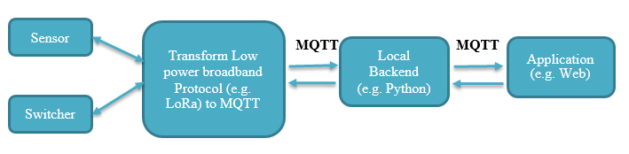
Fig.1. IoT Architecture
Information from several sensor nodes installed in the monitored area is transmitted to the central gateway. The communication protocols used to send data to the IoT gateway are mostly low-power broadband protocols such as LoRa. The IoT gateway has a built-in internet connection module. This data is forwarded to the server (using the Internet) via data protocols MQTT (Message Queuing Telemetry Transport protocol) / HTTP. This information from the cloud server is retrieved from the web/mobile applications associated with the IoT solution [2].

II. 5G Technology

5G refers to the use of fifth-generation (5G) wireless technology. 5G technology is the latest telecommunication network modeled after 4G networks. With low latency, the fifth generation of cellular networking may provide data speeds of many GB/s. The network will accommodate more users than the current generation and have exceptional dependability. The user experience will also be more constant [3]. The following figure shows 5g network features-
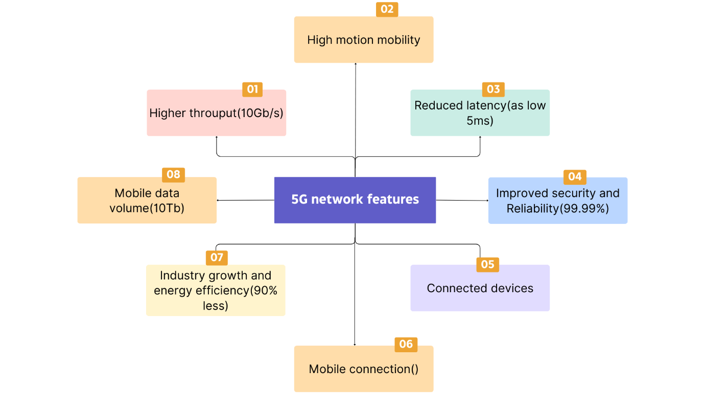
Fig.2. 5G Network features

One of the most significant factors in this growth will be the quick adoption of 5G networks, It will profoundly affect how people live, work, and play around the world [4].

III. Benefits of IoT over 5G

The enhancements brought about by 5G will significantly aid in the real-time processing of massive volumes of data, which is almost impossible with any other technology. Greater data transfer rates enabled by 5G allow for faster communication and data sharing across connected IoT devices. 5G also provides greater connection frequencies, allowing for the connecting of more devices, as well as more effective IoT connection signaling, allowing for improved device connectivity. The very low latency (down to 1 ms), increased reliability, high network capacity, higher availability, and a more consistent user experience, since 5G produces more solid connections, are some additional significant advantages of 5G IoT. Using IoT devices in real-time applications requires a strong and dependable network. Because of 5G's incredible capacity, we can connect more devices without sacrificing quality and mobile data volume up to 10Tb.
The general 5G mobile networks with an IOT architecture are what the 5G is dependent upon. Large networks, small static networks, and mobile networks are all covered by the most recent technologies. Additionally, it provides a silhouette of the 5G basic stations' & cloud's IOT architecture. They also incorporate small cell entrance points, IOT with 5G, and device-to-device networking models. In contrast, the 5G and IOT paradigm is presented in three distinct parts [5].
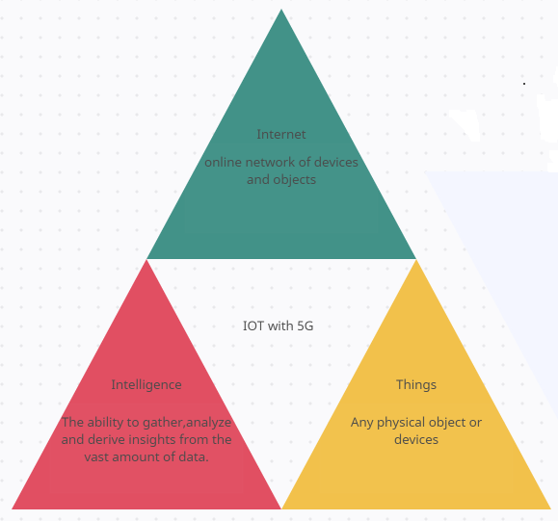
Fig.3. Diagrammatic representation of IoT with 5G

IV. COMMUNICATION TECHNOLOGY

With 5G, a faster communication channel will be available; we can expect speeds of up to several gigabits per second. Together, your devices might be able to accomplish things faster. It will also provide a network with incredibly low latency; early 5G deployment, according to Verizon, demonstrated a latency of 30 ms. this will make it simpler to perform delicate procedures like surgery utilizing IoT devices. Due to 5G's enormous bandwidth, you can connect more devices without suffering a quality decrease [6].

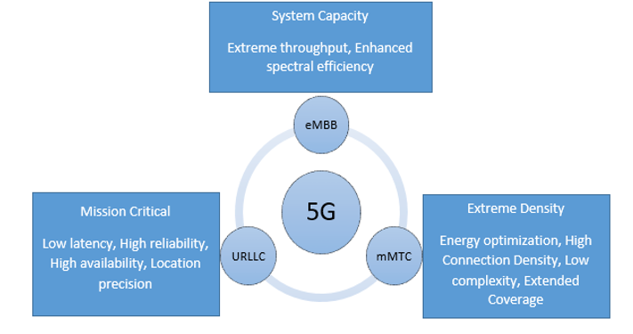

Fig.4. Features and Communication Strategies

A.5G has three facets-

A. Ultra-Reliable Low-Latency Communication (URLLC)
It can be used in use cases with a high priority, such as smart grids, intelligent transportation systems, and remote surgery. Latency is the length of time it takes for a signal to travel from its source to its receiver and vice versa. The 5G latency, which functions faster than human visual processing, makes it possible to remotely control equipment in real-time. Robotic processes are one of the many benefits that URLL capabilities will offer. URLLC applications are becoming more and more prevalent, and the Fifth Generation (5G) New Radio (NR) is a flexible communication system that can only be utilized to develop the unique solutions required to meet them. In order to meet URLLC criteria, a number of Grant-Free (GF) and Grant-based (GB) transmission schemes have been released. [7].
A. Grant Free (GF)-In 5G, grant-free random access is recommended as a key method for lowering latency since it allows access to channel resources without requiring assignment through a handshake process. Both of the suggested strategies yield sizable performance improvements in terms of resource effectiveness. The fundamental idea of GF transmission is to set up/allocate periodic dedicated resources for URLLC service. It works nicely with intermittent traffic. However, because URLLC traffic is intermittent, UE (User Equipment) can skip the GF resource if no data is to be transferred. If a GF resource is devoted to a UE for URLLC service and cannot be used by other UEs or services, it may be wasted. One proposed option for better resource utilization is to allow multiple UEs and services to share the GF resource. However, collisions between UEs may occur, reducing transmission reliability and increasing transmission delay. Diversity transmission is used to increase reliability. Nonorthogonal Multiple Access (NOMA) techniques are used on the transmitter side to improve the utilization of resources while sophisticated receivers are used on the receiving side to prevent collisions in GF transmission. [8].

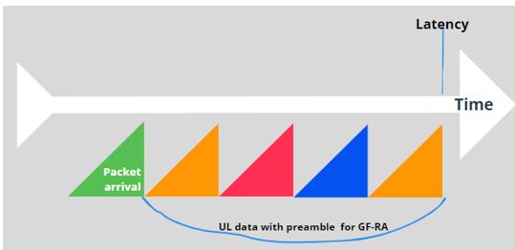

Fig. 5. Uplink transmissions for grant-free random access

B. Grant-Based (GB)-In the current 4G-LTE system, UEs use a grant-based method to provide reliable transmission in UL. To mitigate potential collisions, the grant-based approach includes a four-step handshake process between UEs and base stations (BSs). However, it comes with a long delay for the access grant response. Such a grant-based model is inapplicable for the low latency needs of URLLC's mission-critical applications. As a result, GF random access, which allows UEs to escape from handshake phases and gain quick access, is an appealing alternative for reducing UL access latency.

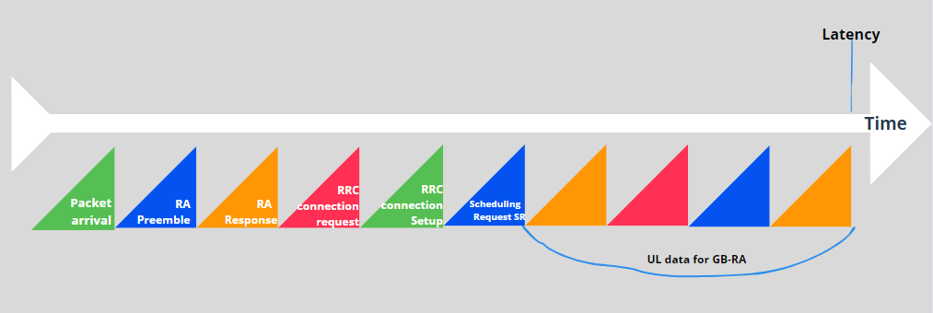

Fig. 6. Uplink transmissions for grant-based random access

The URLLC specifications can rarely be met by the Long Term Evolution (LTE) system in use today. Current LTE uses grant-based (GB) scheduling, which is based on scheduling and is specifically used in the uplink. When the User Equipment (UE) requests access to the network, the Base Station (BS) can reply by granting access via a four-step random access (RA) mechanism, as shown in the figure above. This is how standard GB scheduling works. Such scheduling-request-triggered transmission would not meet the URLLC latency criterion since it would start transmitting data at least 10 milliseconds after the scheduling request, which is not acceptable. Recently, grant-free (GF) access has been suggested and has been intensively debated in 3GPP Technical Specification Group Radio Access Network (TSG RAN) WG1 to deal with the URLLC need in the uplink transmission. Small packets can be transmitted by a UE via uplink GF access [9].

B. Enhanced Mobile Broadband (eMBB)

The phrase "improved mobile broadband" is significant when discussing 5G. Enhanced mobile broadband is accessible through 4G LTE networks. It is one of three use cases or services for 5G NR application deployment that are defined by the 3GPP. The objective of eMBB is to offer more bandwidth with lower latency for applications like augmented reality (AR), 4K media multiplayer mobile gaming, virtual reality experiences, factory robots, and self-driving cars. 5 NR offers enhanced mobile broadband service that is dependable and quick. The wireless communication market is being transformed by eMBB by advancing technology to connect and redefine several industries and enterprises. The cutting edge of increasing coverage regions is also eMBB extension. With eMBB support, 5G networks can give the general public better quality of service (QoS) internet access even in prohibitive or challenging circumstances [10].
How is eMBB delivered over 5G?
5G must accomplish higher throughput, lower latency, larger capacity, better uniformity, and total mobility to live up to those promises and must do it at a cheaper cost to mobile carriers. The following are some of the 5G technologies that make eMBB possible:
A. Massive MIMO stands for Multiple Input, Multiple Output and describes approaches that use a lot of antennas to expand cellular coverage and capacity. While 5G is intended to offer huge MIMO, using up to 256 antenna components in the base station, there are restrictions on how many antennas can fit into a mobile device. As a result, spectrum ranges below 6 GHz are now ready for intelligent beam forming and beam-tracking.
B. Mobility focused on the device – Devices consume a lot of battery power processing and monitoring reference signals from all adjacent cells. The device is also used in 5G's device-centric mobility to transmit periodic reference signals that the access network can track. Depending on how strongly the device's signal is returning, the network may start a cell reselection or handover. The 5G network will also send out the absolute least amount of system information periodically rather than consistently regardless of the existence of a device.
C. Spectrum sharing: These are methods for expanding the 5G network and freeing up additional airwaves. Spectrum sharing has the potential to free up frequency bands that are only marginally utilized by operators, as I highlighted in my blog post regarding spectrum in 5G. Additionally, a sizable portion of the spectrum may be shared or unlicensed, particularly in the higher bands. All current spectrum types are supported by 5G NR, which also has the option to adopt sharing paradigms that are still under development.

C. Massive Machine Type Communications (mMTC)

A brand-new 5G service category called Massive Machine-Type Communications (mMTC) may support unusually large online device connection densities. Devices can exchange brief bursts of traffic using mMTC connections to interact with one another. It is designed for the scalable and effective networking of many devices sending a lot of tiny packets, which is not possible with human-type cellular systems. As a result, one of the primary application areas for 5G will most likely be IoT and machine-to-machine (M2M) communication.5G networks are designed to allow each of the three service zones to operate independently while sharing the same physical infrastructure. Network slicing, also known as software-defined networking or SDN technology, is a method of dividing bandwidth among various different sectors in order to customize different service tasks. This means that each program can access the appropriate resource at the same time, with higher-priority applications taking precedence [11]. In contrast to URLLC, which offers good reliability but less comprehensive coverage, mMTC offers low-bandwidth communication with wide coverage. IoT gateways could need Ethernet because of the low-power wide area networks (LPWAN) used by current IoT technologies. The gateway sends the data to a server through a wired or 4G LTE network once the sensors have communicated over a network like LoRaWAN or Sigfox.

V. ENHANCEMENT OF 5G OVER IOT

5G, the fifth generation of cellular network technology, has the potential to significantly aid the Internet of Things (IoT) in various ways. IoT connects common items, equipment, and gadgets so they can communicate data without human involvement. Here's how 5G enhances IoT [12]:
A. Higher Data Speeds: 5G offers significantly faster data speeds compared to its predecessors. In order to support real-time communication and quicker reaction times, IoT devices must be able to send and receive data at significantly higher speeds. This is particularly important for applications that need low latency, such remote surgery or autonomous cars, which have strict time constraints.
B. Lower Latency: 5G's low latency capabilities reduce the time it takes for data to travel between IoT devices and the cloud. This instant communication is crucial for applications like industrial automation, where split-second decisions are necessary to ensure safety and efficiency.
C. Higher Device Density: 5G can support a higher number of connected devices per unit area than previous generations. This is essential for the growing number of IoT devices that will coexist in urban environments, industrial settings, and public spaces.
D. Energy Efficiency: 5G offers improved energy efficiency, which is vital for IoT devices that are often battery-powered or have limited power resources. With 5G, IoT devices can conserve energy while maintaining consistent and reliable connections.
E. Network slicing, a feature of 5G, enables the network to be separated into virtual slices to meet certain IoT requirements. This makes it possible for various IoT use cases to have specialized network resources customized to their requirements, resulting in improved performance and service quality.
F. Enhanced Coverage: 5G expands network coverage, reaching remote and underserved areas. This broader coverage benefits various IoT applications, such as agricultural monitoring, environmental sensing, and smart infrastructure, where devices may be deployed in remote locations.
G. Massive Machine-Type Communications (mMTC): 5G introduces mMTC, which is designed to efficiently handle large-scale IoT deployments with a massive number of low-power devices. This feature enables the deployment of IoT networks with millions of devices, making it easier to create extensive IoT ecosystems.
H. Edge Computing: 5G facilitates edge computing, which allows data processing to occur closer to the IoT devices themselves rather than solely relying on centralized cloud servers. For real-time IoT applications that require quick data analysis and reaction, edge computing minimizes latency and network congestion.
I. Reliability and Security: 5G offers enhanced security features, which are crucial for safeguarding the massive influx of data generated by IoT devices. Improved security ensures the protection of sensitive information and helps prevent potential cyber threats and attacks.
Overall, 5G's high data speeds, low latency, increased device density, energy efficiency, and other features make it a powerful enabler for the expansion and advancement of the Internet of Things, transforming how we interact with technology and the world around us.

VI. 5G AND HOW IT AIDS IOT

The combination of IoT (Internet of Things) and 5G technology has the potential to significantly transform various industries and improve existing applications. 5G networks, with their high data speeds, low latency, and increased capacity, are an ideal platform for supporting the vast number of devices and data generated by IoT devices. Here are some key IoT applications in 5G [13]:
A. Smart Cities: 5G-enabled IoT can help cities manage urban services like smart street lighting, waste management, traffic control, and public safety more efficiently. Real-time data may be gathered by sensors and linked devices to enhance city services and raise citizens' standard of living.
B. Industrial IoT: 5G makes it possible for numerous sensors and devices to be connected in industrial settings, enhancing automation, enabling predictive maintenance, and allowing for real-time monitoring of production processes. For industries, this can lead to more productivity, less downtime, and cost savings.
C. Healthcare: The low latency and dependability of 5G can help IoT devices in the industry. 5G connectivity can significantly enhance medical wearables, remote patient monitoring systems, and real-time data transmission for telemedicine applications.
D. Autonomous Vehicles: For safe navigation, self-driving cars need to instantly and reliably communicate data with their surroundings. For enabling real-time communication among autonomous vehicles, infrastructure, and pedestrians, 5G's low latency and great data throughput are essential.
E. Agriculture: IoT devices can be used in agriculture to track animals, crop health, weather patterns, and soil conditions. Farmers will be able to make data-driven decisions for better resource management and yield thanks to 5G connectivity, which can assure seamless data transmission.
F. Environmental Monitoring: IoT devices with 5G capabilities can be installed in remote areas to keep an eye on environmental factors including air quality, water quality, and wildlife habitats. Real-time transmission of this data enables earlier identification of environmental problems and more successful conservation measures.
G. Smart Grid Automation: One of the industries with the fastest growth rates and one that is far more effective than the traditional grid is the automation of the smart power grid, which is made possible by 5G. Receiving trustworthy services is made possible by the use of IoT devices for telemetry and AMI. The use of a self-sufficient network system and easy-to-integrate technology called the "smart grid" allows for the control, analysis, and monitoring of issues that assure reliable, high-quality power. It combines a smart electrical network with digital communication technology to provide a modernized smart grid that includes live management of hybrid electric systems, where faults may be identified/predicted and remedies may be provided quickly.
H. Remote monitoring: Ultra HD video may be utilized for remote video surveillance over a 5G network employing IoT sensors to monitor buildings, production lines, and high-security areas. Video analytics are made possible by 5G sensors and the quick, low latency connectivity. As a consequence, IoT sensors instantly notify users when an entrance, vandalism, or suspicious movement is detected.
I. Intelligent traffic management: 5G allows for Intelligent Transportation. When traffic cabinets combine these systems at certain municipal street crossings, IoT sensors at such locations gather real-time data from the roadside infrastructure and moving cars and send out fast messages. Regular use of these technologies can save costs and improve system reliability, flow, safety, and efficiency.
J. Manufacturing Applications: Automation of processes and predictive analytics for maintenance can be done at manufacturing floors using 5G and IoT. In order to accomplish the intended business goals, this converts workflows into instrumented, data-collection, digital procedures that integrate operators, machines, and sensors. Examples of IoT applications that benefit from 5G's low latency, high speed, and HD video streaming capabilities include smart manufacturing, collaborative robots, precise mining, and augmented reality repairs.
K. Applications In Medicine: Minimal latency Ultra-high definition video streaming may be utilized to monitor patients while they are being transported and build up facilities for quick treatment using IoT sensors to link ambulances to hospitals. With the help of smart wearables and sensors integrated into healthcare systems, it may be feasible to keep in continual contact with surgeons during operations and provide patients with therapy earlier than would be physically possible. Robotic operations benefit from the low latency capabilities of 5G and IoT devices.

VII. EXAMINING THE RISK OF IOT IN 5G TECHNOLOGY

A. Security and privacy: IoT devices are frequently targets of cyber-attacks because they collect and transmit sensitive data online. This information may be used maliciously by hackers for things like financial fraud and identity theft [14]. As a result of the difficulty in managing and securing a large number of IoT devices, data breaches may become more common.
B. Interference and reliability: 5G networks employ higher frequency radio signals with a limited range and are more easily blocked by objects like trees and buildings. Weaker signals, slower speeds, and lost connections may result from this. Regulations and infrastructure needs are two additional issues that make the deployment of 5G networks challenging [15].
C. Compatibility and interoperability: Different IoT devices can come from different manufacturers and operate on distinct software platforms. They are affected because there may be issues with device compatibility and interoperability. As a result, data and devices may become fragmented and difficult to integrate [16].
D. Energy use and sustainability: IoT gadgets and 5G networks use a lot of energy to function, which can have negative effects on the environment and the economy. In addition to raising operating expenses for both enterprises and consumers, rising energy use has the potential to contribute to climate change.
E. Implications for ethics and society: The widespread usage of IoT and 5G technologies may give rise to issues for ethics and society, such as how these developments will affect jobs, personal privacy, and human autonomy.

VIII. STRATEGIES TO OVERCOME RISK

A. By implementing strong cyber security measures including encryption and authentication techniques, routine software and firmware updates, limiting access to sensitive data, and deploying intrusion detection systems, the risk of cyber-attacks may be decreased. Furthermore, creating privacy policies and following rules can assist safeguard user data and enhance information security.
B. Increasing the number of 5G towers and equipment, introducing network slicing, and utilizing cutting-edge antenna technology can all help to strengthen the signal and lessen interference. Reliability can also be increased by performing site surveys to identify potential barriers and by enhancing network performance using machine learning.
C. Building open platforms, employing standard communication protocols, and creating standards and protocols for IoT devices can all enhance compatibility and interoperability. The integration and management of devices can also be streamlined by using solutions for device management and monitoring.
D. Energy consumption can be decreased by creating energy-efficient IoT devices, adopting power-saving technologies, and utilizing renewable energy for 5G networks. Additionally, IoT device environmental impact can be decreased by encouraging responsible IoT device use and disposal.
E. Addressing ethical and social ramifications can be made easier by creating policies for moral and responsible use, making sure that everyone is held accountable, and encouraging public awareness and education. Investing in upskilling and retraining programs might also lessen the effect on employment.

IX. CONCLUSION

The introduction of 5G networks and IoT devices will mark the start of a whole new era of interaction. With greater speeds, decreased latency rates, better dependability, a consistent user experience, and remarkable efficiency, it brings in a fundamental revolution in the IoT ecosystem. Additionally, it will contribute to the advancement, convenience, and cost reduction of technology-related applications. 5G networks can securely manage the enormous volume of data that will be produced by IoT devices in addition to being able to serve a very broad range of devices and their varied service requirements.

X. REFERENCES
[1] Kumar S., Tiwari, P. & Zymbler, M. (2019), “Internet of Things is a revolutionary approach for future technology enhancement: a review”, Journal of Big Data, https://doi.org/10.1186/s40537-019-0268-2
[2]Antar Shaddad Abdul-Qawy, Pramod P.J, E.Magesh, T.Srinivasulu. (2015) “The Internet of thing (IoT): An Overview”, Journal of Engineering Research & Applications, ISSN: 2248-9622, Vol. 5, Issue 12.
[3] Nikhil Kumar, Mr. Ajay Singh, Mr. Pushpeel Verma.(2022), “Impact of 5G on IoT Implemented Devices”, International Journal of Computer Science & Mobile Computing, pg.131-137, ISSN: 2320-088X, vol.11, Issue 3.
[4] Khushneet Kour, Kausar Ali. (2016),” A Review Paper on 5G Wireless Networks”, International Journal of Engineering Research & Technology, DOI: 10.17577/IJERTCONV4IS32025, ISSN (Online): 2278-0181.
[5] Mitrabinda Khuntia, Debabratu Singh and Sipra Sahoo.(2021), “Impact of Internet of Things (IoT) on 5G”, Springer Nature Singapore Ptc. Ltd., Intelligent and cloud Computing, Smart Innovations, System & Technologies 153, https://doi.org//0.1007/978-981-15-6202-0_14
[6] Zhengyu Zhu, Xingwang Li, Zheng Chu.(2022), “Three major operating Scenarios of 5G eMBB, mMTC, URLLC”, in Intelligent sensing and communication of Internet of Everything (pp.15-76).
[7] Daquan FENG, Lifeng LAI, JingJing LUO, Yi ZHONG, Canjian ZHENG and Kai YING.(2021), “Ultra-reliable and low latency communication: applications, opportunities & Challenges Springer Nature, vol.64-120301:1-120301:12, http://doi.org//10.100//S11432-020-2852-1
[8] Abreu R.B. (2019), “Uplink Grant free Access for R. Ultra-Reliable Low-Latency Communication in 5G: Radio Access and Resource Management Solutions”.
[9] Yan Liu, Yansha Deng. Arumugam Nallanathan, George K. Karagiannidis. (2020), “Analyzing Grant free Access for URLLC Services”, publication at https://www.researchgate.net/publication/339374251.
[10] Dakhaz Mustafa Abdullah Siddeeq.Y. Ameen. (2021), “Enhanced Mobile Broadband (EMBB): A Review, In Journal of Information Technology and Informatics (JITI)”, Vol.01, No.01, pp.13-19.
[11] Jiale Hu, Zongxiao Li, Peiran Li, Jianwei Liu. (2022), “A Lightweight and Secure Authentication Protocol for 5G mMTC”, IEEE 9th International Conference on Cyber Security and cloud computing DOI 10.1109/CS Cloud-Edge Com54986. 2022.00041.
[12] George Gkagkas, Dimitrios .J .Vergados, Angelos Michalas. (2021), “The advantage of the 5G network for enhancing the Internet of Things”, 6th South-East Europe Design Authentication, Computer Engineering, Computer Networks, and Social Media Conference DOI: 10.1109/SEEDA-CE CNSM53056.2021.9566239
[13] Mario Pons Estuardo Valenzuela, Brandon Rodriguez. (2023),” Utilization of 5G Technologies in IoT Application: Current Limitations by Interference and Network Optimization Difficulties-A Review”, Applications of Internet of Things Networks in 5G and Beyond. https://doi.org.3390/S23083876.
[14]Symmetry Electronics Team in Blogs (2019), “5G IoT security issues: A Guide to Next-Gen Wireless Networks Risks”.
[15]Sabrina Sicari, Alessandra Rizzardi, Alberto coen-Porisini. (2020), “5G in the Internet of Things era: An overview on security and privacy challenges”, in Computer Networks (Elsevier) volume 179.
[16] M.Umaselvi, E.Menaka, V.Chandrasekar, D. Saravanapriya (2022), “5G and IoT Networks Risk Management”, in book-secure communication for 5G and IoT Networks, pp.47-71, DOI: 10.10071978-3-030-79766-9-4.

