Green Energy an alternative to the solar energy: A Conversion of
Mass Human work with hydraulic power to generate Electricity.
¹Dr. Ravi S. Manohar, ²Dr. Dilip K.Kakavipure, ³Aaqib Momin.
^{1,3}Asst. Prof., Dept. of Physics,
²Associate Prof., Dept. of Zoology
BNN College, Bhiwandi, Dist. Thane

Abstract: To maintain the ecology of nature, it’s a global requirement for green energy. No doubt nanotechnology will put a milestone in this by improving storage capacity of the batteries, solar cell conversion capacity, it’s cost effectiveness and so on, although, it will be far away to reach to most of the Indian rural area because of cost factor. Here is the effort to give an alternative to the existing costly green energy. There are numbers of experiments and efforts done so far to produce Electricity through Human Power but none of them stand to provide High wattage requirement. Failure is mainly because the Generator demands huge and constant Human energy. We propose pedaling a bicycle for an electricity generator cascaded with Hydraulic brakes which will amplify Human Pedaling Force or torque to generate Electricity. Our goal is to cascade such units to build a mass unit of Human work energy Power Station which can empower rural schools through their own energy.
Key words: Hydraulic Breaks, Pedal Power

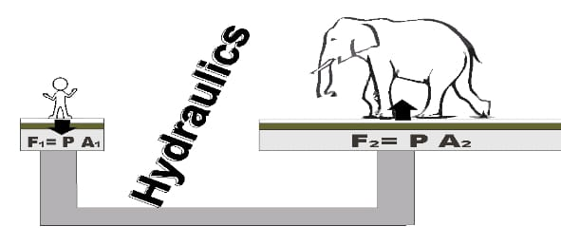
Figure 1
Introduction:
Hydraulic breaks make it possible to amplify force. Fundamental Principal behind the Hydraulic Breaks is F = PA where F,P and A stand for Force, Pressure and area of cross-section
at each limb of a ‘U’ shaped tubes Piston system as shown in above figure 1. If P is constant at both the limbs, Force depends on Cross section area of a piston.
Pedal Power Electric Generator (PPEG) converts human energy through the use of a foot pedal and crank system. A very few efforts has been taken so far to use the concept of PPEG in rural area, agricultural and in all domestic use eg. Alternative to water pump, domestic electric appliances etc. PPEG can’t be utilized to high wattage devices due to constrain of Human Power. Incorporating Hydraulic breaks in PPEG will make it possible to amplify the Human Power consequently will enhance the efficiency of the generator. Mechanical footstep power generation [Ref. no. 1] is also a good option to generate electrical energy by means of a non-conventional method. But the option we offer are more economical and efficient.

Peripherals:
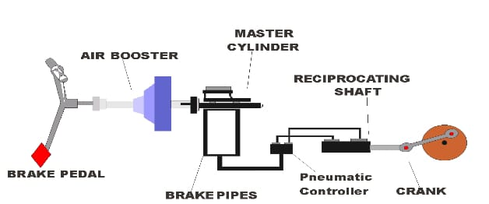
Figure 2
In Figure 2 we have connected Hydraulic Breaks system to the crank. In the working model, Length of a Crank Shaft will fix the device RPM (Revolution per minute). The Crank wheel will drive an Alternator which willgenerate an alternating current (AC).We can use 1 kW to 100 kW rated Alternators. Voltage and Current required for the domestic appliances is about 210 V to 230 V (Single Phase), 440 V (For 3 Phase) and 43 A for 10 kW alternator of single phase. RPM required forthis is inBetween 1490 to 1510.
Formula for RPM calculation
RPM =120×frequency / no. of pole
In electrical power systems, the term "pole" typically refers to the number of poles in an electric machine, such as an electric motor or generator. It is an important parameter that affects the machine's speed, torque, and overall performance.
The number of poles in an electric machine is related to the speed at which the magnetic field rotates within the machine. It is directly linked to the frequency of the AC (alternating current) power supply that the machine is designed to operate with.
The constant "120" in the formula is derived from the fact that in a 60 Hz power system (common in North America), a synchronous motor with four poles runs at a speed of 1800 RPM (60 Hz * 60 seconds). The formula is applicable to different frequencies as well.
Our ultimate goal is to generate 1500 RPM and with the gears and crank length adjustment, we can achieve it for sure.
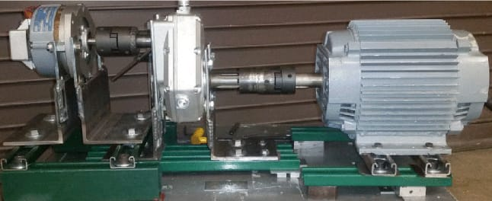
Figure 3 (Alternator with Gear Box- RPM needed-1490-1510)
We worked out on unit costing aiming for the domestic appliances power requirement. As shown in following figure, the total cost for Hydraulic Breaks system + Crank + Alternator is about Rs. 50000 (The Cost may vary time to time)
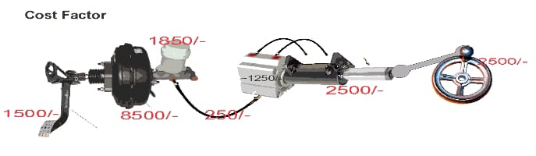
Figure 4

Present Factor Affecting
Factor | Description
Average power output | The average power output of a person pedaling at a moderate pace is about 100 watts. This is enough to power a small light bulb or a laptop computer.
Peak power output | The peak power output of a person pedaling can be much higher than the average power output. For example, a competitive cyclist can generate up to 1,000 watts of power for short periods of time.
Efficiency | The efficiency of hydraulic pedaling systems is typically around 20%. This means that for every 100 watts of power that is generated by pedaling, 20 watts are actually used to power a load.
Load | The amount of power that can be generated by hydraulic pedaling systems is limited by the load that is being powered. For example, a system that is powering a light bulb will be able to generate more power than a system that is powering a laptop computer.
Weight of the person pedaling | The heavier the person pedaling, the more power they can generate.
Efficiency of the system | The cadence is the number of times the pedals are turned per minute. A higher cadence will generate more power.
Cadence of the pedaling | The cadence is the number of times the pedals are turned per minute. A higher cadence will generate more power.

Estimated Statistical Analysis: The capacity of a human to generate power by hydraulic pedaling varies greatly depending on numerous aspects, including the individual's physical condition, the effectiveness of the hydraulic system, and the duration of pedaling. Let's make some educated guesses based on common human skills and assumptions.

Please keep in mind that the values presented are only approximations and may differ from individual variances, the specific hydraulic system employed, and other variables. Depending on the circumstances, actual power generation may be lower or higher.

Conclusion: This is theoretical proposal cascade commercial hydraulic break that can convert linear motion to circular one with an educated gate so that we can reach to the required rpm, and if that can be done, a single human paddling for a couple of hour can generate domestic electrical power.
References:
- International Journal of Engineering Trends and Applications (IJETA) Volume 5 Issue2, Mar., Apr 2018.
- Dean, T. (2008) The Human-Powered Home: Choosing Muscle Over Motors, New Society publishers, Philadelphia, PA, 64, chap. 2.
- Kris, D. (2011) The Short History of Early Pedal-powered Machines, Low-Tech Magazine. http//:www.lowtechmagazine.com/2011/05/history-of-pedal-powered-machines.html, accessed on 14/09/2014 at 12:15pm

