Investigation of Zinc Cobaltite (ZnCo₂O₄) As A Hole Transport Layer (HTL) For Perovskite Solar Cell

I. D. Rummaja, M. I. Idris, Z. A. F. Napiah, N. Norddin
Faculty of Electronic and Computer Engineering,
Universiti Teknikal Malaysia Melaka (UTeM),
Melaka, Malaysia

M. Rashid
School of Physics,
Universiti Sains Malaysia (USM),
Pulau Pinang, Malaysia

ABSTRACT
Perovskite solar cells (PSCs) represent an economically viable and efficient photovoltaic alternative to conventional silicon solar cells, boasting attributes like remarkable mobility, direct bandgap, prolonged carrier lifespan, and robust light absorption. Nonetheless, the conventional materials applied for the holes transport layer (HTL) in PSCs, such as PEDOT:PSS, SPIRO-OMETAD, and copper(I) iodide, grapple with durability issues and diminished carrier mobility. In response, Zinc Cobaltite (ZnCO₂O₄), renowned for its hole transport capabilities, expansive optical bandgap, and amenable solution processability, emerges as a promising contender for HTL replacement. Through synergistic application of OghmaNano software simulations and the Taguchi method, scrutiny was directed towards the FTO/TiO₂/CsPbI₃/ZnCO₂O₄/Au device configuration. By manipulating the ZnCO2O4 layer thickness, optimization was achieved, leading to a commendable power conversion efficiency (PCE) of 32.23% at a ZnCO₂O₄ thickness of 300nm. Robustly supported by ANOVA analysis, the paramount influence on PCE was attributed to ZnCO₂O₄ thickness as the HTL, followed by environmental temperature and ZnCO₂O₄'s bandgap. Significantly, ZnCO₂O₄ thickness wielded an impactful 70% effect on PCE, underscoring its potential to catalyze enhanced PCE through targeted adjustments in thickness.

Keywords—Zinc Cobaltite, Hole Transport Layer, Thin Film, Perovskite Solar Cells.

INTRODUCTION

In the realm of renewable energy, solar cells, also known as photovoltaic cells, play a pivotal role by converting solar energy into usable electricity through the unique properties of semiconductor materials, primarily silicon. Structurally, these cells consist of distinct layers: a light-enhancing anti-reflective coating atop and an absorber layer housing the semiconductor, often crystalline silicon. As sunlight strikes the semiconductor, it triggers the generation of electricity as excited electrons mobilize, establishing an electric current [1]. Central to their functionality is the presence of a p-n junction—a juncture between disparate semiconductor materials—where incoming photons liberate electrons, instigating a voltage disparity. Harnessing these electrons through electrical connections facilitates immediate device empowerment or storage within batteries. The allure of solar energy lies in its eco-friendliness and boundless supply, progressively gaining traction across global households, enterprises, and municipalities due to heightening efficiency and accessibility.

The one of promising third generation of solar cells, particularly perovskite solar cells, has emerged as a potential game-changer. With their remarkable power conversion efficiency (PCE) and scalability, these perovskite solar cells hold significant promise for advancing solar energy production [2]. These cells have exhibited an unprecedented increase in PCE, owing to their ideal characteristics such as high light absorption, extended carrier diffusion length, strong carrier mobility, and tunable bandgaps through atomic composition exchange [3]. Perovskite solar cells are structured with key layers: the electron transport layer (ETL), perovskite layer, and hole transport layer (HTL). Despite the substantial efficiency gains, there remain challenges to overcome for commercial viability. Notably, the choice of HTL material is critical for both PCE and long-term stability [4]. The advantage of perovskite solar cells lies not only in their performance but also in their cost-effective production via solution processing, in contrast to traditional crystalline silicon cells. These cells exhibit unique optoelectrical properties, including low exciton binding energy, enabling efficient charge separation upon photon absorption. In Figure 1, common structures of perovskite solar cells are shown.

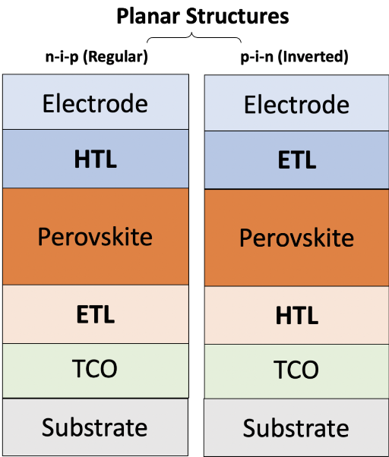
Figure 1: Common structures of perovskite solar cell

As depicted in Figure 2, the perovskite layer absorbs photons, exciting electrons and creating electron-hole pairs. These carriers are effectively separated due to the low exciton binding energy. Electrons pass through the electron transport layer to power external devices, while holes move to the hole transport layer for similar utilization [5]. This multifaceted process underscores the potential of perovskite solar cells as a transformative technology in solar energy utilization. Despite of its advantages, the traditional materials used for the holes transport layer (HTL) in PSCs, such as PEDOT:PSS, SPIRO-OMETAD, and copper(I) iodide, have durability issues, stability issues and lower carrier mobility which cause disadvantages to holes transport layer materials.[6], [7] To overcome these challenges, a potential alternative HTL material with wide optical bandgap, good solution processability and has its advantages of hole transport need to be investigated to replace the traditional material.

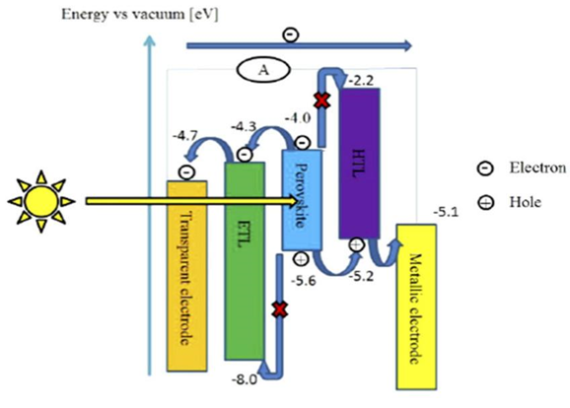
Figure 2: The working principle of perovskite solar cells

Zinc Cobaltite, a metallic alloy primarily composed of cobalt and zinc, exhibits a cubic crystal structure called spinel oxide (ZnCO₂O₄). This compound boasts diverse applications, serving as a catalyst for chemical processes like organic molecule combustion and oxygen reduction in fuel cells. Its remarkable electrochemical activity and durability also render it a valuable electrode material in rechargeable batteries. The extensive advantages of Zinc Cobaltite position it as a promising contender across technology, catalysis, and energy storage domains, showcasing its potential in crafting high-performance tools and components [3]. Figure 3 shows crystallographic of the zinc cobaltite.
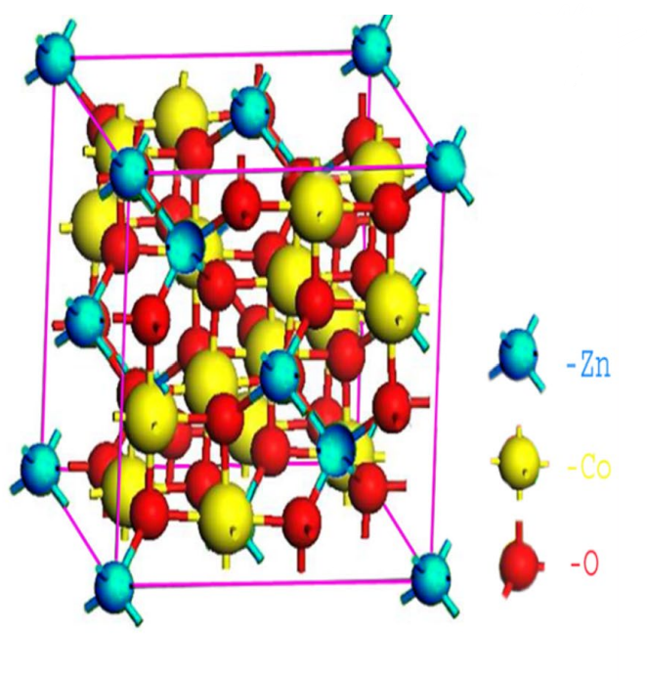
Figure 3: The crystallographic structure of the zinc cobaltite [3].
The production of ZnCO₂O₄ nanoparticles employed a chemical precipitation technique. Initially, Co(NO₃)₂•₆H₂O dissolved in deionized water, followed by gradual NH₄OH(aq) addition to the solution. After sonication, an aqueous Zn(NO₃)₂•6H₂O solution was introduced and stirred. The mixture underwent heating to 150 °C for solvent evaporation and sintering at 225 °C for 2 hours. The ensuing ZnCO₂O₄ nanoparticles were washed, dried at 60 °C for 4 hours, and dispersed in DI water using ultrasonication (50 mg of nanoparticles in 2 mL DI water for 2 hours). It's crucial to highlight that all solutions were freshly prepared before device fabrication. In this study, we explore the potential of Zinc Cobaltite (ZnCO₂O₄) as an alternative hole transport layer (HTL) through simulation using OghmaNano software and optimization via the Taguchi method.

Computational Modelling

Oghmanano software as perovskite solar cell simulation
OghmaNano, an acronym for Organic and Hybrid Material Nano Simulation Tool, serves as a software package designed for the simulation of diverse solar cells and optoelectronic devices. This software empowers users to model device behavior across various operational scenarios, assessing performance under different solar radiation levels, temperatures, and environmental contexts. Utilizing the Poisson equation (1), bipolar drift diffusion equations (2,3), and carrier continuity equations (4,5) as cited in [1], [8], OghmaNano employs the finite element method (FEM) for mathematical solutions, as detailed in [9]. The AM1.5G spectrum is adopted to represent the sun's radiation spectrum in simulations.

$\frac{d}{dx}ε_{0}ε_{r}\frac{dφ}{dx}=q(n-p)$ (1)
$\frac{dJn}{dx}=q(Rn-Gn+\frac{∂n}{∂t})$ (2)
$\frac{dJp}{dx}=q(Rp-Gp+\frac{∂p}{∂t})$ (3)
$Jn=qμ_{e}n\frac{∂e_{LUMO}}{∂x}+qDn\frac{∂n}{∂t}$ (4)
$Jp=qμ_{e}p\frac{∂e_{HOMO}}{∂x}+qDp\frac{∂p}{∂t}$ (5)

In the realm of equations, various symbols hold significant meanings. Permit me to elucidate: ε₀ stands for the permittivity of free space, ε pertains to the permittivity of the perovskite material. Meanwhile, q embodies the elementary charge, p embodies the hole carrier density, and n encapsulates the electron carrier density. Current densities are represented as Jn for electron current and Jp for hole current. The generation rates of liberated electrons and holes, often referred to as Gn and Gp, contribute to the equation's dynamics. Rn and Rp symbolize the recombination rates for electrons and holes. The disparity between HOMO (highest molecular orbital) and LUMO (lowest molecular orbital) energies defines the band gap, a pivotal parameter. The mobility of electrons and holes is denoted by μ, whereas diffusion coefficients for electrons and holes are conveyed through Dn and Dp. This constellation of symbols intertwines to describe the equations used in the OghmaNano simulation software.

Simulation model and eletrical parameter
The simulation model encompasses a composition of five distinct layers, each pivotal to the construction of perovskite solar cells. As illustrated in Figure 4a, this model comprises layers including FTO glass and gold (Au) serving as contact layers. Subsequently, a layer of titanium oxide (TiO₂) functions as the Electron Transport Layer (ETL), while cesium lead iodide (CsPbI₃) serves as the perovskite layer. Finally, the assembly concludes with the inclusion of zinc cobaltite (ZnCO₂O₄) as the Hole Transport Layer (HTL). Notably, the ETL, perovskite, and HTL layers play active roles within the simulation model. The configuration of the simulated device follows the sequence FTO/TiO₂/CsPbI₃/ZnCO₂0₄/Au. To see the overall energy profile of the model, Figure 4b furnishes an illustrative representation of the energy levels of whole device.

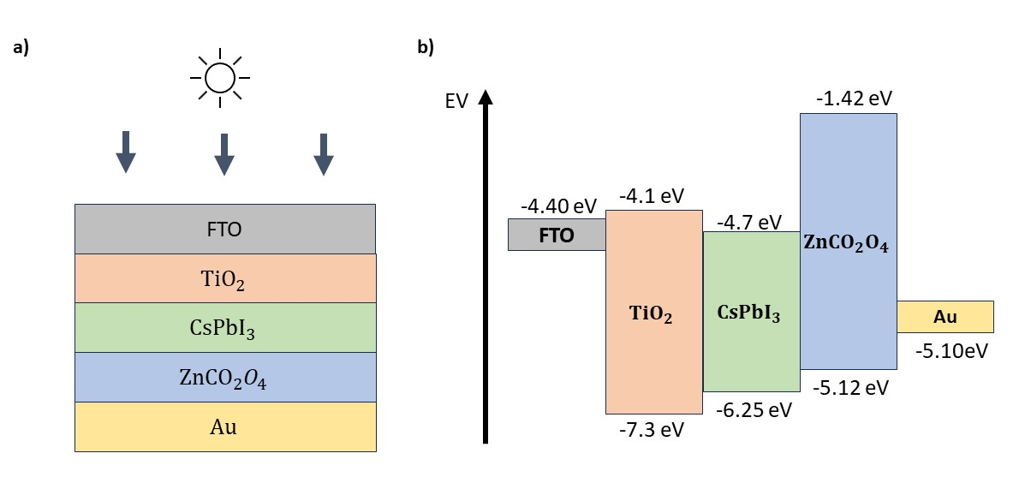
Figure 4 : The simulated configuration of device. a) The schematic configuration of device. b) the energy level diagram of whole device

Utilizing the OghmaNano software, a comprehensive analysis was conducted to evaluate key photovoltaic parameters, namely the open-circuit voltage (Voc), short current density (Jsc), fill factor (FF), and power conversion efficiency (PCE). This assessment was undertaken through systematic variation of the Hole Transport Layer (HTM) thickness across a spectrum ranging from 50nm to 500nm, encompassing increments of 25nm. The simulation harnessed essential electrical parameters including bandgap (eV), Xi (eV), relative permittivity, electron mobility, and mobility. These pivotal electrical parameters, as delineated in Table 1, served as integral components in the simulation framework, facilitating a comprehensive and systematic exploration of the impact of HTM layer thickness on the performance of the perovskite solar cells.

Table 1: Electrical parameters of simulation models

Parameter | TiO₂ (ETL) | CsPbI₃ (Perovskite) | ZnCO₂O₄ (HTL)
Eg (eV) | 3.2 | 1.694 | 2.0
Xi (eV) | 4.0 | 3.95 | 3.7
Relative Permittivity | 9 | 6 | 5
Electron mobility (m²/Vs) | 0.002 | 0.0025 | 0.00000914
Hole mobility (m²/Vs) | 0.001 | 0.0025 | 0.00000914

Optimization via Taguchi method
In this research, the Taguchi method served as a valuable tool for identifying the pivotal factors influencing both Jsc and Voc. This comprehensive analysis encompassed variations in core parameters and the thickness of the HTL within the experimental setup. The Taguchi method originated from the work of Dr. Taguchi at Nippon Telephones and Telegraph Company, Japan. This approach is rooted in "ORTHOGONAL ARRAY" experiments, strategically designed to minimize experiment variability by identifying optimal control parameter settings that significantly reduce variance [10]. Consequently, the Taguchi Method harmoniously merges the principles of Design of Experiments with control parameter optimization, leading to superior outcomes. "Orthogonal Arrays" (OAs) form the cornerstone of this method, furnishing a judicious selection of experiments. Dr. Taguchi's Signal-to-Noise ratios (S/N), logarithmic expressions tied to desired outputs, serve as objective functions for optimization, playing pivotal roles in data analysis and predicting optimal results [11].
A systematic approach was adopted to refine the parameter values, realized through the construction of an Orthogonal Array (OA). Specifically, the L9 Orthogonal Array was chosen, tailored to accommodate up to three control factors (CF) – a fitting match for the three parameters under scrutiny, as outlined in Table 2. The selected value levels represented diverse configurations of the Perovskite Solar Cell, spanning from minimum to maximum extents. While these configurations displayed promising efficiency, they still await complete optimization and cost-effectiveness. Through the implementation of the Taguchi Method, these configuration combinations were meticulously assessed to unveil the most efficient configuration values, with the ultimate goal of achieving optimal efficiency outcomes.

Table 2: Parameter for the control factors

Control Factors \ Levels | 1 | 2 | 3
Thickness (nm) | 100 | 225 | 300
Temperature (K) | 300 | 320 | 340
Bandgap (Eg) | 1.80 | 2.00 | 3.70

With the control factor parameters duly established, the focus shifts to the examination of parameters associated with the noise factor. A noise factor, in this context, exerts a minor influence within the scope of this investigation. Among the noise factors considered, two stand out: hole mobility and electron mobility. Notably, these factors share identical values due to their reliance on the same material, Zinc Cobaltite, as shown in Table 3. The specific values assigned to both factors—0.0000071, 0.0000081, and 0.00000914—reflect carefully chosen variations that contribute to the nuanced exploration of the study's landscape. This scrutiny of noise factor parameters enriches our comprehensive understanding, contributing to the larger narrative presented within this work.

Table 3: Parameter for noise factors

 | Noise Level
Noise factors \ leves | 1 | 2 | 3 | Number of levels
Electron Mobility | 0.00000710 | 0.00000810 | 0.00000914 | 3
Hole mobility | 0.00000710 | 0.00000810 | 0.00000914 | 3

Result and Discussion

Effect of HTL thickness to performance of perovskite solar cell
The transport layer thickness in perovskite solar cells is influenced by the design and materials used. The thickness of the hole transport layer (HTL) directly affects the efficiency of extracting holes from the perovskite layer. Optimizing the HTL thickness minimizes charge recombination losses and ensures effective charge transfer. An excessively thin HTL could lead to insufficient hole extraction, lower photocurrent, and overall weaker device performance. Conversely, an overly thick HTL might impede charge extraction, causing higher recombination rates and reduced device efficiency. Typically, the transport layer thickness for electron and hole transport falls within a specific range. Factors like charge extraction, conductivity, and contact resistance play a role in determining the ideal HTL thickness. Therefore, experimental optimization is often necessary to determine the best HTL thickness for a specific perovskite solar cell design. This underscores the importance of tailoring the HTL thickness to achieve optimal performance in perovskite solar cells. Table 4 shows the PSC performance with various hole transport layer thickness.

Table 4: PSC performance with various hole transport layer thickness

Parameter | Thickness (nm) | Voc (V) | Jsc  (mA/cm²) | FF  (%) | PCE  (%)
ZnCO204 | 50 | 1.41 | -29.77 | 69.8 | 29.25
 | 75 | 1.38 | -29.02 | 70.9 | 28.49
 | 100 | 1.37 | -26.71 | 71.6 | 26.27
 | 125 | 1.36 | -26.83 | 72.1 | 26.37
 | 150 | 1.41 | -31.66 | 69.7 | 31.04
 | 175 | 1.42 | -30.43 | 69.3 | 29.89
 | 200 | 1.38 | -28.76 | 71.0 | 28.25
 | 225 | 1.37 | -28.55 | 71.5 | 28.02
 | 250 | 1.37 | -26.02 | 72.0 | 25.61
 | 275 | 1.37 | -27.35 | 71.5 | 26.84
 | 300 | 1.43 | -32.89 | 68.7 | 32.23
 | 325 | 1.41 | -32.39 | 69.4 | 31.73
 | 350 | 1.39 | -31.74 | 70.2 | 31.09
 | 375 | 1.4 | -29.37 | 70.2 | 28.86
 | 400 | 1.38 | -28.72 | 71.0 | 28.21
 | 425 | 1.37 | -28.3 | 71.7 | 27.79
 | 450 | 1.37 | -25.65 | 71.7 | 25.27
 | 475 | 1.36 | -25.1 | 72.5 | 24.72
 | 500 | 1.31 | -11.48 | 73.5 | 11.09

As indicated by the data in Table 4 and the comprehensive findings of this study, it is evident that an optimal thickness of 300nm for Zinc Cobaltite yields a notably high-Power Conversion Efficiency (PCE) of 32.232068% in the perovskite solar cell. Nevertheless, surpassing this thickness threshold results in a decline in PCE. For instance, at a thickness of 500nm, the perovskite solar cell's PCE diminishes to 11.094%. This underscores the significance of maintaining an appropriate Zinc Cobaltite thickness to achieve optimal PCE in the perovskite solar cell, a crucial consideration emphasized within our work.

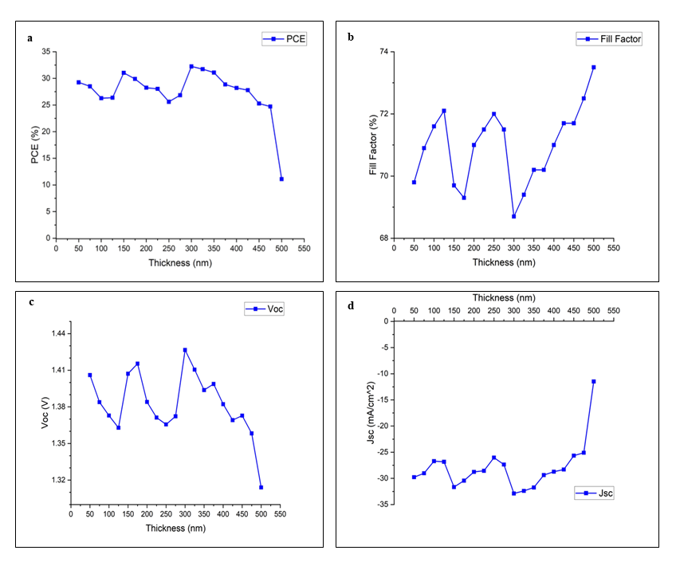
Figure 5: a) Variation of PCE over thickness. b) Variation of FF over thickness. c) Variation of open current voltage, Voc over thickness. d) Variation of current density, Jsc over thickness

The graph depicted on figure 5 reveals a distinct pattern: the efficiency (PCE) of the perovskite solar cell experiences alternating increments and decrements as the thickness of the Zinc Cobaltite hole transport layer varies. Maintaining constant values of 200 nm for the Electron Transport Layer (ETL) composed of Titanium Oxide and 400 nm for the perovskite layer comprising CsPbI3, the hole transport layer's thickness ranged from 100 nm to 500 nm across all materials. From Figure 5, it is evident that the optimal thickness for achieving maximum photo conversion stands at 300 nm. Beyond 400 nm, a saturation point is reached. Excessive thickness in hole transport layers (HTL) can impede carrier movement, negatively affecting device performance by hindering hole transport. Conversely, an overly thin HTL might not facilitate efficient hole injection from the active layer into the HTL. This mismatch can lead to inadequate internal charge balance and an overall reduction in device efficiency, underscoring the importance of optimizing HTL thickness to ensure optimal perovskite solar cell performance.

Result of optimazation via Taguchi method
The Taguchi method seeks to identify influential factors impacting the perovskite's Power Conversion Efficiency (PCE). In this investigation, three key control factors were examined to pinpoint the most impactful on PCE. These factors encompass the thickness of Zinc Cobaltite as the Hole Transport Layer (HTL), the ambient temperature, and the Zinc Cobaltite's bandgap. For a comprehensive Taguchi analysis, two noise factors were identified—hole mobility and electron mobility in Zinc Cobaltite. While the latter factors are anticipated to exert minor influence, the Taguchi method aids in discerning their potential impact on PCE. This approach underscores the pivotal role of these factors in shaping perovskite solar cell efficiency. Table 5- 8 shows the several simulations of solar cell parameters after performed via Taguchi method.

Table 5: Voc result via Taguchi method

Parameter: Voltage open circuit, Voc (V)
 | Repetitions
 | 1 | 2 | 3 | 4 | 5 | 6 | 7 | 8 | 9
1 | 1.373 | 1.373 | 1.373 | 1.373 | 1.373 | 1.373 | 1.373 | 1.373 | 1.373
2 | 1.12 | 1.12 | 1.12 | 1.12 | 1.12 | 1.12 | 1.12 | 1.12 | 1.12
3 | 1.063 | 1.063 | 1.063 | 1.063 | 1.063 | 1.063 | 1.063 | 1.063 | 1.063
4 | 1.371 | 1.371 | 1.371 | 1.371 | 1.371 | 1.371 | 1.371 | 1.371 | 1.371
5 | 1.119 | 1.119 | 1.119 | 1.119 | 1.119 | 1.119 | 1.119 | 1.119 | 1.119
6 | 1.062 | 1.062 | 1.062 | 1.062 | 1.062 | 1.062 | 1.062 | 1.062 | 1.062
7 | 1.425 | 1.426 | 1.426 | 1.426 | 1.426 | 1.426 | 1.426 | 1.426 | 1.426
8 | 1.133 | 1.133 | 1.133 | 1.133 | 1.133 | 1.133 | 1.133 | 1.133 | 1.133
9 | 1.065 | 1.065 | 1.065 | 1.065 | 1.065 | 1.065 | 1.065 | 1.065 | 1.065

Table 6: Jsc result via Taguchi method

Parameter: Current density, Jsc (mA/cm2)
 | Repetitions
 | 1 | 2 | 3 | 4 | 5 | 6 | 7 | 8 | 9
1 | -26.707 | -26.707 | -26.707 | -26.707 | -26.707 | -26.707 | -26.707 | -26.707 | -26.707
2 | -26.709 | -26.709 | -26.709 | -26.709 | -26.709 | -26.709 | -26.709 | -26.709 | -26.709
3 | -26.721 | -26.721 | -26.721 | -26.721 | -26.721 | -26.721 | -26.721 | -26.721 | -26.721
4 | -28.553 | -28.553 | -28.553 | -28.553 | -28.553 | -28.553 | -28.553 | -28.553 | -28.553
5 | -28.580 | -28.580 | -28.580 | -28.580 | -28.580 | -28.580 | -28.580 | -28.580 | -28.580
6 | -28.549 | -28.549 | -28.549 | -28.549 | -28.549 | -28.549 | -28.549 | -28.549 | -28.549
7 | -32.922 | -32.921 | -32.921 | -32.921 | -32.921 | -32.921 | -32.921 | -32.921 | -32.921
8 | -32.883 | -32.883 | -32.883 | -32.883 | -32.883 | -32.883 | -32.883 | -32.883 | -32.883
9 | -32.886 | -32.886 | -32.886 | -32.886 | -32.886 | -32.886 | -32.886 | -32.886 | -32.886

Table 7: FF result via Taguchi method

Parameter: Fill Factor, FF (%)
 | Repetitions
 | 1 | 2 | 3 | 4 | 5 | 6 | 7 | 8 | 9
1 | 71.5 | 71.5 | 71.5 | 71.5 | 71.5 | 71.5 | 71.5 | 71.5 | 71.5
2 | 84.1 | 84.1 | 84.1 | 84.1 | 84.1 | 84.1 | 84.1 | 84.1 | 84.1
3 | 71.8 | 72.5 | 73.1 | 71.8 | 72.5 | 73.1 | 71.8 | 72.5 | 73.1
4 | 71.5 | 71.5 | 71.5 | 71.5 | 71.5 | 71.5 | 71.5 | 71.5 | 71.5
5 | 83.7 | 83.7 | 83.7 | 83.7 | 83.7 | 83.7 | 83.7 | 83.7 | 83.7
6 | 84.4 | 84.4 | 84.4 | 84.4 | 84.4 | 84.4 | 84.4 | 84.4 | 84.4
7 | 68.5 | 68.5 | 68.5 | 68.5 | 68.5 | 68.5 | 68.5 | 68.5 | 68.5
8 | 82.7 | 82.7 | 82.7 | 82.7 | 82.7 | 82.7 | 82.7 | 82.7 | 82.7
9 | 84.1 | 84.1 | 84.1 | 84.1 | 84.1 | 84.1 | 84.1 | 84.1 | 84.1

Table 8: PCE result via Taguchi method

Parameter: PCE (%)
 | Repetitions
 | 1 | 2 | 3 | 4 | 5 | 6 | 7 | 8 | 9
1 | 26.246 | 26.246 | 26.247 | 26.246 | 26.246 | 26.247 | 26.246 | 26.246 | 26.247
2 | 25.15 | 25.15 | 25.151 | 25.151 | 25.151 | 25.151 | 25.15 | 25.15 | 25.151
3 | 20.397 | 20.605 | 20.764 | 20.764 | 20.764 | 20.764 | 20.397 | 20.605 | 20.764
4 | 28.022 | 28.023 | 28.023 | 28.023 | 28.023 | 28.023 | 28.022 | 28.023 | 28.023
5 | 26.772 | 26.774 | 26.776 | 26.776 | 26.776 | 26.776 | 26.772 | 26.774 | 26.776
6 | 25.603 | 25.604 | 25.604 | 25.604 | 25.604 | 25.604 | 25.603 | 25.604 | 25.604
7 | 32.179 | 32.18 | 32.181 | 32.181 | 32.181 | 32.181 | 32.179 | 32.18 | 32.181
8 | 30.83 | 30.83 | 30.831 | 30.831 | 30.831 | 30.831 | 30.83 | 30.83 | 30.831
9 | 29.492 | 29.493 | 29.494 | 29.494 | 29.494 | 29.494 | 29.492 | 29.493 | 29.494

Upon completion of the confirmation experiment, the resulting data, as presented in the table, reveals consistently high-Power Conversion Efficiency (PCE) across all experiments. This outcome signifies the effectiveness of the employed parameters, all contributing to achieving elevated PCE values. The pinnacle PCE achievement at 32.232% corresponds to level 9, indicating that optimal parameters for the thickness of Zinc Cobaltite HTL, environmental temperature of 300K, and Zinc Cobaltite's bandgap value of 2.0 were realized. Moreover, both noise factors, at level 3—0.00000914 for hole mobility and electron mobility—contributed to this exceptional outcome. These findings underscore the potential for harnessing these parameters to attain remarkable PCE values in the perovskite solar cell.
Analysis of Variance (ANOVA) is a statistical method that assesses variations among means of different groups, helping to detect differences between their averages [12]. It's employed across various scenarios to discern potential variations between group means. In this study, ANOVA was utilized to explore the effects of three key factors. The findings reveal that the thickness of Zinc Cobaltite as the Hole Transport Layer (HTL) holds the most significant impact on Power Conversion Efficiency (PCE), followed by environmental temperature and the bandgap of Zinc Cobaltite. Particularly, the thickness of Zinc Cobaltite bears a 70% influence on PCE. Consequently, altering the thickness of Zinc Cobaltite would correspondingly alter PCE values. Figure 6 shows the factor plot effect for PCE using Taguchi method and Table 9 shows the result of ANOVA for PCE.

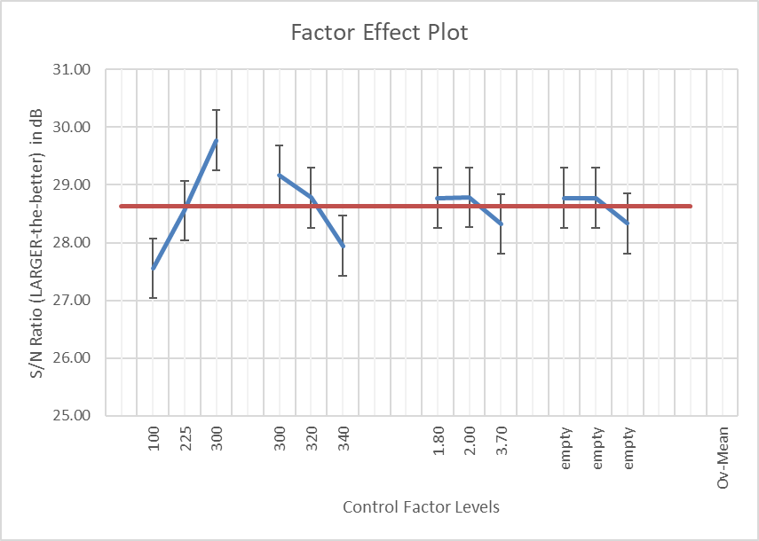
Figure 6 Factor effect plot effect

Table 9: Result of ANOVA for PCE

Control Factors | Degrees of freedom | Sum of squares | Mean square | Factor Effect (%)
Thickness (nm) | 2 | 7 | 4 | 70
Temperature (K) | 2 | 2 | 1 | 22
Bandgap (Eg) | 2 | 0 | 0 | 4

Once the primary influential factor was identified, optimal parameters within each control factor were pinpointed for a confirmation experiment. Table 10 shows the best setting selection for respecting parameter. The optimal parameter for Zinc Cobaltite HTL thickness is level 3, equating to 300nm. Likewise, the ideal parameter for ambient temperature is level 1, set at 300K. Finally, for bandgap, the optimal parameter is identified at level 2, corresponding to a value of 2.0. These meticulously chosen parameters form a trio that was assessed to ascertain their combined impact on achieving high Power Conversion Efficiency (PCE).

Table 10: Best setting selection for respective parameter

Control Factors parameter | Best level | Best value
Thickness (nm) | 3 | 300
Temperature (K) | 1 | 300
Bandgap (Eg) | 2 | 2.0

From the outcomes presented in the table 11 after the confirmation experiment, a noticeable trend emerges: all experiments yield elevated Power Conversion Efficiency (PCE), underscoring the effectiveness of the employed parameters in achieving high PCE values. The most noteworthy achievement stands at a PCE of 32.232% at level 9, denoting optimal parameters—300nm thickness for Zinc Cobaltite HTL, 300K for environmental temperature, and a Zinc Cobaltite bandgap of 2.0. Additionally, both noise factors, at level 3, involving 0.00000914 for hole mobility and electron mobility, further contributed to this remarkable outcome. These results affirm the potential of this parameter combination to drive substantial PCE gains within the perovskite solar cell context, aligning seamlessly with our research 's focus.

Table 11: Result after the confirmation experiment

 | Voc (V) | Jsc (mA/cm²) | FF  (%) | PCE (%)
1 | 1.426 | -32.887 | 68.7 | 32.231
2 | 1.426 | -32.886 | 68.7 | 32.231
3 | 1.427 | -32.886 | 68.7 | 32.232
4 | 1.426 | -32.887 | 68.7 | 32.231
5 | 1.426 | -32.886 | 68.7 | 32.231
6 | 1.427 | -32.886 | 68.7 | 32.232
7 | 1.426 | -32.887 | 68.7 | 32.231
8 | 1.426 | -32.886 | 68.7 | 32.231
9 | 1.427 | -32.886 | 68.7 | 32.232

CONCLUSION

In summation, our investigation has centered on exploring the potential of zinc cobaltite (ZnCo2O4) as an alternative hole transport layer (HTL) material, replacing conventional choices. Through meticulous simulations conducted using OghmaNano software, the performance of zinc cobaltite as HTL was assessed. The findings underscore that a remarkable power conversion efficiency (PCE) of 32.23% can be achieved by employing a Zinc Cobaltite thickness of 300nm. Intriguingly, ANOVA analysis underscores that the thickness of Zinc Cobaltite, serving as the HTL, exerts the most pronounced influence on the perovskite solar cell's efficiency (PCE), closely trailed by environmental temperature and the bandgap of Zinc Cobaltite. Notably, the thickness of Zinc Cobaltite manifests a substantial 70% impact on PCE, signifying the critical role of this parameter in optimizing solar cell performance.

REFERENCES

[1] J. A. Röhr and R. C. I. MacKenzie, “Analytical description of mixed ohmic and space-charge-limited conduction in single-carrier devices,” J Appl Phys, vol. 128, no. 16, Oct. 2020, doi: 10.1063/5.0024737.
[2] S. Muhammad, A. T. Nomaan, AbdulmutolibO. Olaoye, M. I. Idris, and M. Rashid, “Concentration dependence of physical properties of low temperature processed ZnO quantum dots thin films on polyethylene terephthalate as potential electron transport material for perovskite solar cell,” Ceram Int, vol. 48, no. 21, pp. 31559–31569, Nov. 2022, doi: 10.1016/j.ceramint.2022.07.077.
[3] B.-R. Jheng, P.-T. Chiu, S.-H. Yang, and Y.-L. Tong, “Using ZnCo2O4 nanoparticles as the hole transport layer to improve long term stability of perovskite solar cells,” Sci Rep, vol. 12, no. 1, p. 2921, Feb. 2022, doi: 10.1038/s41598-022-06764-w.
[4] S. Muniandy, M. I. Bin Idris, Z. A. F. Bin Mohammed Napiah, and M. Rashid, “The effect of pH level and annealing temperature on NiO thin films as Hole Transport Material in Inverted Perovskite Solar Cells,” in 2022 IEEE International Conference on Semiconductor Electronics (ICSE), IEEE, Aug. 2022, pp. 13–16. doi: 10.1109/ICSE56004.2022.9863126.
[5] E. Danladi, D. S. Dogo, S. M. Udeh, F. O. Uloko, and A. O. Salawu, “Recent Advances in Modeling of Perovskite Solar Cells Using SCAPS-1D: Effect of Absorber and ETM Thickness,” East European Journal of Physics, no. 4, pp. 5–17, Dec. 2021, doi: 10.26565/2312-4334-2021-4-01.
[6] L. Nakka, Y. Cheng, A. G. Aberle, and F. Lin, “Analytical Review of Spiro‐OMeTAD Hole Transport Materials: Paths Toward Stable and Efficient Perovskite Solar Cells,” Advanced Energy and Sustainability Research, vol. 3, no. 8, Aug. 2022, doi: 10.1002/aesr.202200045.
[7] Y. Xia, G. Yan, and J. Lin, “Review on Tailoring PEDOT:PSS Layer for Improved Device Stability of Perovskite Solar Cells,” Nanomaterials, vol. 11, no. 11, p. 3119, Nov. 2021, doi: 10.3390/nano11113119.
[8] R. C. I. MacKenzie, T. Kirchartz, G. F. A. Dibb, and J. Nelson, “Modeling Nongeminate Recombination in P3HT:PCBM Solar Cells,” The Journal of Physical Chemistry C, vol. 115, no. 19, pp. 9806–9813, May 2011, doi: 10.1021/jp200234m.
[9] J. Zhao et al., “Simulation of Crystalline Silicon Photovoltaic Cells for Wearable Applications,” IEEE Access, vol. 9, pp. 20868–20877, 2021, doi: 10.1109/ACCESS.2021.3050431.
[10] S. Kumar, K. Jb, K. Park, K. Scholar, A. P. ( Mech, and R. Sahai, “An Overview on Taguchi Method.” [Online]. Available: https://www.researchgate.net/publication/265282800
[11] A. Mitra, “The Taguchi method,” Wiley Interdiscip Rev Comput Stat, vol. 3, no. 5, pp. 472–480, Sep. 2011, doi: 10.1002/wics.169.
[12] R. A. Armstrong, F. Eperjesi, and B. Gilmartin, “The application of analysis of variance (ANOVA) to different experimental designs in optometry,” Ophthalmic and Physiological Optics, vol. 22, no. 3, pp. 248–256, May 2002, doi: 10.1046/j.1475-1313.2002.00020.x.

