“IOT BASED FIRE DETECTION AND PREVENTION SYSTEM IN FARMLAND”

DARSHINI H S
Electronics And Communication Department,
P E S College Of Engineering,
Mandya, India,
Darshi.ss.ramu@gmail.com

AMULYA B S
Electronics And Communication Department,
P E S College Of Engineering,
Mandya, India,
amulyabs98@gmail.com

I.Abstract:
Agriculture is the main source for food and helps in economic improvement for many countries.In current scenario farmers are facing various problems in water management. In addition, during summer many agriculture fields suffers from fire accidents both naturally and manmade. This issue is addressed by the design of automatic fire detection system with an automatic sprinkler which is used along with fire detection sensor.
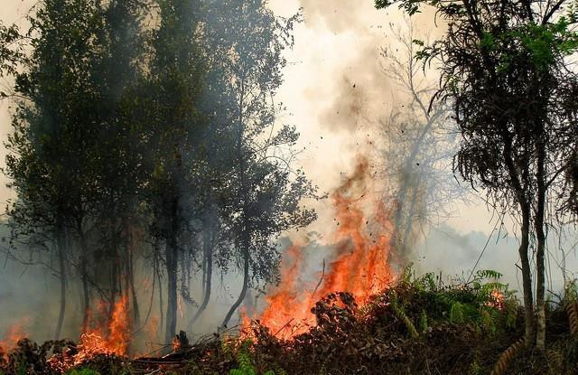
Figure 1: Fire attacked image
Whenever fire detected by sensor then the motor get turns on by automation technology. Internet of Things is rapidly progressing in the present generation and using this technology continuous monitoring agriculture fire status is implemented at unlimited distance range. In this project embedded automation-based agriculture fire detection and water spray system and IOT Monitoring is demonstrated.

II.Introduction:
Agriculture, the backbone of Indian economy, adds to the in general financial development of the nation and decides the norm of life for over 70% of the Indian populace. Agriculture contributes simply around 14% to the general Gross domestic product yet its effect is felt in the assembling area as well as the administrations area as the country populace has turned into a huge buyer of labor and products over the most recent few decades. The vast majority of the cultivating in India is monsoon dependent - on the off chance that rainstorm are great, the whole economy (and in addition to the farming area) is perky and when monsoon fails, everybody wherever endures a shot somewhat.
Agriculture fire occurs by nature and manmade. Nowadays protecting agriculture land from fire is very hard. A image of fire attack on farmland is shown in Figure 1. It causes many growth losses and property loss of farmers. Hence we need to implement smart solution for agriculture fire prevention.
Different strategies are carried out to increment in general efficiency, for example, suggested frameworks, master frameworks for improved results utilizing IoT utilizing techniques like schedule irrigation patterns and reuse of water.
Although these systems are for the most part involved by businesses for cultivating and not accessible for business use, which prompts dry fields and inappropriate development of
AMRUTHA K
Electronics And Communication Department,
P E S College Of Engineering,
Mandya, India,
ammukumar636@gmail.com

HAMSA H M
Electronics And Communication Department,
P E S College Of Engineering,
Mandya, India,
hamsamanjunath31@gmail.com

harvests. Despite the fact that most of the agriculture locale of India has arrived at present day rural practice there is as yet a district where these are inaccessible. Internet of Things (IOT) broadly expanded over the most recent 10 years as simplicity of execution and assortment of strategies can be utilized to carry out in the rural field.
Various sensors can be utilized for associating gadgets
what's more, gathering information. It diminishes labor supply and assists with taking care of and connect with the information gathered. Information assortment is a piece of an investigation that is incredibly expected for information handling and information control. Today the progression of information from the sensor is tremendous to the point that normal information stockpiling isn't enough for quicker recovery of information. Google Firebase is an information storage platform where retrieval of data and storage is simple and quicker than the standard information stockpiling stage. IOT gadgets can undoubtedly be associated with firebase and utilized for data related activities. Thus, it sends the data to the client. In this project , IOT and embedded automation based farming fire detection and prevention system.

III.Problem Statement:
As per the most recent news in India and different nations these homestead fire accident are extremely risky. It will consume every one of the yields and furthermore harm the dirt it makes soil disintegration. These accidents are man-made mishaps like power line flaws and different sorts of mistakes. There isn't any current framework to make a quick move for the counteraction from this fire. Thus, we are building a automation system that is handling this condition. We use ranch water to make action.

IV.Literature survey:

D.Meghanathan[1] In this project, They proposed programmed crop security framework from creatures. This is a microcontroller based framework utilizing PIC family microcontroller. This framework utilizes a movement sensor to recognize wild creatures moving toward close to the field. In such a case the sensor flags the microcontroller to make a move. The microcontroller now sounds a caution to charm the creatures from the field as well as sends sms to the rancher so that he might be aware of the issue and come to the spot in the event that the creatures don't dismiss by the caution. This guarantees total wellbeing of crops from animals in this way safeguarding the ranchers misfortune.
Adithi A.Kulkarni[2] We constructed a smart system which is controlled by IOT based which will shield our fire from fire. At the point when fire happens in encompassing homesteads then our system will detect the fire and begin water sprinklers to extinguish the fire and offer this information on IoT to know the situation with farm to farmer. They additionally doing automation utilizing IOT based irrigation system. They accomplishing this controlling system overall by utilizing IOT based technology.
Ibtisam Ehsan[3] This project is to create and survey an alarm route framework and application that utilizes the Internet of Things. Fire alarm frameworks are intended to caution individuals about flames ahead of time with the goal that they can clear the fire-impacted region and make a prompt move to control the fire. GPS module, a fire sensor, a smoke sensor, bells, LEDs, and a GSM module to guarantee early warning to specialists and fire stations. The point is to lessen the loss of lives and property. A poll was intended to direct a short study in a worldwide sports production company in Sialkot, Pakistan, in regards to the IoT alarm route framework. Other than introducing the framework in the plant, we contrast the outcomes and re incident response time with and without this framework at rescue 1122 fire head station.
Hamood Alqourabah[4] : This paper utilizes different integrated detectors , like heat, smoke, and fire. The signs from those detectors go through the system algorithm to check the fire's possibility and afterward broadcast the anticipated outcome to different gatherings utilizing GSM modem related with the framework. To get genuine information without endangering human lives, an IoT innovation has been carried out to furnish the local group of fire-fighters with the essential information. At long last, the fundamental component of the proposed framework is to limit misleading problems, which, in turn , makes this system more dependable. The experimental outcomes showed the prevalence of our model regarding moderateness, viability, and responsiveness as the framework utilizes the Ubidots stage, which makes the information exchange quicker and reliable.
Varshini B M,Sushma AV [14]: There are numerous escape clauses in such thoughts thus ad libbing horticultural security has turned into a significant issue nowadays. Hence, this paper
centers around proposing a framework which identifies the interlopers, screens any suspicious action and afterward reports to the proprietor of the field. It goes about as a versatile framework which gives a practicable framework to the ranchers for guaranteeing complete security of their farmlands from any assaults or intruding exercises.
Krunal Mahajan,Riya Parate,Ekta Zade,Shubam Khante,Shishir Begal [15]: This paper describes overview of various researches on smart crop protection system. We have a lot of technology that can protect the farm 24x7 those systems and technique we are discussing in this paper. We have different types of technology that can help to secure the farm. We have seen Arduino and raspberry pi based Farm protection system. But those Systems have different mythology and platform for that and the cost of those projects also increased so that those are not affordable with the farmer. Our main aim to design a system that can help to farmer to protect his farm from, animals with getting harm to them.
Shashi Kiran V,Manoj N, Hemanth Kumar M,Namitha M N,Surekha Manoj [16]: Birds and creature is having a particular scope of hearing recurrence. There aggravating recurrence is assessed by a particular rationale at right on time
morning and night time birds falling on the yields and eating rice seeds, ragi crops corns furthermore, wheat...etc. So we can make aggravating sound for birds and the excoriate beyond the field by utilizing this thought we can lessen most
impacted issue in horticulture. This circuit utilizes the movement finder is an electrical gadget that uses a sensor to identify close by movement. such a gadget is frequently incorporated as a part of a framework that consequently plays out an undertaking or cautions a client movement in an region. The circuit predominantly utilizes pir sensor, power source, bell, resistor, transistor.

V.Objective of the proposed work:
- To develop smart automation system to detect fire and develop fire alarm system
- To develop the system for fire incident area by connecting water sprinkler
- To design smart IOT monitoring system on smart phone for monitoring fire status and water sprinkler status.

Figure 2: Image of Android

VI.Methodology followed:
- During summer many agricultural field suffers from fire accidents both naturally and man made. This issue is addressed by the design of automatic fire detection system with an automatic sprinkler which is used along with fire detection sensor.
- Whenever fire occurs ,the fire sensors of the system will sense it and sends those signals to node MCU and notify the owner of the farm using IOT cloud.
- Simultaneously alarm circuit will detect the fire and activates the siren sound or buzzer,then the system starts the water pump,this water pump sprinkles the water to the farm land to stop the fire attack.
- This fire detection and prevention system will frequently sends the status of fire,location of fire attacked area and water pump status to the owner of the farm.

VII.Block Diagram
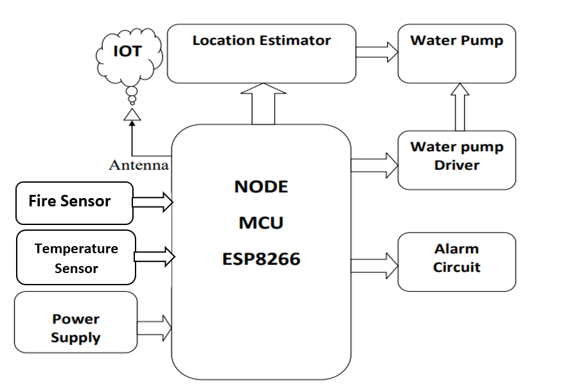
Figure 3: Block Diagram of fire detection and prevention system

Node MCU ESP8266: It connects object and let data transfer using the wifi protocol.Node MCU ESP8266 is programmed to turn on water pump with location estimator whenever fire occur and at the same time alarm is turn on for alerting people.
Fire sensor: It is used for detection of fire and it is analog sensor.fire sensor output is given to node MCU ESP8266 board.
Alarm circuit: It used for producing sound to alert for people.
Water pump: It is controlled through the water pump driver board. Location estimator: It is used for controlling water pump movement in left-right directions whenever fire occurs.
The Embedded C code is written with Arduino OS is open-source software using Node MCU ESP8266. A smart blynk app is used for monitoring fire status and water pump status.

A.Hardware Components
1. NodeMCU ESP8266
NodeMCU Development Unit/Board comprise of ESP8266 wifi chip. ESP8266 chip has GPIO pins, serial communication protocol, and so forth includes on it.ESP8266 is a minimal expense Wi-Fi chip created by Espressif Systems with TCP/IP convention. you can refere ESP8266 WiFi Module for more data about ESP8266.The elements of ESP8266 are extracted on NodeMCU Development board displayed in Figure 4. NodeMCU (LUA based firmware) with Development board/kit that comprise of ESP8266 (wifi chip) chip consolidates NodeMCU Developentt board which make it independent gadget in IoT applications.

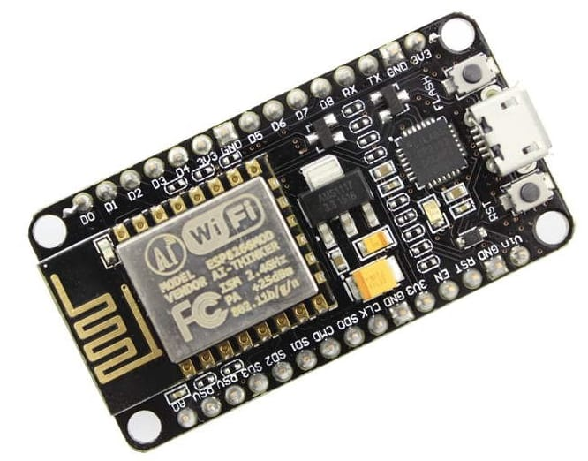
Figure 4:NodeMCU ESP8266

NodeMCU ESP8266 Specifications & Features
- Microcontroller: Tensilica 32-bit RISC CPU Xtensa LX106
- Operating Voltage: 3.3V
- Input Voltage: 7-12V
- Digital I/O Pins (DIO): 16
- Analog Input Pins (ADC): 1
- UARTs: 1
- SPIs: 1
- I2Cs: 1
- Flash Memory: 4 MB
- SRAM: 64 KB
- Clock Speed: 80 MHz
- USB-TTL based on CP2102 is included onboard, Enabling Plug n Play
- PCB Antenna
- Small Sized module to fit smartly inside your IoT project

Pin Detail of NodeMCU Board:
General-purpose input/output (GPIO) is a pin on an IC (Integrated Circuit). It very well may be either an input pin or output pin, whose conduct can be controlled at the run time.
NodeMCU Develpment unit gives admittance to these GPIOs of ESP8266. The main thing to deal with is that NodeMCU Devkit pins are numbered uniquely in contrast to internal GPIO notation of ESP8266 as displayed in the below figure 5 and table. For instance, the D0 pin to the NodeMCU Devkit is mapped to the internal GPIO pin 16 of ESP8266.
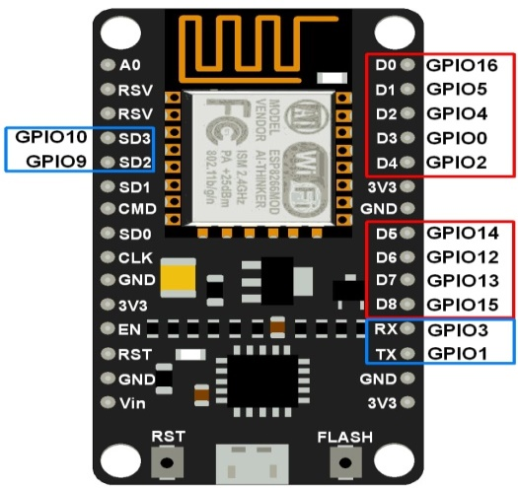

Figure 5: NodeMCU DevKit GPIOs

2.Fire sensor:
It is used for detection of fire and it is analog sensor.fire sensor output is given to node MCU ESP8266 board.
A flame detector is a sensor designed to detect and respond to the presence of a flame or fire, allowing flame detection as shown in below Figure 6. Reactions to a detected fire rely upon the installation, however can incorporate sounding a caution, deactivating a fuel line, (for example, a propane or a petroleum gas line), and enacting a fire concealment framework. At the point when utilized in applications, for example, modern heaters, their job is to give affirmation that the heater is working appropriately; in these cases they make no immediate move past telling the administrator or control framework. A fire detector can frequently answer quicker and more precisely than a smoke or heat detector because of the instruments it utilizations to identify the fire.

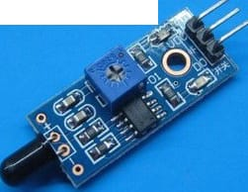
Figure 6: IR Fire sensor
This fire sensor in the circuit takes advantage of the temperature detecting property of a standard sign diode IN 34 to recognize heat from fire. Right now it detects heat, an loud caution mimicking that of Fire unit will be created. The circuit is excessively delicate and can recognize a climb in temperature of 10 degree or more in its area.
.Circuit diagram:
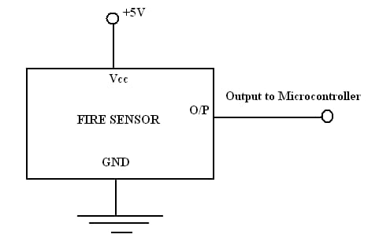

Figure 7:Circuit diagram of fire sensor

3.Alarm Circuit
.
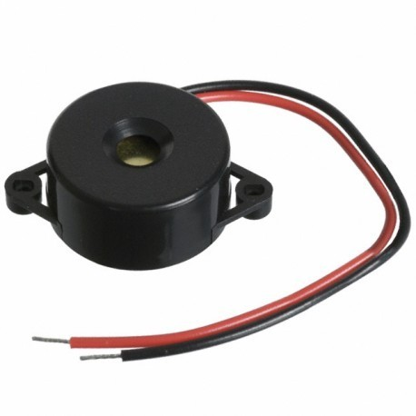
Figure 8: Buzzer
It used for producing sound alert for people .A buzzer or alarm is an audio signalling device shown in Figure 8, which may be mechanical, electromechanical, or piezoelectric (piezo for short). Typical uses of buzzers and beepers include alarm devices, timers, and confirmation of user input such as a mouse click or keystroke.
Buzzer circuit

A buzzer or beeper is a signaling device, generally electronic, commonly utilized in autos, home devices like a microwave, or game shows. It most commonly comprises of various switches or sensors associated with a control unit that decides whether and which button was pushed or a preset time has passed, and as a rule enlightens a light on the suitable button or control board, and sounds an warning in the type of a constant or irregular humming or on the other hand blaring sound the circuit graph of signal is displayed in Figure 9. At first this gadget was in view of an electromechanical framework which was indistinguishable from an electric ringer without the metal gong (which makes the ringing sound).
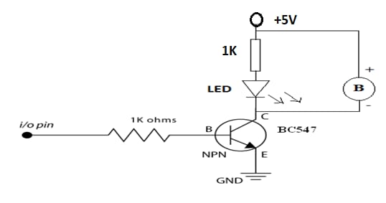
Figure 9: Circuit diagram of buzzer

4.Temperature Sensor
Regularly these units were gotten to a wall then again rooftop and involved the rooftop or wall as a sounding board. Another execution with some air conditioner control system current into a commotion sufficiently noisy to drive an amplifier and connect this circuit to a modest 8-ohm speaker. Nowadays, it is all the more notable to use a mud based piezoelectric sounder like a Sonalert which makes a sharp tone.Typically these were associated with "driver" circuits which moved the pitch of the sound or beat the sound on and off.

The LM35 series are accuracy coordinated circuit temperature sensors displayed in Figure 10 and 11, whose yield voltage is straightly relative to the Celsius (Centigrade) temperature. The LM35 in this way hand over direct temperature sensors aligned in ° Kelvin, as the client isn't expected to deduct a huge consistent voltage from getting helpful Centigrade scaling yield.
The LM35 requires no outer alignment or managing to give common place exactnesses of ±1⁄4°C at room temperature and ±3⁄4°C over a full −55 to +150°C temperature range. Minimal expense is guaranteed by managing and alignment at the wafer level. The LM35's low output,linear output and precise inherent calibration. It very well may be utilized with single power supplies, or with in addition to and short supplies. As it draws just 60 μA from its stockpile, it has extremely low self-warming, under 0.1°C in still air.
The LM35 is evaluated to work over a −55° to +150°C temperature range, while the LM35C is appraised for a −40° to +110°C territory (−10° with further developed exactness). The LM35 series is accessible bundled in airtight TO-46 semiconductor bundles, while the LM35C, LM35CA, and LM35D are additionally accessible in the plastic TO-92 semiconductor bundle. The LM35D is likewise accessible in a 8-lead surface mount little blueprint bundle and a plastic TO-220 bundle.
Features
- Calibrated directly in ° Celsius (Centigrade)
- Linear + 10.0 mV/°C scale factor
- 0.5°C accuracy guarantee able (at +25°C)
- Rated for full −55° to +150°C range
- Suitable for remote applications
- Low cost due to wafer-level trimming
- Operates from 4 to 30 volts
- Less than 60 μA current drain
- Low self-heating, 0.08°C in still air
- Nonlinearity only ±1⁄4°C typical
- Low impedance output, 0.1  for 1 mA load

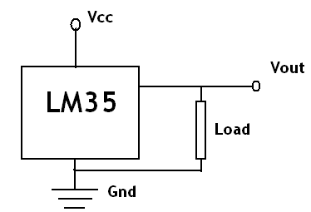Figure 10: Circuit Diagram Of Temperature Sensor

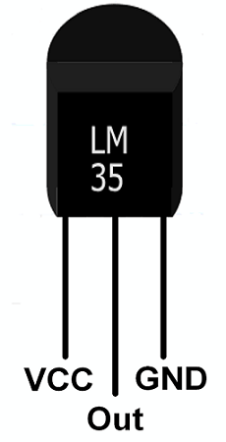
Figure 11:Temperature Sensor

5.Water Pump
12v dc water pump is utilized here which is displayed in Figure 12. A pump overall is a machine which confers energy to anything coursing through it. This can be any liquid, intensity or even electrons. The gadgets pump heat are called as heat pumps and electrical batteries can pump electrons. The unconstrained propensity of anything is to move from high potential to low potential and this regular inclination is saddled in numerous applications. However, the pump does the very opposite; it powers something to move from low potential to high potential. For this reason pumps use energy and by their working exchange that energy to the substance flowing through them.
Liquid pump or Hydraulic pumps move liquids and uproot them starting with one position then onto the next and in course stimulates them. In liquids this energy is appeared as its strain and speed. Also, heat pump move heat from low temperature to high temperature against its regular propensity to move from high temperature to low temperature. An electrical battery is likewise a kind of pump; it pump electrons in a circuit from low electrical potential to high electrical expected which is against the unconstrained propensity of electrons to move from high electrical potential to low electrical potential. Thus, an electrical battery can be called as an Electron Pump.
Specification:
  - Operating Voltage: 3 ~ 6V
  - Operating Current: 130 ~ 220mA
  - Flow Rate: 80 ~ 120 L/H
  - Maximum Lift: 40 ~ 110 mm
  - Continuous Working Life: 500 hours
  - Driving Mode: DC, Magnetic Driving
  - Material: Engineering Plastic
  - Outlet Outside Diameter: 7.5 mm
  - Outlet Inside Diameter: 5 mm

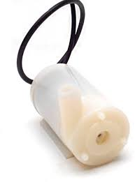

Figure 12 : Water Pump

Circuit Diagram of Water Pump Driver:
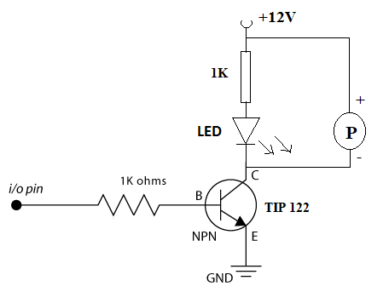

Figure 13:Circuit Diagram Of Water Pump Driver
A Darlington TIP 122 transistor becomes the main active sensing device in the circuit. The device being a Darlington is very sensitive and thus becomes specifically suited to the application. The TIP120 is an extremely powerful thing. It can deal with loads of force (see specs) yet the Arduino can't. So we should safeguard the Arduino from potential party crashers. First of all, we utilize a 1K Ohm resistor between the Arduino pins and the TIP120 Base pin. This is protection against electric shorts. The TIP120 can deal with 60V and 5A yet I guarantee you the Arduino will not. Whenever Input True by NodeMCU then Water Pump will be turn on through the TIP122. LED with 1k resister circuit is used to ensure circuit working.

6.Relay board
Relay board is used here to run water pump and location estimator. A relay is an electromagnetic switch displayed in Figure 14, worked by a moderately little electric flow that can turn on or off a lot bigger electric flow. The core of a relay is an electromagnet (a coil of wire that becomes a temporary magnet when electricity flows through it). You can consider a transfer a sort of electric switch: switch it on with a little flow and it turns on ("leverages") at valuable? As the name proposes, numerous sensors are unbelievably touchy bits of electronic gear and produce just small electric current. But often we need them to drive bigger pieces of apparatus that use bigger currents. Transfers overcome any barrier, making it workable for little flows to actuate bigger ones. That implies transfers can work either as switches (turning things on and off) or as intensifiers (converting small currents into larger ones). 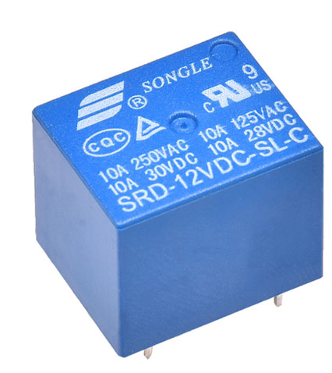

Figure 14:Relay

7.DC Gear Motor

Dc gear motor is used for location estimator designing part shown in below Figure 15.

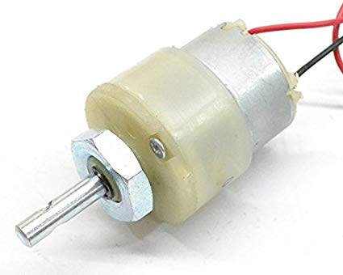

Figure 15: DC Gear Motor

Product description
30 Rpm dc intended engines for mechanical technology applications. Exceptionally simple to utilize and accessible in standard size. Nut and strings on shaft to effectively associate and inward strung shaft for effectively interfacing it to wheel. Features 30rpm 12v dc motors with gearbox 6mm shaft diameter with internal hole 125gm weight stall torque = 2kgcm torque no-load current = 60 ma(max), load current = 300 ma(max).

Product information

Brand  Verve  Model  VTM004  Item model number | VTM004  Additional Features  30RPM 12V DC motors with Gearbox, 6mm  shaft diameter with internal hole, 125gm weight,  Stall Torque = 2kgcm torque, No-load  current = 60 mA(Max),  Load current = 300 mA(Max)

Motor:
Motor is use to drive the Location Estimator when water pump turn on.

8.Location Estimator
- Circuit diagram of Location Estimator Circuit is shown in the figure 16.
- Relay is nothing but it is a electromagnetic switch.
- It receives the signal from Switching Circuit.
- Relay Convert one energy level to another energy level.
- Whenever current flow across the relay, motor will be run.

In this project two relays are used to create motor bride circuit to operates motor in forward and reverse movement.

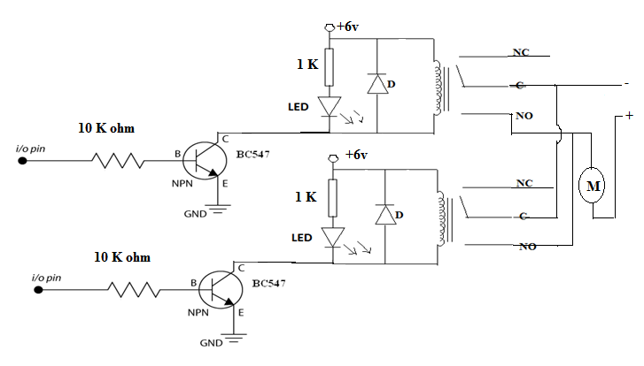
Figure 16: Circuit diagram of Location Estimator

Basic Motor Control and Relay Logic
Many machine capabilities include turning engines on and off and additionally switching their bearing. While there are numerous electronic engine regulators of different types available, in the event that every one of the one necessities is to drive an engine or other burden on and off, an electromechanical hand-off is much of the time everything necessary.
To get it and use transfers in our plans, we should initially grasp the essentials of switch rationale. We as a whole realize that a switch is a gadget that opens and shuts a circuit. "Off" is open, and "On" is shut. We likewise may know that in rationale phrasing, a shut switch addresses a rationale "1", and an open switch addresses rationale "0".
Switches are assigned by how much posts and tosses they have. The tosses are the decent contacts, while the shafts are the contacts that move when the switch is actuated or "tossed". Contingent upon how the switch is assembled it can have tosses that are typically shut, implying that they are in touch with the shaft, shutting the circuit; regularly open, meaning the inverse, that the contacts are ordinarily not in touch, or open; or the switch can have pretty much any number and arrangement of posts and tosses.
The regular classification for switches condenses a "P" for shafts and a "T" for tosses, with the quantity of each likewise being curtailed by a solitary letter. A typical breaking point switch setup, for instance, would be "SPDT" for Single Shaft, Twofold Toss displayed in Figure 17.

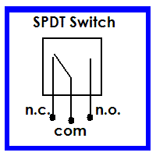

Figure 17: Single Pole Double Throw

Transfers are just electrically worked switches. Transfers utilize an electromagnetic loop to maneuver the shafts of the switch into position. Most transfers return to the typically shut position by a spring when the curl is deenergized, so hand-off contacts are generally recognized similarly as those of a passing contact switch.

Note that in the outline the loop extremity is demonstrated. Transfers will by and large work similarly too paying little heed to curl extremity, but it becomes an integral factor for one significant explanation. Since a transfer is an electromagnetic gadget, the loop creates what is known as flyback when it deenergizes. This is a peculiarity normal to every single inductive gadget (which an electromagnet is). At the point when the loop is deenergized the attractive field encompassing it breakdowns. This imploding field slices through the curl windings and prompts an ongoing the other way from that which charged the loop. This opposite current goes back through the wiring to the ongoing source. Assuming that that source is a rationale door, a microcontroller result, or some other delicate gadget it can harm the gadget or if not make it to malfunction
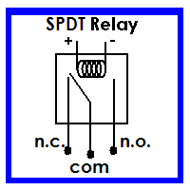
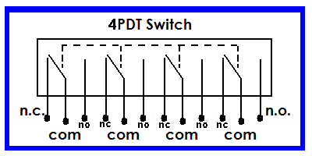
Figure 18: Relays
Consequently, it is normal practice to put a conventional diode across the curl terminals. Any typical diode will work. The diode permits current to charge the curl, yet it will hinder any opposite current. I have tracked down that the most straightforward method for deciding the legitimate extremity of the diode is to just clasp it onto the loop terminals and empower the transfer. In the event that it empowers, the diode is adjusted appropriately. In the event that it doesn't, just flip the diode around.

VIII.Internet Of Things(IoT):
The Internet of Things(IoT) can be characterized as an organization of actual items or individuals called "things" that are implanted with programming, gadgets, organization, and sensors which permits these items to gather and trade information momentarily displayed in Figure 19.
The objective of IoT is to reach out to web network from standard gadgets like PC, versatile, tablet to generally moronic gadgets like a toaster oven. IoT makes for all intents and purposes everything "brilliant," by further developing parts of our existence with the force of information assortment, man-made intelligence calculation, and organizations. The thing in IoT can likewise be an individual with a diabetes screen embed, a creature with GPS beacons, and so on.
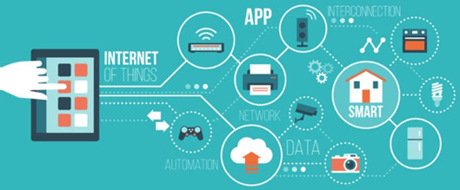
Figure 19: IOT Key Features

How IOT works?
The whole IOT process begins with the actual gadgets like cell phones, smartwatches, electronic apparatuses like television, Clothes washer which assists you with speaking with the IOT stage.
Here, are four essential parts of an IoT framework
1)Sensors/Devices: Sensors or gadgets are a key part that assists you with gathering live information from the general climate. This information might have different degrees of intricacies. It very well may be a basic temperature observing sensor, or it could be as the video feed.
A gadget might have different sorts of sensors which plays out numerous errands separated from detecting. Model, A cell phone is a gadget which has different sensors like GPS, camera however your cell phone can't detect these things.

2) Connectivity: Every one of the gathered information is shipped off a cloud framework. The sensors ought to be associated with the cloud utilizing different mechanisms of correspondences. These correspondence mediums incorporate portable or satellite organizations, Bluetooth, WI-FI, WAN, and so forth.
3) Data Processing: When that information is gathered, and it gets to the cloud, the product performs handling on the accumulated information. This interaction can be simply checking the temperature, perusing on gadgets like AC or radiators. Nonetheless, it can in some cases additionally be extremely mind boggling like recognizing objects, utilizing PC vision on record.
4)User Interface: The data should be accessible to the end-client somehow or another which can be accomplished by setting off cautions on their telephones or sending them warning through email or instant message. The client at times could require a point of interaction which effectively looks at their IOT framework. For instance, the client has a camera introduced in his home. He needs to get to video recording and every one of the feeds with the assistance of a web server.
Nonetheless, it's not generally one-way correspondence. Contingent upon the IoT application and intricacy of the framework, the client may likewise have the option to play out an activity which might make flowing impacts.
For instance, in the event that a client identifies any progressions in the temperature of the cooler, with the assistance of IOT innovation the client ought to ready to change the temperature with the assistance of their cell phone.

Challenges of IoT
At present IoT is faced with many challenges, such as:
- Insufficient testing and updating
- Concern regarding data security and privacy
- Software complexity
- Data volumes and interpretation
- Integration with AI and automation
- Devices require a constant power supply which is difficult
- Interaction and short-range communication

Advantages Of IOT

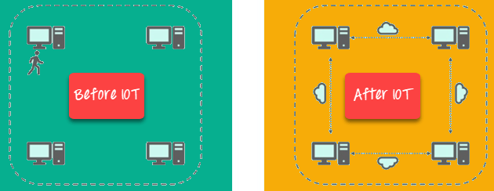

Figure 21: Advantages Of IoT

Key benefits of IoT technology are as follows:

Technical Optimization: IoT innovation helps a ton in further developing advances and improving them. Model, with IoT, a maker can gather information from different vehicle sensors. The producer investigates them to work on its plan and make them more effective.
Improved Data Collection: Customary information assortment has its constraints and its plan for latent use. IoT works with quick activity on information.
Reduced Waste: IoT offers constant data prompting successful direction and the executives of assets. For instance, on the off chance that a producer finds an issue in different motors, he can follow the assembling plan of those motors and tackles this issue with the assembling belt.
Improved Customer Engagement: IoT permits you to further develop client experience by recognizing issues and working on the cycle.

IoT Applications

:

Figure 20: IoT Applications

Application type | Description
Smart Thermostats | Assists you with saving asset on warming bills by realizing your use designs.
Connected Cars | IOT helps vehicle organizations handle charging, leaving, protection, and other related stuff consequently
Activity Trackers | Assists you with catching pulse design, calorie use, movement levels, and skin temperature on your wrist.
Smart Outlets | Remotely turn any gadget on or off. It likewise permits you to follow a gadget's energy level and get custom notices straightforwardly into your cell phone.
Parking Sensors | IOT innovation assists clients with distinguishing the constant accessibility of parking spots on their telephone.
Connect Health | The idea of an associated medical services framework works with constant wellbeing checking and patient consideration. It helps in superior clinical dynamic in view of patient information.
Smart City | Smart city offers a wide range of purpose cases which incorporate traffic the board to water dispersion, squander the executives, and so forth.
Smart home | Smart home typifies the availability inside your homes. It incorporates smoke alarms, home machines, lights, windows, entryway locks, and so on.
Smart supply chain | Helps you continuously following of products while they are out and about, or getting providers to trade stock data.

IX. System Requirements:

A.Hardware Requirement:
SI.NO | HARDWARE | QUANTITY
1 | Node MCU ESP8266 | 1
2 | Fire Sensor | 1
3 | Temperature Sensor | 1
4 | Water Pump Driver | 1
5 | Water Pump | 1
6 | Location Estimator | 1
7 | Alarm Circuit Board | 1
8 | Power Supply | 1
9 | Smart Phone | 1

B.Software Requirement:

SI.NO | Software
1 | Arduino Software (Arduino OS)
2 | Embedded C
3 | Blynk App

X.Expected Outcome:
Automatic fire detection sensors & controlling system for Agriculture fire detection application has been designed and demonstrated. The fire detection sensor detects the fire which is received by master or heart of the project the Node MCU ESP8266. Fire sensor output is given to Node MCU ESP8266 board. Water pump is controlled through the water pump driver board. Location estimator is used for controlling water pump movement in left-right directions whenever fire occurs. Alarm board is used for producing sound alert for people. Node MCU ESP8266 is programmed to turn on water pump with location estimator whenever fire occur and at the same time alarm is turn on for alerting people. The Embedded C code is written with Arduino OS is open-source software using Node MCU ESP8266. A smart blynk app is used for monitoring fire status and water pump status.

XI.References:
- Mr.D.Meganathan, S.Arunkumar, R.Balaji, S.Bhuvaneswar.,“smart crop protection system from animals using”,International Research Journal of Engineering and Technology (IRJET) , Volume: 07 Issue: 03, Mar 2020, www.irjet.net
- Ms. Aditi A. Kulkarni, Ms. Sweety A. Nargunde, Ms. Ruksana A. Mulla, Ms. Karishma D. Kate Prof . K. K. Nikam.,” Design & Implementation of IOT Based Firefighting System to Protecting Farm”, International Journal of Scientific Research & Engineering Trends Volum7,Issue 4,July Aug-2022
- Ibtisam Ehsan , Asia Mumtaz, Muhammad Irfan Khalid, Jawaid Iqbal, Saddam Hussain , Syed Sajid Ullah , and Fazlullah Umar.,” Internet of Things-Based Fire Alarm Navigation System: A Fire-Rescue Department Perspective”, Hindawi Mobile Information Systems Volume 2022, Article ID 3830372, https://doi.org/10.1155/2022/3830372
- Hamood Alqourabah, Amgad Muneer , Suliman Mohamed Fati.,” A Smart Fire Detection System using IoT Technology With Automatic Water Sprinkler”, International Journal of Electrical and Computer Engineering (IJECE) Vol. 9, No. 4, August 2020
- Dr.M. Chandra Mohan Reddy , Keerthi Raju, Kamakshi Kodi, Babitha Anapalli, Mounika Pulla.,” smart crop protection system from living objects and fire using arduino”, Science, Technology and Development, Volume IX Issue IX SEPTEMBER 2020
- Son B., Her Y., Kim J., “A Design and Implementation of Forest Fire Surveillance System based on Wireless Sensor Network for South Korea”, International Journal of Computer Science and Network Security, Vol 6 No. 9B, September 2006
- Hariyawan M.Y., Gunawan A., Putra E.H., “Wireless Sensor Network for Forest Fire Detection”, ISSN:1693-6930,Vol. 11, No. 3, pp. 563~574, September 2013
- P.J Vivek , G. Raju , S. Akarsh, “Forest Fire Detection System”, International Journal of Innovative Research in Science, Engineering and Technology, ISSN: 2319-8753, Vol 3, Issue 6, June 2014
- Tao H., Zhang H., “Forest Monitoring Application Systems Based on Wireless Sensor Networks”, Third International Symposium on Intelligent Information Technology Application Workshops, IEEE, 2009.
- Kanwal, K., Liaquat, A., Mughal, M., Abbasi, A.R. and Aamir, M., 2017. Towards development of a low cost early fire detection system using wireless sensor network and machine vision. Wireless Personal Communications, 95(2), pp.475-489.
[11] Mike C. Baba, JL-Joshua B. Grado, Dean Joshua L. Solis, Isagani M. Roma, Jeffrey T. Dellosa , “A Multisensory Arduino-Based Fire Detection and Alarm System using GSM Communications and RF Module with an Android Application for Fire Monitoring”. International Journal of Innovative Science and Research Technology , Volume 7, Issue 3, March – 2022
[12] Reshma Shinde, Ritika Pardeshi, Archana Vishwakarma, Nayan Barhate , “Need for Wireless Fire Detection Systems using IOT”. International Research Journal of Engineering and Technology (IRJET) , Volume: 04 Issue: 01 , Jan -2017.
[13] A.Divya, T.Kavithanjali, P.Dharshini, “IOT Enabled Forest Fire Detection And Early Warning System”. Proceeding of International conference on systems Computation Automation and Networking 2019.
[14] Varshini B.M , Sushma A.V, “Smart Crop Protection Using Arduino”. International Advanced Research Journal in Science, Engineering and Technology Vol. 8, Issue 7, July 2021
[15] Krunal Mahajan, Riya Parate, Ekta Zade, Shubham Khante, Shishir Bagal,” Review Paper On Smart Crop Protection System”. International Research Journal of Engineering and Technology (IRJET) , Volume: 08 Issue: 02 , Feb 2021 www.irjet.net

[16] Shashi kiran v , Manoj n , Hemanth kumar m , Mamith m n, dr. Surekha manoj.” Smart Crop Protection System From Birds And Animals”. International Journal of Creative Research Thoughts (IJCRT),www.ijcrt.org,Volume10,Issue7,July,2022

