ROLE OF AI IN SPACE COMMUNICATION

P. Rohith, padmanabhunirohith777@gmail.com, Department of CSE, Aditya Engineering College, Surampalem Ch. Swaroop, swaroopch1234@gmail.com, Department of CSE, Aditya Engineering College, Surampalem
N. Sujitha, sujithanagasuri5607@gmail.com, Department of CSE, Aditya Engineering College, Surampalem

M.S.L.S. Sravanthi, msravanthi173@gmail.com , Department of CSE, Aditya Engineering College, Surampalem

- INTRODUCTION

Space communication refers to the transmission of information between the earth and spacecraft, between points on the earth via spacecraft, or between spacecraft. It involves the use of satellites, spacecraft, and ground-based facilities to transmit and receive signals for various purposes.

space craft
Spacecraft are space vehicles that can fly outside of the Earth's atmosphere in space. They give us with a means of getting from Earth to space and the objects in it. Spacecraft are launched into space from Earth using powerful rockets. When a spacecraft successfully exits the Earth's atmosphere, it is propelled by another set of rockets into an orbit around the Earth. The spacecraft does not return to Earth while in orbit. Deep-space spacecraft, which travel beyond the influence of the Moon and Earth, are equipped with rockets. After the rockets successfully propel them beyond the Earth's escape velocity, the spacecraft will use its boosters to propel itself.

Types of spacecrafts:
Crewed Spacecraft –
Crewed spacecraft are those that transport humans to space. The human crew controls this spaceship directly. There have been several crewed spacecraft to space, including Vostok 1 - the first crewed spacecraft in history sent by the USSR in April 12 1961, soviet Cosmonaut Yuri Gagarian orbited the Earth in Vostok 1 on a flight lasting 108 minutes and became the first human being to leave the confines of Earth's atmosphere.

List of crewed spacecraft:
Vostok (USSR, 1961)
Mercury (United States, 1961) Voskhod (Soviet Union, 1964) Gemini ( United States in 1965) Soyuz (Russia/USSR, 1967)
Apollo/Lunar Module (United States, 1968) Space Shuttle (United States, 1981) Shenzhou (2003, China)
Crew Dragon (2020, USA)
The first human in space was Yuri Gagarin on April 12, 1961, and the first human on the moon was Neil Armstrong on July 20, 1969.
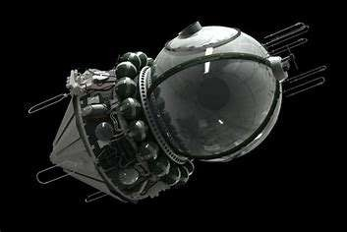

Figure1.1:Vostok 1

- Earth-Orbit Satellites –
This category includes all satellites that orbit the Earth. Hubble Telescope is one of the most well-known satellites in Earth's orbit.

Orbit:
A space object's orbit is a regular, repetitive path it follows around another. The term for an object in orbit is satellite. Natural satellites, such as Earth and the moon, can orbit the planet. Numerous planets have moons in orbit around them. Man-made satellites exist, such as the International Space Station. The orbits assigned to satellites in relation to the earth are known as Earth

orbits, and the satellites that orbit these orbits are known as Earth-Orbit Satellites. A satellite in earth orbit does not always orbit the planet at the same distance. Sometimes they are closest to the earth, and other times they are far away.
The point at which a satellite is closest to the earth is known as " perigee."
A satellite's farthest location from the earth is known as its "apogee."
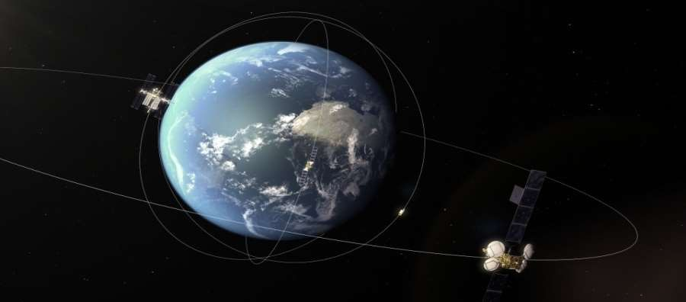

Figure 1.2: Earth-Orbit-Satellites
Types of orbits:
- LEO
- MEO
- GEO
- Polar orbit

Low Earth Orbit:
LEO refers to the path which is very near to Earth. LEO satellites are significantly closer to the surface of the planet than GEO satellites. LEO satellites do not maintain a fixed position relative to the Earth's surface and are only visible for 15 to 20 minutes per orbit. LEO is typically utilized for communication and remote sensing satellite systems, as well as the International Space Station (ISS) and the Hubble Space Telescope. It is used for imaging satellites. [As the orbit approaches the earth's surface, the images have a higher resolution. Satellite placement requires the least quantity of energy in a low Earth orbit. It offers both a large bandwidth and minimal communication latency. LEO satellites and space stations are more accessible for crew and maintenance.

Medium Earth Orbit
MEO is commonly used for navigation systems, such as the Global Positioning System (GPS) of the United States.In MEO, Navigation satellites and a number of artificial satellites are deployed in an Intermediate Circular Orbit.MEO satellite orbits are 8,000 to 18,000 kilometers above the earth's surface. In contrast to LEO satellites, MEO satellites are visible for two to eight hours and are used for global communication such as Email, FAX (20200 km), etc. Additionally, communication satellites can be deployed here. (Example: Constellation of O3b MEO Satellites). It has a diminished signal strength.

Geosynchronous Orbit (GSO) & Geostationary Orbit (GEO):
The distance between this orbit and the earth's surface is 35,780 kilometers.The satellites in GEO orbit the earth at the same rate as the planet itself. It completes one revolution in 24 hours (23 hours 56 minutes 4 seconds). It will serve as global television and radio coverage. Doppler shift is insignificant. If three satellites are placed in geostationary orbit 120 degrees apart, they can encompass the entire planet.This makes it simple for Earth Antennas to track them without rotation, so communication satellites are frequently placed in GEO. The GEO satellites are directly above the equator of the Earth. To a nearby observer, these objects will appear lower in the sky. Indian National Satellite System (INSAT) is positioned in GEO. It is among the greatest domestic satellite communication networks in the Asia-Pacific region

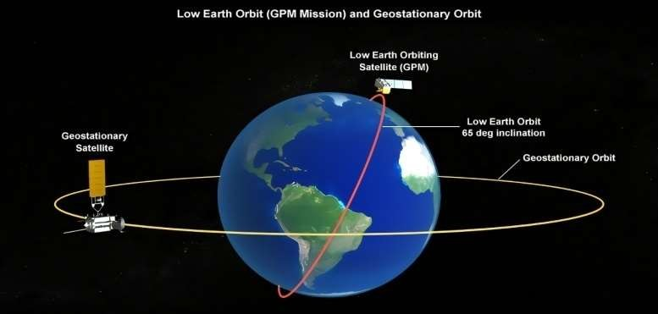.

Polar Orbit& Sun-Synchronous Orbit (SSO)

Figure1.3 :Earth orbits

The polar orbit is utilized by satellites for reconnaissance, weather tracking, assessing atmospheric conditions, and long- term Earth observation within 30 degrees of the Earth's poles. The position of satellites in polar orbit is fixed in relation to the sun. These satellites rotate once every twelve hours. The inclination of these orbits is close to 90 degrees.Sun-synchronous SSO satellites always visit the same location at the same local time. The polar orbit is utilized by satellites for reconnaissance, weather tracking, assessing atmospheric conditions, and long-term Earth observation within 30 degrees of the Earth's poles.

Space Probe-
These are autonomous spacecraft equipped with scientific instruments for the exploration of celestial bodies such as planets, the Moon, and the Sun. A probe is a spacecraft that collects scientific data while traveling through space. Astronauts do not occupy probes. Probes transmit data to Earth for scientists to analyze. Sputnik 1 was the first spacecraft to launch. It was introduced by the former Soviet Union on October 4, 1957. On January 31, 1958, the United States launched the Explorer 1 spacecraft. These early spacecrafts examined the planet from afar. Additionally, they learned what it was like to be in orbit. This marked the commencement of the United States versus Soviet Union Space Race. As soon as probes were able to reach space, the two nations began dispatching probes to fly by the moon and other planets. Mariner 2 was the first spacecraft to examine an alien planet. On December 14, 1962, Mariner 2 passed by Venus. It proved that Venus is extremely heated. The first image of a planet was captured by a different spacecraft, Mariner 4, which was the first to take a picture of a planet. On 14 July 1965, Mariner 4 soared by Mars. Its images of Mars revealed a lunar-like, icy, cratered surface. In 1971, Mariner 9 became the first spacecraft to orbit, or circle, another planet when it arrived at Mars. Mariner 9 captured an image of the tallest volcano in the solar system on Mars.

Satellite communication:
Satellite refers to an object that orbits the planet or another celestial body. It could be a natural satellite, such as the moon, or one of the thousands of artificial satellites. Communication refers to the exchange of information between two or more parties via any means or channel.
It is known as "satellite communication" when two earth stations communicate via a satellite. The global telecommunications system1 relies heavily on satellite communication.
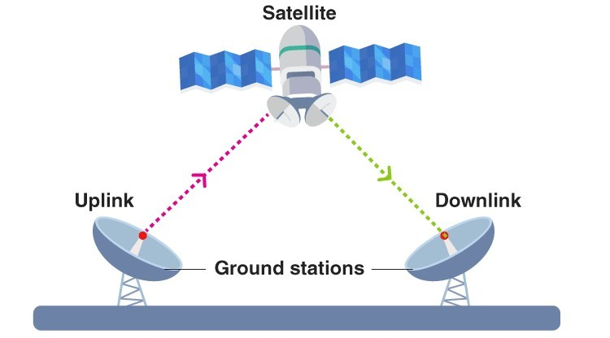

Figure 1.4 : satellite communication

There are numerous sizes and configurations of satellites. However, the majority share at least two components: an antenna and a power source. Typically, the antenna transmits and receives data to and from Earth. The energy source may be solar panels or batteries. Solar panels produce electricity by converting sunlight into electricity.

Main components of a communication satellite:
Transponder that modifies frequency, eliminates noise, and amplifies signal strength. Twenty or more transponders can be installed on a satellite, which necessitates a great deal of power, which is provided by batteries and solar panels. Solar cell Normally, electricity is used to power electronic equipment, but during an eclipse, batteries are used. The thrusters maintain the satellite's position. This Thruster discharge also prevents space congestion, which would be hazardous if the satellite were to leave its orbit. The fuel required for thrusters is stored in satellite-mounted containers. The satellite's position and thruster control are monitored by the Earth station. In addition, earth stations monitor the health and velocity of satellites using tracking and control systems. These systems perpetually transmit signals to the earth station and maintain communication between the satellite and the earth.
When a satellite is no longer operational, it can pose a threat to other operational satellites or spacecraft; to avoid this situation, Utilizing thrusters , inactive satellites are transferred to the gravy yard orbit.
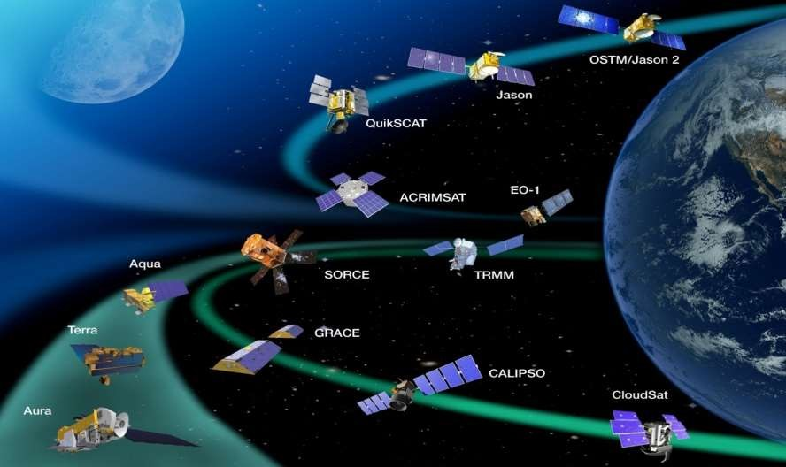

Figure 1.5: Some satellites around the earth

- Origin of satellites:
The idea of satellite was first proposed by Arthur C. Clarke publishes an essay titled "Extra Terrestrial Relays" in 1945 in a science fiction magazine. He assumed that a transponder placed in a space can act as a repeater which can retransmit the signals to a longer distances. Apart from that he is the one who said “That when 3 satellites are placed 120deg apart from each other can
 | establish global communication”.
 | ✓ | 1957 | USSR | Sputnik-1
 | ✓ | 195 | USA | SCORE
 | ✓ | 1960 | USA(AT&T) | Echo-I
 | ✓ | 1962 | USA(Bell labs) | TELSTAR
 | ✓ | 1963 | USA(NASA & US DOD) | SYNCOM
 | ✓ | 1965 | Europe & USA | INTELSAT-I
 | ✓ | 1965 | USA(AT&T) | Echo-II
F. List of Indian Satellites – (1975 – 2023)
 | ✓ | 1975 | ARYABATTA
 | ✓ | 1979 | BHASKARA
 | ✓ | 1979 | ROHINI
 | ✓ | 1982 | INSAT
 | ✓ | 1990-2000 | INSAT SERIES
 | ✓ | 2001 | GSAT(Geo synchronous satellite)
 | ✓ | 2002 | INSAT IISC
 | ✓ | 2004 | EDUSAT(India’s first satellite for education)
 | ✓ | 2005 | PSLV
 | ✓ | 2008 | CHANDRAYAAN1(India’s first lunar probe)
 | ✓ | 2013 | MOM(Mars Orbiter Mission)
 | ✓ | 2019 | CHANDRAYAAN 2
 | ✓ | 2019 | KalamSAT-V2 (world’s lightest satellite.)
 | ✓ | 2020 | PSLV C50
 | ✓ | 2023 | CHANDRAYAAN 3

ARTIFICIAL INTELLIGENCE

- Artificial intelligence
The simulation of human intelligence processes by machines, primarily computer systems, is known as artificial intelligence. Expert systems, natural language processing, speech recognition, and machine vision are specific AI applications.

AI work
As the interest in artificial intelligence (AI) has grown, sellers have hurried to publicize the ways in which their goods and services make use of AI. The term artificial intelligence (AI) is frequently used to refer to something that is solely a technology component, such as machine learning. Artificial intelligence is dependent on a foundation of specialized hardware and software in order to compose and train machine learning algorithms. There is not a single programming language that is synonymous with artificial intelligence; nonetheless, Python, R, Java, C++, and Julia all include characteristics that are popular among AI developers.Artificial intelligence (AI) systems typically function by ingesting enormous volumes of labeled training data, analyzing the data for correlations and patterns, and employing these patterns to forecast future states of affairs. In this way, a chatbot may learn to make natural dialogues with humans by being fed examples of text, and an image recognition program can learn to recognize and describe items in photographs by analyzing millions of examples of those objects. New artificial intelligence systems, which are rapidly advancing, have the ability to generate realistic text, images, music, and other forms of media.

AI programming focuses on cognitive skills that include the following:
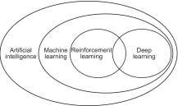
Learning. AI programming focuses data collecting and the formulation of principles for turning it into usable information. Algorithms give computers step-by-step instructions for a mission.Reasoning. AI programming involves choosing the best algorithm to achieve a goal.Self-correction. AI programming uses this to improve algorithms and ensure accuracy.Creativity. Artificial intelligence generates new visuals, text, music, and concepts usingneural networks, rule-based systems, statistical methodologies, and other AI technologies.

Figure 2.1: AI sub fields

- Differences between AI, machine learning and deep learning
AI, machine learning, and deep learning are frequently used terms in enterprise IT, particularly in marketing materials. However, there are differences. In the 1950s, artificial intelligence (AI) was defined as the simulation of human intelligence by machines. It encompasses a range of capabilities that is constantly evolving as new technologies emerge. Machine learning and deep learning are technologies that fall under the purview of AI.
Software applications can use machine learning to become increasingly accurate at predicting outcomes without being expressly programmed to do so. This is made possible by machine learning. In order to make accurate projections of future output values, machine learning algorithms require past data as an input. This strategy grew significantly more effective as increasingly extensive data sets were made available for training purposes. Deep learning is a subfield of machine learning that is founded on our current knowledge of the organizational principles of the brain. Recent developments in artificial intelligence, such as self-driving cars and ChatGPT, are supported by deep learning, which makes use of artificial neural networks for their structure.

Machine learning
Machine learning is an area of AI and computer science that focuses on using data and algorithms to mimic how people learn while continually improving its accuracy.
Data science is a fast emerging field that includes machine learning. Statistical techniques are used to train algorithms in data mining projects so they can make classifications or predictions and discover important insights. These insights then affect how enterprises and apps make decisions, ideally affecting important growth indicators. Data scientists will be more in demand as big data continues to grow and evolve. They will have to help determine the business queries and corresponding data that are most important.
Typically, machine learning algorithms are created using frameworks that speed up solution creation, such as TensorFlow and PyTorch.

Deep learning
Deep learning is a machine learning technique that teaches computers to learn by example, as is intuitive for humans. Deep learning is a crucial component of driverless vehicles, allowing them to recognize stop signs and distinguish between pedestrians and lampposts. It is essential for voice control in consumer devices such as smartphones, tablets, televisions, and hands-free speakers. Recent attention has been lavished on deep learning for good reason. It is accomplishing results that were previously impossible.
Deep learning is the process through which a computer model learns to execute categorization tasks directly from pictures, text, or voice. Deep learning models can attain state-of-the-art accuracy, sometimes outperforming humans. Models are trained utilizing a huge quantity of labeled data and neural network topologies with multiple layers.

Advantages of AI
- Detail-oriented. AI can diagnose breast and melanoma better than doctors.
- Faster data-intensive processes. Banking, securities, medicine, and insurance employ AI to examine massive data faster. AI processes loan applications and detects fraud in financial services.
- Improves labor efficiency. Warehouse automation increased during the pandemic and will likely expand with AI and machine learning.
Consistent results. The best AI translation systems are consistent, allowing small enterprises to contact clients in their local language.
Personalization boosts client satisfaction. AI may customize customer content, communications, adverts, suggestions, and websites.
- Always-available AI-powered virtual agents. AI programs work 24/7 without breaks.

Disadvantages of AI
AI has drawbacks.
- Expensive.
- Technically demanding and AI tool builders are few.
- Scales its training data biases.
- Inability to transfer skills.
Reduces employment, raising unemployment.

SPACE COMMUNICATION

- The Basics
At its most fundamental level, communication in space is comprised of just two components: a transmitter and a receiver. Modulation is the process by which a message can be encoded onto electromagnetic waves. This changes the properties of the wave so that it can more accurately reflect the data. These waves are propagating through space in the direction of the receiver. The electromagnetic waves are collected by the receiver, which then demodulates them in order to decipher the message sent by the sender.
Think about installing a Wi-Fi router and getting other gadgets in your house connected to it. Each device is in communication with the router, which is responsible for relaying information received from the internet. The difficult issue of connecting with space is, at its core, very unlike to wireless communications in the home; the only difference is that it takes place on a gigantic scale and at incredible distances.

2. Ground Network
Communicating from space requires more than simply directing the antenna of a spacecraft toward the Earth. NASA has a global network of antennas spanning all seven continents in order to receive transmissions from spacecraft. Engineers meticulously plan communications between ground stations and missions, ensuring antennas are prepared to receive data as spacecraft pass overhead.
Ground station antennas range from small, very high-frequency antennas that provide backup communications for the space station to a huge, 230-foot antenna that can talk to missions over 11 billion miles away, like the Voyager spaceship.

Space Relays
In addition to direct communications with Earth, many NASA projects use relay satellites to send data back to Earth. Tracking and Data Relay Satellites (TDRS), which send data to ground bases in New Mexico and Guam, are one way the space station talks to Earth. The Mars 2020 Perseverance rover, which was just sent into space, will send data to Earth through orbiters.
Relays have their own benefits when it comes to being able to communicate. For example, by putting TDRS in three different places above Earth, it can cover the whole planet and keep low-Earth orbit missions in close contact with the ground. Users of TDRS don't have to wait until they pass over a ground station to send or receive data. They can do so 24 hours a day, seven days a week.

Bandwidth
NASA uses different bands of electromagnetic waves to code information. Different things can be done with each of these frequency bands, or bandwidths. Higher bandwidths can send more data per second, so satellites can send and receive data faster. The Laser Communications Relay Demonstration (LCRD) from NASA will show how optical communications can be useful. The trip will test the optical links between ground stations in California and Hawaii by sending data back and forth between them.
NASA will also give the space station an optical receiver that can send information to Earth using LCRD.

Data Rates
Higher bandwidths can mean that missions can get more info at a faster rate. From the Moon, the Apollo radios sent back grainy black-and-white film. The Artemis II mission will soon have an optical terminal that will send 4K, ultra-high quality video from the moon's orbit.
But data rates are limited by more than just bandwidth. Data rates can also be affected by how far apart the sender and receiver are, how big their antennas or optical terminals are, and how much power is available at each end. To get the most out of data rates, NASA's communications experts must find a balance between these factors.

Latency
Not all communications are instantaneous. They are limited by the speed of light, which is approximately 186,000 miles per second. This time delay or communications latency is negligible for spacecraft that are close to Earth.
However, as distance from Earth increases, latency can become problematic. At a distance of approximately 35 million miles from Mars, the delay is approximately four minutes. When planets are approximately 250 million miles apart, the delay is approximately 24 minutes. Thus, astronauts would have to wait between four and twenty-four minutes for their communications to reach mission control and another four to twenty-four minutes for a response.

Interference
As transmissions travel over long distances or through the atmosphere, the quality of their data can degrade, causing the message to become garbled. Radiation from other missions, the Sun, and other celestial bodies can also degrade transmission quality.
NASA uses ways to find and fix mistakes to make sure that flight operations centers get correct information. Error correction methods include computer algorithms that translate noisy signals into data that can be used.

ROLE OF AI IN SPACE COMMUNICATION

- The Impact of AI on Satellite Communication in the 21st Century
Artificial intelligence (AI) is becoming increasingly important in satellite communication in the twenty-first century. AI has the potential to revolutionize satellite communication by making data transfer between satellites and ground stations faster, more efficient, and more secure.
One of the key advantages of AI is its ability to improve satellite communication accuracy. AI can discover and analyze abnormalities in satellite data using machine learning techniques, making it easier to spot issues and increasing the dependability of satellite communication. AI may also be used to recognize satellite traffic patterns and optimize bandwidth utilization, allowing for a more effective use of existing resources.
Furthermore, AI may be utilized to increase the security of satellite communications. Organizations can identify and respond to harmful actions more quickly and efficiently by deploying AI-based intrusion detection systems. AI may also be used to discover possible vulnerabilities in satellite systems and put precautions in place.
Finally, AI has the potential to dramatically cut the cost of satellite communication. By automating certain components of satellite communication, AI can minimize the amount of time necessary for setup and maintenance, resulting in cheaper labor expenses. AI may also be used to monitor usage trends and modify charges appropriately, providing for more efficient and cost-effective satellite communication.
Artificial intelligence has the potential to significantly improve satellite communication in the twenty-first century. By boosting accuracy, strengthening security, and lowering costs, AI may make satellite communication quicker, more efficient, and more safe. As technology advances, it is likely that AI will play an increasingly important role in satellite communication.

Exploring the Possibilities of Autonomous Satellite Networks Powered by AI
Artificial intelligence (AI) has changed the way we think about satellites. In the past, satellites were mostly used to communicate, find our way around, and keep an eye on things. Artificial intelligence technology has made it possible for satellites to do a range of tasks on their own. This makes AI-powered independent satellite networks more useful.There are many possible benefits to these networks. Satellites that can work on their own could be used to watch and study space, track changes in the environment, and even find and deal with natural disasters. Autonomous satellites could also be used for remote sensing, like keeping an eye on weather trends and how the climate is changing.AI-powered satellites could also be used to find and study things in space, like rocks and comets. This could help us understand where the world came from. Autonomous satellites could also be used for deep-space missions, as well as for space exploration and science.
AI-powered satellite networks could also be used to provide high-speed Internet access and other communication services.
This could be especially helpful in places that are hard to reach and don't have a lot of contact options.
Autonomous satellite networks that are powered by AI could do a lot of interesting and useful things. As technology keeps getting better and better, these networks will keep growing and changing the way we explore, study, and connect with space.

Chandrayaan3
Pragyan's AI algorithm will use data from the sensors to plan the rover's route, identify obstacles and avoid them. AI will be used to analyze the large dataset of images and other data collected by previous lunar missions.

AI generated images: AI imagines Successful Landing of Chandrayaan-3

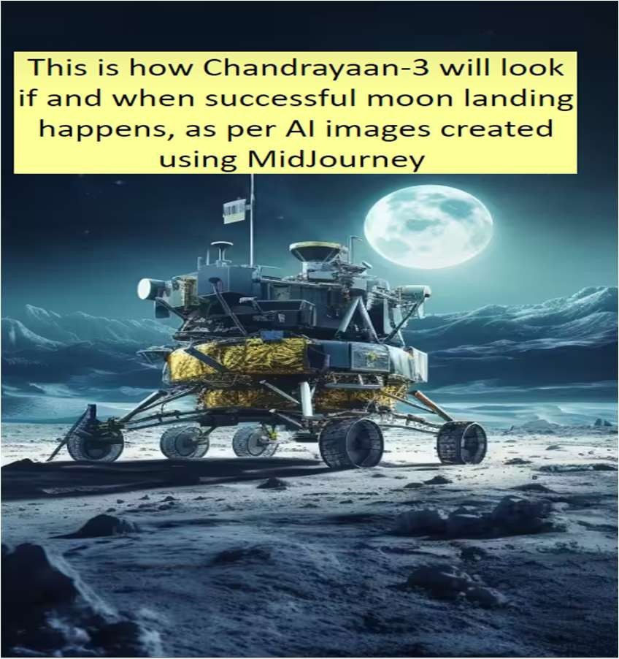
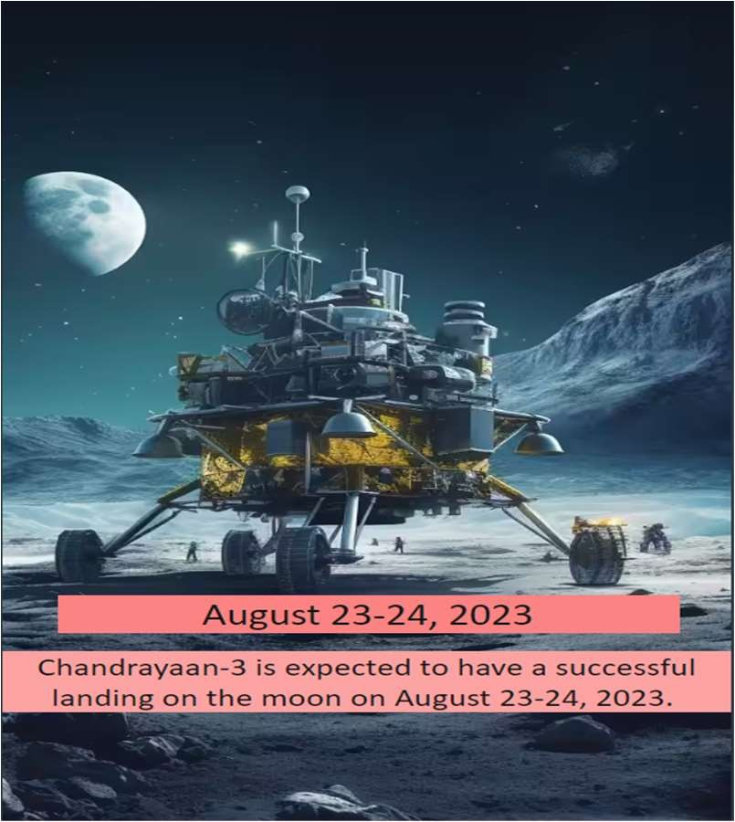
Figure 4.1: image-1 Figure 4.2: image-2

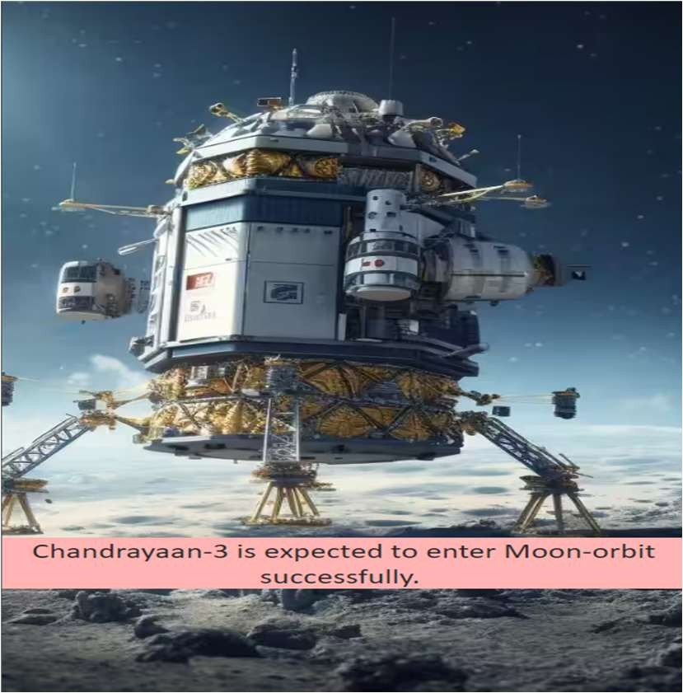
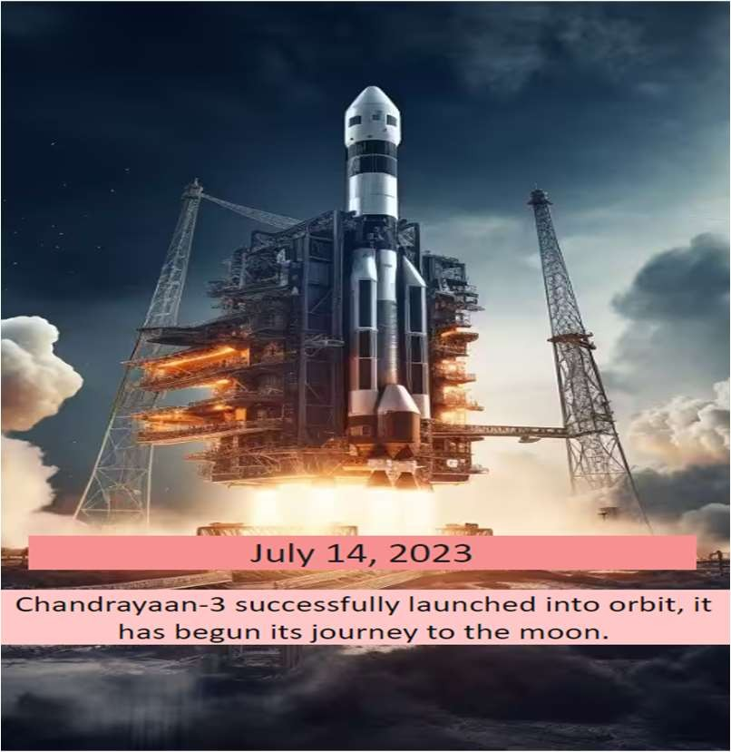

Figure 4.2: image-3 Figure 4.3: image-4

- AI ALGORITHMS IN SPACE COMMUNICATIONS

AI algorithms are used in various aspects of satellite communication to improve performance, optimize operations, and enhance overall efficiency. Some of the key AI algorithms applied in satellite communication include:

Machine Learning (ML) for Signal Processing
Satellite communications use ML algorithms, such as neural networks and support vector machines, for signal processing duties. They can aid in enhancing signal quality, reducing noise, and mitigating interference, particularly in channels that are diminishing or noisy.
Analyzing and modeling analog and digital data representations of physical events is known as signal processing. All of the modern technology we use and rely on in our daily lives (computers, radios, videos, mobile phones), is made possible by signal processing. It thus serves as an illustration of the science underlying our digital existence.

Signal processing can be divided into several categories:
- Analog signal processing
- Digital signal processing
- Nonlinear signal processing
- Statistical signal processing

Machine learning
Machine learning is the study of computer algorithms that develop the ability to make predictions and/or classify objects based only on a set of data that has been obtained, without a strong presumption of an underlying model. It is a subset of artificial intelligence, which is the ability of a digital computer or robot that is controlled by a computer to carry out tasks that are generally performed by intelligent beings. Machine learning is the study of teaching computers to execute tasks for which there is no suitable model.
We see machine learning as a natural extension of the traditional signal processing paradigm, in which linear processing blocks are replaced with non-linear counterparts, allowing us to solve a considerably larger variety of issues. Signal processing and machine learning can be utilized as orthogonal approaches, with domain knowledge mixed with traditional signal processing to provide signal representations suited for machine learning. Machine learning algorithms are now directly incorporated into the signal processing graph, allowing the system to do non-linear prediction or dimensionality reduction. The sort of "signal" or "feedback" accessible to the learning system separates techniques into three major types, according to tradition.

Reinforcement Learning (RL) for Dynamic Resource Management
RL algorithms enable satellites to dynamically optimize and learn their resource allocation strategies. Satellites can use RL to adapt their transmit power, bandwidth allocation, and beamforming parameters in response to changing network conditions and user requirements.
In a reinforcement learning context, the algorithm interacts directly with the observable process. Controlling a game, a vehicle, or an industrial process are a few examples. The goal of reinforcement learning is to find the best policy for attaining the process's goal, which might be winning the game, driving the car safely from point A to point B, or regulating the process within its operational constraints.

Deep Learning for Image Processing and Earth Observation
Utilizing deep learning techniques such as convolutional neural networks (CNNs), satellite imagery is analyzed for Earth observation purposes. They are applicable to a variety of applications, including land cover classification, object detection, and environmental monitoring.

Genetic Algorithms for Satellite Constellation Optimization
Utilizing genetic algorithms, satellite constellation configurations are optimized. Considering coverage requirements, link budgets, and other constraints, these algorithms can determine the optimal positioning of satellites in orbit.
Genetic algorithm (Goldberg, 1983) is a method of stochastic optimization that is based on how live things change over time. Natural selection and reproduction are the two main things that drive their development. Because of natural selection, the people and animals that are best suited to their surroundings are more likely to live and have more offspring. Reproduction lets the DNA inheritance of the parents mix with that of the offspring. This way, the offspring can take advantage of the unique traits of both parents. A third process, called "mutation," is also at work from time to time. Mutation happens when a part of a population's genetic heritage changes by mistake. This keeps populations from being too similar. This process actually helps make sure that a population has a certain amount of variety.
A genetic algorithm finds an answer to an optimization problem in a way that is similar to how life works. A solution to the problem is defined individual and it is represented by a chromosome. In tum, a chromosome is shown by a string of genes, each of which is linked to a number of a problem variable. A population is a group of people made up of a certain amount of people. Generations of individuals or chromosomes are the different ways in which a community changes over time as it evolves.

Natural Language Processing (NLP) for Satellite Commanding
NLP algorithms allow satellites to talk to each other using natural language. This makes it easier for operators to send orders and talk to satellite systems.
A branch of linguistics, computer science, and artificial intelligence known as "natural language processing" (NLP) studies how computers interact with human language, particularly how to instruct computers to process and evaluate massive volumes of natural language data. The goal is to make a computer that can "understand" what's in a paper, including how the language fits into its

context. The system can then effectively extract information and insights from the papers as well as categorize and arrange the documents themselves.

Fuzzy Logic for Decision Making
Fuzzy logic is used in satellite systems to make decisions about things like how to prioritize resources, how to set up adaptive modulation and coding schemes, and how to route data.
- It can help us put together ideas that are clear and easy to understand. So, fuzzy logic is a way to explain how people tend to think accurately, which is the generalization of classical logic.
- It is known as a type of reasoning with multiple values that comes from the fuzzy set theory.
- It focuses on deductions through vague expressions and lingual articulations to figure out marginality enigmas.
- It depends on the relative degrees of association and is driven by how people understand and think about things that are unclear, wrong, only partly true, or need clear limits.
- Fuzzy logic, from a scientific point of view, is meant to explain a lot of problems with approximate representations or vague data in order to provide the expected ways to use knowledge and human expertise.
- Fuzzy logic-based nave computing processes can be used to make smarter and more intelligent systems that can make decisions, identify things, recognize patterns and speech, and optimize and control.
- Fuzzy logic is used a lot in Machine Learning and Artificial Intelligence, which help computers learn new things and figure out how to do jobs.

Swarm Intelligence for Satellite Coordination
Swarm intelligence algorithms, which are based on how social organisms act as a group, can be used to organize the work of several satellites in a constellation. This makes it easier for people to work together and improve things like data relay and area optimization.
According to Sabrina Thompson, an aerospace engineer at NASA's Goddard Space Flight Center in Greenbelt, Md., who is working on the technology for the space agency, swarm intelligence is being used by government agencies to allow a group of satellites, spacecraft, or drones to do a set of tasks by communicating with one another rather than being directed by a team on the ground.
Thompson suggests seeing swarm robots as a "hive mind," with each satellite acting as a bee in a beehive. "They're doing something together in a planned way without too much outside influence," she explains.

She claims that the signals that each unit sends to the other units in the swarm demonstrate how they learn from one another.

"They're preprogrammed with a mission," Thompson explains, referring to NASA's research aims and data collection.

Satellite Swarms Work
Thompson, who works on the orbital and maneuvering parts of NASA's tests with swarms of satellites, says that swarm intelligence needs to be made up of many different parts.
The swarm is driven by its purpose, which could be to gather scientific data or to do something else. She says that the algorithm Thompson made can be used for tasks on Earth and in deep space.
In a satellite swarm, Thompson works on creating the orbits of the satellites after determining how many are required for a certain task. Let's say that the objective is to observe the growth of objects like a storm or a cloud. When given a signal, the satellites would travel into certain geographic formations to capture images from various perspectives in accordance with the rules that the program would have predetermined for how the task should be done.
The satellites would improve over time at maneuvering around one another to create new geometric forms that aid in their work thanks to machine learning. The duties and objectives won't alter, according to Thompson, but the satellite swarm will "learn as it goes and be able to do it on its own, and do it better on its own over time."
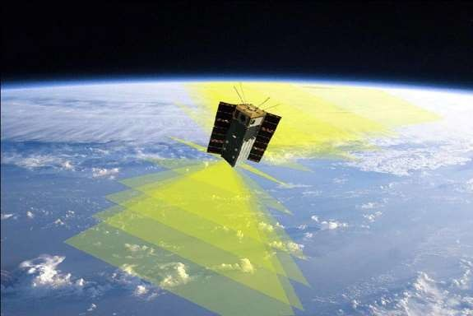

Figure 5.1- Swarms Satellite

- Anomaly Detection for Predictive Maintenance
Anomaly detection algorithms, like Isolation Forest or One-Class SVM, are used to keep an eye on satellite systems and find any strange behavior or changes in performance. Early discovery of anomalies helps with predictive maintenance and cuts down on downtime.
For methods that rank the instances based on how unusual they are, the precision at n (P@n) is the percentage of the first n instances that are outliers . If the number of outliers in the data set is equal to n, the author calls the R-precision P@n. The n number makes this measure less reliable, especially in situations where it is not being watched [14]. In predictive maintenance scenarios, the P@n measure would ignore the time factor and treat the data as if they happened in a vacuum.
With the ROC curve, the problem of balance is taken into account in the labeling of imbalance . The ROC space is described as a [0, 1] by [0, 1] area where the True Positive Rate (TPR or sensitivity, shown on the Y axis) and the False Positive Rate (FPR or 1 specificity, shown on the X axis) are plotted . For example, a perfect TPR and FPR for a program would be (0,

1). This idea is used in general for algorithms that give scores or odds in situations where there are different ways to classify things. Then, we can get different ROC points for each possible threshold, and TPR (and FPR) goes up as this threshold goes up.

Q-learning for Satellite Autonomy
Q-learning is a type of RL program that lets satellites make decisions on their own based on information they get from their surroundings. This ability can help make choices on board, like how to change a satellite's orbit or set up its payload.

Neuromorphic Computing for On-board Processing
Neuromorphic computing, which is based on the neural networks in the human brain, can be used to handle satellite data on-board. It can cut down on the amount of data sent to the ground station, which saves transmission bandwidth.
Among other things, these AI methods are very important to satellite communication systems because they make them smarter, more flexible, and better able to meet the growing needs of modern communication. AI and satellite technology are likely to keep getting better and open up more opportunities in the future.

COMPARATIVE ANALYSIS OF AI ALGORITHMS IN COMMUNICATIONS

comparative analysis of some commonly used AI algorithms in communications:

Reinforcement Learning (RL):
  - RL is well-suited for optimizing spacecraft control and resource management in space missions.
  - It learns through trial and error by interacting with its environment and receiving feedback.
  - RL algorithms, such as Deep Q-Networks (DQNs) and Proximal Policy Optimization (PPO), have shown promising results in optimizing satellite orbits and antenna pointing systems.

Deep Learning - Neural Networks:
  - Deep learning, specifically convolutional neural networks (CNNs) and recurrent neural networks (RNNs), is used in space applications for image recognition and signal processing.
  - CNNs can analyze satellite imagery and identify objects or features of interest, while RNNs are useful for processing time-series data, like telemetry or sensor readings.

Genetic Algorithms (GAs):
  - GAs are employed for optimizing complex problems like satellite constellation design and route planning.
  - They use principles of natural selection and genetics to evolve solutions to problems over generations.
  - GAs can efficiently explore a large solution space and find optimal or near-optimal solutions for space mission planning.

Swarm Intelligence Algorithms:
  - Inspired by the collective behavior of social insects, swarm intelligence algorithms like Ant Colony Optimization (ACO) and Particle Swarm Optimization (PSO) can be used for routing and resource allocation in satellite networks.
  - These algorithms are particularly useful for dynamic and distributed environments, where multiple satellites need to coordinate efficiently.

Supervised Learning:
  - Although not as commonly used in space communications, supervised learning can be used for tasks where labeled data is available.
  - It requires a significant amount of annotated data, which may be scarce in space-related applications.

The "best" artificial intelligence algorithm depends on the particular space communication mission and the available data. In many instances, a combination of multiple algorithms may be more efficient. Additionally, future advancements in hybrid and meta-heuristic approaches may result in more effective and potent solutions.
It's important to remember that the choice of algorithm also relies on the amount of computing power, the needs of the mission, and the need to make decisions in real time. Each algorithm has its own strengths and flaws, and the problem at hand can change how well they work.
You can find the most up-to-date information on the best AI algorithms for space communications in recent study papers, publications from space agencies, and business reports.

Table 1: Various AI algorithms with their respective satellite communication applications.

AI Algorithm | Satellite Communication Application | Description
Machine Learning (ML) | Signal Processing and Interference Mitigation | ML algorithms can process received signals, detect anomalies, and mitigate interference, improving data  quality and communication.
Deep Learning (DL) | Earth Observation and Image Processing | DL algorithms analyze satellite images, enabling automated object detection like buildings, roads, land use, and natural  disasters.
Natural Language Processing (NLP) | Satellite Command and Control | NLP creates natural language interfaces for operators, simplifying command and control processes without  requiring technical expertise.
Reinforcement Learning (RL) | Autonomous Satellite Operations | RL algorithms enable satellites to adapt operations in real-time, optimizing resource allocation, orbital adjustments, and task  prioritization.
Genetic Algorithms (GA) | Satellite Constellation Optimization | GA finds optimal satellite constellation configurations, maximizing coverage and minimizing communication  delays.
Ant Colony Optimization (ACO) | Satellite Routing and Network Planning | ACO optimizes data routing and network planning in satellite constellations for efficient and reliable data transmission.
Swarm Intelligence | Satellite Formation Flying and Coordination | Swarm intelligence algorithms coordinate multiple satellites in formations for collaborative tasks and maintaining relative positions.
Particle Swarm Optimization (PSO) | Satellite Antenna Beamforming | PSO optimizes satellite antenna beamforming, improving signal reception and transmission  capabilities.
Bayesian Networks | Satellite Fault Detection and Diagnostics | Bayesian networks model satellite systems, aiding in detecting and diagnosing faults and malfunctions for quicker  troubleshooting.
Convolutional Neural Networks (CNN) | Satellite Telemetry and Telecommand Compression | CNN algorithms compress telemetry and telecommand data to reduce bandwidth usage, efficiently utilizing communication resources.

- AI BASED SOLUTIONS IN SPACE COMMUNICATION PROBLEMS

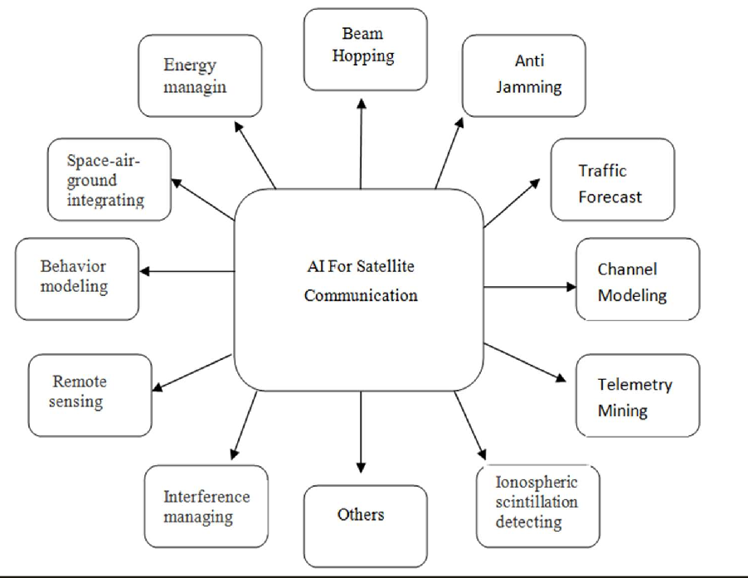

Figure 6.1- AI Based Solutions to space communication problems

- Anti-jamming
Satellite communication systems need to cover a large area and send and receive information quickly and in large amounts. But reliability and security are the most important things in tactical satellite communication systems, so an anti-jamming (AJ) feature is a must. Jamming attacks could be sent to a satellite network's most important places and devices to slow or stop the flow of data. So, several AJ methods have been made to stop attacks and make sure that satellite contact is safe. Jamming can also happen by accident. In 2015, U.S. military officials said that on average, satellite communications were being blocked 23 times per month by mistake.

AI Based Solution:
By learning the temporal trend of a signal using a long short-term memory (LSTM) network, a DL RNN, Lee et al. demonstrated that the overall synchronization time in the FH-FDMA instance may be decreased.
Without being aware of jamming and radio channel models, RL can assist mobile devices in determining the optimum communication channel. This is carried out within a fluid game framework. Han et al. proposed that AJ use AJ routing, a space-based AJ methodology, to prevent smart jamming in the Internet of Satellites (IoS). Han et al. demonstrated how to use RL to handle the interaction between the satellites and the smart jamming environment and DL to handle the wide decision space created by the high dynamics of the IoS. In order to achieve this, they used RL and game theory modeling, simulating the interactions between smart jammers and satellite users as a Stackelberg AJ routing game.
DRL, specifically the actor-critic algorithm with the source node as a state, where the critic network evaluates the expected reward for chosen actions, allowed us to solve the routing selection problem for heterogeneous IoS while maintaining an available routing subset to simplify the decision space for the Stackelberg AJ routing game. The Q-Learning RL algorithm was utilized to swiftly respond to clever jamming and adjust AJ strategies based on this routing subset.
Later, Han et al. used reinforcement learning (RL) and game theory models to develop AJ policies for the satellite-enabled army IoT (SatIoT) that would function in a dynamic and unknowable jamming environment. Here, a distributed dynamic AJ alliance formation game was investigated to determine whether it could lower the energy consumption in a jamming environment. To demonstrate how jammers and SatIoT devices interact in a conflictual way, a hierarchical AJ Stackelberg game was also proposed. To obtain the sub-optimal AJ policies based on the jamming environment, a Q-Learning-based method was also employed.

Interference managing
Satellite communication operators have to deal with interference because it hurts the communication channel and leads to a drop in QoS, lower operational efficiency, and lost income. So, controlling interference is important for keeping communication systems that work well and are reliable. Management includes finding, classifying, and stopping interference, as well as using techniques to make it less likely to happen.

AI Based Solution:
Henarejos et al. suggested using DNN AEs and LSTM, which are both based on AI, to find interference and identify it. In the first, the AE is trained with signals that don't cause interference and then tested with signals that don't cause interference to find

useful thresholds. The interference is then found by looking at the difference in error between messages with and without interference.

remote sensing:
RS is the process of extracting information about a region, object, or phenomenon by remotely analyzing its reflected and emitted radiation, typically from a satellite or aircraft.
RS has numerous applications in a variety of disciplines, including land surveying, geography, geology, ecology, meteorology, oceanography, the military, and communications. As RS permits the monitoring of hazardous, difficult, or inaccessible regions, such as mountains, forests, oceans, and glaciers, it is a popular and active research field.

AI Based Solution:
Recently, Zheng et al. came up with a two-stage way for getting rid of clouds. U-Net and GANs are used to separate the clouds and fix the image, respectively.
AI is being considered for scheduling on-board of agile Earth-observing satellites, since autonomy makes them work better and lets them take more images by depending on on-board scheduling to make quick decisions. Lu et al. showed that RF improved both the quality of the answer and the speed with which it was given. They did this by comparing the use of RF, NNs, and SVM to prior learning and non-learning-based approaches.

Telemetry mining
Telemetry is the process of taking readings and sending them to a computer so that they can be controlled and watched. In satellite systems, on-board telemetry helps mission control centers keep track of the state of the platform, find out when something isn't right, and handle different situations. Satellites can fail for many reasons, but most of the time, it's because of the hard conditions in space, like heat, vacuum, and radiation. The radiation environment can affect important parts of a satellite, like the power source and communication system. Telemetry processing lets the satellite's behavior be tracked so that failure risks can be found and reduced. By processing different aspects of the satellite (like temperature, voltage, and current), finding correlations, spotting trends, finding outliers, classifying, forecasting, and clustering, faults can be found and the satellite can be monitored more accurately.

AI Based Solution:
In space missions that use telemetry, AI methods have been thought about a lot in recent years. People have used probabilistic clustering, dimensionality reduction, hidden Markov, and regression trees to keep an eye on the health of satellites, while others have used the k-nearest neighbor (kNN), SVM, LSTM, and testing on the telemetry of Centre National d'EtudesSpatiales spacecraft to come up with ways to find anomalies.Also, the space functioning assistant was made better by using data-driven and model-based monitoring methods in different space apps. In their study of how AI can be used for fault diagnosis in general and for space use, Sun et al. said that Deep Learning (DL) is the most likely way to go. They suggested using DL for fault diagnosis in China for space use. Ibrahim et al. showed that LSTM, ARIMA, and RNN models are very good at making predictions by comparing them with tracking data from the Egyptsat-1 satellite. They suggested using simple linear models for short-lived satellites (3–5 years) and NNs for long-lived satellites (15–20 years) to predict the most important things about the satellites.

Network traffic forecasting:
In order to ensure dependable and high-quality communication, network traffic forecasting is a proactive strategy. This is because many satellite applications, such as congestion control, dynamic routing, dynamic channel allocation, network planning, and network security, depend on the predictability of traffic. Long-range dependency (LRD) and self-similarity are both characteristics of satellite network traffic. Its self-similarity must thus be taken into account for reliable forecasting. However, self-similarity-based models for terrestrial networks have a high computational complexity; as satellites have a limited amount of processing power, terrestrial models are not appropriate for satellites. Therefore, a satellite network traffic forecasting architecture must be effective. The LRD of satellite networks and the limited on-board computational capacity are the two fundamental challenges in satellite traffic forecasting. Short-range-dependence (SRD) models have failed to produce reliable forecasting due to the LRD property of satellite networks. Although previous LRD models outperformed SRD models, they suffer from high complexity. AI approaches have been used by researchers to overcome these challenges.

AI-based solution
Katris and Daskalaki combined FARIMA and NNs for internet traffic forecasting, while Pan et al. combined differential evolution and NNs for network traffic forecasting. Due to the complexity of traditional NNs, a least-square SVM, which is an optimized variation of an SVM, has also been utilized for forecasting. Liu and Li obtained more accurate forecasting with less training time by employing principal component analysis (PCA) to reduce the input dimensions, followed by a generalized regression NN. In their distributed routing strategy for a LEO satellite network, Na et al. incorporated traffic forecasting. Extreme learning machine (ELM) has also been used for satellite node traffic load forecasting prior to routing. Bieet al. used EMD to decompose satellite traffic with LRD into a series with SRD and at one frequency in order to reduce the complexity of predicting and increase the speed. Their combination of EMD, fruit-fly optimization, and ELM resulted in faster and more accurate forecasting than previous methods.

- CONCLUSION

AI is a large field with many different approaches, and each of these techniques has several algorithms. AI could be based on rules that have already been set or on ML. This learning can be deep or shallow depending on whether it is supervised, semi- supervised, unsupervised, or based on feedback. As each approach brings something different to the field of AI, it should rely on the problem at hand to decide which one to use.
AI and all of its different parts, such as ML, DL, and RL. Then, some problems with satellite communication were shown, and suggested and possible AI-based solutions were talked about. AI has worked well in many areas of satellite communication, such as beam-hopping, AJ, network traffic forecasting, channel modeling, telemetry mining, ionospheric scintillation detection, interference management, remote sensing, behavior modeling, space-air-ground integration, and energy management. The goal of future work should be to use AI to make communication systems that are more effective, safe, reliable, and high-quality. Even though ML has made great progress in terms of precision and accuracy in a number of applications, there is still more work to be done on ML interpretability and adversarial ML to make communication more safe and reliable.

REFERENCES
- www.nasa.gov,
- www.spacefoundation.org
- https://www.sciopen.com
- https://www.sintef.no/en/expertise/digital/sustainable-communication-technologies/signal-processing-and-machine- earning/#:~:text=We%20see%20machine%20learning%20as%20a%20natural%20extension,to%20handle%20a%20much%20broader20set%20of%20problems.
- https://link.springer.com/chapter/10.1007/978-3-642-56656-1_6
- https://en.wikipedia.org/wiki/Natural_language_processing
- https://www.analyticssteps.com/blogs/fuzzy-logic-approach-decision-making
- https://fedtechmagazine.com/article/2022/02/swarm-intelligence-what-it-and-how-are-agencies-using-it-perfcon

