An Evaluation of Thin Layer Chromatography as a Biotechnology Tool for the Isolation of Bioactive Compounds from Medicinal Plants: A Brief Review
Ria Bhar¹*, Amit Gamit²

¹Department of Biotechnology, School of Life Science and Biotechnology, Adamas University, Kolkata, India.
²ICAR-IVRI, ERS, Kolkata-700037

*Corresponding Author: Ria Bhar
Address for Correspondence:
E-mail addresses: bhar.riya89@gmail.com (R.Bhar)

Abstract:
A review of the fundamental ideas and the significance of Thin Layer Chromatography (TLC) in research in general and in phytochemistry in particular were attempted in this paper. For many years, general chemistry laboratories have frequently employed thin layer chromatography to separate chemical and biological components because it is straightforward, affordable, and user-friendly. The analyte spots on the TLC plate are typically observed using chemical and optical techniques. It has numerous uses in locating contaminants in a chemical. The evaluation of TLC and its application for qualitative and quantitative determination of bioactive components from therapeutic plants is highlighted by St.
Keywords: Thin Layer Chromatography, TLC Principle, TLC Benefits, and TLC Uses.
Introduction:
Non-volatile mixtures can be separated using a process called thin layer chromatography. The experiment is carried out on a piece of glass, plastic, or aluminum foil that has been lightly covered with an adsorbent substance. Typically, silica gel, cellulose, or aluminum oxide are utilized as the substance.
Once the separation is complete, each component is seen as vertically separated spots. The retention factor (Rf) for each position is denoted as follows:
Rf = sample travel distance / solvent travel distance
The solvent system, quantity of substance spotted, adsorbent, and temperature all affect the retardation factor. One of the quickest, cheapest, simplest, and most straightforward chromatographic methods is TLC.
One of the most helpful techniques for monitoring the development of organic chemical reactions and determining the purity of organic substances in phytochemistry and biotechnology is thin layer chromatography (TLC). TLC, like all chromatographic techniques, uses the analyte's varying affinities for the mobile and stationary phases to separate complicated mixtures of organic compounds. A thin layer of a solid adsorbent is applied to a sheet of glass, metal, or plastic to create a TLC plate. Near the bottom of this plate, there is a tiny bit of the mixture to be tested. The TLC plate is then positioned in a developing chamber's shallow pool of a solvent such that only the plate's very bottom is submerged. TLC plates are sheets of glass, metal, or plastic that have a thin layer of a solid adsorbent (often silica or alumina) applied to them. Near the bottom of this plate, there is a tiny bit of the mixture to be tested. The TLC plate is then positioned in a developing chamber's shallow pool of a solvent so that just the very bottom of the plate is submerged in the liquid. The mobile phase is this liquid, also known as the eluent, which gently ascents the TLC plate through capillary action. Change the solvent's polarity to find the ideal solvent or combination of solvents (a "solvent system") to develop a TLC plate or chromatography column loaded with an unknown mixture. All the mixture's components will move more quickly as the solvent system's polarity is increased (and vice versa as the polarity is decreased). The system that provides the best separation is the optimum solvent system. Column chromatography elution patterns typically translate to TLC elution patterns. TLC is frequently used to choose the optimal solvent system for column chromatography since it is a process that is significantly quicker than column chromatography. For example, choosing the solvent solution for a flash The optimal chromatographic process is one that separates the desired component from its nearest neighbor by a difference in TLC Rf values of at least 0.20 and moves the desired component of the mixture to a TLC Rf of 0.25 to 0.35. In order to choose the best solvent(s) for a flash chromatography method, a mixture is evaluated by TLC. Thin layer chromatography can be used to monitor a reaction's development, identify the compounds present in a product, and assess a substance's purity. The struggle between the solute and the mobile phase for binding sites on the stationary phase is the basis for compound separation. For instance, silica gel used as the stationary phase in a normal phase reaction can be regarded as polar. When two compounds with different polarities are present, the more polar molecule interacts with silica more strongly and is therefore better able to remove the mobile phase from the binding sites. As a result, the less polar compound climbs the plate. All compounds on the TLC plate will rise higher up the plate if the mobile phase is changed to a more polar solvent or mixture of solvents because it is better able to dislodge solutes from the silica binding sites. Using a combination of ethyl acetate and heptane as the mobile phase, this practically means that adding more ethyl acetate results in higher. In most cases, switching the polarity of the mobile phase won't cause the compounds to run in reverse order on the TLC plate (1, 2, 4,6,7).
Principle of TLC:
Thin-layer chromatography (TLC), like other chromatographic methods, is based on the separation principle. The relative affinity of chemicals for the two phases is what drives the separation. The substances in the mobile phase pass over the stationary phase's surface. The compounds that have a stronger attraction for the stationary phase move slowly whereas the other compounds move quickly during the movement. As a result, the mixture is successfully separated. After the separation procedure is complete, the mixture's constituent components show up as spots at the appropriate levels on the plates. Suitable detecting techniques are used to determine their nature and character (16).
Calculation of the Rf Value:
A amount of a compound's behavior in TLC is what distinguishes it. It is written as R and is a decimal fraction. The R is derived by dividing the compound's displacement from its starting position by the solvent's displacement from its starting position (the solvent front). The adsorbent's nature: For the same solvent, different adsorbents will produce different R values. Only an adsorbent with a consistent particle size and binder may be reproduced. Before usage, plates should be kept over silica gel in desiccators, and samples should be applied rapidly to avoid the plate absorbing atmospheric water vapor. It is much preferable to use plates that have been stored at room temperature rather than activating them due to the challenges involved in the activation operations.
In order to aid in identifying the substances present, measurements are frequently made from the plate. These values include the solvent's travel distance as well as the individual spots' travel distance. The plate is removed from the beaker and the location of the solvent identification of a substance when the solvent front approaches the top of the plate. An authentic sample of the compound, or standard, is spotted and run on a TLC plate side by side (or on top of each other) with the chemical in question if the identity of a compound is suspected but not yet established. Two substances are probably (but not always) the same chemical if they have the same Rf value. They are undoubtedly separate compounds if their Rf values differ. It is important to note that this identification check must be carried out on a single plate because it is challenging to replicate all the variables that affect Rf precisely from trial to experiment (5, 7, 8,14,15).

View in chromatography: Chromatogram:
As the solvent slowly travels up the plate, the different components of the dye mixture t ravel at different rates and the mixture is separated into different coloured spots.
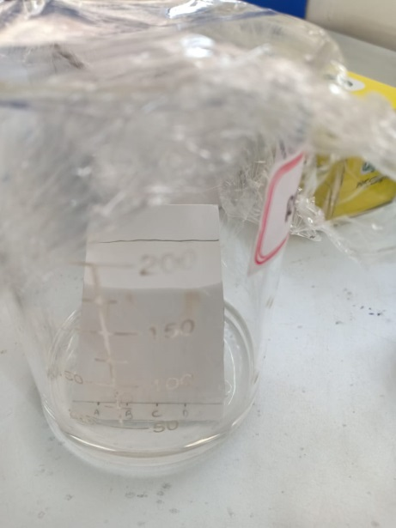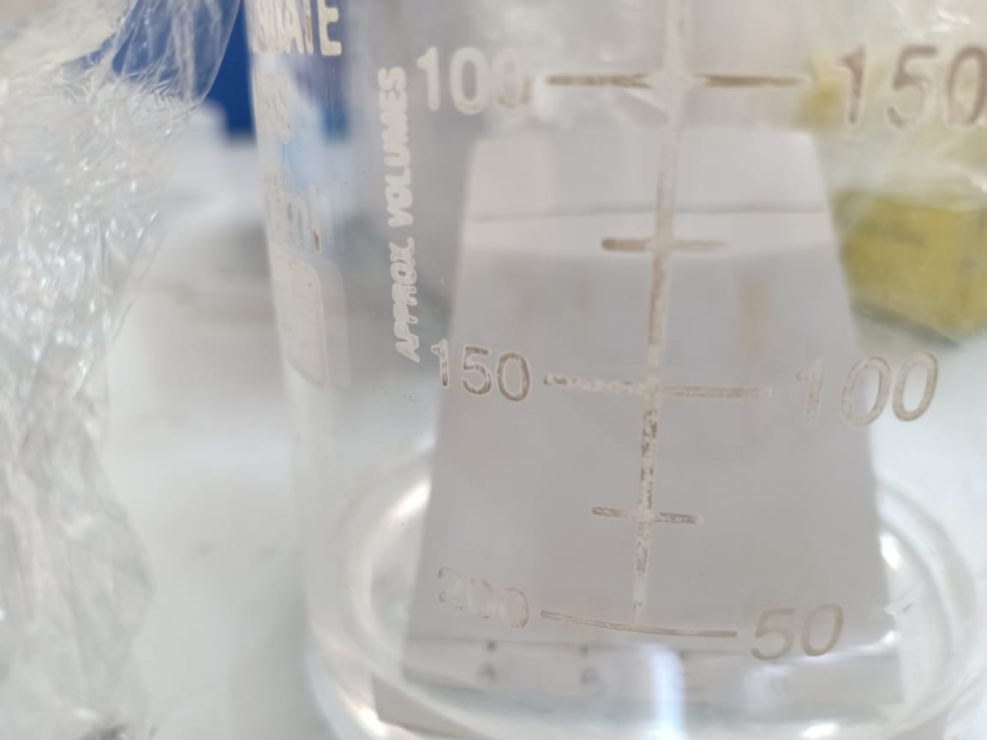
Figure 1: Chromatogram Figure 2: Developing Tank
is marked with another line before it has a chance to evaporate. These measurements are taken as:
Figure 3: Spots as compounds

The Rf value for each dye is then worked out using the formula:
Rf = sample travel distance / solvent travel distance
For example, if the red component travelled 1.7 cm from the base line while the solvent had travelled 5.0 cm, then the Rf value for the red dye is:
If we could repeat this experiment under exactly the same conditions, then the Rf values for each dye would always be the same. For example, the Rf value for the red dye would always be 0.34. However, if anything changes (the temperature, the exact composition of the solvent, and so on), that is no longer true. We have to bear this in mind if you want to use this technique to identify a particular dye. We'll look at how you can use thin layer chromatography for analysis further down the page.
The Rf for a compound is a constant from one experiment to the next only if the chromatography conditions below are also constant:
• Solvent system
• Adsorbent
• Thickness of the adsorbent
• Amount of material spotted
Relative Rf values are typically taken into account because it is challenging to maintain these variables constant from experiment to experiment. "Relative Rf" refers to values that are presented in relation to a standard or to comparisons of compounds that were run simultaneously on the same plate and their respective Rf values. The distance a compound travels on the TLC plate increases with compound Rf. The chemical with the greater Rf is less polar when two different compounds are compared and run under identical chromatographic conditions because it interacts less strongly with the polar adsorbent on the TLC plate. In contrast, you can anticipate that a compound with low polarity will have a higher Rf value than a polar compound run on the same plate provided you know the structures of the compounds in the combination. The Rf can offer supporting information regarding a compound's identity. An authentic sample of the compound, or standard, is spotted and run on a TLC plate side by side (or on top of each other) with the chemical in question if the identity of a compound is suspected but not yet established. Two substances are most likely (but not always) the same chemical if they have the same Rf value. They are undoubtedly separate compounds if their Rf values differ. It should be noted that this identification check must be carried out on a single plate because it is challenging to precisely duplicate all the variables that affect Rf from trial to experiment(5,7,8,14,15).
Preparation of Plate:
Commercially accessible TLC plates often have specified particle size ranges to increase reproducibility. They are made by combining an inert binder, such as calcium sulfate (gypsum), a little amount of water, and an adsorbent, such as silica gel. This mixture is applied as a thick slurry to a nonreactive carrier sheet, typically made of plastic, glass, or thick aluminum foil. The finished plate is heated in an oven for 30 minutes at 110 °C to dry and activate it. For analytical purposes, the adsorbent layer is typically between 0.1 and 0.25 mm thick, while for preparative TLC, it is between 0.5 and 2.0 mm thick(6,10,11).
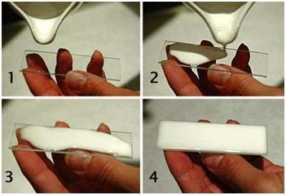
Figure 4: Steps of Preparative TLC (S.kumar, 2012).
Spotting the plate:
When the spotter's thin end is submerged in a diluted solution, capillary forces cause the fluid to rise to the surface. At the starting line, briefly touch the plate. Spot at the same location once the solvent has evaporated. You will achieve a focused and small spot in this manner. Avoid spotting too much material since this will greatly reduce the separation's (or "tailing's") quality. The spots need to be sufficiently spaced from the edges and from one another. If at all possible, mark the compound or mixture on the plate along with the raw components and any potential intermediaries(1,12,13).
Location of the places spots:
There are several ways to locate the positions of different solutes that have been separated using TLC. When viewed against a stationary phase, colored compounds are immediately apparent, but colorless substances cannot be seen without the aid of a spraying agent that creates colored regions in the area they occupy. The following can be utilized to spray the invisible places in TLC specifically:
1. Corrosive substances, which are entirely inorganic in nature, can also be sprayed on the undetectable patches.
2. Potassium dichromate solution in concentrated sulfuric acid. Most organic chemicals, especially those used for sugars, decrease potassium dichromate (yellow) to chromic sulfate (green) throughout the process.
3. Warming fuming sulfuric acid causes sulfur trioxide to be formed, which chars organic compounds and turns them into dark blotches.
4. Potassium permanganate solut ion.
5. Iodine vapors.
Saturated hydrogen sulfide solution, 0.2N aqueous ammonium sulfide, 0.1% alcoholic quercetin, 0.2% methanolic 1-(2- pyridylazo)- 2- napthol, 1% methanolic oxine, and 0.5% aqueous sodium rhodizonate are further popular reagents. If the TLC plate's adsorbent contains a fluorescing substance, the solutes can be seen under ultraviolet light(1,14,18).
Development solvents:
The nature of the material and the adsorbent utilized on the plate determine the best solvent to use. A development solvent should be chosen so that it does not chemically react with the components of the mixture being studied. Always avoid using solvents that are either environmentally harmful (such as dichloromethane) or carcinogenic (such as benzene). There are both polar and non-polar solvent systems. Since highly polar solvents cause any component of the solvent mixture to adsorb, non-polar solvents are typically utilized. Petroleum ether, carbon tetrachloride, pyridine, glycol, glycerol, diethyl ether, formamide, methanol, ethanol, acetone, and n-propanol are among the often used developing solvents(1,4,10).
Mobile Phase:
The mobile phase for silica gel chromatography is an organic liquid or combination of organic solvents. The analyte travels past the stationary phase's particles as the mobile phase passes over the silica gel's surface. The analyte molecules can only travel freely with the solvent if they are not attached to the silica gel's surface. As a result, the percentage of time the analyte spends bonded to the silica gel's surface compared to the percentage of time it spends in solution defines the the analyte's retention factor. It is possible to think of an analyte's capacity to bind to the surface of silica gel in the presence of a specific solvent or combination of solvents as the result of two competing interactions. First, the analyte and polar groups in the solvent may fight for binding sites on the silica gel's surface. A highly polar solvent will therefore interact significantly with the silica gel's surface if it is utilized, leaving few sites on the stationary phase free to bind the analyte. As a result, the analyte will pass through the stationary phase quickly. Similar to this, polar groups in the solvent can interact strongly with the analyte's polar functionality and block the analyte's ability to connect with the silica gel's surface. The analyte moves swiftly out of the stationary phase as a result of this effect. By assessing the solvent's dielectric constant and dipole moment, one can determine the solvent's polarity for chromatography. The solvent is more polar if these two quantities are higher. The solvent's capacity for hydrogen bonds must also be taken into account. As an effective hydrogen bond donor, methanol, for instance, will significantly reduce the capacity of all but the most polar analytes to attach to the surface of the silica gel (1,8, 12,14).
Developing a Plate:
In a beaker or tightly closed jar, a TLC plate can be created. Fill the container with a tiny amount of the solvent (mobile phase). On a plate, a little spot of solution with the sample is applied one centimeter from the bottom. The plate is then placed in a sealed container after being dipped in a suitable solvent, such as hexane or ethyl acetate. By means of capillary action, the solvent rises up the plate and encounters the sample mixture, which the solvent dissolves and carries up the plate.
Due to variations in their attraction to the stationary phase and in their solubility in the solvent, various chemicals in the sample mixture move through space at varying rates. It is possible to alter the separation of components (as determined by the Rf value) by altering the solvent or possibly utilizing a combination. The solvent level must be lower than the TLC's starting line in order to prevent the spots from dissolving. The plate's lower edge is then submerged in a solvent. Due to their varying degrees of contact with the matrix (stationary phase) and solubility in the developing solvent, the components of the samples move at different speeds as the solvent (eluent) travels up the matrix by capillarity. Because non-polar compounds dissolve easily and do not interact with the polar stationary phase, non-polar solvents will push non-polar compounds to the top of the plate. Permit the solvent to ascend the plate up to about 1 cm from the top. Remove the plate and make a notation on the solvent front right away. Do not let the solvent spill over the plate's edge. Next, allow the solvent to entirely evaporate (1,8).
Visualization:
After 15 to 45 minutes, when the solvent front has migrated to within 1 cm of the top end of the adsorbent, the plate should be removed from the developing chamber, the solvent front's location noted, and the solvent left to evaporate.
If the sample's constituent parts are colored, it is possible to see them clearly. If not, they can occasionally be seen by shining ultraviolet light on the plate or by letting the plate stand for a short period of time in a closed container with an iodine-vapor-rich atmosphere. By misting the plate with a reagent that will react with one or more of the sample's components, it is sometimes possible to see the spots (1, 10).
Analysis:
By contrasting the distances the components have traveled with those of the recognized reference materials, the components, which are discernible as isolated dots, are identified. Calculate the separation between the starting line and the solvent front. Then calculate the distance from the spot's center to the starting line. Subtract the distance the solvent traveled from the distance traveled by each location. The ratio that results is known as the Rf-value. It is possible for the compounds being separated to be colorless, thus there are several ways to see the dots. The adsorbent is frequently treated with a small amount of a fluorescent substance, typically manganese-activated zinc silicate, to enable the visibility of spots under a blacklight (UV254).
As a result, the adsorbent layer will naturally glow a light green hue, but spots of analyte will dim this fluorescence. Iodine vapors are a generic color reagent with no specificity, but there are specialized color reagents that can be dipped into the TLC plate or sprayed directly onto the plate. The distance t raveled by the product by the sum of the distances t raveled by the solvent (the solvent front) yields the Rf value, or retention factor, of each spot once it is visible. These numbers are not physical constants and depend on the type of TLC plate and the solvent employed (1,5, 8).
Identifying chemicals with thin-layer chromatography:
Imagine you wanted to identify the specific amino acids that were present in a mixture of amino acids. We'll assume for the sake of simplicity that you are aware that the mixture can only conceivably comprise five of the common amino acids. On the bottom line of the thin layer plate, a small drop of the mixture is deposited, and small spots of the recognized amino acids are placed next to it. The plate is next placed in an appropriate solvent and allowed to continue developing as usual.
The known amino acids are labeled 1 to 5 and the mixture is denoted by the letter M in the diagram. The plate is depicted in the left-hand diagram when the solvent front has nearly reached the top. The spots continue to be undetectable. The second illustration depicts what it would resemble after being sprayed with ninhydrin. Since it is simple to compare the spots in the mixture with those of the known amino acids - both from their positions and their colors - there is no need to measure the Rf values.
The combination in this illustration includes the amino acids 1, 4, and 5. What if the mixture contains amino acids that weren't those we used as a baseline? There would be areas in the mixture that weren't consistent with the known amino acid locations. You would need to repeat the test with different amino acids to make a comparison (1, 12, 16).
The compound's and the adsorbent's interactions:
The strength of the ion-dipole, dipole-dipole, hydrogen bonding, dipole induced dipole, and van der Waals forces determines how strongly an organic compound binds to an adsorbent. With silica gel, the dipole-dipole type of interaction between the adsorbent and the materials to be separated predominates.
Weakly polar molecules are held less tightly while highly polar molecules interact quite strongly with the polar SiOH groups at the surface of these adsorbents and have a tendency to stick or adsorb onto the tiny particles of the adsorbent. Generally speaking, weakly polar molecules have a tendency to pass through the adsorbent more quickly than polar species. The chemicals roughly follow the previously mentioned elution order (1, 10).
Application:
Thin layer chromatography has been a useful tool in numerous applications of pharmaceutical importance (1).
Amino Acid:
Because amino acids are colorless, TLC of them is more challenging than TLC of inks. Therefore, after the plate has fully formed and dried, it is impossible to perceive the spots with the naked eye. Either the black-light visualization method or the ninhydrin visualization method is required to observe the spots. For instance, proteins, peptides, and amino acids 8: Silica gel plates have been used to successfully separate and isolate a mixture of 34 amino acids, proteins, and peptides from urine. All of these compounds tested positive for ninhydrin. The development was done using phenol-water initially, followed by chloroform-methanol-20%ammonium hydroxide.
Pharmaceuticals and drugs:
TLC is used for process control in the production of synthetic pharmaceuticals, as well as for the identification, purity testing, and concentration determination of the active components, auxiliary chemicals, and preservatives in drugs and drug formulations. The TLC technique has been approved by a number of pharmacopoeias for the detection of impurities in drugs and chemicals, such as antibiotics. With the help of the two solvents, acetone-methanol (1:1) and iso-propanol-methanol (3:7), penicillins have been separated on silica gel "G." The dried plates were sprayed with a 0.1% iodine solution containing 3.5% sodium azide to use the iodine-azide reaction as the detecting agent.
Separation of multicomponent pharmaceutical formulations:
Additionally, it is utilized to separate pharmaceutical compositions with many components.

Qualitative analysis of alkaloids:
It is utilized in the control phase of both pharmaceutical formulations and plant-based medications for the qualitative study of alkaloids. TLC has been employed in toxicology for the isolation and identification of alkaloids, where the 30–60 minute runs offer a significant advantage over the 12–24 hour time frame needed for paper chromatography. By using TLC on silicic acid, silica gel, and aluminum oxide, purine alkaloids have been isolated. Spraying a 25% HCl- 96% ethanol solution followed by an alcoholic iodine-potassium iodine solution allows the dots to be seen.
Clinical chemistry and Biochemistry:
For identifying active compounds and their metabolites in biological matrices, as well as for identifying metabolic abnormalities in children including phenylketonuria, cystinuria, and maple syrup disease. It is a helpful instrument for the analysis of numerous urine constituents, including steroids, amino acids, porphyrins, and bile acids, which are formed from lipids. In order to detect and resolve small metabolites fully free of other components, urinary analysis by TLC works best when combined with other chromatographic procedures.
Cosmetology:
When identifying dye raw materials, finished goods, preservatives, surfactants, fatty acids, and scent ingredients.
Food Analysis:
To determine the presence of pesticides and fungicides in drinking water, the presence of residues in fruits, vegetables, salads, and meat, the presence of vitamins in soft drinks, the presence of German-banned additives (such as sandalwood extract in fish and meat products), and the adherence to limit values (such as polycyclic compounds in drinking water and aflatoxins in milk and milk products).
Analysis of Heavy Petroleum Product:
Even though petroleum products are among the most complicated materials, thin-layer chromatography (TLC), which is frequently utilized in the analysis of complex mixtures, is rarely used in the study of these items. There is no such information in the literature, particularly with regard to heavy petroleum products. At the same time, this approach has advantages over column chromatography that are well known, including simplicity, affordability, and efficiency. TLC technique employed (in the preparative variation) for a quick analysis of the group composition of heavy petroleum products (asphalts, pitches, and remains), as well as in association with spectroscopic investigations of the chemical composition of the fractions obtained.
Separation of aromatic amines:
On silica gel layers, aromatic amines have been separated by thin-layer chromatography using cat ionic and non-ionic surfactant-mediated systems as mobile phases. The impact of surfactant concentration on amine mobility both below and beyond its critical micellar concentration was studied. Additionally, the impact of organic and inorganic additions in micellar solutions, such as alcohols, urea, NaCl, and NaBr, on the mobility and separation effectiveness of amines is evaluated.
Applications related to Organic Chemistry:
- A lot of other separation processes have utilized it to check them. TLC has also been utilized successfully in a number of purification procedures, including the analysis of distillation fractions and the monitoring of the molecular distillation process for purification.
- Due to its rapid speed of separation and adaptability to a wide range of chemical substances, TLC has been utilized as an analytical technique in organic chemistry. Its primary application is in the separation and isolation of the individual components of mixtures, but in organic chemistry it has also been employed for purification processes, determining the purity of samples, identifying organic compounds, researching various organic reactions, and characterizing and isolating a variety of compounds, including acids, alcohols, glycols, amides, alkaloids, vitamins, amino acids, antibiotics, food ingredients, and food products. TLC analysis of the reaction mixture determines whether or not the reaction is finished. Other separation and purification processes, including as distillation and molecular distillation, are also checked using this method.

Because high sensitivity makes it possible to detect contaminants in purportedly pure samples, high sensitivity of TLC is used to verify sample purity (3, 17).

Conclusion:

Thin layer chromatography is a straightforward, affordable, and user-friendly phytochemical and biochemical technology with a wide range of uses, including the creation of novel medications and a variety of formulations from medicinal plants. Additional thorough documentation is required for the sustained development of research and teaching.

Reference:

- A. Archana, Bele and Anubha Khale, An overview on thin layer chromatography, IJPSR, 2(2), 2011, 256-267.

- A. M ohammad, S.A. Bhawani and S. Sharma, Analysis of herbal products by thin-layer chromatography: a review, International Journal of Pharma and Biosciences, 1(2), 2010, 1-50.

- A.H. Beckett, J.B.St enlake, Practical pharmaceutical chemistry, thin layer chromatography, CBS publishers, 4th edition, 2005, 115-128.

4. A.V. Kasture, K.R. M ahadik, S.G.W adodkar, H.N. More, A textbook of pharmaceutical analysis, instrumental methods, Nirali Prakashan, 9th edition, 2, 2005, 18-30.

- B. Fried, J. Sharma, Thin-layer chromatography, fourth edition, revised and expanded, M arcel Dekker inc., New York - Basel, 1999, 499.

- B.K.Sharma, Instrumental methods of chemical analysis, Goel publishing house, Meerut, 5th edition, 2007, 241-264.

- D.A.Skoog, F.J.Holler and T.A. Nieman, “ Principles of instrumental analysis, Saunders college publishing, 5th edition, 2006: 761-766.

- E. Dreassi, G. Ceramelli, P. Corti, Thin-layer chromatography in pharmaceutical analysis. In practical thin-layer chromatography—a multidisciplinary approach. Fried b., Sharma J. (eds.) Crc press, Boca Raton, fl, 1996, p. 231.

- G. Szepesi, M . Gazdag , St eroids. In handbook of thin layer chromatography, Sharma G, Fried B (eds.) M arcel Dekker, New York, 1991, 907.

- G. Szepesi, M . Gazdag , St eroids. In handbook of thin layer chromatography, Sharma G, Fried B (eds.) M arcel Dekker, New York, 1996, 971.

- G.Just us, Kirchner, Thin-layer chromatographic quantitative analysis, Journal of Chromatography a-1, 82(1), 1973, 101- 115.

- G.R. Chatwal, S.K Anand, Instrumental methods of chemical analysis, Himalaya publishing house, 5th edition, 2008, 2.599-2.616.

- H.T. Quach, R.L. St eeper, G.W.Griffin, Separat ion of plant pigments by thin layer chromatography. Journal of Chemical Education. 81, 2004, 385-7.

- M Ali and V. Agrawal, Thin-layer chromatography of aromatic amines, Separation Science and Technology, 37, 2002, 363 - 377.

- R.M. Scot t , Clinical analysis by thin-layer chromatography techniques. Ann Arbor science publishers, Ann Arbor, mi. 1969.

- S Singhal, N singhal, S Agarwal, Pharmaceutical analysis-II, Thin Layer Chromat ography, Pragati Prakashan, first edition, 2009, 98-111.

17. Vidya Sagar, Instrumental methods of drug analysis, Pharma M ed Press, first edition 2009,263.

