**Bioreactors: vessels for biochemical production and beyond**

Dr. Kiran Bala

**Department of Zoology**

**Deshbandhu College,**

**University of Delhi-110019, India.**

**Email -** [kbala@db.du.ac.in](mailto:kbala@db.du.ac.in)

**Arushi Dogra**

**Faculty of Life Sciences and Biotechnology**

**South Asian University, Delhi-110068, India.**

**Email -** [dograarushi2001@gmail.com](mailto:dograarushi2001@gmail.com)

**Dr. Pushp Lata**

**Department of Zoology,**

**University of Delhi, Delhi -110 007, India.**

**Email -** [plata@zoology.du.ac.in](mailto:plata@zoology.du.ac.in)

**Anjana Singh**

**Department of Botany, Deshbandhu College,**

**University of Delhi, Delhi110019, India**

**Email -** [asingh12@db.du.ac.in](mailto:asingh12@db.du.ac.in)

**Dr. Shekhar Nagar**

**Department of Zoology, Deshbandhu College,**

**University of Delhi, Delhi110019, India**

**Email -** [snagar@db.du.ac.in](mailto:snagar@db.du.ac.in)

**ABSTRACT**

**Bioreactors are containers or tanks that use entire cells or cell-free enzymes to convert input materials into biochemical products and/or less unwanted chemicals. Bioreactors are a crucial part of bioprocess. According to the demands of the production, bioreactors can be customized and designed in a way to be most cost-effective, easy to use and give high production rates. Parts of bioreactors like impellers, sparger, cooling jacket, temperature control, oxygen control, foam control, pH control and others are briefly discussed. Applications of bioreactors include wastewater treatment, biodiesel production, pharmaceuticals, food industries, brewing industries and others.** **This chapter covers bioreactors, one of the key components of upstream processing. It includes categorization of bioreactors based on their modes of operation (batch, fed-batch, continuous), components of fundamental bioreactors, varieties of bioreactors, benefits, drawbacks, and uses. This chapter focuses on presenting a comprehensive understanding of bioreactors and their function in various sectors.**

**Keywords- Bioreactors, parts of bioreactors, types of bioreactors, applications**

**I. INTRODUCTION**

Bioreactors are the integral part of the upstream bioprocessing, a process that utilises living organisms and their constituents (mitochondria, chloroplast, genetic material, etc.) to yield desirable products [1] . In the current era, bioreactors can be defined as vessels in which the cell-system transforms substrate into expected or desired product under controlled and optimal conditions. Bioreactors have a history of more than 5000 years and eventually the design developed with technology.

Around 5000 BC, baking and brewing industries found bioreactors homology in large vessels to carry out fermentation and produce wine, beer and bread [2]. Antibiotics like Penicillin were produced around the early 1940s. Although the production was earlier happened to be in Petri dishes but later on small vessels are used for its synthesis. As soon as recombinant DNA technology came to light in 1973, the first product produced commercially was Insulin. In 1982-83, bioreactors were scaled up many folds of volume to produce enormous amounts of insulin to meet the public demands [1]. From the increasing volume to advancements in design, bioreactors have evolved a lot.

Bioreactors are generally cylindrical in shape [3]. Their shape is more or less same but size can vary from a few litres to thousands and lakhs of litres. They can be of simple as well as of complex design, based on the requirement of the mode of operation and type of fermentation [4]. All the bioreactors are designed in a way to avoid no interference with temperature, pH, and sterility of the medium. Proper agitation system is installed to ensure uniform distribution of air to ensure desired production. Sampling ports, impellers, valves, seals, foam control, baffles and aeration system are some of the other key components of types of bioreactors [5]. Bioreactors are generally either made up of stainless steel or glass [3]. Glass bioreactors having capacity less than 50 litres are used for small scale production like in laboratories while stainless steel bioreactors are used for pilot scale or large commercial productions [5]. Reusable bioreactors are being replaced with single-use bioreactors that have been sterilized beforehand, are made of plastic, may be constructed independently for varied demands of volume, and can be referred to as disposable bioreactors. This makes the process more adaptable, "germ-free," and avoids contamination. Single-use bioreactors still have challenges in terms of scalability before they can gain widespread acceptance [6] Occasionally, fermenters and bioreactors are mixed up. Although the phrases can be used interchangeably, there are variations based on the requirements for aeration and the type of cell (bacterial, fungal, or yeast). One can infer that while all bioreactors are fermenters, not all fermenters are bioreactors.

Bioreactor technology has advanced significantly over the last few decades, and a wide range of productions now use them. The synthesis of various biomolecules has increased and is anticipated to continue growing in the upcoming years [4]. The need for more effective bioreactors will expand along with the variety of desired products, and this will also have an impact on their instrumentation and operating systems.

**II. CLASSIFICATION OF BIOREACTORS**

Bioreactors can be classified into vast categories on the basis of many ways: mode of operation, nature of the process, electron accepting nature, physical form of reactants and products and many more [1][4]. In this article, the discussion revolves around classification based upon mode of operation and nature of the process.

On the basis of mode of operation, that means, in what manner a process is carried, bioreactors are categorised into batch, fed-batch and continuous process. In batch operation, the vessel is loaded with all the requirements in aseptic conditions at once and products are derived at the end [2]. In fed-batch bioreactors, popularly known as semi continuous bioreactors have come into play to avoid depletion of all the substrate at once and providing the same at regular intervals to keep the process going. Fed-batch offers advantages including increasing overall productivity and speeding product yield, biomass concentration, oxygen concentration profile, and so forth [7]. In a continuous process, the product is taken from one side of the vessel while the substrate is continuously added to the other. It aids in eliminating time-consuming processes like repetitive batch preparation and sterilization. This makes the process quicker and easier than the other two. However, it is important to manage the task of keeping each of the significant variables stable [8].

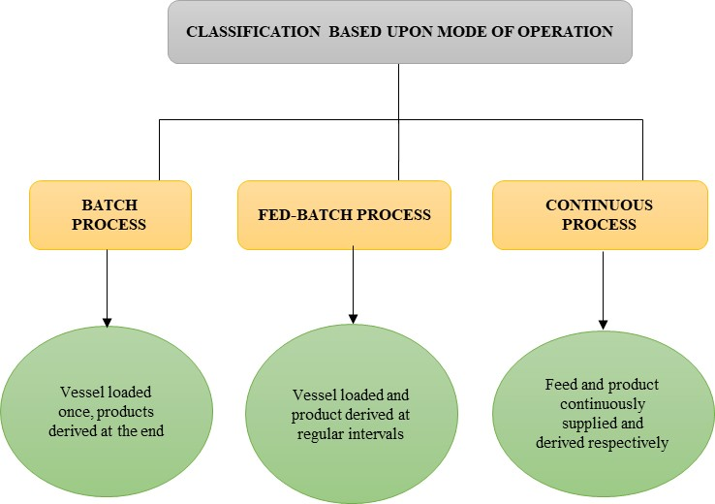

**Figure 1: Classification of bioreactors based upon mode of operation**

**III. PARTS OF BIOREACTORS**

1. **Vessel for Fermentation**

The vessel must meet certain standards, such as being able to withstand the highly corrosive nature of the media it contains. These vessels are mostly built of stainless steel, with glass jars being utilized in laboratories and small-scale manufacturing (Figure 2). Less than 50 liters can be stored in the glass vessels [5]. The vessels can't be used as a generalization for all processes. They must be created to meet the requirements of the procedure. The vessel must be able to endure extreme temperatures, high pressure, chemicals, and cleaning agents, to name a few common requirements (Figure 2). For a longer period of time, the vessel should be able to maintain a stringent aseptic and sterilized condition (Figure 3).

To ensure a convenient mass transfer process, the vessels need to have the appropriate stirrers and mixers [9]. The top and bottom plates of vessels are typically cylinder-shaped and can be customized to meet specific needs [2][9]. It is connected to numerous pipelines and valves. The ideal height to diameter ratio is 10:1, however occasionally a conical form is utilized at the top of the tank to increase its surface area and improve aeration [9]. It is important to construct the customized vessel so that there is adequate head space volume left above for foam and the optimal gas exchange [10]. 20–25% of headspace volume is typically thought to be sufficient to allow for foam production and air departure (Figure 3).

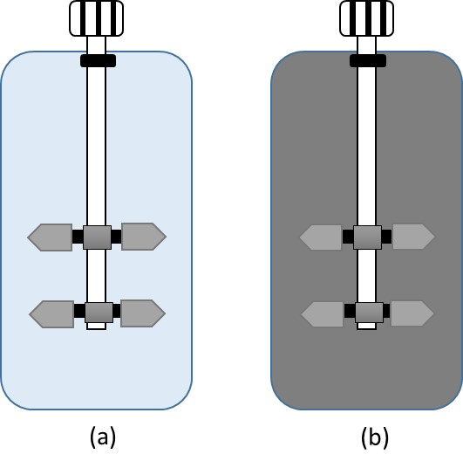

**Figure 2: a) Glass Vessel b) Stainless Steel Vessel**

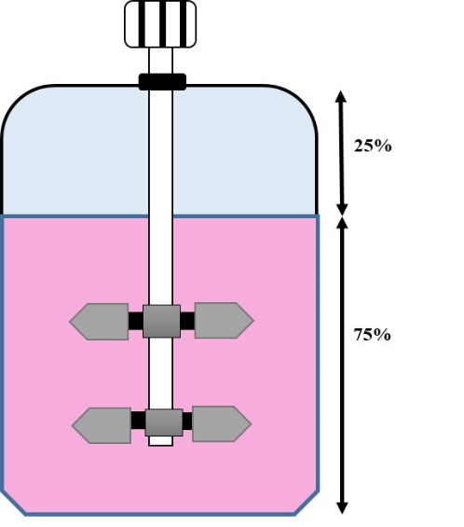

**Figure 3: Division of head space volume (25%)**

## **Heating and Cooling Management**

Heat can be generated by excessive agitation and cellular activities carried out by the growing cells which can challenge the heat coping mechanism of the bioreactor. Excessive heat may interfere with the product and can alter its physical or chemical properties. This will decrease the yield of product [5]. Temperature probes and a cooling jacket or coil are used in a temperature control system[5][10]. Because internal coils meet more exact temperature requirements than jackets, they are thought to be more effective[5]. On a modest scale, heat requirements are met by putting the fermenter in a bath that has a temperature control or by employing internal heating coils or jackets. However, a heating jacket becomes too tiny after a certain size. In such situation, the IR radiator's limited heat capacity kicks in to prevent medium overheating and precisely regulate temperature [10].

C. **Aeration System**

Air exchange system include compressor, inlet air, sparger, exit air sterilisation system, and overall sterilization system to avoid contamination [10]. Bioreactors are usually designed for self-sterilization which high pressure steam. Aeration system has two key devices: sparger and impellers. Spargers come in two different varieties: (1) a tube with a single aperture or (2) a ring-like structure with numerous tiny holes. Small-scale applications frequently use spargers with tubular structures, but sparging rings, which produce tiny bubbles and provide better gas dispersion, are preferred [5]. For a sparger to operate better, some characteristics are necessary, such as: (1) Holes should be on the axis facing the inner edges of the impeller blades (2) Holes should be oriented downward to minimize medium retention. (3) The sparger intake should be positioned so that it allows unobstructed draining into the vessel[9].

To achieve uniform dispersion throughout the entire culture media, impellers are necessary. They are made up of motorized impeller blades that are mounted on the lid. The suspension of solid particles, the passage of heat and air, the breakdown of bigger bubbles into smaller ones, and the uniform distribution of oxygen all depend on it. However, other critical elements to ensure successful gas dispersion include the type of impeller being utilized, its rotating speed, and liquid phase properties[5][9]. Additional direct and magnet-influenced agitator alternatives are found for particular industrial biotechnology applications[11]. There are many different types of impellers in use; some of them are listed in tablebelow[9] [12].

D. **Sealing System**

It is crucial to seal the contact between the stirred tank bioreactor and shaft since the agitator shaft is connected to both non-sterile and sterile environments. Aseptic seals, radial seals, axial seals, hermetic seals, stuffing boxes, magnetic drives, mechanical seals, etc. are only a few of the seal assemblies that are utilized to maintain exact agitation. Although more expensive, mechanical seals are more enduring and effectively block the entry of organisms[11] [9]. The impeller shaft is utilized to ferment bacteria but does not pierce the magnetic drive [9]. As the name implies, aseptic seals guard against microbiological contamination coming from either the inside or outside of the vessel. Radial seals like lip seals and other like stuffing boxes remain unaffected by push of axial direction however can cause leakage because of radial shaft distortions. Unlike radial seals, seals like mechanical seals act on horizontal direction securing them from radial shaft deflections. Stuffing boxes are not so expensive and have been into use from long time. Hermetic seals are quite preferable, because force is indirectly transferred from outer motor to impeller present inside the vessel with the help of magnetic coupling. It can be deduced from the above varieties that sealing assembly can be used on the basis of pressure applied, temperature condition, speed and sterility demands [11].

E. **Baffles**

Baffles are vertical metal strips placed into fermenters to reduce vortices, increase aeration prevent sedimentation and formation of stagnant zone at the inner side of the baffle especially during mixing of viscous fluid medium[2]. Baffles cause extra turbulence ensuring mixing of the medium top to bottom[11]. They are generally the 1/10 of the vessel diameter. The agitation graph falls sharply when the width of the baffles is decreased while there is a slight increase observed with increase in the width of the baffle. Baffles should be placed at a distance from the side and bottom walls to prevent microbial growth. Supplementary cooling coils can be connected to the baffles to enhance cooling capability of vessel without interrupting their structure[9].

F. **Foam Control**

The excessive agitation of medium during fermentation is followed by foam formation due to presence of some proteins acting as surfactants due to their amphiphilic nature[5][13]. Foam controlling system is very crucial for the bioreactor as large amount of foam can reach the top of the head space volume and can wet the filter of the air exit providing a severe threat of microbial contamination in the medium and damaging the production [5]. Blockage of air exit pathway can also lead to build pressure inside the vessel [10]. The foam is usually detected by resistivity probe situated at the top of bioreactor in the headspace. The foam later is perceived by contact probe resulting in release of antifoam [14]. Measurements of foam can be taken by static and dynamic methods, former method refers to measurements taken after the foam formation as latter refers to measurements taken during foam formation [13]. Key difference in between antifoam agent and defoamer is that antifoam agents are used to inhibit foam formation at the beginning of the process while defoamer destroys foam that has been already formed [14].

It is possible to utilize a variety of anti-foaming agents, including oil, organic antifoam (for instance, based on polyglycol moieties), silicone-based foam control, hydrophobic particles, and mixtures of oil and hydrophobic-solid particles. There are numerous different types of antifoam materials, including oxalated fatty acids, polydimethylsiloxane emulsions, powdered antifoam, and more[14]. To minimize foam buildup, chemicals can also be added to the medium, but doing so has certain drawbacks, such as: (1) interfering with microbial development in the medium by limiting oxygen transfer (2) If not eliminated sooner, it may affect the product's quality during post-processing [5].

G. **Sampling Ports**

In order to introduce inoculums, water, chemicals, enzymes or to collect samples frequently for examining the progress, sampling ports or feed ports are needed [10]. Taking sample may seem easy but it also possesses a high risk of contamination and hence sterilization is required simultaneously. The port should be constructed in such a way that it will ensure sterility before and after use. Sampling pipe has a bladder generally made up of silicone and clamped at the end. Once the sample is taken the end of the pipe are sterilised with alcohol to prevent any microbial growth and interfere with production of the final product. However advanced bioreactors have better mechanism to maintain sterility during the process [9].

H. **Valves**

In the bioreactors, the valves are used to control the flow of liquid and gases in many ways. Valves play an important role in carrying out the fermentation inside the reactor to ensure proper regulation of oxygen, substrate, air exchange, antifoam agent etc. There are multiple types of valves present for use. According to the requirement of the type of fermentation, valves are used in customised way in the bioreactors.

Different types of valves present for use are: globe valves, butterfly valves, ball valves, diaphragm valves, needle valves, safety valve, steam traps and gate valves (Figure 4).



**Figure 4: Classification of Valves**

I. **pH Control**

Some of the medium require particular pH for fermentation to occur. In order to maintain the pH of the medium pH controlling sensors or probes are used to detect any fluctuation in the medium present inside the bioreactor [9]. To maintain the pH of the medium, neutralizing agents are used. The only condition neutralizing agent has to follow is: (1) non-corrosive (2) non-toxic. These conditions will make sure that neutralizing agent should not hamper the quality of the product and become a hurdle during downstream processing. One of the most common neutralizing agent is Sodium carbonate which is used in small-scale applications [10].

**IV. TYPES OF BIOREACTORS**

Bioreactors are divided mainly into two major types:

* Suspended growth bioreactors- examples including continuous stirred tank reactors (CSTRs) use microbial metabolic activities under different conditions to convert substrates into desirable products[2].
* Bio-film bioreactors- examples like packed bed, airlift, fluidized and membrane bioreactors in which organisms are stick to the wall of the vessel and carry out breakdown of toxic substances especially in waste water treatment plant [2].

A. **Stirred Tank Reactors (STR)**

Stirred tank bioreactors typically consist of a glass or stainless steel vessel with a motor, an impeller-based baffle, an air inlet and exit port, a bottom drain, foam, and temperature control (Figure 5)[11]. A tool known as a sparger, which can be a ring-like structure with numerous holes or a tube with a single pore, adds air to the vessel. But rings with holes make sure that the gas is distributed more evenly throughout the vessel. The earlier-discussed types of impellers are employed to provide improved liquid-gas mixing. However, a good sparger system is far more crucial, as high agitation will be useless at bigger scales if the sparger cannot provide uniform gas distribution [5]. These reactors are one of the most traditional and commonly used bioreactors in the industry. They have some pros over other bioreactors like: (1) easy operating requirements (2) readily available (3) it provides effective gas flow to the medium and their volumetric mass transfer coefficient is quite high [5].

Stirring system is the key element of the reactor, including an agitator shaft with precise impeller as per the requirement pierced into the vessel, with a motor attached to it on the outer side of the vessel and sealed by sealing assembly to prevent any contamination [11]. Factors like sterility, pH control, low energy consumption and geometry are considered while designing a STR. Excessive foam can be a threat to invite microbial ‘guests’ and contaminate the product as foam can wet the air exit filter and serve as a medium for the microbes to enter[5].

Stirred tank reactors can be customised as per the demands of the process, using different types of impellers, which help in breaking larger bubbles into smaller ones. Shear stress generated by the impellers is a problem in STRs. However, shear stress generated by impeller increase secondary metabolism in plant [15]. But shear stress needs to be reduced due to some reasons: (1) genetically engineered organisms are more prone to lysis when introduced with shear stress, (2) shear stress often alters the physio-chemical properties of the product making downstream process cumbersome to happen [5].

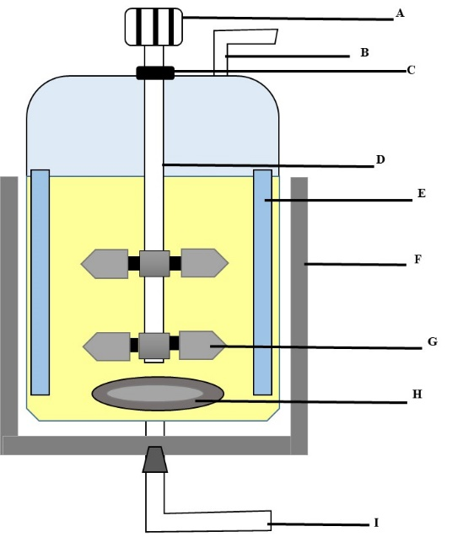

**Figure 5: Stirred tank bioreactor (A) Agitator, (B) Air exit (C) Seal, (D) Baffles, (E) Cooling jacket, (F) Heat transfer jacket (G) Impeller, (H) Sparger, (I) Air inlet**

**Continuous Stirred Tank Reactors (CSTRs),** are similar to STRs with only difference that CSTRs carry out continuous fermentation including regular addition of substrate and removal of product simultaneously (Figure 6) [2]. Temperature control is simple; customization is affordable and can be operated with decent training, with easy cleaning and sterilization facility. CSTRs work on two types of strategies: Chemostat and turbid stat. Chemostat refers to the use of culture in which excessive nutrient medium is added and liquid volume remains unchanged while turbid stat refers to the use of constant cell concentration and constant liquid volume. More than one CSTRs, each with different combination of parts can be connected together and can be used to carry out fermentation [2].

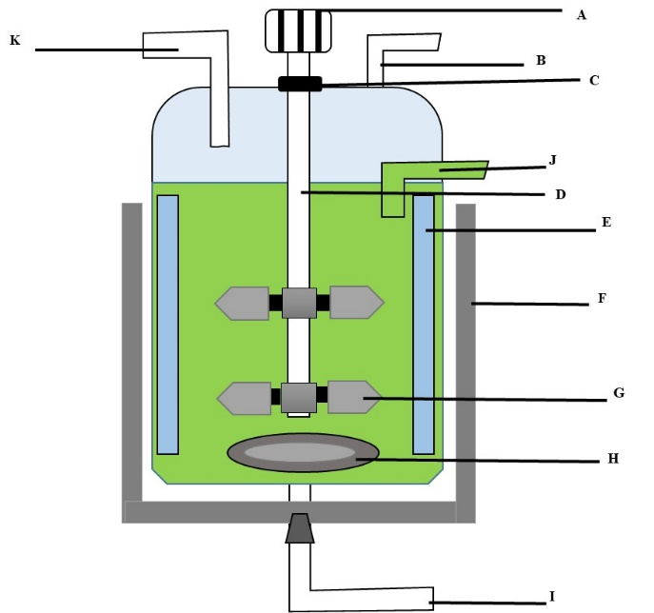

**Figure 6: Continuous stirred tank bioreactor (A) Agitator, (B) Air exit (C) Seal, (D) Baffles, (E) Cooling jacket, (F) Heat transfer jacket (G) Impeller, (H) Sparger, (I) Air inlet, (J) Product outlet, (K) Feed**

**J**

STRs and CSTR **s**have their application in waste water treatment, production of alpha interferon, clinical use in cancer and production of tissue plasminogen activator [2].

B. **Bubble Column Bioreactors (BCRs)**

Bubble column bioreactors are generally cylindrical shape vessels also called as pneumatic mixed reactors. The gas is supplied with the help of sparger into the medium. When solid phase is present, the reactors are referred to as slurry bubble column. The vessel usually designed with a height: diameter ratio of 2:1, 3:1 or sometimes 6:1 to allow better mixing of medium and air supplied [2]. The bubbles column reactors are dependent on the sparger system for agitation as impellers are not included in BCRs [5]. They require less maintenance, highly durable, and affordable commercially. Their scale-up needs knowledge of computational fluid dynamics (CFD) [16]. BCRs working are dependent on few parameters like: gas holdup, bubble features, mass transfer and heat transfer coefficient. A simple design of bubble column reactor is shown in Figure 7.

For BCRs, there are two different types of operation modes: semi-batch and continuous. In semi-batch, the suspension is kept in place while the gas moves in the vessel's upward direction; in continuous mode, as the suspension reaches the top of the column, it is recycled into the feed tank. The volume that the gas bubbles occupy is referred to as "gas hold up." Depending on the kind of gas sparger being used. A key factor in the uniform agitation of the medium is gas velocity. As a result, the type of sparger also affects the gas's velocity. In comparison to the perforated plate, the ring sparger offers a lower gas velocity. Large, quickly rising bubbles cause a rapid decline in gas holdup, whereas small, slowly rising bubbles reduce the rate of drop. Bubble size is yet another factor that influences how well BCR functions. For good mass transfer rates, smaller bubbles are preferred[17]. Application areas for bubble column reactors include fermentation, wastewater treatment, methanol synthesis, environmentally friendly synthetic fuels, and hairy root culture of plant cells[10].

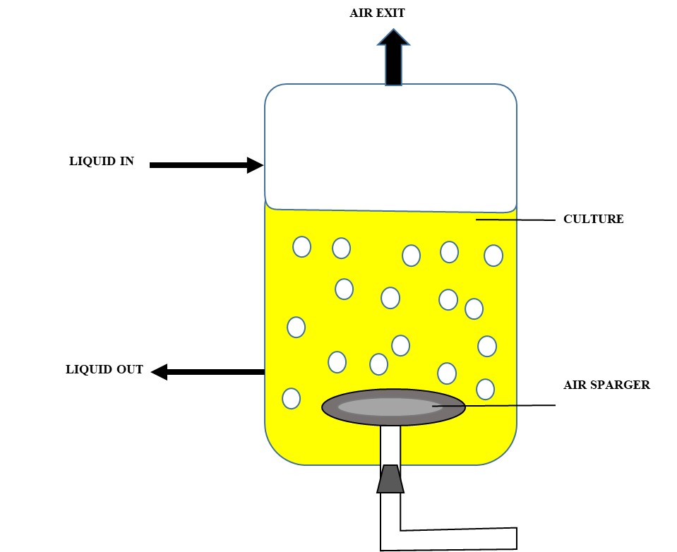

**Figure 7: Bubble column bioreactor**

C. **Airlift Bioreactors (ALBs)**

Airlift bioreactors is another type of pneumatic bioreactor having either an internal or external loop [5]. They are similar to the bubble column reactor but have a central draft tube, which is absent in BCRs. The two configurations namely, internal loop (Figure 8) and external loop reactors (Figure 9). In the former one the suspension along with the gas in the upward direction moves through draft tube and comes downwards from sideways, while latter one work on barrier strategy in a vessel in which a peripheral channel is created [2]. Few bubbles coalesce and exit from top while some smaller bubbles re-enter into the down-comer column [18].

Tower reactors, also known as airlift bioreactors, use high pressure gas for mixing. They can be applied to bacteria, plant, animal, and cells that have been immobilized or released. The downward tube can also act as a heat exchanger inside the body. When compared to stirred tank bioreactors, airlift bioreactors are more energy efficient and have increased mass transfer[10] [5]. Due to its capabilities to ensure low-shear environments and improved mass transfer, airlift bioreactors are required for filamentous fermentation. The benefits of employing an airlift bioreactor include simple scaling up (analytical studies scale up relatively similarly to BCRs), a low shear environment, a simple operating system, and improved mass and heat transmission. Foam is seen to rise less in external loop reactors than in the airlift bioreactor with internal loop[18]. Since airlift bioreactors are much more efficient than bubble column bioreactors, they can be readily available to use at pilot scale. ALBs are used for denser suspension of microorganisms because mixing is better than BCRs and coalescence of bubbles is not a hurdle in them. Another advantage of using ALBs is they have multiple injection points to prevent the depletion of substrate in the suspension. Imperial Chemical Industries Limited in England has built a 1,500,000 litre bioreactor to carry out production of single-cell protein[5].

The applications of airlift bioreactors are in the field of wastewater treatment, filamentous fermentation, production of single cell proteins [18].

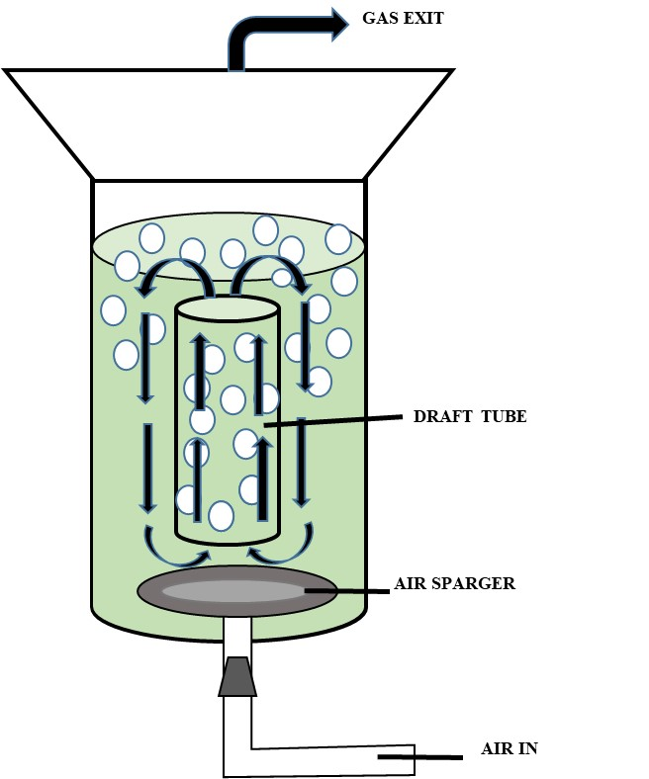

**Figure 8: Airlift bioreactors (Internal Loop)**

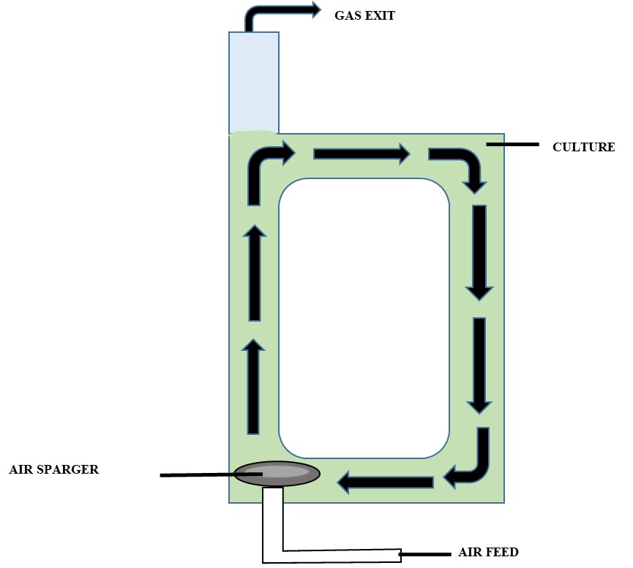

**Figure 9: Airlift bioreactors (External Loop)**

D. **Packed Bed Bioreactors (PBBs)**

Packed bed bioreactors include a structure of packed-bed, which is usually present in the shape of spheres and made up of supporting material like ceramic as shown in Figure 10. There can be other shapes too made up of non- woven polyester and other polymer [10] [2]. The PBBs are generally cylindrical in shape and filled with immobilized catalyst [19]. The substrate moves through the packed- bed using three simple ways: downward, upward, and recycling. However, recycling flow is advantageous over other two methods as it permits the substrate to flow at a desired velocity and give desired amount of product. Industries usually prefer upward flow in enzymatic reactions as it produce a large amount of gas [19]. The spheres of packed-bed usually range from 100-300 **μm in size which sustain their position inside the reactor vessel and allow smaller cells to pass [15]. Plugging is a major concern in PBBs, can be avoided but the process has to face high pressure drop. The key factors that influence the interface of this heterogeneous matrix are flow rate of liquid and residence time[10].**

**The packed bed bioreactors have numerous advantages like easy operating, good quality products, less complex machinery and reaction rates. However, PBBs have some of the undesired characteristics like low heat and mass transfer (for which intra-particle connective flow is used), poor temperature management system, undesired sideway reactions and blockages sometimes [10] [19].**

**Packed-bed bioreactors have its applications in wastewater treatment, dairy production, brewing industry, generation of bio energy [19].**

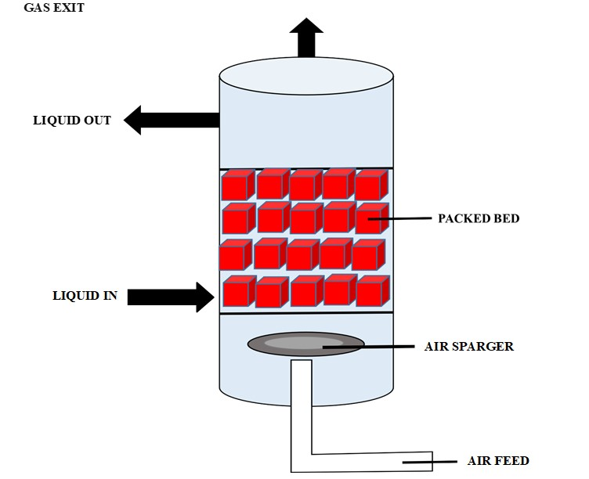

**Figure 10: Packed-Bed bioreactor**

**E. Fluidized Bed Bioreactors (FBBs)**

**FBBs use cell immobilization technique in which biocatalyst is immobilised solid support fluidized by passing liquid or gas through it (Figure 11) [15]. The fluidization is the result of clubbed upward and downward movement of particles (upward movement due to passing of liquid or gas and downward due to gravity) [18]. Due to the distance created between spheres, the surface area for reaction has been increased for more production [3].The structure of the such bioreactors has an expanded diameter on the top while a normal one below and believed to have ratio >10:1 of height to diameter [2] [10]. Their packed-bed comprises of smaller spheres. This prevents clogging and high pressure drop unlike packed bed bioreactors. In such reactors, the particles which are immobilised move along with fluid and smaller size of particles gives them the advantage of high mass transfer and oxygen transfer [10].**

**The fluidized bed bioreactors have some advantages like: the system is quite easy to operate, has effective temperature control and oxygen control, mixing up to great extent to prevent any gradient formation, have high mass and heat transfer quality, and shear stress is also quite low [18] [15].**

**Although FBBs have a long list of advantages it has disadvantages as well. Some of them are like: high cost solid separation equipment needed for fluidization, bubble development, destruction of solids due to high velocity, and it is quite difficult to scale up these bioreactors [20]. Some other undesirable characteristics are pumping needs, damage to internal environment due to high velocity and pressure loss [10].**

**The applications of fluidized bioreactors are in the arenas of wastewater treatment, micro-carrier cultures, and production of microbial biomass [2].**

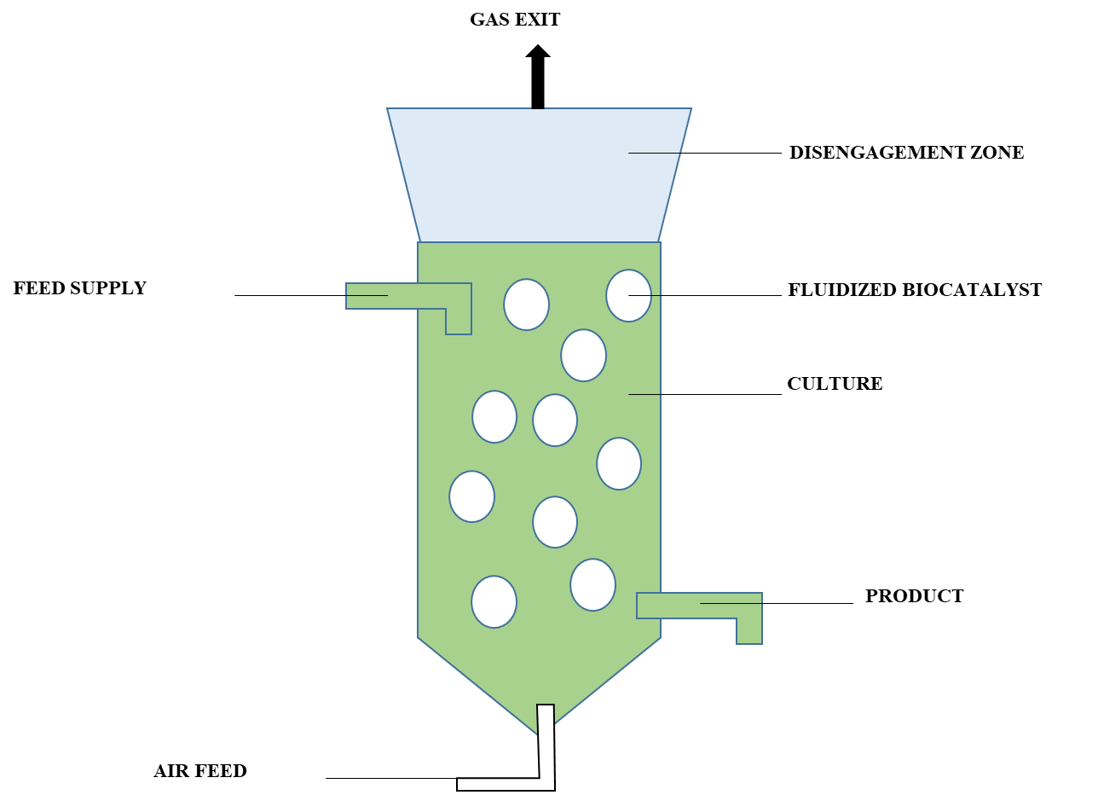

**Figure 11: Fluidized-bed bioreactor**

**F. Membrane Bioreactors**

**Membrane bioreactors are those reactors that uses membrane integration to separate biomolecules, cells, and different molecules based on their charge and size from the continuous stream of product [3]. Production and separation can be done in a single step using membranes in situ [18]. Membranes are made up of different kind of material like cellulose, ceramic, ion exchange membranes, polyvinylidene difluoride, polyacrylonitrile and many more. Membranes can be of two types: (1) microfiltration, have pore size 0.1-0.5** μm used to resist cells, (2) ultra filtration membranes, have pore size 20-1000 Å used to separate macromolecules [3]. Commonly, membranes can be packed in modules like: plate-sheet, spiral bound, hollow-fibre and tubular [15].

Working of membrane bioreactors can be better explained in wastewater treatment plant. Membranes of membrane bioreactors are usually sinking in the water tank with proper aeration. Filtrate matter is withdrawn from membrane using suction pump and air blowers play a crucial role in maintaining uniformity of the suspended solids. This flow of air also help the membrane to avoid fouling [3].

The advantages of the membrane bioreactors are removing organic matter efficiently and decreasing biological oxygen demand(BOD), lesser sludge formation and water reclamation [2]. The membrane bioreactors can also be connected with the stirred tank bioreactors to elevate the production (Figure 12) [15]. There are other two types of membrane bioreactors namely: reverse membrane bioreactor and immersed membrane bioreactor [3].

Membrane bioreactors have major application in wastewater and waste gas treatment plant. Along with that it has its application extended in the field of vaccine production, lactic acid purification, pharmaceuticals, food industry, bioethanol production **and list goes on [21].**

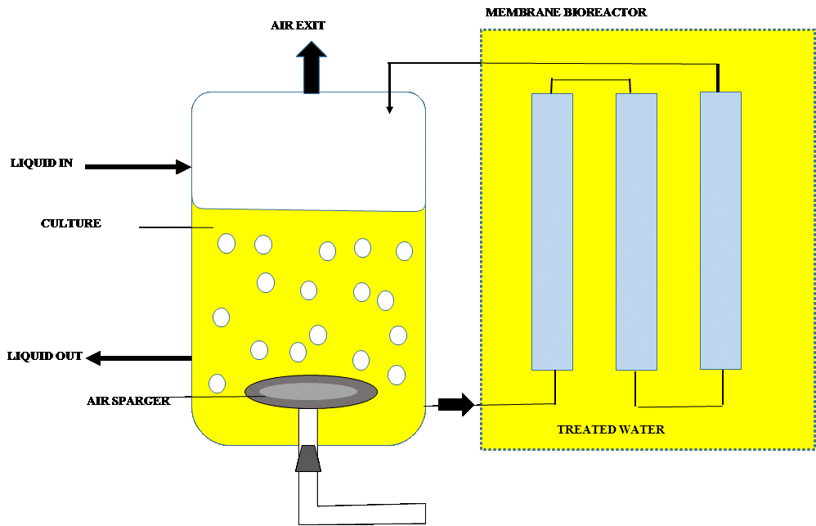

**Figure 12: Membrane bioreactor**

**G. Photobioreactors (PBR)**

**Photosynthetic machinery of algae has been of great importance for mankind since a long time ago. But their huge production has always been a challenge. To tackle the increasing demands photobioreactors are designed [22]. These bioreactors utilize the source of light in which photon travels through transparent walls of vessel and reach cultivated cells (Figure 13) [3]. Reactors can be of multiple types including tubular, helical, conical, seaweed type, flat plate, annular [2]. Recently, compact tubular photobioreactors are designed and popular for their high photosynthetic rate and salt stress tolerance [15].**

**The following elements must be considered while designing a photobioreactor: adequate CO2 supply, oxygen removal to prevent any interference with production, suitable light source arrangements to ensure uniformity and optimal amount of light, and scaling up of the technology. To promote microbial development, particularly fungi, the aforementioned conditions must be controlled. The algal medium returns to the feeding vessel once the flow is finished. The rate at which algae are gathered and processed is also determined[3].**

**The applications of photobioreactors is in the areas of water treatment engineering, aquaculture, production of supplements, bio-diesel from oils, bio-sorption of heavy metals[3] [2]. Even though with mentioned applications, photobioreactors has some disadvantages like expensive equipment, adhesion of algae to glass walls and formation of biofilm [3].**

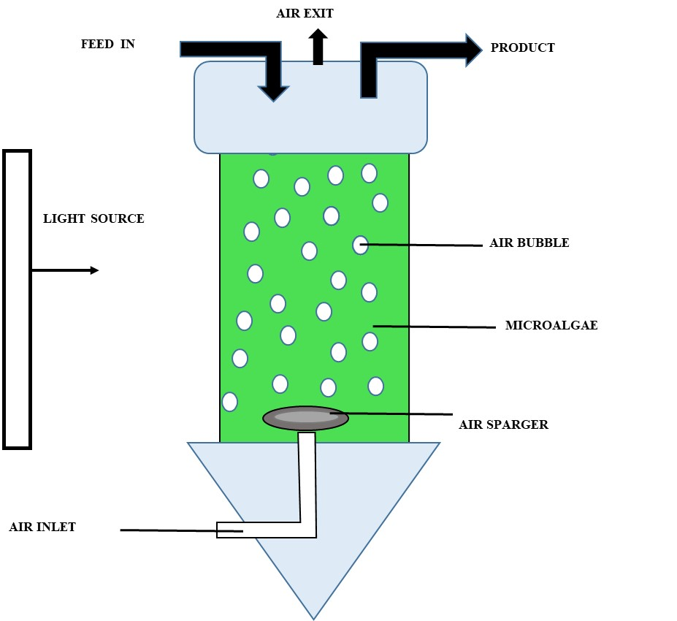

**Figure 13: Photobioreactor**

**Table 1: Types of Bioreactors with their Applications**

|  |  |  |
| --- | --- | --- |
| **Types of Bioreactors** | **Applications** | **References** |
| Stirred/Continuous Tank Bioreactor | Waste water treatment, production of alpha interferon, clinical use in cancer and production of tissue plasminogen activator | [2] |
| Bubble Column Bioreactor | Fermentation, wastewater treatment, methanol production, synthetic fuels which are good for environment and hairy root culture of the plant cells | [10] |
| Airlift Bioreactor | Wastewater treatment, filamentous fermentation, production of single cell proteins | [18] |
| Packed Bed Bioreactor | **Dairy production, brewing industry, generation of bioenergy** | **[19]** |
| Fluidized Bed Bioreactor | **Micro-carrier cultures, and production of microbial biomass** | **[2]** |
| Membrane Bioreactor | Vaccine production, lactic acid purification, pharmaceuticals, food industry, bioethanol production **and list goes on** | [21] |
| Photobioreactor | **Water treatment engineering, aquaculture, production of supplements, biodiesel from oils, bio-sorption of heavy metals** | **[2] [3]** |

**V. FUTURE PERSPECTIVES**

**Bioreactors and their designs are evolving according to the demand of the process. For more efficient working, the designs have better scope for improvements and development. It is required to take notice of limitations a design is proposing and more steps need to be taken towards developing more efficient, cost-effective and easy operated systems. Most of the existing systems are no doubt one of the best designs in the history of bioreactors but evolved technologies can make huge difference.** The future prospects of bioreactors are promising, with advancements in design, the emergence of miniature bioreactors, and their applications in tissue engineering and medical fields. Technological advancements and the acceptance of single-use systems also contribute to the future development of bioreactors. The potential implications of bioreactors extend beyond bioprocessing, with implications for healthcare and cellular agriculture.

**VI. CONCLUSION**

**Since many types of bioreactors have been discussed, each type possesses its own specific operating system and has its application in different fields. Bioreactors have travelled a long evolution from being a simple one to the most complex one and always with better version. Every bioreactor aims to produce more product with a smaller amount of time spent on downstream processing. Bioreactors have expanded their uses in a wide range of areas, from wastewater treatment to the production of biodiesel. However, there are some drawbacks to each and every type of bioreactor that must be worked with.**

**REFERENCES**

1. Erickson, L. E. (2009). Bioreactors.
2. Antolli, P. G., & Liu, Z. (2012). Bioreactors : design, properties, and applications.
3. Naga Vignesh, S. (2020). Working principle of typical bioreactors. In Bioreactors: Sustainable Design and Industrial Applications in Mitigation of GHG Emissions (pp. 145–173).
4. Erickson, L. E. (2011). Bioreactors for Commodity Products. In Comprehensive Biotechnology, Second Edition (Vol. 3, pp. 653–658).
5. Glick, B. R., Pasternak, J. J., Patten, C. L. (2010). Molecular Biotechnology: Principles and Applications of Recombinant DNA.
6. Eibl, R., & Eibl, D. (2011). Single-Use Technology in Biopharmaceutical Manufacture. In Single-Use Technology in Biopharmaceutical Manufacture.
7. Mears, L., Stocks, S. M., Sin, G., & Gernaey, K. V. (2017). A review of control strategies for manipulating the feed rate in fed-batch fermentation processes. Journal of Biotechnology, 245, 34–46.
8. Li, T., Chen, X. Bin, Chen, J. C., Wu, Q., & Chen, G. Q. (2014). Open and continuous fermentation: Products, conditions and bioprocess economy. Biotechnology Journal, 9(12), 1503–1511.
9. Jagani, N., Jagani, H., Hebbar, K., Gang, S. S., Vasanth Raj, P., Chandrashekhar, R. H., & Rao, Jv. (2010). An Overview of Fermenter and the Design Considerations to Enhance Its Productivity. Pharmacologyonline, 1, 261–301.
10. Singh, J., Kaushik, N., & Biswas, S. (2014). Bioreactors – Technology & Design Analysis Jagriti Singh, Nirmala Kaushik* & Soumitra Biswas. The Scitech Journal, I(June 2014), 28–36.
11. Schirmer, C., Maschke, R. W., Pörtner, R., & Eibl, D. (n.d.). An overview of drive systems and sealing types in stirred bioreactors used in biotechnological processes.
12. Gogate, P. R., Beenackers, A. A. C. M., & Pandit, A. B. (2000). Multiple-impeller systems with a special emphasis on bioreactors: A critical review. Biochemical Engineering Journal, 6(2), 109–144.
13. Koller, K. (2004). Foam control in fermentation processes. Chemical Engineering, 111(8), 24–27.
14. Delvigne, F., & Lecomte, J. (2010). Foam Formation and Control in Bioreactors. Encyclopedia of Industrial Biotechnology, 1–13.
15. Valdiani, A., Hansen, O. K., Nielsen, U. B., Johannsen, V. K., Shariat, M., Georgiev, M. I., Omidvar, V., Ebrahimi, M., Tavakoli Dinanai, E., & Abiri, R. (2019). Bioreactor-based advances in plant tissue and cell culture: challenges and prospects. Critical Reviews in Biotechnology, 39(1), 20–34.
16. Van Tran, B., Ngo, S. I., Lim, Y. il, Kim, W., Go, K. S., & Nho, N. S. (2018). Computational fluid dynamics of gas-liquid bubble column with hydrocracking reactions. In Computer Aided Chemical Engineering (Vol. 44).
17. Kantarci, N., Borak, F., & Ulgen, K. O. (2005). Bubble column reactors. Process Biochemistry, 40(7), 2263–2283.
18. Wang, S. J., & Zhong, J. J. (2007). Bioreactor Engineering. Bioprocessing for Value-Added Products from Renewable Resources, 131–161.
19. Sen, P., Nath, A., & Bhattacharjee, C. (2017). Packed-Bed Bioreactor and Its Application in Dairy, Food, and Beverage Industry. In Current Developments in Biotechnology and Bioengineering: Bioprocesses, Bioreactors and Controls.
20. Werther, J. (2012). Principles of Chemical Bonding - Fluidized bed reactors. Ullmann’s Encyclopedia of Industrial Chemistry ||, 15(8), 320–361.
21. Asif, M. B., Hai, F. I., Jegatheesan, V., Price, W. E., Nghiem, L. D., & Yamamoto, K. (2018). Applications of membrane bioreactors in biotechnology processes. In Current Trends and Future Developments on (Bio-) Membranes: Membrane Processes in the Pharmaceutical and Biotechnological Field.
22. Suh, I. S., & Lee, C. G. (2003). Photobioreactor engineering: Design and performance. Biotechnology and Bioprocess Engineering, 8(6), 313–321.