SOIL-LESS CULTURE
Priya Raj A N and Yaashwini K S
Soilless culture is a method of growing plants in a medium other than soil. The artificial means of providing plants with support and a reservoir for nutrient and water.
The simplest and oldest method of soilless culture is a vessel of water in which inorganic chemicals are dissolved to supply all of the nutrients that plant require.
The origin of soilless culture dates back to 18th century. Father of soilless culture is “William Frederick Gericke”, in the year 1937 he grew tomato vines about 7.6m high in his backyard in mineral nutrient solution (hydroponics).
Soilless culture is also known as Solution culture or Water culture. Soilless media can be inorganic like sand, gravel, pebbles, perlite, rock-wool, vermiculite, and organic like rice hulls, peat sawdust, coconut coir or synthetic like foam ship, sponges, moisture absorbent plastic fiber.

Types of soilless culture
- Liquid-medium systems are further differentiated from solid-medium systems by method of operation. Liquid systems are generally closed circuit with respect to nutrient-solution supply. The two most common liquid systems in use today are nutrient-flow technique (NFT) and gravelbed culture. Copper in 1979 provided greater information regarding NFT management.
- Gravel-bed culture utilizes a waterproof trough filled with pea gravel (or some other inert material of similar size), which is plumbed to a nutrient solution reservoir.

Solid-medium soilless culture may employ any one of many types of suitable media in various types of containers. Basic requirements are a material of uniform texture that drains well yet retains some nutrients and water, a container in which the material is confined, and a means of supplying nutrient solution.
Soilless culture in bags, pots, or troughs with a lightweight medium is the simplest, most economical, and easiest to manage of all soilless systems.
Advantages over other types of soilless culture:
(1) The medium materials have excellent retention qualities for nutrients and water
(2) Containers of medium are readily moved in or out of the greenhouse whenever necessary or desirable
(3) They are lightweight and easily handled
(4) The medium is useful for several successive crops
(5) The containers are significantly less expensive and less time-consuming to install- and
(6) In comparison with recirculated-hydroponic systems, the nutrient solution system is less complicated and less expensive to manage.
There are two types of soilless culture :
1. Hydroponics
2. Aeroponics

HYDROPONICS
Hydroponics is the art and science of growing crops without soil. It is also defined as growing of plants in nutrient solutions with or without an inert medium(such as soil) to provide some mechanical support to plants. It is also known as Aquaculture, Tank farming, Soilless culture and Nutriculture.
The word is derived from Greek and means working with water. The hydroponically grown plants roots often simply hang in water with a rich mix of nutrients dissolved in it.
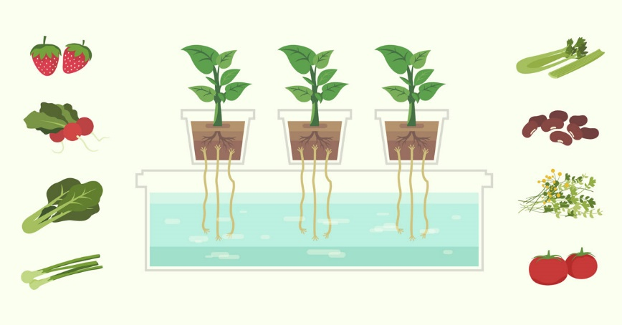
The advantage of hydroponics are;
- Higher yield
- Controlled level of nutrition
- Less water consumption compared to soil grown crops.
- Less prone to pest and diseases
- Weeds can be easily eliminated
- Productivity of plants is increased by 3-10% compared to soil grown crops
- Requires less labor
- Healthy plants are grown
- Crops are grown faster
The disadvantages of hydroponics are
- More expensive to set up
- Requires constant monitoring and maintenance
- Algal infestation
History of Hydroponics
- In the 10th century, the Aztecs were reportedly using floating gardens in nearby lakes, and the Chinese utilized hydroponics for rice fields devoid of soil in the 13th century.
- By the 16th century, Belgian Jan van Helmont recorded the earliest known science based research on hydroponics.
- It was introduced to India around 2008-2010.
Hydroponics solves this problem in three different ways
- Oxygenated Nutrient Reservoir: The water reservoir can be constantly oxygenated, making sure that the plant’s roots obtain the optimum level of oxygen. Additionally, the problem of no longer has soil surrounding it, blocking oxygen uptake by the roots.
- Uses Less Water: Hydroponics uses much less water than soil farming because it can be recirculated. In traditional farming, water is poured over the ground and seeps into the soil. Only a small fraction of the water actually gets used by the plant. Hydroponics allows for the unused water to be recycled back into the reservoir, ready for use in the future. In dry and arid areas, this is a massive benefit.
- Total Growing Control: final major benefit of hydroponics is the amount of control a grower has over the environment. Pests and diseases are much easier to deal with – your environment is often times portable and raised off of the ground. This makes it hard for bugs to reach your plants. Any soil-related diseases are completely written off in hydroponics as well. Lastly, you’re able to control the amount of nutrients provided to your plant precisely, saving on nutrition costs watering is solved by the fact that the plant’s root system.
Growing media for hydrophonics: Why is it so important?
- The growing media are to help provide plants’ roots with moister & oxygen they need. It also supports the plant weight and holds it upright.
- Another role of the media is to allow plant’s roots to have maximum exposure to the nutrient. People will moister the growing media with the nutrient solutions. And the wet media will transfer the nutrient to the root system
- Some growing media like sand, gravel, peat moss, perlite, vermiculite
- Even the air can be used as an effective growing medium for the roots. But each has its pros and cons.
What makes a great growing medium?
- Eliminating all objective factors, an ideal medium is the one that is organic-made, biodegradable and environmentally friendly.
- Keeps an even ratio of air to water.
- Has a medium cation-exchange capacity to hold nutrients.
- Helps protect plants from pH changes over time.
• Is inexpensive and easy to find
• Is lightweight enough and easy to carry around

Materials which is used as growing media and their benefits
Perlite
Benefits -
•Reasonably inexpensive
•Lightweight
•High air retention.
•Reusable
Downsides -
•Lightweight, not suitable for certain system kinds
•Dust from the medium – effects on the environment and health

•Can be used in drip systems, aeroponic systems.
Coconut Coir
Benefits –
•Excellent water retention and aeration
•Organic material
•Environmentally friendly
Downsides –
•Uncompressed after several uses.
•Doesn’t drain well, so often mixed with other media.
•Can be used in drip systems, aquaponic systems, ebb and flow system.
Vermiculite
Benefits -
•Water and nutrient retention
Downsides -
•Poor drainage capacity
•Danger of suffocating plants
Rockwool
Benefits -
- greater absorption and aeration capacity
Downsides -
- Not environmentally friendly
- The dust is not good for the health.
- Disturb the pH of the nutrient solution.
Expanded clay material
Benefits -
- Reusable, sustainable.
- Effective water drainage, and air retention.
Downsides -
- Poor moisture retention capacity
- More expensive than other growing media
Oasis Cubes
Benefits -
- Inexpensive
- Good water and air holding
Downsides -
- Not organic
- Not sustainable
- Used for germination and seedling growing phases.
Starter plugs
Benefits -
- Excellent for seedlings, and propagation
- Sustainable (depending on the material used)
Downsides –
- Suitable for seed starting, or cloning.
- Relatively expensive
Rice Hulls
Benefit -
- Totally organic
Downsides -
- Break down over time
- Not pH neutral
Pumice
Benefits -
- Lightweight
- Excellent air holding capacity
Downsides -
- Lightweight for some hydroponic system
Grow stones
Benefits -
- Lightweight
- Good air to water ratio
- Sustainable
Downsides -
- Cling to some roots, which can cause root damage for some plant types.
- A little bit of dust.
- More expensive than other media.
Sawdust
Benefits -
- Organic
- Sustainable
Downsides -
- pH fickle
- Rot over time, and can cause bacteria.
- May not be sterile
Wood Chips/Fibers
Benefit -
- Totally organic
- Able to retain water well.
Downsides -
- Biodegradable
- Can contain chemicals.
- May bring fungi, pests.
Peat Moss
Benefits -
- Good water, and nutrient holding.
- Doesn’t compact
- Doesn’t comprise of harmful bacteria or weeds

Downsides -
- Not renewable.
- Low pH, acidic.
- Relatively expensive
Sand
Benefits -
- Cheap (or free).

Downsides -
- Heavy
- Low aeration
- The tiny size which can block some system types.
Gravel
Benefits -
- Cheap (or free).
Downsides -
- Poor water retention, not suitable for heavy plant roots.
- Heavy
Air
Benefit -
- Plenty of oxygen.
Downside -
- Plant danger in the event of-of power, pump, timer failure
Can be used in nutrient film technique systems, deep water culture systems.
Fun facts about hydroponics
- Farmers claim that some hydroponic crops requires 90% less water than the same crops in the traditional soil farming.
- We can plant 4 times the amount of crops in the same space provided as traditional soil farming.
- Some crops can grow twice as fast in hydroponics than grown in traditional method.
- No use of herbicide or pesticide chemicals.
- Grown in an inert medium without soil with well balanced pH, nutrients solutions are highly oxygenated water which is delivered directly to roots.
- Crops can be grown throughout the year.
Hydroponic gardening is a dirt-free, low cost, space saving, low in pesticides, and environmentally friendly way of growing plants without any soil. – Rick Helweg
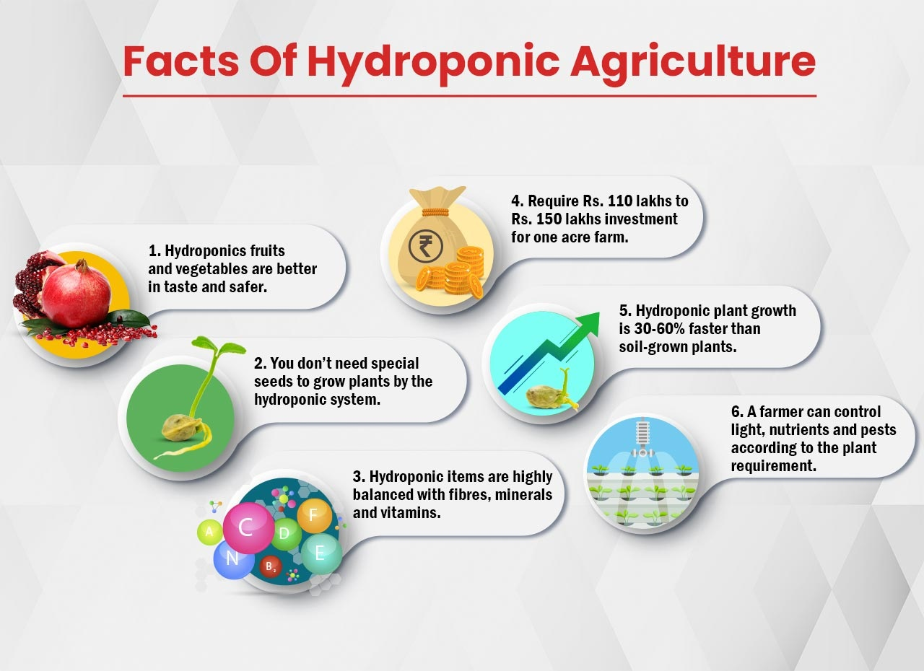
Future of hydroponics in India?
Nowadays, in India there is a great demand for sustainable and protected farming practices. The hydroponics market is expected to reach USD 35.4 billion by 2030, at a CAGR of 15.6% during the forecast period of 2023 – 2030. The hydroponics farming allows a plant to grow 50% faster than the conventional method.
The government scheme for hydroponics
The National Horticulture Board of India provides the subsidy for a hydroponic farm set up under the Scheme-1 named Development of Commercial Horticulture through Production and Post-harvest Management of Horticulture Crops.
List of Best Hydroponic Training Centres/
Institutes in India
- Institute of Horticulture Technology
- Sai Swayam Society
- Tichxelons Agrotech. Techxellance Solutions Pvt Ltd
- Kerala Agricultural University
- Future Farms
- Bellesiri – Hydroponics Training & Consultant
- The earliest examples of hydroponics date back to the Hanging Gardens of Babylon and the Floating Gardens of China. Humans used these techniques thousands of years ago. Although the general theory behind hydroponics remains the same, modern technology has enabled us to grow plants faster, stronger, and healthier.

AEROPONICS
It is the process of cultivation of plants in an air or mist environment, eliminating the need of soil or an aggregate medium.
The term aeroponic originates from a Greek word aer and ponos. It falls under the category of hydroponics, as water is employed in aeroponics to deliver nutrients to plants.
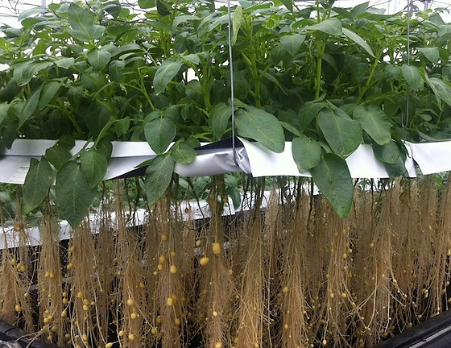
The word “aeroponics” is a combination of two Latin root words meaning “air” and “work”. The “aero” in Aeroponics refers to the fact that the plant roots grow in air. The roots are periodically sprayed with a nutrient solution that delivers all the macro- and micronutrients the plants need to grow

Who invented aeroponics?
- The term aeroponics was originally coined by the Dutch biologist, Frits Warmolt Went in 1957 but it was a full 29 years before the first aeroponically grown food was sold in a national grocery chain by Richard Stoner.

History
- The types of plants that were used early on included coffee and avocado plants.
- “The Land” pavilion at Disney’s Epcot Center opened in 1982 showcasing an aeroponic system.
- Stoner filed his first aeroponic patent in 1983 and went on to found a number of companies which would research and advance aeroponic technology. One of his companies, called Genesis Technology Incorporated or GTI, was the first to bring commercial-scale aeroponic systems into greenhouses for commercial crop production. Both the company’s name and their first product, the Genesis Machine, were inspired by the plot of a recent Star Trek movie, “Star Trek II: The Wrath of Khan”. In the film, the Genesis Device was a sophisticated technological innovation designed to alleviate sociological problems such as overpopulation and limited food supplies. Stoner was a big advocate for the resource-conserving capacity of aeroponics, particularly its efficient use of water.
- Stoner began working at Colorado State University on a disease control formula which could cooperate with a plant’s immune system within the aeroponic environment to improve growth and prevent disease and infection. The formula was called Organic Disease Control, ODC. In the past, other researchers’ previous attempts to stimulate a plant’s immune system had all come up short. News of Stoner’s successes was spreading and caught the attention of the National Aeronautics and Space Administration, or as it is more commonly called, NASA.

- Aeroponics Market by Product, Type and Geography – Forecast and Analysis 2023-2027

- The aeroponics market size is estimated to grow at a CAGR of 22.84% between 2022 and 2027 and the size of the market is forecast to increase by USD 2,928.87 million.
- How Much Does An Aeroponic System Cost? You can build your own aeroponic system for less than $100. But if you want to buy a ready-made design, it will typically cost over $1,000. A good quality trained aeroponic system starts in the four-figure capacity with a backup power supply and mechanical nutrient observing.(2022)
- The ideal pH range for your hydroponics and aeroponics systems is between 5.7 and 6.3. Keeping your pH within this range will ensure your plants have the ability to absorb all the nutrients available to them

No GMOs are used in aeroponics
- This technique is becoming increasingly popular in India due to its many benefits, including water conservation, higher crop yields, and the ability to grow crops in limited spaces.
- In saffron greenhouse cultivation (soil-free), initiated by China and a person named Zhaoji, saffron bulbs should be first planted in June and July or the first week of August (if the bulb belongs to the colder region).
- The best ppm for aeroponics Between 800 and 1500 ppm
- GST is exempt from Hydroponic Farming, as As per GST Law, there is no GST payable on Agricultural implements animal-driven. So the rate of GST payable on Agricultural implements Hydroponic Farming is nil rate.
Aeroponics in space
- NASA began funding Stoner’s research into aeroponics. In 1997, they teamed with Stoner to develop an aeroponic experiment for use on the Mir space station. Much of the importance placed on aeroponics by NASA centres around efficient resource use. For long-term space missions to be successful, crews will need to produce some of their own food while in transit. Every bit of food produced and water conserved on a spacecraft reduces weight and opens up space for other cargo. This, along with the increased growing speeds and reduced weight of the growing set-up itself (due to the removal of soil and reduction in water use) made aeroponics an attractive solution for space travel. It was not just NASA who got involved. The EDEN ISS project, based in Antarctica also took an interest. The Eden ISS “develops safe food production for on-board the International Space Station (ISS) and for future human space exploration vehicles and planetary outposts”. The Future Exploration Greenhouse was the heart of the project, it aims to “investigate and validate techniques for plant cultivation in future bio-regenerative life support systems”. One of these techniques is aeroponics.
Why is this relevant today
- Over 97% of human land-use can be attributed to agriculture and our soils are becoming increasingly degraded. To maintain sustainable levels of water resources, rates of water withdrawals must be below rates of freshwater replenishment.
- Globally we use approximately 70 percent of freshwater withdrawals for agriculture. Aeroponic technology can streamline resource use in agriculture. Aeroponic farms need no fertile land to operate and use 95% less water than traditional agriculture
. 1. Tower Garden can increase yields by an average of 30%.
• The University of Mississippi compared product yield of crops grown in aeroponic growing systems and in soil. Researchers found the yields of plants grown with aeroponic technology were more than 30% bigger on average. Here’s the breakdown by crop:
• Basil – 19% increase
• Chard – 8% increase
• Red kale – 65% increase
• Parsley – 21% increase
• Bell pepper – 53% increase
• Cherry tomatoes – 35% increase
• Cucumber – 7% increase
• Squash – 50% increase
• On a side note, the study also measured total phenolics, flavonoids and antioxidants in the produce grown. It turns out aeroponic and soil methods yield produce with comparable nutritional value.
2. Plants grow up to 3x more quickly.
• According to NASA, plants grow up to 3x faster in aeroponic growing systems compared to in soil. Plus, yields are more consistent, and, with grow lights, year-round growing is possible.
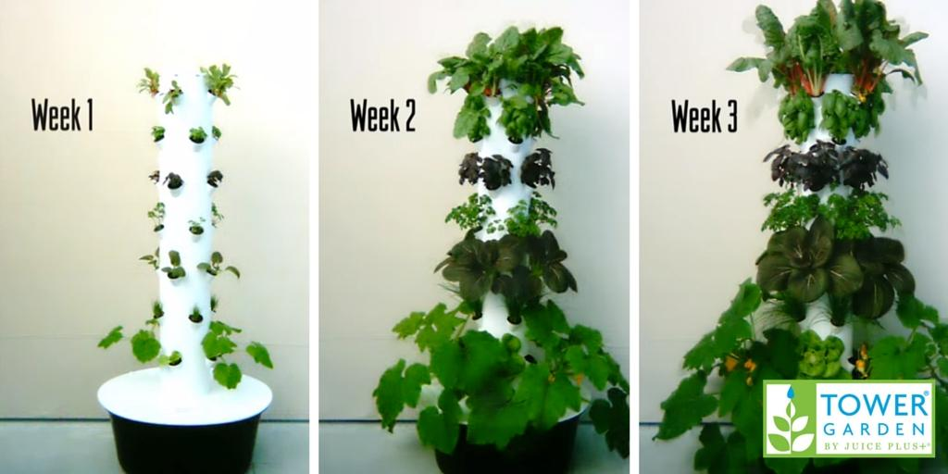
3. Tower Garden uses as much as 98% less water.
• Traditional agriculture uses approximately 80% of our water. This is a serious problem, especially for western states, where water is already in short supply. The good news? NASA found that aeroponic technology uses up to 98% less water.
4. A vertical design requires 90% less space.
- Another known issue with traditional growing methods is that of space. You need a lot of it. And we have less and less of it—in fact, we lose about 3,000 acres of farmland to development daily. But growing vertically requires only 10% of the space traditional farming uses.
5. Pollution and pests are less of a problem.
- How much do you really know about your backyard’s history? City soil is often contaminated with heavy metals, asbestos, petrochemicals and other pollutants—a number of which you can’t test for (I don’t know about you, but I don’t really want that stuff seeping into food I ultimately eat). Luckily, Tower Garden is a soilless growing system. So there’s no cause for concern about contaminated dirt.
Worried about pesticides?
Thanks to a close-loop system that recycles water and nutrients, Tower Garden plants experience less stress. So they’re healthy enough to naturally resist most pests. Weeds are not an issue, of course, since they need soil to grow.

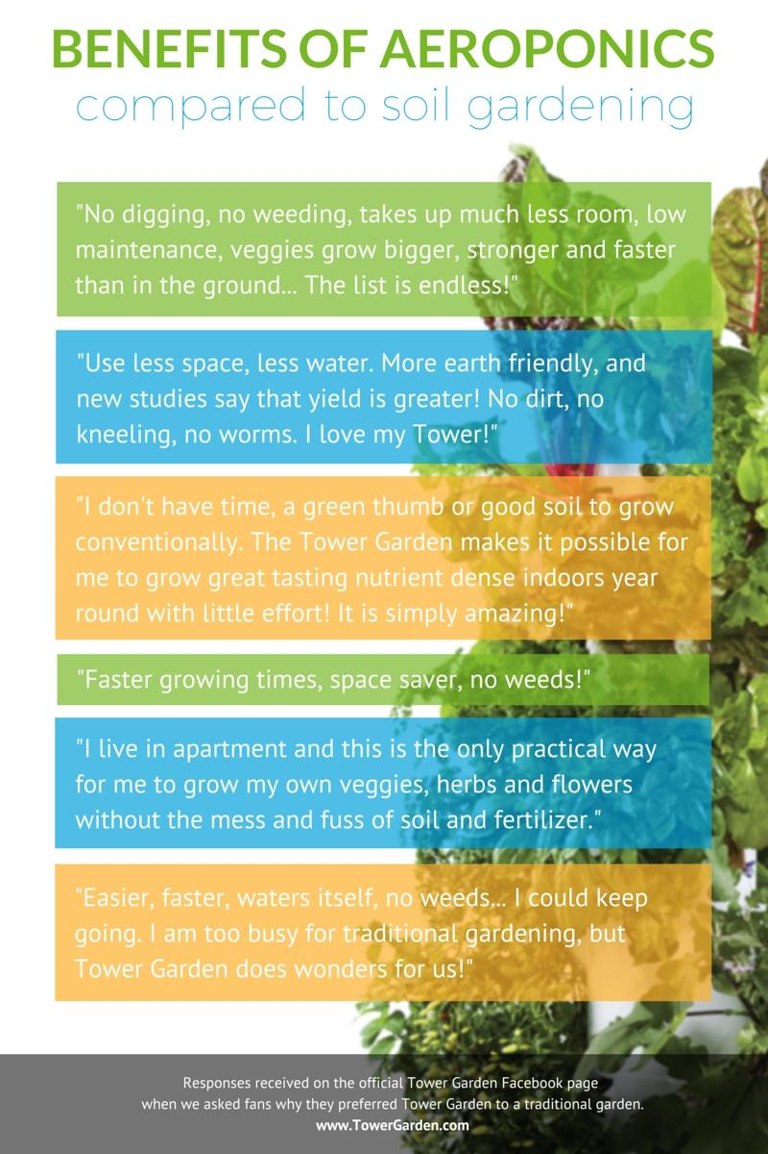
- Aeroponics, on the other hand, and “fogponics” both spray the nutrient solution directly onto the roots. The “fogponics” approach nebulizes the nutrient solution into a fog that continuously wets the roots. Aeroponics, in contrast, sprays a very fine mist on a regular schedule, then allows the plants to absorb the nutrients before the next spraying, which supplies both a high level of nutrients and high oxygen levels, making it the most efficient method yet devised for cultivating plants
Examples of aeroponics
- Vertical aeroponic gardens: This type of aeroponic system is designed to grow plants vertically, in a stacked arrangement, allowing for maximum use of space in a limited area. For example, the Airgarden is a vertical aeroponic garden that allows you to grow 30 plants in just one metre²
- NFT (Nutrient Film Technique) aeroponics: This type of aeroponic system involves circulating a thin film of nutrient-rich solution over the roots of the plants. The film is constantly replenished, providing a continuous supply of nutrients. Closed-loop aeroponics: This type of aeroponic system is fully enclosed and recirculates the nutrient solution, reducing water waste and providing a stable, controlled growing environment.
- DIY aeroponic systems: There are many DIY aeroponic systems available that allow individuals to set up their own aeroponic growing system using off-the-shelf components and basic construction skills.
Commercial aeroponic systems: Commercial aeroponic systems are used by large-scale growers and can be designed to grow a wide variety of crops, including leafy greens, herbs, and small fruits.
Plants for aeroponics
- Tomatoes
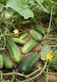 - Cucumbers
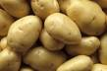 - Potato
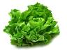 - Lettuce
- Spinach
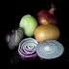 - Onions
- Beans
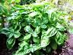 - Basil
- Strawberry
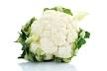 - Cauliflower
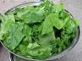 - Leafy greens
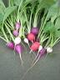 - Radish
- Barley
- Carrots
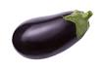 - Eggplant
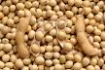 - Soybeans
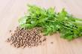 - Cilantro
- Blueberries
- Fava Beans
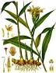 - Ginger
- Watercress
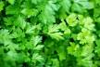 - Parsley
- Lentils
- Leek

There are two main types of aeroponics: Low pressure and High pressure.
Low pressure is the most used by home growers since it is low cost and easier to set up.
High pressure is the preferred method for commercial production as it is typically more efficient.
The nutrients in Aeroponic Plant Food for Vegetables
Primary nutrients are nitrogen, phosphorus, and potassium and are used by plants in different amounts according to the growth stage.
- Advanced Nutrients Grow, Micro, Bloom is an ideal fertilizer for use in aeroponics mist systems.
- Aeroponic systems use water-based solutions to perform properly, they use about 95% less water than standard farming
- Plants grown in aeroponics cannot be labeled commercially as “organic” as long as rockwool is used as a medium and a mineral blend solution is used for fertilizers.
- Ultrasonic technology is used to create high-frequency sound waves that shake water, until it disperses into lots of tiny droplets, like a mist. This removes the need for nozzles and increases the viability of using aeroponics in much larger, commercial growing spaces, where its impact is maximized.
- Simple Misting Time: One method of delivering nutrient spray in commercial aeroponic systems is the ‘regular, intermittent misting cycle’. This is a burst of nutrient solution, misting 3 minutes every 5 minutes.
- Grow lights: One can mimic the right sunlight levels in a greenhouse without the need for grow lights. However, if the aeroponics system is indoors or in a shaded area, grow lights are essential

Components of aeroponics system?
There are five basic components of an aeroponics system: the reservoir, a repeat cycle timer, the water/nutrient pump, misting nozzles, and growing collars or net cups. The reservoir is a closed container with holes cut in the cover where plants are suspended using a foam collar or net cup.
21st century aeroponics
- Modern aeroponics allows high density companion planting of many food and horticultural crops without the use of pesticides – due to unique discoveries aboard the space shuttle
- Aeroponics represents a significant advancement in artificial life support for plants, offering benefits such as non-damaging plant support, efficient seed germination, precise environmental control, and unrestricted growth. In comparison to traditional agricultural techniques like hydroponics and drip irrigation, which have been in use for decades, aeroponics provides notable improvements in plant cultivation.
Contemporary aeroponics
Contemporary aeroponic techniques have been extensively researched at NASA’s BioServe Space Technologies ( Archived 2018-06-15 at the Wayback Machine ) located on the campus of the University of Colorado in Boulder, Colorado. This research center focuses on the development and commercialization of aeroponic systems. Additionally, scientists at Ames Research Center have conducted research on enclosed loop systems, investigating methods for growing food crops in low-gravity environments to support future space colonization efforts. In 2000, Stoner was granted a patent for his organic disease control biocontrol technology, which enables pesticide-free cultivation in aeroponic systems. A notable milestone in aeroponics occurred in 2004 when Ed Harwood, the founder of AeroFarms, invented an innovative aeroponic system that utilizes micro fleece cloth to grow lettuces.[33][34] AeroFarms, leveraging Harwood’s patented aeroponic technology, currently operates the largest indoor vertical farm in the world based on its annual growing capacity in Newark, New Jersey. This state-of-the-art farm employs aeroponic technology to produce and distribute up to two million pounds of pesticide-free leafy greens each year.
Aeroponic bio-pharming
Aeroponic bio-pharming is an innovative approach used to cultivate pharmaceutical medicines within plants. This technology provides complete containment, ensuring that effluents and by-products of biopharma crops are confined within a closed-loop facility. In a notable development in 2005, Dr. Neil Reese of South Dakota State University conducted GMO research using aeroponics to grow genetically modified corn. Dr. Reese considers it a significant achievement to successfully grow corn in an aeroponic system for bio-massing. Previous attempts at growing various types of corn using hydroponics had been unsuccessful. Through the implementation of advanced aeroponics techniques, Dr. Reese was able to harvest mature ears of genetically modified corn while effectively containing the corn pollen and spent effluent water, thus preventing their release into the environment. This containment ensures that the surrounding environment remains free from GMO contamination. Dr. Reese emphasizes that aeroponics offers the potential for economically viable bio-pharming practices, making it a promising avenue for pharmaceutical production.
Large scale integration of aeroponics
In 2006, the Institute of Biotechnology at Vietnam National University of Agriculture, in collaboration with Stoner, established a postgraduate doctoral program focused on aeroponics. The Agrobiotech Research Center, led by Professor Nguyen Quang Thach, is utilizing aeroponic laboratories to advance Vietnam’s minituber potato production for certified seed potato cultivation.
This development holds significant historical importance as it marks the first time a nation has specifically prioritized aeroponics to bolster its agricultural sector, promote economic growth in farming, meet rising demands, improve food quality, and increase overall production.
“We have shown that aeroponics, more than any other form of agricultural technology, will significantly improve Vietnam’s potato production. We have very little tillable land, aeroponics makes complete economic sense to us,” affirmed Thach. [citation needed]
- Aeroponic greenhouse for potato minituber product Hanoi 2006
The integration of aeroponics in Vietnamese agriculture begins with the production of low-cost, certified disease-free organic minitubers. These minitubers then serve as a local supply for farmers engaged in field plantings of seed potatoes and commercial potatoes. The adoption of aeroponics will benefit potato farmers by providing them with disease-free seed potatoes grown without the use of pesticides. Importantly, it will also reduce their operational costs and increase their yields, according to Thach.
Participation of different countries in Aeroponics
- Currently, the country with the highest number of vertical farms is the USA.
- In Asia, the leading countries in the industry are Japan, China, Singapore, South Korea, Taiwan, and Thailand.
- In Europe, vertical farms can be found among others in Germany, France, UK, and the Netherlands. Countries from the Middle East also don’t lag behind with farms in Kuwait and UAE.
- In 2015, North America and Asia-Pacific dominated the vertical farming market, each having more than 33% of the share
- In 2020,Europe had the second-highest share in the global vertical farm market, right after North America
- In India aeroponics is usually done in West part of the country but it’s still in nascent stage.
What are the risks of aeroponics?
Roots in aeroponic systems are more vulnerable to pathogens than traditional substrate-based system due to the lack of a root zone buffer. For this reason, preventing pathogens from establishing themselves is critical.
Government and Aeroponics
The Delhi government has started training women for underprivileged communities and physically handicapped individuals in hydroponics, a soilless agriculture system, to grow exotic vegetables such as lettuce, bok choy, parsley, rocket leaves, and fruits, among others, which are in high demand in fine-dining institutions in the Capital.

Aeroponics in space
- NASA began funding Stoner’s research into aeroponics. In 1997, they teamed with Stoner to develop an aeroponic experiment for use on the Mir space station. Much of the importance placed on aeroponics by NASA centres around efficient resource use. For long-term space missions to be successful, crews will need to produce some of their own food while in transit. Every bit of food produced and water conserved on a spacecraft reduces weight and opens up space for other cargo. This, along with the increased growing speeds and reduced weight of the growing set-up itself (due to the removal of soil and reduction in water use) made aeroponics an attractive solution for space travel. It was not just NASA who got involved. The EDEN ISS project, based in Antarctica also took an interest. The Eden ISS “develops safe food production for on-board the International Space Station (ISS) and for future human space exploration vehicles and planetary outposts”. The Future Exploration Greenhouse was the heart of the project, it aims to “investigate and validate techniques for plant cultivation in future bio-regenerative life support systems”. One of these techniques is aeroponics.
Aeroponic Facts
- In 1952, G.F. Trowel successfully grew apple trees using a spray culture technique. In 1957, F. W. Went coined the term “aeroponics” to describe the air-growing process. He grew coffee plants and tomatoes with air-suspended roots, nourishing them through the application of a nutrient mist to the root section.
- Aeroponic tomatoes can produce fruit four times per year. Traditional growing methods produce tomato crops one or two times per year.
- The absence of soil made the aeroponic crops easier to harvest.
- Plants can be grown more densely because roots are not fighting for the same nutrients as they would be in soil
- can experience the benefits of aeroponics for yourself with personal indoor gardening systems like the AeroGarden
- Aeroponics Market Outlook – 2026
- The global aeroponics market was valued at $578.70 million in 2018, and is projected to reach $3.53 billion by 2026, growing at a CAGR of 25.60% from 2019 to 2026
- The world’s biggest aeroponics farm is under construction, with 6400 m2 of cultivated spaces without soil. The infrastructure is being developed by AeroFarms and is fueled by photo-voltaic panels, which is expected to produce over 2 million kg of vegetables per year. In addition, the UAE received its first vertical aeroponics farm on January 2018 from Indoor Farms of America, an American vertical farming industry. The farm is located in Dubai and is set to open for business in the coming months.
- The aeroponic origin story is deeply rooted in space and science fiction. In space, crews must utilise all resources to their fullest potential, reducing, reusing and recycling everything they take with them
- Strawberries are best crop for aeroponics due to short growing period
- Can grow a huge variety of herbs, leafy greens and vegetables. With the Air garden’s vertical aeroponic system, there are 150 different herbs, fruits, vegetables, and edible flowers that you can grow in just 1 metre² of space.
- Single-level aeroponic systems are best for carrots
- technique of growing potatoes is widely used in India
- Aeroponic systems are far more precise and technical and can be more susceptible to breakdowns and other difficulties.
HYDROPONICS or AEROPONICS which is better??
Hydroponics and Aeroponics both have their own pros and cons, it ultimately depends on the specific goals and needs of the grower. Aeroponics offers higher efficiency and yields, but requires more attention and expertise, whereas Hydroponics is more forgiving and easier to manage (as depicted in below figure)
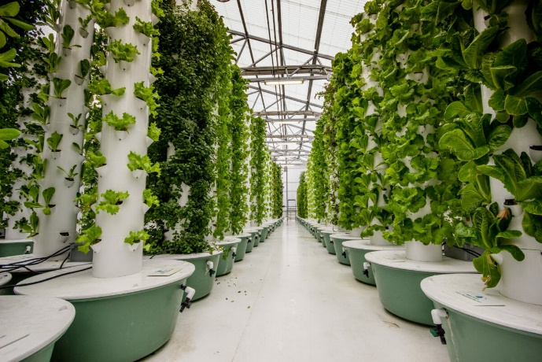
Hydroponics
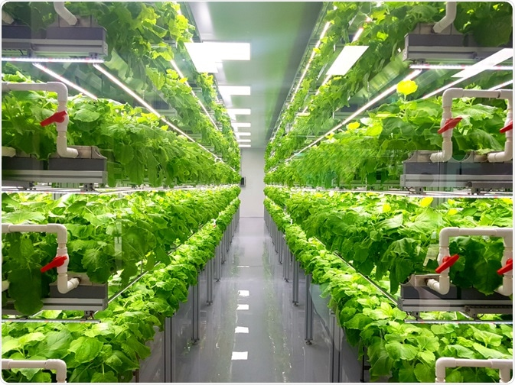
Aeroponics
SOURCE AND REFERENCE LINKS
- The Complete Guide to Soilless Gardening by Dr.William F Gericke
- https://smartgardenguide.com/21-amazing-hydroponics-facts-2/
- https://www.alliedmarketresearch.com/aeroponics-market
- https://www.powerhousehydroponics.com/aeroponics-101-facts-about-soilless-growing-technology/
- https://www.merriam-webster.com/dictionary/hydroponic
- https://www.towergarden.com/blog.read.html/en/2015/4/5_research-backedbe.html
- https://edengrowsystems.com/blog/eden-blog-1/post/15-reasons-why-nasa-chose-aeroponics-28
- https://www.trees.com/gardening-and-landscaping/aeroponic

- https://www.epicgardening.com/history-of-hydroponics/#:~:text=The%20earliest%20examples%20of%20hydroponics,faster%2C%20stronger%2C%20and%20healthier https://www.ijfmr.com/papers/2023/2/2286.pdf
- https://www.researchgate.net/publication/276320585_A_REVIEW_ON_PLANT_WITHOUT_SOIL_-_HYDROPONICS
- https://www.jsr.org/hs/index.php/path/article/view/1506
- https://www.diva-portal.org/smash/get/diva2:1559003/FULLTEXT01.pdf
- https://ycmou.ac.in/media/publication/research_paper/MSS_RP_202.pdf
- https://www.lettusgrow.com/blog/history-aeroponics

- https://www.grandviewresearch.com/industry-analysis/hydroponics-market
- https://avestia.com/MCM2018_Proceedings/files/paper/ICMIE/ICMIE_131.pdf
- https://www.intechopen.com/chapters/81512
- http://www.greenhouse-management.com/greenhouse_management/greenhouse_production_systems/soilless_culture.htm
- https://www.phytojournal.com/archives/2019/vol8issue1S/PartF/Sp-8-1-65-802.pdf
- https://www.researchgate.net/publication/320944163_Soilless_culture_in_fruit_cultivation

