THE ROAD TO RECOVERY: OVERCOMING THE CHALLENGES OF STROKE
Dr. Vishal Verma (PT), Assistant Professor, School of physiotherapy and allied health sciences, Sardar Bhagwan Singh University, Balawala, Dehradun, Uttarakhand.
Dr. Shivee Sharma, Assistant Professor, SGRR Paramedical college, Kotdwar, Uttarakhand.

Abstract-

Stroke is a leading cause of disability worldwide, and early intervention with physiotherapy is critical for maximizing recovery and minimizing long-term impairments. This chapter provide an overview of the principles and techniques of stroke physiotherapy management, with a focus on evidence-based practices for promoting motor recovery, improving functional outcomes, and enhancing quality of life for stroke survivors. The chapter begins with a discussion of the pathophysiology of stroke, including the various types of stroke and the implications for physiotherapy management. The importance of early intervention and the role of physiotherapy in the acute and subacute phases of stroke recovery will be highlighted, along with the benefits of a multidisciplinary approach to stroke rehabilitation. The chapter then delve into the specific techniques and exercises used in stroke physiotherapy, including motor relearning, task-specific training, and constraint-induced movement therapy. The use of technology and virtual reality in stroke rehabilitation will also be explored, along with the potential for future research and advancements in the field. Challenges and limitations of stroke physiotherapy will also be discussed, such as the need for individualized treatment plans and the potential for plateauing or regression in recovery. Finally, the chapter conclude with a summary of the key takeaways for stroke physiotherapy management and the importance of ongoing support and follow-up care for stroke survivors. Overall, this chapter provide a comprehensive overview of stroke physiotherapy management, with a focus on evidence-based practices and the latest research in the field. By highlighting the importance of early intervention, a multidisciplinary approach, and individualized treatment plans, this chapter serve as a valuable resource for healthcare professionals, researchers, and students in the field of stroke rehabilitation.
Keywords- Rehabilitation, Motor function, Bo-bath therapy, Quality of life, Physiotherapist, Progress, Recovery, Flexibility, Balance

Stroke is a major cause of long-term disability, with approximately 17 million people worldwide experiencing a stroke each year 1. The impact of stroke on physical function can be significant, with many stroke survivors experiencing hemiparesis, spasticity, and balance deficits that can lead to decreased mobility and independence 2. As such, effective rehabilitation is critical for optimizing functional outcomes and quality of life in stroke survivors. Physiotherapy is an important component of stroke rehabilitation, with the goal of improving motor function, gait, and balance 3. Physiotherapy interventions typically involve a combination of exercise, neuromuscular re-education, and gait training, with the aim of promoting neuroplasticity and facilitating recovery 4. The physiotherapy management of stroke is a complex and multifaceted process that requires a comprehensive understanding of the underlying pathophysiology of stroke and the principles of motor learning and neuroplasticity. The physiotherapy management of stroke is typically divided into three main phases: the acute phase, the subacute phase, and the chronic phase. In the acute phase of stroke, the primary goal of physiotherapy is to prevent complications and promote early mobilization. This may involve passive range of motion exercises, positioning, and bed mobility training. Early mobilization has been shown to improve functional outcomes and reduce the risk of complications such as pneumonia and deep vein thrombosis. In the subacute phase of stroke, the focus of physiotherapy shifts to motor recovery and functional rehabilitation 5. This may involve a combination of task-specific training, gait training, and balance training. The use of evidence-based interventions such as CIMT and VRT may also be beneficial in promoting motor recovery 6.
Stroke is a heterogeneous disease that can be classified based on various factors, including the underlying pathophysiology, clinical presentation, and imaging characteristics. The most common classification of stroke is based on the underlying pathophysiology, which can be either ischemic or hemorrhagic. Ischemic stroke accounts for approximately 87% of all strokes and occurs as a result of a blockage or occlusion of a blood vessel in the brain. Ischemic stroke can be further classified based on the location of the occlusion, with the most common types being large vessel occlusion, small vessel occlusion, and cardioembolic stroke. Hemorrhagic stroke accounts for approximately 13% of all strokes and occurs as a result of bleeding in the brain. Hemorrhagic stroke can be further classified based on the location of the bleeding, with the most common types being intracerebral hemorrhage and subarachnoid hemorrhage.
Classification of stroke
Clinical classification of stroke is based on the presenting symptoms and signs, and can be classified into the following types: (1) cerebral infarction, (2) intracerebral hemorrhage, (3) subarachnoid hemorrhage, and (4) undetermined stroke. This classification system is widely used in clinical practice and has been shown to be useful in predicting prognosis and guiding treatment decisions 7. Imaging classification of stroke is based on the characteristics of the stroke on neuroimaging studies, including computed tomography (CT) and magnetic resonance imaging (MRI). Imaging classification of stroke includes the following types: (1) ischemic stroke, (2) hemorrhagic stroke, and (3) transient ischemic attack.
1. Ischemic Stroke:
Ischemic stroke occurs when a blood clot blocks a blood vessel in the brain, which leads to a lack of blood flow and oxygen to the brain tissue. This can cause brain damage and result in various neurological symptoms. Common causes of ischemic stroke include atherosclerosis, cardio-embolism, and small vessel disease. Atherosclerosis is a condition where plaque builds up in the arteries and can block blood flow. Cardio-embolism is when a blood clot forms in the heart and travels to the brain, blocking a blood vessel. Small vessel disease is when the small blood vessels in the brain become damaged and block blood flow.
2. Hemorrhagic Stroke:
Hemorrhagic stroke occurs when a blood vessel in the brain ruptures and causes bleeding in the brain tissue. This can cause brain damage and result in various neurological symptoms. Common causes of hemorrhagic stroke include high blood pressure, aneurysms, and arteriovenous malformations (AVMs). High blood pressure can cause the blood vessels in the brain to weaken and rupture. Aneurysms are a bulging or ballooning of the blood vessel wall, which can rupture and cause bleeding. AVMs are abnormal connections between arteries and veins in the brain, which can rupture and cause bleeding.

3. Transient Ischemic Attack (TIA):
A transient ischemic attack (TIA) is a temporary blockage of blood flow to the brain, which can cause neurological symptoms that resolve within 24 hours. TIAs are often referred to as "mini-strokes" and can be a warning sign of an impending stroke. Common causes of TIA include atherosclerosis, cardio-embolism, and small vessel disease. 8

4. Cryptogenic Stroke:
Cryptogenic stroke is a type of stroke where the cause is unknown. This can occur in up to 30% of all strokes. The cause of cryptogenic stroke is often difficult to determine and may require extensive testing and evaluation. 9
Physiotherapy plays a crucial role in the rehabilitation of stroke patients. The aim of physiotherapy is to improve the patient's mobility, strength, and balance, as well as to prevent complications such as muscle contractures and pressure sores. The physiotherapy management of stroke patients typically involves three stages: acute care, rehabilitation, and community reintegration.
In the acute care stage, the focus is on preventing complications and maintaining joint range of motion. Passive range of motion exercises, bed mobility exercises, and positioning are some of the techniques used in this stage.
In the rehabilitation stage, the focus is on improving the patient's functional abilities. A variety of techniques can be used in this stage, such as:
1. Range of motion exercises: These exercises aim to improve the patient's joint range of motion. Techniques such as active-assisted range of motion, passive range of motion, and stretching can be used.
2. Balance training: This involves exercises to improve the patient's balance, such as standing on one leg, weight shifting, and perturbation training.
3. Bobath therapy: This involves using techniques such as handling, facilitation, and inhibition to improve the patient's movement patterns. 10
4.Neurodevelopmental treatment: This involves using techniques such as facilitation, inhibition, and positioning to improve the patient's movement patterns.
5. Strengthening exercises: These exercises aim to improve the patient's muscle strength. Techniques such as resistance training, isometric exercises, and functional electrical stimulation can be used.
6. Task-specific training: This involves practicing functional tasks that are important to the patient, such as dressing, grooming, and walking
7. Constraint-induced movement therapy: This involves restraining the unaffected limb to encourage the use of the affected limb.
8. Mirror therapy: This involves using a mirror to create the illusion of movement in the affected limb.
9. Virtual reality: This involves using virtual reality systems to provide an immersive and interactive environment for rehabilitation.
10. Gait training: This involves training the patient to walk again. Techniques such as treadmill training, partial body weight support, and over ground training can be used.

Range of motion (ROM)
Range of motion (ROM) exercises are important for stroke patients to maintain or improve their functional abilities. Here's how ROM exercises can help:
1. Improves joint mobility: ROM exercises can help improve joint mobility in stroke patients. This can help reduce the risk of contractures and improve the ability to perform ADL (24).
2. Enhances muscle strength: ROM exercises can also help enhance muscle strength in stroke patients. This can improve their ability to perform ADL such as standing up from a chair or climbing stairs (25).
3. Improves circulation: ROM exercises can help improve circulation in stroke patients. This can help reduce the risk of blood clots and improve overall cardiovascular health (26).
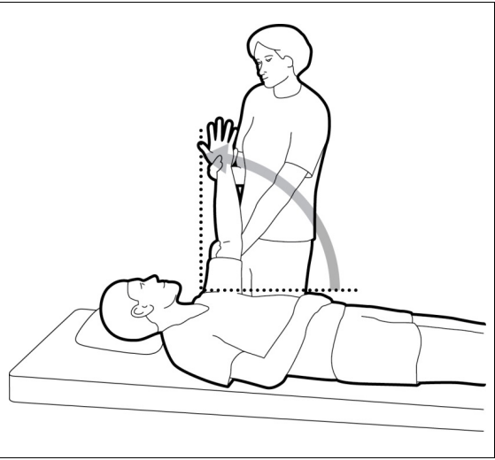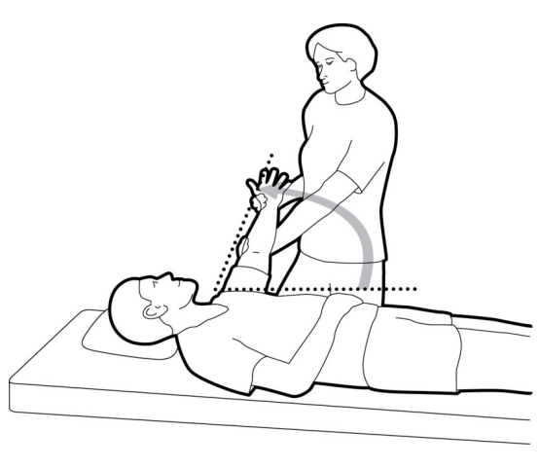
4. Reduces spasticity: ROM exercises can help reduce spasticity in stroke patients. This can improve their ability to perform ADL and reduce pain (27).
Research has shown that ROM exercises can be effective in improving joint mobility, muscle strength, circulation, and reducing spasticity in stroke patients. A randomized controlled trial found that a ROM exercise program was effective in improving shoulder range of motion in stroke patients (28).
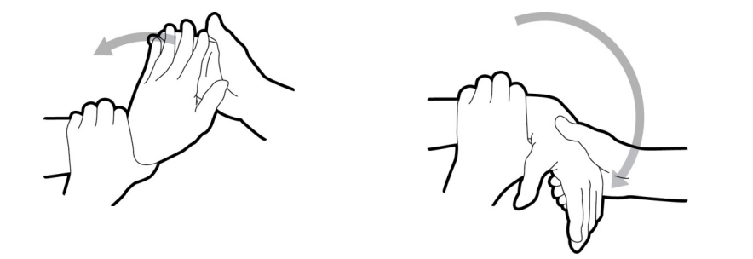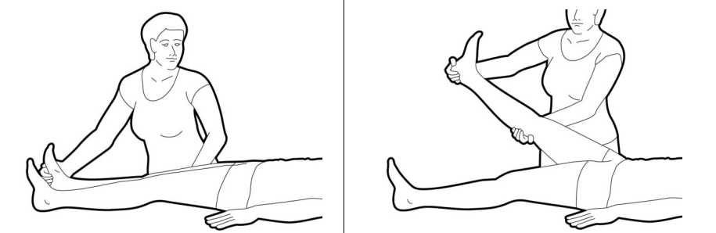
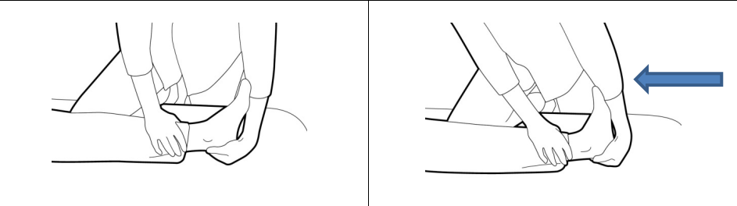

Another study found that ROM exercises combined with other interventions such as electrical stimulation were effective in reducing spasticity in stroke patients
Balance training
Balance training is an important component of stroke rehabilitation, as stroke patients often experience balance impairments that can affect their ability to perform activities of daily living and increase their risk of falls. Here are some guidelines for designing a balance training program for stroke patients:
1. Assess the patient's balance: The first step in designing a balance training program is to assess the patient's balance. This can be done using standardized balance tests such as the Berg Balance Scale or the Timed Up and Go test. The results of the assessment can be used to identify the patient's specific balance impairments and to set goals for the training program.
2. Choose appropriate exercises: The exercises chosen for the balance training program should be based on the patient's specific impairments and goals. Exercises may include static and dynamic balance exercises, weight shifting exercises, and gait training. The exercises should be challenging but not overwhelming, and should be progressed as the patient's abilities improve.
3. Incorporate feedback and cueing: Feedback and cueing can be used to help the patient improve their balance. Feedback can be provided verbally or using visual cues such as mirrors or video feedback. Cueing can be used to help the patient maintain proper alignment and weight distribution.
4. Consider the environment: The environment in which the balance training takes place can have an impact on the patient's ability to perform the exercises. The training should take place in a safe and supportive environment, with appropriate equipment and supervision as needed.
Balance training
Research has shown that balance training can be effective in improving balance and reducing the risk of falls in stroke patients. A systematic review of randomized controlled trials found that balance training was effective in improving balance and reducing the risk of falls in stroke patients (18). Another study found that a balance training program that included weight shifting exercises and gait training was effective in improving balance and gait speed in stroke patients (19).
Stranding exercise is a type of balance training that can be used to improve the ability of stroke patients to perform activities of daily living (ADL). Here's how stranding exercise can help:
1. Improves balance: Stranding exercise involves standing on one leg while reaching for an object or performing other tasks. This type of exercise can help improve balance and reduce the risk of falls in stroke patients (20).
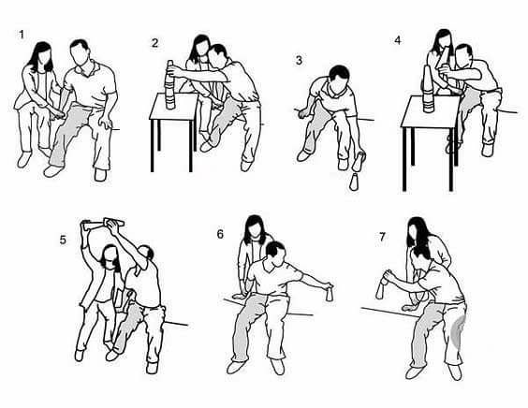
2. Increases strength: Stranding exercise can also help improve strength in the lower extremities. This can make it easier for stroke patients to perform ADL such as standing up from a chair or climbing stairs (21).
3. Enhances motor control: Stranding exercise can help improve motor control in stroke patients. This can improve their ability to perform ADL such as dressing, grooming, and feeding (22).
4. Improves gait: Stranding exercise can also help improve gait in stroke patients. This can make it easier for them to walk and perform other ADL (23).
Research has shown that stranding exercise can be effective in improving balance, strength, motor control, and gait in stroke patients. A randomized controlled trial found that a stranding exercise program was effective in improving balance and gait in stroke patients. Another study found that a stranding exercise program that included balance and strength training was effective in improving ADL performance in stroke patients.
Bobath therapy
Bobath therapy is a rehabilitation technique that can help stroke patients improve their motor function. The technique involves analyzing the patient's movement patterns and developing a treatment plan to improve motor function based on the patient's unique needs (42).
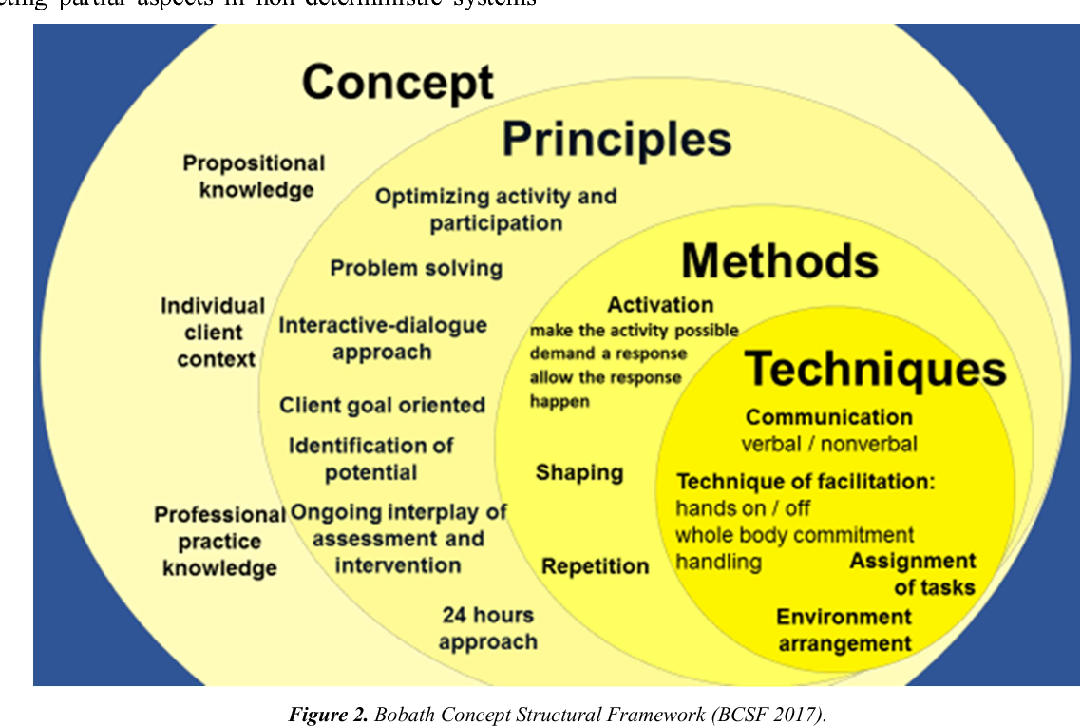
Research has shown that Bobath therapy can be effective in improving motor function in stroke patients. One study found that Bobath therapy was effective in improving upper limb function in stroke patients (43). Another study found that Bobath therapy was effective in improving walking ability in stroke patients (44).
Bobath therapy focuses on the principles of motor learning, such as repetition, task-specific practice, and feedback. By incorporating these principles into the treatment plan, stroke patients can improve their motor function and regain independence in their daily activities (45).
The conclusion of the chapter on Physiotherapy Management for stroke patients is that physiotherapy plays a crucial role in the rehabilitation of stroke patients. Through a combination of exercises, techniques, and equipment, physiotherapists can help stroke patients regain their independence and improve their quality of life. Specific techniques such as Bo-bath therapy can be effective in improving motor function in stroke patients. It is important for stroke patients to work closely with their physiotherapist to develop a treatment plan that meets their unique needs. With the right rehabilitation program, stroke patients can make significant progress in their recovery and achieve their goals.
Neurodevelopmental therapy (NDT)
Neurodevelopmental therapy (NDT) is a rehabilitation technique that can help stroke patients improve their motor function. The technique involves analyzing the patient's movement patterns and developing a treatment plan to improve motor function based on the patient's unique needs (38).
Research has shown that NDT can be effective in improving motor function in stroke patients. One study found that NDT was effective in improving upper limb function in stroke patients (39). Another study found that NDT was effective in improving walking ability in stroke patients (40).
NDT focuses on the principles of motor learning, such as repetition, task-specific practice, and feedback. By incorporating these principles into the treatment plan, stroke patients can improve their motor function and regain independence in their daily activities (41).
Task-specific training
Task-specific training is a physiotherapy technique that involves practicing functional tasks that are important to the patient. This technique has been shown to be effective in improving the patient's functional abilities and quality of life. 11
Task-specific training involves identifying the specific tasks that the patient is having difficulty with and designing a training program that focuses on those tasks. The training program should be tailored to the patient's individual needs and abilities. The patient should be encouraged to actively participate in the training program and to set goals for themselves.
The training program should be progressive, with the difficulty of the tasks increasing as the patient's abilities improve. The patient should be provided with feedback on their performance and encouraged to reflect on their progress. 12
Task-specific training can be delivered in a variety of settings, including the hospital, the patient's home, and the community. The training can be delivered by a physiotherapist, an occupational therapist, or a trained caregiver. 13
There are several factors that should be considered when designing a task-specific training program, such as the patient's cognitive abilities, their motivation, and their social support. The training program should be designed to be challenging but not overwhelming.
Research has shown that task-specific training can improve the patient's ability to perform the specific tasks that are targeted in the training program. It can also improve the patient's overall functional abilities and quality of life. 14
Constraint-induced therapy with trunk
When designing a training program for a stroke patient, it's important to consider the patient's level of impairment. The training program should be tailored to the patient's individual needs and abilities. Here are some guidelines for designing a training program for stroke patients at different levels of impairment:
1. Severe Impairment: Patients with severe impairments may have difficulty with basic activities of daily living (ADLs) such as feeding, grooming, and toileting. The training program should focus on these basic ADLs. The patient should be encouraged to actively participate in the training program and to set goals for themselves. The program should be delivered in a supportive environment with a focus on safety. 15
2. Moderate Impairment: Patients with moderate impairments may have difficulty with more complex ADLs such as dressing and bathing. The training program should focus on these more complex ADLs. The program should be designed to be challenging but not overwhelming. The patient should be provided with feedback on their performance and encouraged to reflect on their progress.
3. Mild Impairment: Patients with mild impairments may have difficulty with more complex functional tasks such as cooking and cleaning. The training program should focus on these functional tasks. The program should be designed to be progressive, with the difficulty of the tasks increasing as the patient's abilities improve. The patient should be encouraged to actively participate in the training program and to set goals for themselves. 16
Research has shown that task-specific training can be effective in improving the patient's functional abilities and quality of life, regardless of the level of impairment. Task-specific training involves practicing functional tasks that are important to the patient. The training program should be tailored to the patient's individual needs and abilities. 17
Mirror therapy
Mirror therapy is a rehabilitation technique that can help stroke patients improve their motor function. The technique involves using a mirror to create an illusion of movement in the affected limb. This illusion can help the brain rewire itself and improve motor function (35).
Research has shown that mirror therapy can be effective in improving motor function in stroke patients. A systematic review found that mirror therapy was effective in improving upper limb function in stroke patients (36). Another study found that mirror therapy was effective in improving hand function in stroke patients (37). Motor recovery and cortical reorganization after mirror therapy in chronic stroke patients: a phase II randomized controlled trial. Neurorehabilitation and neural repair.
Constraint-induced movement therapy (CIMT)
Constraint-induced movement therapy (CIMT) is a rehabilitation technique that can help stroke patients improve their motor function. The technique involves constraining the unaffected limb and using the affected limb in functional tasks. This can help the brain rewire itself and improve motor function.
Virtual reality (VR)
Virtual reality (VR) can be an effective tool to improve the function of stroke patients. Here's how VR can help:
1. Improves motor function: VR can help improve motor function in stroke patients. By engaging in virtual activities that require movement, stroke patients can improve their motor skills and coordination (29).
2. Increases motivation: VR can be a motivating tool for stroke patients. By making therapy more engaging and fun, VR can help increase patient motivation and adherence to treatment (30).

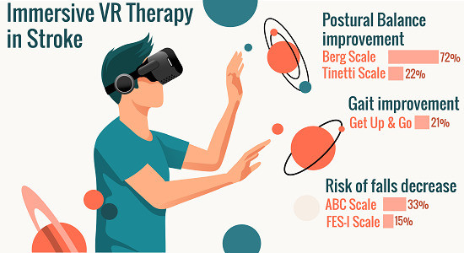

3. Provides feedback: VR can provide real-time feedback to stroke patients, allowing them to adjust their movements and improve their performance (31).
4. Enhances cognitive function: VR can also enhance cognitive function in stroke patients. By engaging in virtual activities that require problem-solving and decision-making, stroke patients can improve their cognitive skills (32).
Research has shown that VR can be effective in improving motor function, motivation, feedback, and cognitive function in stroke patients. A systematic review found that VR-based therapies were effective in improving upper limb function in stroke patients (33). Another study found that VR therapy was effective in improving balance and gait in stroke patients (34).

.

- Updated Criteria for Population-Based Stroke and Transient Ischemic Attack Incidence Studies for the 21st Century, Valery Feigin, Bo Norrving, Cathie L.M. Sudlow and Ralph L. Sacco Originally published1 Aug 2018 https://doi.org/10.1161/STROKEAHA.118.022161Stroke. 2018;49:2248–2255

Stroke rehabilitation Peter Langhorne ¹, Julie Bernhardt, Gert Kwakkel Affiliations expand PMID: 21571152 DOI: 10.1016/S0140-6736(11)60325-5
- Physical rehabilitation approaches for the recovery of function and mobility following stroke Alex Pollock ¹, Gillian Baer, Pauline Campbell, Pei Ling Choo, Anne Forster, Jacqui Morris, Valerie M Pomeroy, Peter Langhorne Affiliations expand PMID: 24756870 PMCID: PMC6465059 DOI: 10.1002/14651858.CD001920.pub3
- The evolution of stroke rehabilitation randomized controlled trials Amanda McIntyre ¹, Marina Richardson, Shannon Janzen, Norhayati Hussein, Robert Teasell Affiliations expand PMID: 24621406 DOI: 10.1111/ijs.12272
- Guidelines for Adult Stroke Rehabilitation and Recovery: A Guideline for Healthcare Professionals From the American Heart Association/American Stroke Association Stroke. 2016 Jun;47(6):e98-e169.doi: 10.1161/STR.0000000000000098. Epub 2016 May 4.
- Interventions for improving upper limb function after stroke Alex Pollock ¹, Sybil E Farmer, Marian C Brady, Peter Langhorne, Gillian E Mead, Jan Mehrholz, Frederike van Wijck Affiliations expand PMID: 25387001 PMCID: PMC6469541 DOI: 10.1002/14651858.CD010820.pub2

An Updated Definition of Stroke for the 21st Century A Statement for Healthcare Professionals From the American Heart Association/American Stroke Association Ralph L. Sacco, Scott E. Kasner, Joseph P. Broderick, Louis R. Caplan, J.J. (Buddy) Connors,
- Antonio Culebras, Mitchell S.V. Elkind, Adams, H. P., Bendixen, B. H., Kappelle, L. J., Biller, J., Love, B. B., Gordon, D. L., Marsh, E. E. (1993). Classification of subtype of acute ischemic stroke
- Donnan, G. A., Fisher, M., Macleod, M., & Davis, S. M. (2008). Stroke. The Lancet, 371(9624), 1612-1623.
- Grysiewicz, R. A., Thomas, K., & Pandey, D. K. (2014). Epidemiology of ischemic and hemorrhagic
- Gilliaux, M., Lejeune, T. M., Detrembleur, C., Sapin, J., Dehez, B., Selves, C., &
- Lang, C. E., & MacDonald, J. R. (2006). Task-specific rehabilitation: approaches to stroke motor recovery. Seminars in neurology, 26(3), 267-275.
- Winstein, C. J., Wolf, S. L., Dromerick, A. W., Lane, C. J., Nelsen, M. A., Lewthwaite, R., ... & Azen, S. P. (2014). Interdisciplinary Comprehensive Arm Rehabilitation Evaluation (ICARE): a randomized controlled trial protocol. BMC neurology, 14(1), 1-17.
- Lohse, K. R., Lang, C. E., & Boyd, L. A. (2014). Is more better? Using metadata to explore dose–response relationships in stroke rehabilitation. Stroke, 45(7), 2053-2058.
- Wu, C. Y., Chuang, I. C., Ma, H. I., Lin, K. C., & Chen, C. L. (2013).
- Lang, C. E., & MacDonald, J. R. (2006). Task-specific rehabilitation: approaches to stroke motor recovery. Seminars in neurology, 26(3), 267-275.
- Winstein, C. J., Wolf, S. L., Dromerick, A. W., Lane, C. J., Nelsen, M. A., Lewthwaite, R., ... & Azen, S. P. (2014). Interdisciplinary Comprehensive Arm Rehabilitation Evaluation (ICARE): a randomized controlled trial protocol. BMC neurology, 14(1), 1-17.
- Lohse, K. R., Lang, C. E., & Boyd, L. A. (2014).
- Saunders, D. H., Greig, C. A., Mead, G. E., & Young, A. (2009). Physical fitness training for stroke patients. Cochrane Database of Systematic Reviews
- Kim, C. M., Eng, J. J., & Whittaker, M. W. (2004). Balance training for hemiplegic stroke patients: a randomized controlled trial. Neurorehabilitation and neural repair, 18(4), 242-250.
- Saunders, D. H., Greig, C. A., Mead, G. E., & Young, A. (2009). Physical fitness training for stroke patients. Cochrane Database of Systematic Reviews
- Kim, C. M., Eng, J. J., & Whittaker, M. W. (2004). Balance training for hemiplegic stroke patients: a randomized controlled trial. Neurorehabilitation and neural repair, 18(4), 242-250.
- Chou, Y. H., Liang, C. K., Chen, S. D., Hsu, M. J., & Wang, J. S. (2013). Balance control in elderly people with stroke: comparison of visual feedback training and weight-shift training. Archives of physical medicine and rehabilitation, 94(4), 686-692.
- Kim, C. M., Eng, J. J., & Whittaker, M. W. (2004). Effects of a simple functional task-based exercise program on gait and balance performance in
- Mehrholz, J., Wagner, K., Rutte, K., Meissner, D., & Pohl, M. (2007). Predictive validity and responsiveness of the functional ambulation category in hemiparetic patients after stroke. Archives of physical medicine and rehabilitation, 88(10), 1314-1319.
- Ada, L., Dean, C. M., & Hall, J. M. (2003). A treadmill and overground walking program improves walking in persons residing in the community after stroke: a placebo-controlled, randomized trial. Archives of physical medicine and rehabilitation, 84(10), 1486-1491.
- Pang, M. Y., Eng, J. J., & Dawson, A. S. (2005). The use of aerobic exercise training in improving aerobic capacity in individuals with stroke: a meta-analysis. Clinical rehabilitation, 19(9), 977-987.
- Ada, L., & Foongchomcheay, A. (2002). Efficacy of electrical stimulation in improving arm function of subjects with stroke. Archives of physical medicine and rehabilitation, 83(7), 960-968.
- Kim, J. S
- Laver, K. E., George, S., Thomas, S., Deutsch, J. E., & Crotty, M. (2015). Virtual reality for stroke rehabilitation. The Cochrane Library.
- Saposnik, G., Levin, M., & Outcome Research Canada (SORCan) Working Group. (2011). Virtual reality in stroke rehabilitation: a meta-analysis and implications for clinicians. Stroke, 42(5), 1380-1386.
- Crosbie, J. H., Lennon, S., Basford, J. R., & McDonough, S. M. (2007). Virtual reality in stroke rehabilitation: still more virtual than real. Disability and rehabilitation, 29(14), 1139-1146.
- Kim, J. S., & Lee, B. H. (2013). Effect of virtual reality on cognition in stroke patients. Annals of rehabilitation medicine, 37(6), 920-926.
- Laver, K. E., George, S., Thomas, S., Deutsch, J. E., & Crotty, M. (2015). Virtual reality for stroke rehabilitation. The Cochrane Library.
- Cho, K. H., Lee, K. J., Song, C. H., & Virtual reality training with three
- Ramachandran, V. S., & Rogers-Ramachandran, D. (2000). Synaesthesia in phantom limbs induced with mirrors. Proceedings of the Royal Society of London. Series B: Biological Sciences, 267(1455), 1901-1907.
- Thieme, H., Mehrholz, J., Pohl, M., Behrens, J., & Dohle, C. (2012). Mirror therapy for improving motor function after stroke. The Cochrane Library.
- Michielsen, M. E., Selles, R. W., van der Geest, J. N., Eckhardt, M., Yavuzer, G., Stam, H. J., & Bussmann, J. B. (2011).
- Taub, E., Miller, N. E., Novack, T. A., Cook III, E. W., Fleming, W. C., Nepomuceno, C. S., ... & Connell, J. S. (1993). Technique to improve chronic motor deficit after stroke. Archives of Physical Medicine and Rehabilitation, 74(4), 347-354.
- Corbetta, D., Sirtori, V., Castellini, G., Moja, L., & Gatti, R. (2015). Constraint-induced movement therapy for upper extremities in stroke patients. The Cochrane Library.
- Dromerick, A. W., Edwards, D. F., Hahn, M., & Lum, P. S. (2009). Stroke rehabilitation: strategies to enhance motor recovery. Annual review of medicine, 60, 55-68.
- Bobath, B. (1990). Adult hemiplegia: evaluation and treatment. Butterworth-Heinemann.
- Kollen, B. J., Lennon, S., & Lyons, B. (2009). The Bobath concept in stroke rehabilitation: a focus group study of the experienced physiotherapists’ perspective. Disability and rehabilitation, 31(26), 2213-2223.
- Mehrholz, J., Elsner, B., Werner, C., Kugler, J., & Pohl, M. (2013). Electromechanical-assisted training for walking after stroke. The Cochrane Library.
- Langhorne, P., Bernhardt, J., & Kwakkel, G. (2011). Stroke rehabilitation. The Lancet, 377(9778), 1693-1702.

