New Age Trend of Recruiting Millennials from Universities

Dr. Arati Deepak Kale
LalaLajpatrai Institute of Management, Mumbai-400034

Dr. Priyadarshini Nidhan
LalaLajpatrai Institute of Management, Mumbai-400034

ABSTRACT
Recruiting millennials from the Universities has become a very important aspect to both the organization as well as the Universities. The organization wants to understand whether it is worth recruiting graduating millennials from the universities who are freshers eagerly wanting to commence their careersalong with the willingness to take on challenges. The universities are looking at their millennials being placed in organizations with good compensation packages which help in boosting the University Brand as well as building up of a strong relationship over the years which can turn into a win-win situation for both. Whilst few organizations feel that hiring experienced people is more beneficial as they feel that the university millennials are lazy, less of people skills or more interested in their phones and social media which has been proved to a certain extent. The other organizations believe that graduating millennials are a better catch as they are multitalented and multiskilled filled with creativity and innovation not to mention of the time and cost-saving factors. Recruiting out of universities brings several pros and cons and this paper is exactly attempting to investigate the same.
Keywords: Recruitment, universities, millennials,organizations, millennials

INTRODUCTION
Millennials/Students being recruited by the corporates is an integrated management and marketing strategy for the Universities. This strategy is becoming vital in the education sectors around the globe.Parents, as well as the policymakers, view recruitment and retention of graduating millennials as both an effective part of measure and indicator of University performance and millennial success. Hallmark of management and marketing deficiency can be witnessed through the variation in recruitment and retentions strategies. Hence University recruiting is really about Brand building.Many leaders believe that the Millennial Business

graduates bring in new ideas, new perceptive along with freshness to the company because the millennials have a different approach which is necessary for the business to evolve and grow. They also believe that millennials have the corporate acumen and data analytics skills essential to thrive. With these beliefs, more and more employers are recruiting business graduates than in the past. Corporates are partnering with the Universities in the recruitment process through on- campus visits and other means. This kind of partnership ensures that the millennials have enough exposure and get organically absorbed into professional roles on graduating. The millennials find that the theoretical learning encompassed with experiential learning helps them to forge ahead on their chosen career path with a positive attitude, the right competency and know-how which could be beneficial to the corporates and hence recruiting millennials could be profitable to the corporates at the same time it could prove otherwise also. The pros could be that the millennials are very technologically literate as they have grown up using it and hence a maestro. They are also very ambitious and career-driven thereby very passionate about their work as well as performance. Also, since its beginning of their career and hence the cost to the company is less. Also, its time saving and saves a significant cost to the company.
Recruitment refers to the overall process of identifying, attracting, screening, shortlisting, and interviewing suitable candidates for jobs (either permanent or temporary) within an organization. Millennials, also known as Generation Y or Gen Y, are the demographic cohort following Generation X and preceding Generation Z. Researchers and popular media use the early 1980s as starting birth years and the mid-1990s to early 2000s as ending birth years, with 1981 to 1996 being a widely accepted defining range for the generation. Most Millennials are the children of baby boomers and early Gen Xers. According to this definition, the oldest millennials will turn 40 years old and the youngest will turn 25 years old in 2021.
The pros and cons are the variables that have been taken up to be investigated in this Research Paper.

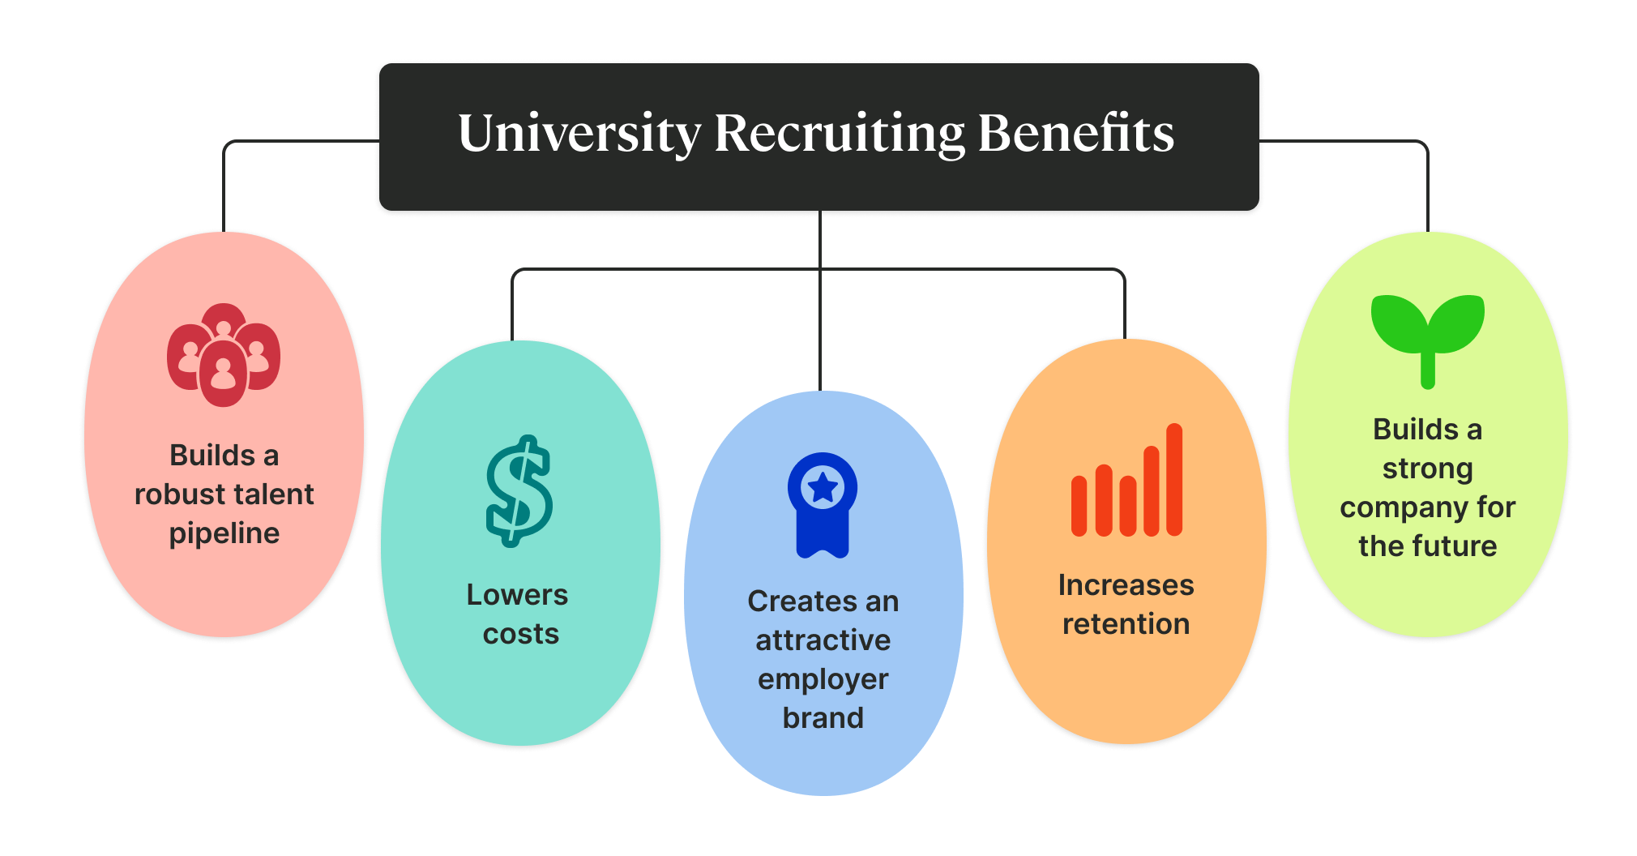

LITERATURE REVIEW
Marsh and Maclennan (2020) found the challenge of designing an effective hiring process from campus, shortlisting campus for a company visit and building brand, screening and shortlisting candidates for interview in online recruitment from campus in their survey conducted in 2019-20. Dalal and Bondre (2020) proposed online training and placement model for colleges which reduces the chances of error in the manual campus recruitment process and saves time to notifies all updates instantly on websites to students.
Xin Yang (2016) analyzed risk in campus recruitment in his research it was found that companies have shown cluster phenomenon in hiring candidates from universities which leads to wastage of manpower and resources. He suggested a strategy for enterprises to first do human resource analysis then recruit candidates considering different universities' specialties and geographical locations.
Shashikanth K and Panay G (2016) stated that campus placement surely one of the ways to solve the problem of unemployment in India where there is job scarcity on one hand and scarcity of skilled labor on the other hand. He suggested if universities provide student campus recruitment training which helps them to skilled in job-related proficiency, it is a boon for the students.

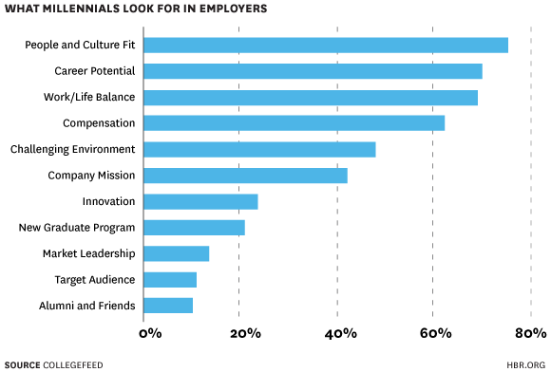
Aithal and Shenoy (2016) proposed an "Online oriented industry placement model" for campus recruitment by companies as per this model, students studied the business model of the company of their interest and competency along with suggestions on how the company sustains and survive with current challenges. If company recruiters found solutions and approaches of candidates productive for organization growth, they will proceed recruitment process further.

Sapra and Maheshwari (2013) found the challenge of finding the right candidate, competition among recruiters, and attracting students to work with a specific industry in a specific location in campus recruitment in their exploratory research.

Saviour, Buabasah and Kafui (2016) referred that campus recruiting is one of the cheapest methods of recruitment of final year students. It requires the organization to visit the university campus and invite students to apply for the desired job position.

Corporate recruiter's survey (2015) reported to increase in campus hiring by 75% from 2014 to 2015 coz management graduates bring fresh energy to the company, innovation, new perspectives and power-packed enthusiasm which is necessary for organization growth and survival in changing environment.

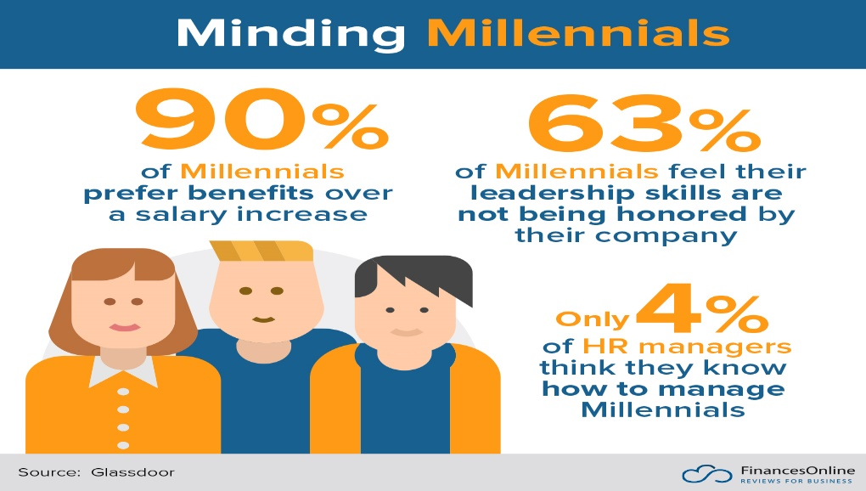

CONCLUSION

University recruitment is one of the most effective recruitment methods and on-campus recruiting is one of the best practices of university recruitment of fresher employees. Most of the time employee gets the same salary whether they are recruited from campus or by any other source, campus hiring is economic as compare to organizing walk-ins which is a most expensive method of hiring and has highest employee turnover rate as recruitment like it has highest joining ratio, Mostly it takes three to six months for companies to train university graduates which get hired on the parameter of good communication skill, teamwork skill and being honest to follow work ethics whereas adaptability and flexibility are still considered to be the crucial factor for millennial recruitment which decides many universities hired not only complete their probation period in the company successfully but also eligible for the promotion. These all benefits made university hiring the most effective budget-friendly recruiting. It is found in this research study that seventy percent of university-hired candidates leave jobs in less than six months and survived their notice period. The reason can be from not following the structural recruitment process by many recruiters to less transparency in pre-placement talks; mostly recruiters explained only job descriptions to candidates. Today's millennials are technological literates i.e. they have practically grown up with it and hence they are more in tune with digitalization than any previous generation. They all are very ambitious, inspired and driven when they love the work they are doing and can be easily molded to blend with the company's culture. They bring fresh eyes to projects which can be very beneficial to the Organisations. This all is enough to say that campus recruitment is a very economic and effective method of recruitment for the companies and it can be more effective if there would be more transparency in the process.

RECOMMENDATIONS
  - Internships are a great way to build a bridge between the university and corporates. It's a lot easier to convert the intern into a full-time employee thereby saving on recruitment, induction, training, etc costs.
  - The criteria to hire through campus can be broad by giving equal weightage to all skills.So, paying them competitively or as close to the market average will be advantageous.
  - Employee motivation is a crucial factor that could get more weightage during the hiring process which is one of the important factors in employee job performance.
  - Companies who involve themselves with the University's events like career fairs, on-campus interviews, tech/management talks, dynamic presentations, etc. at first establish credibility. It would be very beneficial in the long run.
  - An exit interview should be conducted to understand and minimize fresh graduates leaving the company in the first six months.
  - The recruitment process should be more structured and more transparent to reveal company rules, regulations, policies and expectations from employees.
  - Feedback should be taken to understand the reason behind millennials' declines in joining the company after getting the job offer.
  - Recruiters should talk to candidates and understand what type of job role would they like to take or are suitable for.
  - Recruiters should also consider the aspirations of many fresh graduates who in long run want to start a start-up after getting some exposure in the company.
  - Use creative strategies to stand out from the crowd. It's not about having the coolest swag; it's about being compelling in every way.

REFERENCES
- DalalSamiksha and BondreAmruta 2020 March, International research journal of engineering and technology (IRJET), p-ISSN: 2395-0072, e-ISSN: 2395-0056, Volume: 06 Issue: 25, “Campus recruitment system”.
- Corporate recruiters survey 2015 by Graduate management admission council in partnership with MBA career services and employer alliance.
- https://mpra.ub.uni-muenchen.de/72245/
- Marsh and Maclennan companies 2020, Mercer mettl, “Campus hiring 2019-20: Challenges, trends and best practices”.
- www.metlt.com
- SapraJayashree and Maheshwari SP 2013 December, Global research analysis, ISSN No. 2277- 8160, Volume 2, Issue 12, "Campus recruitment: acquiring high-quality talent through corporate presence".
- Saviour AW, Kofi A, Yao BD and Kafui LA 2016, Global journal of management and business research: A administration and management, Publisher: Global journals Inc. (USA), Volume 16 Issue 11 Version 1.0, e-ISSN: 2249-4588, p-ISSN: 0975-5853, “The impact of effective recruitment and selection practice on organizational performance (A case study at university of Ghana).
- Shashikanth K and Pranay G 2016 February, International journal & magazine of engineering, technology, management and research, Volume No. 3, issue No. 2, page 420, A peer-reviewed open access international journal, "A study report on the importance of "Campus placement"- A boon to students career.
- SreeramanAithal and ShenoyVarun 2016 June, Munich personal RePEc archive, MPRA paper number 72245, “Changing approaches in campus placements: a new futuristic model”.
- DalalSamiksha and BondreAmruta 2020 March, International research journal of engineering and technology (IRJET), p-ISSN: 2395-0072, e-ISSN: 2395-0056, Volume: 06 Issue: 25, “Campus recruitment system”.
- Corporate recruiters survey 2015 by Graduate management admission council in partnership with MBA career services and employer alliance.
- https://mpra.ub.uni-muenchen.de/72245/
- Marsh and Maclennan companies 2020, Mercer mettl, “Campus hiring 2019-20: Challenges, trends and best practices”.
- www.metlt.com
- SapraJayashree and Maheshwari SP 2013 December, Global research analysis, ISSN No. 2277- 8160, Volume 2, Issue 12, "Campus recruitment: acquiring high-quality talent through corporate presence".
- Saviour AW, Kofi A, Yao BD and Kafui LA 2016, Global journal of management and business research: A administration and management, Publisher: Global journals Inc. (USA), Volume 16 Issue 11 Version 1.0, e-ISSN: 2249-4588, p-ISSN: 0975-5853, “The impact of effective recruitment and selection practice on organizational performance (A case study at university of Ghana).
- Shashikanth K and Pranay G 2016 February, International journal & magazine of engineering, technology, management and research, Volume No. 3, issue No. 2, page 420, A peer-reviewed open access international journal, "A study report on the importance of "Campus placement"- A boon to students career.
- SreeramanAithal and ShenoyVarun 2016 June, Munich personal RePEc archive, MPRA paper number 72245, “Changing approaches in campus placements: a new futuristic model”.
- Yang Xin 2016 "Research on the risk of campus recruitment "published by Atlantis Press, presented in 6th International Conference on electronic, mechanical, information and management (EMIM).
- www.gmac.com
- www.ijmetmr.com
- www.irjet.net

