Robotics and Automation for Sustainable Industry 4.0
Pulkit Kumar¹ Harpreet Kaur Channi^{2*}
^{1,2} Department of Electrical Engineering, Chandigarh University, SAS Nagar, Mohali, Punjab
pulkit10001@ieee.org, harpreetchanni@yahoo.in
Abstract: There has been an increase in the usage of new technologies in manufacturing, service delivery, and communication. This new fourth industrial revolution, dubbed "Industry 4.0," encourages efficient operations among businesses. Robotics is an essential component of the production capabilities offered by Industry 4.0. Thanks to this technology, the accuracy and efficiency with which routine chores may now be completed. Producing high-quality items is progressively made possible by robotics, all while maintaining the value of existing worker compensation programs. Because of advances in robotics, data, cloud computing, safety, sensors, the Internet of Things, and other cutting-edge technologies, Industry 4.0 has created intelligent factories that are very powerful, secure, and cost-effective. As a result, businesses will increase worker safety and reliability on real work while reducing costs and honing production for widespread adoption. The vast potential of robots in manufacturing and other industries is explored in this article. The proximity of robots to the component during assembly makes them ideal for acquiring hitherto inexplicable manufacturing data. With this technology, hazardous jobs can be automated, temperatures can be kept constant, and assembly lines can run nonstop. Many robots rely on artificial intelligence to do complicated jobs in intelligent industries. In many ongoing situations, they may now make judgments and learn from past mistakes.
Keywords: Industry 4.0, Robotics, Internet of Things, industrial revolution
I. Introduction
Robotics and industrial automation use computers, control systems, and information technology to run machines and processes in the industrial sector, eliminating the need for human labor while increasing output, velocity, and quality. Automated manufacturing methods have many potential uses, from medicine to aerospace. Since mechanical systems don't tire like humans, increasing output was one of their priorities. However, as time progressed, attention switched to other factors, such as improved manufacturing quality and adaptability[1]. Artificial intelligence and machine learning are incorporated into current automated systems, taking them to the next level beyond simple mechanization. The employment of robots to automate laborious tasks on automobile assembly lines is an example of where automation and robotics intersect. However, not every automation uses robots, and not all robotics applications are connected to automation. During World War II, one of the first examples of industrial automation was using CNC (Computer Numerical Control) equipment to produce precision aeroplanes in the United States. Early CNC machines, which used the earliest industrial computer systems, still needed human input, although this gradually changed during the 1950s[2].

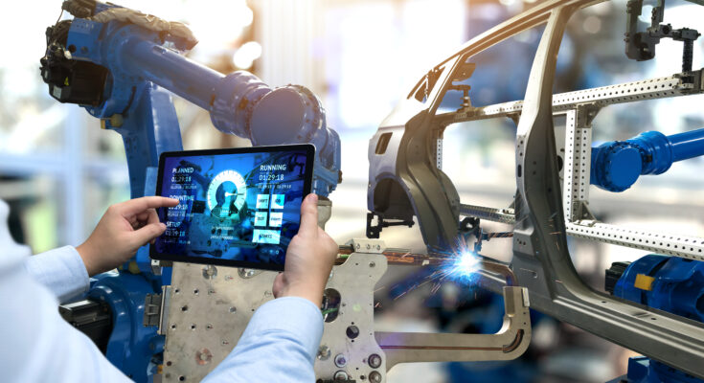
Fig.1. Industry 4.0
Modern industrial automation uses a wide variety of data and control systems, including data collection, distributed control, supervisory control, and programmable logistics controllers. They are stable and predictable, ideal for processing chemicals, pulp, paper, oil and gas, and other raw materials. By incorporating Industry 4.0 features, automated factories will have access to data from the surrounding environment, allowing them to improve operations in real-time. When machines, computer programs, or other forms of technology are used to do tasks that humans would typically handle, this is called automation. Automation may take the shape of simulated and real-world processes[3].

A. Software Automation
Computer programs are increasingly mechanizing activities formerly performed by people. Examples of this field include business process automation (BPA), which uses software to document and streamline business procedures formally; robotic process automation (RPA), which uses “software robots” to mimic human behavior via computer programs; and intelligent process automation (IPA), which employs artificial intelligence to learn how people carry out tasks via a computer program. The primary distinction between BPA and RPA is that the former is akin to replacing a human production line with an autonomous factory. At the same time, the latter is more akin to incorporating a collaborative robot to complement the present staff[4].
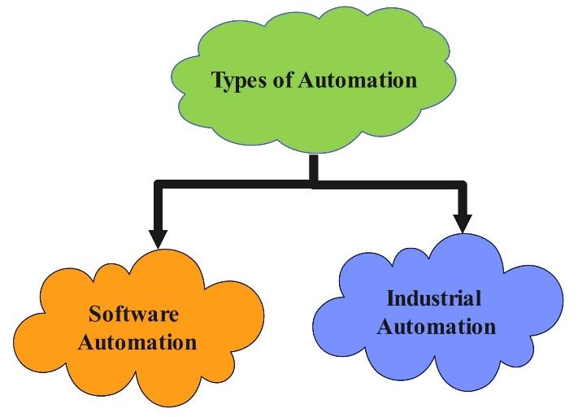
Fig.2. Types of Automation

B. Industrial Automation
This is the automation of industrial processes by controlling physical processes using machinery and control systems. This kind of physical automation makes use of robots as well as non-robotic devices like CNC machines.
II. Robotics
Robotics engineering involves the study, creation, and use of robot technology. Robots are programmed machines that perform autonomous or semi-autonomous activities by interacting with the physical world via sensors and actuators. Robots have more flexibility than single-purpose devices because they can be reprogrammed. Collaborative robots are designed to function more humanely than traditional industrial robots, which may be faster at specific tasks. Robotics and factory automation are becoming more important in the electric vehicle (EV) industry due to their ability to streamline production, reduce costs without sacrificing quality, and increase output. Some of the most critical areas of the electric vehicle industry that have used robotics and automation are listed below[5].

Fig.3. Features of Robotics and Automation
a) Manufacturing and Assembly:The production and assembly of electric vehicles rely heavily on robots. They are adept at doing routine tasks quickly and accurately, such as welding, painting, and component assembly. Inside the factory, automated guided vehicles (AGVs) transport raw materials and finished goods[6].
b) Battery Production:Complex techniques requiring high levels of regularity and accuracy are used to produce batteries for electric cars. Robots handle everything from handling and assembling battery cells to applying coatings and adhesives and performing quality checks. Batteries and their components may be recycled and disposed of safely thanks to automated processes.
c) Electric Motor Manufacturing: Robotics are used in several phases of producing electric motors, a crucial component of electric vehicles. Robots assemble motor parts, place magnets, and wind copper coils. This automation speeds up production, increasing efficiency, precision, and reproducibility[7].
d) Testing and Quality Control:Throughout the EV manufacturing cycle, robotics and automation are heavily utilized in testing and quality control procedures. Robots are capable of doing detailed examinations and tests, such as examining electrical connections, examining battery performance, testing the crashworthiness of vehicles, and analyzing their safety features
e) Autonomous Vehicle Development:Automation and robotics are strongly related to creating self-driving electric automobiles (AEVs). The design, prototyping, and testing of AEVs use sophisticated robotics technology, including creating simulation environments, sensor integration, and autonomous driving systems.
f) Supply Chain and Logistics:In the EV sector, supply chain and logistics procedures are optimized via automation and robotics. Inventory management, tracking shipments, and automating warehouse tasks can all be done effectively by autonomous robots. Automated systems manage to charge stations and maximize their use, supporting the infrastructure for charging vehicles[8].
g) Maintenance and Service:Electric vehicle maintenance and servicing involve robotics and automation. Robots can help with problem-solving, regular maintenance, and even repairs. Automated systems can also forecast maintenance requirements and remotely monitor vehicle performance.Robotics and automation have revolutionized the manufacturing of electric cars, leading to improvements in autonomous driving, product quality, and supply chain efficiency.These developments aid in the widespread use and expansion of electric vehicles in the worldwide auto industry[9].
III. Affect of Robotics and Automation on Electric Vehicle Market
The following are some more ways that robotics and automation are affecting the market for electric vehicles:
a) Charging Infrastructure: Robotic technologies are being created to automate the electric vehicle charging procedure. These robots can attach the charging wire to the car, keep track of the charging process, and cut the line off when the charge is complete. This technology aims to increase the accessibility and convenience of charging, particularly at public charging stations[10].

Fig.4. Affect of Robotics and Automation in the EV Market
b) Advanced Manufacturing Techniques: Additive manufacturing, also known as 3D printing, is growing in the EV sector. Robots and automated systems are used for 3D printing components, such as lightweight structures, custom parts, and prototypes. As a result, production cycles can be completed more quickly, less material is wasted, and designs can be more flexible.
c) Collaborative Robots (Cobots):Cobots, or collaborative robots, assist human operators in manufacturing environments. These robots are made secure and straightforward to train, enabling productive collaboration between machines and people. In specific EV manufacturing procedures, cobots help workers with duties like lifting bulky components or carrying out repetitive activities[8].
d) Predictive Maintenance:Robots and automation technology enable predictive maintenance for electric cars. Vehicle components are monitored, possible breakdowns or maintenance needs are identified, and preventive repairs or replacements are scheduled using sensors and data processing algorithms. This method lessens downtime, increases uptime, and increases the lifespan of EVs[11].
Fig.5. Benefits of using Robotics and Automation in the Automotive Industry
e) Smart Manufacturing:Integrating robots and automation with AI and the IoT has been a driving force in the electric vehicle sector's rise in intelligent manufacturing. Networked systems and intelligent machines provide real-time data collecting, analysis, and decision-making to maximize process optimization, resource efficiency, and overall productivity.
f) Autonomous Mobile Robots (AMRs):AMRs are self-directed robots that can independently move about factories or warehouses. These robots can carry supplies, parts, or finished goods, improving logistics and requiring less physical labor. AMRs are used in the EV industry for operations like material handling, inventory management, and part distribution[12].
g) Vehicle Customization:Automation and robotics allow customizing electric vehicles to suit individual customer needs. Automated systems can manage various interior layouts, paint colors, and optional features, enabling effective customization procedures during production. This degree of customization raises client satisfaction and satisfiesmultiple market demands.Robotics and automation will probably become increasingly important as the electric vehicle industry develops, helping streamline production, boost vehicle performance and dependability, and facilitate the shift to sustainable mobility[13].
IV. Role of Robotics and Automation for Sustainable Transportation
Robotics and automation are essential to attaining sustainable transportation through increased productivity, decreased emissions, increased safety, and system-wide optimization. Here are some significant ways that robots and automation support environmentally friendly transportation:
a) Electric and Autonomous Vehicles: The development and use of electric and autonomous vehicles require robotics and automation. EVs contribute to a decrease in greenhouse gas emissions and reliance on fossil fuels. Automation technologies provide self-driving capabilities, which boost transportation system effectiveness, efficiency, and traffic safety[14].
b) Intelligent Traffic Management Systems:Automation and robots allow for the creation of intelligent traffic management systems. Improve traffic flow, reduce congestion, and reduce fuel consumption with the help of these systems, which include real-time data from sensors, cameras, and other sources. The effectiveness of transportation networks can be considerably increased by using automated traffic signals, adaptive signal control systems, and intelligent routing algorithms.
c) Freight and Logistics:Operations in logistics and freight are changing due to robotics and automation, becoming more sustainable. For last-mile deliveries, autonomous robots and drones are being deployed, eliminating the need for huge trucks and lowering emissions. Robotic picking and sorting are only two examples of automated warehouse systems that optimize storage, lower energy use, and boost supply chain effectiveness[15].
d) Public Transportation:Automation and robots are transforming public transit networks. Autonomous buses and trains may improve reliability, utilize less energy, and be more cost-effective to run. Furthermore, automated fee-collecting systems, intelligent scheduling algorithms, and passenger information systems provide improved operations and a more sustainable public transportation experience.
e) Infrastructure Maintenance:For the inspection, upkeep, and repair of transportation infrastructure, robotics, and automation can be used. When conducting aerial reviews of bridges, highways, and tunnels, drones with cameras and sensors can spot possible problems and eliminate the need for human inspection teams. Automated maintenance robots can efficiently complete repetitive jobs, lowering costs and improving safety.
f) Renewable Energy Integration:Robotics and automation can facilitate the incorporation of renewable energy sources into transportation networks. For instance, automated electric vehicle charging infrastructure that utilizes intelligent grid technologies may effectively control the charging process, balance energy consumption, and incorporate renewable energy output. Sustainable transportation networks can be created and optimized to minimize adverse environmental effects, increase energy efficiency, improve safety, and give people more mobility options. To fully realize the potential of robotics and automation for sustainable transportation, it is crucial to maintain research and development activities in these fields.
g) Vehicle-to-Infrastructure Communication:Robotics and automation make it easier for automobiles to communicate with infrastructure, allowing them to interact with traffic lights, road sensors, and other infrastructure elements. This link enables real-time data transfer, which increases energy efficiency, decreases congestion, and optimizes traffic flow[16].
V. Integrated Manufacturing Methods with EVs
The development of the modern automobile is occurring at a breakneck pace. Process automation is moving quickly alongside the electric vehicle industry in the auto manufacturing sector. An EV drive train has no moving parts; therefore, antiquated robotic assembly is unnecessary. Consequently, you must adopt older devices or buy new, more sophisticated ones. However, as the demand for EVs rises, newly integrated production techniques and automated procedures are gradually becoming the norm[17].
The advanced features found in electric vehicles, which have more computer technology than engine technology, include:
- Connectivity to the Internet of Things (IoT)
- Hydrogen fuel cells
- Adaptive lighting
Parts must be precisely and safely made for all of these qualities to pass stringent examinations. Automation advancements like machine vision use various inspection techniques, like x-rays and infrared digital video signals, to discover flaws in invisible parts to the naked eye. The result is a reduction in production time and an increase in precision[18].
VI. Current scenario of robotics and automation in the Indian market
Rising labor costs, improved technology, government efforts, and increased demand for automation across sectors all contributed to India's thriving robotics and automation industry. Please be aware that the following may not represent the latest happenings in the Indian market[19].India has been focusing heavily on manufacturing and industrial automation. Robotic systems are becoming more common in the industrial sector to enhance productivity, quality, and efficiency[20]. Several automobile manufacturers use robots for welding, painting, and assembling, making the automotive industry a notable early user of robotics and automation.The Indian government has actively supported robotics and automation via programs like "Make in India" and "Digital India." These programs are designed to promote local production, improve industrial capacities, and foster an environment conducive to the widespread adoption of new technologies. The government has also established programs to aid startup companies and university institutions engaged in robotics and automation R&D[21, 22]. Robotic process automation (RPA) has increased over the last several years in many industries, including the financial sector, insurance, healthcare, and logistics. In RPA, "bots" (software robots) are used to automate mundane jobs and improve efficiency in company operations. It has aided businesses in increasing productivity, decreasing expenses, and better serving their clients[23].However, it should be noted that there are still several obstacles in the Indian robotics and automation sector. Among them are worried about job loss, costly start-up expenses, and an absence of experienced workers. There are worries about the effect on employment, especially for low-skilled individuals, despite automation having many advantages[24][25].

VII. Conclusion
Industrial production is constantly evolving to assist organizations in meeting rising customer demand and preserving their worldwide competitiveness. Mechanical gadgets are now making inroads into a variety of industrial industries. Robotic devices will soon be available to consumers in some configurations, potentially having a wide range of effects on our lives as they become more affordable. Robotics applications in the industrial sector have boosted corporate protection, quality, and sustainability. With the coming of Industry 4.0, robotics integration is favorable to the industrial sector for various reasons, including reliability, accuracy, performance, and resistance to hazardous conditions. It may be used in Industry 4.0 to make more rational decisions. It may also be combined with business processes to promote cooperation across data systems. It provides a more reliable and efficient manufacturing process. Intelligent robots that operate swiftly and accurately have simplified various industrial manufacturing processes. Because of the current demand, solutions that allow for rapid product changes at a low cost are necessary. Consequently, industrial robots have emerged as the ideal option for assembly automation. As a result, automation will give the industrial industry enormous profit opportunities in the coming years.

VIII. References
1. Araujo, H., M.R. Mousavi, and M. Varshosaz, Testing, validation, and verification of robotic and autonomous systems: a systematic review. ACM Transactions on Software Engineering and Methodology, 2023. 32(2): p. 1-61.
2. Schlegel, D. and P. Kraus, Skills and competencies for digital transformation–a critical analysis in the context of robotic process automation. International Journal of Organizational Analysis, 2023. 31(3): p. 804-822.
3. Lowe, B.D., et al., Case studies of robots and automation as health/safety interventions in small manufacturing enterprises. Human Factors and Ergonomics in Manufacturing & Service Industries, 2023. 33(1): p. 69-103.
4. Azamfirei, V., F. Psarommatis, and Y. Lagrosen, Application of automation for in-line quality inspection, a zero-defect manufacturing approach. Journal of Manufacturing Systems, 2023. 67: p. 1-22.
5. Herm, L.-V., et al., A framework for implementing robotic process automation projects. Information Systems and E-Business Management, 2023. 21(1): p. 1-35.
6. Vaisi, B., A review of optimization models and applications in robotic manufacturing systems: Industry 4.0 and beyond. Decision Analytics Journal, 2022: p. 100031.
7. Chugh, R., S. Macht, and R. Hossain, Robotic Process Automation: a review of organizational grey literature. International Journal of Information Systems and Project Management, 2022. 10(1): p. 5-26.
8. Liu, L., et al., Application, development and future opportunities of collaborative robots (cobots) in manufacturing: A literature review. International Journal of Human–Computer Interaction, 2022: p. 1-18.
9. Emaminejad, N. and R. Akhavian, Trustworthy AI and robotics: Implications for the AEC industry. Automation in Construction, 2022. 139: p. 104298.
10. Lee, J.S., et al., Challenges, tasks, and opportunities in teleoperation of excavator toward human-in-the-loop construction automation. Automation in Construction, 2022. 135: p. 104119.
11. Wankhede, V.A. and S. Vinodh, State of the art review on Industry 4.0 in manufacturing with the focus on automotive sector. International Journal of Lean Six Sigma, 2022. 13(3): p. 692-732.
12. Sader, S., I. Husti, and M. Daroczi, A review of quality 4.0: Definitions, features, technologies, applications, and challenges. Total Quality Management & Business Excellence, 2022. 33(9-10): p. 1164-1182.
13. Yuan, C., et al., Trends in intelligent manufacturing research: a keyword co-occurrence network based review. Journal of intelligent manufacturing, 2022. 33(2): p. 425-439.
14. Jayasekara, D., et al., Level of automation (LOA) in aerospace composite manufacturing: Present status and future directions towards industry 4.0. Journal of Manufacturing Systems, 2022. 62: p. 44-61.
15. Maganga, D.P. and I.W. Taifa, Quality 4.0 conceptualisation: an emerging quality management concept for manufacturing industries. The TQM Journal, 2022.
16. Rao, A.S., et al., Real-time monitoring of construction sites: Sensors, methods, and applications. Automation in Construction, 2022. 136: p. 104099.
17. Farooq, M.U., A. Eizad, and H.-K. Bae, Power solutions for autonomous mobile robots: A survey. Robotics and Autonomous Systems, 2023. 159: p. 104285.
18. Anagnostou, M., et al., Characteristics and challenges in the industries towards responsible AI: a systematic literature review. Ethics and Information Technology, 2022. 24(3): p. 37.
19. Sharm, P., RESEARCH ARTICLE OUS ELECTRICAL VEHICLES, CYBERTHREATS, AND T FUTURE OF SMART LOGISTICS. 2022.
20. Chen, X., et al., Implementation of technologies in the construction industry: a systematic review. Engineering, Construction and Architectural Management, 2022. 29(8): p. 3181-3209.
21. Ghobadpour, A., et al., Off-road electric vehicles and autonomous robots in agricultural sector: trends, challenges, and opportunities. Vehicles, 2022. 4(3): p. 843-864.
22. Lee, J., et al., Key Enabling Technologies for Smart Factory in Automotive Industry: Status and Applications. International Journal of Precision Engineering and Manufacturing, 2023. 1(1): p. 94-105.
23. Karamuk, M., İ. SAVCI, and H. Ocakli, A Survey on Traction System Development of Automated Guided Vehicles. European Journal of Technique (EJT), 2022. 12(1): p. 1-12.
24. Xiao, J., C. Jiang, and B. Wang, A Review on Dynamic Recycling of Electric Vehicle Battery: Disassembly and Echelon Utilization. Batteries, 2023. 9(1): p. 57.
25. Tappeta, V.S.R., et al., A Review on Emerging Communication and Computational Technologies for Increased Use of Plug-In Electric Vehicles. Energies, 2022. 15(18): p. 6580.

