INTERNAL AUDITOR’S PIVOTAL ROLE IN ESG REPORTING:
FROM CONFUSION TO CONVERGENCE
Dr. Amit Kumar Nag
Professor, BSSS Institute of Advanced Studies (BSSS IAS),
Email: amitnag148@gmail.com
Dr. Atul Dubey
Associate Professor, BSSS Institute of Advanced Studies (BSSS IAS),
Email: dubey.atul@bsssias.ac.in

Dr. Rahul Joshi
Assistant Professor, Department of Commerce, The Bhopal School of Social Sciences
Email: joshirs@rediffmail.com
Abstract
We are living in an era of significant change and awe-inspiring opportunity. If the human species is to live and thrive, planet Earth must be preserved in its natural state. For this to happen ESG must be implanted in the DNA of firms and enterprises all around the world. ESG, as a result, can no longer be viewed as three letters of the English alphabet deserving of debate solely in conferences, research papers, and glossy annual reports. In order for ESG to be more than just a piece of literature or a decorative accent, regular evaluations of ESG activities are required. For such an evaluation to be effective, an evaluation framework with benchmarks for three variables – environmental, social, and governance – must be established. This is where an internal auditor steps in......
Introduction To ESG :-Sounding The Alarm
For years, people have been talking about ESG. However, it was a Swiss report in 2021 that caused a stir. Swiss Re, the world's largest reinsurer, has predicted that if global temperatures rise by 3.2 degrees Celsius by 2050, 18 percent of global GDP will be depleted. It alarmed investors since such dramatic climate change could wipe out investable options, i.e., operational enterprises, in just 30 years. To avoid long-term losses, investors began screening companies based on ESG criteria.
ESG is more than a list of checkboxes. It's about making a difference - for the company and for the globe. ESG is about creating long-term results that drive value and fuel growth and simultaneously benefiting our environment and societies.
ESG is more than a set of good ideals. It is about developing a concrete, actionable plan that yields genuine outcomes. Climate change, diversity, and transparency are not enough to ensure success. It is about incorporating these concepts, throughout the organization, from investment to long-term innovation.
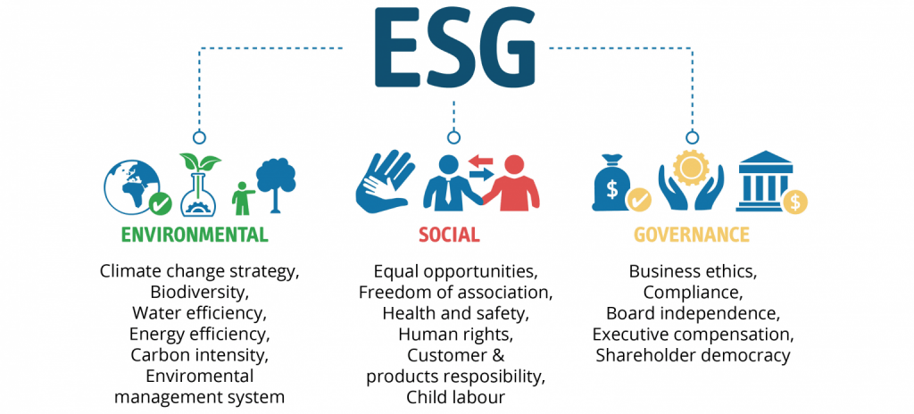
ESG Analysis- Factors Analysed
- Environment: Environment: This section focuses on a company's environmental disclosure, its impact on the environment, and any measures it may be making to decrease pollution or carbon emissions.
- Social: Social: Refers to workplace ethics (diversity, management, human rights) as well as their relationships with people in the community (philanthropy or corporate citizenship)
- Governance: Accounts for compensation, shareholder rights, and the relationship between shareholders and management
ESG Reporting:- The Investor Way
Historically, financial considerations have dominated investment decisions. Although climate change has become a big worry on an international scale, adapting and minimising its effects through migrating to sustainable models of development (and hence, investment) has emerged as a key concern. Investors are changing their focus away from finance-centric investment models and toward more socially and environmentally responsible long-term investing trends. As a result, the demand for Environmental, Social, and Governance (ESG) investing, which focuses on non-financial aspects as a yardstick for directing investment decisions where improved financial returns are no longer the main goal of investors, has grown significantly around the world. Indian investors are becoming more interested in companies and investment products that follow ESG standards, and companies are taking steps to incorporate ESG into their corporate governance strategies. For Example:-
Tata Consultancy Services announced intentions to reduce its absolute greenhouse gas emissions to net zero by 2030.
Similarly, Hindustan Unilever established a centre in Mumbai to address the lack of personal hygiene, lack of access to clean water, and poor sanitation in slums.
In a first-of-its-kind move, the Ghaziabad Municipal Corporation became the first civic body in India to issue green bonds listed on the BSE for a project to reuse wastewater in a way that is good for the environment. The bonds raised rupees 150 crores, which will be used to build a tertiary water treatment plant that will help industries in Ghaziabad.
From an investment point of view, more and more people want to put their money into businesses that care about people and the environment. If ESG factors aren't considered in business strategy or policies, business processes may become useless in the future because laws and regulations may change to make certain ways of doing business illegal, making the business less attractive to investors. Until now, investors based their decisions on practical variables such as raw material constraints, debt levels, and operating efficiencies when deciding whether or not to invest in a company. ESG, a new layer of intangibles, is now being introduced. Investors want to know if companies can maintain the same level of profitability while sticking to these intangibles. Even though India has 10 ESG-focused mutual fund plans, most of them are now doing worse than the BSE 100 Total Return Index. Given the scarcity of natural resources, especially human capital, the ESG buzz may not be an isolated incident
So, investors don't just want to make more money; they also want to make sure their portfolios are in line with sustainable development. So, combining ESG disclosures with a company's corporate governance practises is becoming very important from an investment point of view because it plays a big role in figuring out company’s real worth.

Relevance of ESG Reporting:-
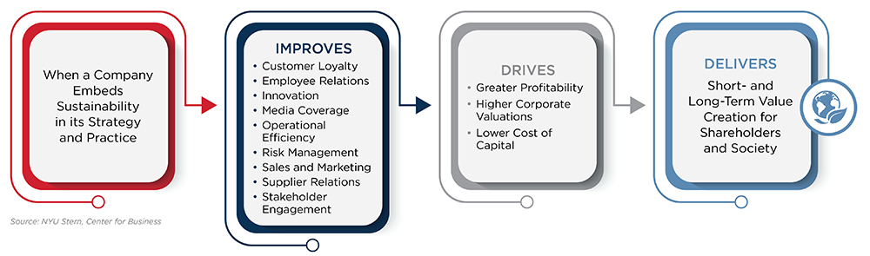
Internal Auditors’ ESG Role: Adding value through assurance and advice
Internal audit's aim is to "improve and safeguard organizational value by providing risk-based and objective assurance, counsel, and insight," its involvement in ESG reporting is paramount and a natural fit.
Impending legislation are fuelling the transition toward a greater focus on ESG reporting, in addition to stakeholder expectations.
Internal auditors bring together knowledge, humanity, and technology to transform uncertainty into curiosity, complexity into clarity, and problems into opportunities. As a result, internal auditing should go beyond simply identifying risks to include root cause analysis, potential risk management strategies, and preventive controls. It should also guarantee that the organization's governance, risk management, and internal controls are all functioning properly.
By validating the effectiveness of ESG-related controls and activities, Internal Auditors are helping organizations to manage those risks and foster resilience.
Internal audit by and large is involved in assurance services that support processes, controls, and data validation for reported material ESG data. Typical advisory services include assessing climate risk and incorporating ESG into the organization's enterprise risk management.
The internal audit department should at the very least provide the following assurances on ESG reporting.
ASSURANCE
• Evaluating how ESG objectives and KPIs are tracked and monitored. • Examining the ESG program's execution and relevant policy papers
• Evaluating the accuracy of ESG reports distributed to stakeholders
• Evaluating reporting metrics for correctness, timeliness, and consistency: All public ESG reports must offer information that appropriately portrays an organization's ESG activities. This is really important as regulatory oversight and public scrutiny grow.
• Evaluating reporting to ensure it is consistent with formal financial disclosure filings: While ESG reporting contains non-financial data; any information that contradicts formal financial disclosures would cause investors and authorities to raise an eyebrow.
• Assess the materiality or risk assessment on ESG reporting: Organizations must understand how ongoing ESG activities or public eagerness to achieving ESG goals might rise to the level of materiality.
• Include ESG in regular audit plans.
ADVISORY
• Advising on the development of ESG program goals and metrics
• Establish an ESG control environment: Internal audit can provide guidance on the development of specialized internal controls for ESG reporting.
• Recommend reporting metrics: Internal audit can provide insights into the type of data that appropriately reflects the organization's relevant ESG efforts.
• Guidance on ESG Governance: Internal audit would be in a position to guide on ESG governance because of its holistic awareness of risk across the organisation.
Apart from these Assurance and Advisory services -
• Internal audit departments conduct governance engagements to determine whether suitable roles, responsibilities, and processes are in place to carry out the ESG strategy and manage risk.
• Internal audit can also perform ESG audits on subjects including climate, environmental compliance and performance, worker safety, data security, and sustainable supply chain practices.
More broadly, internal audit can support management in answering relevant questions such as:
• Do we have a comprehensive understanding of all ESG risks, including compliance risk associated with existing and upcoming national and international regulations, and are they constantly re-assessed?
• Do we have a proper ESG culture that complements our ESG initiatives?
• Do we track and report on our ESG efforts based on key performance indicators (KPIs) linked to the ESG strategy?
As the ESG market and regulatory landscape continue to grow, internal audit functions play a critical role in supporting risk management and performance with controls assurance.
Following figure depicts internal audit involvement in an organisation’s ESG program
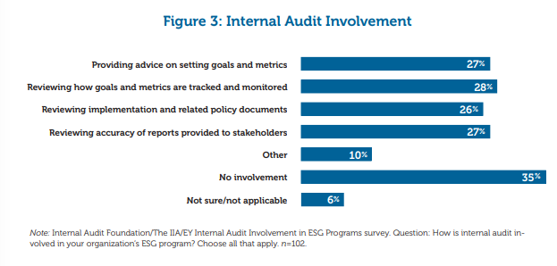
MACRO CHALLENGES TO AUDITING ESG-LADDER TO CLIMB
A portion of the difficulty stems from the growth of ESG ratings and risk assessment metrics that were mostly created in isolation. Ratings are opaque and incomparable since they are based on diverse criteria culled from frameworks established by numerous standard-setting organizations. Even in organizations that prioritize ESG issues, ESG is held back by competing business agendas, reporting rules, and leadership obligations.
Following chart depicts the biggest barriers which are preventing companies from progressing on ESG
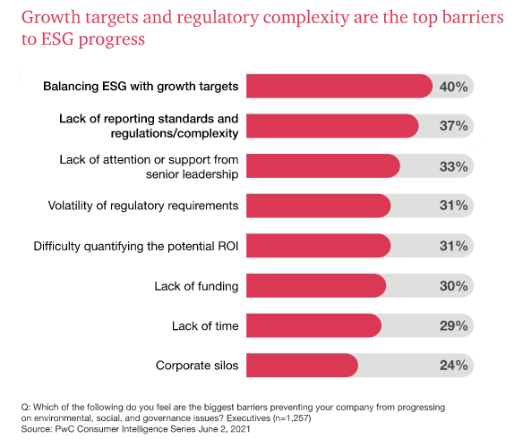
Steps to Take-Navigate through Challenges
Many internal auditors will need to learn new areas of competence in order to handle these difficulties and provide strong assurance. Auditors must become acquainted with topics such as Green House Gas (GSG) Calculation Frameworks.
Many internal audit teams may need to rely on internal or external technical sustainability experts in the short to medium term, particularly for more technical parts of ESG information, such as injury reporting.
Internal auditors will also need to learn how to evaluate IT systems and key data elements that are utilized in ESG reporting but have never been used in financial reporting.
ESG ASSESSMENT – Steps An Internal Auditor Should Follow To Decode And Define The Gap Between Intent And Action.
1. Perform a Materiality Evaluation:
A materiality analysis should form the basis of the ESG strategy. Without a proper assessment, businesses frequently employ ad hoc methods or lack a continuous commitment to agreed priorities. The objective is to focus on the ESG concerns and opportunities that are most likely to impact the business performance of the firm and its stakeholders.
2. Analyse Current Situation :
Once its decided which ESG variables to address, the auditor must review the company's existing programs, policies, measurements, and activities. He can accomplish this by collaborating directly with cross-functional stakeholders inside the business who possess expertise in each priority ESG issue.
This assessment enables him to examine the present health of the firm and the relative maturity of ESG across the enterprise.
3. Establish goals and objectives for ESG strategy:
Now that he is aware of ESG baseline statistics, he should begin planning how he will direct his efforts moving ahead. To further identify strategic objectives, auditor should offer topic-focused working sessions with key stakeholders, beginning with:
• Maintain: What are we already doing well that only need to be communicated or maintained?
• Improve: In what areas can we make incremental adjustments to better align with peers, satisfy the expectations of stakeholders, or demonstrate our commitment to ESG?
• Optimize: Where can we strengthen our present efforts to achieve ESG leadership in our industry?
4. Analyse: Hurdles to Future State Achievement
Steps 1, 2, and 3 are the initial round of health tests to prepare for a successful ESG sprint, but he also needs to be aware of all the potential obstacles organization may face as it attempts to reach its new objectives. Auditor should complete a brief gap analysis between current state and aims or goals to determine what may be missing so that he may build strategy and plan for the future accordingly.
5. Develop a roadmap and framework for ESG:
An ESG program will not be sustainable without a framework that specifies where the vision and mission of the firm align with ESG priorities. Internal auditor should be involved in construction of a roadmap that assures responsibility for critical initiatives, and a persuasive ESG framework that provides stakeholders with a clear image of organization’s capabilities and objectives.
6. Develop and evaluate action plans and key performance indicators:
To implement an ESG program effectively, auditor must integrate ESG into company practices and processes. In order to develop a plan along these lines, auditor must be able to identify pertinent issues, monitor ESG performance, and act consistent with ESG ideals.
7. Provide an Update on ESG Strategy:
While finalising the report the auditor must first determine as to what he really wants to deliver. Ideally, it should be a combination of:
• Communicating ESG strategy to stakeholders and proving alignment with business goals.
• Highlighting existing ESG policies and programs.
• Sharing ESG-specific objectives and indicators.
• Evaluating your progress and initiatives in key ESG domains.
In addition to choosing what to disclose, he must also decide how to do it. Auditor should provide information in a clear and simple manner, ensuring that the report should cover the topics that are most relevant to the organization.
Lastly, internal auditor should regularly evaluate and update ESG strategy to ensure that organization’s ESG strategy is aligned with stakeholder and business expectations. It should be understood that it is not a one-time evaluation plan, but rather a living, breathing approach that must continue to develop and expand.
SUSTAINABILITY REPORTING FRAMEWORKS: - MEASURES OF TRANSPARENCY
The cornerstone for dependable, comparable, and pertinent ESG information is the quality of reporting by firm management. In a universe of various frameworks and standards, it is difficult for businesses to understand how to communicate meaningful information to stakeholders and what ESG data to report. There are numerous frameworks and standards that management can employ to choose which ESG data to disclose.
Reporting frameworks give guidelines based on guiding principles to assist organizations in identifying ESG subjects to cover and determining how to structure and prepare ESG information for public disclosure. Reporting standards provide clear and detailed guidelines to help firms determine what specific information (qualitative and quantitative) to provide for each issue.
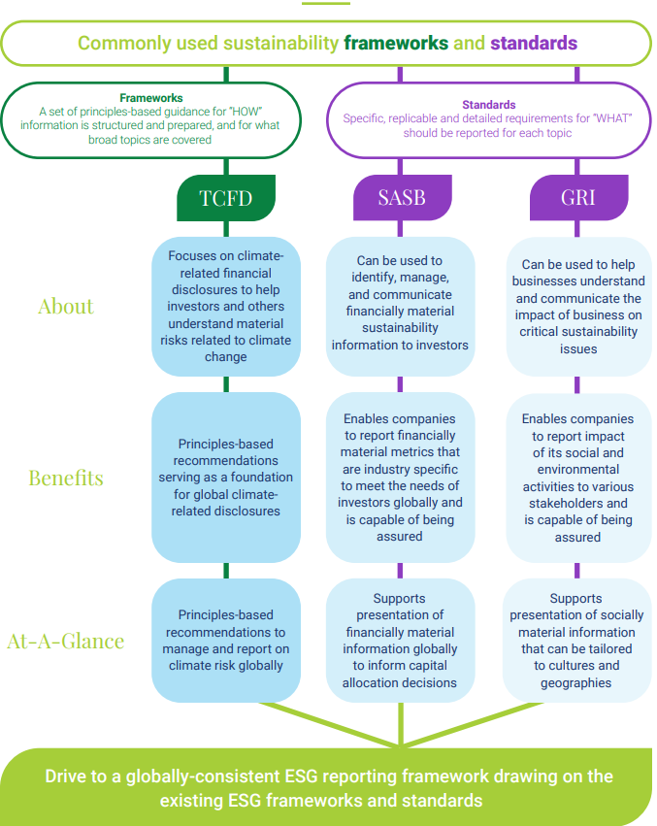

What support and resources does internal auditor require to take ESG forward ?
Internal auditors are of the opinion that for the organizations to move forward, ESG-related risks need to be given more weight in the enterprise-wide risk assessment, and the board and C-suite need to make sure that it happens. 44% are of the opinion that regulations and requirements for compliance with regulations are needed, and 43% say that the IIA needs to provide guidance and official positions on the role of internal audit in ESG efforts.
Following chart depicts the factors needed to support internal auditor’s involvement in ESG related initiatives
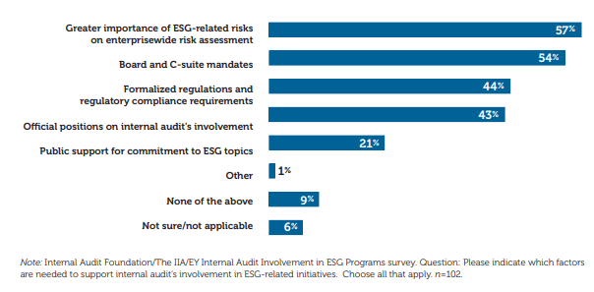
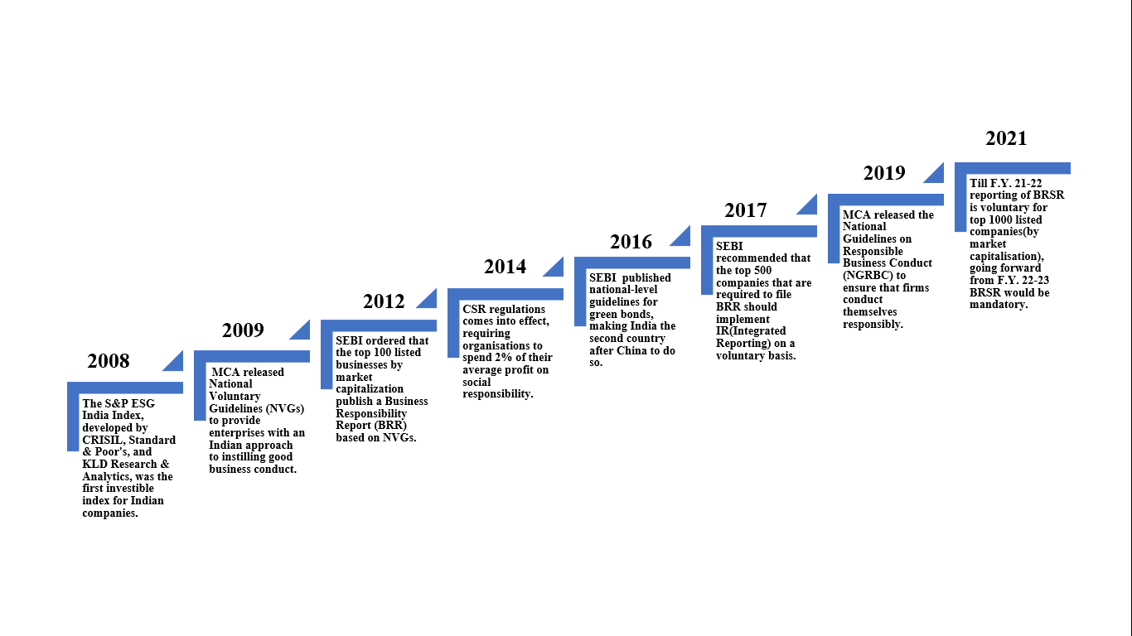
Relevant Guidelines & Reporting Standards, In India –Catching Up With Global Trend

BRR To BRSR-Towards A More Comprehensive Integrated Mechanism
Traits | Business Responsibility Reporting (BRR) | Business Responsibility & Sustainability Reporting (BRSR)
Release Year | 2012 | 2021
Applicable to | In the year of release, it was applicable to top 100 listed companies (by market capitalization). This number rose to 1000 companies in the year 2019. | Till F.Y. 21-22 reporting of BRSR is voluntary for top 1000 listed companies(by market capitalisation), going forward from F.Y. 22-23 BRSR would be mandatory.
Core guideline | National Voluntary Guidelines(NVGs) framed in 2011 | 9 principles of National Guidelines on Responsible Business Conduct (NGRBC) which underwent revision in 2019.
Basic Reporting Values | Integrity & ethics | Accountability, increased clarity, cross-reporting and interlinkage with other reporting standards, well defined performance indicators, industry standardisation and comparability.
Reporting method | Published in annual reports | Published in Annual Reports and simultaneously filed with Ministry of Corporate Affairs (MCA)
Fundamental Values | Ethics and openness, Safety, Employee welfare, Management of stakeholder, Human rights, Environmental protection, Public and regulatory policy, Inclusive growth, Customer-oriented service. | The NGRBC's 9 principles have been expanded upon and matched to performance metrics that may be mandatory or voluntary (Leadership). The details required in the BRSR requires leadership accountability, consistency in reporting, and ownership of the business impact.
SEBI has proposed two BRSR reporting options:
- BRSR Lite- For organisation just starting out.
- BRSR Comprehensive- For Mature Organisations.
CONCLUSION:-
In India, the ESG regulatory environment is fast growing, and there has been a noticeable increase in the frequency and quality of company reporting. The goal is to gradually develop a more comprehensive and extensive ESG reporting regime, with the goal of encompassing all listed and unlisted entities and bringing them under the ESG reporting framework's purview, in order to achieve a more sustainable, transparent, and long-term viable investing trend. However, this is not without difficulties. The lack of cross-border standardisation of reporting standards may make it challenging to harmonise ESG principles, frameworks, and considerations. Furthermore, problems related to the transparency, consistency, materiality, and comparability of ESG standards may impede the smooth deployment of an ESG reporting system in the future. These challenges must be addressed in order to develop an effective and efficient ESG reporting process in the future.
This article is an attempt by the authors to assist readers in comprehending the current ESG landscape, including the implications of the current reporting environment and how internal auditors may support boards and investors in advocating the use of high-quality, comparable, trustworthy, and relevant ESG disclosure.
REFERENCES:-
- Bhatia, A. (2021, October 29). Environmental, Social, and Governance Compliance in India: New Reporting Requirements. India Briefing, pp. 1-7. Retrieved May 31, 2022, from https://www.india-briefing.com/news/esg-reporting-india-new-disclosure-requirements-sustainability-23471.html/
- Business Responsibility and Sustainability Reporting (BRSR). (2022, January 2). Sattva Delivering High Impact, pp. 1-3. Retrieved June 4, 2022, from https://www.sattva.co.in/insight/business-responsibility-and-sustainability-reporting-brsr/
- CAQ (October, 2020). The Role of Auditors in Company- Prepared Cybersecurity Information : Present and Future About the Center for Audit Quality. https://www.thecaq.org/rota-esg/
- Chu, P. (2021, November 13). 7 Steps to Develop and Implement an ESG Strategy. Antea Group, pp. 1-9. Retrieved June 1, 2022, from https://us.anteagroup.com/news-events/blog/develop-and-implement-an-esg-strategy
- Dayal, G., & Sawhney, S. (2022, May 25). Taking ESG Reporting to the next level. BusinessLine, p. 4. Retrieved June 4, 2022.
- Gassmann, P., & Scott, L. (2017, June 4). Environmental, Social and Governance (ESG). PwC Global, pp. 1-5. Retrieved June 2, 2022, from https://www.pwc.com/gx/en/issues/esg.html
- Gassmann, P., Herman, C., & Kelly, C. (2021). Are you ready for the ESG revolution? www.strategy-business.com, pp. 1-15. Retrieved June 2, 2022, from https://www.pwc.com/gx/en/issues/reinventing-the-future/take-on-tomorrow/download/pwcSB_2021-06-15-Are-you-ready-ESG-revolution.pdf
- Kroll, K. (2022, April 12). As New Rules Loom, Internal Audit’s Role in ESG Reporting Under Review. Internal Audit 360", pp. 1-8. Retrieved June 3, 2022, from https://internalaudit360.com/as-new-rules-loom-internal-audits-role-in-esg-reporting-under-review/
- Roberts, S., Ogunnaike, O., Uwasomba, M., Wong, S., & Munaretto, A. (2021). Prioritizing Environmental , Social , and Governance., 1-16. Retrieved May 30, 2022, from https://www.theiia.org/globalassets/site/foundation/latest-research-and-products/2021-3910-fnd-prioritizingesg-report_final_v6.pdf
- Woo, P., & Lee, A. (2012). Internal Audit ’ S Role in ESG. KPMG August, 37–41.

