,,

CHAPTER NAME
FINANCIAL RISK MANAGEMENT AND DERIVATIVES
Chapter submitted by-
Mr. Pratham Joshi
Kolkata, West Bengal

FINANCIAL RISK MANAGEMENT AND USE OF DERIVATIVES

Overview of Financial Risk Management-
Financial Risk Management –
Involves understanding & managing the financial risks faced by the organisation It alludes to the most common way of recognizing, surveying, and overseeing potential dangers and risks that can impact an association's financial well-being. It involves the implementation of strategies and practices to mitigate or minimize the negative consequences of these risks, while maximizing opportunities for growth and profitability.
The significance of financial risk management lies in its ability to protect an organization from unexpected events or circumstances that can jeopardize its financial stability and viability. By proactively identifying and addressing risks, organizations can safeguard their assets, optimize their financial performance, and maintain investor confidence. Effective risk management enables businesses to make informed decisions, allocate resources efficiently, and navigate through uncertain economic conditions.

Types of Financial Risks:
- Market risk: also known as systematic risks which includes interest rate risk, foreign exchange risk, and commodity price risk
- Credit risk: assessing the likelihood of default by borrowers or counterparties
- Liquidity risk: managing the availability of funds to meet financial obligations
- Operational risk: identifying and mitigating risks arising from internal processes, systems, or human error
- Regulatory risk: understanding and complying with legal and regulatory requirements
-Interest rate risk - Risk occur due to the changes in interest rates
- Exchange rate risk - Risk of possible losses due to the changes in the exchange rates
-Commodity price risk - Risk of possible losses due to the changes in commodity prices

3. Principles and Methodologies of Financial Risk Management:

- Risk identification: recognizing potential risks and their sources
- Risk assessment: analysing the actual impact of risk on entity.
- Risk mitigation: the implementation of strategies to reduce or transfer risks
- Risk monitoring: monitoring the strategies and risks risks

Qualifying financial risk-
- Standard Deviation (SD)-Reflects the volatility of an investment. Often used to measure turn
stock or a stock portfolio - Le., higher the SD/volatility, higher the risk, higher the expected return
-Coefficient of Variation – It measures the risk of investments as it determines how much
volatility (risk) is being assumed in comparison to the expected return from investment.
Coefficient of Variation= Standard Deviation/Expected Return
Note- Lower the Coefficient of Variation, the better is the risk-return tradeoff for an investment
- Regression analysis - Analysis of how one variable (e.g., cash flow) is affected by changes in various factors/variables which influences it.
-Value-at-Risk (VaR) analysis - Maximum likely loss on an investment/portfolio/derivative at a particular probability level (or, confidence level) over a holding period
-Scenario analysis (Sensitivity tests, or "what if?" analysis) - Involves a financial model with a set of "what if" scenarios. e.g .What if" the S&P 500 crashes by 15%?

Capital Asset Pricing Model (CAPM)-
CAPM is a widely used financial model that helps investors to analyse and determine the expected return on an investment based on its systematic risk. It provides a framework for understanding the relationship between risk and return in the context of an investment portfolio.
CAPM = Risk-Free Rate + Beta × (Market Return - Risk-Free Rate)
Where ,
Risk-Free Rate-an absolutely risk-free rate, usually consider the rate of G-Secs.
Beta(β) –measure of the volatility or the systematic risk of a stock or portfolio as in comparison to the market.
Market Return- it is the return which the financial market is offering, usually the return of benchmark index.
Limitations –
-Beta often based on several unrealistic assumptions
-Beta and expected market return are based on historical data and may not be reflective of the future
-Risk-free rates are volatile (and change regularly)

Alpha- measures abnormal/excess return of an investment over expected return.

4. Managing financial risks:
Managing financial risks help protect cash flows and reduce earnings volatility. May
contribute to a lower cost of capital, increase access to financing and help achieve financial
objectives.
Techniques =>
- Hedging: using derivatives to protect against adverse price movements
- Diversification: spreading investments across different asset classes or sectors
- Insurance: transferring risks to insurance companies
- Capital management: maintaining adequate capital buffers to absorb potential losses

5. Best Practices in Financial Risk Management:

- Establishing a risk management framework
- Developing risk appetite and tolerance levels
- Regular updating risk management policies and procedures according to market scenario
- Integrating risk management into investment related decision-making and asset allocation.
- Encouraging a risk-aware culture within the organization

USE OF DERIVATIVE AND HEDGING –
The use of derivatives and hedging is an integral part of financial risk management. These tools are employed by organizations to mitigate the impact of potential adverse price movements, manage market risks, and protect against financial losses. The CAPM model is a widely used framework that incorporates derivatives and hedging strategies to assess and manage investment risk.

Derivatives:
These are financial instruments whose value is derived from the value of an underlying asset such as stocks, bonds, commodities, or currencies. They provide organizations with the ability to hedge against price fluctuations, speculate on future price movements, and manage their exposure to various risks. Mostly used for Translation (accounting) risk occurs when financial statements need to be translated or converted from one currency to another
• Transaction risk results from gains or losses that occur because a transaction will be
denominated (received or paid) in a foreign currency
✓ Gain or loss goes to the balance sheet as other comprehensive income
✓ To minimize this effect, many companies will enter into derivatives hedging contracts include futures contracts, options, swaps, and forward contracts-

→ Options – Derivative contract which provides buyer the right ,but not the obligation to buy or sell a specific or standard commodity or instrument, at a specified price during a specified period of time or at a specified date.

→Forwards contracts- where holder buy or sell at a price specified at origination of the contract, with delivery and payment at a specified future date. They are not trade on a centralized exchange, they are over-the-counter (OTC) instruments traded in over the counter, thus have counter party risk.

→ Futures- A forward-based standardized contracts (which are traded on an exchange).
Futures contracts are traded on organized exchanges and are subject to margin requirements.
→ Long position - Right & obligation to buy in the future
→ Short position - Right & obligation to sell in the future

→Currency swaps- Forward-based contracts or agreement for a financial exchange where one party will trade the value of a asset or liabilities with another party. Often swap trading is based on bonds or loans.

→ Money market hedge- helps to manage the currency or exchange-rate risk as it allows a company to fix an exchange rate ahead of a transaction with a party overseas. E.g., borrow money in foreign currency (say, yen) when an agreement to receive the foreign currency in the future is executed. By the use of this strategy, it promptly converts the yen completely to US $. Then, when the yen are collected from the deal, the loan can be reimbursed, bringing no foreign exchange loss or gain.

Hedging:
Hedging is the practice of using derivatives or other financial instruments to offset or reduce the risk of adverse price movements in an underlying asset. It involves taking an opposite position in the derivative instrument to protect against potential losses in the value of the asset. Hedging strategies are employed to manage market risks, including interest rate risk, commodity price risk, foreign exchange risk, and credit risk.
Lets take an example-
Scenario: ABC Corporation is a manufacturer that relies heavily on a specific commodity, copper, for its production. The price of copper is subject to significant fluctuations in the market, which can impact ABC Corporation's profitability. To mitigate the risk of rising copper prices, ABC Corporation decides to implement a derivative hedging strategy using copper futures contracts.

Identify the Risk:
ABC Corporation anticipates that the price of copper will increase in the future. This would result in higher production costs and potentially reduce their profit margins.

Determine the Hedge Ratio:
ABC Corporation analyzes historical data and market trends to determine the correlation between the price of copper and copper futures/options contracts. They find that, on average, the price of copper futures moves in tandem with the spot price of copper. Based on this analysis, they decide to use a 1:1 hedge ratio, meaning they will hedge their exposure to copper prices by entering into futures contracts for an equivalent amount of copper.

Implement the Hedge:
ABC Corporation decides to enter into copper futures contracts to hedge their exposure. They sell (short) copper futures contracts equivalent to the amount of copper they expect to purchase in the future. By doing so, they lock in a predetermined price for the purchase of copper, protecting themselves against potential price increases.

Monitor and Adjust:
As time passes, ABC Corporation closely monitors the price of copper and the value of their futures contracts. If the price of copper starts to rise, the value of their futures contracts will increase, offsetting the higher cost of purchasing copper. Conversely, if the price of copper decreases, the value of their futures contracts may decline, but they will benefit from lower purchase prices.

Close out the Hedge:
When the time comes to purchase the actual copper for production, ABC Corporation closes out their futures contracts by buying an equivalent amount of copper futures contracts. The gains or losses from the futures contracts will offset the changes in the price of copper, effectively hedging their exposure.
By implementing this derivative hedging strategy, ABC Corporation has protected themselves from potential losses caused by rising copper prices. They have effectively locked in a predetermined price for the purchase of copper, ensuring stability in their production costs and safeguarding their profit margins.

Option Contracts and its use in Hedging-

As discussed above about the options contract where buyer of an option pays a premium price to the seller for this right but not the obligation. Options can be used for hedging and speculation.
Key features of options include:
1. Call and Put Options: Call options contract gives the holder of the contact the right to buy underlying derivative asset, while put options give the holder of the contract the right to sell the underlying asset.
Call-option - Right (not obligation) to buy in the future
Put-option - Right (not obligation) to sell in the future

2. Strike Price: The strike price is the predetermined fixed price set by reference to the spot price (market price) of the underlying at which the owner can buy or sell the underlying asset can be bought or sold. It is specified in the option contract.

3. Expiration Date: Options have a limited lifespan and expire on a specific date. After the expiration date, the option becomes worthless.

4. Premium: price which is paid by the option buyer to the seller for the right to buy or sell the underlying derivative asset. It is determined by various factors, including the price of the underlying asset, time to expiration, volatility, and interest rates.

Options Greeks-

Options Greeks are a set of risk measures that help investors and traders assess the sensitivity of options prices to various factors. These risk measures are derived from mathematical models and provide insights into how changes in different variables can impact the value of an options contract. The main options Greeks are:

1. Delta (Δ): It helps to calulate the sensitivity of an option's premium to changes in the price of the underlying asset. It shows the expected change in the option price for the change in the underlying price. Delta ranges from 0 to 1 for call and from -1 to 0 for put options.

2. Gamma (Γ): Measures the rate of change of an option's delta in relation to changes in the price of the underlying. It reflects the convexity of an option's price curve.
A higher gamma implies greater sensitivity to changes in the underlying asset's price.

3. Theta (Θ): It measures the rate of change in the option price with respect to time. It quantifies the time decay of an option's value as it approaches its expiration date. Theta is typically negative, reflecting the diminishing value of an option as time passes. It indicates the expected change in an option's price per day, assuming all other factors remain constant.

4. Vega (V): The sensitivity of an option's premium to changes in implied volatility. It is particularly relevant for options traders who want to assess the impact of changes in market volatility on their option positions.

5. Rho (ρ): Measures the rate of change of an option's price to changes in interest rates. It is more relevant for options on interest rate-sensitive assets, such as bonds, rather than equity options.

6. Implied volatility (IV)- represents the volatility of the underlying instrument

7. Open interest (OI)- It represents the number of outstanding derivative contracts for an underlying asset.

Understanding the options Greeks helps traders and investors make informed decisions about their options strategies. By analysing these risk measures, they can assess the potential impact of changes in the underlying asset's price, time decay, implied volatility, and interest rates on their options positions. This knowledge allows for better risk management and the ability to adjust strategies to align with market conditions.

Options provide flexibility for investors and it can be used for risk management purposes, such as hedging against price movements, as well as for speculative purposes to profit from anticipated price movements.

What is an option chain-
An option chain is the listing of all possible option contracts of different strike prices for the underlying assets. It is also known as options matrix. It shows all the required details of different option greeks and other technical factors such as Open Interest (OI), LTP, expiration dates and volume with the option chain of strike prices for a single underlying asset.

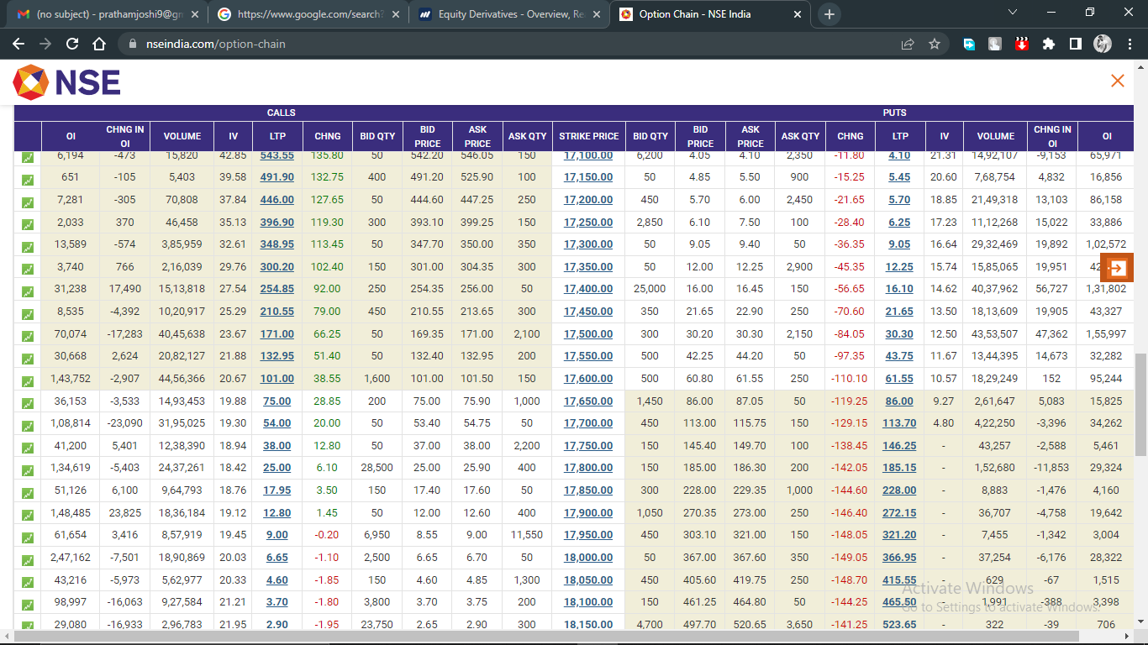

Hedging using options

We have discussed about futures hedging earlier. Now let us see how one can take hedging positions using options.

Taking above example into consideration, hedging the long position in ABC Ltd by buying put option contract of At the Money (ATM) strike price. Let’s assume, 100 put is trading at Rs 3 and the lot size is again 1000. So, the total cost of the hedging contract here is Rs 3000 (3*1000) and the Break Even Point for this option trade is 97 (100-3) i.e. Strike Price-Premium paid. Here the maximum risk of the hedge is the premium amount paid by organisation. Even though stock corrects 10% from current level, organisation may lose Rs 3,000 only.
We have just elaborated couple of illustrations on how organisations can use to limit their downside as markets can be unpredictable at times. Hedging is just like a vaccine shot that works against a virus. Hence, organisations should always opt for hedging as and when required.

Overall Use of derivatives in risk management-
As discussed in this chapter about risk which is a situation where actual result may stray from expected result due to any unexpected factors. It is categorized into two - external risk and internal risk. Risk management is the process of understanding, mitigation and sharing of risk using different techniques and tools of risk management. Risk management have a crucial role in the financial industry. Financial instruments helps the organisation to manage these risks by the use of derivatives. The core role of derivatives are not only to control the certain level of risks but they are also used for the purpose of trading by taking more risk in order to increase the return. Firms use to hedge their financial risks with the use of these derivatives. So, we can say that financial derivatives have a crucial role in emerging markets, thus improves the financial health of the business.

