FUTURISTIC TRENDS IN DENTISTRY

CONTENT

- AI – powered imaging tools.
- Tele Dentistry.
- Computer – assisted design and 3 D Printing.
- Advance Intra oral camera.
- Regenerative Dentistry.
- CRISPR & Gene- Editing Technology.
- Smart Tooth Brush.
- Augmented Reality.
- Virtual Reality in Dentistry.
- Monitoring of Inflammatory Markers & Biomarkers.
- Increasing Demand for LASER Dentistry.

ABSTRACT
Oral diseases, while largely preventable, are one of the major health burdens globally and affect about 3.5 billion people. Dental caries or cavities (commonly known as tooth decay) and gum (periodontal) disease are the most common conditions that severely affect oral health and account for the most considerable part of the oral disease burden. High sugar consumption and snacks, tobacco use, alcohol usage, and eating certain harmful foods and drinks are major risk factors that lead to the development of oral diseases. The growing urbanization, poor hygiene, changing lifestyles, and poor access to oral health care services also impact oral health conditions.

Untreated decay in the permanent teeth leads to several other illnesses and complications that may affect people throughout their lifetime, causing long-term pain and discomfort. Moreover, it can lead to facial disfigurement and, in some cases, can lead to death. Treatment and oral health management are expensive and lengthy and usually not part of universal health coverage, which is a key factor for the rising burden. Overall, it has a higher impact on the psychological development and quality of life of the affected person and their families.

To provide better diagnosis and treatment options in the dental care market. Globally, several key companies are actively working on developing a new solution for better diagnosis and treatment of oral health conditions.

Teledentistry, 3D & Digital Dental X-Rays, Augmented Reality (AR), and Virtual Reality (VR) in Dental Care are some of the leading technologies making inroads in the dental care market. The emerging technological advancements are leading to quicker, easier, less painful, and more reliable oral health management. Due to these advancements, the dental industry is growing rapidly and looking much different than it did in past years.

KEYWORDS- #Trends #Dentistry #AI #Tele #3D #Intraoralscan #Camera #CRISPR #Toothbrush #Virtualreality #Biomarkers #LASER

- AI – powered imaging tools

Dentist employ software to get insights into clinical decision-making. A.I. algorithms is integrated to enable clinicians to find the best modalities for their patients.
Smart algorithms can be integrated within the healthcare system to analyse health data, research findings and treatment techniques to offer diagnostic and therapeutic recommendations for individual patients.
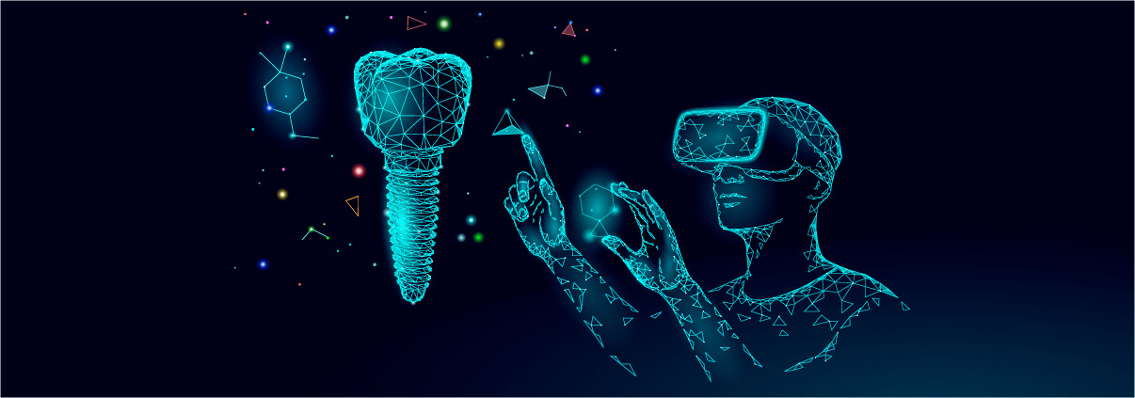
This will be made further possible with the accumulation of health data; in particular, genomic data, that can offer a deeper understanding of each individual’s system for personalised care. With A.I. tools having access to such information, they can instantly offer the best treatment options and probabilities of success to the clinicians.

On top of churning health data, A.I.-based algorithms can help specialists better tend to dental conditions. In case of oral cancer gives better insights into the spread of and resistance to cancer; thereby helping in determining the chances of survival. Others are using neural networks to better detect dental decay and periodontal disease from radiographs. Such approaches can become standard practice in the near future.
However, as the field of dentistry it is exploring the potential beneficial uses of digital data both for dental practice and in research, digitalisation is raising numerous novel and unpredictable ethical challenges in the biomedical context.
- Tele Dentistry

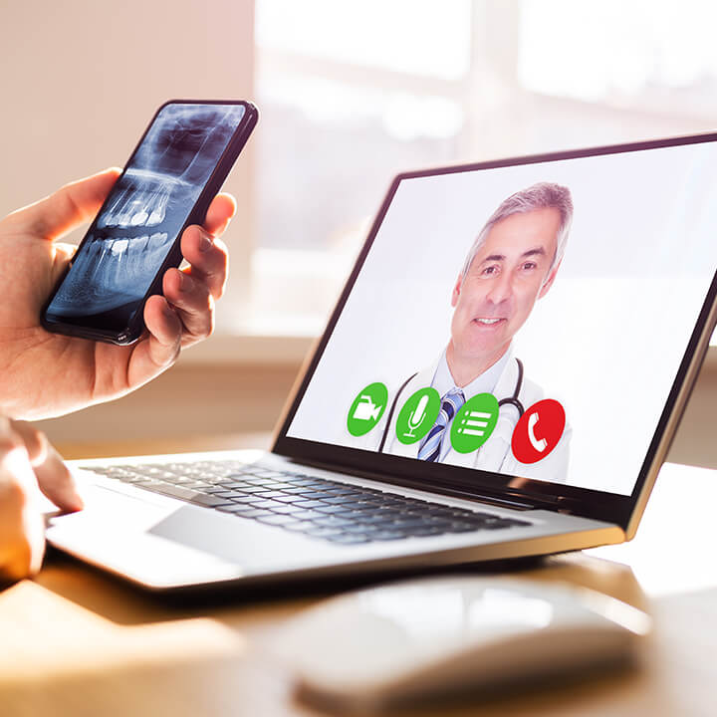
Adults are reluctant to visit the dentist, imagine how hard it is for children, patients with special needs or the elderly in nursing homes. Another issue is distance: people living in rural areas rarely get access to a dentist, and almost never have the possibility of choice. This can change significantly with the spread of teledentistry.
Teledentistry services offered by many companies like The Teledenists and MouthWatch provide easier access to dental care; are significantly cheaper for patients; shift towards cheaper prevention practices; and allow patients to consult with otherwise uunavailable dental professionals. For instance, MouthWatch’s TeleDent service offers an all-in-one teledentistry platform allowing patients to capture images, send relevant information to a dentist remotely and do a live consult. The dentist might start a video chat with the patient and the caregiver so that the dental professional can actually see and talk to the patient, build rapport, help connect them and bring them into the office (if necessary).
As remote care’s importance swelled during the pandemic, teledentistry is also picking up steam and authorities are responding accordingly. The American Dental Association issued a policy on teledentistry that offers guidance on the modalities that such services can follow. This sets the pace in making teledentistry a general practice.

3.Computer – assisted design and 3 D Printing

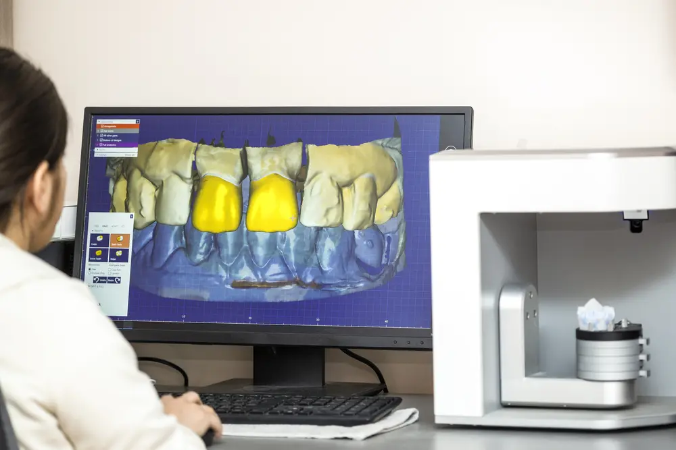
3D-printing does not need any introduction considering it Buzz that is generated in healthcare a while ago with the technology’s potential to print medicines, prosthetics and even organ replicas. Its importance was further highlighted during the COVID-19 crisis to bypass supply chains to meet hospitals’ demands. As the technology is set to become an integral part of healthcare practice, it will also become incorporated in dental labs.

Computer-assisted design (CAD) and computer-assisted manufacture (CAM), including 3D-printing, are revolutionising the sector; they are turning them into low-cost, more effective digital labs. Traditionally, when a patient needs a crown, a dentist must make a mould of the tooth and fashion a temporary crown, then wait for the dental laboratory to make a permanent one.
With CAD/CAM technology, the tooth preparations for the crown and a picture is taken with a computer. This image is then relayed to a machine that manufactures the crown right in the office. With a 3D printer doing the hard work, dental labs eliminate the bottleneck of manual modelling. Stratasys, Envisiontech or FormLabs offer such high-tech solutions for dental labs.
3D printers are also able to produce orthodontic models, surgical guides, aligners, retainers and more dental equipment faster and more precisely; tasks that would take longer with traditional methods. This helps in improving workflows, reducing error, the amount of labour and cost-efficiency.
- Advance Intra oral camera

One of the greatest inconveniences while being seated in the dentists’ chair is that sometimes, no matter how wide you open your mouth, the dentist still cannot see what they would like to see, even by using the trusty dental mirror. Such situations are not only uncomfortable for both the patient and the doctor, but also painful. However, the advent of intra-oral cameras can remedy this exact problem.
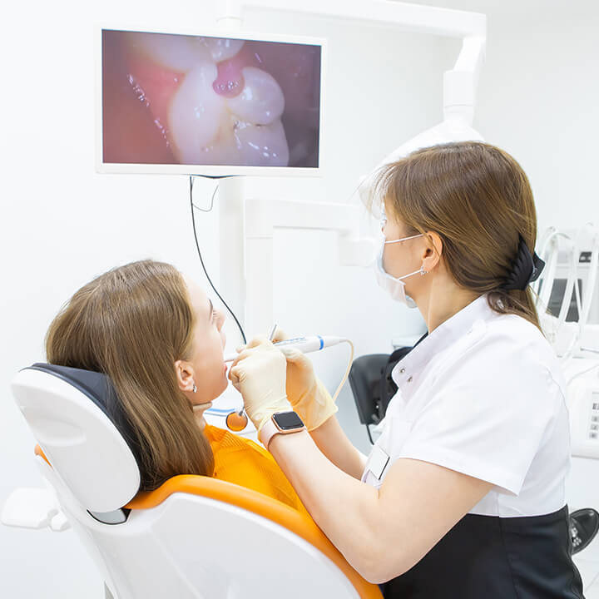

The latter promises revolutionary cameras, which are real “patient conversation starters.” The cameras’ unique liquid lens technology works like the human eye to ensure effortless image capture to deliver clear, detailed images patients can really understand.

- Regenerative Dentistry

We’ve come to expect to have our teeth fall off with age or with, caries and have them replaced by prostheses. However, the field of regenerative dentistry challenges this preconceived idea with developments that can lead to regenerative dentistry and biological therapy for damaged teeth.
Previously, researchers from the University of Nottingham and Harvard University developed dental fillings that allow teeth to heal themselves. These fillings stimulate stem cells to promote the growth of dentin, or the main constituent of our teeth. This effectively enables patients to regrow teeth damaged through dental disease and potentially eliminate the need for root.
From researchers at Karolinska Institute in 2020 can accelerate development in the field of regenerative medicine. They were able to map the differentiation pathways of the cells that make up human teeth. They also discovered new cell types and cell layers in teeth that can impact tooth sensitivity.
This is very exciting to think that you might not need to have false teeth to replace your own when you are old, but you might grow new one! Research is going on world wide.
- CRISPR & Gene- Editing Technology

CRISPR is a genome editing method offered by Mother Nature herself, but researchers have discovered its immense potential only recently. As explored in our dedicated articles, it might become the ultimate weapon against cancer or, more controversially, help design babies in the future. And the field of dentistry will also benefit from the technology as well.

So what could CRISPR achieve in dentistry? Well quite a lot, in fact. Chinese researchers are conducting studies with the technology to isolate and switch off oral cancer-associated genes. Other researchers are using CRISPR to alter the functioning of bacteria responsible for plaque formation. Their endeavour could even lead to the reduction or outright prevention of dental caries and periodontal disease. But please don’t give up on brushing your teeth just yet!

- Smart Tooth Brush

Our home will be filled with connected, smart devices in the future, so why would our bathroom be an exception. At first, it might feel a bit strange to let a sensor into one of your most intimate activities, tooth brushing, but it makes a lot easier to maintain oral hygiene and prevent plaque or cavities.
The Kolibree smart electric toothbrush makes sure you are brushing your teeth the right way through its app and offers kids fun games to keep up the good habit of regularly cleaning their teeth. Toothbrush comes packed with sensors in its handle. These provide real-time feedback via a companion app warning you if you are applying too much pressure, where you are brushing and even coach the user as to how to brush properly. And there are several such devices on the market from companies like Colgate and Oral-B.
While having a personal coach to optimise your daily oral hygiene might sound enticing, not everyone is enthusiastic about the technology. Firstly, dental experts emphasise the need for proper brushing techniques which these devices won’t improve upon. Rather, it’s a dental professional who can demonstrate the proper techniques at your next appointment.
Additionally, by buying smart toothbrushes from companies like Procter & Gamble and Philips Oral Healthcare you agree to their privacy policies that enable them to share your data with third parties. Now that health data is the new oil, companies will want to profit off of these in as many ways as possible. So you might want to adopt a smart toothbrush from a company that gives you more control over your data or one that doesn’t share it with third parties at all.

8.Augmented Reality

You might be familiar with Augmented Reality (AR) through social media apps; it’s the same technology that instagram uses to superimpose filters on your face during your guilt trip selfie with a dog face filter. But AR also found a home in dentistry for both educational and clinical purposes.

Image Navigation’s DentSim Simulator pairs AR with a mannequin on which students can perform procedures while receiving immediate feedback as their movements are tracked. This helps them identify faster where they should improve and develop their skills in the process. It’s already in by 8 500 students in dental schools around the world.

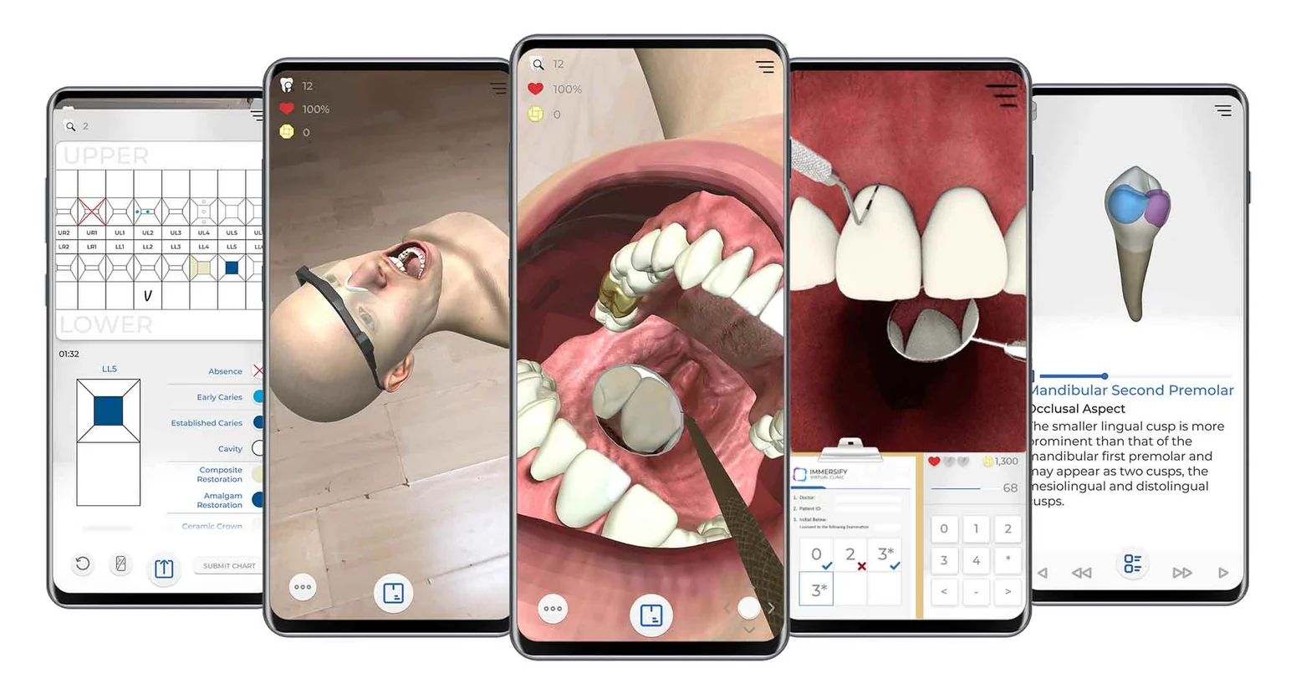

In dental practice, the technology is more prevalent in reconstructive and aesthetic procedures in order to help patients know what they will look like after the treatment. SmartTek and Kapanu have developed such AR apps that use their phone or tablet’s camera to overlay virtual depictions of the improved set of teeth prior to the procedure. This allows patients and dentists to configure features of their teeth such as height and spacing to their liking before they even enter the surgery room.
- Virtual Reality in Dentistry

We should not be confused with AR, Virtual Reality (VR) completely closes off the outside world with a dedicated headset and immerses the user in a virtual environment. By slipping such a headset on their head, students and aspiring dental surgeons can be transported to the OR from their couch; while patients can visualise a calming landscape while seated at the dreaded dentist’s chair to improve their experience.
Today, only a few students can peek over the shoulder of the surgeon during an operation and it is challenging to learn the tricks of the trade like that. With a virtual reality camera, surgeons can stream operations globally and allow medical students to actually be there in the OR using their VR goggles. Dentistry even outpaced other fields of medicine in adopting this method. Back in 2015, Nobel Biocare held the first dental surgery filmed through VR and allowed observers to virtually assist the whole procedure from the surgeon’s perspective. In comparison, the first VR-recorded surgery was performed at the Royal London hospital in 2016. The technology can further be used to help dentists build on their empathy skills through simulations putting them in the shoes of their patients or in challenging situations.
On the patient side, VR might be the solution to our dentist’s office anxiety. An experiment with 99 participants showed that VR can be used as an effective distraction tool in dentistry. Patients wore goggles which displayed calming natural scenes, and remembered the treatments more positively afterwards. OperaVR is one such VR tool for reducing dental anxiety.

10. Monitoring of Inflammatory Markers & Biomarkers.
As Dental technology improves, dentists should expect improved patient monitoring and the ability to diagnose Dental and systemic disease with greater accuracy.
By monitoring inflammatory markers and biomarkers, dentists can understand their patient’s health more granularly. For example saliva can be collected non invasively and used to obtain an individual’s “snapshot” of the microbiome, indicating information such as collagen breakdown, enzymes levels and various inflammatory markers.
As it stands today, most Dental diseases are diagnosed after the damage has been done. Dental Futurists advocate for solution such as saliva testing that screen for high enzyme activity levels, early inflammation, collagen breakdown, or other precursors to more serious Dental diseases.
Overall, dentists should expect improved patient monitoring and the ability to diagnose various Dental conditions and diseases earlier, with greater accuracy.
11.Increasing Demand for LASER Dentistry
One of the most exciting patient care trends in the dental industry is the rise of laser technology. Before laser dentistry, routine dental care such as filling cavities and repairing damaged gums required invasive and often painful treatment. The potential of experiencing pain is a deterrent to patients who are nervous about visiting the dentist and can cause them to delay care.
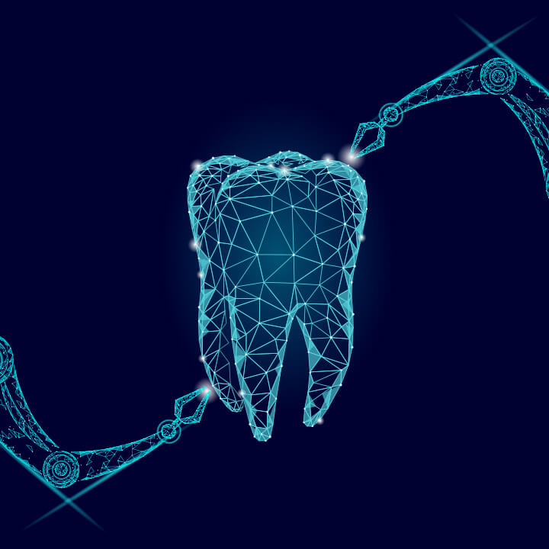
Laser dentistry is in a period of intense growth that is expected to continue for several years. According to an article in BioSpace, the laser dental industry is projected to reach $345.1 million in 2028. The most used laser technology is the diode laser, which is a portable and cost-efficient option for minimally invasive oral surgery.
Technologies are best when they address problems that can hold dental practices back and laser technology is no exception. Laser dentistry can eliminate cavities with little or no pain. It can also kill bacteria in the cavity, making it less likely that a patient will experience complications because of tooth decay.
The advantages of laser dentistry in patient care are:
- Decreased need for sutures
- Less bleeding
- Little to no pain
- Reduced risk of infection
- Faster healing
If your practice uses laser dentistry for routine dental procedures, you should mention it on your website and in your social media marketing. This is an especially good tactic if you want to attract new patients since the promise of painless dental treatments can help reluctant patients get over their fear of going to the dentist.

- Consumer Demand Natural Oral Hygiene Products
Herbs are staging a comeback and herbal ‘renaissance’ is happening all over the globe. The herbal products, today, symbolize safety, in contrast to the synthetics that are regarded as unsafe to humans and the environment. A herb, botanically speaking, is any plant that lacks the woody tissue which is characteristic of shrubs or trees. More specifically, herbs are plants which are used medicinally or for their flavour or scent.

Herbs ( neem, tulsi, mint, green tea) with medicinal properties are a useful and an effective source of treatment for various disease processes. Herbal extracts have been successfully used in dentistry as tooth cleaning and antimicrobial plaque agents. The use of herbal medicines continues to expand rapidly across the world. Many people take herbal medicines or herbal products now for their health care in different national healthcare settings. Herbal extracts have been used in dentistry for reducing inflammation, as antimicrobial plaque agents, for preventing release of histamine and as antiseptics, antioxidants, antimicrobials, antifungals, antibacterials, antivirals and analgesics. They also aid in healing and are effective in controlling microbial plaque in gingivitis and periodontitis, thereby improving immunity.

Conclusion
That concludes our list of key Dental industry trends to keep an eye on.
Many of this year’s Dentistry trends are focused on improving patient care. Specifically, the dental.

The bright future of dental medicine
It is amazing how more and more disruptive innovations will be at our disposal – either for improving oral health as a patient or upgrading our practice as a professional. Our task at The Medical Futurist is to follow the latest innovations and keep pace with the growing possibilities in healthcare.
References
- Gopal G., Suter-Crazzolara C., Toldo L. Digital transformation in healthcare—Architectures of present and future information technologies. Clin. Chem. Lab. Med. 2019;57:328–335. doi: 10.1515/cclm-2018-0658.[PubMed] [CrossRef] [Google Scholar]
- Weber G.M., Mandl K.D., Kohane I.S. Finding the missing link for big biomedical data. J. Am. Med. Assoc. 2014;311:2479–2480. doi: 10.1001/jama.2014.4228. [PubMed] [CrossRef] [Google Scholar]
- Joda T., Waltimo T., Pauli-Magnus C., Probst-Hensch N., Zitzmann N.U. Population-based linkage of big data in dental research. Int. J. Environ. Res. Public Health. 2018;15:2357. doi: 10.3390/ijerph15112357. [PMC free article] [PubMed] [CrossRef] [Google Scholar]
- Glick M. Taking a byte out of big data. J. Am. Dent. Assoc. 2015;146:793–794. doi: 10.1016/j.adaj.2015.09.002. [PubMed] [CrossRef] [Google Scholar]
- Miyazaki T., Hotta Y. CAD/CAM systems available for the fabrication of crown and bridge restorations. Aust. Dent. J. 2011;56(Suppl. 1):97–106. doi: 10.1111/j.1834-7819.2010.01300.x. [PubMed] [CrossRef] [Google Scholar]
- Jones K.H., Laurie G., Stevens L., Dobbs C., Ford D.V., Lea N. The other side of the coin: Harm due to the non-use of health-related data. Int. J. Med. Inform. 2017;97:43–51. doi: 10.1016/j.ijmedinf.2016.09.010.[PubMed] [CrossRef] [Google Scholar]
- Joda T., Waltimo T., Probst-Hensch N., Pauli-Magnus C., Zitzmann N.U. Health data in dentistry: An attempt to master the digital challenge. Public Health Genom. 2019;22:1–7. doi: 10.1159/000501643. [PubMed] [CrossRef] [Google Scholar]
- Joda T., Ferrari M., Gallucci G.O., Wittenben J.-G., Bragger U. Digital technology in fixed implant prosthodontics. Periodontology 2000. 2017;73:178–192. doi: 10.1111/prd.12164. [PubMed] [CrossRef] [Google Scholar]
- Dawood A., Marti Marti B., Sauret-Jackson V., Darwood A. 3D printing in dentistry. Br. Dent. J. 2015;219:521–529. doi: 10.1038/sj.bdj.2015.914. [PubMed] [CrossRef] [Google Scholar]
- Lech G., Nordström E. Master’s Thesis. Malmö University Electronic Publishing; Malmö, Sweden: 2018. Dimensional Stability of 3D Printed Dental Models. [Google Scholar]
- Galantea R., Figueiredo-Pinaa C.G., Serro A.P. Additive manufacturing of ceramics for dental applications: A review. Dent. Mater. 2019;35:825–846. doi: 10.1016/j.dental.2019.02.026. [PubMed] [CrossRef] [Google Scholar]
- Zocca A., Colombo P., Gomes C.M., Gunster J. Additive manufacturing of ceramics: Issues, potentialities, and opportunities. J. Am. Ceram. Soc. 2015;98:1983–2001. doi: 10.1111/jace.13700. [CrossRef] [Google Scholar]
- Bose S., Ke D., Sahasrabudhe H., Bandyopadhyay A. Additive manufacturing of biomaterials. Prog. Mater. Sci. 2018;93:45–111. doi: 10.1016/j.pmatsci.2017.08.003. [PMC free article] [PubMed] [CrossRef] [Google Scholar]
- Sutherland J., Belec J., Sheikh A., Chepelev L., Althobaity W., Chow B.J.W., Mitsouras D., Christensen A., Rybicki F.J., La Russa D.J. Applying modern virtual and augmented reality technologies to medical images and models. J. Digit. Imaging. 2019;32:38–53. doi: 10.1007/s10278-018-0122-7. [PMC free article] [PubMed] [CrossRef] [Google Scholar]
- Pensieri C., Pennacchini M. Overview: Virtual reality in medicine. J. Virtual Worlds Res. 2014;7:1–34. doi: 10.4101/jvwr.v7i1.6364. [CrossRef] [Google Scholar]
- Kwon H.B., Park Y.S., Han J.S. Augmented reality in dentistry: A current perspective. Acta Odontol. Scand. 2018;76:497–503. doi: 10.1080/00016357.2018.1441437. [PubMed] [CrossRef] [Google Scholar]
- Joda T., Gallucci G.O., Wismeijer D., Zitzmann N.U. Augmented and virtual reality in dental medicine: A systematic review. Comput. Biol. Med. 2019;108:93–100. doi: 10.1016/j.compbiomed.2019.03.012. [PubMed] [CrossRef] [Google Scholar]
- Farronato M., Maspero C., Lanteri V., Fama A., Ferrati F., Pettenuzzo A., Farronato D. Current state of the art in the use of augmented reality in dentistry: A systematic review of the literature. BMC Oral Health. 2019;19:135. doi: 10.1186/s12903-019-0808-3. [PMC free article] [PubMed] [CrossRef] [Google Scholar]
- Joda T., Gallucci G.O. The virtual patient in dental medicine. Clin. Oral Implant. Res. 2015;26:725–726. doi: 10.1111/clr.12379. [PubMed] [CrossRef] [Google Scholar]
- Lee S.H. Research and development of haptic simulator for dental education using virtual reality and user motion. Int. J. Adv. Smart Conv. 2018;7:114–120. [Google Scholar]
- Ayoub A., Pulijala Y. The application of virtual reality and augmented reality in Oral & Maxillofacial Surgery. BMC Oral Health. 2019;19:238. [PMC free article] [PubMed] [Google Scholar]
- Durham M., Engel B., Ferrill T., Halford J., Singh T.P., Gladwell M. Digitally augmented learning in implant dentistry. Oral Maxillofac. Surg. Clin. N. Am. 2019;31:387–398. doi: 10.1016/j.coms.2019.03.003. [PubMed] [CrossRef] [Google Scholar]

