CHAPTER-1. Bioengineering- An emerging trend in biology (An Introduction)
Bioengineering is also known as Biological Engineering. It is the study of applied engineering practices in general biology. It is used to apply the principles of biology and the tools and techniques of engineering to manufacture visible, accessible, and cost effective products. It gives the knowledge and learning related to applied sciences like biocatalysts, biomechanics, bioinformatics, bioreactor designing, mass and heat transfer, polymer science kinetics, separation and purification, surface science, fluid mechanics, and thermodynamics.

This science is used in the designing of medical devices, diagnostic equipment, biocompatible materials, renewable energy resources, ecological, agricultural, and process engineering and catalysis, etc. to add the life values in the society. It tries to meet in integrative, innovative, collaborative and interdisciplinary manner. It provides the solutions for the problems that are unable to solve by the disciplines of engineering and physical and life science.

This branch of biology meets with technology so that challenges that remain unaddressed can create a novel change in this world. It provides devises and innovative solutions to open-ended, which can solve the unknown issues that present in biology, health and medicine.

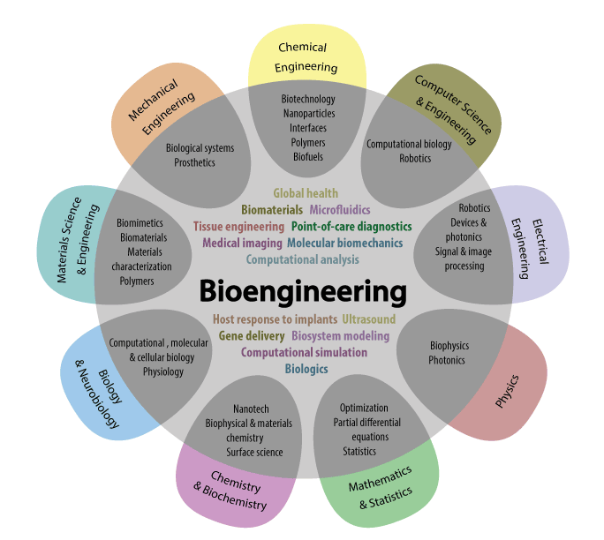

Fig. Explanation of various field collaboration and related to Bioengineering.

Bioengineering make a bridge between engineering, biology and physical science. It possesses a different perspective of academics. Subjects like Applied Mathematics, Computer Science and Engineering creates connections and collaborations among engineering, physical and quantitative sciences. Biochemistry and Oceanography makes an intersection between life, physical and quantitative sciences. Environmental and Civil Engineering provides some unique principles to specific area of life sciences.
Bioengineering is used to apply the knowledge of engineering to the various areas of medicine and biology. This subject matter applies engineering principles of designing and analytical knowledge to the biological systems and biomedical technologies.
A bioengineer works on a way which is apply to various areas of natural sciences to face different issues at different pace. They always become excited to make modify and control some products, of biological systems. They can be work with doctors, medical professionals, and researchers. They become trained in disciplines of biology and engineering, such as electrical and mechanical engineering, chemistry, and biology computer and, materials science.
Examples of bioengineering research include bacterial engineering for producing different kinds of chemicals, medical imaging technology, fast disease diagnostic devices, prosthetics, bio-pharmaceuticals, and tissue based artificially engineered organs. Bioengineering overlaps with biotechnology and the biomedical sciences in some areas.
  - History
The term Bioengineering was unknown before World War-II and less in communication and. But agricultural engineers and the chemical engineers, who were performing the fermentation processes are said to be bioengineers because they work with biologists and deals with biological systems to modify the process for creating new and diverse variants.
The civil engineers, who completed their specialization in sanitation, applied many biological principles for creating aseptic environment to performing their work. Mechanical Engineers worked with the Medical Professionals for the development of artificial limbs. Engineers and physiologists worked together in the early 1920s to study the effects of temperature and humidity on human beings for providing a design for heating and air-conditioning systems in American Society of Heating and Ventilating Engineering.
In 1954 at the National Institute for Medical Research term ‘Bio-engineering’ was coined by British scientist Heinz Wolff. Bioengineering was recognized as its own branch here for the first time. At starting electrical engineering was the focus of this discipline, because of working with medical devices and machinery.
In 1950s the field of bioengineering becomes dominated and used in medical electronics with the help of electrical engineers. Medical instrumentation and medical electronics becomes attractive along with the biological modeling, blood-flow dynamics, prosthetics, biomechanics (dynamics of body motion and strength of materials), biological heat transfer, biomaterials, etc.
As the surgeons needs to bypass heart, and to replace the organs ‘Bioengineering’ got developed. At that time interactions between physicians, physiologists, and engineers creates the result of education.
When engineers and life scientists started working together, they recognized that the engineers didn't know enough about the actual biology behind their work. To resolve this problem, engineers who wanted to get into biological engineering devoted more time to studying the processes of biology, psychology, and medicine.
In 1966 first biological engineering program was started at University of California, San Diego (United States). Recently some novel and valuable programs have been launched at MIT and Utah State University. Over the world some old agricultural engineering departments are re-branded as an agricultural and biological engineering or agricultural and bio systems engineering.
Professor Doug Lauffenburger of MIT proposed that biological engineering has a broad base which is used to apply engineering principles to the molecular biology, biochemistry, microbiology, pharmacology, cytology, immunology and, neuroscience (which involves the proper study of various devices and sensors). They can be applicable over whole macroscopic organisms (like plants, animals) that are present in the biomes and ecosystems.

1.2. Role of bioengineering in the field of medical Science:-
- Various “smart” therapies are used for treating cancer.
- By making biocompatible implants which are used in resisting the infection.
- By using nanoparticles for imaging enhancement.
- Different kinds of paper-based diagnosis are used for checking health at home and it is used globally.
- Various adaptable prosthesis techniques are used for amputees.
- Bio-Engineered heart cells can be prepared for improving cardiac functions from post-heart attack issues.
- Artificially prepared biomimetic materials are used to prevent various gut infections.
- By creating miniature cell culture techniques are used for learning neurobiology science.
- Synthesis of bio-materials can be made for using as biofuels.
- Preparation of “Catch” bonds for creating various novel adhesives.
- For making photonic biosensors artificially for sensing blood typing.
- An important role played by high intensity focused ultrasound which is used to stop unnecessary bleeding.
- Different types of computational methods are using for monitoring brain growth and development at different levels.
- Under in vitro condition DNA, protein and glycan microarrays are used for various kinds of drug production.
- Different technologies are used for learning and making cure during neuro-rehabilitation.
- For treating cardiac damage and failure in different situations.
- For diagnosing various diseases.

1.3. As a Bioengineer, one can do following:-
  - Biology, health & medicine: One can solve the issues created in biology, health and medicine to make progress in human life.
  - Quantitative approach: One can use the quantitative tools and techniques such as mathematical modeling and simulation.
  - Solving open-ended problems: One can produces novel varieties of solutions for cure the real-world issues at different levels.
  - Independent research & design: One can conduct research independently and designing the various projects (in vitro, in vivo and in silico) reports which can be mentoring by leaders of bioengineers.
  - Hands-on learning: One can enjoyed the learning of technologies by experimenting, via performing experiments in labs, preparing projects and doing research.
  - Team-based problem solving: One can enjoy their working with smart, mature and diverse team leaders by solving the different issues creatively and instantly.
  - Broad knowledge: One can acquired the broad range of knowledge by spanning engineering, biology and the physics.
  - Cohort experience: One can move forward sequentially and smartly through a core course of curriculum and with the help of talented and knowledgeable peers of Bio-Engineering.

1.4. Branches of Bioengineering:-
- Medical engineering: In this branch we have to study about the principles of medical problems, such as damaged organs replacement, instrumentation, and the health care systems, like diagnostic applications through computers by using various databases.
- Agricultural engineering: In this branch we have to study about to cure the created in of biological production and to the external environment and operations which trigger the production.
- Biochemical engineering: It is the branch which deals with the study of fermentation engineering, microscopic biological systems which are used to create new products by synthesis, like protein production.
- Human-factors engineering: In this branch we can study about physiology, and psychology to optimize the relationship between human and machine.
- Environmental health engineering: It is also known as bioenvironmental engineering; this branch is used to control the environment for the health, comfort, and security of individuals.
- Genetic engineering: This branch is used in artificial manipulation, modification, and recombination of nucleic acid molecules for creating some useful modifications in an organism. It is used to produce the medical products, like human insulin, human growth hormone, human albumin, and vaccines for hepatitis-B, covid-19, antihaemophilic factors monoclonal antibodies, follistim (for infertility treatment) etc.
1.5. Sub- Branches of Bioengineering:-
Followings are the sub-branches of Bioengineering:-
- Biomedical engineering: Importance of principles of engineering and design concepts for making medicine for healthcare purposes.
  - Biomechanics
  - Clinical engineering
  - Neural engineering
  - Pharmaceutical engineering
  - Tissue engineering
- Biological systems engineering: Application of engineering and designing principles, agriculture, food sciences, and ecosystems are comes under this category.
- Bioprocess engineering: It develops technology for monitoring the conditions at which a particular process occurs, (such as bio-catalysis, bioenergy, bioprocess design, bio-separation etc.)
- Human factors and ergonomics engineering: It is used to apply engineering, physiology, and psychology to optimize the relation between human and machine. (For example:- human–computer interaction, physical ergonomics, cognitive ergonomics,)
- Biotechnology: It is used for living beings and organisms to create various products. (Such as pharmaceuticals, Bioinformatics, Genetic engineering).
- Biomimetic: It is used for the imitation of models, systems, and elements of nature for solving the complicated human health issues. (Like Velcro, designed after George de Mestral noticed that burs stuck to a dog's hair easily).
- Bioelectrical engineering: It is used to incorporate living cells and tissues into micro-devices, which are then incorporated into micro-devices, that are used to study the mechanisms of thought processes and memory related issues, mechanical properties of cells, bio-sensing and drug screening.
- Biomechanical engineering: It is used for mechanical engineering principles and different biological systems to determine the areas related which can be integrated to improve the human health.
- Bionics: It is used for integration of biomedical substrates for the robotics and assisted technologies. (Like: prosthetics)
- Bio-printing: It is used to utilize the biomaterials to print new tissues and organs.
- Bio-robotics: It is used in the electrical prosthetics.
- System biology: It is used to investigate the molecules, cells, organs, and organisms in terms of their interactions and behaviors.

1.6. Roles of bioengineering in medical science:-

Four ways Biomedical Engineering has enhanced healthcare are:-
Biomedical Engineers are operates in an environment which promotes creativity, and allowed to create treatments for a wide range of health problems to cure. Below four ways which Biomedical Engineers improved in the healthcare services are:-

1. Inventions
Some incredible healthcare inventions are created by Biomedical Engineers recently. For example, development of prosthetics limbs, artificial hearts, livers, and bionic contacts lenses, etc.

2. Medicine
Various new researches related to body functions also lead to develop new medicines and drugs to cure our health, keeps us fit and treat diseases well including cancer. New medicine also used to solve long-term health issues. For example laser surgery is also a result of hard work of Bioengineers.

3. Tools and Devices
Bioengineers create some vital tools and devices such as MRI machines, dialysis machines, ultrasound and various other diagnostic equipment. They inventing different kinds of devices because they work together with other healthcare professionals, like doctors, nurses, surgeons and technicians, to cure the health issues.

4. Biological processes

In this new version of technology of Bioengineering like wearable sensors and pacemakers makes patients feel comfortable and monitor their health conditions remotely, sequentially and in real-time. Hemodialysis is a process of purifying the blood of a person whose kidneys are not working normally also comes under this subject.
Biomedical engineering (BME) or we can say medical engineering is to applying the engineering principles and design concepts to medical and biological system for healthcare purposes (like diagnosis or therapeutic). It is also works as a simple to advance health care treatment, diagnosis, monitoring, and therapy.
1.7 Other Fields included in Bioengineering:-

1. Bioinformatics:-

It is a branch of Biology in which methods and software tools are being studied for understanding the biological data. It combines computer science, statistics, mathematics, and engineering to analyze and interpret biological data for uses of various purposes. It is used for biological studies in which use of computer programming took as a part of their methodology, as well as a reference to specific analysis that are used repeatedly, basically in the field of genomics. Bioinformatics used to study and to identify the candidate genes and nucleotides (SNPs).

It is used for better understanding of genetic basis of diseases, unique adaptations, desirable properties (especially in agricultural species), or identify the differences between populations. It also tries to explain the organizational principles present behind nucleic acid and protein sequences.

2. Biomaterial Science/ Biomaterials Engineering

Biomaterial Science is the study of any matter, surface, or construct which creates interactions with living systems. For a science, bio-materials are about fifty years old. It is also known as biomaterial engineering. It grows steadily and strongly over the past history. Many companies investing large amounts of money into the development of new products are also included in this. Biomaterials science possessing the courses related to biology, chemistry, medicine, tissue engineering and materials science.

3. Biomedical optics

Biomedical optics is the science in which one can learn the principles of physics, engineering, and biology to study the interaction of biological tissue and light, and how this can be used for sensing, imaging, and treatment. It is having so many importance, like in the field of optical imaging, microscopy, ophthalmoscopy, spectroscopy, and therapy. Examples of biomedical optics techniques and technologies are optical coherence tomography (OCT), fluorescence microscopy, confocal microscopy, and photodynamic therapy (PDT). Optical coherence tomography (OCT) uses light to create high-resolution, three-dimensional images of internal structures so. That we can identify where is retina present in our eye and where is coronary arteries present in our heart.

By using Fluorescence microscopy we can label the specific molecules with fluorescent dyes and visualizing them by utilizing light, which clears the idea about biological processes and the mechanism of diseases. Recently, adaptive optics is helping in imaging by correcting aberrations in biological tissue which enabling higher resolution imaging and helps to improve accuracy in procedures like laser surgery and retinal imaging.

4. Tissue engineering

Tissue engineering is also a part of biotechnology like genetic engineering, which is also somewhat similar to the Biomedical Engineering. Its main focus is to create artificial organs for patients who need organ transplants by using biological material. Biomedical engineers are currently researching on the methods of creating such kind of organs. Researchers have grown solid jaw bones and tracheas from human stem cells towards this end.

Many artificial urinary bladders have been grown in laboratories and transplanted into human successfully. Bio-artificial organs, which uses both synthetic and biological component, are also an important area of research in this field, like with hepatic assist devices which use liver cells within an artificial bioreactor.

5. Neural engineering

Neural engineering is a branch of Bioengineering in which engineering techniques are uses to understand, repair, replace, or enhance neural systems of a human body. Neural engineers are become able and qualified to solve the designing issues at the interface of living and non-living neural tissues.

6. Pharmaceutical engineering

Pharmaceutical engineering is a branch of science which includes pharmaceutical technology, drug engineering (construction), novel drug delivery and targeting. It is the unit operations of Chemical Engineering, and Pharmaceutical Analysis. It may be included as a part of pharmacy because of its use in technology on chemical agents for providing better medicinal treatment and cure.

7. Hospital and medical devices
It is the branch in which study of all health care products are covered which do not achieve their target results via chemical (pharmaceuticals) or biological (vaccines) means. It also does not involve the process of metabolism.
A medical device is targeted for use in:
- To diagnosis the disease and other medical issues.
- To cure, mitigation, treatment, and prevention of various diseases.
For example pacemakers, infusion pumps, heart-lungs machine, dialysis machines, artificial-organs, corrective lenses, cochlear and dental implants, ocular, facial and somatic prosthetics.
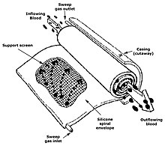
Fig. Diagrammatic representation of silicone membrane oxygenator.

8. Medical imaging

Medical/biomedical imaging is related to the study of medical devices. In this technique we can study about the process of imaging the internal parts of a body for clinical analysis and medical diagnosis. For this purpose we can use ultrasound, magnetism, UV, radiology, and other various techniques. For example, catheter placement into the brain or feeding tube placement systems alternatively navigated and guided with various equipment, which utilizes electromagnetic tracking technologies.

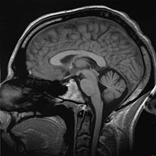
Fig. Diagrammatic representation of MRI scan of a human head comes under Biomedical Imaging.
Imaging technologies are often essential to medical diagnosis, and are typically the most complex equipment found in a hospital including: fluoroscopy, magnetic resonance imaging (MRI), nuclear medicine, positron emission tomography (PET), PET-CT scans, projection radiography such as X-rays and CT scans, tomography, ultrasound, optical microscopy, and electron microscopy.

9. Medical implants
Medical implant technology is the study in which we can replace a missing biological structure of human body (as compared to transplant, which indicates transplanted biomedical tissue). We can construct various medical devices for that purpose. The surface of implants which comes in contact to the body can be made up of different biomedical materials like titanium, silicone or apatite, which is depends on the most functionality. Implants contain electronics in some cases, e.g. artificial pacemakers and cochlear implants.

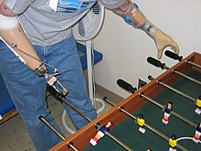
Fig. Diagrammatic representation of Artificial limbs: The right arm shows prosthesis, and left arm shows myoelectric control.
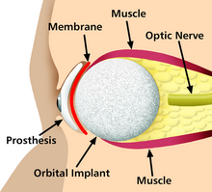
Fig. Diagrammatic representation of a prosthetic eye, an example of medical implants

10. Bionics
Under bionics we have to study about the artificial body part replacements, which is the most important application of this branch of Bioengineering. It is concerned with the study of the various properties and functions of human body systems. It can be applied for solving many engineering problems. Study of the different functions and processes of the eyes, ears, and other organs in a proper way give the right direction to improve cameras, television, radio transmitters and receivers, and many more.

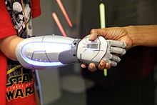
Fig. Diagrammatic representation of Bionics (An organ replacement technology)

11. Biomedical sensors
Biomedical sensors technology is based on microwave, which gained the most attention. Different sensors are manufacturing for particular uses in both to diagnose and monitor various diseases, for example microwave sensors can be used to monitor the lower extremity trauma as a complementary technique by using X-rays. Biomedical sensors notice the changes present in various tissues of bones, muscles, fat etc. under the skin, which can be monitor by the dielectric properties. So, during the healing process, which is measuring at different levels the response from the sensors changes with the healing of trauma.
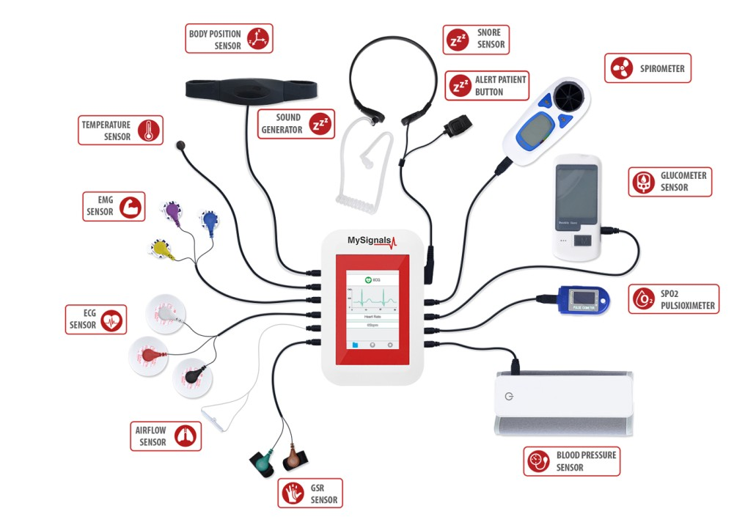
Fig. Diagrammatic representation of biomedical sensors.
12. Clinical Engineering
Clinical engineering, which is a branch of biomedical engineering deals with the study of the process of implementation of equipment and technologies in hospitals and other clinical labs. Clinical engineers also works in the collaboration of medical device producers related to various design improvements, which are based on their clinical experiences. They also monitor to redirect procurement patterns accordingly to the progression of the state of the art.

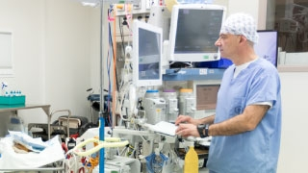

Fig. A clinical Engineer supervising the medical equipment.

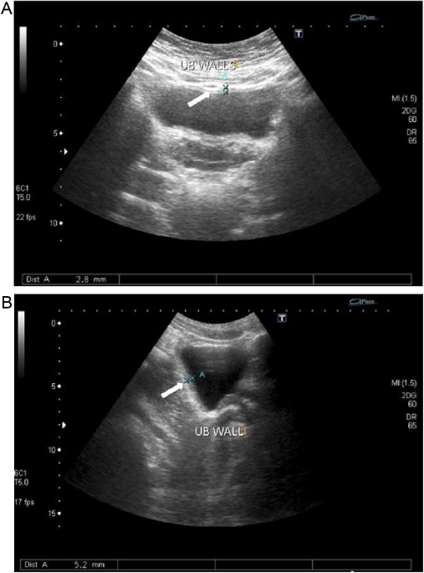
Fig. Diagrammatic representation of Ultra-sound of urinary bladder (black butterfly-like shape) shows hyperplastic prostate, which is an example of practical and medical science working together.
13. Rehabilitation engineering

Rehabilitation engineering is the study of engineering sciences in which students will learn to solve the problem related to the person, who possess physical disabilities by designing, developing, adapting, testing, evaluating, applying, and distributing the problem related organs. Problems related to mobility, communications, hearing, vision, and cognition, and activities associated with employment, independent living, education, and integration into the community are solve under Rehabilitation engineering.

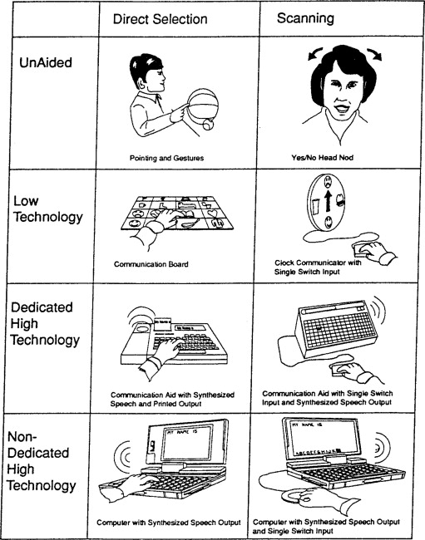

Fig. Diagrammatic representation of a hearing, vision, and cognition through Rehabilitation engineering.

