RESEARCH OF PERFORMANCE MANAGEMENT IN THE FIELD OF INFORMATION TECHNOLOGY
Author : Dr. SYED ARSHAD HUSSAIN,
Professor & Vice principal, Hyderabad School of Management.

Abstract

Human resources management is becoming more vital in today's fast-paced world since people are a crucial resource. Taking care of your organization's "internal customers," or employees, by concentrating on ways to enhance their performance over time can pay dividends in terms of both morale and productivity. At the same time, the Organization is committed to developing its employees via rigorous training in the hopes that they can, in turn, boost the Organization's efficiency and effectiveness. Briefly said, "Performance management" is all the rage these days, and the old adage "perform or perish" no longer applies. Here, it's crucial that researchers have a firm grasp of the idea of "employee perception" in relation to "performance management systems in the IT industry," as well as the relevant literature, and any gaps that may be filled in by future studies. The information technology sector is the subject of this article since it is the second most populous industry in India. Buyer trust has been bolstered thanks to the Indian IT industry's well-deserved reputation for excellence in software development, service quality, and data security in international markets. HR has shifted its emphasis to develop operational strategies that aid in carrying out the company's overarching goals. Human resources nowadays strives to help and boost workers' productivity by creating a positive work environment and giving workers a voice in the company's strategic planning and daily operations as much as possible. The study examines the significance of performance management in the information technology sector. Employees, teams, and departments may all benefit from a Performance Management System (PMS), which is a methodical and ongoing strategy to assessing how well they're meeting organisational objectives and how well those objectives and goals coincide with those of individual workers. Through the use of the PMS, management may determine whether any employees' work habits are in conflict with the company's overarching aims and objectives. A company may use the PMS as a starting point to discover where it stands in terms of existing and future skill sets.

Keywords: Workforce, Employee Opinions, Performance Management and Company Results are all aspects of Performance Management.

- INTRODUCTION
An organisation can only succeed if its leaders put its workers, whom they refer to as "internal customers," first and work hard to help them improve their skills and abilities in a manner that benefits both their careers and the company as a whole. At the same time, the Organization is committed to developing its employees via rigorous training in the hopes that they can, in turn, boost the Organization's efficiency and effectiveness. Briefly said, "performance management" is all the rage these days, and the old adage "perform or perish" no longer applies. Organizations often struggle with defining, measuring, and motivating employee performance, yet addressing these issues is essential to performance management. It's the way bosses make sure their staff is working to achieve their organization's objectives. There has to be an agreement on the targeted results, how they will be accomplished, organised, executed, and assessed, and how all managers and staff will be given feedback on their performance if this process is to be carried out effectively. Managers and staff members, via exchanging comments, may become aware of shortcomings and work out solutions. Evaluation of past performance is crucial to effective performance management. To be clear, it is not Performance Management in and of itself, but rather one of several instruments available for such an endeavour. Conversely, the Manager will learn who is doing well and who isn't thanks to the feedback mechanism in place. As a kind of organisational motivation, performance evaluation is only one component. The purpose of a performance assessment is to gather, examine, and document evidence of an employee's relative value. Its purpose is to assess a worker's performance. The contemporary climate of intense rivalry necessitates the use of performance management techniques. Together with employees, managers establish goals, track progress toward those goals, provide constructive criticism and guidance in an effort to boost performance, and finally, recognise and reward those who excel. A new employee's performance is managed from the time they are hired until the time they leave the company.
The scope of a performance management system may be as broad as a whole company, a single department, an individual person, or even the procedures used to manufacture a product or service. The majority of the time, this is employed in offices where individuals will be interacting with one another. A company can only thrive if it consistently rewards its best employees and works to enhance the skills of its underachievers. Successful businesses understand that in order to succeed in today's competitive market, they must recruit, train, and keep personnel who are both skilled and productive. A performance management system aids in the recruitment of top talent, the placement of employees in positions where they can best contribute to the organization's goals, the enhancement of employees' skills and the distribution of rewards in proportion to their performance. There are a lot of external elements that can't be controlled and the business climate is changing rapidly. Changes in the social, cultural, legal, political, economic, technological, and competitive environments occur at a rapid pace. Once again, we are in need of hardworking individuals with specialised expertise who are committed to producing excellent results. It is very challenging to launch a firm, much alone maintain it, reach critical mass, and eventually become a market leader in today's cutthroat business climate. Businesses that invest in their employees and treat them well will have a leg up on the competition. Employees' efforts in the workplace are crucial to the success and growth of any company. Organizational success relies on the efforts of many people doing a variety of tasks in tandem with one another. These include workforce alignment, competency development, improved business outcomes, ongoing training and development, and enhanced productivity. In a nutshell, the Performance Management process includes actions like goal-setting, conducting regular qualitative and quantitative performance evaluations, pinpointing areas of weakness, and formulating strategies for improvement. These factors will be used in the employee evaluation. We strive for excellence in all aspects of our business, including but not limited to: customer service, operations, finances, people management, and personal growth.
  - Managing Performance: A Flowchart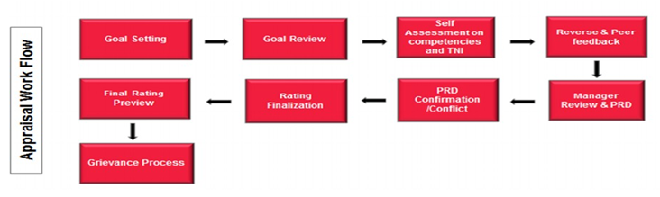
The Performance Management System employs a specific approach, as seen in Figure 1.
A Framework for the Management of IT Organizational Performance:

Frameworks for managing employees' performance are developed with the intention of boosting productivity at every level: from the individual to the company. This is done by pinpointing specific areas for improvement, communicating those areas' expectations, and giving workers ample opportunities to learn and grow in their roles. Integrating all of an organization's parts for maximum efficiency is the key to performance management. An efficient method for managing performance requires certain parts. Planning, assessing, and receiving feedback on performance, as well as recognising and rewarding exceptional effort, are all examples. At the outset of a performance session, the appraiser and reviewer should work together to plan the employee's performance, including the employee's input on the session's goals and KPIs. Appraisals are typically conducted twice yearly. Here, the appraiser presents the employee with self-evaluation forms before giving final evaluations for the individual's observable and measurable accomplishments. The performance management method places a heavy emphasis on providing constructive criticism and guidance. An employee's incentive to work will be greatly aided by the availability of rewards. Staff members that go above and beyond their duties are given public praise and monetary bonuses. Employees who feel their efforts are appreciated by their employers are better able to bounce back from setbacks and are less likely to leave the company in search of appreciation elsewhere. There will be a new set of goals made for the worker and a new deadline given if the worker's performance continues to be subpar.
- Review of Literature
The use of performance management systems may be a potent catalyst for positive transformation. In the 1980s besides 1990s. As one would assume, workers with comparable levels of experience were paid similarly and advanced through the ranks at about the same rate. The transition to a society focused on public display was radical. It was governed by performance and centred on equity rather than equality. For workers to feel appreciated for their efforts, supervisors must provide frequent guidance and constructive criticism of their work. Objectives and objectives were to be defined, along with indications of success like key performance or key outcome areas. A meaningful yearly evaluation and consistent progress assessments were essential. In order to make any kind of call, it was necessary to gather data on performance.
Craig when seeking to increase efficiency, output, and quality via the use of a performance management system, common roadblocks were outlined by Eric Schneir. Companies establish long-term strategies that often include the introduction of new goods and services. These strategies will only work if put into action. The objectives and the envisioned future are important, but they are usually not enough. They need to be used in conjunction with a performance management system that defines success, provides tools for measuring it, and holds individuals responsible for reaching it. Modifying fundamental HRM processes like performance evaluation, bonus distribution, recruitment, and education and development may have a profound impact on organisations over the long term. In many businesses, the gap between what is officially proclaimed as vital and what is understood to count is wide. According to the results of a recent poll, upper management must institute new measures of responsibility in order to facilitate transformation. There should be both good and negative outcomes for actions taken. Pay raises for all employees have been reduced or cancelled at several companies. In an era when monetary prizes are more limited, it's clear that those of a different kind are greatly prized. The beliefs and expectations of modern employees need a more flexible approach to compensation. A number of academics responded to Deming's warning by arguing that conventional performance management approaches might be adapted to foster quality. When human resource management is more integrated into the organization's overall strategy, a focus on quality has a more profound impact on productivity. Constituents of a Performance Management Structure Management by Objectives as per Dr Syed Arshad Hussain When it comes to managing performance, the first and perhaps most important step is performance planning, which in turn serves as the cornerstone of performance evaluations. Planning for the performance appraisal is a collaborative effort between the appraisee and reviewee. After discussing and agreeing on a performance budget with their reporting officer, workers use this time to set annual goals and choose which critical performance areas will be measured. Rating and Assessing Performance
  - Performance Evaluations, followed by Individual Counselling and Performance Enhancement:
The performance management method places a heavy emphasis on providing constructive criticism and guidance. At this point, the employee receives feedback from their appraiser on where they can improve their performance and what kind of contributions they are making to the company. In addition to identifying the employee's training and development requirements, the employee gets open and honest feedback. At this point, the employee's outstanding work is acknowledged in public and rewarded monetarily. There is a lot at stake at this point for the worker, since it may have an immediate effect on their sense of worth and motivation to succeed. Employees who feel their efforts are appreciated by their employers are better able to rebound from setbacks and are more likely to feel loved by their employers.
  - Improvement Strategies for Performance
In this phase, a worker is given a new set of goals to work toward and a fresh deadline by which to complete them. The employee is given explicit feedback on where they may improve, as well as a time frame in which this feedback is required. Appraiser and client work together to create and agree upon this strategy.
  - Evaluating Possibilities
Employees' ability to advance laterally and upward is based on their potential evaluation. Potential is evaluated via the use of competence mapping and other evaluation strategies. Evaluation of potential is a vital component of succession planning and job rotation.
Human performance in businesses may be identified, measured, and developed via performance management. Information obtained via systematic observations that may be used to not only correctly gauge present performance, but also to suggest adjustments that will improve future performance.
Planning for performance, evaluating that performance, and engaging in mutually beneficial corrective and adaptive action via feedback talks are the three phases of the cycle outlined by Ainsworth and Smith (1993). Another three-stage procedure is proposed by Dr. Syed Arshad Hussain (2022), which includes preparation, implementation, and evaluation. Planning, providing assistance and evaluating results are the three stages of the paradigm suggested by Torrington and Hall (1995). All three models stress the need of communication between the management and the managed on roles and responsibilities. The line manager is responsible for providing assistance in achieving performance goals and has an important role to play in conducting performance reviews.
  - Approach and Research Plan Analysing the State of Performance Management
Identifying the factors that most affect employee performance; and recommending any necessary adjustments to the PMS as it stands.
To stay ahead in today's world of globalisation and cutthroat competition, businesses have begun using strategic HR strategies.
• A company's ability to coordinate its workers' efforts toward the realisation of its goal and vision depends in large part on the effectiveness of its performance management system.
To a large extent, an organization's success rests on the dedication, expertise, and transparency of its people, making performance management a formidable issue.
• If implemented correctly, a performance management system may be a powerful instrument for motivating and developing employees via the use of a well-planned reward practise and feedback mechanism.
Methods of Observation and Measurement Statistics and Detailed Description Tables:
Employees' Knowledge of the Performance Review System There were 113 people who filled out our survey, and we wanted to know how many of them were aware of the company's performance assessment procedure (see table 1.1) The remaining 26 people polled, or 23.1%, were either unable to answer or had no idea how performance reviews were handled at their workplace (see in Fig 1.1) Conducting Performance Planning (Awareness of Performance Appraisal Process) Performance planning is often handled at a granular level inside an organisation. The people that do this are identified by surveying them and tabulating their answers to a series of questions.
Planned Performance Actions in table 1.1.

“OPTION | NO OF RESPONDENTS | % OF RESPONSE
APPRAISE | 28 | 24.7
REVIEWEE | 40 | 35.39

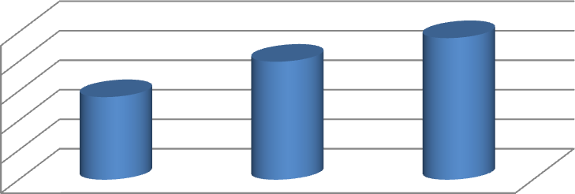
Appraisal or self-evaluation are common methods for completing performance planning. Twenty-eight of those polled (24.7%) claimed they utilize assess to figure out prices.
50
40
30
20
10
0
APPRAISE
REVIEWEE
BOTH
Performance Planning in Action, Fig. 1.1

From a total of 40 responses, 35.39 percent think the reviewee is responsible for conducting the evaluation, while 42.47 percent say both parties are involved”. Sharing Information Regarding Organizational Objectives
In businesses, workers are made aware of their aims and objectives so that gaps may be filled and progress can be monitored.
Goals and objectives are discussed in Table 1.2.
“OPTION | NO OF RESPONDENTS | % OF RESPONSE
YES | 80 | 70.79
NO | 33 | 29.21
TOTAL | 113

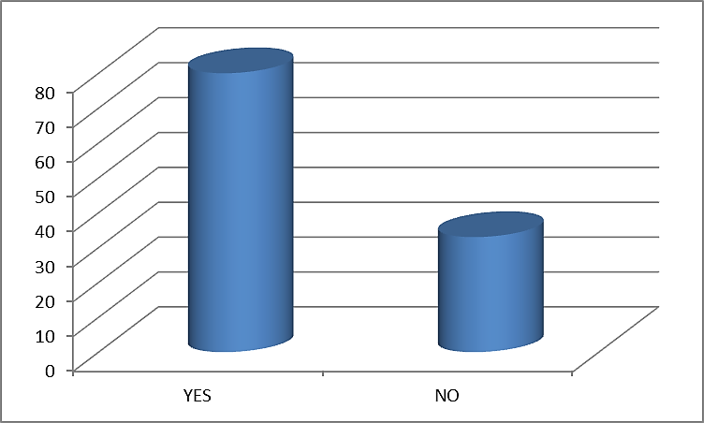
In order to accomplish the set goals and objectives, personnel are assigned specific responsibilities and given a deadline by which they must finish the work ”. Eighty people
Goals and objectives are discussed in Figure 1.2.

Responded, and 70.79 percent of them reported being aware of their own personal aims.
Key Performance Indicators Set in Stone
Some aspects are constant in every firm, and among them are the areas in which personnel are evaluated. There are 4 choices provided to learn how companies are improving their key performance areas.
Key Performance Indicators Set in Stone
Of the 15 respondents, 36.28% claimed KPAs are determined by company goals, 13.13% by departmental targets, and 15.04% by personal performance.
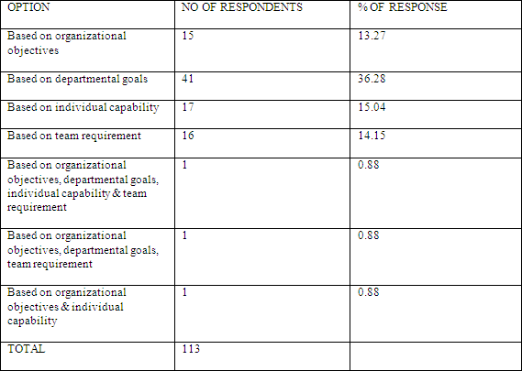

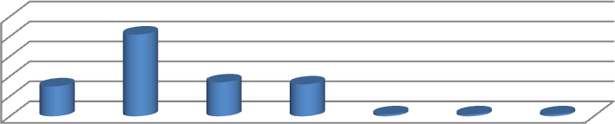
50
40
30
20
10
0
Figure 1.2 Key Performance Indicators Set in Stone

1.3 Performance Evaluation Strategy
The method used to assess staff performance will vary depending on the company. We know what style is preferred since we gave it a few choices and recorded the outcomes.
Technique for Evaluating Performance
The method used to assess staff performance will vary depending on the company. We know what style is preferred since we gave it a few choices and recorded the outcomes
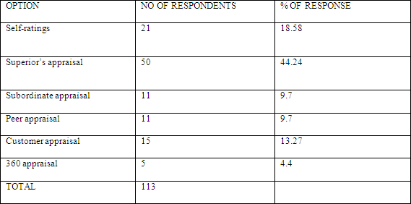
Method of Performance Evaluation Table 1.3
While 18.58 percent of respondents said it is based on workers' own opinions of their performance, 44.24 percent said it is determined by managers' assessments. Only 9.7 percent of respondents.
50
40
30
20
10
0

Figure 1.4: Individual Advice and Direction
Critical role of advice and criticism Employee performance may be influenced in part via the provision of feedback and counselling. This shows how seriously they take comments inside the company.
“Table 1.4: The Value of Comments and Advice
OPTION | NO OF RESPONDENTS | % OF RESPONSE
YES | 75 | 66.37
NO | 38 | 33.62
TOTAL | 113 | ”

Seventy-five people (or 66.37 percent) out of 113 stated they feel that their company gives criticism and counselling adequate attention.

Figure 1.5. the Value of Constructive Critiques and Advice

The company is not placing enough value on feedback and counseling, according to 38 respondents (33.62%). Training Program Nomination After a performance assessment is completed, workers who are falling behind are often recommended for the company's internal training programmes.When workers do a good job, it shows that they care about their work and attempt to do it even better when they are publicly acknowledged and recognised for it.
.
1.7. Points Mean Standard in Merit Pay Administration
Staff performance may be evaluated and merit raises can be distributed with the aid of a performance management system.

Sixty-four percent of the 113 respondents indicated the performance management system they are using aids in the implementation of merit pay. “Merit Pay Administration Using a PMS (Figure 1.7) PMS's Role in Promotion Decisions Promotions are awarded based on how well workers perform as measured by the PMS.
Table 1.7.: PMS linking to Promotion decisions

Management might base raise and promotion choices on employee performance reviews and ratings”. Seventy-nine people out of 113 (78.7%) responded that their performance management system was involved in their promotion.

Findings and Suggestions
- 76% of those who participated in the survey reported having a high level of knowledge of PAP.
- Appraisal and review are used interchangeably in the majority of cases (42.63%).
- Alignment of performance planning with company goals and objectives was rated favorably by 70.79 percent of respondents.
- 36.28% of respondents said that KPIs are determined by organisational objectives. The other replies to the question on how to establish KPAs in light of corporate goals, personal strengths, and team needs were more or less evenly split.
- According to the results, 44.24% of respondents work in an environment where superiors conduct performance reviews. Next came evaluations by one's superiors, followed by evaluations by one's customers, subordinates, and peers, and finally a 360-degree evaluation (4.6% of respondents).
- According to the results, 80.53 percent of respondents said that quantitative and qualitative factors were both considered when assigning ratings.
- In the self-evaluation forms, 77.87% of respondents said that they were aware of the relevant factors.
- Findings showed that following a performance assessment, the appraiser provides open and transparent comments to 50.44 percent of respondents. Then, 39.82 percent of people said they had gotten their share of the anticipated performance.
- There was a significant increase in the percentage of those who said they get individual counseling and advice after their performance assessment (60.17%).
- The majority of employees (66.37 percent) agree that their opinions and suggestions are valued by the company.
- 51.32 percent of participants in the survey attested that they get nominations for training programmes as a result of their performance reviews.
- 53.11% of people said they felt appreciated by the general population.
- Results show that over half of respondents (55.75%) believe that performance reviews should focus on an employee's specific performance.
- A total of 51.32 percent of participants said their company does performance reviews twice a year.
- Three-and-a-half percent (37.5%) of those surveyed said their present performance management system is helpful in reaching organisational goals. Then, 34.51% of them said they would pick up the pace to meet market expectations.
- The current performance management approach is judged to improve operational efficiency by 20.35 percent of respondents.
- A total of 64.60 percent of respondents agreed that the company's performance management system aids in the distribution of merit pay, as shown by the study's results.
- An overwhelming majority of respondents (77.87%) said that promotion choices are tied into the company's performance management system.
- Sixty-nine point one percent of those surveyed said that taking part in the performance evaluation process improved workplace relationships.
- When asked whether a performance management system aids in the formation of long-term professional objectives, 54.86 percent of respondents said it did.

Conclusion
The research concludes that the performance management system is crucial to the success of the business. Insightful analysis of the data gathered shows that everyone in the company is familiar with the system and its functions. They are also familiar with the self-assessment forms, key performance areas, and overall goals that they have set for themselves. Employees are counselled and guided individually and collectively based on the system's determined performance. With this system in place, we can more quickly adapt to changes in the market and fulfil the needs of our customers. It's also useful for management when deciding someone to promote. As a result, the organization's staff is happy with the current system and reaping its advantages. The primary goal of this research is to investigate the relationships between the Performance Management System and other explanatory factors, and to provide some tentative recommendations based on those analyses. After conducting a thorough literature research, several aspects were found using content analysis. In order to illustrate the connection between the Performance management System and the other factors, a conceptual model was presented. This research is entirely theoretical and thus requires empirical evidence from the real world.

REFERENCES

  - “Chandhana, K and Dr. David T Easow (2015), Performance Appraisal Method Used in Top 10 IT Companies – 360 Degree Feedback & Balanced Score Card: A Review, Bonfring International Journal of Industrial Engineering and Management Science, Vol. 5, No. 2, pp- 73-77.
  - Rajput, Veena. (Apr-Jun 2015) Performance Appraisal System, Asian Journal of Nursing Education and Research 5.2 (Apr-Jun 2015): 287-292.
  - Rinku Sanjeev and Sanjeev Kumar Singh (2014), Employee Perception towards Performance Appraisal Program in Packaging Industry, Journal of Strategic Human Resource Management, Volume 3, Issue 1, February 2014, PP – 16-22.
  - Anbarasu Thangavelu and Dr.J Clement Sudhahar (2014), Performance Management Challenges in IT Industry – An Overview, Global Journal for Research Analysis, Vol-03, Issue -02, ISSN No 2277-8160.
  - Jawad Abdas, Asif Muzaffar, Hassan Khawar Mahmood, Muhammad Atib Ramzan and Syed Sibi UI Hassan Rizvi (2014), Impact of Technology on Performance of Employees (A Case Study on Allied Bank Ltd, Pakistan), World Applied Sciences Journal, Vol-29 (2), PP-271-276.
  - Bethuel Sibongiseni Ngcamu (2013), ‘the Empirical Analysis of Performance Management System: A Case Study of a University in South Africa, Journal of Economic and Behavioural Studies, Vol-5, No-5, PP-316-324, May 2013, ISSN: 2220-6140.
  - Rohan Singh, Madhumita Mohanty and Mohanty A.K. (2013), Performance Appraisal Practices in Indian Services and Manufacturing Sector Organisations, Asian Journal of Management Research, Integrated Publishing Association, Vol-4, Issue -2, PP-256-265.
  - Hamumokola, Ndafuda Ndayandjoshisho (2013), The Contributions of Performance Management Systems To performance in The Namibian Context’, Ph.D Thesis, the Faculty of Commerce, Law and Management, University of the Witwatersrand, Johannesburg, September 2013.
  - Rajesh K. Yadav and Nishant Dabhade (2013), Performance Management system in Maharatna Companies ( a leading public Sector undertaking) of India – A Case study of BHEL, Bhopal (M.P.), International Letters of Social and Humanistic Sciences, Vol-4, PP-49-69.
  - Sunil Kumar Pradhan and Dr. Suman Kalyan Chaudhury, (2012), A survey on employee performance management and its implication to their relation in OCL India Ltd, Asian Journal of research in social sciences and Humanities, Vol .2, Issue 4, April 2012.
  - Mrs. U. Priya and Dr. A. Peer Mohideen. A Study on Attitude of Worker's towards Performance Management System at Robinsons Cargo and Logistics Pvt. Ltd., Chennai. International Journal of Management, 7(2), 2016, pp. 629-635.
  - Dr. R. Gopinath, A Study on Performance Management In BSNL with Special Reference To Job Satisfaction In Three Different SSAS Using Modeling. International Journal of Management, 7(5), 2016, pp.43–51.
  - Nitu Yadav, Performance Management & Measurement In HR and Payroll. International Journal of Management, 8 (6), 2017, pp. 76–80.
  - Dr.L.Vijay and B.Jayachitra, Effectiveness of Performance Management System, International Journal of Advanced Research In Management (IJARM), Volume 1, Issue 1, January- June (2000), pp. 53-59 ”.

