TOOLS FOR DATA COLLECTION:
Ms. Muskan Thakur, Ms. Pooja, Ms. Yoshita
Akal College of Nursing, Eternal University, Baru Sahib
ABSTRACT
In this chapter we have provided an overview of various tools used for various data collection methods. One of the main stages in a research study is data collection that enables the researcher to find answers to research questions. Data collection is the process of collecting data aiming to gain insights regarding the research topic. There are different types of data and different data collection methods accordingly. However, it may be challenging for researchers to select the most appropriate type of data collection based on the type of data that is used in the research. This article aims to provide a comprehensive source for data collection tools. The possible methodologies for gathering data are then explained based on these categories and the advantages and disadvantages of utilizing these tools are defined. Qualitative researchers prefer more open-ended, less structured data collection tools than do quantitative researchers. Direct observation of participants is common in experimental and qualitative research; it is less common in so-called survey research, which tends to use self-report questionnaires. It is important that investigators use tools that are reliable and valid for the population and purpose for which they will be used. Standardized tools have manuals that provide norms and indexes of reliability and validity. However, if the populations and purpose on which these data are based are different from yours, it may be necessary for you to develop your own tool or provide new evidence of reliability and validity.
KEY TERMS: Data, Data Collection, Data Collection Tools.
INTRODUCTION
Data collection is the process of gathering and measuring information on variables of interest, in an established systematic fashion that enables one to answer stated research questions, test hypotheses, and evaluate outcomes. As is well known, gathering primary data is costly and time intensive. The main techniques for gathering data are observation, interviews, questionnaires, schedules, and surveys.
The term "data collecting tools" refers to the tools/devices used to gather data, such as a paper questionnaire or a system for computer-assisted interviews. Tools used to gather data include case studies, checklists, interviews, occasionally observation, surveys, and questionnaires. While qualitative research focuses on words and meanings, quantitative research deals with figures and statistics. You can systematically measure variables and test hypotheses using quantitative methods. You can delve deeper into ideas and experiences using qualitative methodologies.
While there are numerous other ways to get quantitative information, the methods indicated above—probability sampling, interviews, questionnaire observation, and document review—are the most typical and frequently employed, whether collecting information offline or online. User research that includes both qualitative and quantitative techniques is known as mixed methods research. For deeper user insights, mixed methods research combines insightful user data with useful statistics.
TOOLS FOR DATA COLLECTION:
A research instruments is a device used to measure the concept of interest in a research-projects that a researcher uses to collect data.
S.NO. | TYPES OF METHODS/TECHNIQUES | TOOLS FOR DATA COLLECTION
1. | Interview | - Interview Schedule  - Opinionnaire
2. | Questioning | - Questionnaire  - Opinionnaire  - Attitude Scale/ Composite Scales (Likert Scale/ Semantic Differential Scale)  - Visual Analogue Scale
3. | Observation | - Rating Scales  - Checklists  - Anecdotes  - Videotapes/Films  - Closed Circuit TV
4. | Biophysiological Methods | - In vivo Biophysiological methods  - In vitro Biophysiological methods
5. | Other Methods | - Projectile techniques  - Q-Sorts  - Vignettes

1.INTERVIEW METHOD
DEFINITION:
- Interview method is a method of data collection in which one person (interviewer) asks the questions from another person (respondent) which is conducted either face to face or telephonically.
- An interview is a conversation between two or more people (interviewer & interviewee) where questions are asked by interviewer to obtain information from the interviewee.
CHARACTERSTICS OF INTERVIEW:
- The participants, the interviewer and respondents are strangers.
- The relationship between the participants is a transitory one.
- Interview is a mode of obtaining verbal answers to question put verbally.
- Investigators records information's.
- Interviews can be conducted over telephone also.
- It is not always limited to a single respondent.
- It is not a standardized process. It can be modified according to the situation.
BENEFITS OF INTERVIEW:
- Provide in depth and detailed information
- Permits greater depth of response
- Data form illiterate subjects
- Higher responses
- Clarify misunderstandings
- Ask questions at several levels
Types of Interviews:
- Structured Interview (Directive interview)
- Un-structured Interview (non-directive Interview)
- Semi-structured Interview
- In depth Interview
- Focused Group Interview

INTERVIEWING PROCESS:

ADVANTAGES OF INTERVIEWS: It is useful to obtain information about people feelings, perceptions and opinions.
- It allows more detailed questions to be asked.
- High responses rate is achieved
- Respondent’s own words are recorded.
- Ambiguities can be clarified.
- Meanings of questions can be clarified.
DISADVANTAGES: It is time consuming and costly.
- High degree chances of interviews bias.

2.QUESTIONNAIRE METHOD
DEFINITION:
- A questionnaire is a structured instruments consisting a series of questions prepared by researcher that a research subject is asked to complete, to gather data form individuals about knowledge, attitude, beliefs & feelings.
- A questionnaire is a structured self-report paper and pencil instruments that a research subject is asked to complete.
TYPES OF QUESTIONNAIRES:
- OPEN FORMAT QUESTIONS: Open ended questions are those questions which provide opportunity to the respondents to express their opinions and answer in their own way.

Examples-
- Tell me about your relationship with your friends.
- What happened at the meeting?
- How do get to work?
- Why is it that every time I talk with you, you seem irritated?
- Where do you want to be in five years?

- CLOSED FORMAT QUESTIONS: These questions offer respondents a number of alternative replies, from which the subjects must choose the most likely matches the appropriate answer. A closed ended questions refers to any questions for which a researcher provides research participants with options from which to choose a response.

- Dichotomous questions: these require the respondent to make a choice between two responses such as yes/no or male/female.
Example
1. Have you ever been hospitalized?
a. Yes b. No
2. Please enter you gender:
a. Male b. Female

- Multiple choice question: these questions require respondents to make a choice between more than two responses alternatives.
Examples
1. What is the basic functional unit of the kidney?
a. Renal cortex b. Nephron c. Glomerulus d. Renal medulla

2. Who is known as Lady with the lamp?
a. Mother Teresa b. Sarojini Naidu c. Florence nightingale d. None of these

- Cafeteria questions: these are a special type of multiple-choice questions that ask respondents to select a response that most closely corresponds to their views.
Examples
1. People have different view on family planning which of the following best represent your views?
a. It is necessary to quality life.
b. It is immoral and should be totally banned.
c. It has undesirable side effects that suggests needs for caution.
d. It is immoral and should be practiced.

- Rank order questions: these questions ask respondents to rank their responses from most favourable to least favourable.
Example
1. What according to you is most important for your life. Rank from most favourable to least favourable.
a. Money b. Education c. Family d. Health

- Contingency questions: A question that is asked further only if the respondent gives a particular response to previous questions.
Examples
1. Do you have children under 18 at home?
a. No b. yes, if yes please list ages

2. Did you buy anything in the hotel shop?
a. Yes (go to Q. 10) b. no (go to Q. 13)

3.What did you buy in the shop?
a. Clothes b. Stationery c. Other d. Toys

- Rating questions: these questions ask respondents to judge something along an order dimension. Respondents is asked to rate a particular issue on a scale that ranges from poor to good. They may provide a number of choices.
Examples
- How do you rate the following ?
Items | Very poor 1 | Poor 2 | Ok 3 | Good 4 | Very good5
Service
Cleanliness
Parking
Quality of food
Choice of food

- Importance questions: In this respondent are asked to rate the importance of a particular issue, on a rating scale of 1-5. this helps to know that the things/ issues that are important to a respondent.
Examples-
1 | 2 | 3 | 4 | 5
Extremely  important | Very  Important | Somewhat  important | Not very  Important | Not At all important

- Likert questions: It helps to know how strongly the respondents agrees with a particular statement. These questions help to assess how respondents feels towards a certain issues/ service.
- Person with multiple sex partners is at high risk of AIDS?
1 | 2 | 3 | 4 | 5
Strongly  Agree | Agree | Uncertain | Disagree | Strongly Disagree

- Bipolar questions: Bipolar questions are questions that have two extreme answers. Respondent has to mark his or her response between two opposite ends of the scale.
Examples
- What is your balance of preference here?
I like going for walks ( ) ( ) ( ) ( ) I like watching movie

- Matrix questions: It includes multiple questions and identical response categories are assigned. Questions are placed one under another, forming a matrix. Response categories are placed under along the top and a list of questions down the side.
Examples
- How satisfied or dissatisfied are you with each of the following attributes?
ITEMS | Very satisfied 5 | Satisfied 4 | Natural 3 | Dissatisfied 4 | Very dissatisfied 5
Staff behaviour at the reception
Food quality
Speed of service
Behaviour of the waiter
Cost of the food items
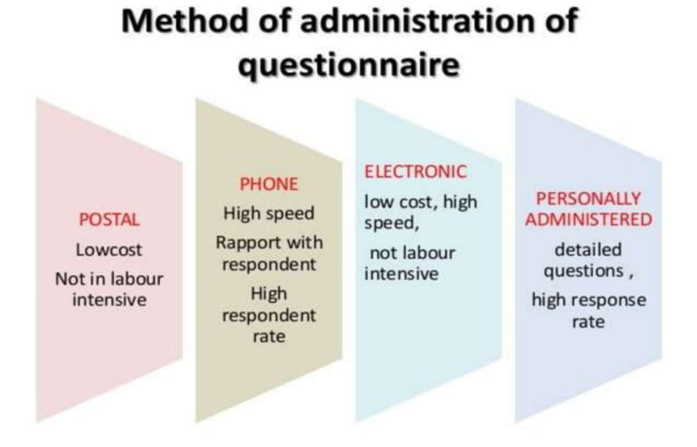
Guidelines for designing a good questionnaire:
- It must be developed exactly in accordance with study objectives.
- It should begin with the instructions for the respondents to provide the responses.
- The questionnaire should be concise, precise and brief.
- Language should be according to the respondent’s knowledge about a particular knowledge.
- Avoid professional jargons.
- As far as possible open-ended questions should be avoided.
- Avoid questions with difficult concepts.
- Controversial and ambiguous questions should be avoided.
- Questions which are likely to lead too bias in the respondents should be avoided.
ADVANTAGES OF QUESTIONNAIRE:
- Cost effective.
- Easy to analyse.
- Less time and energy to administer.
- Reduce bias.
- Used for large sample size.
DISADVANTAGES:
- Not suitable for all.
- Low response rate.
- It sent by mail may be filled by someone.
- Its provide only superficial information.
- Chances of misinterpretations.
- People can lie and answer the questions vaguely.

- COMPOSITE SCALE / ATTITUDE SCALE
DEFINITION:
- Composite scales are socio-psychological measurements, which are directed towards quantifying the qualitative attributes` such as feelings, attitude, self concepts, perceptions and beliefs etc.
- Attitude scale is a special type of questionnaire designed to produce scores indicating the intensity and direction (for/against) of a person’s feelings about an object or event.
Likert scale:
- Likert scale was developed by psychologists Rensis likert in 1932 as a psychological concept measurement scale.
- It scale was developed to measure the attitudes, values, and feelings of peoples.
- Primarily original version of this scale is 5 point scales (strongly agree, agree, uncertain, disagree or strongly disagree).
- How ever in recent times one can even observe the likert scale with 4 point scale (strongly agree, moderately agree, disagree, and uncertain) to 7 point scale (very strongly agree, strongly agree, agree, uncertain, disagree, strongly disagree and very strongly disagree).
Definition:
- Likert scale is a composite measurement scale used to measure attitude, feelings and value of the people that involve summation of scores on the set of positive and negative declarative statements regarding measurable variables to which respondents are asked to indicate their degree of agreement or disagreement.
Use of Likert scale:
- It scales used to measure the attitudes, values, and feelings of the people about specific concepts such as situation, peoples, places, objects, programmes, practices, policies and so on.
- It may also be used to assess the opinions of the respondents.
- This scale is used to have quantified measurement of the qualitative attributes of peoples such as feelings, values, beliefs.
Likert scale examples: •
Agreement  Question: “The checkout process was straightforward” | - Strongly Agree  - Agree  - Neither Agree nor Disagree  - Disagree  - Strongly Disagree

Likelihood  Question: “I would recommend this product to my friends” | - Very Likely  - Likely  - Neutral  - Not Likely  - Very Unlikely

Satisfaction  Question: “Please rate your satisfaction with your recent customer service experience:” | - Very Happy  - Somewhat Happy  - Neutral  - Not Very Happy  - Not at All Happy

Statement | Strongly agree | Agree | Uncertain | Disagree | Strongly Disagree
Positive statement:  Person with multiple sex partners is at high risk of AIDS | 5 | 4 | 3 | 2 | 1
Negative statement:  You can get AIDS by sharing utensils | 1 | 2 | 3 | 4 | 5

ADVANTAGES:
- Easy to construct this scale.
- More reliable and valid tool to measure the psychological variables.
- Easy to administer, since respondents only have to tick in spaces.
- Less time-consuming during construction & administration.
DISADVANTAGES
- Respondents may feel forced to answer the questions against all pre planned items and their categories.
- Feelings of the respondents may not be fully assessed due to researcher’s pre planned statements and categories.
- Difficulty in justifying the selection if the number of categories and numerical assignment to these categories.
- Good attitude statements take time to construct.

4.SEMANTIC DIFFERENTIAL SCALE
- The Semantic Differential Scale is a seven-point rating scale used to derive the respondent’s attitude towards the given object or event by asking him to select an appropriate position on a scale between two bipolar adjectives (such as “warm” or “cold”, “powerful” or “weak”, etc.)
DEFINITION:
Semantic differential scale is a type of rating scale designed to measure the connotative meaning of objects, events and concepts. These connotations are used to derive the respondent’s attitude towards the objects, events and concepts.
USE OF SEMANTIC DIFFERENTIAL SCALE
- Patient satisfaction survey
- Customer satisfaction survey
- Employee survey
- Marketing survey
- Personality measurement
- Clinical psychology
SEMANTIC DIFFERENTIAL SCALE:
The checkout process was:

Example of semantic differential scale: Assess the belief about HIV/AIDS-
Cure | 1 | 2 | 3 | 4 | 5 | 6 | 7 | Death
No punishment | 1 | 2 | 3 | 4 | 5 | 6 | 7 | Punishment
Social acceptance | 1 | 2 | 3 | 4 | 5 | 6 | 7 | Social rejection
Affordable treatment | 1 | 2 | 3 | 4 | 5 | 6 | 7 | Expensive treatment
Normal life | 1 | 2 | 3 | 4 | 5 | 6 | 7 | Miserable life

ADVANTAGES
- It is a convenient method to assess the beliefs, attitudes and values in quantitative form.
- Easy to administer.
- Provides reasonable valid and reliable quantitative data.
DISADVANTAGES
- Lack of standardization of the tool.
- Time consuming to find the appropriate adjective pairs.

5.VISUAL ANALOGUE SCALE
- Visual "Analogue" Scale, is a psychometric response scale that is used to measure the intensity of certain sensations and feelings, such as pain, discomfort, anxiety, quality of sleep, severity of clinical symptoms, functional ability and attitude towards environmental conditions.
- This has 10 cm lines and the ends marks semantic opposites. (Alert-drowsy)
DEFINITION:
- VAS is a tool that is used to assist a person in rating the intensity of certain feelings and sensations.
- The VAS is a bipolar scale used to determine the degree of stimuli a patient experiences. One side of the scale expresses the absence of stimuli, while the other expresses the presence of stimuli.
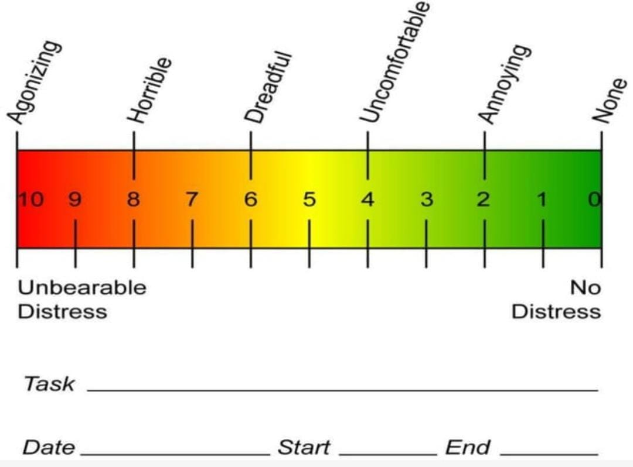

6.OBSERVATION METHOD
DEFINITION:
- The word observation is derived from Latin word ‘observere’ which means ‘to notice’.
- Observation is a technique for collecting data or acquiring information through occurrences that can be observed through senses with or without mechanical devices.
- It is a two-part process to collect data for study that includes an observer (someone who is observing) and the observed (there is something to observe).
USES
- To understand an ongoing process or situation.
- To gather data on individual behaviours or interactions between peoples.
- To know about a physical setting.
- Data collection where other methods are not possible.
TYPES
- Structured Observation
- Unstructured Observation
- Participant Observation
- Non participant Observation
- STRUCTURED OBSERVATION: In this method, researcher prepares a structured or semi-structured tool in advance to observe the phenomenon under study. This helps researchers to be on track while carrying out an observation as well as analysis of data collected during this method of observation remains easy.
- Check list
- Rating scale
- Category system

- UNSTRUCTURED OBSERVATIONS: This method is generally used in qualitative studies, where observation is made with minimally structured. It is used for complete and nonspecific observation of phenomenon, which is very well known by the researcher.
- Log and field notes
- Anecdotes
- Field dairy
- Video recording

- PARTICIPANT OBSERVATION: Historically, field and ethnographically researches have been associated most strongly with participant observations, where observer may live or work in field and actively participated in ongoing activities for an extended period.
- Log books
Fields notes
- Field diary
- Tape
- Video recording

- NON-PARTICIPANT OBSERVATION: In this type of observation, the observer works as an eavesdropper, where an attempt is made to observe peoples without interacting with them.
- In this technique the observer is not a participant in the setting but is merely viewing the situations. Peoples are observed without their knowledge that they are being observed.
And also, Naturalistic observations are done in natural settings commonly used by psychologists the technique involved here observing subjects in their natural settings. Problem in naturalistic observation is observer biasness. Example if farmer understands that researcher is doing research on him, he may not work naturally that is called observer biasness. To avoid this problem, we can follow some of the remedies, i.e.(i) Using one-way mirror: It means observer can see the participants but participants cannot see observer. (ii) Participant observation: In participant observation rather than bringing information to the participants, researcher himself can become one of the participants in the study and try to observe the participants and his activities
ADVANTAGES OF OBSERVATION METHOD: It provides direct, real-time information on ongoing and unfolding behaviour, process, situation or event.
- It facilitates access to people and situation where questionnaires and interviews are impossible or inappropriate to use.
- Data collected is accurate and reliable.
- It provides access to people in real life situation.
- It improves precision of research results.
- Researcher gets current information.
DISADVANTAGES OF OBSERVATION METHOD:
- Hawthorne effect
- Time consuming & expensive
- Does not enhance the clear-cut understanding of why people behave as they do.

OBSERVATION METHODS USED IN VARIOUS TYPES OF OBSERVATIONS:
S.NO. | CATEGORIES | OBSERVATION METHOD
1. | Narrative Observation | - Field notes  - Anecdotes
2. | Sample Observation | - Rating Scales  - Checklists  - Event sampling  - Time sampling
3. | Technology Assisted Observation | - Photographs  - CCTV/ Audiotapes/ Videography

- NARRATIVE OBSERVATION:
- FIELD NOTES:
- Field note is a qualitative note of an observation made by a researcher in a research setting, which includes descriptive and reflective narrations of the observed behaviour, event, place or person. It may even include sketches, drawing and diagrams.
- Descriptive information is factual data that is being recorded. Includes time and date, physical setting, social environment, descriptions of the subjects being studied and their roles in the setting, and the impact that the observer may have had on the environment.

- ANECDOTES:
- It is a brief, non-judgemental written record of an observed incident. Anecdotes are record of what, when, where, how event happened and what was said and done.
- An anecdotal record is a short, objective, descriptive summary of one event or incident writing down after the event has taken place.

- SAMPLE OBSERVATION:

RATING SCALE
- Rating is the term used to express the opinion or judgement regarding some performance of a person, objects, situations or character.
- Rating scale is a tool in which the one person simply checks of another person’s level of performance.
- Rating scale could be three-point, five point, seven points or more points.
TYPES OF RATING SCALE:
- Graphic Rating Scale
- Descriptive Rating Scale
- Numerical Rating Scale
- Comparative Rating Scale

- GRAPHIC RATING SCALE: The graphic rating scale is the simplest and most popular method for appraising performance. In this scale, the performance is printed horizontally at various points from lowest to highest. It included the numerical points on the scale.
Likert Scale is a popular graphic rating scale.

items | 1 | 2 | 3 | 4 | 5
To what extent staff nurse participates in clinical conference?

- DESCRIPTIVE RATING SCALE: These types of rating scale does not use number but divide the assessment into series of verbal phrases to indicate the level of performances.
Examples: Judge the level of performance of nursing personnel in medical ICU
Nursing personnel in a ward | Level of clinical performance
 | Very active | Active | Moderately active | Passive
Kiran
Tara
Jasveen
Karan

- NUMERICAL RATING SCALE:
In this scale, each statement is generally assigned a numerical score ranging from 1-10, or even more. It divides the evaluation criteria into a fixed number of points. Visual Analog Scale or a Semantic Differential Scale can be presented using a numerical rating scale.
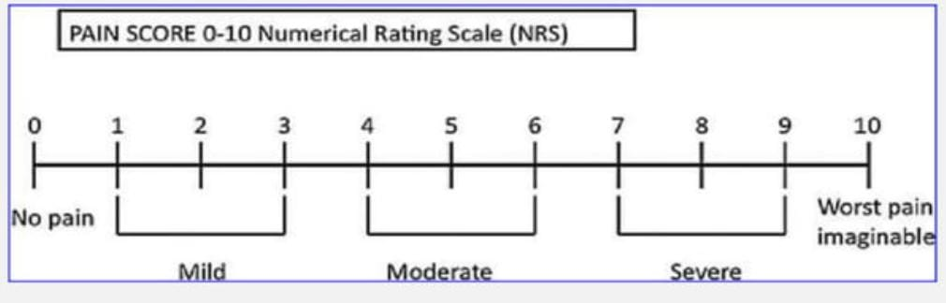
- COMPARATIVE RATING SCALE:
In this type of rating scale, the researcher makes a judgement about an attribute of a person by comparing it with that of a similar another person.
ADVANTAGES OF RATING SCALES:
- It can be used for large number of subjects.
- Easy to administer and score.
- Efficient and economical in terms of time and money.
- Helps to reduce unreliability.
- It is used to evaluate performance and skills.
DISADVANTAGES OF RATING SCALE:
- Difficult to fix up rating about many aspects of an individual.
- Misuse can result in decrease in objectivity.

CHECK LIST:
- A checklist is a simple device consisting of a prepared list of items, which are thought by the researcher to be relevant to the problem, which is being studied. The checklist consists of a list of items with a place to check or mark yes or no.
- A checklist is a list of all the things that you need to do, information that you want to find out, or things that you need to take somewhere, which you make in order to ensure that you do not forget anything.
CHARACTERSTICS OF CHECKLISTS:
- Observe one respondent at one time.
- Use only carefully prepared checklist to avoid more complex traits.
- The observer should be trained how to observe, what to observe, and how to record the observed behaviour.
Construction of checklist:
- Express each item in a clear, simple language.
- The list of items in the checklist may be continuous or divided into groups of related items.
- Avoid negative statements whenever possible.
- Ensure that each items have clear responses: yes or no. true or false.
- Review the items independently.
Three Essential Types of a Checklist:
- Procedural Checklists: list steps that must be followed in order.
- Communication Checklists: encourage communication in organizations.
- Project Checklists: List tasks that must be completed.
Ex: PROCEDURAL CHECKLIST FOR HAND WASHING:
PROCEDURAL CHECKLIST FOR HAND WASHING
Sl. no. | STEPS/TASKS | 1 | 2 | 3 | 4 | 5
1. | Remove rings, bracelets and watch
2. | Get hands in clean running water, apply soap.
3. | Vigorously rub hands together in following manner: palms, fingers and web spaces
4. | Back of hands
5. | Fingers and knuckles
6. | Thumbs
7. | Fingertips and creases
8. | Wrist and forearm up to the elbow
9. | Thorough rinse hands in clean running water
10. | Dry hands using clean personal towel, paper towel, or allows to air dry.

ADVANTAGES OF CHECKLISTS:
- They can be developed very easily, quickly and are relatively less expensive.
- Their design can be highly specific and adequate.
- Checklist reduces the chances of error in observation.
- It is useful to obtain a large amount of data.
- It Saves time.
- It is useful in evaluating learning activities.
- It helps in evaluating procedural work.
- It has objectivity in evaluating characteristics.
DISADVANTAGES OF CHECK LIST:
- Does not indicate quality of performance, so usefulness of checklist is limited.
- It is very easy for certain important items to be omitted in a checklist

CONCLUSION
Data collection is an essential part of the research process, whether you're conducting scientific experiments, market research, or surveys. The methods and tools used for data collection will vary depending on the research type, the sample size required, and the resources available. Data collection is an essential part of the research process, whether you’re conducting scientific experiments, market research, or surveys. The methods and tools used for data collection will vary depending on the research type, the sample size required, and the resources available. Several data collection methods include surveys, observations, interviews, and focus groups. We learn each method has advantages and disadvantages, and choosing the one that best suits the research goals is important. With the rise of technology, many tools are now available to facilitate data collection, including online survey software and data visualization tools. These tools can help researchers collect, store, and analyze data more efficiently, providing greater results and accuracy.

REFERENCES:
- DataCollectionHhs.gov: https://ori.hhs.gov/education/products/n_illinois_u/datamanagement/dctopic.html

- Simplilearn. What is collection of data? Methods, types & everything you should know [Internet]. Simplilearn.com. Simplilearn; 2021 https://www.simplilearn.com/what-is-data-collection-article

- Researchgate.net. https://www.researchgate.net/publication/359596426_Data_Collection_Methods_and_Tools_for_Research_A_Step-by-Step_Guide_to_Choose_Data_Collection_Technique_for_Academic_and_Business_Research_Projects

- Anupama.k. research methodology, IJNSPR (2017) 63–67 2016. https://www.researchgate.net/publication/343363376_Research_Methodology [accessed Jul 28 2023].

- Augustine R. Tools and methods of data collection. In: Nursing Research. Jaypee Brothers Medical Publishers (P) Ltd.; 2016. p. 108–108.

- Tools of data collection [Internet]. Slideshare.net. [cited 2023 Jul 27]. Available from: https://www.slideshare.net/sgisave/tools-of-data-collection

