Performance of concrete casted with treated wastewater: A sustainable solution in construction industry
Milind V. Mohod¹, Swati S. Nibhorkar²
¹Assistant Professor, Prof, Ram meghe institute of Technology & Research Badnera
²P. R. Pote (Patil) College of Engineering and Management, Amravati
mvmohod@mitra.ac.in¹, swatinibhorkar12@gmail.com²
__________________________________________________________________________________

Abstract
The ultimate aim of this research is to know an effectiveness of sustainable construction techniques, needed to be implemented in construction industry. Particularly, those techniques that can be applied in medium/ major size construction projects. Due to the success of the sustainable system in many sectors, the construction industry has adapted sustainable techniques to eliminate waste and increase long term profit. If we successfully adopt the sustainable practice in construction technology then it is very eco-friendly solution for construction industry. In this research paper the effectiveness of the sustainable construction techniques is evaluated through the implementation of sustainable and simple approaches by studying performance of treated effluent on concrete. Experimental and analytical study were carried out to ascertain the effectiveness of sustainable practice, consequentially after conducting research treated effluent on concrete it observed that use of treated effluent on concrete are cost effective and sustainable solutions.
Keywords: Treated effluent, sustainable solution, corrosion

- Introduction
The chronic problems of construction are well-known: low productivity, poor safety, inferior working conditions, and insufficient quality. Several solutions or visions have been offered to relieve these problems in construction. Industrialization (i.e., prefabrication and modularization) has for a long time been viewed as one direction of progress. Currently, reuse of water in construction is seen as an important way to reduce fragmentation in construction, which is a major cause of existing problems. The vision use of treated effluent on concrete construction, closely associated with integrated construction, is another solution promoted by researchers.
Sustainable construction is a philosophy based on the concepts of sustainable methods or material optimization methods. It is about managing and improving the construction process to profitably deliver what the customer needs. In construction projects, signiﬁcant uncertainty exists throughout the project. Weather conditions, soil conditions, owner changes, and the interaction between multiple operations can produce unique circumstances, which could be as critical as the planned activities and have a signiﬁcant impact on project cost.
a. The Sustainable Principles
1. Recycle recuse waste from construction projects / sites
2. Precisely identify the recycled material / sustainable process to perform on material
3. Make the remaining value adding steps flow without interruption by managing the interfaces between different steps
5. Make it robust and effective for other materials
6. Pursue perfection by continuous improvement

2. Literature Review
A comprehensive literature survey carried out to know performance of treated effluent in concrete and presented below
Vinut Kulkarni et al (2014)
This study deals with Introduction to treated domestic waste water utilized in concrete preparation where there is a scarcity of fresh water. It discusses physical properties of Materials and chemical properties of treated domestic waste water. At the age of 14days marginal increase in compressive strength is observed in case of mix M1 but in case of mix M2 compressive strength remains same as that of 7days.And at 28days curing age decrease in compressive strength was observed. This decrease in compressive strength may be due the use of treated domestic waste water for mixing and curing.
A.Narender Reddy (2015)
This study deals with the effect of treated domestic wastewater (TDWW) on properties of cement blended with 20% fly ash such as compressive strength, setting times and soundness. Water used for mortar includes portable water (PW), treated domestic wastewater (TDWW) and treated domestic wastewater (TDWW) partially replaced with portable water. This study analyses the quality of these types of waters as for standard methods for the examination of water and wastewater, Therefore, it is suggested that treated domestic wastewater may be considered as mixing water for blended cement mortar where portable water resources are scarce. However, it is advised that long-term strength development and durability be studied before use.
Ayoup M. Ghrair et al (2018)
This project aims to evaluate the potential of reused grey water in concrete and mortar in order to preserve fresh water for drinking purposes. Using both Treated Grey Water and Raw Grey Water (TGW and RGW, respectively) led to a significant increase in the initial setting time and a decrease in the concrete slump value. The mortar and concrete compressive strength results obtained at 7 days moist curing time showed a significant increase. Mortar and concrete mixes using TGW cast at curing times of 28, 120, and 200 days led to no significant effects on compressive strength. On the contrary, the RGW achieved slightly negative impact on compressive strength at all curing ages. According to the American Society for Testing and Materials (ASTM C109), TGW and RGW are suitable for mortar and concrete production. Furthermore, these results are in harmony with established requirements for ASTM C94.
Ehsan Nasseralshariati et al (2021)
Concrete, as one of the essential construction materials, is responsible for a vast amount of emissions. Using recycled materials and gray water can considerably contribute to the sustainability aspect of concrete production. Thus, finding a proper replacement for fresh water in the production of concrete is significant. The usage of industrial wastewater instead of water in concrete is considered in this paper. In this study, 450 concrete samples are produced with different amounts of wastewater. The results showed that the usage of industrial wastewater does not significantly change the main characteristics of concrete. Although increasing the concentration of wastewater can decrease the durability and strength features of concrete nonlinearly, the negative effects on durability tests are more conspicuous, as utilizing concentrated wastewaters disrupt the formation of appropriate air voids, pore connectivity and pore-size distribution in the concrete.
Mr. Manjunatha.M et al ( july-2017)
As a sustainable approach this project is conducted to study the possibility of reuse of treated waste water in concrete, concrete is the most widely used construction material in the world. Production of Portland cement used in concrete produces 2.5 billion tone’s of carbon dioxide and other greenhouse gases worldwide. In addition concrete is one of the largest water consuming industries.. This project presents the reuse of treated waste water and potable water in concrete for both mixing and curing. Concrete in prepared for M-20 grade concrete with SNF super plasticizer for both treated waste water and portable water and cured for a age of 7 day,14 days and 28 days. Compressive strength, durability properties and microscopic study both concrete prepared with treated waste water and portable water is studied.
Shrilatha1, Rohtih et al (2017)
Concrete is the most widely used construction material in the world, making it one of the largest water consuming industries. Approximately 150 liters of water is required per cu. m. of concrete mixture without considering other applications of water at the concrete industry. In M20 concrete mix the potable water was replaced with the PTWW in different dilution ratios of 20%, 40% and 100%. The compressive strength result obtained from treated effluent showed an increase in 10.68% for 28 days compared to fresh water. From this study, it is believed that the recommended reuse of waste water in plain concrete works will indirectly conserve the scarce water resources of the study area, as the regular water sources would be concentrated on supply of drinking and other potable water usage .
Micheal M. Farouk M (2020)
The water consumption keeps on increasing due to the huge increase in the overall human population. This increasing consumption presents the vital need for providing alternative solutions at which can preserve the increase in water use. Therefore, the reuse of wastewater is considered the best option in order to reduce or provide alternative use of water in multiple applications. The consistency of concrete has a minimal effect when using the treated wastewater in the concrete mixture. This indicated that treated wastewater could be quite useful in terms of accomplishing required properties and results of compressive strength in the design of concrete mixtures.
Ramkar A.P., Ansari U.S. (2016)
This study deals with the effect of different type of treated waste water on properties of strength of concrete such as compressive strength, tensile strength and flexural strength with respect to Potable water. The tests conducted are initial and final setting time on cement, Compressive strength, tensile strength and flexural strength on concrete which is compared with the mix of M30 of potable water. The results indicate that the initial and final setting time of cement was same as that of Potable water and STWW but decreased for PTWW, for compressive strength it was increased in STWW and domestic waste water at longer duration, for tensile and flexural strength tests was same results so, there was no any improvement in tensile and flexural strength by using STWW.
Mr. Manjunatha.M. et al (2017)
As a sustainable approach this project is conducted to study the possibility of reuse of treated waste water in concrete, concrete is the most widely used construction material in the world. Production of Portland cement used in concrete produces 2.5 billion tones of carbon dioxide and other greenhouse gases worldwide. In addition concrete is one of the largest water consuming industries. Approximately about 150 liters of water is required for per cubic meter of concrete mix. This project presents the reuse of treated waste water and potable water in concrete for both mixing and curing. Concrete in prepared for M-20 grade concrete with SNF super plasticizer for both treated waste water and portable water and cured for a age of 7 day,14 days and 28 days. Compressive strength, durability properties and microscopic study both concrete prepared with treated waste water and portable water is studied.
Mr. S.P. Kale et al (2021)
In this paper Studied that , Water is a critical environmental issue and water supplies and water quality are becoming more limited worldwide . The study deals with the effect of different type of treated waste water on properties of strength of concrete such as compressive strength, tensile strength, flexural strength and workability with respect to potable water. Water sample were used as treated waste water which was analyzed for its chemical properties in laboratory, In that use of concrete mix of M30 the potable waste water was replaced with treated waste water. The impurities present in the water are reacting differently with different constituent of cement. All impurities may not have adverse effects on the properties of concrete. Some impurities react such that, net result may be harmless or improve concrete properties.
Ali Raza et al (2020)
The present study endeavors to investigate the mechanical and durability performance of recycled aggregate concrete (RAC) made with five different kinds of wastewater taken from domestic sewerage, fertilizer factory, textile factory, sugar factory, and service station. the fertilizer factory in the production of RAC depicted the maximum mass loss (19.62% at 120 days of testing) due to an attack of 4% H2SO4 and the highest CP (16.49 mm at 28 days of testing). The statistical analysis depicted a considerable difference among the CS and CP of RAC mixes while no considerable difference was depicted by the statistical tests for the WA, STS, and acid attack for various RAC mixes.
Carlos Barrera-Díaz et al
Two problems are addressed simultaneously. One is the utilization of sludge from the treatment of wastewater. The other is the modification of the mechanical properties of concrete. The sludge was subjected to two series of treatments. In one series, coagulants were used, including ferrous sulphate , aluminum sulphate or aluminum polyhydroxychloride. In the other series, an electrochemical treatment was applied with several starting values of Ph .. Diagrams of the compressive strength and compressive strain at the yield point as a function of time passed through the minima as a function of time for concretes containing sludge; therefore, the presence of sludge has beneficial effects on the long term properties. Some morphological changes caused by the presence of sludge are seen in scanning electron microscopy. A way of utilizing sludge is thus provided together with a way to improve the compressive strain at yield point of concrete.
- Summary of Literature Review
After carried out a literature from various researcher it is found that sustainable technology is a huge scope in construction industry and hence proper technology is need to developed/study. Water is a main material in concrete and as far as potable water is concern sources of potable water is lower nowadays and hence research in terms of reuse of water is initiated in this research paper.
3. Methodology
Wastewater is used in concrete mix to get the required strength so that the natural resources are limited and used more efficiently and the environment is protected. Considerable research has been carried out on the use of treated sewage effluent in concrete. The main concern of using sewage effluent is not only cost effective but also to get the substitute for the potable water, which can indirectly protect the natural resource. To effectively study the improvement in the mechanical properties of the concrete, procedures and method must be wisely chosen. The criteria to access the mechanical properties are based on the activities to plan and preparation, which carried out before the testing of concrete.
These activities are:
- Aggregate and cement testing
- Sieve analysis
- Mix Design
- Water testing
- Concrete Mixing and curing.
The objective of the present work is to compare the compressive strength of concrete for M20 grade and M25 grade by using the different qualities of water such a tap water and Wastewater (Treated and Untreated) which are available on different construction sites and are directly being used for making concrete, also identification of civil works where these water can be used without compromising structural strength parameters.
- Procedure Adopted
The whole process of this study is to collect water samples, carried out laboratory test over the water sample and cement, Sand and aggregate, analyze the test result and finally come to conclusion.
- Determining the laboratory properties of all water samples i.e. Potable, Treated and Untreated
- Determining the laboratory properties of ingredients used in concrete.
- Casting of conventional concrete 3 cube, 2 cylinder and 2 beams as per design mix .
- Casting of concrete using treated water and untreated water from WTP with 9 cube , 9 cylinder and respectively .
- Let the cube cylinder and beam for curing
- After 3, 7 & 14 days conduct compressive strength test, flexural strength test and split tensile test on cubes, beams and cylinder respectively.
- Determining the compressive strength, flexural strength, tensile strength results of concrete and compare conventional, treated and untreated
3.2.2 Material Used
Cement: The cement used was Pozzolona Portland cement (PPC) grade 53 and confirming to IS 1489-1991. Initial and final setting time of cement was 158 min and 345 min, respectively. Pozzolona Portland cement is obtained by grinding fly ash with Portland cement clinker, no material other than gypsum (natural or chemical) or water or both, shall be added.
Table. No 1: Chemical composition of constituents in PPC cement
Sr.No | Constituents | PPC Cement (%)
1 | SiO2 | 23.5
2 | Al2O3 | 12.9
3 | Fe2O3 | 2.04
4 | CaO | 47.0
5 | MgO | 1.74
6 | Loss of ignition | 1.05
7 | Chloride | 0.01

Aggregate: Aggregates are the important constitutes in concrete. They give body to the concrete, reduce shrinkage and effect economy. One of the most important factors for producing workable concrete is a good gradation of aggregates. Good grading implies that a sample fraction of aggregates in required proportion such that the sample contains minimum voids. Samples of a well graded aggregate containing minimum voids require minimum paste to fill up the voids in the aggregates. Minimum paste means less quantity of cement and less water, which are further mean increased economy, higher strength, lower shrinkage and greater durability.
- Fine Aggregate : Those fractions from 4.75 mm to 150 micron are termed as fine aggregate. The river sand is wash and screen, to eliminate deleterious materials and over size particles. Good Quality crushed sand is used as a fine aggregate.

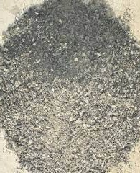
Figure 1: Crushed Sand

- Coarse Aggregate : The material whose particles are of size as retained on IS Sieve 4.75 mm is termed as coarse aggregate. Coarse aggregate were used are of grade 10 mm and 20 mm

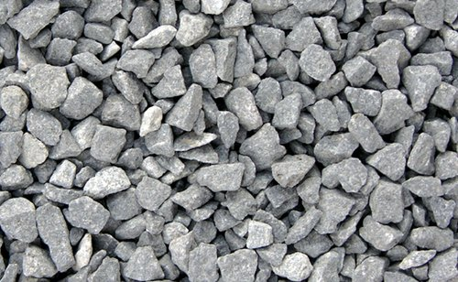
Figure 2: Coarse Aggregate
Plasticizer : Plasticizer is used for better workability of concrete. During the trial mix the workability was found to be very less so the plasticizer was used. The plasticizer used was Mapefluid R 122 which was added to concrete mix as 0.8% of weight of cement. This plasticizer only gives better workability and does not increase strength or any other properties of concrete.
Water : Water is also one of the most important ingredients of concrete. As the strength, workability is depends on water, the quantity and quality of water is required to be taken very carefully. Two types of water is used potable and sewage (Treated and untreated) for the experiment.
Potable water: Potable water, also known as drinking water, comes from surface and ground sources and is treated to levels that that meet state and federal standards for consumption. Water from natural sources is treated for microorganisms, bacteria, toxic chemicals, viruses and fecal matter.
Sewage water: Sewage water is wastewater from people living in community. It is the water released from household after use for various purposes like washing dishes, laundry, and flushing the toilet, thus the name wastewater.

Figure 3: Types of sewage water
Grey water : Grey water is the wastewater from washing either from bathing, dishes and laundry.
Black water : Black water is the wastewater from toilets.
Collection of wastewater: In the experiment the waste water which is used is collected from the water treatment plant which is at the college premises. The term "sewage treatment plant" (STP) (or "sewage treatment works" in some countries) is nowadays often replaced with the term wastewater treatment plant (WWTP). Strictly speaking, the latter is a broader term that can also refer to industrial wastewater. The terms "water recycling center" or "water reclamation plants" are also in use.
Purpose: The overall aim of treating sewage is to produce an effluent that can be discharged to the environment while causing as little water pollution as possible, or to produce an effluent that can be reused in a useful manner. This is achieved by removing contaminants from the sewage. It is a form of waste management.
With regards to biological treatment of sewage, the treatment objectives can include various degrees of the following: transform dissolved and particulate biodegradable components (especially organic matter) into acceptable end products, transform and remove nutrients (nitrogen and phosphorus), remove or inactivate pathogenic organisms, and remove specific trace organic constituents (micropollutants).
Collection: Sewerage (or sewage system) is the infrastructure that conveys sewage or surface runoff (stormwater, meltwater, rainwater) using sewers. It encompasses components such as receiving drains, manholes, pumping stations, storm overflows, and screening chambers of the combined sewer or sanitary sewer. Sewerage ends at the entry to a sewage treatment plant or at the point of discharge into the environment. It is the system of pipes, chambers, manholes, etc. that conveys the sewage or storm water.
Treatment Process: Sewage treatment plant consists of two chambers (i.e. Inlet and outlet). The inlet chamber fills with the Plant (Raisin plants) which helps in treatment of water. These plants are specially brought from Akola. These plants help to remove some impurities from water which is more harmful or which reduce toxic materials and impurities from sewage water and try to make water chemical free.
In this dissertation we make the use of those plants for water treatment and from that it is observed this plant plays an important role in treatment of water. The water obtain after getting treated with raisin plants can be used for the construction. One of the best thing which we observed is that the water get naturally treated without the help of other units which are used generally for different process of water treatment. The water obtain after treating naturally is get transfer to second chamber for the further use. That water is treated water which is csustainable and which can be used.
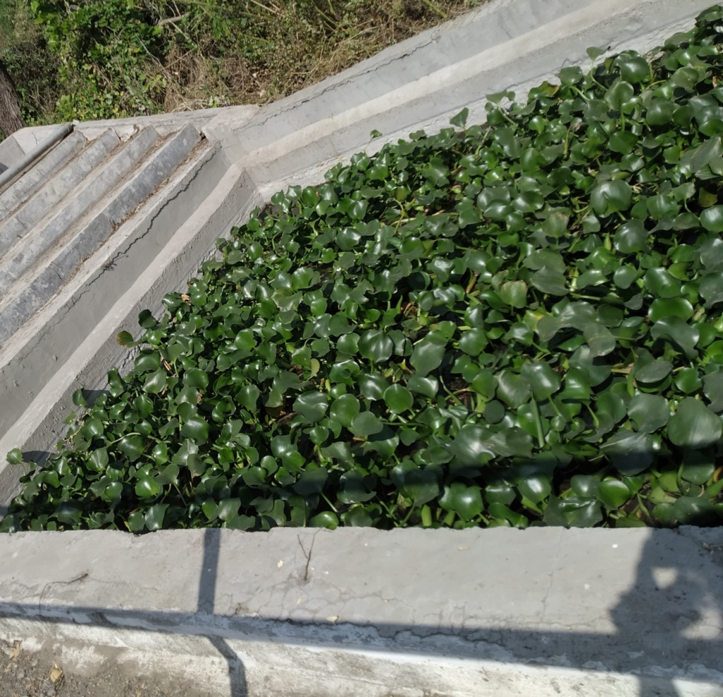
Figure 4: Raisin Plants

- Laboratory Test on Waste Water:
Determination of PH: The term “pH” refers to the measurement of hydrogen ion activity in the solution. Determination of pH plays an important role in the wastewater treatment process. Extreme levels, presence of particulate matters, accumulation of toxic chemicals and increasing alkalinity levels are common problems in wastewater. “pH” stands for the Latin terms pondus hydrogenii (quantity of hydrogen) or potentia hydrogenii (power of hydrogen).
pH by pH strips :
- Take a waste water sample in the test tube.
- Make sure your strips test the range you need.
- Read the box to determine how long to leave the strips in. Some test strips only need to be left in the test liquid for about a second, while others need about 20 seconds to produce a reading.
- Dip one of the end of the test strip in the substance you want to test.

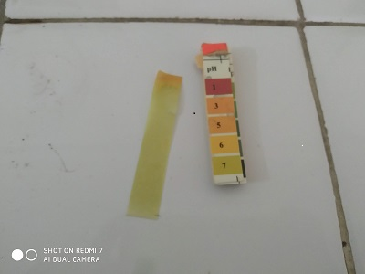

Figure 5: pH strips
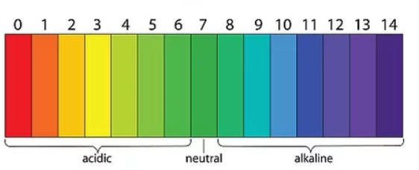

Figure 6: pH Scale
pH by Digital pH meter :
- Place an electrode in the buffer with pH value of 7 and begin reading.
- Press the “measure” or calibrate button to begin reading the pH once your electrode is placed in the buffer, allow the pH reading to stabilize before letting it sit for approximately 1-2 minutes.
- Set the pH. Once you have a stable reading, set the pH meter to the value of the buffer’s pH by pressing the measure button a second time.
- Rinse your electrode with distilled water.
- Place your electrode for appropriate buffer for your sample and begin reading.
- Set the pH a second time. Once your reading has stabilized, set the pH meter to the value of the buffer’s pH by pressing the measure button.
- Rinse your electrode.

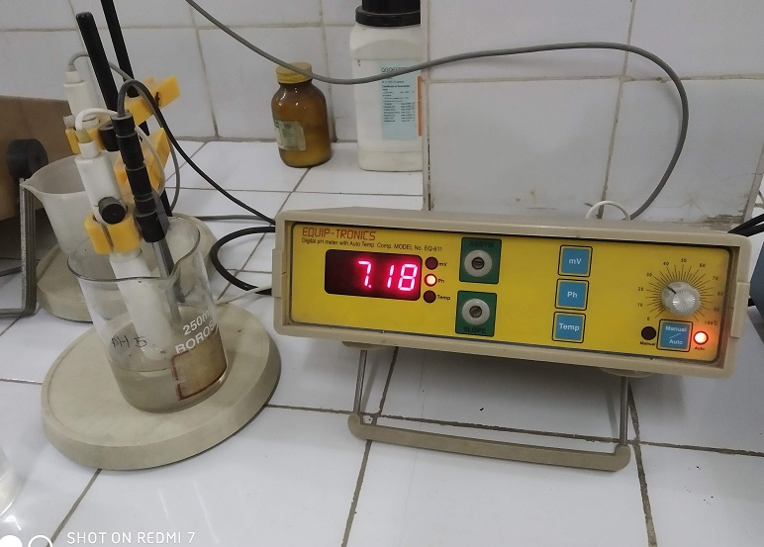
Figure 7: pH meter
Determination of Total solid and suspended solids.
1) Total Solid:
Test procedure
- Take the weight of empty crucible (W1).
- Take 20 ml of your sample.
- Place that sample in drying oven on 105⁰ to 103⁰ temperature for 2 hr.
- Take the weight of crucible after evaporating (W2).

Total solid = (Weight of crucible after - Empty weight of crucible) x 1000/ Volume of sample
Evaporating

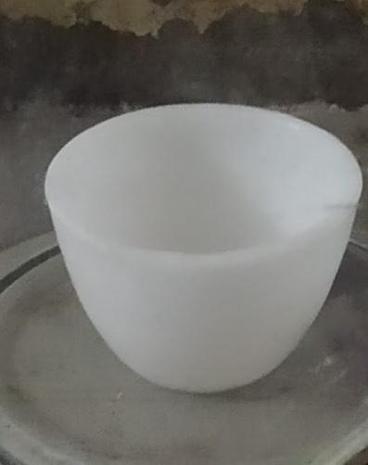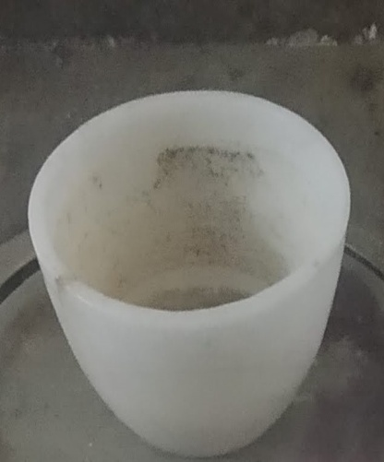
Figure 8: Empty Crucible Figure 9: Crucible after drying
Suspended solids:
Test procedure
- Take 20 ml of sample
- Take the weight of filter paper before passing sample through it (W1).
- Filter that sample through filter paper.
- Take the weight of that filter paper before placing it in drying oven.
- Place that filter paper in drying oven.
- After getting it dry remove it from drying oven and weight it again (W2).
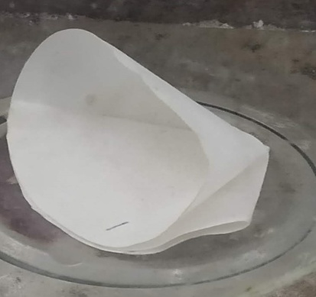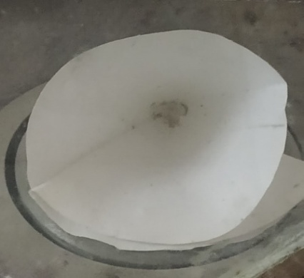
Figure 10:Filter paper after passing sample Figure 11: Filter paper after oven drying
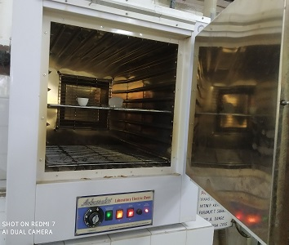
Figure 13: Drying Oven
Alkalinity Test
Test Procedure
- Take 100 ml of water sample.
- Take 2 ml of Hcl.
- Add 2 to 3 drops of phynopthelyne indicator to the water sample.
- Then titrate it with Hcl until it turns colorless.
- Mark the readings.
Acidity Test
Test Procedure
- Take 100 ml sample.
- Add 2 to 3 drops of orange indicator.
- Add 2 to 3 drops of Phenolphthalein indicator
- Take 1000 ml distill water add 8 mg NaOH.
- Titrate the sample with the above titrant.

Methyl orange Acidity = ml of NaOH titrant used x N x 50 x 1000/ Volume of sample

Phenolphthalein or Total Acididty = ml of NaOH titrant used x N x 50 x 1000 / Volume of sample

Test on Chloride content
Test Procedure
- Take 0.05 gm of Kr2CO4 and put it in 100 ml of distilled water and rest it for 12 hr in Brown bottle.
- Take 0.039 mg of AgNo3 for 100 ml distilled water.
- Take 50 ml of water sample.
- In 50 ml sample add 1 ml Kr2CO4 and titrate till it get pink yellow colour.
Chloride Content = (A – B) X N X 35450 / ml of sample

NaCl = Chloride content X 1.65

- Laboratory Tests on Material
For mix design calculations we required certain data of materials like specific gravity, sieve analysis and water absorption. For which we had conducted the different tests on material which are described below.
TEST ON CEMENT:
- Fineness Test:
The fineness of cement has an important bearing on the rate of hydration and hence on the rate of gain of strength and also on the rate of evolution of heat. Finer cement offers a greater surface area for hydration and hence faster the development of strength. The fineness of grinding has increased over the years. But now it has got nearly stabilized. Different cements are ground to different fineness. Fineness of cement is tested by sieving
- By Sieving:-
Weight correctly 100 grams of cement and take it on a standard IS Sieve 90 microns. Break down the air-set lumps in the sample with fingers. Continuously sieve the sample giving circular and vertical motion for a period of 15 minutes. Mechanical sieving devices may also be used. Weight the residue left on the sieve. This weight shall not exceed 10 for ordinary cement. Sieve test is rarely used.
Table No 2: Fineness of cement
Sr.No | Weight of sample Retained on sieve | Weight of sample Retained on sieve | % of weight Retained
1 | 100 | 7 | 7%
2 | 100 | 8 | 8%
3 | 100 | 6 | 6%

Average retained weight = (7+8+6)/3 = 7%
After the experiment, our group was able to determine the fineness of the cement by sieve method. Based on our results, we have observed that sieving process should be done properly and carefully. In our data, the average fineness of the cement is 93% which means it passed the standard because it is clearly not less than 90%. Other sources of errors could come from careless while sieving and wrong calculation.

- Standard Consistency Test :
For finding out initial setting time, Final setting time and soundness of cement, and strength of cement, and strength of parameter known as standard consistency has to be used. It is pertinent at this stage to describe the procedure of conducting standard consistency test. The standard consistency of a cement paste is defined as that consistency which will permit a vicat plunger having 10mm diameter and 50 mm length to penetrate to a depth of 33-35 mm from the top of the mould. The apparatus is called Vicat Apparatus. This apparatus is used to find out the percentage of water required to produce a cement paste of standard consistency. The standard consistency of the cement paste is some time called normal consistency (CPNC).
Table No.3.5 standard consistency
Sr.No | Water added for different trials in percentage | Penetration of plunger from bottom in mm
1 | 25% | 33
2 | 28% | 15
3 | 32% | 7

Standard Consistency in percentage = Total water for standard consistency × 100/400
= 128 × 100/400
= 32%
This experiment tells us the amount of water content at which we can obtain the maximum strength of cement. The achieved standard consistency is coming with range of water (26% to 33%). So, the standard consistency of cement paste is 32%. Moreover the temperature and humidity value were not in the specified range. This test also gives us information that how much amount of water is enough to prepare a paste of cement before using it at the site at the time of construction.
- Setting Time Test
The initial setting time is the time elapsed between the moment that the water is added to the cement, to the time that the paste starts losing its plasticity. The final setting time is the time elapsed between the moment the water is added to the cement, and the time when the paste has completely lost its plasticity and has attained sufficient firmness to resist certain definite pressure. In actual construction dealing with cement paste, mortar or concrete certain time is required for mixing, transporting, placing, compacting and finishing. During this time cement paste, mortar or concrete should be in plastic condition. The time internal for which the cement products remain in plastic condition is known as initial setting time. Normally a minimum of 30 minutes is given for the mixing and handling operations. Before commencing setting time test, do the consistency test to obtain the water required to give the paste normal consistency (p). The constituents and fineness of cement is maintained in such a way that the concrete remains in plastic condition for certain minimum time. Once the concrete is placed in the final position, compacted and finished, it should lose its plasticity in the earliest possible time so that it is least vulnerable to damages from external destructive agencies. This time should not be more than 10 hours which is often referred to as final setting time.
Initial setting time = t2-t1
Final setting time = t3-t1
Where,
t1 = Time at which water is first added to cement
t2 = Time when needle fails to penetrate 5 mm to 7 mm from bottom of the mould
t3 = Time when the needle makes an impression but the attachment fails to do so
Min Initial Setting time for PPC cement is 30 min and Min Final setting Time for PPC cement is 600 min as per IS: 1489,P-1
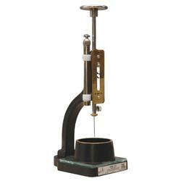

Figure 14: Vicat Apparatus
Table No. 3: Observation table for setting time
Sr. No | Sample No | Result
1 | Weight of sample | 400
2 | Water added in (ml) | 160
3 | Time when water added | 11.50 PM
4 | Time of initial set | 2.28 PM
5 | Time of final set | 5.30 PM
6 | Initial set in min(4-5) | 158 min
7 | Final set in min (5-3) | 345 min

- Tests on Aggregate
Specific Gravity test
Test Procedure
- Determine and record the weight of the empty csustainable and dry pycnometer(W1)
- Place dry sand sample in the pycnometer. Determine and record the weight of the pycnometer containing the dry sand (W2)
- Add water to fill about half to the three-fourth of the pycnometer, soak the sample for 10 minutes.
- Apply a partial vacuum to contents for 10 minutes, to remove the entrapped air.
- Stop the vacuum and remove the vacuum line from the pycnometer.
- Fill the pycnometer with distilled (water to the mark), csustainable the exterior surface of the pycnometer with a csustainable , dry cloth. Determine the weight of the pycnometer and contents (W3).
- Empty the pycnometer and csustainable it. Then fill it with distilled water only (to the mark). Csustainable the exterior surface of the pycnometer with a csustainable , dry cloth. Determine the weight of the pycnometer and distilled water (W4).
- Empty the pycnometer and csustainable it.
- Calculate the specific gravity of the sand using the following formula:
Specific Gravity, Gs = (w2-w1)/(w4-w1)-(w3-w2)

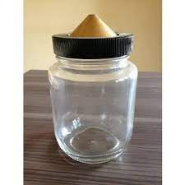
Figure 15: Pycnometer
Sieve analysis test
Test procedure
Take a representative dry sample of sand that weights about 1000 g. (this is normally used for sand samples the greatest particle size of which is 4.75)
- Determine the mass of sample accurately, W1 (g).
- Prepare a stack of sieves. Sieves having larger opening sizes ( i.e. lower number ) are placed above the ones having smaller opening sizes ( i.e. higher number ). The very last sieve is 150 micron and a pan is placed under it to collect the portion of sand passing 150 micron sieve. Here is a full set of sieves.
- Make sure sieves are csustainable , if many sand particles are stuck in the openings try to poke them out using brush.
- Weight all sieves and the pan separately.
- Pour the sand from step 3 into the stack of sieves from the top and place the cover, put the stack in the sieve shaker and fix the clamps, adjust the time on 10 to 15 minutes and get shaker going.
Stop the sieve shaker and measure the mass of each sieve + retained sand.

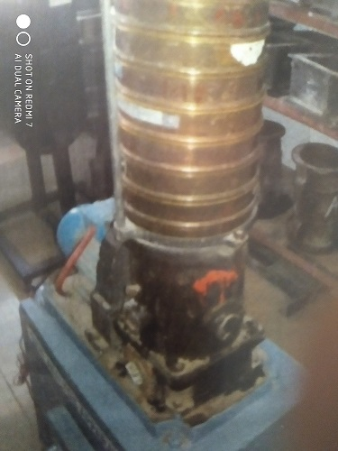

Figure 16: Sieve Analysis

3.2.6 Mix Design
Concrete fix design is a step by step procedures to work out the various proportions of the ingredients which go to make concrete. There are various methods of mix design available. These methods can only give guideline to the site engineer to work out the various parameters of concrete mix & it may or may not be necessary to make minor adjustments thereafter. However, it is very essential for the site engineer to get the feel of concrete material & concrete by continuous check on workability, cohesiveness, finished surface, strength & durability parameter. It is only then that the engineer acquires the art of designing concrete mixes.
It is difficult to design the concrete mixes in our country as the materials available from time to time at site are not consistent in quality. Therefore a watchful eye and skills of the engineer designing the concrete mix plays an important role. The various properties of a concrete-mix like compressive strength, flexural strength and split tensile strength are to be calculated and compared. The method we used is popularly known as ‘AMBUJA METHOD’. This method has been adopted on several sites in and around Mumbai and has give technically and economically good results. The study carried on the basis of these following adjectives:
- To determine the mechanical properties of wastewater mix concrete .
- T o determine the results of compression, flexural and split tensile strength for wastewater mix over the plain traditional mix.
- To develop cost saving concrete.
- To develop feasible waste management of wastewater.
In this method, for various concrete specifications, various tables from IS 456 were referred. The concrete was designed and tested for different types of water. Three specimen for each cubes, cylinder and beams where casted for different proportion of water. The specimens were casted in batches for portable, treated wastewater and untreated wastewater. The aim is to increase the quality of concrete using sewage water. The compressive, flexural and split tensile strength is calculated for specimen for 3 days , 7 days and 14 days. Design mix for M25 grade of concrete was presented by replacing the type of water during mix. For calculating the various strength and properties of concrete tests were performed on the specimen viz., cube of size 150×150mm, beams of length 500mm and cross section of 100mm, and cylinder of diameter 150mm of length .
Ambuja Concrete Mix Design
Concrete mix design is the process of finding right proportions of cement, sand and aggregates for concrete to achieve target strength in structure. So, concrete mix design can be stated as Concrete Mix = Cement: Sand: Aggregates. The ambuja concrete mix design involves various steps, calculations and laboratory testing to find right mix proportions. This process is usually adopted for structures which require higher grades of concrete such as M25 and above and large construction projects where quantity of concrete consumption is huge.
Benefits of ambuja concrete mix design is that it provides the right proportions of materials, thus making the concrete construction economical in achieving required strength of structural members. As the quantity of concrete required for large constructions are huge, economy in quantity of materials such as materials such as cement makes the project construction economical.
Concrete mix design : Mix design for M25
- Grade of designation = M25
- Type of cement = Pozzolona Portland Cement
- Max nominal size of aggregate = 20 mm
- Minimum cement content = 300 kg/m3
- Water-cement Ratio = 0.50
- Standard deviation = 4 N/mm2
- Crushed sand = Zone 1
- Exposure Condition = Moderate
- Target mean strength = 31.6 N/mm2
After various calculations and corrections of oversize, specific gravity the final quantity of materials are calculated as
- Cement = 394.32 kg/m3
- Water content = 177 lit
- Fine Aggregate = 769.88 kg/m3
- Coarse Aggregate = 495.88 kg/m3
By using this quantity of material a mix design of concrete is prepared. This mix design helps in achieving a desire workability, strength and durability for concrete work. For making the mix more workable admixture is also used.
- Tests For Properties on Concrete Specimen
Compressive Strength Test
Compressive strength of concrete is a measure of its ability to resist load, which tends to crush it. Most common test on hardened concrete is compressive strength test. It is because the test is easy to perform. Furthermore, many desirable characteristic of concrete are qualitatively related to its strength and the compressive strength of concrete in structural design. The compressive strength gives a good and clear indication that how the strength is affected with the used of treated and untreated sewage water.
From the result it is observed that the addition of untreated waste water has a little effect on the compressive strength. It is observed that the use of treated wastewater increases the compressive strength of concrete when the untreated waste water is used then reduction in compressive strength is observed. The decrease in compressive strength is observed when the untreated wastewater or direct sewage water get used. The use of untreated wastewater undergoes absorption in concrete, when the untreated water is use during mix the concrete absorb more percent of water as compare to treated waste water. Due to absorption of more water the concrete form by using untreated wastewater is of poor quality and does not give good strength.
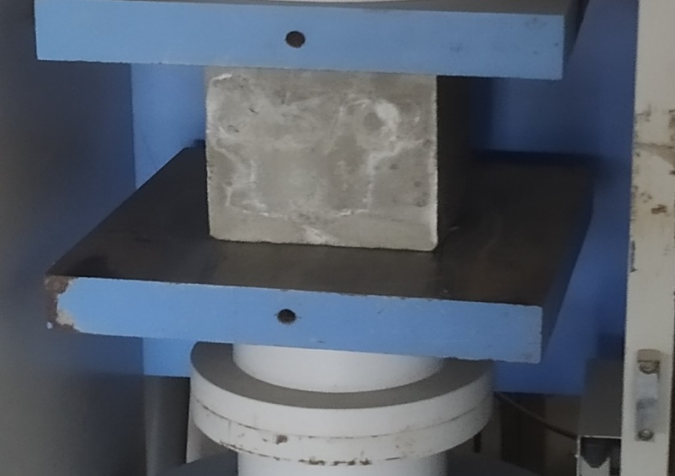
Figure 17: Compressive testing machine
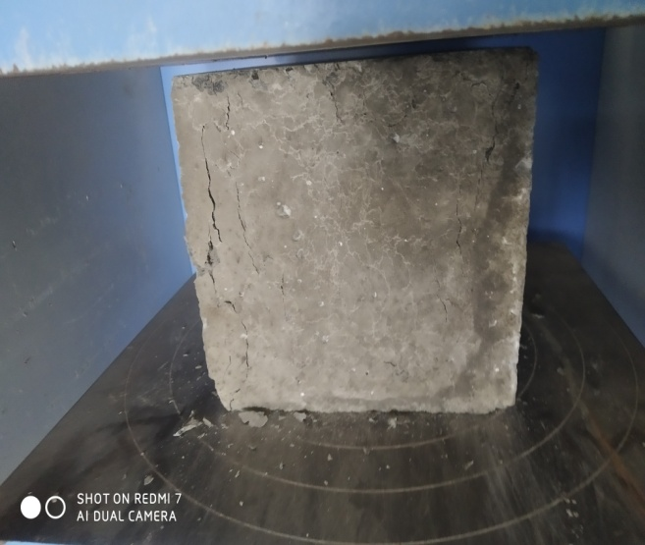
Figure 18: Cube break after compression test
The Compressive strength of concrete can be calculated using the following formula
Compressive strength = (Load in N / Area in mm2) = ….N/mm2
Split Tensile Strength Test
The concrete is very weak in tension due to its brittle nature and is not expected to resist the direct tension. The concrete develops cracks when subjected to tensile forces, it is necessary to determine the tensile strength of concrete to determine the load at which the concrete members may crack. Tensile strength of concrete is a measure of its ability to resist force, which stretch or bend it. Unlike steel, the concrete is sufficient in strength only in one direction. Nevertheless it is an important property in many applications.
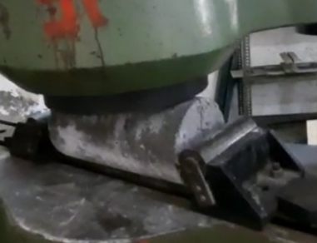
Figure 19: Cylinder Cracked during split tensile strength test
It is noted that with the use of untreated wastewater the split tensile strength decreases. The result shows that the split tensile strength increases with the use of treated waste water and gives similar results to that of potable water. The test was performed on CTM. The fig shows the setup for the split tensile strength test on CTM. The task of this test was performed to find the increase and differences of strength of concrete according to the use of different water.
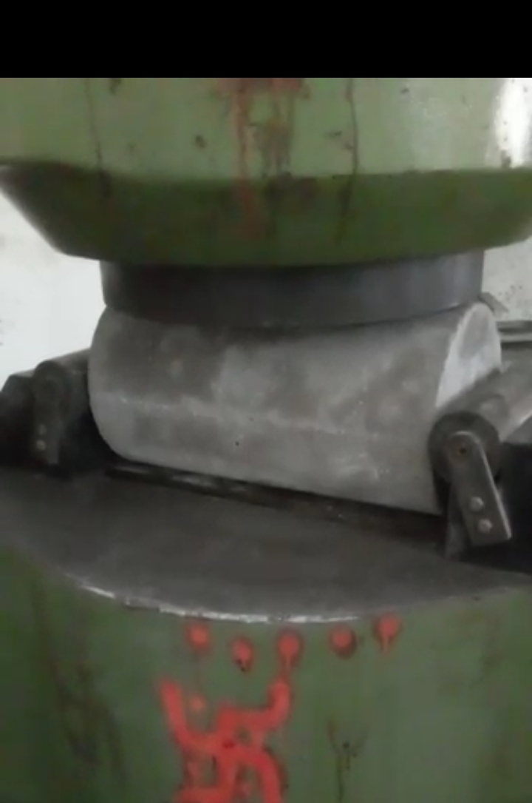
Figure 20: Cylinder arrangement in split tensile test
The indirect tensile strength of concrete is calculated using the following formula:
$fct= \frac{2p}{πLD}$
Where,
Fct = Indirect tensile strength of concrete
P = Maximum load applied to the specimen in N
L = Length of specimen in mm
D = Diameter of the specimen in mm
Flexural Strength Test
Flexural strength of concrete is a measure of its ability to resist bending. Flexural strength can be expressed in terms of “modulus of rupture”. Concrete specimens for the flexural strength were cross sectional area of 100mm width and 500mm of length with the concrete. The task of this test was performed to find the flexural strength of the beam, and to compare its differences. Types of loading are Third point loading and center point loading. Center point loading is when the entire load is applied at the center span as shown in fig.no.3.21. The maximum stress is present only at the center of the beam. Third point loading is the when half the load is applied at each third of span length. Maximum stress is present over the center 1/3 portion of beam as shown in fig.no.3.22. We have applied loading in this manner. Use of three point loading is preferred for determining flexural strength of concrete in IS 516.2021.
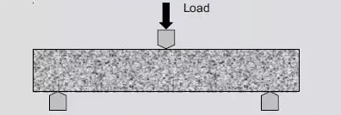
Figure 21: Center-point loading
It is observed that flexural strength decreases with the use of untreated wastewater concrete and it gets maximum when the treated wastewater and potable water get used

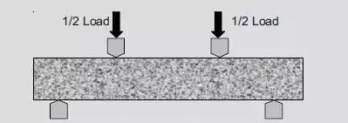
Figure 22: Third-point loading
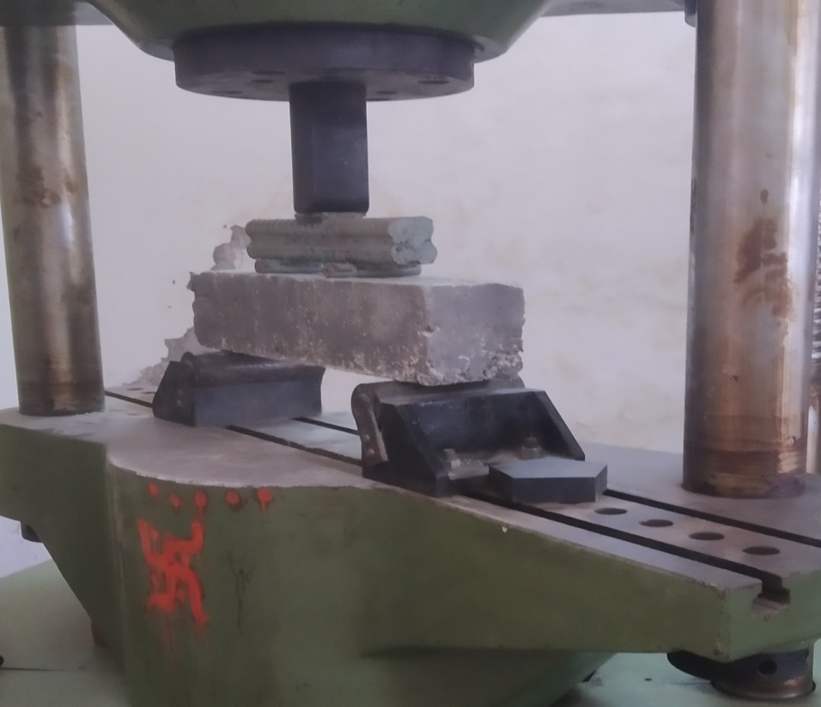
Figure 23: Flexural strength Test Apparatus
The load shall be applied at through two similar rollers mounted at the third point of the supporting span that is, spaced at 20 or 13.3 cm center to center. The flexural strength test was conducted in the strength of material laboratory. The concrete specimens were cured for 3, 7 and 14 days
The flexural strength of concrete van be calculated using the following formula
$$fact=X= \frac{PL}{BD2}$$
Where,
Fact = Flexural strength of concrete (Mpa)
P = Maximum load applied to the specimen in N
L = Supported length of the specimen in mm
B = Width of the specimen in mm
D = Diameter of the specimen in mm
- Results and Discussion

This research focuses on the experimental results obtain from compressive test, split tensile test, flexural test and the analysis of the test results. This research is also deals with the experimental results obtain from Ph test, Alkalinity test, acidity test and chloride content of different types of water. The experimental tests were carried out to obtain the mechanical properties of untreated wastewater concrete, treated wastewater concrete and the potable concrete. The comparisons of mechanical properties like compressive, strength split tensile strength and the flexural strength is carried out. Effect of corrosion due to wastewater is also studied. Observation for 3, 7 and 14 days curing period ware recorded and presented in the form of tables and graphs
A. Test Results for The Different Types of Water
pH test result
pH test of potable water, treated wastewater and untreated wastewater
pH test by pH strips
Table. No. 4: pH test by pH strips
Types Of Water | pH Value
 | 1 | 2 | 3
Potable water | 7 | 7.5 | 7
Treated wastewater | 7 | 6.5 | 7.5
Untreated wastewater | 6 | 6 | 6.5

pH test by digital pH meter
Table. No. 5: pH by digital pH meter
Types Of Water | pH Value
 | 1 | 2 | 3
Potable water | 7 | 7.5 | 7
Treated wastewater | 7 | 6.5 | 7.5
Untreated wastewater | 6 | 6 | 6.5

Suspended solid test
Suspended solid test on potable water, treated wastewater and untreated wastewater
Suspended solid test on potable water
Suspended solid test on Treated wastewater
Table. No. 6: Suspended solid test on potable water
Potable Water | Value (mg/lit)
 | 1 | 2 | 3
Total Solid | 1170 | 1103 | 1166
Suspended Solid | 420 | 450 | 480
Dissolve solid | 750 | 653 | 686

Table.No.4.40 Suspended solid test on treated wastewater
Treated wastewater | Value (mg/lit)
 | 1 | 2 | 3
Total Solid | 61000 | 50200 | 56800
Suspended Solid | 12000 | 15000 | 11500
Dissolve solid | 49000 | 35200 | 45300

Suspended solid test on Untreated wastewater
Table. No. 7: Suspended solid test on treated wastewater
Untreated wastewater | Value (mg/lit)
 | 1 | 2 | 3
Total Solid | 75500 | 93200 | 75000
Suspended Solid | 16500 | 18000 | 17500
Dissolve solid | 69000 | 75200 | 57500

Alkalinity Test
Alkalinity test for potable water
Table. No. 8: Burette reading of yellow to pink colour
Sr. No | Yellow to Pink
 | Initial | Final | Difference
1. | 7 | 8 | 1
2. | 9 | 10 | 1
3. | 7.5 | 8 | 0.5

Phenopthelyne (P) : Diff X 0.02 X 50 X 100 / 100
Total Alkalinity (T) : Diff X 0.02 X 50 X 1000 / 100
Table No 9: Alkalinity
Sr.No | Hydroxide Alkalinity | Carbonate Alkalinity | Bicarbonate Concentration Caco3 (mg/lit)
1. | 0 | 4 | 171
2. | 0 | 5 | 165
3. | 0 | 7 | 173

Alkalinity test for Treated wastewater
Table No 10: Burette reading of pink to white colour
Sr. No | Pink to white
 | Initial | Final | Difference
1. | 7 | 8 | 1
2. | 9 | 10 | 1
3. | 7.5 | 8 | 0.5

Table No 11: Burette reading of yellow to pink colour
Sr. No | Yellow to Pink
 | Initial | Final | Difference
1. | 8 | 21.5 | 13.5
2. | 7 | 18.5 | 11.5
3. | 8.5 | 19 | 10.5

Phenopthelyne (P) : Diff X 0.02 X 50 X 100 / 100
Total Alkalinity (T) : Diff X 0.02 X 50 X 1000 / 100
Table No 12: Alkalinity
Sr. No | Hydroxide Alkalinity | Carbonate Alkalinity | Bicarbonate Concentration Caco3(mg/lit)
1. | 0 | 2 | 133
2. | 0 | 2 | 113
3. | 0 | 1 | 104
Alkalinity test for Untreated wastewater
Table No 13: Burette reading of pink to white colour
Sr. No | Pink to white
 | Initial | Final | Difference
1. | 13 | 15 | 2
2. | 14.75 | 17 | 2.5
3. | 12.5 | 16 | 3.5

Table No 14: Burette reading of yellow to pink colour
Sr. No | Yellow to Pink
 | Initial | Final | Difference
1. | 11 | 28.5 | 17.5
2. | 12.5 | 29.5 | 17
3. | 11 | 29 | 18

Phenopthelyne (P) : Diff X 0.02 X 50 X 100 / 100
Total Alkalinity (T) : Diff X 0.02 X 50 X 1000 / 100
Table No 15: Alkalinity
Sr.No | Hydroxide Alkalinity | Carbonate Alkalinity | Bicarbonate Concentration Caco3 (mg/lit)
1. | 0 | 4 | 171
2. | 0 | 5 | 165
3. | 0 | 7 | 173

B. Test Results for The Ingredients of Concrete
Specific gravity test result
Specific gravity of fine aggregate
Table No 16: Specific gravity of Fine aggregate
Type of material | Fine Aggregate
Sample | 1 | 2 | 3
Wt of Container | 0.654 | 0.654 | 0.654
Wt of Container + Solid | 0.939 | 0.875 | 0.940
Wt of material + water + solid | 1.699 | 1.648 | 1.685
Wt of Container + Water | 1.523 | 1.523 | 1.523
Specific gravity of material | 2.415 | 2.302 | 2.306

Specific gravity of coarse aggregate (10mm)
Table No 17 Specific gravity of Coarse aggregate (10mm)
Type of material | Coarse Aggregate
Sample | 1 | 2 | 3
Wt of Container | 0.654 | 0.654 | 0.654
Wt of Container + Solid | 1.197 | 1.141 | 1.189
Wt of material + water + solid | 1.869 | 1.831 | 1.860
Wt of Container + Water | 1.523 | 1.523 | 1.523
Specific gravity of material | 2.756 | 2.702 | 2.702
Average specific gravity of coarse agg. 10 | 2.72

Specific Gravity of coarse aggregate (20mm)
Table No 18 Specific gravity of coarse aggregate (20mm)
Type of material | Coarse Aggregate
Sample | 1 | 2 | 3
Wt of Container | 0.654 | 0.654 | 0.654
Wt of Container + Solid | 1.134 | 1.310 | 1.235
Wt of material + water + solid | 1.825 | 1.917 | 1.853
Wt of Container + Water | 1.523 | 1.523 | 1.523
Specific gravity of material | 2.696 | 2.503 | 2.314
Average specific gravity of coarse agg. 20 | 2.72

C. Sieve Analysis Test Result
Sieve analysis of fine aggregate
Table No 19: Sieve analysis of fine aggregate
Total Weight of Fine Aggregate = 2000 gm
Sieve Analysis |  |  | Fine Aggregate
IS Sieve Size | Wt retained (gm) | Wt retained (%) | Cumulative Wt.Retained (%) | % passing
10mm | 0 | 0 | 0 | 100
4.75mm | 87 | 8.7 | 4.37 | 95.63
2.36mm | 889 | 88.9 | 49.09 | 50.91
1.18mm | 586 | 58.6 | 78.57 | 21.43
600µ | 147 | 14.7 | 85.96 | 14.04
300µ | 125 | 12.5 | 92.25 | 7.75
150µ | 82 | 8.2 | 96.37 | 3.63
Pan | 72 | 7.2 | 100 | 0.6
 | 1988 | 198.2 | Fineness modulus | 4.04

Sieve analysis of coarse aggregate (10mm)
Table No 20: Sieve analysis of Coarse aggregate (10mm)
Total Weight of Fine Aggregate = 5000 gm
Sieve Analysis |  |  | Fine Aggregate
IS Sieve Size | Wt retained (gm) | Wt retained (%) | Cumulative Wt.Retained (%) | % passing
20mm | 982 | 19.6 | 19.6 | 80
12.5mm | 0 | 0 | 19.6 | 80.36
10mm | 3498 | 70 | 89.6 | 10
4.75mm | 475 | 94 | 99 | 1
600µ | 0 | 0 | 99 | 1
300µ | 0 | 0 | 99 | 1
150µ | 0 | 0 | 99 | 1
Pan | 4 | 0.1 | 99.1
 | 4956 | 99.1 | Fineness Modulus | 6.2
Sieve analysis of coarse aggregate (20mm)
Table No 21 Sieve analysis of coarse aggregate (20mm)
Total Weight of Fine Aggregate = 5000 gm
Sieve Analysis |  |  | Fine Aggregate
IS Sieve Size | Wt retained (gm) | Wt retained (%) | Cumulative Wt.Retained (%) | % passing
20mm | 982 | 19.6 | 19.6 | 80
12.5mm | 0 | 0 | 19.6 | 80.36
10mm | 3498 | 70 | 89.6 | 10
4.75mm | 475 | 94 | 99 | 1
600µ | 0 | 0 | 99 | 1
300µ | 0 | 0 | 99 | 1
150µ | 0 | 0 | 99 | 1
Pan | 4 | 0.1 | 99.1
 | 4956 | 99.1 | Fineness Modulus | 6.2

D. Test Performed on Concrete
Compressive strength, Flexural strength and split tensile strength test results for M25 concrete.
For Conventional Concrete mix M25
Test results obtain for compressive strength, flexural strength and split tensile strength
Compressive strength for conventional mix M25
Table No 22: Compressive strength for conventional mix M20
Grade of concrete | M25
Days of curing | 7 days | 14 days | 28 days
Strength in Mpa | 20.69 | 29.55 | 35.89

Figure 24: Compressive strength for conventional mix M25
From the above figure it can be seen that the conventional concrete has achieved satisfying results according to days of curing i.e. at 7 days period of curing the concrete has achieved about 60% results, at 14 days curing about 80% and at 28 days achieved 100%
Flexural strength for conventional mix M25
Table No. 23: Flexural strength for conventional mix M25
Grade of concrete | M25
Days of curing | 7 days | 14 days | 28 days
Strength in Mpa | 7.24 | 9.72 | 12.24

Figure 24: Flexural strength for conventional mix M25

From the figure, it can be seen that the flexural strength for the M25 mix of 7,14 & 28 days curing shows good gain in strength.

Split tensile strength for conventional mix M25
Table No 24 Split tensile strength for conventional mix M25
Grade of concrete | M25
Days of curing | 7 days | 14 days | 28 days
Strength in Mpa | 1.186 | 1.79 | 1.98

Figure 25: Split tensile strength for conventional mix M25
From the above figure it can be seen that the split tensile strength for 7, 14 & 28 days shows satisfying results.
- Treated wastewater added concrete mix M25
Treated sewage wastewater is used in concrete with replace to potable water in concrete and from the tests results obtained for compressive strength, flexural strength and split tensile strength.
Compressive strength for treated wastewater added concrete.
Table No 25 Compressive strength for Treated wastewater concrete
Grade of concrete | M25
Days of curing | 7 days | 14 days | 28 days
Strength in Mpa | 20.325 | 22.246 | 35.42

Figure 26: Compressive strength for treated wastewater mix M25
From the fig above plotted graph for the variation of compressive strength of concrete using treated wastewater shows similar results to that of conventional mix .
Flexural strength for treated wastewater added concrete
Table No 26: Flexural strength for Treated wastewater concrete
Grade of concrete | M25
Days of curing | 7 days | 14 days | 28 days
Strength in Mpa | 7.79 | 10.15 | 12.9

Figure 27: Flexural strength for treated wastewater mix M25
From the fig above plotted graph for the variation for the flexural strength of concrete for mix proportion of M25 using treated wastewater. The strength of conventional concrete is similar to the treated wastewater concrete but if we increase the curing days or time of curing then we get the more strength than the conventional concrete. So we conclude that use of treated wastewater is preferable over the potable water.
Split tensile strength for the treated wastewater added concrete
Table No 27: Split tensile strength for Treated wastewater concrete
Grade of concrete | M25
Days of curing | 7 days | 14 days | 28 days
Strength in Mpa | 1.60 | 1.82 | 2.12

Figure 28: Split tensile strength for treated wastewater mix M25
From the fig above plotted graph for the variation of split tensile strength test of treated wastewater added concrete mix M25. The strength of conventional concrete and treated wastewater added concrete is similar and gives good strength. So we conclude that the use of treated wastewater concrete in place of potable is preferred.
- Untreated wastewater added concrete mix M25
Treated sewage wastewater is used in concrete with replace to potable water in concrete and from the tests results obtained for compressive strength, flexural strength and split tensile strength.
Compressive strength for untreated wastewater added concrete.
Table No 28: Compressive strength for Untreated wastewater concrete
Grade of concrete | M25
Days of curing | 7 days | 14 days | 28 days
Strength in Mpa | 12.164 | 13.593 | 14.047

Figure 29: Compressive strength for untreated wastewater mix M25
From the fig above plotted graph for the variation of compressive strength of concrete using treated wastewater shows that the results are drop as compared to treated wastewater and conventional.
Flexural strength for untreated wastewater added concrete
Table No 29 Flexural strength for Untreated wastewater concrete
Grade of concrete | M25
Days of curing | 7 days | 14 days | 28 days
Strength in Mpa | 6.45 | 8.35 | 10.23

Figure 30: Flexural strength for untreated wastewater mix M25
From the fig above plotted graph for the variation for the flexural strength of concrete for mix proportion of M25 using treated wastewater. The strength of conventional concrete is not similar to the Untreated wastewater concrete. The results of strength for untreated wastewater concrete decreases as compared to treated wastewater concrete. So we conclude that the untreated wastewater should not be used in concrete.
Split tensile strength for the untreated wastewater added concrete
Table No 30 Split tensile strength for untreated wastewater concrete
Grade of concrete | M25
Days of curing | 7 days | 14 days | 28 days
Strength in Mpa | 0.977 | 1.209 | 1.42

Figure 31: Split tensile strength for untreated wastewater mix M25
From the fig above plotted graph for the variation of split tensile strength test of treated wastewater added concrete mix M25. The strength of conventional concrete and treated wastewater added concrete is similar and gives good strength. So, we conclude that the use of treated wastewater concrete in place of potable is preferred.
- Variation in the optimum percentage of potable concrete, treated wastewater concrete and untreated wastewater concrete.
Treated wastewater concrete and Conventional Concrete
Compressive strength at optimum percentage
Table No 31: Compressive strength of optimum percentage
M25 | Treated wastewater concrete | Untreated wastewater concrete | Conventional  Concrete
Compressive strength (Mpa) 28 days | 35.42 | 14.047 | 35.89

Figure 32: Compressive strength at optimum percentage
Bar graph from the figure above shows the variation in compressive strength for the type of water used in concrete mix. Here treated waste water and conventional mix gives comparatively same results but the untreated wastewater mix gives less strength. Treated waste water concrete mix satisfied the target strength but the untreated wastewater concrete mix cannot satisfy the target strength.
Flexural strength at optimum percentage
Table No 32:Flexural strength of optimum percentage
M25 | Treated wastewater concrete | Untreated wastewater concrete | Conventional  Concrete
Flexural strength (Mpa) 28 days | 12.9 | 10.23 | 12.24

Figure 33: Flexural strength at optimum percentage
Bar graph from the figure above shows variation in flexural strength for the different types of water used in concrete mix. Here treated wastewater shows comparatively good strength than that of conventional concrete and untreated wastewater. The strength for treated wastewater concrete and conventional concrete satisfying the target strength.
Split tensile strength at optimum percentage
Table No 33 Split tensile strength of optimum percentage
M25 | Treated wastewater concrete | Untreated wastewater concrete | Conventional  Concrete
Split tensile strength (Mpa) 28 days | 2.12 | 1.42 | 1.98

Figure 34: Split tensile strength at optimum percentage
From the fig above split tensile strength for treated wastewater shows highest results than untreated wastewater and Conventional concrete.
- Effect of corrosion on reinforced bars
Corrosion of reinforced bars is the most important part of the concrete structure. The type of water used affects the corrosion property of reinforced bars. As the properties are concrete important during replacement of water in such a way the effect of corrosion is also important. In this research to understand that effect of corrosion we performed an small test in our laboratory by using different diameter of bars in different types of water.We use 10mm, 12mm and 16mm bar for the test and also the bar of diameter 16mm which is coated is also used.
Procedure :
- Collect the different diameter of bars which we were used in our regular construction work.
- Take 3 samples of each bar
- Dip that bar separately in different type of water i.e. Potable water, Treated wastewater and Untreated wastewater.
- Wt the water properly before imbedded the bar in it and after removal of bar
- From that wt calculate the results obtain.
We performed this test for the duration of 24 hour: From this test we observed that the corrosion of bar in untreated wastewater is more as compared to treated and treated wastewater is more than the potable. But if we use the coated bar in construction then the treated water affects less and the corrosion due to treated wastewater is similar to the potable one.nThere are some figures which shows the corrosion effect due to due of different types of water as follows:
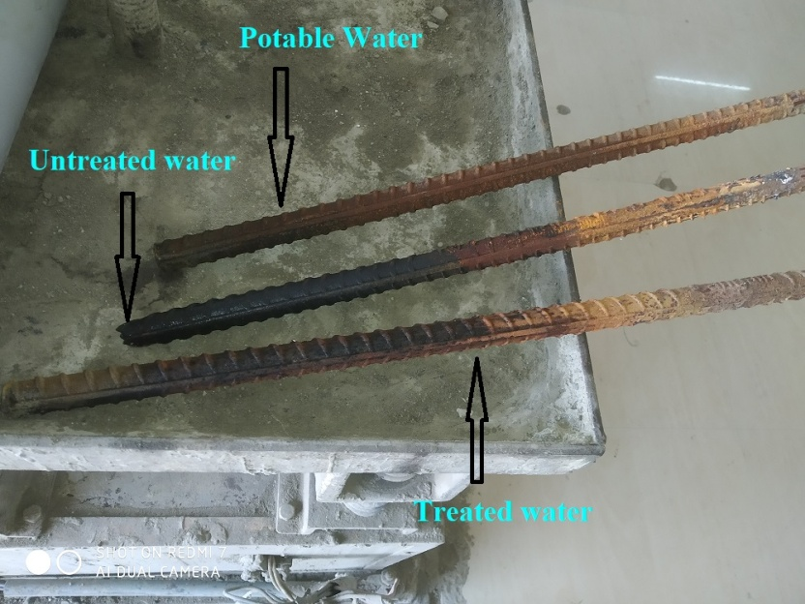
Figure 35: Effect of corrosion on reinforced bars
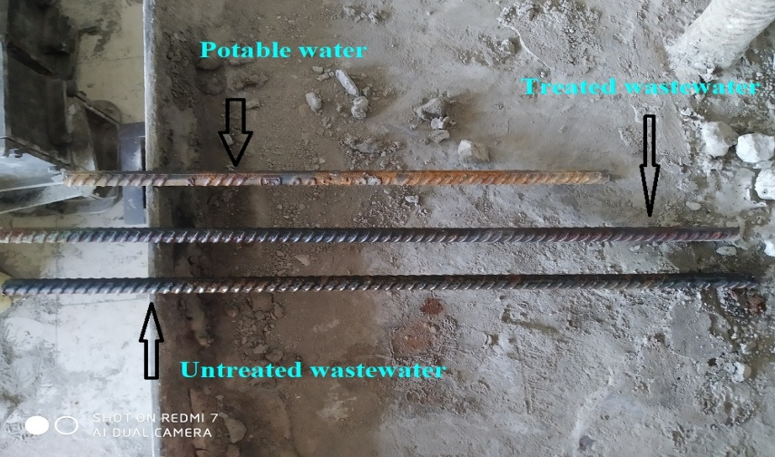
Figure 36: Effect of corrosion on reinforced bars
The Above figures shows the effect of corrosion due to use of different types of water.
- CONCLUSION

This research focus on implementing a sustainable practice in construction technology, such as performance of Treated Effluent on Concrete. Based on this sustainable practice used in this research following conclusion is presented.
            - From the experimental results, we can conclude that use of treated wastewater shows the highest compressive strength like conventional strength. The flexural strength, split tensile strength is found to have highest value for treated wastewater. If we increase curing days then the strength increases than conventional flexural strength.
            - Treated wastewater in concrete mix proved to be very useful to solve environmental problem. Therefore, it is recommended to re-use the naturally treated sewage wastewater in concrete to move towards sustainable development in construction industry with proper care of the corrosion effect due to treated wastewater is more than the potable water.
            - Consequentially, sustainable practice in construction industry show the potential for achieving economy with serviceability in long term effect.
References
[1] Ayesha Siddika, Md. Abdullah Al Mamun and Md. Abu Bakar Siddique (2017), “Evaluation of Bamboo Reinforcements in Structural Concrete Member”
[2] N. L. Rahim, N. M. Ibrahim, S. Salehuddin, S. A. Mohammed and M. Z. Othman (2020), “Investigation of bamboo as concrete reinforcement in the construction for low-cost housing industry”
[3] Prof. Ajit M.Kadam1, Shahid Y. Shaikh, Chetan D. Jagtap, Gauravraj G. Nage, Pratham P. Yadav, Pratik P. Mohite (2020), “An Experimental Project On 100 % Replacement of Steel Reinforcement with Bamboo”
[4] Masakazu TERAI and Koichi MINAMI (2012), “Research and Development on Bamboo Reinforced Concrete Structure”
[5] Alvin Harison, Akash Agrawal, Ashhad Imam (2017), “Bamboo as an Alternative to Steel for Green Construction towards Low Cost Housing”
[6] Omkar Gaikwad, Dipak Patil, Mayuri Rathod, Suraj Saw , Vijay Wairagade (2014), “Bamboo Reinforced Concrete”
[7] Hector Archila, Sebastian Kaminski, David Trujillo, Edwin Zea Escamilla, Kent A. Harries (2017), “Bamboo reinforced concrete: a critical review”
[8] Alireza Javadian, Ian F. C. Smith and Dirk E. Hebel (2012), “Application of Sustainable Bamboo-Based Composite Reinforcement in Structural-Concrete Beams: Design and Evaluation”
[9] Preetpal Singh and Gurjeet Singh (2016), “Low-Cost Housing in India”
[10] Isabel Mino-Rodríguez, Carlos Naranjo-Mendoza, and Ivan Korolija (2016), “Thermal Assessment of Low-Cost Rural Housing”
[11] Felichism Kabo (2004), “Low-cost housing: The effects of design and building materials on user preferences”
[12] Mohammad Sharif Zami (2010), “Inhibitors of adopting stabilised earth construction to address urban low cost housing crisis”
[13] K. Jaiganesh, S. Dinesh and R. Preetha (2013), “A comprehensive review on low cost building system”
[14] Ali Raza , Umer Rafique, Faraz ul Haq , Mechanical and durability behavior of recycled aggregate concrete made with different kinds of waste water, Journal of Building Engineering (2020)
[15] Shrilatha, Rohtih M, Puneeth H C, Naveen K Khatavkar , Effect of primary treated waste water in concrete mix, ISSN (PRINT): 2393-8374, (ONLINE): 2394-0697, VOLUME-4, ISSUE-8, 2017
[16] pooja Kirange , Monali Mhanavar , Ruchita Borhade , Shweta Tanksale, Yogesh Tamke ANALYZING THE EFFECT OF USING TREATED WASTE WATER ON STRUCTURAL CONCRETE, ISBN. No. 978-93-87901-03-2 February, 15th and 16th, 2019
[17] Ayoup M. Ghrair , , Othman A. Al-Mashaqbeh , Mohmd K. Sarireh , Nedal Al-Kouz , Mahmoud Farfoura , Sharon B. Megdal , Influence of grey water on physical and mechanical properties of mortar and concrete mixes, Engineering Journal 9 (2018) 1519–1525
[18]Mohamed H. Hegazy, Micheal M. Farouk, Effect of using secondary treated wastewater in production and curing of concret , J. Mater. Environ. Sci., 2020, Volume 11, Issue 9, Page 1493-1502
[19]Ehsan Nasseralshariati , Danial Mohammadzadeh , Nader Karballaeezadeh, Amir Mosavi Uwe Reuter and Murat Saatcioglu , The Effect of Incorporating Industrials Wastewater Durability and Long-Term Strength of Concrete , Materials 2021, 14, 4088
[20] Prachi S. Tetu, R. K.Ingle, P. L. Bongirvar “Bridge Cum Bandhara – A Crossing and Storage Bridge Structure” International Journal of Mechanical and Production Engineering, Volume- 3, Issue-7, 2015
[21] Arun Kumar and Rajendra Chalisgaonkar “Inflatable Weirs: A Viable Alternative for Bandhra/ Barrage Structures” Organized by Indian Institute of Technology Roorkee and National Institute of Hydrology, Roorkee, February 26-28, 2020
[23] Aniruddha N. Chavan, Prof. Umesh L. Deshpande “Review on Replacement of Conventional Steel plate needles by FRP needles in K. T. weirs” International Journal of Technical Innovation in Modern Engineering & Science (IJTIMES),e-ISSN: 2455-2585 Volume 5, Issue 2, February-2019
[24] Seong Haeng Lee, Kyoung Nam Kim, and Solomon C. Yim, F.ASCE, “Experimental study of flow-induced vibration of lens-shaped vertical lift gates”, ASCE J. Waterway, Port, Coastal, Ocean Eng.
[25] Dr. R. K. Ingle, Shri P. L. Bongirwar “Development of Standardised Design and Drawings of A Bridge Cum Bandhara System” R&D Project National Rural Roads Development Agency, 2016
[26] Joni Arliansyaha,*, Adi Tarunaa , Rhaptyalyania , Astri Yuli Kurnia “Needs analysis of the bridge infrastructures crossing over the Musi River of Palembang” The 5th International Conference of Euro Asia Civil Engineering Forum (EACEF-5)
[27] Rupen Goswami, and C. V. R. Murty, “Seismic vulnerability of RC bridge piers designed as per current IRC codes including Interim IRC: 6-2002 provisions”, Dept of Civil Engineering, IIT Kanpur, Kanpur 208016
[28] M/s Godbole Gates Pvt. Ltd., “Installation of automatic gates (patented) is the most economic solution for raising the storage capacity of existing dams and resolving water crisis” ON JUNE 6, 2018
[29] Mr.B.M.Jha Chairman of Central Ground Water Board “Manual on Artificial Recharge of Ground Water” Government of India ministry of water resources Central Ground Water Board, September, 2007
[30] Yogender Antil1, Er. Vivek Verma2, Er. Bhupinder Singh, (2012) "Rubberized Concrete Made with Crumb Rubber", International Journal of Science and Research (IJSR)
ISSN (Online): 2319-7064
[31] Su, Haolin; Yang, Jian; Ling, Tung-Chai; Ghataora, Gurmel; Dirar, Samir, "Properties of concrete prepared with waste tyre rubber particles of uniform and varying sizes",University of Birmingham,Research at Birmingham
[32] Ayman Moustafa, Mohamed A. ElGawady," Mechanical properties of high strength concrete with scrap tire rubber", Dept. of Civil Engineering, Missouri University of Science and Technology, Rolla, MO 65401, United States
[33] B. Waris, Nehal N. Ali, and Khalifa S. Al-Jabri (2016) “Use of Recycled Tire in Concrete for Partial Aggregate Replacement ”International Journal of Structural and Civil Engineering Research Vol. 5, No. 4, November 2016.
[34] Toutanji,H.A.,(1996) “The use of Rubber Tire Particles In Concrete To Replace Mineral Aggregates” published on Science Direct Volume 18, Issue 2, 1996, Pages 135-139
[35] G. Nagesh Kumar, V. Sandeep, Ch. Sudharani, “Using Tyres Wastes As Aggregates in Concrete to Form Rubcrete – Mix for Engineering Applications” IJRET: International Journal of Research in Engineering and Technology eISSN: 2319-1163 | pISSN: 2321-7308.

