GEOGRAPHICAL INDICATIONS IN INDIA- AN OVERVIEW
SCENARIO OF INDIA
G.Sandhya, T. Sivasakthi Devi*, A. Pouchepparadjou, S.Parthasarathi and Dr.S Selvaraj
PAJANCOA & RI, Karaikal, Puducherry UT, India.
*Corresponding author E-mail: sivapts2003@gmail.com

ABSTRACT
Geographical Indication (GI) has developed as a significant type of Intellectual Property Rights issue in India. A GI tag is a matter of pride to both the manufacturer and consumer as a symbol of excellence and a sense of guarantee or uniqueness and safety of rights to the parties involved in the production. It has been a boon to people around the world, especially the poor craftsmen who put in their best efforts to maintain such quality that is known and retained worldwide. It is an essential component to maintain the essence and originality of a product of certain features and characteristics. It provides the right to use the indication for the product to their manufacturers or producers from that particular region.
France was the first country to enact a comprehensive system for the protection of GIs that has later influenced the making of both national laws and international treaties. Till 30thSeptember, 2020 out of 706 applications, 370 products were registered under GI in India. Under this context, the objectives of the study such as to study the judicial pronouncements, laws concerning, legal effects, positions, issues related to GIs at global level, various agricultural commodities enrolled in GIs and the procedure of registration in Indian GI registry system.
INTRODUCTION
A geographical indication (GI) is a name or sign used on products which corresponds to a specific geographical location or origin (e.g., a town, region, or country). The use of a geographical indication, as an indication of the product's source, is intended as a certification that the product possesses certain qualities, is made according to traditional methods, or enjoys a good reputation due to its geographical origin.
Article 22.1 of the TRIPS Agreement defines geographical indications as "indications which identify a good as originating in the territory of a Member [of the World Trade Organization], or a region or locality in that territory, where a given quality, reputation or other characteristic of the good is essentially attributable to its geographical origin."
Appellation d'origine contrôlée ('Appellation of origin') is a sub-type of geographical indication where quality, method, and reputation of a product originate from a strictly defined area specified in its intellectual property right registration.
History
One of the first GI systems is the one used in France from the early part of the 20th century known as appellation d'origine contrôlée (AOC). Items that meet geographical origin and quality standards may be endorsed with a government-issued stamp which acts as official certification of the origins and standards of the product. Examples of products that have such "appellations of origin" include Gruyère cheese (from Switzerland) and many French wines.
Geographical indications have long been associated with the concept of terroir and with Europe as an entity, where there is a tradition of associating certain food products with particular regions. Under European Union Law, the protected designation of origin framework which came into effect in 1992 regulates the following systems of geographical indications: "Protected designation of origin" (PDO), "protected geographical indication" (PGI), and Traditional Specialities Guaranteed" (TSG).
Governments are protecting trade names and trademarks used in context to food products identified from a particular region, which until the late nineteenth century, laws were used or passed against inaccurate trade descriptions, which Usually protect against suggestions that have a certain origin, quality, of the product or association when it does not. In such cases, the competitive freedom that arises from the grant of a monopoly of use on a geographic indication is justified by governments for consumer protection benefits or producer protection benefits.
Among the major developing economies, India has a quick and efficient G I tagging mechanism. Geographical indications have been associated strongly with the concept of Terrero and as a unit with Europe, where there is an existence of a tradition of linking certain food products with particular regions and its origin. India has put in place a Sui Generis system of legislation for G.I. security as well as G.I. protection in particular. “Sui Generis” can be termed as of its own kind and which involves laws which are recognized nationally. The laws relating to the preservation of G.I.s in India are the ‘Geographical Indications (Registration and Protection) Act, 1999’ (G.I. Act), and the ‘Geographical Indications (Registration and Protection of Goods) Rules, 2002 (G.I. Rules). India enacted its G.I. law for the country to enforce national intellectual property laws in compliance with India’s obligations under TRIPS. Under the G.I. Act, under the G.I. Act, since 15 September 2003, the Central Government has established a Geographical Indication Registry in Chennai, with the jurisdiction of Pan-India, where rights holders can register their G.I.
OBJECTIVES
(i). to study the importance of Geographical indications in India and the positions and the issues related to GIs in global level
(ii) to know the judicial pronouncements, the laws concerning and the legal effects of GIs in India
(iii) to list the various agricultural commodities enrolled in GI tags of India and briefing the procedure of registration in Indian GI registry system.
Areas covered
The use of geographical indications is not limited to agricultural products. A geographical indication may also highlight specific qualities of a product that are due to human factors found in the product’s place of origin, such as specific manufacturing skills and traditions. For example, handicrafts, which are generally handmade using local natural resources and usually embedded in the traditions of local communities.
Trademarks
Geographical indications and trademarks are distinctive signs used to distinguish goods or services in the marketplace. Both convey information about the origin of a good or service, and enable consumers to associate a particular quality with a good or service. Trademarks inform consumers about the source of a good or service. They identify a good or service as originating from a particular company. Trademarks help consumers associate a good or service with a specific quality or reputation, based on information about the company responsible for producing or offering it. Geographical indications identify a good as originating from a particular place. Based on its place of origin, consumers may associate a good with a particular quality, characteristic or reputation. A trademark often consists of an arbitrary sign that may be used by its owner or another person authorized to do so. A trademark can be assigned or licensed to anyone, anywhere in the world, because it is linked to a specific company and not to a particular place. In contrast, the sign used to denote a geographical indication usually corresponds to the name of the place of origin of the good, or to the name by which the good is known in that place. A geographical indication may be used by all persons who, in the area of origin, produce the good according to specified standards. However, because of its link with the place of origin, a geographical indication cannot be assigned or licensed to someone outside that place or not belonging to the group of authorized producers.

Appellation of origin
Appellations of origin are a special kind of geographical indication. The term is used in the Paris Convention and defined in the Lisbon Agreement. Article 2 of the Lisbon Agreement defines appellations of origin as “the geographical denomination of a country, region, or locality, which serves to designate a product originating therein, the quality or characteristics of which are due exclusively or essentially to the geographical environment, including natural and human factors.” This definition suggests that appellations of origin consist of the name of the product’s place of origin. However, it is interesting to note that a number of traditional indications that are not place names, but refer to a product in connection with a place, are protected as appellations of origin under the Lisbon Agreement, for example, Reblochon (cheese) and Vinho Verde (green wine). It is sometimes argued that products with a certain reputation, but no other quality due to their place of origin are not considered appellations of origin under the Lisbon Agreement. However, this interpretation is not universally accepted.
Nevertheless, appellations of origin and geographical indications both require a qualitative link between the product to which they refer and its place of origin. Both inform consumers about a product’s geographical origin and a quality or characteristic of the product linked to its place of origin. The basic difference between the two terms is that the link with the place of origin must be stronger in the case of an appellation of origin. The quality or characteristics of a product protected as an appellation of origin must result exclusively or essentially from its geographical origin. This generally means that the raw materials should be sourced in the place of origin and that the processing of the product should also happen there. In the case of geographical indications, a single criterion attributable to geographical origin is sufficient, be it a quality or other characteristic of the product, or only its reputation. Moreover, the production of the raw materials and the development or processing of a GI product do not necessarily take place entirely in the defined geographical area. The term appellation of origin is often used in laws that establish a specific right and system of protection for geographical indications, in so-called sui generis systems of protection. Geographical indication is a more general concept that does not determine a specific mode of protection.

International Issues
Like trademarks, geographical indications are regulated locally by each country because conditions of registration such as differences in the generic use of terms vary from country to country. This is especially true of food and beverage names which frequently use geographical terms, but it may also be true of other products such as carpets (e.g. 'Shiraz'), handicrafts, flowers and perfumes.
When products with GIs acquire a reputation of international magnitude, some other products may try to pass themselves off as the authentic GI products. This kind of competition is often seen as unfair, as it may discourage traditional producers as well as mislead consumers. Thus, the European Union has pursued efforts to improve the protection of GI internationally. Inter alia, the European Union has established distinct legislation to protect geographical names in the fields of wines, spirits, agricultural products including beer. A register for protected geographical indications and denominations of origin relating to products in the field of agriculture including beer, but excluding mineral water, was established (DOOR). Another register was set up for wine region names, namely the E-Bacchus register. In November 2020, the European Union Intellectual Property Office launched the comprehensive database GI View covering food, wine, and spirit GIs. A private database project (GEOPRODUCT directory) intends to provide worldwide coverage. Accusations of 'unfair' competition should although be levelled with caution since the use of GIs sometimes comes from European immigrants who brought their traditional methods and skills with them.

Paris convention and Lisbon agreement
International trade made it important to try to harmonize the different approaches and standards that governments used to register GIs. The first attempts to do so were found in the Paris Convention on trademarks (1883, still in force, 176 members), followed by a much more elaborate provision in the 1958 Lisbon Agreement on the Protection of Appellations of Origin and their Registration. 28 countries are parties to the Lisbon agreement: Algeria, Bosnia and Herzegovina, Bulgaria, Burkina Faso, Congo, Costa Rica, Cuba, Czech Republic, North Korea, France, Gabon, Georgia, Haiti, Hungary, Iran, Israel, Italy, Macedonia, Mexico, Moldova, Montenegro, Nicaragua, Peru, Portugal, Serbia, Slovakia, Togo and Tunisia. About 9000 geographical indications were registered by Lisbon Agreement members.

Agreement on Trade-Related Aspects of Intellectual Property Rights
The WTO Agreement on Trade-Related Aspects of Intellectual Property Rights ("TRIPS") defines "geographical indications" as indications that identify a good as "originating in the territory of a Member, or a region or locality in that territory, where a given quality, reputation or other characteristic of the good is essentially attributable to its geographic origin."
In 1994, when negotiations on the WTO TRIPS were concluded, governments of all WTO member countries (164 countries, as of August 2016) had agreed to set certain basic standards for the protection of GIs in all member countries. There are, in effect, two basic obligations on WTO member governments relating to GIs in the TRIPS agreement:
- Article 22 of the TRIPS Agreement says that all governments must provide legal opportunities in their own laws for the owner of a GI registered in that country to prevent the use of marks that mislead the public as to the geographical origin of the good. This includes prevention of use of a geographical name which although literally true "falsely represents" that the product comes from somewhere else.
- Article 23 of the TRIPS Agreement says that all governments must provide the owners of GI the right, under their laws, to prevent the use of a geographical indication identifying wines not originating in the place indicated by the geographical indication. This applies even where the public is not being misled, where there is no unfair competition and where the true origin of the good is indicated or the geographical indication is accompanied by expressions such as "kind", "type", "style", "imitation" or the like. Similar protection must be given to geographical indications identifying spirits.
Article 22 of TRIPS also says that governments may refuse to register a trademark or may invalidate an existing trademark (if their legislation permits or at the request of another government) if it misleads the public as to the true origin of a good. Article 23 says governments may refuse to register or may invalidate a trademark that conflicts with a wine or spirits GI whether the trademark misleads or not.
Article 24 of TRIPS provides a number of exceptions to the protection of geographical indications that are particularly relevant for geographical indications for wines and spirits (Article 23). For example, Members are not obliged to bring a geographical indication under protection where it has become a generic term for describing the product in question. Measures to implement these provisions should not prejudice prior trademark rights that have been acquired in good faith; and, under certain circumstances — including long-established use — continued use of a geographical indication for wines or spirits may be allowed on a scale and nature as before.
In the Doha Development Round of WTO negotiations, launched in December 2001, WTO member governments are negotiating on the creation of a 'multilateral register' of geographical indications. Some countries, including the EU, are pushing for a register with legal effect, while other countries, including the United States, are pushing for a non-binding system under which the WTO would simply be notified of the members' respective geographical indications.
Some governments participating in the negotiations (especially the European Communities) wish to go further and negotiate the inclusion of GIs on products other than wines and spirits under Article 23 of TRIPS. These governments argue that extending Article 23 will increase the protection of these marks in international trade. This is a controversial proposal, however, that is opposed by other governments including the United States who question the need to extend the stronger protection of Article 23 to other products. They are concerned that Article 23 protection is greater than required, in most cases, to deliver the consumer benefit that is the fundamental objective of GIs laws.

Geneva Act of the Lisbon Agreement
In 2015, The Geneva Act was adopted. It entered into force early-2020 with the accession of the European Union. The Geneva Act bridges the Lisbon system of Appellations of Origin, and the TRIPS system of Geographical Indications.
Legal Effects
Geographical Indications protection is granted through the TRIPS Agreement. Protection afforded to geographical indications by law is arguably twofold:
- On one hand it is granted through sui generis law (public law), for example in the European Union. In other words, GI protection should apply through ex officio protection, where authorities may support and get involved in the making of GI collective dimensions together with their corresponding GI regulatory council, where ongoing discourse with the government is implied for effective inspection and quality control.
- On the other hand, it is granted through common law (private law). In other words, it is similar to the protection afforded to trademarks, as it can be registered through collective trademarks and also through certification marks, for example in the United States of America.
GI protection systems restrict the use of the GIs for the purpose of identifying a particular type of product, unless the product and/or its constituent materials and/or its fabrication method originate from a particular area and/or meet certain standards. Sometimes these laws also stipulate that the product must meet certain quality tests that are administered by an association that owns the exclusive right to license or allow the use of the indication. GIs are recognised through either public or private law: depending on the GI protection system applied among the different WTO state members, either through common law or through sui generis law. Thus, the conflicts between prior trademark registration and GIs are a subject of international debate that is yet to be resolved; this is what makes the GI system rather positional in terms of international trade negotiations. These conflicts are generally resolved through three intellectual property protection approaches: first in time –first in right approach, coexistence approach, GI superiority approach.
Arguably trademarks are seen as a valuable asset in terms of private business and their economic assets, while GIs are strongly connected to socio-economic development, along the lines of sustainability in countries rich in traditional knowledge. The geographical origin of a product can create value to producers by:
- communicating to consumers the product's characteristics, which derive from the climate, soil and other natural conditions in its particular area;
- promoting the conservation of local traditional production process; and
- protecting and adding value to the cultural identity of local communities.
The consumer-benefit purpose of the protection rights granted to the beneficiaries (generally speaking the GI producers), has similarities to but also differences from the trademark rights:
- While GIs denote a geographical origin of a good, trademarks denote a commercial origin of an enterprise.
- While comparable goods are registered with GIs, similar goods and services are registered with trademarks.
- While a GI is a name associated by tradition with a delineated area, a trademark is a badge of origin for goods and services.
- While a GI is a collective entitlement of public-private partnership, a trademark refers entirely to private rights. With GIs, the beneficiaries are always a community from which usually, regardless of who is indicated in the register as applicant, they have the right to use. Trademarks distinguish goods and services between different undertakings; thus, it is more individual (except collective trademarks which are still more private).
- While the particular quality denoted by a GI is essentially related to a geographical area, although the human factor may also play a part (collectively), with trademarks, even if there is any link to quality, it is essentially because of the producer and provider (individually).
- While GIs are an already existing expression and are used by existing producers or traders, a trademark is usually a new word or logo chosen arbitrarily.
- While GIs are usually only for products, trademarks are for products and services.
- While GIs cannot become numerous by definition, with trademarks there is no limit to the number that might be registered or used.
- While GIs may not normally qualify as trademarks because they are either descriptive or misleading and distinguish products from one region from those of another, trademarks normally do not constitute a geographical name as there is no essential link with the geographical origin of goods.
- While GIs protect names designating the origin of goods, trademarks – collective and certification marks where a GI sui generis system exists – protect signs or indications.
- While with GIs there is no conceptual uniform approach of protection (public law and private law / sui generis law and common law), the trademark concepts of protection are practically the same in all countries of the world (i.e., basic global understanding of the Madrid System). In other words, with GIs there is no international global consensus for protection other than TRIPS.
- While with GIs the administrative action is through public law, the enforcement by the interested parties of trademarks is through private law.
- While GIs lack a truly global registration system, trademarks global registration system is through the Madrid Agreement and Protocol.
- While GIs are very attractive for developing countries rich in traditional knowledge, the new world, e.g., Australia, with a different industry development model they are more prone to benefit from trademarks. In the new world, GI names from abroad arrive through immigrants and colonisation, leading to generic names deriving from the GIs from the old world.
Geographical indications have other similarities with trademarks. For example, they must be registered in order to qualify for protection, and they must meet certain conditions in order to qualify for registration. One of the most important conditions that most governments have required before registering a name as a GI is that the name must not already be in widespread use as the generic name for a similar product. Of course, what is considered a very specific term for a well-known local specialty in one country may constitute a generic term or genericized trademark for that type of product. For example, parmigiano cheese in Italy is generically known as Parmesan cheese in Australia and the United States.
Rural Developmental Effects
Geographical indications are generally applied to traditional products, produced by rural, marginal or indigenous communities over generations, that have gained a reputation on the local, national or international markets due to their specific unique qualities.
Producers can add value to their products through Geographical Indications by:
- communicating to consumers the product's characteristics, which derive from the climate, soil and other natural conditions in its particular geographical area;
- promoting the conservation of local traditional production processes; and
- protecting and adding value to the cultural identity of local communities.
The recognition and protection on the markets of the names of these products allows the community of producers to invest in maintaining the specific qualities of the product on which the reputation is built. Most importantly, as the reputation spreads beyond borders and demand grows, investment may be directed to the sustainability of the environment where these products originate and are produced. In the International Trade Centre's "Guide to Geographical Indications: Linking Products and their Origins", authors Daniele Giovannucci, Professor Tim Josling, William Kerr, Bernard O'Connor and May T. Yeung clearly assert that geographical indications are by no means a panacea for the difficulties of rural development. They can however offer a comprehensive framework for rural development, since they can positively encompass issues of economic competitiveness, stakeholder equity, environmental stewardship, and socio-cultural value. The application of circular economy will ensure socio-economic returns in the long-run to avoid growth at an environmental cost. This approach for GI development may also allow for investment together with promoting the reputation of the product along the lines of sustainability when and where possible.
Rural development impacts from geographical indications, referring to environmental protection, economic development and social well-being, can be:
- the strengthening of sustainable local food production and supply (except for non-agricultural GIs such as handicrafts);
- a structuring of the supply chain around a common product reputation linked to origin;
- greater bargaining power to raw material producers for better distribution so as for them to receive a higher retail price benefit percentage;
- capacity of producers to invest economic gains into higher quality to access niche markets, improving circular economy means throughout the value chain, protection against infringements such as free-riding from illegitimate producers, etc.;
- economic resilience in terms of increased and stabilised prices for the GI product to avoid the commodity trap through de-commodisation, or to prevent/minimise external shocks affecting the premium price percentage gains (usually varying from 20-25%);
- added value throughout the supply chain;
- spill-over effects such as new business and even other GI registrations;
- preservation of the natural resources on which the product is based and therefore protect the environment;
- preservation of traditions and traditional knowledge;
- identity based prestige;
- linkages to tourism.
None of these impacts are guaranteed and they depend on numerous factors, including the process of developing the geographical indications, the type and effects of the association of stakeholders, the rules for using the GI (or Code of Practice), the inclusiveness and quality of the collective dimension decision making of the GI producers association and quality of the marketing efforts undertaken.

GI Challenges In Global and India
Global GI challenge
In the recent times, the IPR protection has taken centre stage. Developed countries which possess most intellectual properties in terms of high knowledge-based technologies, seek to protect their self-interest by the IPR conventions and often complain about the inadequacy of IPR protection in developing countries and accuse them of IP piracy. Developed countries, in particular those which possess GI products, have enacted laws to protect their genetic resources. Thailand with its sui generis GI protection system hopes to mitigate the problem of exploiting origin-based names. The Thai GI Act was enacted not only due to the requirements of the multilateral trading framework but also due to biopiracy related to its widely known Thai jasmine rice. The biopiracy issue was seen as the main driving force accelerating the process for enacting the GI law.
However, increased trade liberalization through bilateral FTAs and RTAs with economies such as the United States and the attempt to protect its national "assets" by obtaining a patent for the rice genes in the USPTO have created a situation that has started to challenge GI protection in Thailand. This is due to the limited protection period for patents registered in the United States (only up to 20 years). Furthermore, patenting life forms was never a position of Thailand at the multilateral trade negotiations on patent protection.
Suggestions on how to solve such problems do exist, such as opening negotiations that go much further than the existing request of extending GI protection, or upgrading its national sui generis system for GI protection by adding protection on genetic resources of GI plants. However, there is a cost to such suggestions and the expected outcome is unsure. Raising the issue of automatic protection on genetic resources of GI plants within the scope of GI protection is much more challenging, while there is criticism of the sui generis system of GI protection by opponents in a series of bilateral FTAs and RTAs. Questions like whether the country would be better off by using its resources on other facets of development that are more likely to yield sustainable outcomes. While creating consumer awareness about GIs, for example, is generally recommendable, it must also be considered that GI promotion is expensive and sustainable benefits are not guaranteed. Nevertheless, given the social, cultural and economic importance of GIs for Thailand, it is necessary and worth trying to seek win-win solutions which are of benefit to both sides, the opponents and proponents of GI protection. Many Thai GIs are agricultural in nature and involve all kinds of actors from poor rural households to GI exporters. Losing "GI assets" due to inadequate protection might have a negative impact on many of the million poor in the rural areas.
GI challenge in India
India may have unknowingly made it more difficult for its producers to get GI protection for their agricultural products. Section 9 of the Act, which prohibits registration of GIs which are determined to be generic names or indications of goods, says that an indication becomes generic when it goes back to the public domain and is not or has ceased to be protected in their country of origin, or which has fallen into disuse in that country.
It should be noted that TRIPS leaves it exclusively to the discretion of the country of origin to decide whether a particular geographical name has become generic or not. Thus, it is the governments/courts of WTO members that will decide whether or not a particular GI has become generic or needs to be protected. It is submitted that India ought to have kept the scope of genericide as narrow as possible, i.e., it should have allowed its courts to determine which term is generic and which is not, based only on the situation in India (the country of origin) and not based on the status in the areas of consumption. The more areas and situations we consider, the more likely that the term is generic, especially considering the drive with which industries in the 'New World' are attempting to exploit GIs.
The Common GI Logo
The Department for Promotion of Industry and Internal Trade under Ministry of Commerce and Industry, in June 2019 released a notification stating the guidelines of the common GI logo and tagline on all GIs of India. The logo consists of a ‘G’ and ‘I’ bearing the three colours of the Indian flag. The tagline in English is ‘Invaluable Treasures of Incredible India’ along with the same in Hindi.
The usage of this logo helps consumers across the globe to identify the authentic GI products of India. It also helps in promotion and marketing of Indian products. Foreign GI products are not permitted to use this logo.
Geographical indication logo

PROTECTIONS OF GEOGRAPHICAL INDICATIONS
The general standards of protection for Geographical Indication can be traced down to the Paris Convention for protection of Industrial Property,1883, which includes in its wide connotation, protection to- patents, trademarks, industrial designs, utility models, trade names and service mark, in addition to geographical indications. These were followed by the Madrid Agreement for repression of False or Deceptive Indications of Source of Goods 1891.
This was followed by treaties and conventions which focussed on the registration process for geographical indications. The Madrid Agreement concerning the International Registration of Marks signed in 1891, the Lisbon Agreement for the Protection of Appellations of Origins and their International Registration, 1958 and the Protocol Relating to the Madrid Agreement Concerning the international registration of marks, which came into being in 1989 have played important role in the development of a framework for the process of international registration of marks.
However, the seeds for the development of laws on Geographical Indications in India were sown through the Trade-Related Aspects of Intellectual Property Rights (TRIPS) agreement which came into force on 1st January 1995. This agreement is considered to be the most comprehensive document on Intellectual Property Rights. Post coming into force of the TRIPS agreement the Parliament of India enacted the Geographical Indication of Goods (Registration and Protection) Act, 1999. This Act aimed at providing for the registration and better protection of geographical Indications of goods.
The Geographical Indications of Goods (Registration and Protection) Act, 1999 (GI Act) is a sui generis Act of the Parliament of India for protection of geographical indications in India. India, as a member of the World Trade Organization (WTO), enacted the Act to comply with the Agreement on Trade-Related Aspects of Intellectual Property Rights.
The GI tag ensures that only those registered as authorised users (or at least those residing inside the geographic territory) are allowed to use the popular product name. Darjeeling tea became the first GI tagged product in India, in 2004–05, since then 370 goods had been added to the list as of August 2020.
According to section 2 (e) of the Geographical Indications of Goods (Registration and Protection) Act,1999, Geographical Indication in relation to goods means “an indication which identifies such goods as agricultural goods, natural goods or manufactured goods as originating, or manufactured in territory of a country, or a region or locality in that territory, where a given quality, reputation or other characteristics of such goods is essentially attributable to its geographical origin and in case where such goods one of the activities of either the production or of processing or preparation of goods concerned takes place in such territory, region or locality as the case may be”
India has registered over 361 geographical Indications till date. The first GI to be registered was for Darjeeling Tea in the state of West Bengal, which was registered in the year 2004. Handicrafts make up the largest type of goods which have been registered as GIs, followed by Agricultural products.
THE REGISTRATION PROCESS - FLOW CHART
- In December 1999, Parliament passed the Geographical Indications of Goods (Registration and Protection) Act 1999. This Act seeks to provide for the registration and protection of Geographical Indications relating to goods in India. This Act is administered by the Controller General of Patents, Designs and Trade Marks, who is the Registrar of Geographical Indications. The Geographical Indications Registry is located at Chennai.
- The Registrar of Geographical Indication is divided into two parts. Part ’A’ consists of particulars relating to registered Geographical indications and Part ‘B’ consists of particulars of the registered authorized users. The registration process is similar to both for registration of geographical indication and an authorized user which is illustrated below:

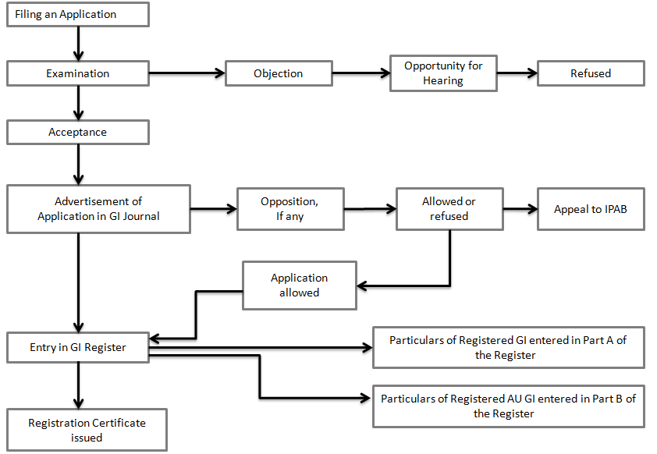

The procedure and manner in which the Geographical Indication for a place in India can be registered as per provisions enlisted under the Geographical Indications of Goods (Registration and Protection) Act,1999:

Who can file for Geographical Indications?
An application for registration of the Geographical Indication can be made by an association of persons or producers or any organisations or authority established by or under any law for time being in force; who must be representing the interest of the producers of the concerned goods; and desirous of registering a geographical indication in relation to such goods.”

Authorised User
An authorised user is a person who has been registered as such under Section 17 of the Geographical Indications of Goods (Registration and Protection) Act,1999 act. A producer of the goods in respect of which geographical indication has been registered is eligible to register himself as an authorised user.
In order to register oneself as an authorised user, the producer needs to provide a statement and other documents of facts which would allow the registrar to ascertain the veracity of their claims. The registration of an authorised user is valid for 10 years, or till the date on which the registration of the related geographical indication expires.
Steps applicable for registration as authorised user are-
- Filing of an application
- Preliminary Scrutiny and exam
- Issue of Show cause notice
- Advertisement
- Opposition for registration
- Registration

Prohibition on registration of certain Geographical Indications
There are certain Geographical Indications, the registration of which is prohibited by law. These include such indications:
- The use of which is likely to deceive or cause confusion
- The use of which is contrary to the law for time being in force
- Which comprises of or contains any scandalous or obscene matter
- Which comprises or contains any matter that is likely to hurt the religious sentiments of any class or section of people
- Which would be disentitled to protection of law
- Which are determined to be the generic names or indications of goods and therefore ceased or not protected in the country of origin
- Which, although literary true as to the territory, region or the locality in which the goods have originated, but falsely represent that the goods originate in a different territory or locality or region of a country

Step by step procedure for registration of Geographical Indication
Step 1-Filing of the Application
- The application for the registration of Geographical Indication shall be made in triplicate.
- The application then must be signed by the applicant or his agent along with the statement of case and has to be submitted along with the prescribed form GI-1
- A single application can be filed for different classes of goods and fees payable shall be in respect of each of such class of goods.
- An affidavit is required to accompanying the forms has to be submitted by the association of persons, producers, organisations or authority representing the interest of the producers over certain goods and how the applicant claims to represent their interest.
What should be the contents of the application?
- Firstly, it should state how the geographical indication serves to designate the goods as originating from the concerned territory of the country or region or localities as the case may be, in respect to quality specifications, reputation, characteristics which are exclusively due to certain environmental conditions with inherit natural or human factors relating to the territory.
- It should also state the class of goods to which the geographical Indication shall apply
- The geographical map of the territory of the country or region or the locality of the country in which the goods are produced or manufactured should be included.
- Particulars regarding the appearance of the geographical indications as to whether it is comprised of words or figurative elements or both.
- Statement containing the details of the applicant including the names, addresses and other such details as may be specified from time to time

Step 2 and 3 – Preliminary Scrutiny and Examination
- The application will be scrutinized by the examiner for any deficiencies and discrepancies.
- In case of any deficiencies and discrepancies, the applicant is required to rectify the same with a period one month of its communication.
- The correctness and authenticity of the content of statement furnished by the applicant shall then be assessed by the Registrar in consultation with a group of experts consisting of not more than 7 representatives who are well versed on the subject.
- Only after proper scrutiny and examination that the examination report will be issued
Step 4 – Issue of Show Cause Notice
- If the Registrar has any objection with regards to the application, then the same shall be communicated to the applicant.
- The applicant must respond within a period of two months from the receiving of the notice or he can apply for hearing
- The Registrar has been entrusted with the power to withdraw the application after giving the applicant a reasonable opportunity of being heard, if he is of opinion that there has been an error on the part of the applicant and the same has been conveyed to him
- If aggrieved, an appeal can be made within period of one month of the Registrar’s decision.
Step 5: Advertisement
- Every application for registration of geographical indication that has been accepted absolutely or with subject to conditions or limitations shall within three months of acceptance shall be published in the Geographical Indications Journal.

Step 6: Opposition to Registration
- Any person can file a notice of opposition within three months (extendable by another month on request which has to be filed before three months) opposing the Geographical Indication application published in the Journal in triplicate along with the form GI-2
- The registrar shall serve a copy of the notice on the applicant for registration and the applicant shall within period of two months from the date of the receipt of such notice send to the Registrar the copy of the counter statement stating the grounds on which he relies on his application, failure to do so will result in abandonment of his application.
- On receiving the counter statement from the applicant, the Registrar shall serve a copy of the of the same to the person giving the notice of opposition.
- The applicant and the opponent have to submit to the registrar any evidence on which they rely, in manner and time as may be prescribed from time to time by the registrar.
- Registrar shall give adequate time to both the parties to be heard
- The registrar after hearing both the parties and considering all the evidence shall decide whether to accept the application with or without limitations or conditions
- If it comes to the notice of the registrar that either the applicant or person giving the notice of opposition neither resides nor carries on the business in India, the registrar may require him to give the security for the cost of proceedings before him and in case of any default of such security duly given, may treat the application or opposition as the case may be, as abandoned.
- On request the Registrar may permit to make any correction or amendment of an error in the notice of opposition or counterstatement.
Step 7– Corrections and amendments
The Registrar may from time to time with subject to certain terms and conditions permit either before or after the acceptance of the application, the correction of any error or an amendment of the application.
Step 8: Registration
- On acceptance of the application, the registrar shall register the geographical indication for the same.
- If registered the date of filing of the application shall be deemed to be the date of registration.
- The registrar shall then issue to the applicant a certificate with the seal of the Geographical indication’s registry in Form-02 as per Rule 55 0f The Geographical Indications of Goods (Registration and Protection) Rules, 2002
Step 9: Duration, Renewal and Restoration
- A registered Geographical Indication shall be valid for 10 years and can be renewed on payment of renewal fee.
- At the time before the expiration of last registration of geographical indication, the Registrar shall send the notice to the registered proprietor or the authorised user as the case may be, about the date of expiration and the conditions as to payment of fees and upon renewal of which registration shall be obtained.
- Failure to do so may result in removal of geographical indication
- Where a geographical indication has been removed by the Registrar on grounds of non-payment of the renewal fees may after six months and within period of one year from the expiration of last registration of geographical indication may, on an application in a prescribed manner and after payment of prescribed fees may restore the geographical indication for period of 10 years from the expiration of last registration.
Step 10: Appeal to the Appellate Boards
- Any person aggrieved by an order or decision of the Registrar under the act or under the rules made thereunder, may prefer an appeal to the Intellectual Property Appellate Board (IPAB) within three months from the date on which the order or decision sought to be appealed is communicated.

Rights conferred by Registration
Under section 21 of the act, the authorised user and proprietor of the geographical indication is allowed certain rights in terms of the indication. These include:
- An exclusive right to make use of the indication in relation to goods to which the indication has been obtained.
- In case of infringement, to seek relief in a manner provided in the act.
However, it needs to be remembered that these rights conferred by registration are not absolute and are subject to conditions which restrict the powers allowed to the user, including:
- Variation Condition: This includes cases where the proprietor agrees to have variations in the mark assigned to goods, other than those mentioned in the label.
- Restraining Conditions: The geographical indication shall not be used for the purpose of certain specific goods
- Blank Space condition: This condition requires all blank spaces in the label to only be occupied by matter that is non-distinctive in nature.
- Limitation Condition: This condition restricts the area within which the registration is allowed to operate.
Examples of Indian Geographical Indications.
- Basmati Rice
- Darjeeling Tea
- Kanchipuram silk saree
- Nagpur orange
- Kolhapuri chappal
- Bikaneri bhujia
- Agra petha
REGISTRATION STATUS OF GI IN INDIA
- The registration process of GI products has been started in India since 2003. In its inception, three products were registered.
- Under agriculture product The Darjeeling Tea (both word and logo) was first registered, followed by Aranmula Kannadi, Handicraft product of Kerala, and Pochampalli Ikat from Andhra Pradesh.
- Till today out of 706 applications, 370 products were registered under GI, 53 products were refused, 25 were withdrawn, 28 were abandoned and230 products are pending for registration.
- Some products were also registered by foreign Countries in India. 15 products from 9 countries were registered for GI.
- Peruvian Pisco, a brandy under manufactured goods was the first product registered by Peru in the year 2009-10, followed by France Champagne (2010-11) and Cognac (2011-12), USA Napa Valley (2010-11), United Kingdom Scotch Whiskey (2010-11), Italy Prosciutto di Parma (2010-11), Parmigiano Reggiano, Prosecco and Asiago (2016-17) and Grana Padano (2018-19), Portugal Porto and Douro (2011-12), Mexico Tequila (2012-13), Thailand Lamphun Brocade Thai Silk (2017-18) and Ireland Irish Whisky (2019-20).
Table – 1. State wise registration status of GI
Sl. No. | State | No. of GI Registered | Percentage (%)
1 | Karnataka | 42 | 11.35
2 | Tamil Nadu | 38 | 10.27
3 | Maharashtra | 30 | 8.11
4 | Kerala | 28 | 7.57
5 | Uttar Pradesh | 27 | 7.30
6 | West Bengal | 21 | 5.68
7 | Andhra Pradesh | 17 | 4.59
8 | Odisha | 17 | 4.59
9 | Gujarat | 15 | 4.05
10 | Telangana | 15 | 4.05
11 | Rajasthan | 14 | 3.78
12 | Karnataka | 13 | 3.51
13 | Madhya Pradesh | 10 | 2.70
14 | Assam | 9 | 2.43
15 | Himachal Pradesh | 8 | 2.16
16 | Jammu & Kashmir | 8 | 2.16
17 | Chhattisgarh | 6 | 1.62
18 | Mizoram | 6 | 1.62
19 | Manipur | 5 | 1.35
20 | Nagaland | 3 | 0.81
21 | Arunachal Pradesh | 2 | 0.54
22 | Goa | 2 | 0.54
23 | Meghalaya | 2 | 0.54
24 | Pondicherry | 2 | 0.54
25 | Jharkhand | 1 | 0.27
26 | Sikkim | 1 | 0.27
27 | Tripura | 1 | 0.27
28 | Uttarakhand | 1 | 0.27

Graph – 1. State wise registration status of GI
It has been revealed from Table – 1, that in India, maximum i.e. 42 (11.35%) Geographical Indications were registered by the state of Karnataka followed by 38 (10.27%) from Tamil Nadu State, 30 (8.11%) from Maharashtra State, 28 (7.57%) from Kerala while the state of Uttar Pradesh has registered 27 (7.30%) GIs.
Table – 2. Product wise distribution in India
Sl. No. | Type of Goods | No. of GI Registered | Percentage (%)
1 | Handicrafts | 214 | 57.84
2 | Agricultural | 112 | 30.27
3 | Manufactured | 24 | 6.49
4 | Food Stuff | 18 | 4.86
5 | Natural Goods | 2 | 0.54
Total |  | 370 | 100

Graph – 2. Product wise distribution in India
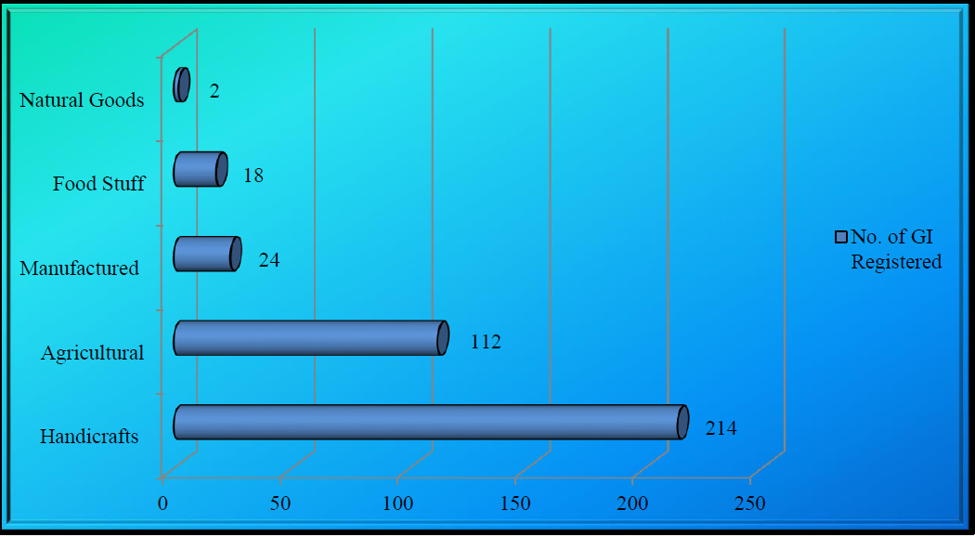
Table – 2 shows that the maximum number of GIs was registered from the Handicrafts category i.e., 214 (57.84%) of the total registration followed by 112 (30.27%) from Agricultural and 24 (6.49%) from the Manufactured category.
Table – 3. Year wise distribution in India
Sl. No. | Year | No. of GI Registered | Percentage  (%) | Sl. No. | Year | No. of GI Registered | Percentage  (%)
1 | 2004 – 2005 | 03 | 0.81 | 10 | 2013 – 2014 | 22 | 5.95
2 | 2005 – 2006 | 24 | 6.49 | 11 | 2014 – 2015 | 20 | 5.41
3 | 2006 – 2007 | 03 | 0.81 | 12 | 2015 – 2016 | 26 | 7.03
4 | 2007 – 2008 | 31 | 8.38 | 13 | 2016 – 2017 | 33 | 8.92
5 | 2008 – 2009 | 45 | 12.16 | 14 | 2017 – 2018 | 26 | 7.03
6 | 2009 – 2010 | 14 | 3.78 | 15 | 2018 – 2019 | 23 | 6.22
7 | 2010 – 2011 | 29 | 7.84 | 16 | 2019 – 2020 | 22 | 5.95
8 | 2011 – 2012 | 23 | 6.22 | 17 | 2020 – till date | 05 | 1.35
9 | 2012-2013 | 21 | 5.68

Graph – 3. Year wise distribution in India
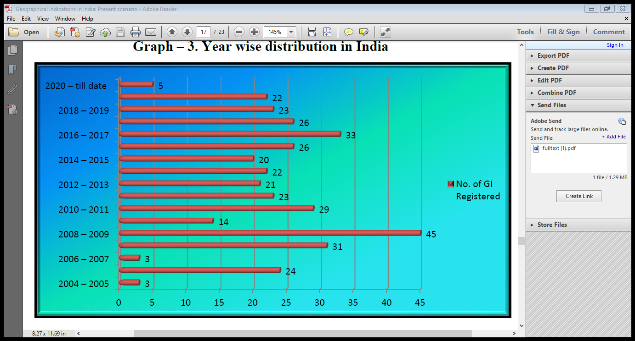
Table – 3 depicts the year-wise distribution of GIs registered in India. Maximum 45 (12.16%) GIs were registered in the year 2008 – 2009 followed by 33 (8.92%) in the year 2016 – 2017 and a minimum of 3 (0.81%) GIs were registered in the year 2004 – 2005 and 2006 – 2007 respectively.
Table – 4. Application status of GIs registered in India
Sr. No. | Refused | Withdrawn | Abandoned | Pending | Registered | Total Applications
1 | 53 | 25 | 28 | 230 | 370 | 706

Graph – 4. Application status of GIs registered in India
It has been observed from Table – 4, that in India, out of 706 applications, 53 were refused, 25 were withdrawn, 28 were abandoned, 230 applications were pending while 370 products were registered in Geographical Indication Registry.
FINDINGS AND SUGGESTIONS
- In total 2, 00,227 GIs are in force till 2018 worldwide.
- Germany had the largest number of GIs in force (15,566) in 2018.
- Till 30th September 2020, a total of 370 items were registered under 34 classes in India.
- The Darjeeling Tea (both word and logo) under the class agriculture product is the first GI that is registered in India.
- Maximum i.e. 42 (11.35%) Geographical Indications were registered by the state of Karnataka.
- 11 products were collaboratively registered by 19 states.
- Peru is the first country to register its product Peruvian Pisco, a brandy, under manufactured goods class 33 in the year 2009-10.
- Italy has registered 5 (1.35%) GIs.
- Maximum numbers of GIs were registered from the Handicrafts category i.e. 214 (57.84%).
- Maximum 45 (12.16%) GIs were registered in the year 2008 – 2009.
- Till 30th September 2020, out of 706 applications, 52.40% of products were registered while 32.57% of applications were pending and under process.
- Maximum 65 products were registered under class 31 - Agricultural, horticultural, and forestry products and grains.
- Out of 370 products, 88.91% of products were renewed for further 10 years while 4.05% of products were not renewed to date.

CONCLUSIONS
A Geographical Indication tag is a matter of pride to both the manufacturer and consumer as a symbol of excellence and a sense of guarantee or uniqueness and safety of rights to the parties involved in the production. GI has been a boon to people around the world, especially 21 the poor craftsmen who put in their best efforts to maintain such quality that is known and retained worldwide. A GI tag is an essential component to maintain the essence and originality of a product of certain features and characteristics. France was the first country to enact a comprehensive system for the protection of GIs that has later influenced the making of both national laws and international treaties. India hasn't been left behind in lawfully taking this aspect of Intellectual Property Rights forward.
REFERENCES
- Patel Mr, R. M., & ZALA, D. (2021). Geographical Indications in India: Present scenario.
- Sharma, Swati (2019). Geographical Indication in India: Current Scenario and their Product Distribution, International Journal of Social Science and Economic Research, Vol. 4 (4), 2792-2806.
- Das, K. (2010). Prospects and challenges of geographical indications in India. The Journal of World Intellectual Property,13(2), 148-201.
- Das, K. (2009). Socioeconomic implications of protecting geographical indications in India. Available at SSRN 1587352.
- Das, K. (2007). Protection of geographical indications: An overview of select issues with particular reference to India. Centre for Trade and Development working paper.
- Soam, S. K. (2005). Analysis of prospective geographical indications of India. J. World Intell. Prop., 8, 679.
- Lalitha, N., & Vinayan, S. (2019). Regional products and rural livelihoods: a study on geographical indications from India. Oxford University Press.
- Marie-Vivien, D. (2015). The protection of geographical indications in India: A new perspective on the French and European experience. SAGE Publications India.

