**Extraction of Bioactive Compounds from Seaweeds and its Applications**

**Sedyaaw P1*, Ajay Desai1#, Jayappa Koli 2 and Makarand Sharangdhar2**

**---------------------------------------------------------------------------------------------------------------------------------------**

**1*. Post Graduate student, College of Fisheries, Shirgaon, Ratnagiri.**

**1#. Professor, College of Fisheries, Shirgaon, Ratnagiri.**

**2. Professor, College of Fisheries, Shirgaon, Ratnagiri.**

**---------------------------------------------------------------------------------------------------------------------------------------**

**Abstract**

The finding of metabolites and biological activity from seaweed has intensely increased over the past three decades. There are several research techniques for creating chemical compounds, but still naturally occurring bioactive molecules in natures are play an important role. Scientists are searching for additional physiologically active compounds. Pharmaceutical industry and researchers are increased attention to the bioactive compounds found in seaweeds that can be used for development of drugs. Seaweeds are receiving scientific attention because of their bioactive compound and several beneficial features, including anti-viral, anti-tumour, anti-inflammatory, and. The key topics covered in this review were chemicals like metabolites, seaweed types, and their characteristics. The primary metabolite and its characteristics are highlighted. Marine seaweeds include a variety of bioactive substances that can be used for dietary, cosmetic, and therapeutic purposes to enhance health. Several compounds, including polyphenols, polysaccharides, carotenoids, and fatty acids, were shown to exhibit bioactive properties. These chemicals have been extracted using cutting-edge methods such as supercritical fluid extraction (SFE), pressurised liquid extraction (PLE), ultrasound-assisted extraction (UAE), enzyme-assisted extraction (EAE), and microwave-assisted extraction (MAE), which have advantages over traditional methods. To produce extracts containing the desired bioactive chemicals, each method's process parameters must be tuned.

**Keywords: Seaweeds, Algae, Health, Industry, Extraction**

1. **Introduction**

Seaweed cultivation is a type of marine microalgae that grew by 1.4 percent globally from 34.6 million tonnes in 2019 to 500,000 tonnes in 2020. In 2020, seaweed harvests in Southeast Asia and the Republic of Korea, which also includes China and Japan, showed significant development. Additionally, seaweeds are processed into dietary additives and supplements and are a good source of iodine, fucoidan, fucoxanthin, and phlorotannins (Cai et al., 2021). According to FAO2022, aquatic products made from seaweed and other algae represent for USD 1.9 billion (58%) of the total revenue from microalgae and seaweed. According to the Central Marine Fisheries Research Institute (CMFRI), 342 prospective sites are available for cultivating marine plants and algae in India and has the capacity to generate about 9.7 million tonnes of seaweed annually. ICAR-CMFRI also stated that as of 2022, the world produced 35 million tonnes of seaweed, which consists of various marine plant species and algae, and was valued at about USD 16.5 billion. Moreover, government’s made an allocation of Rs. 640 crores under the Pradhan Mantri Matsya Sampada Yojana (PMMSY) for the promotion of seaweed cultivation, with a goal production of more than 11.2 lakh tonnes by 2025.

Seaweeds and microalgae are major sources of a number of important bioactive compounds with various biological roles. In addition to the pharmaceutical, cosmetic, and other food-related industries, they are widely utilised and marketed commercially in the food sector. The utilisation of bioactive compounds obtained from seaweeds in the food and pharmaceutical industries for enhancing health has the potential to increase due to the multiple biological benefits they are connected with (Merilyn et al., 2022). Consumer demand for healthful and useful meals has increased in recent years as they become more aware of the connection between diet and health (Granato et al., 2020). According to their primary colours, green, brown, and red algae (Chlorophyta, Phaeophyta, and Rhodophyta, respectively) are typically divided into three groups. Rhodophyta is the phylum of algae with the greatest variety and number of species. These species have large concentrations of carotenoids, including, carotene, fucoxanthin, astaxanthin, and xanthophyll, as well as additional pigments including phycoerythrin, phycocyanin, and allophycocyanin (Maria et al., 2021). Macroalgae have a variety of bioactivities due to the presence of biocompounds, including anti-aging, antioxidant, antibacterial, anti-inflammatory, anti-proliferative, and neuroprotective action (Ana-Marija et al.,2018)

**2.Classification of Seaweeds**

Seaweeds are categorised into three classes based on their photosynthetic pigments: brown (Phaeophyta), green (Chlorophyta), and red (Rhodophyta). Among the about 10,000 different types of seaweed, there are about 2000 brown, 1500 green, and 6500 red seaweed species **(**Collins et al., 2016; Gutierrez-Rodriguez et al., 2018).

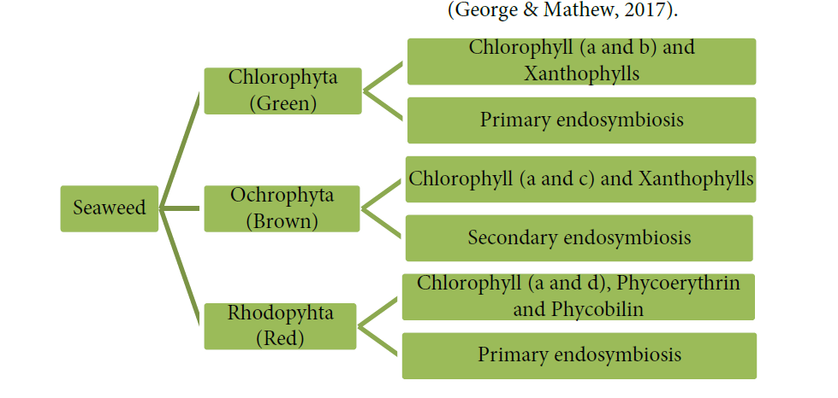

**2.1 Pigments present in seaweeds** **(Yu et al., 2014)**

|  |  |
| --- | --- |
| Green seaweeds | α-, β-, and γ-carotene, chlorophylls a and b, siphonoxanthin, lutein, and siphonein |
| Brown seaweeds | Chlorophylls a, c1, and c2, β-carotene, and fucoxanthin |
| Red seaweeds | Chlorophyll a, r- allophycocyanin, phycocyanin, c-phycoerythrin, α- and β-carotene |

**3. Bioactive compounds obtained from seaweeds (Merilyn et al.,2022)**

**Bioactive compounds and their structure**

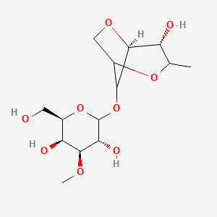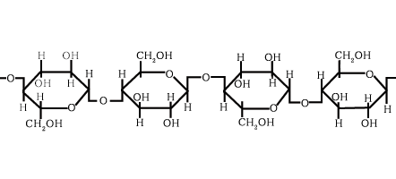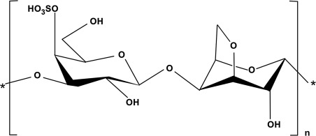

**Fig 1.** structure of Phycocolloids  **Fig 2**. structure of Polysaccharide

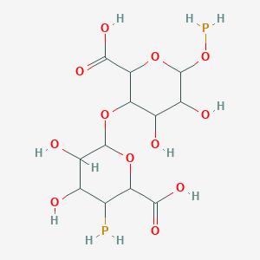

**Fig 3.** structure of Alginate  **Fig 4.** structure of Agar

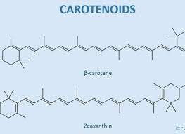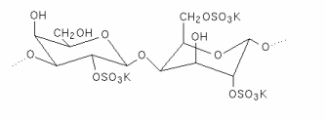

**Fig 5.** structure of Carrageenan **Fig 6 .** structure of Carotenoids

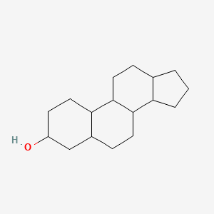

**Fig 7.** structure of Sterols

**Other bioactive compounds and their structure**

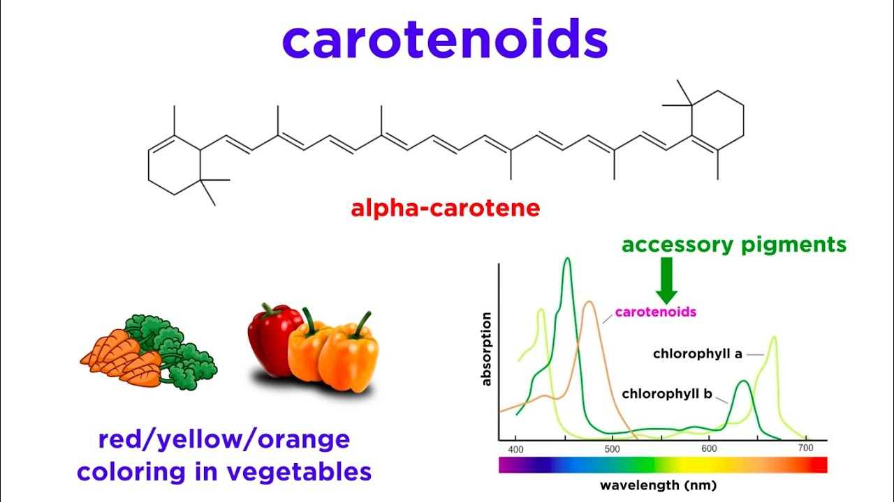

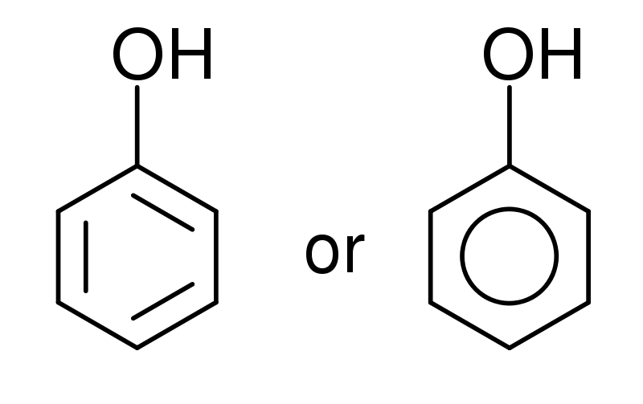

**Fig 1.** structure of Pigments **Fig 2.** structure of Phenolic Compounds

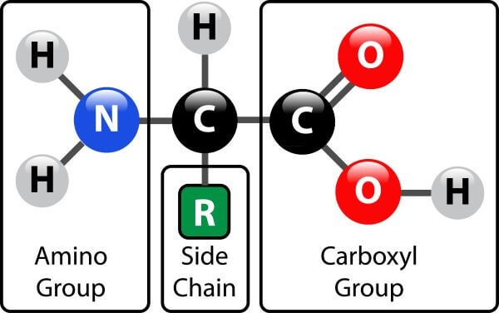

**Fig 3.** structure of *Proteins*

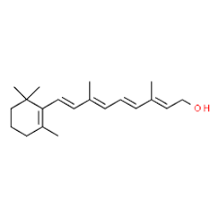

**Fig 4.** structure of *Vitamins*

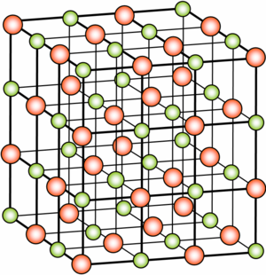

**Fig 5.** structure of *Minerals*

**3.1Phytocolloids**

Seaweed cell wall structural composition is influenced by phytocolloids. They aid in the discovery of the interaction between infections and seaweeds. Phycocolloids are polysaccharides with a high molecular weight made up of several sugar unit repetitions. Alginates, carrageenan, and agar are the three main categories of phycocolloids; they are mostly used in the food and cosmetic industries. (Archana et al., 2014)

**3.2 Polysaccharides**

Polysaccharides are abundant in marine algae, where they are largely found in the cell walls as well as in mycopolysaccharides and storage polysaccharides. Simple sugars or monosaccharides with short chains that are joined together by glycosidic bonds are known as polysaccharides. Ulva, a kind of green seaweed, has a dry weight content of 65% polysaccharide. The amount of cellulose and hemicellulose in the relevant seaweed species ranges from 2% to 10% and 9% of dry weight, respectively. Sulphated galactans, a polymer containing sulfuric acid, are found in chlorophyceae or green algae. (Archana et al., 2014)

**3.3 Alginate**

Brown algae is used to produce alginate, which has a substantial impact on the food and pharmaceutical industries due to its ability to chelate metal ions and produce highly viscous solutions. Additionally, it serves as a gelling agent in the textile sector. There are two types of it: acid and salt. Additionally, it helps to empty the digestive tract and prevents cancer. They can also absorb materials like cholesterol, which is then excreted from the colon and results in hypolipidemic and hypocholesterolemic reactions (Archana et al., 2014).

**3.4 Agar**

Agar is a polysaccharide mixture made of agarose and agro pectin that shares structural and functional characteristics with carrageenan. Sulphated polysaccharides called agar are derived from red seaweeds such Gelidium sp. and Gracilaria sp. as well as from the Phaeophyceae family. Due to its ability to gel, emulsify, and have a high viscosity, agar is mostly used in commercial and scientific settings. Agar is a general term for seaweed galactans that contain (1-4)-3, 6-anhydro-L-galactose and (1-3)-D-galactose residues and have up to 6% (w/w) of sulphate esterification. Additionally, it has been demonstrated that agar-oligosaccharide inhibits the enzyme responsible for nitric oxide generation as well as the creation of a pro-inflammatory cytokine (Archana et al., 2014).

**3.5 Carrageenan**

It is a sulfated galactan that occurs naturally and dissolves in water. Its alternative backbone is made up of (1-4)-3, 6-anhydro-D-galactose and (1-3)-D-galactose. Carrageenan comes in a variety of forms. Lambda (carrageenan), kappa (carrageenan), and iota (carrageenan) Although reports of more carrageenan types, including -carrageenan and v-carrageenan (Rhein-Knudsen et al., 2017) which ranges between 20% (w/w) and 40% (w/w), is generated by the different types of seaweeds and how they were collected. Additionally, carrageenan exhibits anti-tumor, anti-viral, anti-coagulant, and immunomodulatory properties, making it a potential pharmaceutical. (Archana et al., 2014)

**3.6 Carotenoids**

The most prevalent pigments are carotenoids, which are present in all algae, higher plants, and photosynthetic microorganisms. They stand in for red, orange, or yellow wavelength photosynthetic pigment. Five isoprene carbon units are used to form the natural pigments known as carotenoids. An enzyme subsequently polymerizes these five isoprene carbon units to produce regular, highly conjugated 40-carbon structures with up to 15 conjugated double bonds. (Archana et al., 2014)

**3.7 Sterols**

Seaweed's nutritional value comes from its sterol content. Sterols predominate in plants, animals, and fungus, with "cholesterol" being the most well-known sterol found in animals. Animal cell membrane fluidity and cellular activity are both influenced by cholesterol, which also serves as a secondary messenger in embryonic signalling. Precursors to steroid hormones and fat-soluble vitamins include cholesterol. According to reports, plant sterols such -sitosterol and fucosterol cause a reduction in the amount of cholesterol present in serum in both human and animal experiments. (Archana et al., 2014)

**Other bioactive compounds**

1. **Pigments**

Chlorophyll, carotenoid, and phycobiliproteins, three separate types of pigments found in seaweeds, have antiangiogenic, anticancer, anti-diabetic, anti-inflammatory, antioxidant, and immunomodulatory properties. These pigments have a lot of potential as both physiologically active agents and ingredients for nutraceuticals. They are also used in food colouring. Chlorophylls are lipid-soluble, greenish pigments that play an important role in seaweed photosynthesis. These three colours exhibit various protein concentrations, spectrum characteristics, and protein shapes (Cherry et al., 2019; Aryee et al., 2018).

**b) Phenolic Compounds**

Catechins, flavonoids, phenolic acids, phlorotannins, tannins, and other phenolic compounds are found in seaweed. As a result, the type and volume of phenolic chemical extraction are significantly influenced by the species of seaweed. Green and red seaweeds are rich in phenolic acids, flavonoids, and borophenols. The majority of the complex polymers found in brown seaweeds (1,3,5-trihydroxy benzene) are phlorotannin and phloroglucinol oligomers. (Montero et al., 2017; Gomez-Guzman et al., 2018; Cotas et al., 2021).

**c) Proteins**

Seaweed's protein content is influenced by elements such as species, seasonal cycle, and seasonal change. According to Erna (2011) and Fleurence et al. (2018), it is often higher for red seaweeds (up to 47% dry weight), medium for green seaweeds (35% dry weight), and lower for brown seaweeds (24% dry weight). Nitrogen-to-protein conversion ratios lower than 6.25 have been advised for feed components because the protein content of seaweeds has been overestimated as a result of the presence of nonprotein nitrogen (Makkar et al., 2016). Seaweeds also include critical amino acids like aspartic acid, glycine, alanine, proline, arginine, and glutamic acid (Gullon et al., 2020). (Furuta et al., 2016).

**d) Minerals**

According to Cofrades et al. (2017) and Lorenzo et al. (2017), seaweeds have a high mineral concentration (8–40%) that includes minerals like Na, K, Mg, and Fe. Calcium, the mineral with the highest visibility, is most abundant in plant sources. Additionally, they are better for promoting a healthy cardiovascular system since they have a lower Na/K ratio than other foods included in typical Western diets. (2018) Circuncisao et al. Consuming seaweeds can also help treat an iodine shortage due to their high iodine content (Zava & Zava, 2011).

**e) Vitamins**

According to Hentati et al. (2020), seaweeds are a good source of water-soluble vitamins including vitamin C, folic acid, pantothenic acid, niacin, riboflavin, and vitamin B vitamins like vitamin B12, B6, B3, and B2. They are also high in fat-soluble vitamins like vitamin A, D, E, and provitamin A. However, because seaweed species' vitamin content varies, some of them only have a negligibly low level (Hentati et al., 2018; Cherry et al., 2019).

**Table 1.**Bioactive Compounds and their Source(**(Silvia et al 2022)**

|  |  |  |  |  |
| --- | --- | --- | --- | --- |
| **Sr.no** | **Class of Seaweed**  **Bioactive Compounds** | **Principal Source** | **References** | **Year of publication** |
| 1 | Alginate | Brown seaweed  (Laminaria sp.,  Ascophyllum nodosum) | Review of extractions of seaweed hydrocolloids: Properties and applications. | 2018 |
| 2 | Fucoidan | Brown seaweed  (Undaria pinnatifida, Fucus sp.) | A Sulfated Polysaccharides from Brown Algae as Therapeutic Target for Cancer | 2015 |
| 3 | Laminarin | Brown seaweed  (Laminaria sp.) | Extraction, structure and biofunctional activities of laminarin from brown algae | 2015 |
| 4 | Agar | Red seaweed  (Gracilaria sp.) | Algal biotechnology industries and research activities in China. | 2001 |
| 5 | Carrageenan | Red seaweed  (Gigartina sp., Chondrus sp.) | Metabolites from algae with economical impact. | 2007 |
| 6 | Porphyran | Red seaweed  (Porphyra sp.) | Antioxidant and anti-inflammatory activities of porphyran  isolated from discolored nori (Porphyra yezoensis). | 2015 |
| 7 | Ulvan | Green seaweed  (Ulva sp.) | Ulvan from Ulva armoricana (Chlorophyta)  activates the PI3K/Akt signalling pathway via TLR4 to induce intestinal cytokine production. | 2017 |
| 8 | Phlorotannin | Brown seaweed  (Ecklonia sp., Eisenia sp.,  Laminaria sp., Undaria pinnafitida) | Bactericidal activity of phlorotannins from the brown alga  Ecklonia kurome. | 2002 |

**4.Method of extraction**

**4.1. Enzyme-Assisted Extraction (EAE)**

The enzymatic conditions and characteristics of the enzymes are given in Table 2. One litre of the suitable buffer and one gram of seaweed powder were added to a two-liter reaction vessel. The reaction vessel was placed in a water bath that was maintained at the proper temperature for enzyme activation, and it was connected to an overhead stirrer. Once the mixture had achieved the correct temperature, 1 mL (0.1% enzyme) was added, and it was stirred in a water bath for 20 hours at 350 rpm. After incubation, the enzyme was deactivated by heating at 100 °C for 10 minutes and cooling in ice. The mixture was centrifuged at 1500g for 10 minutes to separate the supernatant. The resulting extract was freeze dried, weighed to ascertain its yield, then reconstituted in a predetermined volume of water. A water extract was also created in the same way for comparison. (Sabeena et al., 2019)

**Table 2.** Optimum conditions and characteristics of enzymes used. (**Source:** Habeebullah et al 2020)

|  |  |  |  |  |
| --- | --- | --- | --- | --- |
| Enzyme | Optimum conditions | | Buffer used | Characteristics |
|  | Temperature | pH |  |  |
| Carbohydrases |  |  |  |  |
| Viscozyme L | 50 °C | 4.5 | 0.1 M acetate buffer | A multi-enzyme complex (containing arabinase, cellulase,  β-glucanase, hemicellulase, and xylanase) |
| AMG 300 L | 60 °C | 4.5 | 0.1 M acetate buffer | Exo-1,4-α-D-glucosidase |
| Celluclast 1.5 L FG | 50 °C | 4.5 | 0.1 M acetate buffer | Cellulase |
| Termamyl 120 L | 60 °C | 6 | 0.1 M phosphate buffer | A heat-stable α-amylase |
| Ultraflo L | 40 °C | 6 | 0.1 M phosphate buffer | A heat-stable multi-β-glucosidase |
| Flavourzyme 500MG | 50 °C | 7 | 0.1 M phosphate buffer | Containing both endoprotease and exopeptidase |
| Alcalase 2.4 L FG | 50 °C | 8 | 0.1 M phosphate buffer | Endopeptidase |
| Neutrase 0.8 L | 50 °C | 8 | 0.1 M phosphate buffer | Metalloendoprotease |

**4.2. Microwave-Assisted Extraction (MAE)**

Using a Microwave reactor Monowave 450 with an auto-sampler Mas 24 (Anton Paar, Austria), Microwave Assisted Extraction (MAE) was carried out to recover highly valuable compounds from milled algae with an average particle size of 200 m. Purified water, dried milled algae, and a solid liquid ratio of 1:30 (w:w) were placed in the microwave vials. Initial studies were carried out to choose the operating parameters while taking into account the findings of past seaweed-related research. The first set of samples were heated for a microwave time (tMAE) of 3 min at a wide range of temperatures: 70, 90, 130, 150, 170, 190 °C and the second set of samples were heated for tMAE of 6 min at the same temperatures. Following that, both were cooled to a temperature of 55 °C. The liquid fraction was then separated from the solid fraction using a vacuum filter. The samples were kept in the freezer until further usage.

A volume of the liquid fraction created by MAE was precipitated using a volume of ethanol (96%, Sigma-Aldrich, USA). Filtering was performed if necessary to separate the precipitate. After that, a 40 °C oven was used to dry the recovered biopolymer. The dried carrageenan was weighed in order to determine the yield (g hybrid carrageenan/g dried alga powder) (Elise et al., 2020)

**4.3. Ultrasound-Assisted Extraction (UAE) (Wizi et al. 2022)**

A universal disintegrator was used to clean, oven dry, and pulverise seaweed-wakame (Undaria pinnatifida) samples. Algae samples were extracted using an ultrasonic device (Ningbo Licheng co. Ltd., China) using a 25kHz ultrasound frequency. For the extraction, a solvent mixture of 70% ethanol and 30% water (v/v) was used, which promotes good recovery. The algae sample was cleaned, dried in the oven, and pulverised with a universal disintegrator (Yongshi Jiupin Company, China). To achieve the best extraction conditions, algae powder was added to the solvent and chemicals were leached at several temperatures (45°C, 55°C, and 65°C) and periods (20 and 30 min) using ultrasonic power of 70% and 30%, respectively. For each extraction condition in UAE, temperature, ultrasonic power treatment, and time were set. Each extraction condition was repeated three times, and the temperature of the mixture was measured using a thermometer. The input power was supposed to be turned into heat and diffused in the medium during the UAM extraction. The liquor extract was centrifuged for 5 minutes at 3000 rpm in a countertop high-speed Bioridge (TG16-WS) centrifuge. The residue was re-extracted to ensure that all soluble bioactive compounds were recovered. The concentrated extracts were dried using a freeze dryer.

The yield for each form was calculated using the equation below

Yield% = (Mass of extract / Mass of sample used ) ×100

**4.4. Supercritical fluid extraction (SFE)**

A CO2 flow rate of 2 ml/min was employed with 0.5 g of dried algal biomass for each extraction. Each extraction took two hours to complete in triplicate. Three variables influence the extraction conditions: temperature (40–60 °C), pressure (100–300 bar), and the amount of ethanol used as a co-solvent (0–15%). Following extraction, the obtained extracts were put into vials, and the extraction yield was determined by vacuum-evaporating the remaining ethanol. The dried extracts were then diluted with ethanol to concentrations ranging from 10 to 20 mg/ml and kept at 20 °C until analysis while being shielded from light. (Joanna et al., 2016)

**4.5. Pressurized liquid extraction (PLE)**

Once the procedure is complete, an extract is pushed out using a pump. an extraction cell, which is the actual location of the extraction. In order to maintain consistent extraction conditions, it must be designed for high pressures and have at least two on/off valves. The extraction cell is placed in an oven so that it can be heated to the desired temperature of 200 °C. The PLE instrument may have heating coils for the purpose of heating the solvent during dynamic extractions. Additionally, it may incorporate a nitrogen circuit, which aids in exhausting all of the solvent from the lines following extraction. It must be remembered that corrosive-resistant materials must be utilised due to the typical operating pressures and temperatures (Ballesteros et al., 2020)



**Table 3.** Name of Method and Procedure (**Source:** Seaweed extraction process (adapted from Admassu et al. (2018), Kadam et al. (2015), Praveen et al. (2019))

|  |  |  |  |
| --- | --- | --- | --- |
| **Extraction Method** | **Procedure** | **Bioactive Components** | **Author** |
| Enzyme-Assisted  Extraction (EAE) | *Incorporating food-grade enzymes  such as *cellulase, a-amylase, pepsin ,viscozyme, cellucast, termamyl ,ultraflo, carrageenase, agarase, xylanase, kojizyme, neutrase, alcalase, and umamizyme* into seaweeds.  * Degradation of glycosidic bonds  and other internal bonds | *Fucoxanthin  *Lipids  *Phlorotannins  *Phenolic compounds | Admassu et al. (2018), Kadam et al. (2015), Praveen et al. (2019)) |
| Microwave-Assisted  Extraction (MAE) | *Most researched extraction  technique.  *Microwave energy was used to heat  solvent-containing samples.  *Dielectric and total volumetric  heating by microwaves.  *2.45 GHz | *Sulfated polysaccharides,  such as fucoidan, ulvan,  and rhamnan sulfate. | Admassu et al. (2018), Kadam et al. (2015), Praveen et al. (2019)) |
| Ultrasound-Assisted  Extraction (UAE) | *Ultrasonic radiation pressure was  used to generate intense mixing and  agitation, which promotes  Extraction. *Compression and  rarefaction (pressure variation and  cavitation)  *20 kHz  *50-60 kHz | *Polyphenols  * Fucose and uronic acid  * Laminarin  *Phycobiliary proteins  *Taurine  *Antioxidants | Admassu et al. (2018), Kadam et al. (2015), Praveen et al. (2019)) |
| Ultrasound-Assisted  Extraction (UAE) | *Ultrasonic radiation pressure was used to generate intense mixing and agitation, which promotes Extraction. *Compression and  rarefaction (pressure variation and  cavitation)  *20 kHz  *50-60 kHz | *Polyphenols  * Fucose and uronic acid  * Laminarin  *Phycobiliary proteins  *Taurine  *Antioxidants | Admassu et al. (2018), Kadam et al. (2015), Praveen et al. (2019)) |
| Supercritical Fluid  Extraction (SFE)  Pressurized | *The supercritical fluid’s  temperature and pressure are both  greater than the critical point. | *Fatty acids (ω-3)  *Carotenoids,  * Fucoxanthin,  *Fluorotannins  * Volatile compounds  *Polyphenols,  *Cytokinins,  * Auxins, Microelements,  and macro elements | Admassu et al. (2018), Kadam et al. (2015), Praveen et al. (2019)) |

**4. Applications of bioactive compounds from seaweeds**

**4.1 Industrial purpose**

Brown edible seaweeds serve as the only food supply for the development of lactic acid bacteria. Three types of edible Irish brown seaweed, *Himanthalia elongata, Laminaria digitata, and Laminaria saccharina*, were utilised to research the growth kinetics of lactic acid bacteria (LAB; *Lactobacillus plantarum*). The results of this study suggest that LAB-based seaweed fermentation has potential, as does the potential for the production of a wide range of functional foods. (Gupta et al., 2011). Seaweed polysaccharides with low molecular weight as prebiotics. Bifidobacterial populations significantly increased in Gelidium seaweed. The possibility of prebiotics is increased by seaweeds' creation of agar and alginate. Seaweed and pure glucose were fermented to provide similar amounts of butanol (Innocenzo et al., 2012).

**4.2. Pharmaceutical**

Many studies use in vitro and in vivo testing to assess the biological components of marine seaweed species in order to look at their mechanisms of action and use them as potential therapeutics. Over time, there has been substantial progress in the study of marine medicine. Marine pharmacology, a unique discipline of pharmacy that combines multiple academic fields and calls for a broad knowledge base, is being created on the basis of this foundation. It is crucial to establish whether there is a chance that seaweed contains bioactive components before beginning pharmacological research. Through parameter standardisation and quality control, it is feasible to have a defined spectrum of the compounds present in seaweeds that can be precisely identified and assessed. Through such research, the authenticity, calibre, and efficiency of biological compounds will be guaranteed. Examples of pharmacognostic analysis are given for *Chaetomorpha antennina*, Ulva lactuca, and *Sargassum cinereum*.(Lomartire et al., 2022)

**4.3. Nutraceutical**

Several studies examined the effects of seaweed addition on the nutritional, sensory, and textural properties of fish products.Recently, the sensory quality and lipid oxidation of enriched fish cakes were assessed after they had been supplemented with high quality lipids (long chain n-3 LCPUFAs) and seaweed extracts as natural antioxidants. (Dellarosa, Laghi, Martinsdóttir, Jónsdóttir, & Sveinsdóttir, 2015). It was found that the quality of the products or lipid oxidation was unaffected by the addition of seaweed extracts in aqueous and ethanol. Additionally, none of the samples had an unpleasant flavour, and rotten odour and flavour received poor ratings.

**4.4. Medical**

**Therapeutic properties of seaweed-derived compounds**

**4.4.1Metabolism**

In recent years, a variety of novel diabetic medications have emerged, including insulin mimickers and oral hypoglycemic agents. Type-2 diabetes, which reverses glucose metabolism enzymes, has been demonstrated to be safe and efficient against bioactive substances from seaweed. Alkaloids, flavonoids, carotenoids, polyphenols, and phlorotannins were among the seaweed bioactive that were proven to have a hypoglycemic effect. Fucoxanthin dramatically increases insulin sensitivity and lowers blood glucose levels in diabetic rats, according to Maeda et al findings’ There have been numerous reports of fucoidan from the brown algae Fucus vesiculosus and Ascophyllum nodosum lowering blood glucose levels in an animal model. This study showed that fucoidan, which has a low molecular weight, stimulates the development of beta cells while limiting glucagon output from alpha cells in the reversal of blood sugar. (Abirami et al., 2019)

**4.4.2. Antiviral Activity**

Some sulphated polysaccharides from red algae have reportedly been shown to exhibit antiviral effect against viruses that cause human infection. The two most well-known species are *Aghardhiella tenera* and *Nothogenia fastigiate*.Galactan sulphate (from Aghardhiella tenera) and xylomannan sulphate (from Nothogenia fastigiata) are investigated for antiviral action against the most contagious viruses, including the human immunodeficiency virus or HIV, the herpes simplex viruses types 1, 2, and the respiratory syncytial virus. These seaweeds contain a polysaccharide that becomes active when it binds to the cell's surface during the first stage of RNA replication.(Archana et al., 2014)

**4.4.3Anti-Inflammatory Activity**

The 20-carbon polyunsaturated fatty acids such as eicosapentaenoic and docosahexanoic referred to as PUFAS, are abundant in macroalgae, particularly red seaweeds. The two primary metabolites of the oxidative metabolism of C20 PUFAS by seaweeds are prostaglandin and gracilariales. There are two main alternate methods for producing prostaglandins: the first technique employs lipooxygenase, which also acts as archidonic acid in mammalian cells, and the second approach uses fatty acid cyclooxygenase (Archana et al., 2014)

**4.4.4Anti-Thrombic and Anti-Coagulant Activity**

Fucoidan have anti-thrombotic and anti-coagulant properties that are heparin-like in both vivo and in vitro. These characteristics are mediated by blood coagulation inhibitors such anti-thrombin III and heparin cofactor II. Direct interaction between fucan and thrombin produces anti-coagulant activity, which typically rises with sulphation levels.*Ascophyllum nodosum* and *Fucus vesiculosus* both generate sulphated fucan, which has been patented as an anticoagulant (Archana et al., 2014)

**4.4.5Antilipemic, Hypocholesterolaemic Activity**

There are numerous severe illnesses nowadays that are bad for society, including cardiovascular disease, which is mostly brought on by excessive blood pressure and plasma cholesterol levels. Some macroalgae, including alginate, funoran, fucoidan, laminaran, porphyran, and ulvan, have been found to cause hypocholesterolemic and hypolidemic reactions as a result of decreased gut absorption of cholesterol. This is caused by a hypoglycemic reaction and an increase in faecal cholesterol.(Archana et al., 2014)

**4.5.Food industry**

In Hawaii, red macroalgae (Gracilaria spp.) are consumed fresh. Commonly marketed species include G. coronopifolia, G. parvispora, G. salicornia, and G. tikvahiae, however their postharvest life is only around four days (Paul and Chen, 2008). The anti-oxidant and antibacterial phytochemicals found in seaweeds are abundant. Minerals and fibres help to improve the mineral content while lowering the salt concentration. ( Innocenzo et al., 2012)

**4.6. Cosmetics**

**4.6.1Tyrosinase Inhibition Activity of Seaweed**

The enzyme tyrosinase is important for catalysing the formation of the pigment melanin, which gives skin its colour. The abnormal buildup of melanin pigments in the skin is what causes hyperpigmentation. Skin pigmentation is brought on by aberrant melanin synthesis brought on by excessive UV exposure. Natural tyrosinase inhibitors are in high demand as safe and effective skin-whitening agents. Seaweed-based skin-whitening chemicals may therefore be helpful for the cosmetics business. Ishige okamurae Yendo, Endarachne binghamiae, and other seaweed extracts showed tyrosinase inhibitory activity when tested by researchers**.** (Jesumani et al., 2019)

### 4.6.2. Hyaluronidase Inhibition

The extracellular matrix contains hyaluronic acid, which is broken down by an enzyme called hyaluronidase, hastening skin ageing. A comparatively small number of research have only focused on inhibiting hyaluronidase. Fucophloroethol, fucodiphloroethol, fucotriphloroethol, 7-phloroeckol, and phlorofucofuroeckol, phlorotannin derivatives from Cystoseira nodicaulis (Withering) M. Roberts, revealed hyaluronidase activity with an IC50 of 0.73 mg/mL and showed that the higher molecular Ecklonia kurome Okamura and *Eisenia bicyclis* (Kjellman) Setchell's phlorotannin derivatives strongly inhibited hyaluronidase.

**4.6.3. Hyaluronidase**

Controlling moisture is essential for skincare since it improves skin's condition and texture, making it look younger and healthier. Extracts from A. nodosum (Linnaeus) Le Jolis, Cladosiphon okamuranus Tokida, Undaria pinnatifida (Harvey), Durvillea antarctica (Chamisso), Pediastrum duplex Meyen, and Polysiphonia lanosa (Linnaeus), among others. Tandy showed that it hydrates skin and protects against dryness. Polysaccharides can be employed as humectants and moisturisers in the cosmetics industry due to their excellent water-holding capacity. It has been established that Laminaria japonica Areschoug polysaccharides provide hyaluronic acid with excellent hydration and moisturising characteristics. (Jesumani et al., 2019)

**Table 4 .**Main biological properties and industrial applications of seaweed’s bioactive compounds **(Source:** Silvia et al 2022)

|  |  |  |
| --- | --- | --- |
| **Class of Seaweed**  **Bioactive Compounds** | **Application and Properties** | **Principal Source** |
| Alginate | Used as stabilizer and thickening  agent in food products and medicine | Brown seaweed  (Laminaria sp.,  Ascophyllum nodosum) |
| Fucoidan | Antiproliferative,  Antimicrobial and  Antiviral activity  Anticoagulant activity  Antidiabetic activity | Brown seaweed  (Undaria pinnatifida, Fucus sp.) |
| Laminarin | Used in food industry and  biomedicine because of its  nutraceutical properties;  immunostimulatory, antitumour and  antioxidant activity | Brown seaweed  (Laminaria sp.) |
| Agar | Used in food products and  pharmaceutical field as jellifiers,  stabilisers, thickeners and emulsifiers | Red seaweed  (Gracilaria sp.) |
| Carrageenan | Red seaweed  (Gigartina sp., Chondrus sp.) |
| Porphyran | Anti-inflammatory, antioxidant,  antihyperlipidemic and  anticancer activities | Red seaweed  (Porphyra sp.) |
| Ulvan | Immunostimulatory, antitumoural,  antiviral activities | Green seaweed  (Ulva sp.) |
| Phlorotannin | antimicrobial, antioxidant, antiviral,  anticancer, anti-inflammatory,  antidiabetic properties | Brown seaweed  (Ecklonia sp., Eisenia sp.,  Laminaria sp., Undaria pinnafitida) |

**Conclusion**

Seaweeds are regarded as an economically significant biological resource because they contain a variety of bioactive substances with a variety of biological functions, such as different pigments, phenolic compounds, lipids, vitamins, proteins, minerals, polysaccharides, and polyunsaturated fatty acids. Seaweeds are most commonly used in the food, pharmaceutical, cosmetic, and other industries. Commercially, they are provided as fresh and extracts. Despite the fact that seaweeds are mostly safe and healthful, there are still certain hazards associated with them, including exposure to heavy metals, arsenic, and excessive iodine concentrations. Due to the epidemiological study's ongoing inconclusiveness, there is still a paucity of information on this method. Further green extraction methods were used to separate the bioactive components, and the extract's purity was verified by chromatographic analysis. Marine medicines seek to reduce side effects brought on by synthetic substances and produce innovative treatments with natural-source ingredients. Only less than 50% of the world's population now has access to essential medicines due to the high cost of prescription drugs and the low purchasing power of the populous in regions like Africa and Asia. Despite the enormous number of studies on the constituents and extracts of seaweeds, further investigation is required to uncover unique molecules for usage in diverse biotechnological applications, improving human health both directly and indirectly.

**References**

1. Abirami, R., Tiwari, U and Rajauria,G.. .Seaweed nutraceuticals and their therapeutic role in disease prevention.Food Science and Human Wellness.8(3):252-263,ISSN 2213-4530, 2019.
2. Amlani, M. & Yetgin, S.. Seaweeds: Bioactive Components and Properties, Potential Risk Factors, Uses, Extraction and Purification Methods . Marine Science and Technology Bulletin , 11 (1) , 9-31 . DOI: 10.33714/masteb.1021121FAO (2022) The State of World Fisheries and Aquaculture.Towards blue transformation. Rome.2022
3. Ballesteros, V., D., Ortega,B.,Camargo,S.,Rodríguez,Varela., P..Pressurized Liquid Extraction of Bioactives. In *Comprehensive Foodomics*; Elsevier: Amsterdam, The Netherlands, 13:754–770. 2020
4. Cikos, A., Jokic, S., Subaric, D and Jerkovic I. Overview on the Application of Modern Methods for the Extraction of Bioactive Compounds from Marine Macroalgae. Marine Drugs.16(10):348.2018
5. CMFRI Annual Report . Central Marine Fisheries Research Institute, Kochi, India.2020-21
6. Collins, K. G., Fitzgerald, G. F., Stanton, C., & Ross, R. P.Looking beyond the terrestrial: The potential of seaweed derived bioactives to treat non-communicable diseases.*Marine Drugs*, *14*(3), 1–31.2016
7. Dellarosa, N., Laghi, L., Martinsdóttir, E., Jónsdóttir, R. and Sveinsdóttir, K. Enrichment of convenience seafood with omega-3 and seaweed extracts: Effect on lipid oxidation. LWT - Food Science and Technology. 62. 746-752.2015
8. Granato, D., Barba, F. J., Kovacevic, D. B., Lorenzo, J. M., Cruz, A. G., & Putnik, P.Functional foods: Product development, technological trends, efficacy testing, and safety. Annual Review of Food Science and Technology, 11:93–118. 2020

# Habeebullah, S., Alagarsamy, S. and Sattari .Enzyme-assisted extraction of bioactive compounds from brown seaweeds and characterization. [Journal of Applied Phycology](https://www.springer.com/journal/10811/).**32**: 615–629 (2020).

1. Innocenzo,. M..Seaweeds for Food and Industrial Applications.Intech Open chapter 7:17–38.2013
2. Jesumani, V., Du, H,. Aslam, M,. Pei, P. and Huang., N. Potential Use of Seaweed Bioactive Compounds in Skincare-A Review. Marine Drugs.17(12):688. 2019
3. Joanna,F., Ibanez, E., Łęska,B.,Miguel.Supercritical fluid extraction as a tool to valorize underexploited freshwater green algae,Algal Research19:237-245.2016
4. Lomartire, S. and Gonçalves,A. An Overview of Potential Seaweed-Derived Bioactive Compounds for Pharmaceutical Applications. Marine Drugs, 20:141.2022
5. Pal, A., Kamthania, M. and Kumar, A.Bioactive Compounds and Properties of Seaweeds—A Review. *Open Access Library Journal*, **1**:1-17. 2014
6. Pappou, S., Dardavila, M., Savvidou, M., Louli, V,, Magoulas, K. and Voutsas, E.Extraction of Bioactive Compounds from Ulva lactuca.Applied. Science. 12: 21-17. 2022
7. Ponthier, E., Dominguez, H. and Torres, M. The microwave assisted extraction sway on the features of antioxidant compounds and gelling biopolymers from Mastocarpus stellatus. Algal Research. 7(3):.32-46.2020
8. Wizi, J., Wang, L., Hou, X., Tao, Y., Ma, B. and Yang, Y. Ultrasound-microwave assisted extraction of natural colorants from sorghum husk with different solvents. Industrial Crops and Products*.*  *120*: 203–213.2018
9. Yu,Xin,K.,Ibrahim, J.Ahmad,R.,Ching, Lee. The major bioactive components of seaweeds and their mosquitocidal potential. Parasitology research.3:113-117. 2014