Psychotherapy

Shabnam Ara¹

Sr.nursing Officer (Msc mental health Nursing & psychology )

currently working as tutor college of Nursing ,GMC Srinagar

shabnamrashid24@gmail.com

Yasmeen Akhter²

Sr.nursing Officer (Msc medical surgical Nursing)

currently working as tutor college of Nursing ,GMC Srinagar.

Rais Ahmad³

Tutor (Msc community Health nursing)

College of Nursing, GMC Srinagar.

ABSTRACT:
In present chapter we have discussed on different psychological therapies based on various psychological theories. Objectives of this chapter is to understand various types, techniques and goals of psychotherapy .How psychotherapy helps to improve in signs and symptoms of mental illness .It is non pharmacological intervention used to treat victimized thoughts or behavior of a client. According to the American Psychological Association, about 75% of people are benefited by psychotherapy it also reveals that psychotherapy causes change in their brain as that of same as observed in clients taking medication (Karlsson, 2011).From all studies related to psychotherapy, mental illness are recovered and help the client to improve in their thought, impulses and behavior.
Key words: psychotherapy, psychological therapies, signs and symptoms, thought
Introduction
Psychotherapy is the non pharmacological intervention used to treat mental illness with the application psychological techniques. Psychotherapy is also called as talk therapy, counseling, psychosocial therapy. There are various psychotherapies, based on different psychological theories and concepts. All therapies require to develop interpersonal or therapeutic relationship, professional communication to overcome victimized thoughts or behaviors of an individual.
.

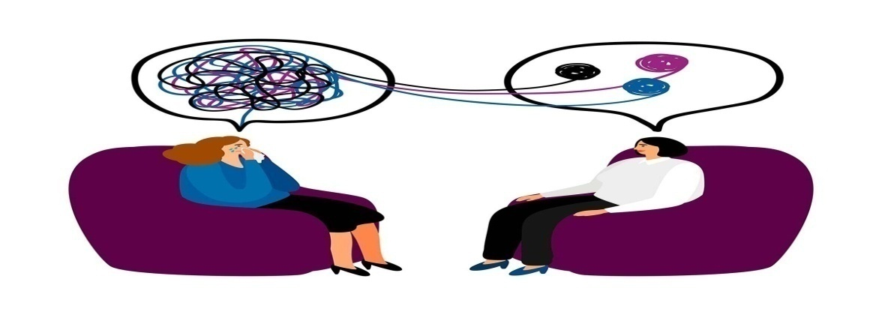
Professionals who provide psychotherapy involue clinical psychologists, psychiatric nurse’s psychotherapists, psychiatrists, counselors, social workers, and mental health counselors. The trained professional help the client to overcome with the specific or general problems, like examination stress, family problems etc. Psychotherapy is a collaborative intervention based on the relationship between the client and a therapist, within a supportive environment that allow the client to talk openly without judging them. Psychotherapy helps to understand &learn about one’s moods, feelings, thoughts, and behaviors. Client learn skills to tackle their challenging situations with healthy coping strategies and can enjoy their life happily, healthy, productive & equipped to face new challenges in the present and the future.
Psychotherapy is a evidence based therapy that some times used first line treatment in psychological problems like neurotic while as in psychotic problem it is second line treatment.
Psychotherapy is a vast tem with lot of importance in our every stage of life for normal and abnormalilty.

Indication of psychotherapy
Anxiety disorders
Phobias
Panic Disorder
Social Anxiety Disorder,
Generalized Anxiety Disorder (Gad).

Mood disorders
Depression ,bipolar disorder.

Eating disorders
anorexia or bulimia nervosa

Addictions
substance-use disorder or compulsive gambling, smart addiction

Personality disorders

Personality Disorder Or Dependent Personality Disorder.
Schizophrenia Or Other Disorders

Somatoform disorders

Converssion, hypochondriasis, multiple aches.
Others
Divorce, psychosocial stressor, financial problems ,death of loved ones

Types and techniques of Psychotherapy

There are different types of psychotherapy depends on patients condition and need of the client
Individual therapy | It is most common involves one-on-one session with the therapist in a calm and confidential environment.  It encourages the client to discuss their in-depth problems  This is best indicated for people who do not like group sessions and feel more comfortable with one to one session.In this way there is strong rapport,that work together to solve the client’s issues.
Couples therapy | Couples therapy involves interaction between therapist and couple as to improve their relationship and function  .Here the couples explore their issues with the therapist and resolve conflict.
Family therapy | Family therapy is used to solve the problems of a dysfunctional in which therapist provides individual and joint therapy to the family members to correct their family unit.  The therapist help the family members to develop cohesion by means of corective cognitions, understand each other , change negative behaviors, resolve conflicts etc.  .
Group therapy | Group therapy is a session of small group of individuals that share a common goal.  This help the group members to practice new skills and behaviors within a supportive group.  It may be homogenous or heterogeneous group with a definite goal. It includes 6-12 members lasting for one hour twice in a week. Group therapy help the client to develop skills, learn to express their feelings, and accept criticism from others

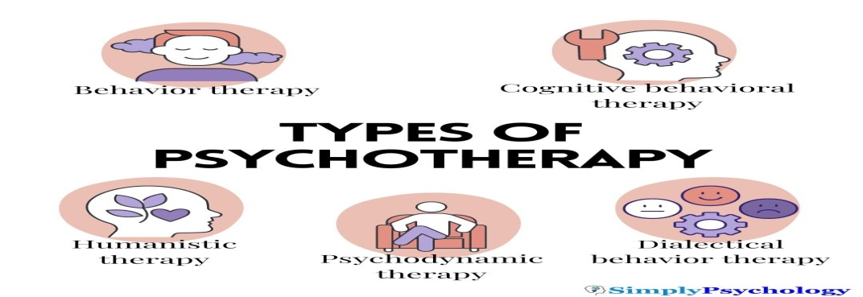

Behavior therapy : It is based on school of bahaviourism such as classical conditioning, operant conditioning, and social learning theory. It is actually an umbrella term under which different therapies are used.This helps to identify & seek change in destructive or unhealthy behaviors of a client. Behavior therapy emphasizes on the idea that all behaviors are learned, and can be modified for healthy functioning

Exposure therapy is a type of behavior therapy where client is exposed to fear, incorporating relaxation strategies among them.

Systematic desensitization is another technique that involves learning of client to relax through visualization or progressive muscle relaxation, follwed by a list of fears based on their intensity. This helps the therapist to plan and encourages the individual to work on exposing themselves to their fears in different stages in order to gain comfort.

Cognitive behavioral therapy (CBT) . Its aim is to correct cognition along behavior of a client. In CBT, goals are set by a client that he/she want to work on, solve problems and practice new skills with the therapist.

Rational emotive behavior therapy (REBT) is a type of CBT that emphasises on identifying negative thoughts and feelings. Here the client is learned to challenge their thought and replace them with rational and realistic thoughts .

Another type of CBT is mindfulness-based cognitive therapy that combines CBT with meditation. This type of therapy helps to cultivate a non-judgmental, approach .

Dialectical behavior therapy (DBT) It is intended to treat borderline personality disorder and other conditions having problem in emotional regulation or exhibit self-destructive behaviors such as eating disorders or substance-use disorders. DBT focuses to teach people how to develop healthy coping, regulate their emotions, and improvement in relationship. This therapy emphasizes on mindfulness, distress tolerance, and interpersonal effectiveness.

Humanistic therapy : This emphasizes on the principle that everyone has their own unique philosophy of life & world that impacts choices and actions of a client/individual. The humanist psychologist Carl Rogers developed an approach known as client-centered therapy. According to this therapy people absorb criticism or disapproval from others that distorts once thought ,blocking personal growth, ultimately leads mental distress. This therapy helps the client to know themselves in order to maximize their potential and stresses the importance of self-exploration, free will, and self-actualization

Psychodynamic therapy: uses psychoanalysis which is given by Sigmund Freud’s, it states that how the unconscious mind influence our thoughts, feelings, and behaviors. This therapy helps a therapist to examines how person’s experiences are influnced from childhood to old age that may lead psychological distress.
Some techniques of psychoanalysts include:
DREAM INTERPRETATION
FREE ASSOCIATION
TRANSFERENCE

Goals of Psychotherapy

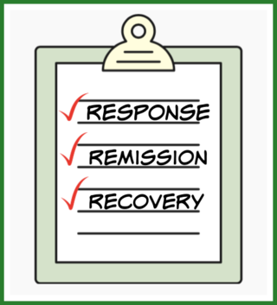
- Response is defined as an improvement in illness after psychotherapy begins.eg client feels better after few sessions of psychotherapy.

- Remission is defined as the experience of being symptom-free from illness. When a client gains optimism, self-confidence and a returns to healthy state of living.

- Recovery is defined as the absence of symptoms for at least 4 months following the onset of remission .It presents with periods of improvement and growth as well as with setbacks and stumbling blocks.
Evidences on psychotherapies
Karlsson, 2011 conducted a study that identified that there is change in brain of clients with mental health disorders (including depression, panic disorder, PTSD, etc.) after psychotherapy similar to that of pharmacological treatment.
Hofmann et al., 2012; NIDA, 2018 conducted meta-analyses that psychotherapy is effective in improving the symptoms of client with anxiety-related disorders, including OCD and PTSD, as well as in anger problems, drug abuse, and general stress.
Oud et al., 2019 reveals that CBT is effective in treating symptoms of depression and anxiety among children and an adolescent.
Elliott, 2002 states that a review of 86 studies finds humanistic therapies are effective in client improvement in mental health issue .In 2016 Elliott suggests that client-centered approaches are helpful for trauma, relationship difficulties, psychosis, and coping with chronic health issues.
Abbass et al., 2021 has reviewed studies related to psychoanalytic therapy emphasized on improvements in somatic symptoms, depressive symptoms, and anxiety symptoms.
Conclusion: psychotherapies are effective intervention as evidenced by various studies with the help of different techniques and application of psychological theories

References:
- KAPLAN & SADOCK”S Synopsis of psychiatry 11th edition updated with DSM-5
- P.Prakash ,Text book of Mental Health & Psychiatric Nursing ,
- American Psychological Association. (2020, July 31). Understanding psychotherapy and how it works. https://www.apa.org/topics/psychotherapy/understanding
- Elliott, R. (2002). The effectiveness of humanistic therapies: A meta-analysis.
- Elliott, R. (2016). Research on person-centred/experiential psychotherapy and counselling: summary of the main findings.
- Hofmann, S. G., Asnaani, A., Vonk, I. J., Sawyer, A. T., & Fang, A. (2012). The efficacy of cognitive behavioral therapy: A review of meta-analyses. Cognitive therapy and research, 36(5), 427-440.
- Karlsson, 2011, How psychotherapy changes the brain: Understanding the mechanisms, August 2011 ,Psychiatric Times 28(8):21-23

