MODELING AND DESIGN OF A LEVEL CONTROLLER SYSTEM USING THE ARTIFICIAL NEURAL NETWORK

RAJA S  Lecturer, Department of Instrumentation and Control Engineering,  Bharathiyar Centenary Memorial Government Women’s Polytechnic College, Ettayapuram-628 902, Thoothukudi District.  E-mail: sraja034@gmail.com | ANANTHAMOORTHY N P  Professor, Department of Electrical and Electronics Engineering,  Hindusthan College of Engineering and Technology,  Coimbatore-641 032, Tamilnadu.  E-mail:npaeee16@gmail.com

ABSTRACT

This article explains the design of Artificial Neural Network (ANN) based liquid level controllers System which is generally used in numerous control operations. The Artificial Neural Network (ANN) based controllers have a unique feature of learning. By way of learning the ANN gets the experience about the operational behavior of the plant under control. The experience obtained from training is stored in the synaptic weights. An ANN based controller may be trained with the data obtained from running the already designed Proportional Integral (PI) or the Proportional Integral Derivative (PID) controller. However, the dynamic performance of the ANN and the adaptability of the ANN based controller will be increased because of the adaptive nature and the interpolation and extrapolation capabilities of the ANN. Performances of different controllers were compared and ANN offers better performance than other controllers.
Keywords- Artificial Neural Network (ANN), Proportional Integral (PI), Proportional Integral Derivative (PID)

- INTRODUCTION

Liquid level control and regulation is an important aspect of industrial engineering. Many physical, chemical and electrical processes require maintenance of liquids in containers at predefined levels and the level needs to be regulated by adjusting the inflow in the face of changes in the outflow conditions. Traditionally Proportional Integral Derivative (PID) controllers have been exhaustively used for this application [1]. The pumps or valves were the actuating elements. Either by the control of the speed of the pump or the vale opening the liquid levels can be maintained. A manipulated variable should have an influence on the controlled variable and it should be possible to shift the controlled parameter in the desired direction by the manipulation of the manipulated variable. Such an aspect is known as controllability [2]. In a typical Proportional Integral (PI) or the Proportional Integral Derivative (PID) controller, the error is processed through a proportional, an integral and a differential operator and the final control output is generated [3]. The final control output changes in each measurement and control cycle because in each measurement and control cycle the error is reduced [4]. A PID controller requires proper tuning. If not tuned properly the performance of the PI or the PID controller may not be as good as required. The tuning of a PI or the PID controller depends upon the system parameters or constants and the required operating point [5].
The Artificial Neural Network (ANN) based controllers have a unique feature of learning. By way of learning the ANN gets the experience about the operational behavior of the plant under control [6]. The experience obtained from training is stored in the synaptic weights. An ANN based controller may be trained with the data obtained from running the already designed PI or the PID controller [7]. However, the dynamic performance of the ANN and the adaptability of the ANN based controller will be increased because of the adaptive nature and the interpolation and extrapolation capabilities of the ANN [8].
A typical water filling and level regulatory system uses a pump, a valve a tank and the tank may have an outlet for the delivery of the stored liquid for the industrial process. The valve on the inlet side is responsible for topping up the liquid level. The outlet valve is responsible for controlling the rate of delivery of the liquid to the external system. Such an arrangement may be translated as an electrical equivalent circuit for the purpose of analysis. Figure 1 shows the equivalent circuit arrangement of a typical water filling system. The tank is represented by an electrical capacitor. The inlet valve is represented by the power electronic switch on the input side. The resistor across the capacitor represents the outflow of the liquid from the tank which is represented by the capacitor.
Based on the duty cycle applied to the power electronic switch the inflow can be controlled. Depending upon the duty cycle maintained in the power electronic switch the rate of filling of the tank and the rate of rise of level of the liquid in the tank are decided. The equivalent circuit of the water filling system has been modeled in the SIMULINK platform as shown in Figure 1.

Source
Pump / Control Valve
Tank
Out flow
Level Monitor and Control

Figure 1 Block Diagram of the Liquid Level Regulation System
A typical liquid level control scheme is shown in Figure 1. The main components of the system are the main source of the liquid, the control valve or a pump, the tank and the output arrangement. The monitoring and the control unit measures the level of liquid in the tank and controls the rate of inflow by the control of the valve opening or the speed of the pump such that the level of liquid in the tank is maintained at the desired level in the face of the disturbances caused to the level by the outflow of the liquid. The rate of the outflow may change from time to time.
In the design of the liquid level controller has been carried out with an electronic equivalent circuit of the water filling system for industrial applications that has a continuously controllable inlet valve and a continuously controllable outflow valve. The opening of the outflow valve and hence the discharge and fall of the liquid level is independent action that is decided by the plant and process requirements and cannot be controlled by the level controller. Therefore the level controller will treat the changes in the outflow only as a disturbance. The proposed system has been modeled in the MATLAB SIMULINK platform and is as shown in Figure 2.
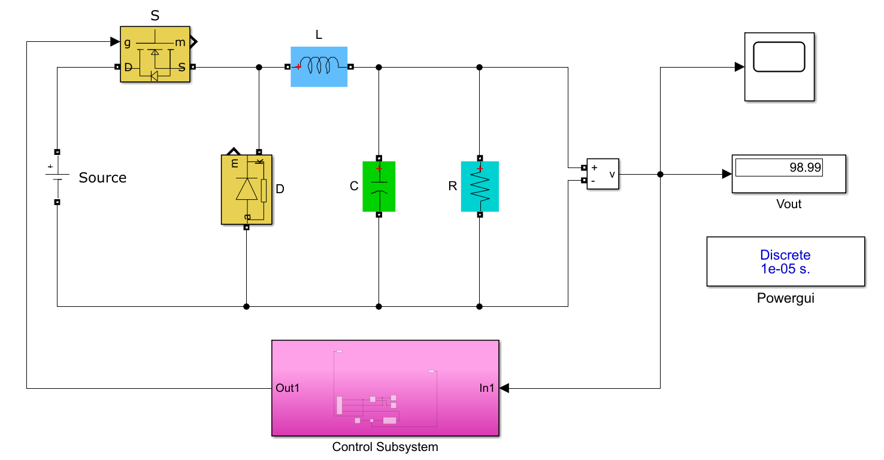
Figure 2 Equivalent circuit of MATLAB SIMULINK of a liquid filling and regulatory system
With reference to the circuit model equivalent of the proposed water filling system the tank is represented with a large capacitor C. The output of the tank is caused by the resistor (R) that is connected in parallel with the capacitor that represents the tank. The Switches S, D and the inductor L constitute the pumping mechanism. The source of water is represented by the voltage source marked as Source.
When the tank is full and if the inlet valve is closed the level of voltage across the capacitor falls down as shown in Figure 3. This is analogically similar to a water tank where the outlet is open and the inlet is closed. The fall of voltage across the capacitor is shown in Figure 3.

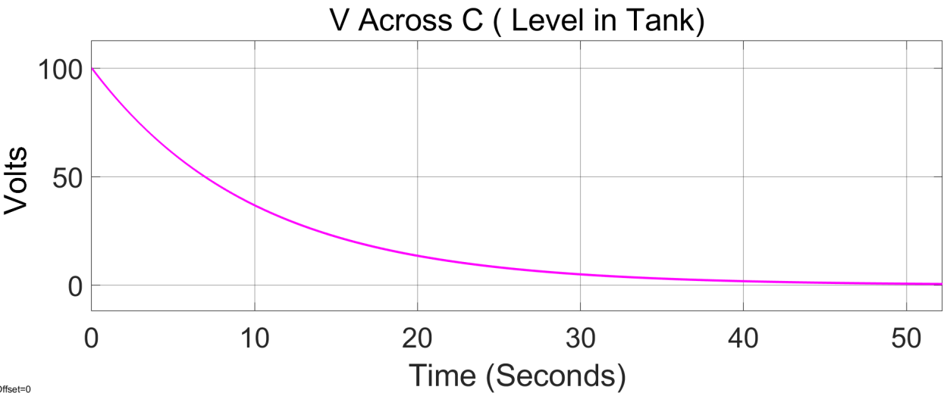
Figure 3 Trajectory of the Rate of fall of level with a fixed outlet opening
Initially the tank is full and the outlet valve is open with a fixed open angle. As time passes on level falls in an exponential manner. This characteristic is obtained when the tank is emptied from the full condition with only the outlet open while no refilling action is active.
Figure 4 shows the trajectory of the level when the tank is being filled by an inlet valve with a fixed opening of 80%. This trajectory ensures that the tank can be filled in a finite time with a fixed opening and the time it takes to fill the tank is a function of the percentage opening of the inlet valve.
Figure 5 shows the trajectory of the analogical rise of level in the tank as the filling valve is opened at 50% and the outflow is also active. As a result of continuous inflow and outflow the level of water in the tank remains to be in a specific level as shown in Figure 5.

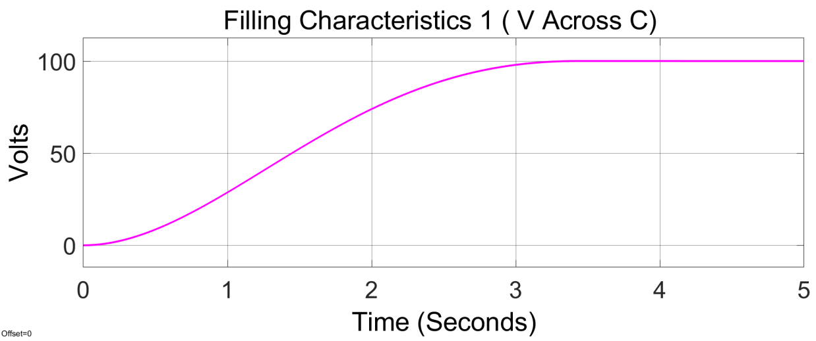
Figure 4 The trajectory of the level with an inlet valve set at 80% and no outflow.
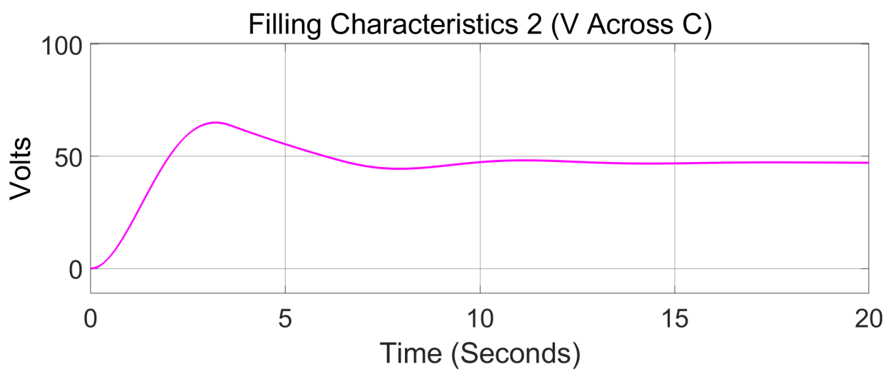
Figure 5 Trajectory of rise of liquid level with inlet valve 50% opened
Studies have been carried out with constant outflow for different inlet opening and for a constant inlet opening with a different outflow and the final steady state level is different accordingly as shown in Figures 6 and Figure 7.
Figure 6 shows the trajectory of the rise of level of water in the tank from an initial zero condition. The inlet valve is opened 25% and the same outflow is maintained as in the case shown in Figure 5. Figure 7 shows the trajectory of the rise of level of water in the tank from an initial zero condition. The inlet valve is maintained at 25% and the outflow is doubled. As a result the steady state level of water in the tank will settle at a lower level as compared to Figure 5. The case of Figure 6 and 7 both use an inlet valve opening percentage of 25 % however because of the change in the outflow the steady state level is lower as shown in Figure 7.
Thus it is possible that the level of the tank can be adjusted and regulated at the desired level by the manipulation of the inlet control valve done analogically by controlling the duty cycle in the analogy.

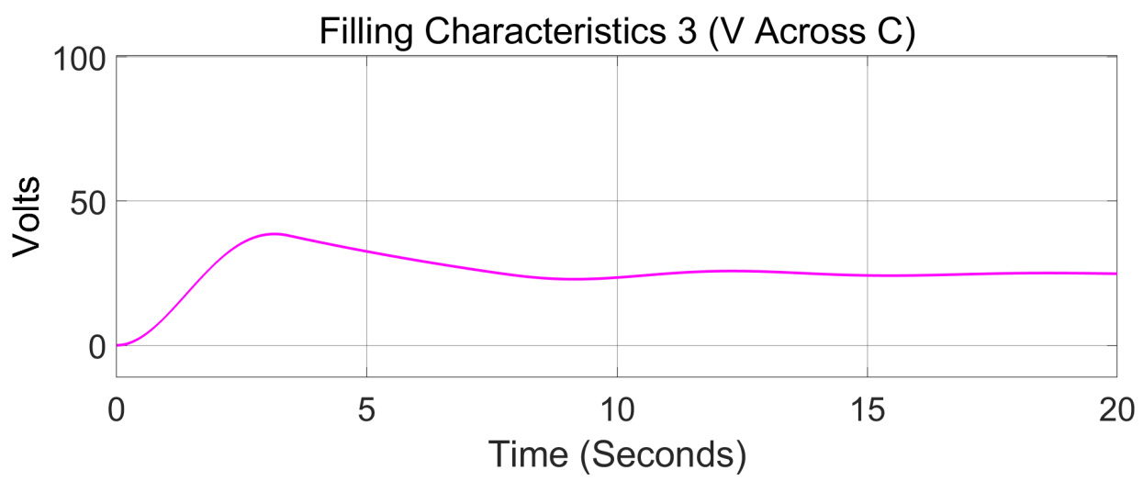
Figure 6 The trajectory of the level with 25% inlet opening and outflow same as previous case

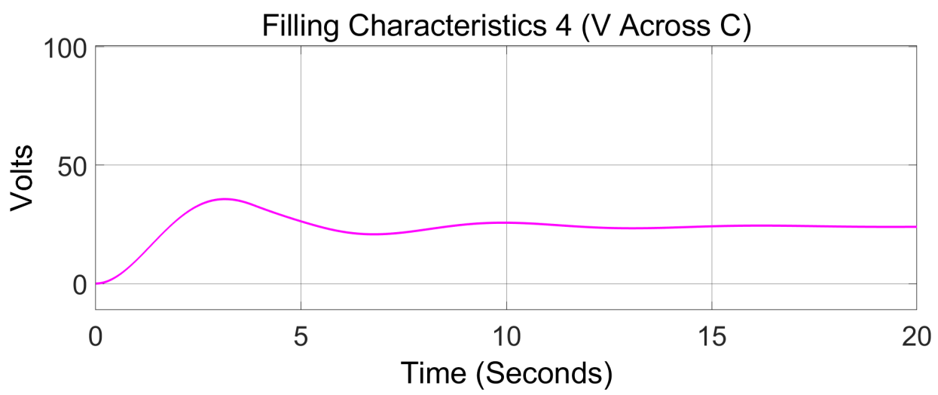
Figure 7 Trajectory of level with 25% inlet with increased outflow as compared to the previous case

- IMPLEMENTATION OF PI CONTROLLER

A PI controller can be developed to regulate the level of the liquid at the desired level. The PI controller is responsible for reaching the command at the shortest possible time, with zero or minimal steady state error, a lower Integral Square Error and lowest overshoot.
The closed loop control scheme for the regulation of the liquid level has been developed and demonstrated. The PI controller was developed in the MATALB SIMULINK environment and the model is shown in Figure 8.
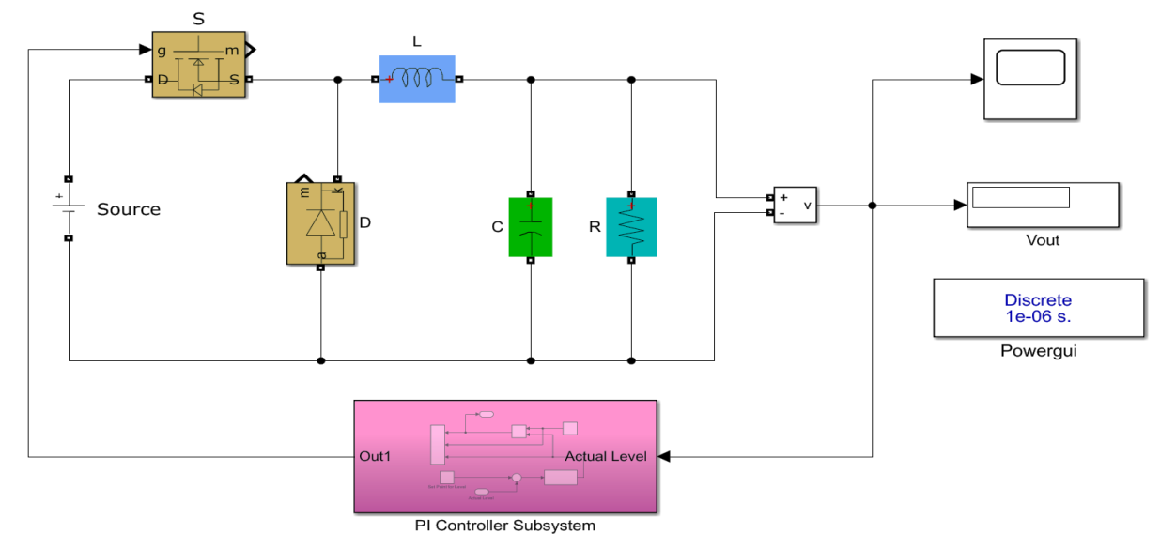
Figure 8 PI Controller based level control system

For the experiment the set point was fixed at 50 V. The proposed controller has been tested against sudden increase in the source side head of liquid as represented by the source voltage in the analogical circuit and sudden out flow and the results have been recorded and presented herein. The proposed PI controller has to follow the command even in the case of disturbances caused on the source side as well as on the delivery side.
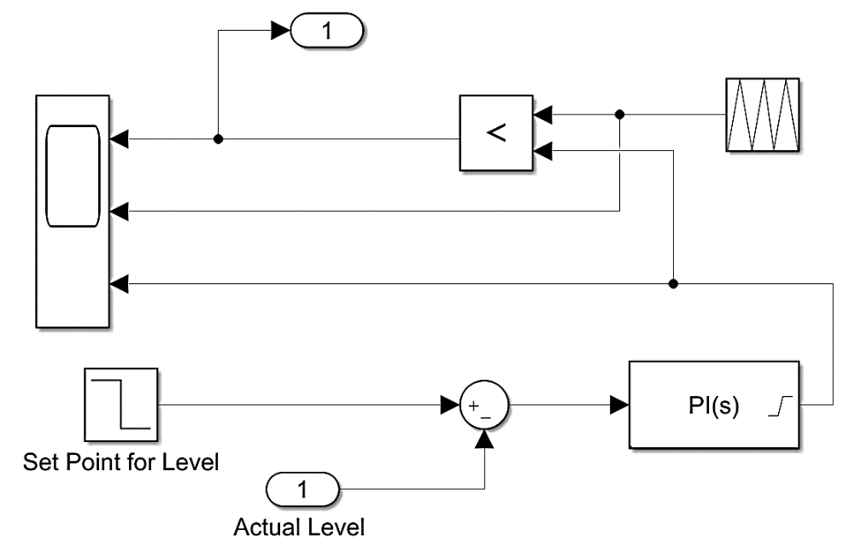
Figure 9 SIMULINK Model of PI Controller

- IMPLEMENTATION OF THE ANN CONTROLLER

The ANN Based controller is realized as shown in Figures 10 to Figure 12
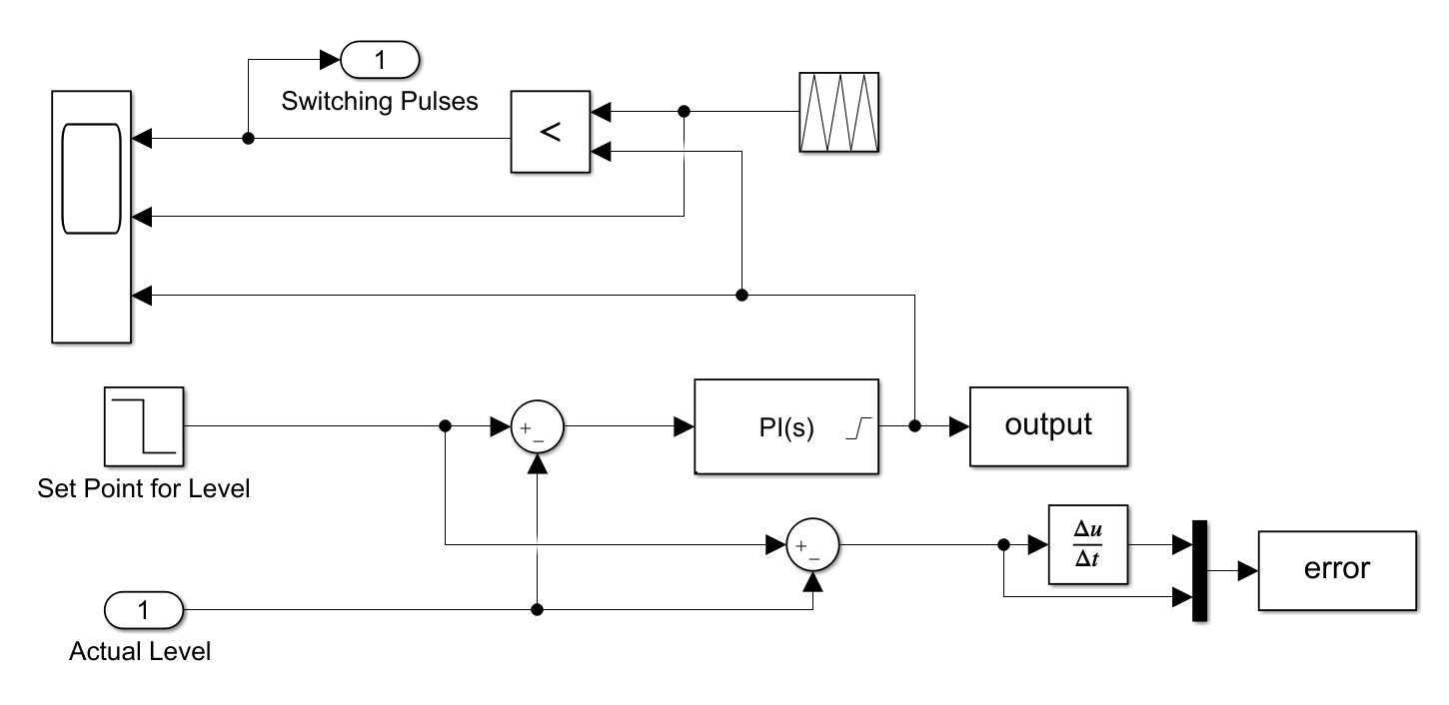
Figure 10 Collection of training data for the ANN

The position of the ANN based controller is similar to the other controllers as shown in Figure 11. In place of the PID controller the ANN is used. The input to the ANN is the error and the rate of change of error.
The method of data collection for training from a PID controller is shown in Figure 11. The ANN based controller has shown better results as compared to the PI controller.
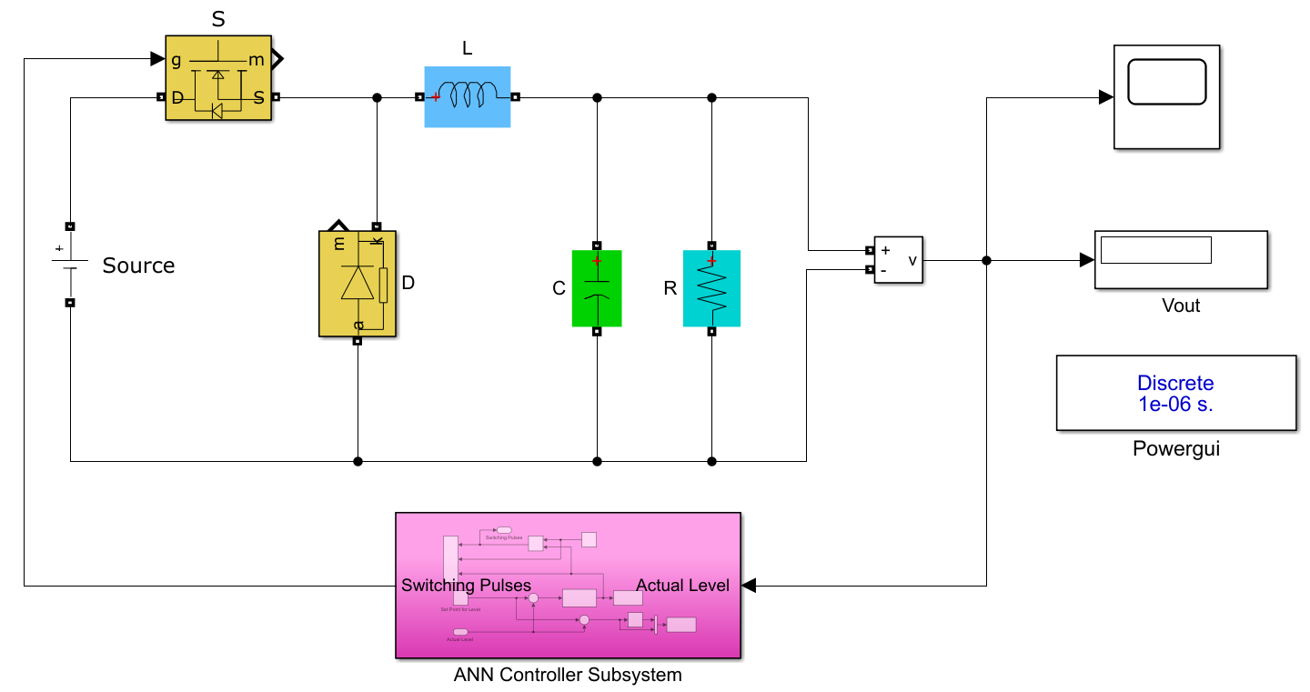

Figure 11 ANN Controller based level control system
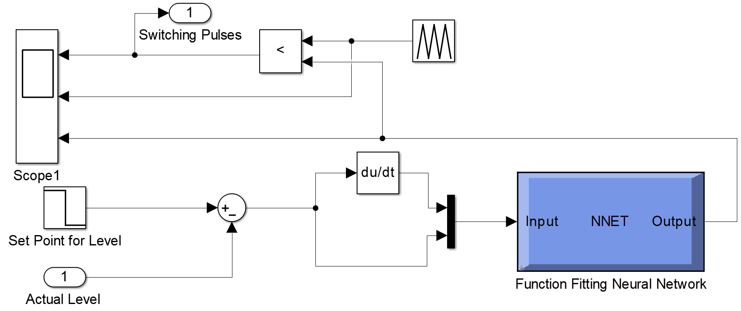

Figure 12 SIMULINK Model of the ANN Based Controller

Figure 12 shows the control scheme using an ANN. The set value and the actual value are brought to a sub tractor and the error is produced. The error is then passed through a differentiator so as to find out the rate of change of error. The error and the rate of change of error are multiplexed and fed as input to the ANN as a vector of two variables. The ANN based upon the instantaneous values of the error and the rate of change of the error produces the duty cycle. The obtained duty cycle is then compared against a triangular carrier and the switching pulses are thus produced. The switching pulses are applied to the power electronic switch and the control action ensures that the output or the level is regulated at the desired set point.

TABLE 1 PERFORMANCE OF DIFFERENT CONTROLLERS

Type of controller | Steady state error (cm) | Peak overshoot% | Rise time (S) | Integral Square Error
PI | 2.9 | 3.2 | 119 | 1320
PID | 2.7 | 0.7 | 130 | 789
ANN | 3.1 | 0.57 | 126 | 675

- Conclusion

In this work the liquid filling system has been represented by an analogous electronic circuit. The capacitor is treated as the tank to be filled and the power control switch S is used as the filling side valve. The outflow is represented by a resistor across the capacitor.
A PI controller has been designed to regulate the level of liquid in the tank analogously represented by the voltage level of the capacitor C. The data obtained from the PI controller, namely the error and the change in error and the corresponding output of the PI controller are used for training the ANN. The ANN is then used in place of the controller. The performance of the ANN based controller was found to be better than the PI controller in terms of steady state error and the Integral Square Error.

- REFERENCES
- Khayamy, H, Khayamy, M & Okoye, O 2018, 'Adaptive RBF network based direct voltage control for interior PMSM based vehicles', IEEE Transactions on Vehicular Technology, vol. 67, no. 7, pp. 5740–5749.
- Rossomando, FG & Soria, CM 2015, 'Identification and control of nonlinear dynamics of a mobile robot in discrete time using an adaptive technique based on neural PID', Neural Computing and Applications, vol. 26, pp. 1179-1191.
- Unluturk, A & Aydogdu, O 2017, 'Adaptive control of two-wheeled mobile balanc robot capable to adapt different surfaces using a novel artificial neural network–based real-time switching dynamic controller', International Journal of Advanced Robotic Systems,
vol. 14, p. 1729881417700893.
- Yonggang Wang, Tianyou Chai, Jun Fu, Jing Sun & Hong Wang, 2013, 'Adaptive Decoupling Switching Control of the Forced-Circulation Evaporation System Using Neural Networks', IEEE Transactions on Control Systems Technology, vol 21(3), pp.964 – 974.
- Fei, JT, Wang, Z & Liang, X 2020, 'Robust adaptive fractional fast terminal sliding mode controller for micro gyroscope', Complexity, vol. 2020, Article ID 8542961, P.18.
- Unluturk, A & Aydogdu, O 2017, 'Adaptive control of two-wheeled mobile balanc robot capable to adapt different surfaces using a novel artificial neural network–based real-time switching dynamic controller', International Journal of Advanced Robotic Systems,
vol. 14, p. 1729881417700893.
- Khooban, MH 2014, 'Design an intelligent proportional-derivative (PD) feedback linearization control for nonholonomic-wheeled mobile robot', Journal of Intelligent & Fuzzy Systems, vol. 26, pp. 1833-1843.
- Khooban, MH, Alfi, A & Abadi, DNM 2013, 'Teaching–learning-based optimal interval type-2 fuzzy PID controller design: a nonholonomic wheeled mobile robots', Robotica, vol.31,pp.1059-1071.
- Kwok, K. Ezra, Michael Chong Ping & Ping Li 2001, 'A model based augmented PID algorithm', Journal of Process Control,vol10(1), pp.9-18.
- Mathew MithraNoel B & JaganathaPandian 2014, 'Control of a nonlinear liquid level system using a new artificial neural network based reinforcement learning approach', Applied Soft Computing,
vol 23, pp.444-451.

