AI in the Profession of Design and Construction

Authors: Amit Kumar, Varuni Jindal, Devasani Badrinath, Muhammed Ashhar R S, Kasina Sree Vardhan

Abstract
Artificial Intelligence (AI) has yet to have a substantial impact in a quickly changing world where it is being investigated. With this, AI undoubtedly can be seen as a fundamental instrument for the future, although whether it will be successful, while still intelligent, is still in question. Analyzing the various technologies, this research paper will examine which role AI could play in the architectural design process as well as architects themselves. A case study of two houses which have been designed using AI in real time helps to uncover the limitations of current AI and subsequent scope of development in the future for AI to assist in better design solutions. Interviews with field experts helps to understand how present architects can keep pace with the future that Ai offers and the utmost need for SOCIAL VALUE addition to make the designers indispensable. Further look at the AI advancements in other fields, this paper attempts to predict the future critical AI developments which can be revolutionary in the field of architecture and the possible opportunities that it offers to the designers as the programme developer.

Keywords: Artificial Intelligence, Architect, Impact of AI on Architecture, GAN, Architect’s role, disruptive technology

1.0 Introduction and background for Research
Artificial intelligence (AI) stands out as a digital-age revolutionary technology. With its advancement everyday, it is changing every profession including the work of an architect. The architecture profession is a mix of science, engineering and art. The role of an architect has evolved over the years and has emerged as a so called mediator between different professions to give birth to a building. What was once done by hand is now getting digital. With the rise of AI, there is a common fear that what was developed as a tool to assist designers could eventually replace them and make them obsolete.
1.1 Research Aims
This paper aims to study the current and the expected trends, developments in AI technologies in architecture and if it has an advantage over human intelligence and empathy when it comes to data analysis and designing, considering human emotions, psychology, artistic appreciation and the expected impacts.

This research also focuses on finding how AI might have an impact on the employment and work-force of architects in the near future.

1.2 Research Objectives
- To understand various AI technologies and their relationship to the work of an architect
- To understand the pros and cons of AI generated buildings
- To understand which parts of an architect’s job are likely to get automated in the future and its impact on the future of the architecture profession.

1.3 Research Questions
- What is the expected impact on the conventional role of architects with the advent of artificial intelligence?
- Where does AI currently stand and what are the current technologies used in the field of architecture?
- Can the profession be fully automated with computers and machines to be able to respond to all kinds of architectural problems similar to humans?
- What are the possible advantages and risks of the employment of architects with the involvement of AI?

1.4 Research Methodology
This paper uses the case study method to study certain modern examples in architecture and the current advancements in AI in the field of architecture. Also, some currently practicing architects and planners who have studied and used the advanced softwares/technologies in this field have been interviewed to understand the current and the expected future scenarios when it comes to AI technologies in architecture.

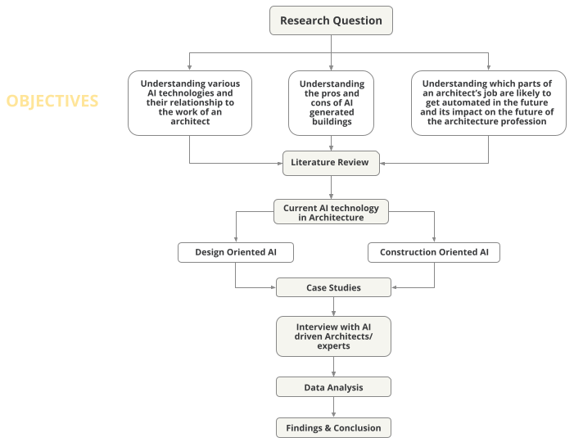
Figure 1. Research Methodology Source: Author

2.0 Understanding AI
According to Britannica, artificial intelligence is "the ability of a digital computer or computer-controlled robot to do activities typically associated with intelligent beings."

However, "artificial intelligence" has become a common term for any advancements in computing, systems, and technology that enable computer programmes to perform activities or solve problems that require the type of thinking we associate with human intellect, such as learning from previous operations. This ability to learn is essential to AI. Algorithms are generally linked to artificial intelligence, such as the infamous Facebook algorithm that replaced all of our friends with paid content. There is, however, a crucial distinction to be acknowledged.

According to Kaya Ismail, a software journalist, an algorithm is basically a "collection of instructions" or a method for processing data. This is taken a step further with AI, which is made up of a set of algorithms that can adapt and rewrite itself in reaction to the data they're given, displaying "intelligence."

2.1 How does AI work?
AI allows a programme to be 'trained' for a certain activity and then explore and improve on its own. When confronted with unknown scenarios, a smart AI 'works out' what to do. You'll need data to use AI. There is a lot of it. Large datasets are used to train AI algorithms so that they can recognise patterns, make predictions, and recommend actions in the same way that humans can, only faster and better.

3.0 Current Technologies in Architecture
As a part of the research to understand the current AI technologies that are being used in the architecture industry, the following softwares and technologies have been identified through our extensive research and the opportunities and threats that will have impacts on the jobs in this field. The technologies are divided into two sections:
Section 1 : Technologies used in design process
Section 2 : Technologies used in construction and project management

3.1 Section 1: Design oriented AI
Table below shows the evolution of AI technologies and the current softwares in the industry. It is evident that the future is shifted more towards a time where other than manual documentation work, psychological and emotional intelligence are developed.

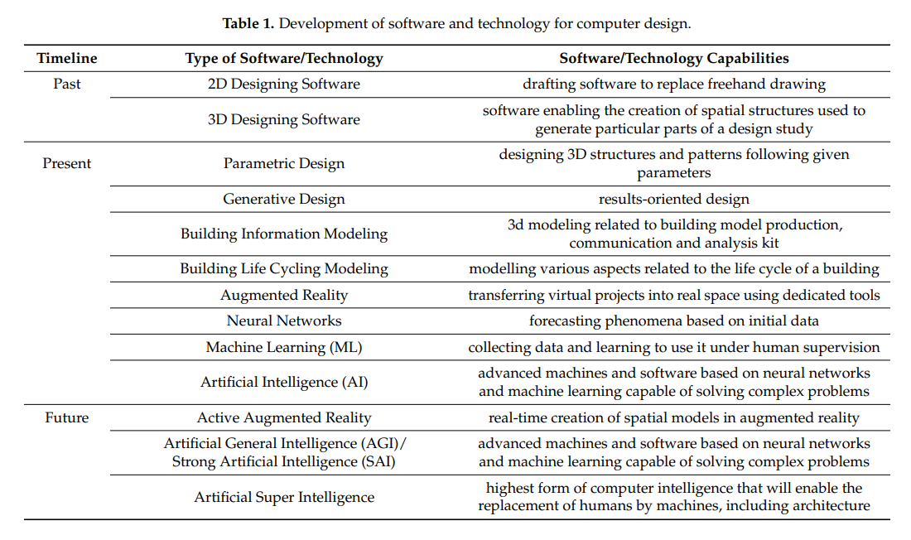
Figure 4. Development of software and technology for computer design (Source: Kołata, Zierke, , 2021)

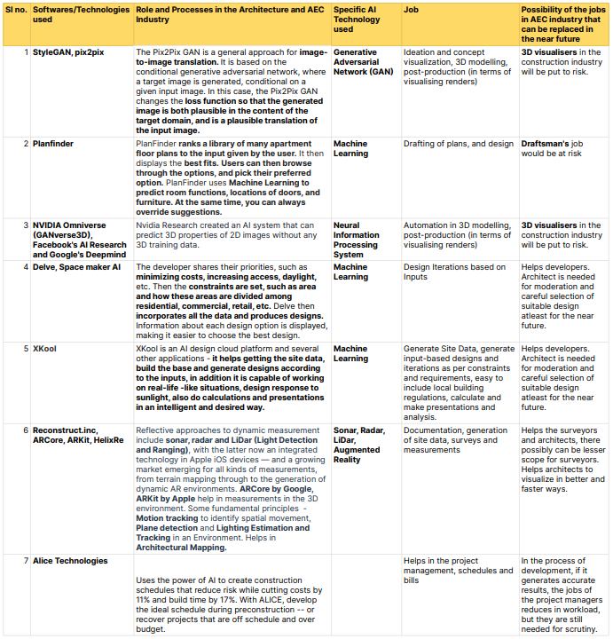
Figure 5. Softwares and technologies currently used and their application
Source: Author

This table helps us understand the current level at which AI and can also help us project into how AI can possibly advance in the possible near future in the field of architecture.

3.2 Section 2: AI in construction and project management

3.2.1 The Future of AI in Construction

Construction costs can be cut by up to 20% using robotics, artificial intelligence, and the Internet of Things. Engineers can wear virtual reality goggles and dispatch mini-robots into under-construction buildings. These robots employ cameras to monitor the progress of the work.Artificial intelligence is being used in modern structures to arrange the routing of electrical and plumbing systems. Businesses are employing artificial intelligence to create workplace safety solutions. Artificial intelligence (AI) is being used to track the interactions of employees, machinery, and materials on the job site in real time and alert supervisors to potential safety issues, construction errors, and productivity difficulties.

AI will not be able to entirely replace the human worker, despite predictions of major job losses. Instead, it will alter the economic models of the construction sector, eliminating costly errors, minimizing jobsite injuries, and improving the efficiency of construction operations.
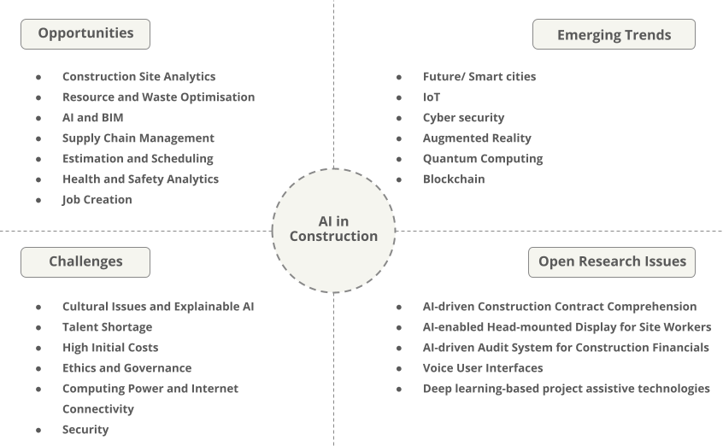
Figure 6. Analysis of opportunities, challenges and further research in AI in construction. Source: Author

As market barriers to entry gradually fall and discoveries in AI, machine learning (ML), and analytics accelerate, it is projected that AI (and the allocation of resources focused towards AI) will play a larger role in construction in the coming years. (10 Examples of Artificial Intelligence in Construction, no date)

3.2.2 Advantages of AI in Construction
1. Prevent cost overruns
2. AI for better design of buildings through generative design
3. Risk mitigation
4. Project planning
5. AI makes job sites more productive
6. AI for construction safety
7. AI will address labor shortages
8. Off-site construction
9. AI and big data in construction
10. AI for post-construction
(10 Examples of Artificial Intelligence in Construction, 2022)

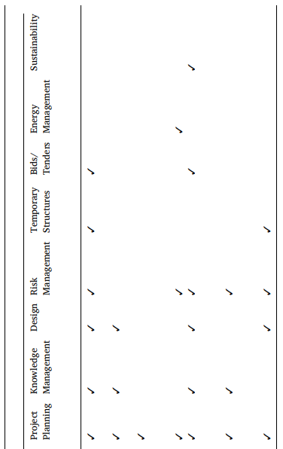
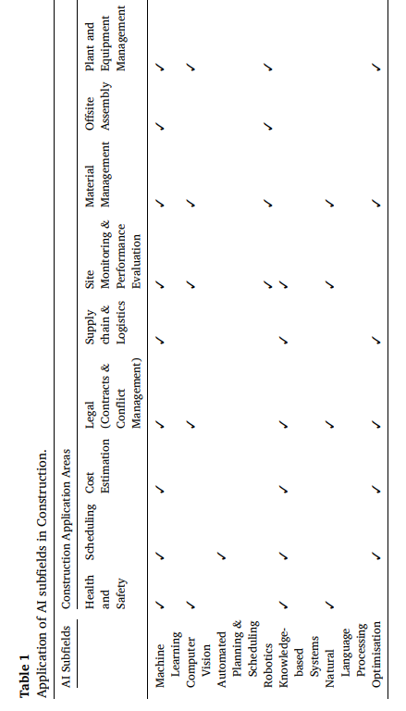

Figure 7. A matrix of different AI technologies and their application at various tasks in a project (Artificial intelligence in the construction industry: A review of present status, opportunities and future challenges | Elsevier Enhanced Reader, 2021)

A new technology that helps in the management of design and construction and cost is the Next-generation 5-D BIM. It is a five-dimensional depiction of the physical and functional characteristics of any project. It considers a project's budget and timeline, as well as the standard 3-D spatial design features. Geometry, specifications, aesthetics, thermal, and acoustic properties are all included. The implications of modifications on project costs and timelines can be discovered, analyzed, and recorded using a 5-D BIM platform by owners and contractors. (Mckinsey, 2016)

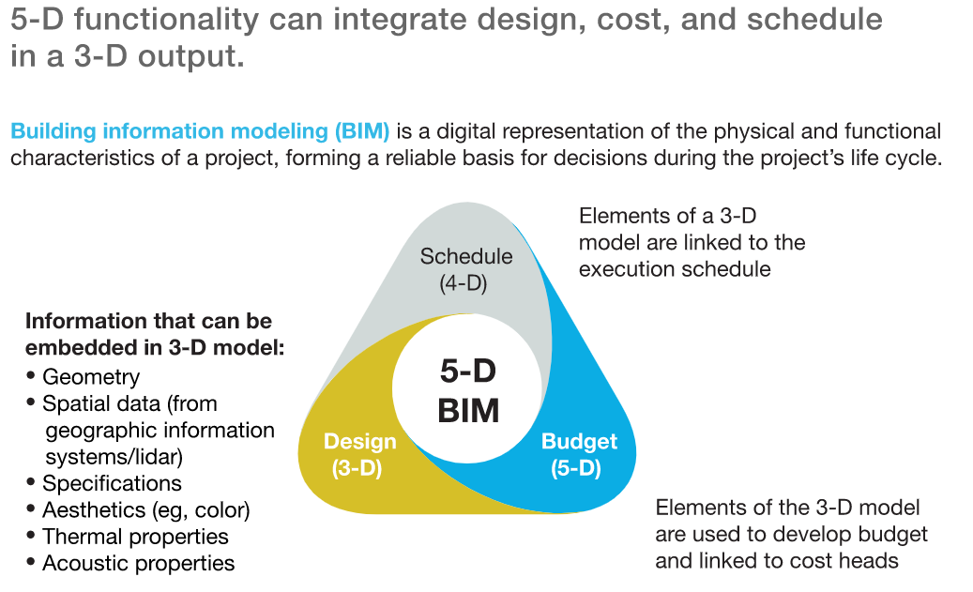
Figure 8. 5-D BIM (Mckinsey, 2016)

4.0 Practical application of softwares which help to compute automated design

In order to analyze whether machines can fully replace the architect's job, it is crucial to understand how accurate they are at doing the most important tasks of an architect - developing the building scheme and plans. Currently there are two live projects where AI has been practically applied to develop a building .

This part of the section will discuss the method adopted in these softwares to understand what parameters had been used to compute the data. Later on it will compare the two case studies to analyze the effectiveness of these AI automated design schemes as compared to ones prepared by an architect himself.

4.1 GAN generative housing- layout design by Stanislas Chaillou, Harvard

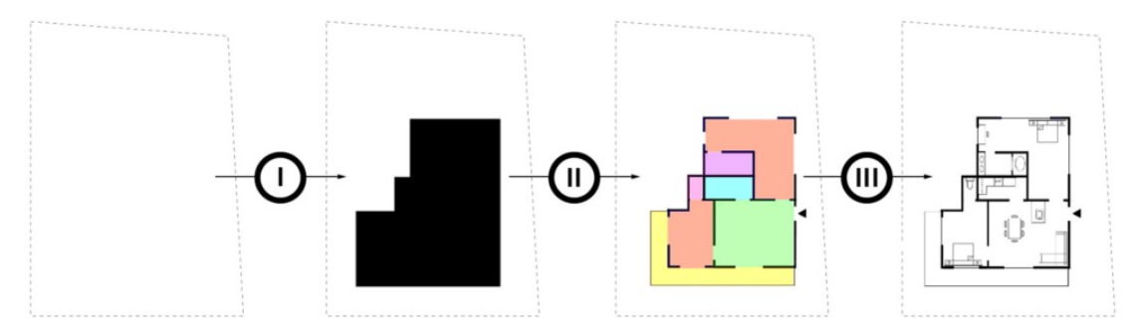
Figure 10. Breakdown of design process (Chaillou, 2019)

Chaillou's approach is to use Generative Adversarial Networks to develop residential tower layouts (GANs).The design process is divided into three stages:
- The footprint
- The layout
- The furniture
This design approach currently requires some human input and allows the architect to make changes to the design at various phases.

Stage 1 : Generating footprint

Normal footprints were input into it from real-world Boston layouts, which taught the computer typical footprint shapes for a particular plot of land, which it then utilized to create new footprints.
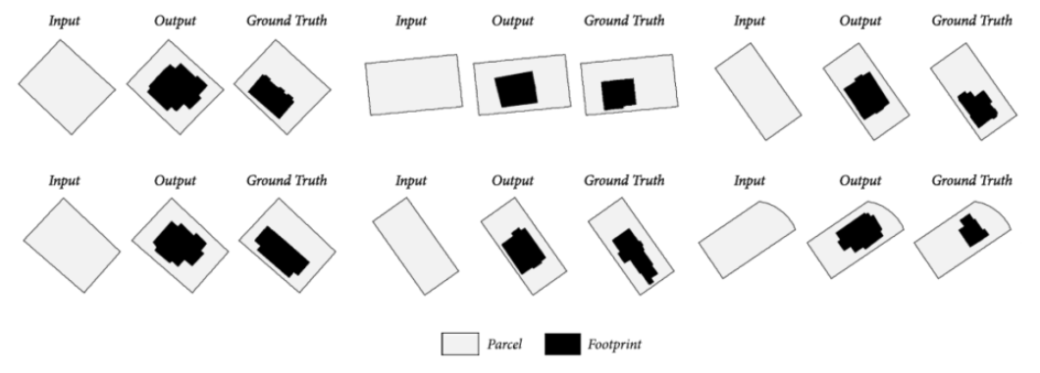
Figure 11. Footprint layout iterations (Chaillou, 2019)

Stage 2 : Generating layout
The front door (green square) and the major windows must be manually placed by the architect (red lines). This is then transmitted back to the computer, which generates a layout based on data from over 800 real-world apartment layouts.
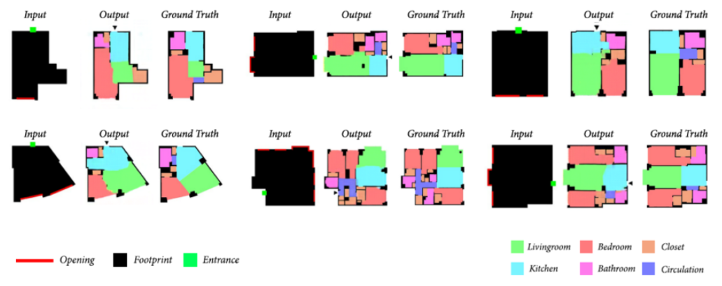
Figure 12. Spatial layout iterations (Chaillou, 2019)

Stage 3: Creating furniture layout
A new feature was added that allows the architect to determine the individual footprint of each floor. Load-bearing walls, on the other hand, are currently unspecifiable. This might be corrected using the same method as the positioning of doors and windows.
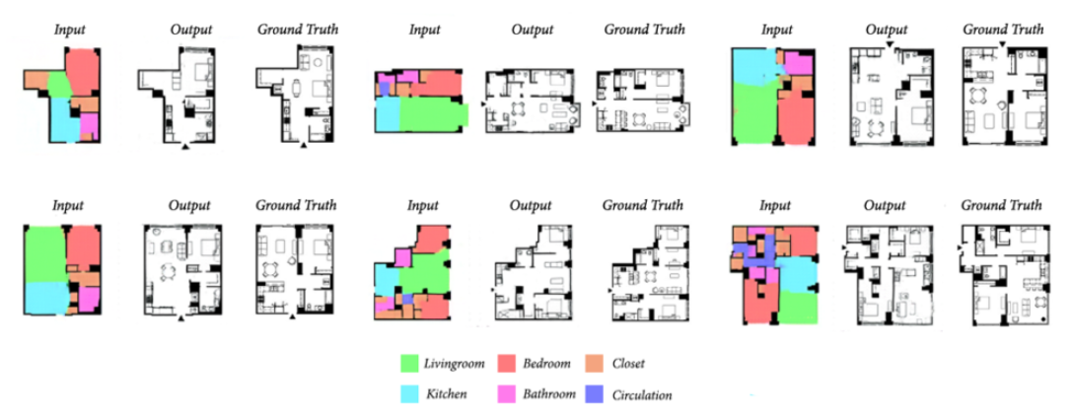
Figure 13. Furniture layout iterations (Chaillou, 2019)

4.2 House (Y) amnitski by Benjamin Ennemoser, California
In this research, certain case examples were chosen to examine the projects and build an Analytical machine learning algorithm, ranging from John Lautner and Frank Lloyd Wright to modern real estate houses. In order to train and build the design, datasets were constructed from street view pictures, ImageNet, Google Database, and 3D models.
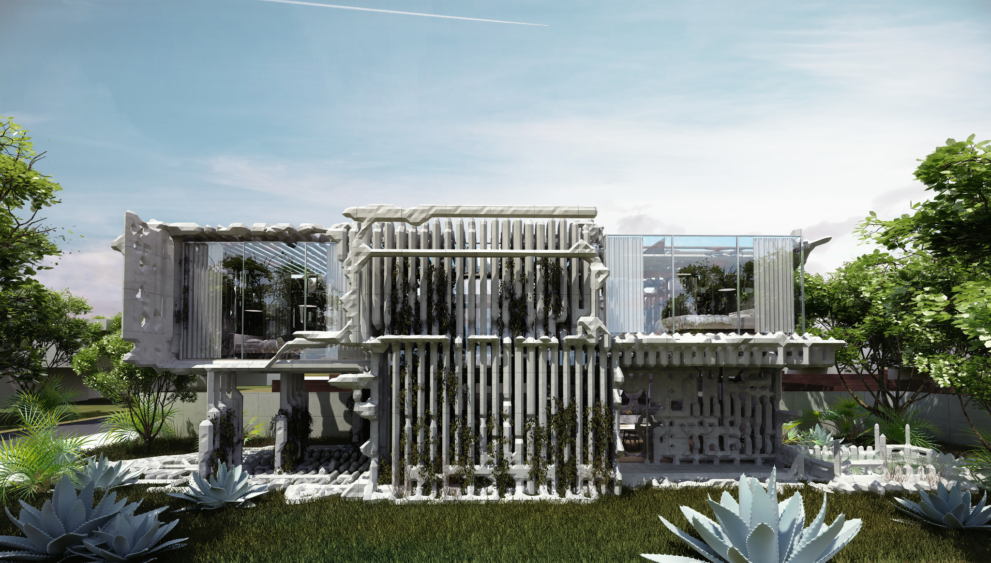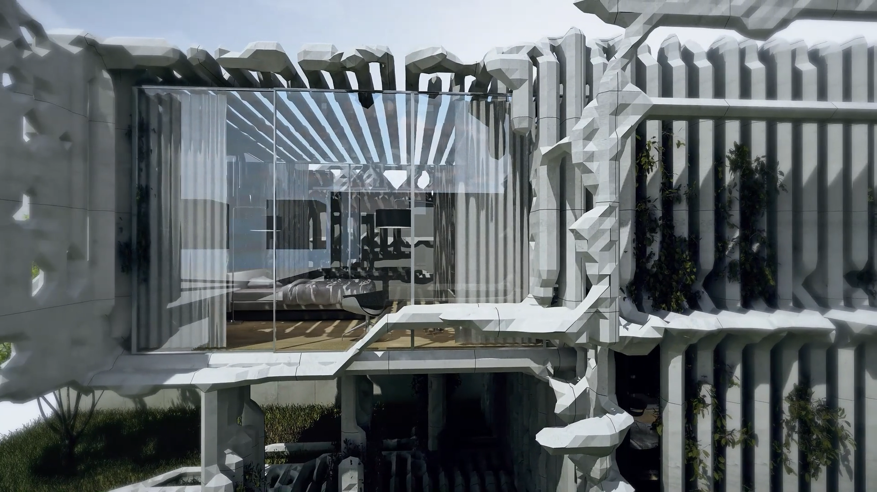
Figure 15. 3d visualization of the house as generated by GAN (Ennemoser, 2020)

After creating a series of artificially generated 2D facades, it is further developed to 3D models and geometry by GAN.
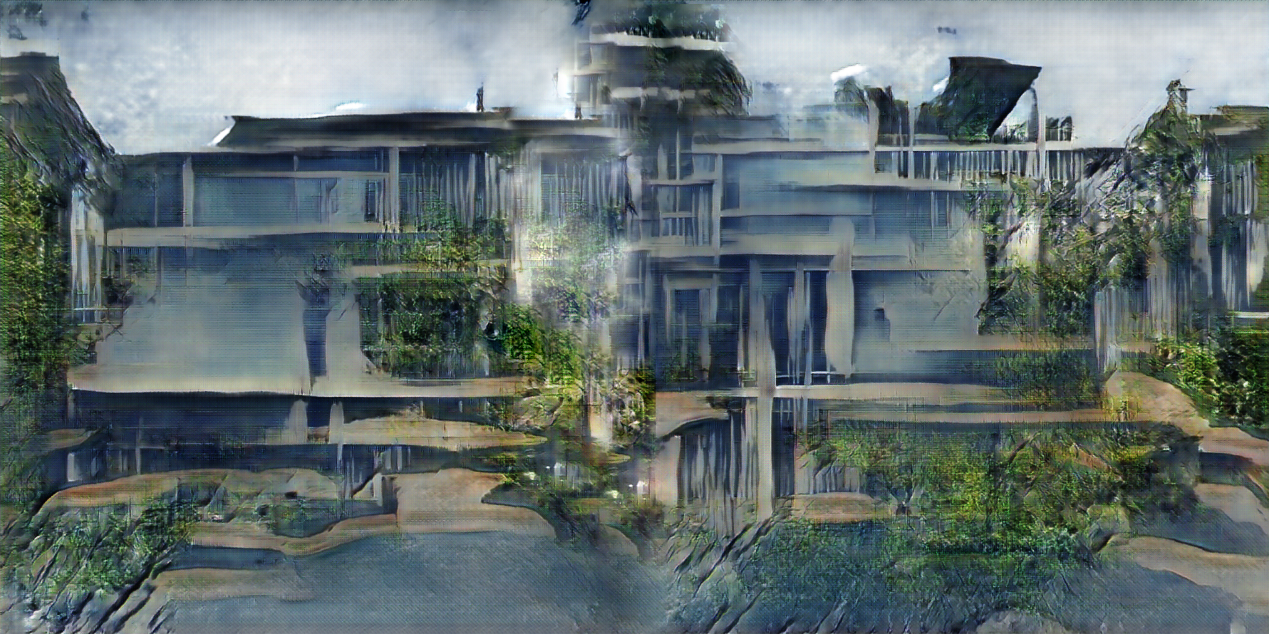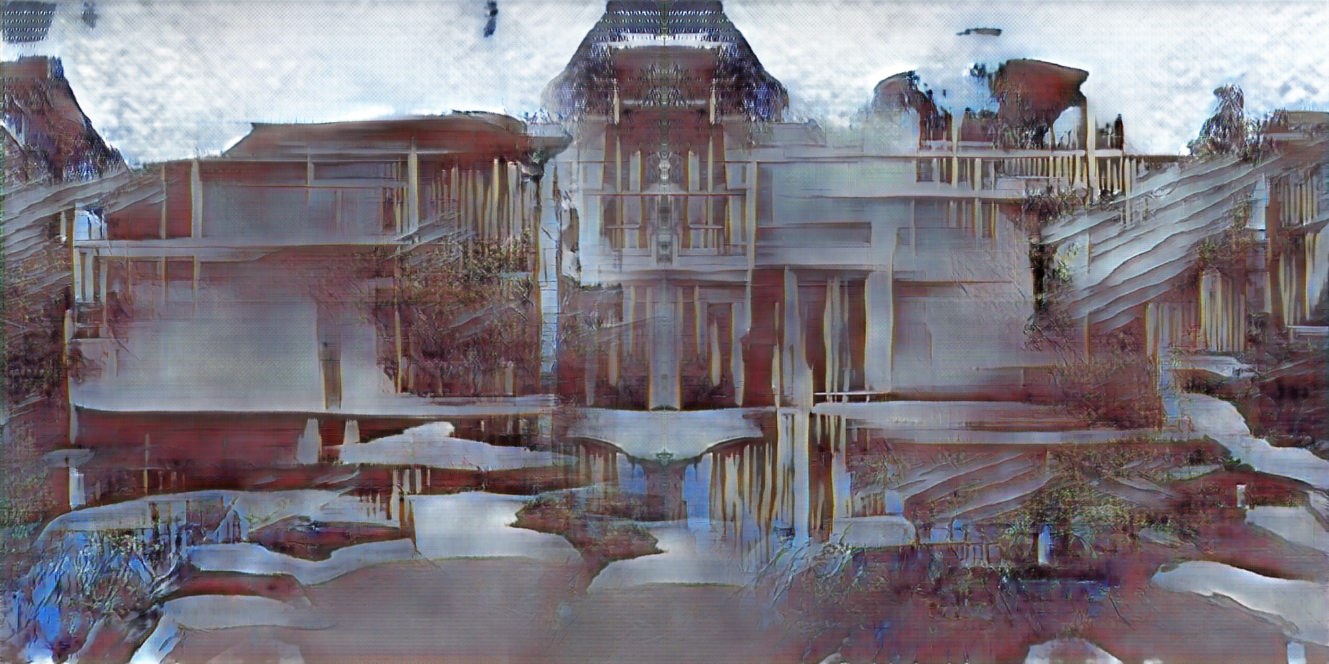
Figure 17. Concept sketches of house developed by GAN (Ennemoser, 2020)

The 3D GAN is a way to implement machine learning into a collaborative design process, where the designer curates the generative process by choosing a specific dataset. The curational act influences the decision making process of artificial intelligence and what the machine learning algorithm thinks to be a modern Californian house.

In terms of a case study, the project focuses on a new method to computational design that leverages machine learning to provide an alternative to current parametric models. The exterior and structure will be created using digital fabrication and precast fiber-reinforced concrete panels. As a result, AI is a successful designer since it can develop a new conceptual shape based on prior work fabricating new methodologies.

4.3 Comparative analysis of GAN based design and architects’s design
- Comparing the design with a modern house in California, it is clearly different in terms of materiality with some similarities in the nature of design.
- Because the computer in both situations was using the supplied data, it was discovered that it wasn't actually designing anything new, but rather calculating comparable conclusions from previous designs. However, an architect has the ability to create new concepts and design individual building experiences.
- The existing design is also confined to data from building layouts in a single location, and does not reflect the design preferences and needs of a worldwide audience. This contextual sensitivity can be improved in the future, but at the same time, an architect’s judgment towards contextual and social sensitivity will always trump a machine’s.
- The designs are not without limitations, stating that the architect's contribution to the machine learning design by inputting case examples and datasets in the AI, influenced the final design.

5.0 Questionnaire prepared for the Interviews
- What is your take on current AI trends in architecture? Is/Will it be a boon or a bane?
- What are the present trends and technologies with AI in architecture?
- What do you think about AI taking over human jobs and making the work faster and easier? Can AI replace architects?
- What are the recent major developments and expected developments in AI in the near future?
- What current duties of an architect can be worked/automated by AI?
- What aspects/qualities/duties of an architect prevent the profession from complete automation?
- How can architects adapt to the fast-pacing AI development in the field of architecture?

5.1 Key Takeaways from discussions

- AI can produce much more logical and rational thinking decisions but it can take longer for the machine to understand the social, emotional and intuitive aspects of humans. Hence, one can expect that in the near future, although the scientific and technical aspect of an architect’s job may be completely automated, the artistic side of the profession will always require human input.

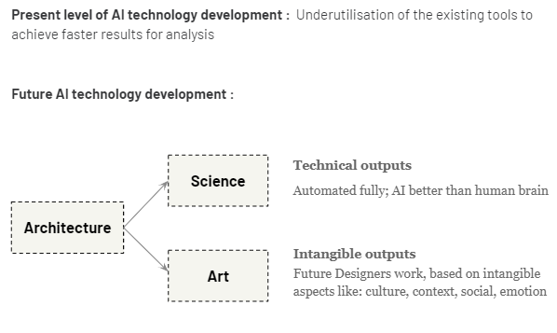
Figure 18. Role of an architect which can be automated in the future. Source: Author

- Another major limitation in use of AI for designs is in the input data that helps the AI to design, as the data can be misleading and requires some human supervision currently. However, as research is going, the near future allows the possibility of the machines to improvise their solutions on their own and resolve more complex problem statements.
- Computers require a lot of data input to design a building which has its own limitations in terms of the number of parameters which can be used at a time. Since architects use their intuitive skills, they will always remain to have an upper hand even as AI gets advanced in the future.

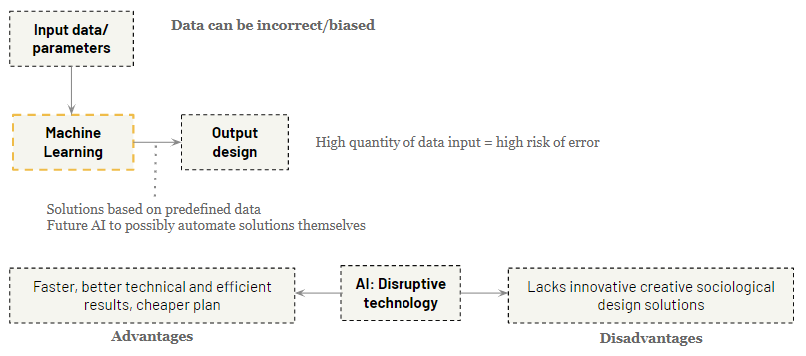
Figure 19. AI as a disruptive technology. Source: Author

6.0 Predicting the future of AI from technological developments in other fields

This part of the research looks at the development of AI in different fields to draw inferences on how the architecture world could be advanced in the future. A remarkable advancement which shows to what extent the future could be transformed by AI is the use of Predictive Policing. This helps the cyber security teams to predict the future crime scenes and helps in preventing unfortunate accidents in the future. A very similar application of the same can be easily expected in architecture in the future where the on site work can be monitored online and accidents and structural failures be predicted on the site.
Currently, drone technology and robots are being developed which can in future eliminate the need of an architect to visit the site and control the work. With a possible combination of the two, one can visually assess the site work from screens and command the robots who could be the future construction workers to do specific tasks.
The Ecole Polytechnique Fédérale de Lausanne has developed a machine-learning algorithm that can be linked to a human brain and used to control a robot. Based on electrical inputs from the brain, the programme can change the robot's movements. Currently the technology is being used for tetraplegic patients who are unable to speak or perform movements. A future adaptation of this technology can be expected in architecture, the senior architect can feed information into robots from his brain and command them to complete tasks thus eliminating the need to employ multiple junior architects and draftsmen. This could in one way be a threat to the jobs of many architects whose role is limited to assisting senior architects in project completion.

3D printing is another technology that is currently and in the future changing architecture. 3D printing is predicted to become a common technology by the end of 2030. More phases in the production process will be affected by the decision between 3D printing and traditional production, such as ramp-up goods being printed while product series are manufactured conventionally, and after-market products being printed again. The huge performance boost of machines, automated workflows, and product designs that are natively available for 3D printing will all contribute to this. Newer materials explorations will lead to easy availability of a wide range of customized products in the manufacturing and construction industry.

6.1 Future opportunities for architects due to AI
While it is clear that machines will be deployed in certain aspects of an architect's job, AI also presents a vast opportunity for architects to explore in the future. AI softwares which aid in design are emotionally intelligent deep learning softwares which if developed by the architects, can be more effective in design application. Architects can combine software development and computation to develop better AI making design better. Digital world like the metaverse is another opportunity for architects to expand their work in limitless possibilities.

7.0 Conclusions from the Research
From the research it is evident that AI is better at technical outputs whereas Architects are better at social and spatial experience. AI has the ability to take over human thinking in the very long run, but the way how it can be achieved is quite unsure and unpredictable at the moment. It can fill gaps of unknown or unthought solutions in the profession of architecture, however, as of now, single-handedly an AI system will not be able to generate a more successful design than that of a human designer, mainly due to the need of human-nature in design. As AI can work on to produce rationalized designs based on the type of inputs, with the increase in scale of architecture to urban design and to urban planning, the number of variables increase, therefore the data to be fed into the machine is also higher, posing greater level of risk.

When looking at the developments taking place in other fields, it can be predicted that man force in construction and architecture could very well be replaced by robots and the need to employ multiple architects in a firm could be reduced significantly. Therefore in keeping pace with the fast-paced AI development and for the architects to survive their jobs, it remains of high importance that they contribute some VALUE which AI lacks. Architects would need to stay up-to-date with the developing technologies in the world and not just architecture. In the future it can be expected that the role of an architect gets redefined and might be limited to critical and creative design thinking approaches. But at the same time AI is currently a more boon to the profession than a bane as it helps designers get results faster and more accurately and efficiently. AI also presents architects with an opportunity to combine software development with design and develop these AI technologies themselves for better results. It now depends upon the users to make the best of AI and become better designers.

Bibliography
- Ceylan, S. (2021) Artificial Intelligence in Architecture: An Educational Perspective. In Proceedings of the 13th International Conference on Computer Supported Education (CSEDU 2021) - Volume 1, pages 100-107
- Chaillou, 2019. AI+ Architecture, Towards a New Approach. Harvard Thesis. Available at : .https://issuu.com/stanislaschaillou/docs/stanislas_chaillou_thesis_ (last accessed: 17 March, 2021)
- Kołata, J. Zierke, P. (2021) The Decline of Architects: Can a Computer Design Fine Architecture without Human Input? Available at: https://doi.org/10.3390/ buildings11080338
- Nidal, D. (2019) The Impact of Artificial Intelligence on the future of architecture & architects (The Revolution of Artificial Intelligence). 10.13140/RG.2.2.26502.91209
- The new age of engineering and construction technology | McKinsey (no date). Available at: https://www.mckinsey.com/business-functions/operations/our-insights/the-new-age-of-engineering-and-construction-technology (Accessed: 16 March 2022)
- 10 Examples of Artificial Intelligence in Construction (no date). Available at: https://constructible.trimble.com/construction-industry/the-benefits-of-ai-in-construction (Accessed: 17 March 2022)
- Barfield, R. (2020) AI Architecture Generative Design Housing - Bricsys CAD Blog. Available at: https://blog.bricsys.com/ai-architecture-generative-design-housing/ (Accessed: 17 March 2022).
- Ennemoser, B. 2020) House (Y)amnitski - Benjamin Ennemoser. Available at: https://www.benjamin-ennemoser.com/projects/house-yamnitski (Accessed: 17 March 2022).
- Ismail Agha, D. (2019) The Impact of Artificial intelligence on the future of architecture & architects (The Revolution of Artificial Intelligence). doi:10.13140/RG.2.2.26502.91209.
- Rao, S. (2022) 10 Examples of Artificial Intelligence in Construction. Available at: https://constructible.trimble.com/construction-industry/the-benefits-of-ai-in-construction (Accessed: 17 March 2022).
- Bennet, E. (2020) BArch (Hons) Dissertation: The Inception of Artificial Intelligence in Architecture by Eddie Bennet - Issuu. Available at: https://issuu.com/eddiebennet1/docs/the_inception_of_artificial_intelligence_in_archit (Accessed: 17 March 2022).
- Mckinsey, 2016. Imagining construction's digital future, Available at: https://www.mckinsey.com/business-functions/operations/our-insights/imagining-constructions-digital-future ( last accessed: 15 March, 2022)
- Artificial intelligence in the construction industry: A review of present status, opportunities and future challenges | Elsevier Enhanced Reader (2021). doi:10.1016/j.jobe.2021.103299.
- Kołata, J.; Zierke, P. The Decline of Architects: Can a Computer Design Fine Architecture without Human Input? Buildings 2021, 11, 338. https://doi.org/10.3390/ buildings11080338

