HEARING LOSS (DEAFNESS)
Author: Ms. Kumuthavalli. T, Lecturer
Department of Physician Assistant,
School of Allied Health Sciences,
Vinayaka mission research foundation
Deemed to be university
Paiyanoor Chennai, India.
Email ID: kumuthavalli.sahst14@avit.ac.in

Abstract:
By 2050 nearly 2.5 billion people are projected to have some degree of hearing loss and at least 700 million will require hearing rehabilitation. Hearing loss may develop at any age in the lifetime, congenitally developed hearing loss cause difficult to speech production in children and the mid age hearing loss causes the person socially isolated and makes communication barrier. Hearing loss occurs due to various causes and treated by minor to major procedures. In the AI world management of hearing loss from surgery to hearing aids results high prognosis rate.
Introduction
A person is said to have hearing loss if they are not able to hear as well as someone with normal hearing, meaning hearing thresholds of 20 dB or better in both ears Hearing loss affects people of all ages and can be caused by many different factors.
Hearing loss
Hearing loss is a total or partial loss of hearing and it may be congenital or acquired at any time afterwards. If hearing loss occurs in childhood age, the child can affect the ability to acquire to spoken language. In adults they may face the difficulty in interact each other as well as socially. Hearing loss may occur temporarily or permanently, in specific case of aging hearing loss is irreversible and other types are treated by symptomatically or with the help of hearing aids
Classification :

Table No . 1
CONGENITAL HEARING LOSS:
Many hereditary conditions are the reason behind the congenital hearing loss. This hearing loss mainly occur due to secondary degeneration of the inner ear structures.
HEREDITARY CAUSES:
- Waardenburg’s syndrome – Characterized by heterochromia a white forelock, widest eyes and progressive hearing loss
- Usher’s Syndrome (Retinitis pigmentosa)
- Alport’s Syndrome

Other Causes:
- Congenital Cholesteatoma
- Fixation of malleus
- Meatal atresia
- Fixation of stapes and footplate
- Ossicular discontinuity
ACQUIRED HEARING LOSS:
Acquired hearing loss is a hearing loss which appears after birth, at any time in one's life, perhaps as a result of a disease, a condition, or an injury.
Conductive Hearing loss:
- Any disease process which interferes with the conduction of sound to reach cochlea causes conductive hearing loss.
- The lesion may lie in the external ear and tympanic membrane, middle ear or ossicles up to stapediovestibular joint.
Possible Causes:
- Middle ear infection
- Collection of fluid in the middle ear(Glue ear in children)
- Blockage of outer ear(By Ear wax)
- Damage to the ear drum by infection or an injury
- Otosclerosis
The Characteristics Of Conductive Hearing Loss Are:
1. Negative Rinne test, i.e. BC > AC.
2. Weber lateralized to poorer ear.
3. Normal absolute bone conduction.
4. Low frequencies affected more.
5. Audiometry shows bone conduction better than air conduction with air-bone gap. Greater the air-bone gap, more is the conductive loss.
6. Loss is not more than 60 dB.
7. Speech discrimination is good

SENSORINEURAL HEARING LOSS
Sensorineural hearing loss (SNHL) results from lesions of the cochlea, VIIIth nerve or central auditory pathways. It may be present at birth (congenital) or start later in life (acquired).
The Characteristics Of Sensorineural Hearing Loss:
1. A positive Rinne test, i.e. AC > BC.
2. Weber lateralized to better ear.
3. Bone con duction reduced on Schwabach and absolute bone conduction tests.
4. More often involving high frequencies.
5. No gap between air and bone conduction curve on audiometry.
6. Loss may exceed 60 dB.
7. Speech discrimination is poor.
8. There is difficulty in hearing in the presence of noise.
ETIOLOGY
CONGENITAL
It is present at birth and is the result of anomalies of the inner ear or damage to the hearing apparatus by prenatal or perinatal factors.
ACQUIRED
It appears later in life. The cause may be genetic or non-genetic. The genetic hearing loss may manifest late (delayed onset) and may affect only the hearing, or be a part of a larger syndrome affecting other systems of the body as well (syndromal).
Common causes of acquired SNHL include:
1. Infections of labyrinth—viral, bacterial or spirochaetal
2. Trauma to labyrinth or VIIIth nerve, e.g. fractures of temporal bone or concussion of the labyrinth or the ear surgery
3. Noise-induced hearing loss
4. Ototoxic drugs
5. Presbycusis
6. Ménière’s disease
7. Acoustic neuroma
8. Sudden hearing loss
9. Familial progressive SNHL
10. Systemic disorders, e.g. diabetes, hypothyroidism, kidney disease, autoimmune disorders, multiple sclerosis, blood dyscrasias

NONORGANIC HEARING LOSS (NOHL)

In this type of hearing loss, there is no organic lesion. It is either due to malingering or is psychogenic. In the former, usually there is a motive to claim some compensation for being exposed to industrial noises, head injury or ototoxic medication. Patient may present with any of the three clinical situations:

- Total hearing loss in both ears,
- Total loss in only one ear or
- Exaggerated loss in one or both ears.

OTHER FORMS OF HEARING LOSS:
- Noise Trauma
Exposure to sudden excessive noise or repeated exposure to sounds
- Ototoxicity
It can be defined as a capacity of a drug or chemical to damage the inner ear structure or derange its function. Damage may occur in the auditory or vestibular portion or in both parts of the inner ear
- Presbycusis
Presbycusis is defined as a sensorineural hearing loss associated with increase in chronological age but patient may or may not be aware of the hearing loss in the initial stage
- Sudden sensorineural hearing loss
It can be defined as a deterioration more than 35dB in at least three adjacent frequencies occurring within 3 days
- Inflammation of labyrinth
- Familial progressive sensorineural hearing loss

HEARING LOSS AND DEAFNESS

- Hearing loss is impairment of hearing and its severity may vary from mild to severe or profound, while the term deafness is used, when there is little or no hearing at all.

- In 1980, WHO recommended that the term “deaf” should be applied only to those individuals whose hearing impairment is so severe that they are unable to benefit from any type of amplification
A similar definition is used in India while extending benefits to the hearing handicapped.

DEFINITION OF DEAF: “The deaf are those in whom the sense of hearing is non-functional for ordinary purposes of life.” They do not hear/ understand sounds at all even with amplified speech. The cases included in the category will be those having hearing loss more than 90 dB in the better ear (profound impairment) or total loss of hearing in both ears. The partially hearing is defined as those falling under any one of the following categories:

LEVEL OF HEARING IMPAIRMENT

- Mild impairment | More than 30 but not more than 45 dB in better ear
- Serious impairment | More than 45 but not more than 60 dB in better ear
- Severe impairment | More than 60 but not more than 90 dB in better ear

DEGREE OF HEARING LOSS (WHO CLASSIFICATION)

WHO (1980) recommended the following classification on the basis of pure tone audiogram taking the average of the thresholds of hearing for frequencies of 500, 1000 and 2000 Hz.
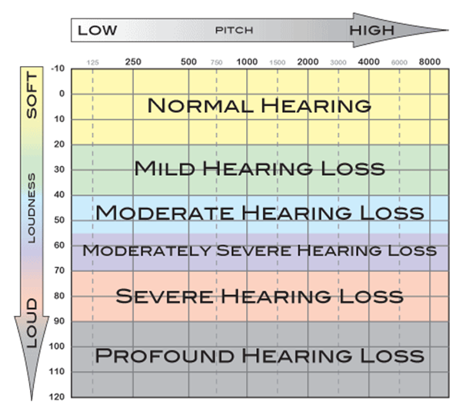

Table No.2

DEGREE OF HEARING LOSS :

1. Mild 26–40 dB
2. Moderate 41–55 dB
3. Moderately severe 56–70 dB
4. Severe 71–91 dB
5. Profound More than 91 dB
6. Total

DIAGNOSIS OF HEARING LOSS
- History. It is important to know whether disease is congenital or acquired, stationary or progressive, associated with other syndromes or not, involvement of other members of the family and possible aetiologic factors.
- Severity of deafness (mild, moderate, moderately severe, severe, profound or total). This can be found out on audiometry.
- Type of audiogram.- Whether loss is high frequency, low frequency, mid-frequency or flat type.

- Site of lesion, i.e. cochlear, retrocochlear or central.

- Laboratory tests - They depend on the aetiology suspected, e.g. X-rays or CT scan of temporal bone for evidence of bone destruction (congenital cholesteatoma, glomus tumour, middle ear malignancy or acoustic neuroma), blood counts (leukaemia), blood sugar (diabetes), and serology for syphilis, thyroid functions (hypothyroidism), kidney function tests, etc.

AUDIOMETRICAL FINDINGS OF HEARINGLOSS:

Normal Hearing AC Loss
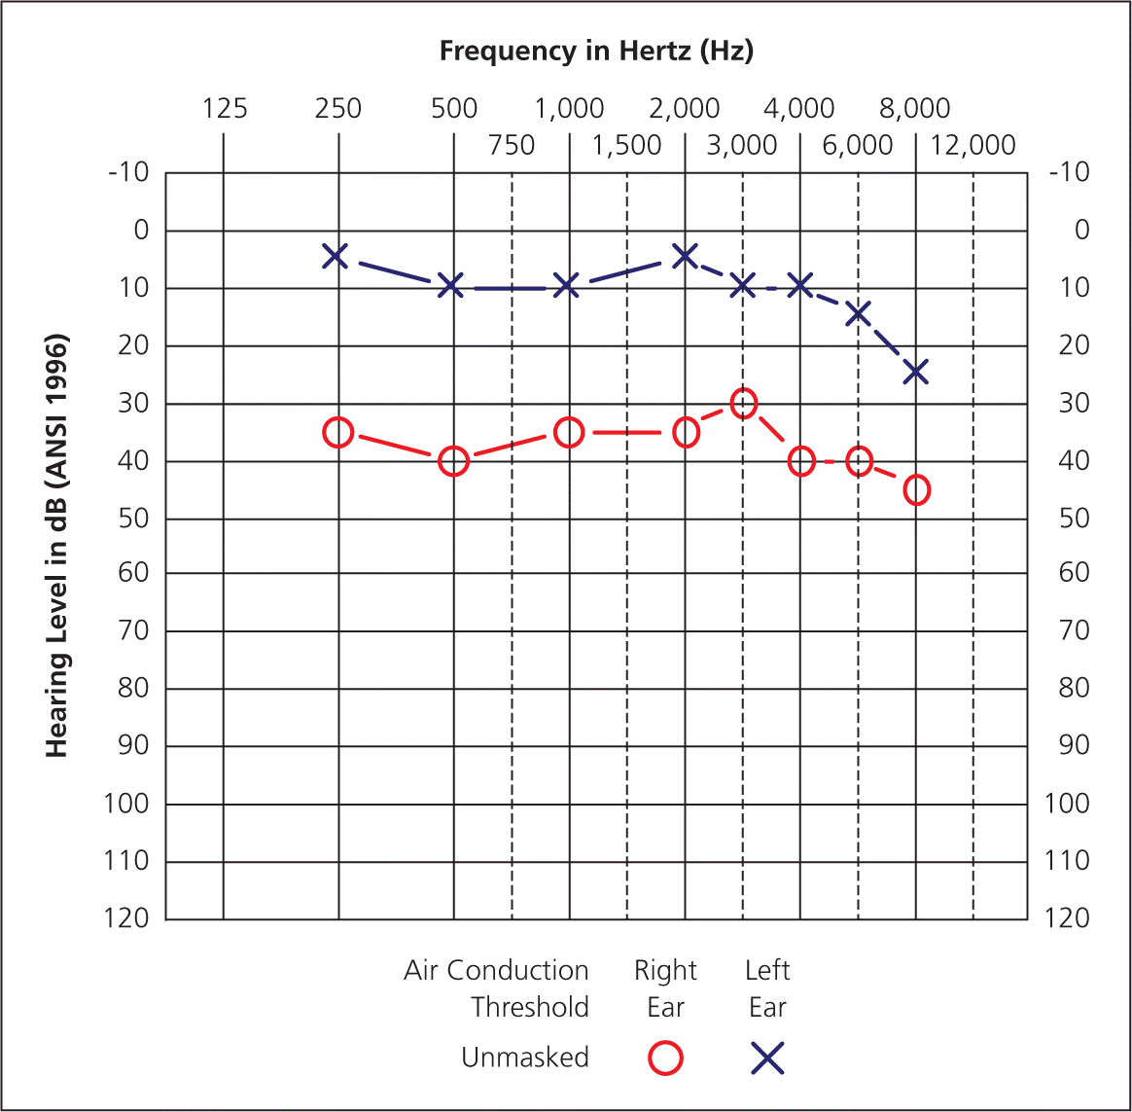
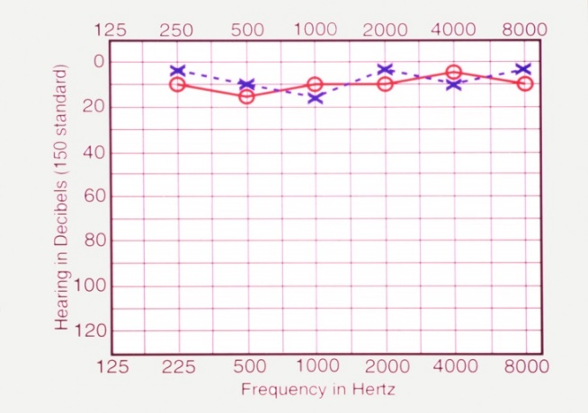

Table No.3 Table No.4

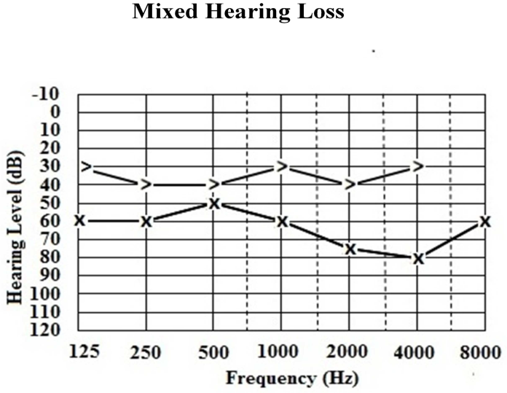
Sensorineural Hearing loss

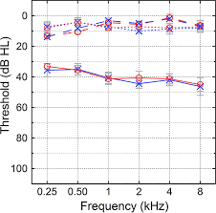
Table No.6

Table No.5

Noise induced Hearingloss Otosclerosis
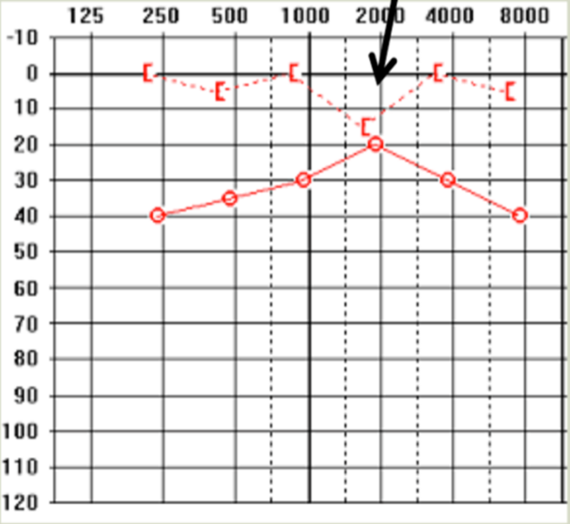
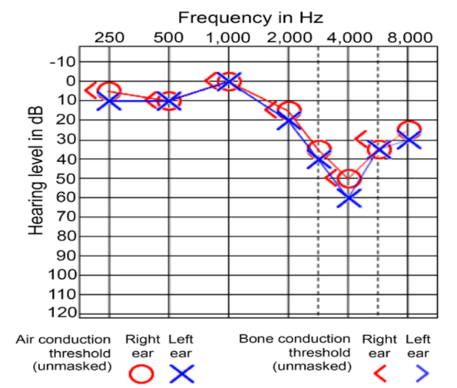

Table No.7 Table No.8

Otitis Media with Effusion
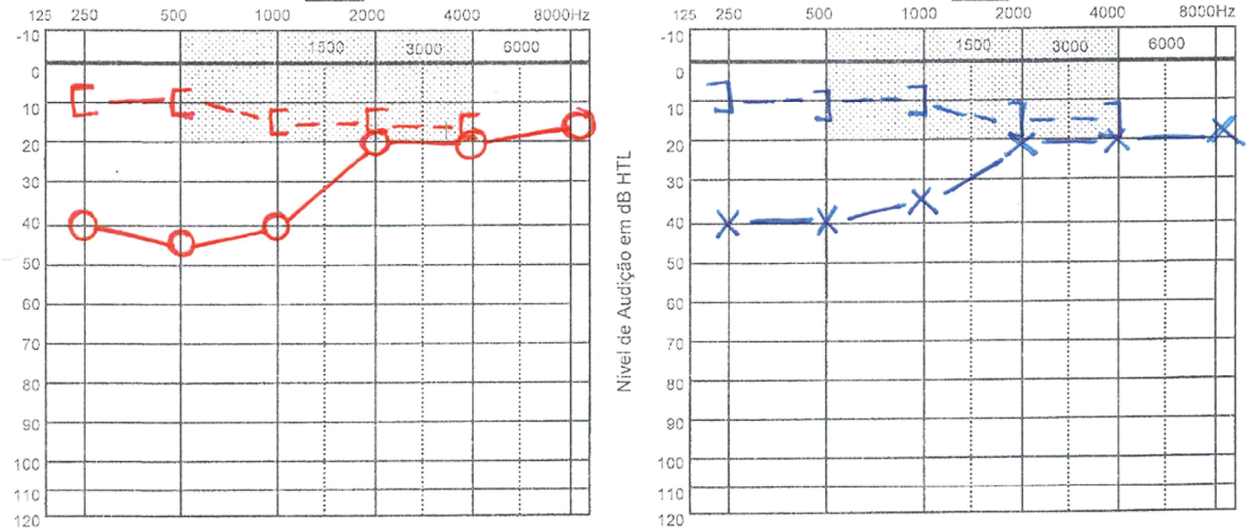
Table No.9

Age related Hearingloss

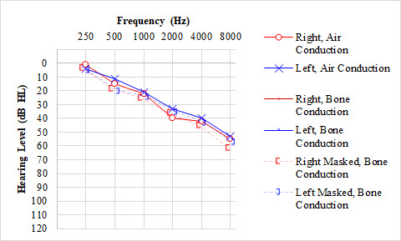
Table No.10

Management of Hearing loss

Conductive Hearing loss:
Most cases of conductive hearing loss can be managed by medical or surgical means. Treatment of these conditions is discussed in respective sections. Briefly, it consists of:

1. Removal of canal obstruction: e.g. impacted wax, foreign body, osteoma or exostosis, keratotic mass, benign or malignant tumours, or meatal atresia.

2. Removal of fluid: Myringotomy with or without grommet insertion.

3. Removal of mass from middle ear: Tympanotomy and removal of small middle ear tumours or cholesteatoma behind intact tympanic membrane.

4. Stapedectomy: as in otosclerotic fixation of stapes footplate.

5. Tympanoplasty: Repair of perforation, ossicular chain or both.

Hearing aid: In cases, where surgery is not possible, refused or has failed.

Types of Tympanoplasty:

Wullstein classified tympanoplasty into five type.
Type I - Defect is perforation of tympanic membrane which is repaired with a graft. It is also called myringoplasty.

Type II - Defect is perforation of tympanic membrane with erosion of malleus. Graft is placed on the incus or remnant of malleus.

Type III - Malleus and incus are absent. Graft is placed directly on the stapes head. It is also called myringostapediopexy or columella tympanoplasty.

Type IV - Only the footplate of stapes is present. It is exposed to the external ear, and graft is placed between the oval and round windows. A narrow middle ear (cavum minor) is thus created to have an air pocket around the round window. A mucosa-lined space extends from the eustachian tube to the round window. Sound waves in this case act directly on the footplate while the round window has been shielded.

Type V - Stapes footplate is fixed but round window is functioning. In such cases, another window is created on horizontal semicircular canal and covered with a graft. Also called fenestration operation.

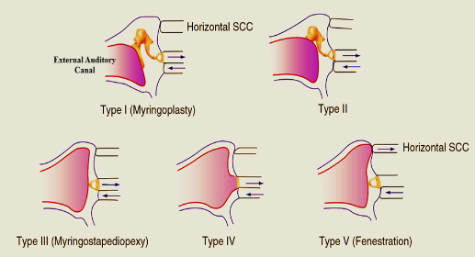

Figure No.1

Myringoplasty:

Myringoplasty is a surgery to repair eardrum
- Synthetic materials. Surgeons may use gel foam, surgical paper or other synthetic materials to patch the hole (paper patch myringoplasty).
- Temporalis fascia. Your temporalis fascia is a strong layer of connective tissue that covers your temporalis muscle. Your surgeon can harvest a small piece of your fascia and use it to patch the hole in your eardrum.
- Perichondrium. Your perichondrium is a layer of connective tissue that covers the elastic cartilage in your ear. Your surgeon can harvest some of this tissue and use it to perform the myringoplasty.
- Fat. In some cases, surgeons take fat tissue from your earlobe and use it to repair your eardrum (fat graft myringoplasty).
- Cartilage. Your surgeon might also take a small piece of your cartilage to patch the hole in your eardrum (cartilage myringoplasty)
Hearing Aids:
Hearing aids are sound-amplifying devices designed to help people who have hearing loss. Most hearing aids share several similar electronic components:
- A microphone that picks up sound.
- Amplifier circuitry that makes the sound louder.
- A miniature loudspeaker (receiver) that delivers the amplified sound into the ear canal.
- Batteries that power the electronic parts
Indications:
  - Hearing aid can be prescribed to all types of deafness which cannot be cured by medicine or surgery
  - People who are reluctant for surgery
  - Contraindication for surgery
Types of Hearing Aids:

BODY WORN HEARING AIDS
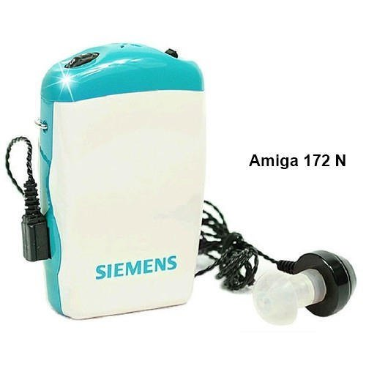

Figure No.2

POST AURAL HEARING AID EAR CANAL HEARING AID

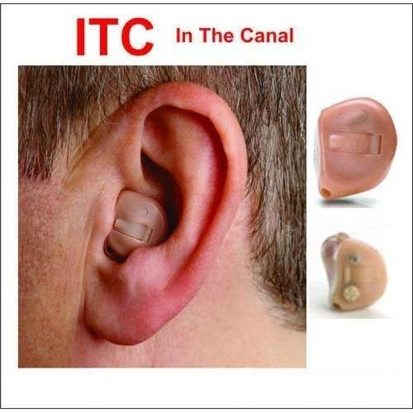
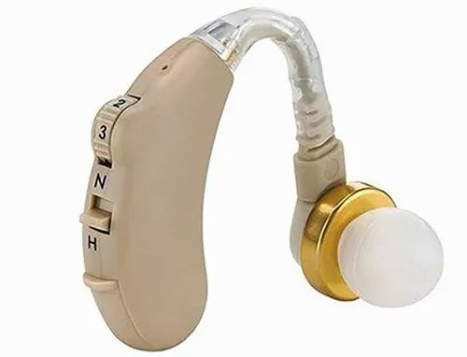

Figure No.3 Figure No.4
SPECTACLE TYPE HEARING AID Implantable hearing aid
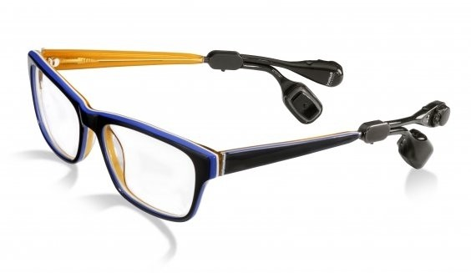
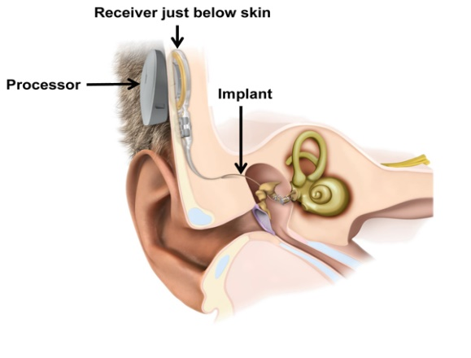

Figure No.5 Figure No.6

BONE ANCHORED HEARING AID DIGITALLY PROGRAMMABLE AND
REMOTE CONTROL HEARING AID
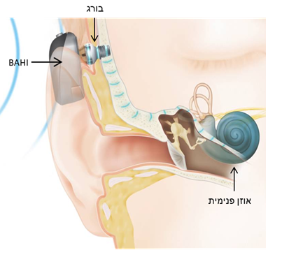

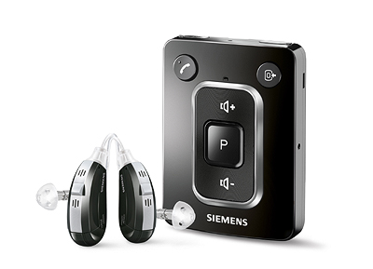

Figure No.7 Figure No.8
IMPLANTABLE HEARING AIDS:
BONE-ANCHORED HEARING DEVICES MIDDLE EAR IMPLANT
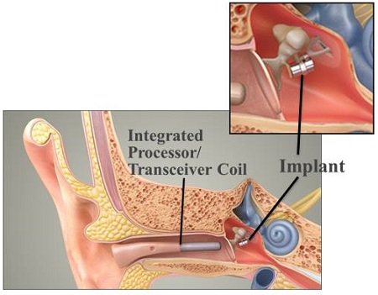
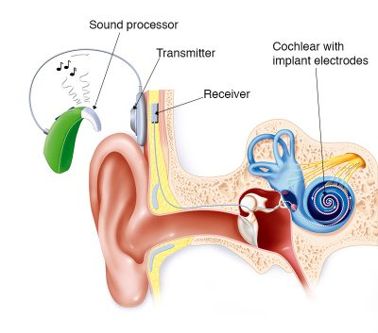

Figure No.9 Figure No.10
COCHLEAR IMPLANT AUDITORY BRAINSTEM IMPLANTS
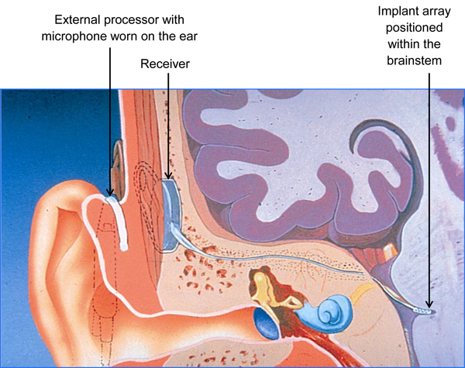
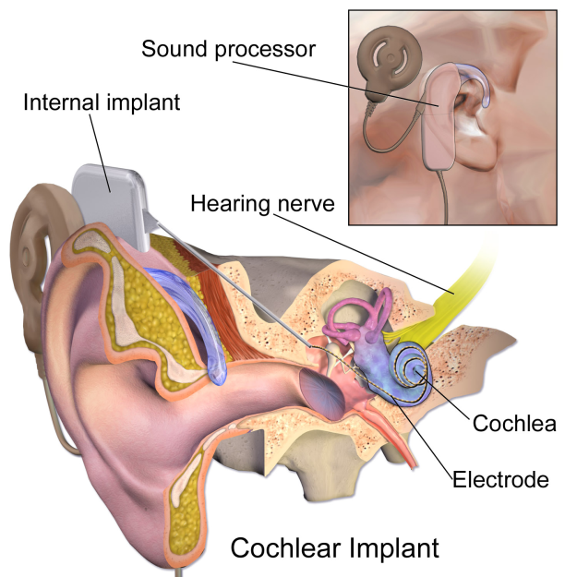
Figure No.11 Figure No.12

REHABILITATION:
It is done by the audiologist, speech therapist, psychiatrist, engineers, family member, social worker and teachers etc.
Communication Methodology:
Oral approach: Encourage to developing vocabulary and training and it is more preferred
Manual approach: Communicate with sign language
Educational Placement of the deaf child

