Consumer Behavioral Trends Towards Sustainable Fashion Products: A Systematic Review (2012-2023)
Ms. Mona Sharma, Research Scholar
Manav Rachna University
Manav Rachna University
Faridabad
monanps9@gmail.com

Dr. Priyanka Chadha, Assistant Professor
Amity Business School
Amity University
Noida
priyanka03chadha@gmail.com

Abstract
Consumer nowadays are becoming more and more concerned about environmental degradation, yet there has not been a corresponding increase in the demand of sustainable goods. This study tries to investigate factors behind sustainable consumption to systematise earlier research findings and identifying the most important factors for accelerating the shift to a greener economy. This article's goal is to define and categorise all the primary factors influencing sustainable fashion consumer behavior in order to systematise past research findings and determine the key factors propelling the shift to a more sustainable economy. We also focused on the most used theoretical frameworks, frequent paper published year and motives for buying sustainable fashion products. Findings revealed that TPB is the most used theory in the recent years in relation to sustainable marketing. Year 2020 got maximum number of publications. Factors like environmental knowledge, environmental concern are found to be the most significant factors behind the adoption of sustainable fashion products.
Keywords: TPB, Sustainable Fashion Products, Consumer Behavior, Sustainable Consumption.

I. INTRODUCTION
Environmental degradation is said to be mostly caused by overpopulation over the past three decades and the waste produced as a result of over consumption of food, manufactured goods, and services. As a result, in order to achieve sustainable growth, businesses and consumers must take steps to reduce their negative effects on the environment [3]. Due to this, a sizeable segment of environmentally conscious consumers has emerged in recent years who are eager to buy eco-friendly products and value businesses that use sustainable practises in their economic and commercial activities [4-6]. Companies are working to create, market, sell, and distribute products that have fewer harmful environmental effects as a result of this trend in customer behaviour [7]. As a result, they were forced to make adjustments to their products, production methods, and packaging materials, among other things that suggest a deeper commitment to environmental preservation [8].
These initiatives, which the authors refer to as "Green Marketing" (GM) [9,10], aim to meet the needs of customers who have a preference for eco-friendly goods and services. The consumer becomes increasingly demanding and continuously assesses company status as a result avoiding businesses who merely use "greenwashing" to improve their public image [11]. This unethical behaviour entails a deceptive ecological orientation that aims to sway consumers' opinions of an organization's goods, services, and policies in order to boost its profitability [12,13]. In this aspect, it's critical to distinguish between legitimate GM practises and unethical ones.
The process of making textiles has a terrible effect on the environment because it not only consumes more water and energy but also pollutes air and water through greenhouse emissions and intensive usage of Pesticides [14]. The global textile sector ranks second in terms of environmental pollution, and it alone is responsible for 10% of all CO2 emission [15]. Global environmental quality is also impacted by the toxic by-products of the textile production process that are emitted into the air and wastewater [16]. Due to the "fast fashion" style that has developed over the years and is quite popular among the younger generation [17], this problem has gotten worse in recent years as the demand for textile products around the world is expanding quickly [18].
The goal of this systematic review is to further knowledge on sustainable practises that have been linked to important aspects of consumer purchasing behaviour, with a focus on green purchasing behaviour, in the scientific literature. This study is significant because it advances sustainable development by raising awareness of the shared responsibility that businesses and consumers have for protecting the environment. This awareness can be raised by understanding these practises and how they relate to consumer behaviour. As a result, this study will assist managers and marketing specialists in implementing commercial policies and strategies connected to sustainable development while also assisting them in enhancing their companies' credibility, consumer acceptance, profitability, and competitiveness. Additionally, this study will assist academics in visualising the various factors connected to sustainable marketing and consumer spending which will eventually help in the studies related to review as well as empirical papers.
We mainly focused on the sustainable fashion products. Fashion products in our paper include apparels, sportswear, cosmetics etc. Study mainly found papers related to clothing in sustainability context. In order to understand the themes, sub-themes, and gaps between consumers' views and purchasing behaviours towards green products, a comprehensive review of the literature on sustainable marketing was undertaken as background for this study. A model for making green purchasing decisions that is divided into three categories—personal variables affecting green purchasing, sustainable purchasing, and sustainable marketing mix—was also provided [15].
The current study aims to present a comprehensive understanding of green purchase behavior studies, by answering three main research questions:
RQ1. What are the determinants of sustainable fashion purchase intention in the selected studies?
RQ2. What are the main theories employed as the theoretical framework?
RQ3. What are the motives to purchase sustainable fashion products?
A. Sustainability
The ability of the present and future generations to meet their needs without compromising the ability of the latter to do the same is referred to as sustainability. Finding a balance between social progress, economic growth, and environmental protection is required. Sustainability has gained significance as the world grapples with more serious environmental problems like pollution, resource depletion, and climate change. One of the most well-known definitions of sustainability may be found in the Brundtland Report, which was published in 1987 by the World Commission on Environment and Development. In the study, development that meets the needs of the present without compromising the ability of future generations to meet their own needs; [16] is defined as sustainability.

B. Sustainable Marketing:
Sustainable marketing, also known as green marketing or eco-marketing, refers to the practice of promoting products or services that have minimal negative impact on the environment and society. It involves incorporating sustainability principles and values into various marketing strategies, such as product design, packaging, communication, and distribution. The primary objective of sustainable marketing is to meet the needs of present consumers without compromising the ability of future generations to meet their own needs.

C. Sustainable Fashion:
Sustainable fashion refers to the production, consumption, and disposal of clothing and accessories in a way that minimizes the negative impact on the environment, society, and economy. It involves making choices that consider the environmental and social consequences throughout the entire lifecycle of a fashion product, including design, sourcing, manufacturing, distribution, use, and disposal. Sustainable fashion aims to address issues such as excessive waste, pollution, exploitation of workers, and depletion of resources commonly associated with the fashion industry.

II. LITERATURE REVIEW
Various studies have been done in the area of sustainability with relation to fashion products. But we have analysed good 35 papers based on systematic review as well as empirical study not only in the area of clothing but cosmetics and other fashion areas also. Table 1. Shows the review of 20 most cited papers out of the 35 papers based on the title name, authors name, publishing year, finding related to the article etc.

Table 1. Relevant Papers for Review
Title of the paper | Year of publication | Authors | Model/  theory used | Review/  Empirical | Findings
Factors Affecting Sustainable Apparel Consumption  in Emerging Countries: A Systematic Literature  Review | 2019 | Nornajihah Nadia Hasbullah  , Zuraidah Sulaiman and Adaviah Mas’od | TPB and TRA | Review | According to the review's findings, the majority of consumers in emerging markets have already shown an increasing interest in sustainable clothing due to their strong growth in knowledge, intense concern, values, and social networks.
Interdisciplinary Literaure Analysis between Cosmetic Container Design  and Customer Purchasing Intention | 2021 | Ikkyung Sung |  | Review | Different consumers' purchasing habits are affected differently by various container design elements. Shape, colour, material and textual, and artistic aspects are the most important elements of container design. These elements have varying levels of market appeal and are employed by designers for various projects.
Green Marketing Practices Related to Key Variables of  Consumer Purchasing Behavior | 2022 | Elizabeth Emperatriz García-Salirrosas , and Rafael Fernando Rondon-Eusebio | TPB theory | Review | Environmental awareness, Green satisfaction, Green attitude, Green purchasing intention, Green purchasing preference, Word of mouth, Perceived value, Green experiential value, Responsible consumption, Green engagement, Green trust, Green loyalty, and Green purchasing decision are the main factors of purchasing behaviour that were discovered.
Green purchase: A systematic review and future research agenda | 2022 | Setyo Ferry Wibowo, Mukhamad Najib, Ujang Sumarwan, Yudha Heryawan Asnawi | theory of planned behaviour | Review | Three major theoretical frameworks for the study of consumer green buying behaviour across goods and nations emerged: the theory of planned behaviour, the theory of perceived value, and the theory of personal worth.
Exploring Consumer Behavior towards  Sustainability of Green Cosmetics | 2021 | Surabhi Acharya, Santosh Bali and B. S. Bhatia | Not mentioned | Empirical | The participants  of this research were 250 people of tri-city. (Chandigarh,  Panchkula, Mohali). the age limit is from teenagers to  senior citizen. According to research, the majority of consumers place a higher priority on product quality when making a purchasing decision than any other consideration.
Investigating the determinants of  behavioral intentions of generation Z  for recycled clothing: an evidence  from a developing economy | 2020 | Pallavi Chaturvedi, Kushagra Kulshreshtha and Vikas Tripathi | Theory of planned behavior | Empirical | The results indicated that factors such as desire to pay, concern for the environment, perceived value, and personal norms affect generation Z's inclination to buy recycled clothing. The likelihood of making a purchase, financial ability, and concern for the environment were the main predictors of intention to buy recycled clothing.
Green Marketing and Customers’ Purchasing Behavior:  A Systematic Literature Review for Future Research Agenda | 2023 | Ilona Skackauskiene and Neringa Vilkaite-Vaitone | Theory of planned behavior | Review Paper | According to the review, the theory of planned behaviour and its predecessor idea of reasoned action appear to be prominent. The literature places a strong emphasis on green marketing's tactical influence on customer behaviour metrics during and after the purchase stage.
Success factors for environmentally sustainable product innovation: a  systematic literature review | 2014 | Janine Fleith de Medeiros, Jose Luis Duarte Ribeiro, Marcelo Nogueira Cortimiglia | Not mentioned | Review paper | Results indicate that market, legislation, and regulation knowledge; interfunctional collaboration; innovation-oriented learning; and R&D spending are the four primary critical success elements for the development of environmentally friendly products.
Environmentally Sustainable Clothing  Consumption: Knowledge, Attitudes,  and Behavior | 2014 | Kim Y. Hiller Connell and Joy M. Kozar | Not mentioned | Review paper | Numerous academics have observed that consumers' ability to act in an environmentally responsible manner may be constrained by a lack of knowledge and information. Additionally, customers need greater information on the variety of accessible options for adopting ecologically friendly clothing practises, such as reducing overall consumption and buying better-quality, historically-inspired clothing.
The sustainable clothing market:  an evaluation of potential  strategies for UK retailers | 2012 | Helen Goworek, Tom Fisher, Tim Cooper | Not mentioned | Empirical | Because of this, there is a lot of opportunity for more stores of all sizes to provide sustainable clothing lines, which might result in benefits including lower operating costs, more brand recognition, and new marketing opportunities.
Sustainable clothing: challenges, barriers and interventions  for encouraging more sustainable consumer behaviour | 2015 | Fiona Harris, Helen Roby and Sally Dibb | TPB | Empirical | Internal barriers – those relating to consumers themselves – included a lack of concern for the environment among Consumers, limited knowledge about clothing consumption’s impact on the environment, negative attitudes towards sustainable  clothing and demographic characteristics, such as age and education.
Sustainable Fashion Consumption: Advocating Philanthropic  and Economic Motives in Clothing Disposal Behaviour | 2022 | Siti Hasnah Hassan , Jasmine A. L. Yeap and Nabil Hasan Al-Kumaim | Theory of inter-personal behavior which is based on TRA and TPB | Empirical | The findings show that the main influencing elements of the use of sustainable fashion were personal norms, social norms, and environmental awareness. As a result, charitable and financial motivations for garment disposal behaviours showed a positive and significant link with sustainable fashion consumption.
Antecedents of green purchase  behavior of cosmetics products  An empirical investigation among  Malaysian consumers | 2019 | Azila Jaini, Farzana Quoquab, Jihad Mohammad, Nazimah Hussin |  |  | The findings showed that hedonic value significantly and favourably influences pro-environmental belief. Additionally, it has been discovered that pro-environmental thinking has a favourable impact on personal norm, which in turn influences green purchasing behaviour.
Antecedents to green apparel purchase behavior  of Indian consumers | 2020 | Arpita Khare, Pradeep Kautish | TRA/TPB | Empirical | The findings showed that green apparel knowledge (GAK) and perceived effectiveness (GAPE) both had a favourable impact on Indian consumers' green apparel buying behaviour (GAPB). Consumer independent judgement making (CIJM) and novelty-seeking behaviour (CNS) constructs of consumer innovativeness had no beneficial effects on the buying behaviour of eco-friendly clothing (GAPB).
The values and motivations behind sustainable fashion consumption | 2016 | Louise Lundblad, Iain A. Davies | Means End theory approach | Empirical | Benefits for the self in terms of sense of accomplishment, better health, self-esteem and value for money found to be one of the important motives for purchase.

A. Theoretical Framework:
In our study we reviewed 35 papers and found that Theory of planned behavior (TPB) and TRA(Theory of Reasoned Action) is one of the most used theoretical framwrok in the field of sustainability.
- The Theory of Reasoned Action: According to (Ajzen and Fishbein), Theory of reasoned action explains that there are two main elements of performing a particular type of behavior. Theory of reasoned action talks about the important element Attitude towards any product or service which later on decides how the consumers deals with it. Attitude of a particular product or service directly explains the behavior intention of the consumer. Another element found was perception, it means how others let the consumer choose the particular product or service. Due to this, Ajzen revised his Theory of Planned Behaviour in 1988 and included a new variable called perceived behavioural control, which is described as "the person's belief as to how easy or difficult performance of the behaviour is likely to be" (Ajzen and Madden, 1986).

- Theory of Planned Behavior: The TPB of Ajzen (1991) is recognised as a valuable social psychology model in research of consumer purchasing behaviour. The TPB states that a person's attitude towards behaviour, subjective norms, and perceived behavioural control are highly predictive of behavioural intents and subsequent behaviour (Ajzen, 1991). According to Ajzen (1991), the first factor, attitude towards behaviour, is "the degree to which a person has a favourable or unfavourable evaluation or appraisal of the behaviour." Ajzen (1991, and Fishbein and Ajzen (1975) all define attitude as an individual's beliefs and evaluation of the results that can be attained through a behaviour. It may also be referred to as a person's level of approval or disapproval of a particular behaviour. The second factor, subjective norms, is the degree to which a person feels pressured by friends, family, or coworkers to follow a specific conduct (or not) (Ajzen, 1991).

III. RESEARCH METHODOLOGY
The terms used in the development of this research were defined in relation to the study's goal and were as follows: quantitative empirical research articles referring to sustainable marketing practises and containing, at the same time, a relationship with the major factors influencing consumer behaviour, without making any distinctions based on the age of the publications, the nation, or the economic sector of the organisations where they have been used. On a survey of the literature, this study is built. Additionally, we used the PRISMA technique to retrieve the publications. The scientific articles were located using the Scopus and Web of Science (WoS) databases. These sources index a variety of reputable periodicals that disseminate peer-reviewed, rigorously analysed scientific research papers. As a result, the scientific community acknowledges their level of dependability when presenting data. Given that the systematic reviews that serve as the foundation of this study exclusively used Scopus as a search source [17,18] and used Google Scholar as a search engine to find the Scopus and WoS databases [15], the use of these databases is warranted. The analysis was completed, and the discussion that follows will focus on the conclusions and suggestions. review articles, conference proceedings, and research papers with a high assessment citation index that have been published in reputable journals. Master's theses and pieces of opinion research were not included in this study. Additionally, each paper was subjected to an individual analysis to see whether it followed the study's methodology. Only peer-reviewed journals and conference papers were taken into account in order to increase the review's credibility; dissertations, books, and volumes were left out. The keywords "sustainable behaviour," "sustainable fashion," "green," "consumer purchase intention," "intention behind sustainability," "undergraduate," or when abstracting papers from databases, this and a wide range of additional boolean variations yielded the most hits. We only used citations from articles that met the following criteria: With regards to entrepreneurship education (or a component thereof) and its empirical impact on entrepreneurial results (broadly defined to include both attitudinal and behavioural outcomes), the following conditions dictate that higher education be the major focus: Peer-reviewed journal publications as opposed to working papers, conference papers, or unpublished material; (A) empirical rather than merely conceptual.
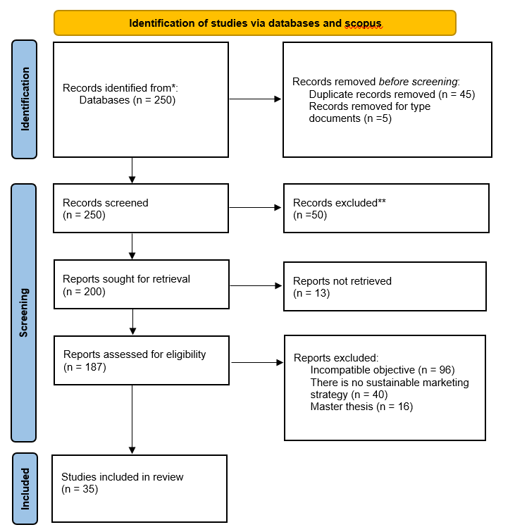
(Figure 1. PRISMA Flow Chart (35), n= no. of documents)

IV. RESULTS AND DISCUSSION
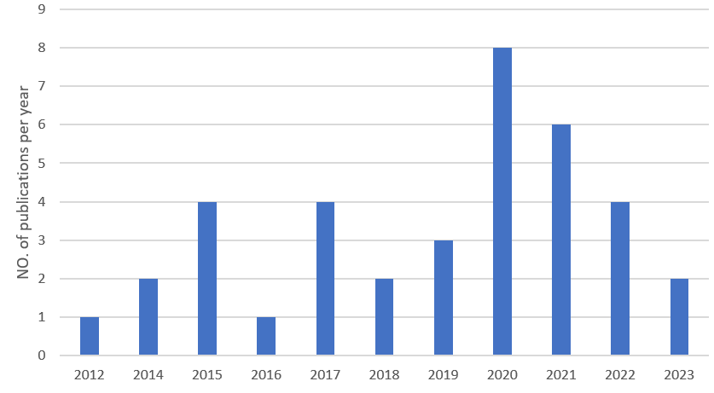
“Figure 2. Number of Publication Per Year”

THEORY USED | NO. OF PAPERS
Theory of planned Behavior | 25
Theory of reasoned action | 15
Means-end theory | 2
Theory of Interpersonal Bhevaior1 | 1

Figure 3. Theory Used in Number of Papers

Figure 2. depicts that the year which has the maximum number of publications out of the 35 papers is year 2023 followed by 2022 and 2017. This result shows that after the pandemic 2020, consumers drastically has shifted to sustainable products from the traditional products. They now are more aware about the environmental concern after using any product or service. This section provides an overview and discussion of the findings from the related papers we have incorporated into this study.
Figure 3. depicts the theories used in number of papers. Following results can be analysed by this reviewed paper:
- This study's evaluation of the research approaches, techniques, and theoretical frameworks frequently applied in sustainability articles was one of its key research topics. The primary goal of the study was to identify numerous elements that contribute to the successful development of sustainable fashion goods and their influence on customer behaviour.
- Our research also centered on identifying the numerous factors that influence consumer adoption of sustainable fashion goods. The 35 publications that were included in the study and contributed to identifying these criteria by various authors are pertinent to this research.
- Theory of planned behaviour (TPB) and Theory of reasoned action (TRA) are the behavioral theories that have been utilized most frequently in past studies to assess users' propensity to accept new technologies and innovations (Gupta et al., 2021).
- Benefits for oneself, environmental concern, environmental awareness, sense of success, improved health, self-esteem, and value for money, have been identified as one of the key purchasing factors.
- Internal barriers – those relating to consumers themselves – included a lack of concern for the environment among Consumers, limited knowledge about clothing consumption’s impact on the environment, negative attitudes towards sustainable clothing and demographic characteristics, such as age and education.

V. RESEARCH IMPLICATIONS
Today, every organisation and manufacturing business has switched from using conventional techniques to creating products in a way that is more sustainable or favourable to the environment. Our government has also created a number of sustainability-related policies that can be adopted by any organisation to protect the environment. In our essay, we sought to identify the driving forces behind consumer adoption of sustainable goods while also concentrating on the obstacles that prevented them from doing so. The results provide helpful information for educators, legislators, and fresh graduates who want to launch their own firms. This study might aid stakeholders in choosing more sensible sustainable products for upcoming marketing campaigns.
VI. LIMITATIONS
There are a few limitations to this study that should be emphasised. Due to the growing complexity and resource constraints, the paper only focused on a few factors. It is possible to identify additional obstacles, factors and motives and rank them according to importance. For various consumer groups, different segments might be used. Future academics can examine the barriers behind the non-adoption of sustainable fashion products . We recently added 35 papers to our study for review, and based on those papers, we identified a few characteristics that influenced customers' intentions to use sustainable products. After reading more articles, future researchers will be able to identify more factors.

VII. FUTURE DIRECTIONS
Future studies should examine the most effective media platforms and marketing techniques for teaching customers about environmental concerns connected to the apparel and textile supply chain as well as the variations in operations and practises of green versus conventional businesses. For apparel and textile businesses operating with a stronger commitment to environmental sustainability, this has significant implications, including the need to better educate customers about their brands and increase their awareness through focused media campaigns.

REFERENCES
- Severo, E.A.; de Guimarães, J.C.F.; Henri Dorion, E.C. Cleaner Production, Social Responsibility and Eco-Innovation: Generations’ Perception for a Sustainable Future. J. Clean. Prod. 2018, 186, 91–103.
- Chekima, B.C.; Syed Khalid Wafa, S.A.W.; Igau, O.A.; Chekima, S.; Sondoh, S.L. Examining Green Consumerism Motivational Drivers: Does Premium Price and Demographics Matter to Green Purchasing? J. Clean. Prod. 2016, 112, 3436–3450.
- Severo, E.A.; Guimarães, J.C.F. de Dorion, E.C.H. Cleaner Production and Environmental Management as Sustainable Product Innovation Antecedents: A Survey in Brazilian Industries. J. Clean. Prod. 2017, 142, 87–97.
- Chung, K.C. Green Marketing Orientation: Achieving Sustainable Development in Green Hotel Management. J. Hosp. Mark. Manag. 2019, 29, 722–738.
- Do Paço, A.M.F.; Reis, R. Factors Affecting Skepticism toward Green Advertising. J. Advert. 2012, 41, 147–155.
- Yazdanifard, R.; Mercy, I.E. The Impact of Green Marketing on Customer Satisfaction and Envi- Ronmental Safety. Int. Conf. Comput. Commun. Manag. 2011, 5, 637–641.
- Peattie, K.; Crane, A. Green Marketing: Legend, Myth, Farce or Prophesy? Qual. Mark. Res. Int. J. 2005, 8, 357–370.
- Ahuja, K. A Study on Green Advertisement and Its Impact on Consumer Purchase Intention. J. Creat. Commun. 2015, 6, 259–276.
- Lee, Y.K. The Relationship between Green Country Image, Green Trust, and Purchase Intention of Korean Products: Focusing on Vietnamese Gen Z Consumers. Sustainability 2020, 12, 5098.
- Lakatos, E.S.; Nan, L.M.; Bacali, L.; Ciobanu, G.; Ciobanu, A.M.; Cioca, L.I. Consumer Satisfaction toward Green Products: Empirical Insights from Romania. Sustainability 2021, 13, 10982.
- FAO-ICAC (2015), “Measuring sustainability in cotton farming systems: towards a guidance framework”,
- Rome, available at: www.fao.org/3/a-i4170e.pdf (accessed 5 July 2019).
- Allwood, J.M., Laursen, S.E., de Rodriguez, C.M. and Bocken, N.M. (2006), “Well dressed? The present and future sustainability of clothing and textiles in the United Kingdom”, Journal of the Home Economics Institute of Australia, Vol. 22, p. 42.
- Khan, S. and Malik, A. (2014), “Environmental and health effects of textile industry wastewater”, in Malik A., Grohmann E. and Akhtar R. (Eds), Environmental Deterioration and Human Health, Springer, Dordrecht, pp. 55-71.
- Bhardwaj, V. and Fairhurst, A. (2010), “Fast fashion: response to changes in the fashion industry”, The International Review of Retail, Distribution and Consumer Research, Vol. 20 No. 1, pp. 165-173.
- The Fiber Year Consulting (2015), “The fiber year 2015, world survey on textiles and nonwovens”, Issue 15, available at: www.textilemedia.com/assets/Uploads/TFY15-sample-pages.pdf
- Sharma, A.P. Consumers’ Purchase Behaviour and Green Marketing: A Synthesis, Review and Agenda. Int. J. Consum. Stud. 2021,45, 1217–1238.
- World Commission on Environment and Development. (1987). Our common future. Oxford: Oxford University Press.
- Zhang,X.;Dong,F.WhyDoConsumersMakeGreenPurchaseDecisions?InsightsfromaSystematicReview. Int.J.Environ.Res.PublicHealth 2020 , 17 ,6607.

