BIOFUEL
Dr. Manjusha Pouranik

Biofuel is a type of fuel that is predominantly sourced or manufactured from living stuff known as biomass. It is classified as a non-conventional liquid or gaseous fuel, and it can be used to replace or supplement diesel, petrol, or other fossil fuels for transportation, stationary, portable, and other functions. Biofuels are a surprisingly old concept. Rudolf Diesel, whose invention bears his name, envisioned vegetable oil as the engine's fuel source. Similarly, Henry Ford anticipated that his Model T would be powered by ethanol, a corn product. However, huge petroleum deposits kept petrol and diesel affordable for decades, and biofuels were mostly neglected. However, with the concomitant rise in oil costs, as well as growing worry about energy security and global warming caused by CO2, The biofuels are found to be appropriate for such a transition for the following reasons: "(i) Simplicity; (ii) production via well-known agricultural technologies; (iii) potential for mitigation of global warming without complete restructuring of the current working energy system; (iv) use of existing engines for their transportation; (v) potential to facilitate worldwide mobilization around a standard set of regulations; (vi) potential as a directly available fuel." Biofuels have the ability to meet energy needs while simultaneously contributing to energy security, reducing GHG emissions from the transportation sector, and delivering on environmental goals.

The use of fossil fuels contributes significantly to the increase in CO2 levels in the atmosphere, which is directly linked to the recent global warming (Leonardo et al., 2008). The negative environmental repercussions of GHG emissions have been identified. As a result, the search for sustainable energy sources for the Indian economy and consumer communities has grown increasingly critical in recent years (Prasad et al., 2014). India's energy demand is expanding at a 6.5% annual rate, while world petroleum reserves are steadily declining.
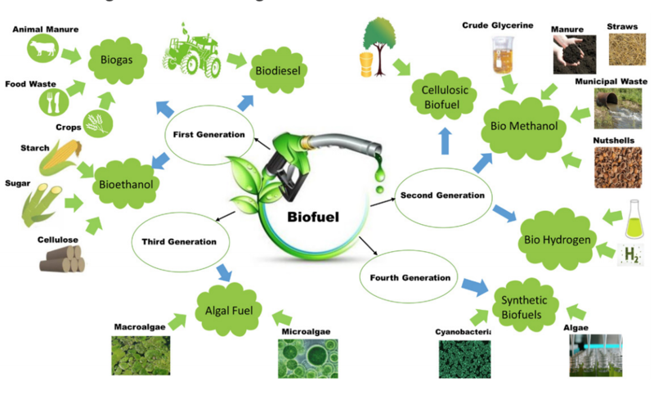
First Generation (1G) Biofuels
First generation biofuels are biofuels produced using standard or proven technology from sugar, starch, vegetable oil, or animal fats. Sugarcane juice or molasses, as well as grains, are frequently used as major feedstock in the manufacturing of first generation biofuels. Starch is fermented to make bioethanol, or sunflower seeds are pressed to produce oil that can be turned to biodiesel via fermentation.

Second Generation (2G) Biofuels
Second generation biofuels are made from non-food crops such as lignocellulosic biomass, particularly crop leftover or waste biomass such as wheat stalks and straw, rice straw, maize stalks and other biomass wastes. Biomass feedstock can be transformed into a variety of fuels using a variety of processes to produce cost-effective biofuels such as biomethanol, Bio-DME, Fischer-tropsch diesel, biodiesel, mixed alcohols, bio-oil and biohydrogen, syngas, biogas, and so on.
Lignocellulosic biomass accounts for a major portion of the most abundant plant material on the planet. Farm residues, the remaining organic part of municipal solid waste (MSW), industrial and urban residues, wastes, and dedicated non-food energy crops planted on marginal land unsuitable for crop cultivation as feedstocks for fuel production are typical examples of lignocellulosic biomass.
Lignocellulosic biomass accounts for a major portion of the most abundant plant material on the planet. Farm residues, the remaining organic part of municipal solid waste (MSW), industrial and urban residues, wastes, and dedicated non-food energy crops planted on marginal land unsuitable for crop cultivation as feedstocks for fuel production are typical examples of lignocellulosic biomass.
Hemicellulose is also a sugar polymer, but the types and distributions of these sugars differ depending on the biomass source. For many types of lignocellulosic biomass, the five-carbon sugar xylose is the most important. Hemicellulose is also a sugar polymer, but the types and distributions of these sugars differ depending on the biomass source. The five-carbon sugar xylose dominates the hemicellulose portion in several forms of lignocellulosic biomass. The third most significant percentage is often lignin, a phenyl-propene polymer with complicated components that cannot be broken down to generate sugar molecules. The remaining fraction of the lignocellulosic biomass structure is made up of various components such as plant oils, proteins, and ash (Charles E. Wyman, 1994).

Limitation of Second Generation (2G) Biofuels
Second-generation ethanol plants have much higher capital costs than first-generation units. Again, complete data is unknown, but the best estimates for capital expenditures are three to five times more than for facilities using first generation technology. Some process combinations may be even more extreme than others. The high construction costs, combined with similar running costs, make these plants a less viable investment than first-generation reactors. As a result, for the same return on investment, these second-generation biofuels are still more expensive than the present first-generation biofuels production pathway.
Third Generation (3G) Biofuels
Third generation biofuels are algae-derived biofuels. Algal biomass is a feedstock to consider since it has the potential to produce biodiesel, bioethanol, biogas, biohydrogen, and other products. Furthermore, there is no competition from food and feed production (Demirbas, 2007). Transesterification or conversion of algal biomass into biodiesel via transesterification or conversion of algal biomass into bioethanol and biohydrogen (fermentation), biogas (anaerobic digestion), biooil (pyrolysis), and syngas (gasification). Two factors contribute to the interest in algae as a potential biofuel source. Many algae species have remarkable photosynthetic efficiency, turning up to 6% of incident solar energy into biomass. Because of the vast availability of algae for conversion into biofuels, India has higher potential. Further, high growth rates and near continuous harvesting which is possible with algae makes them an essential alternative energy resource for biofuel.

Limitation of Third Generation (3G) Biofuels
Third-generation biofuels have limits in terms of economic performance, ecological footprint, reliance on sunshine, and spatial allocation, and hence are insufficient to replace fossil fuels. They are grown in high yields in bioreactors. Microalgae are expected to produce 10 to 300 times more oil (for biodiesel) than regular or dedicated energy crops in the future (Dutta et al., 2014). The algal-based oil production platform, on the other hand, is technologically immature.

Fourth Generation (4G) Biofuels
Fourth generation biofuels are just a step up from third generation biofuels. It is primarily based on metabolic engineering, a powerful tool for improving biofuel production, either through genetic modification to increase CO2 capture and lipid production, as well as to develop low-input, fast-growing energy crops with lower fertilizer, insecticide, and water requirements, or through targeted alteration of metabolic pathways in a model organism to improve biofuel yields. Many efforts have been undertaken to establish fast-growing, high-yielding trees/crops that store more CO2 and hold the promise of carbon-negative biofuels. Thermo-chemical biomass conversion using carbon capture and storage technologies is sustainable and eco-friendly, with fourth-generation biofuels being more carbon neutral or negative, contributing to reduced greenhouse gas emissions.
The thermo-chemical conversion of biomass to biofuel coupled with carbon capture and storage technologies are seen as sustainable and more eco-friendly. The carbon-rich crops biomass can be converted intofuel and gases using second generation techniques. In this way, fourth generation biofuels are thought to contribute better to reducing greenhouse gas emissions,
by being more carbon neutral or even carbon negative compared to the other generation biofuels.

NATIONAL POLICY ON BIOFUELS, 2018
Salient Features of the Policy:
1. The Policy categorizes biofuels as "Basic Biofuels" viz. First Generation (1G) bioethanol &biodiesel and "Advanced Biofuels" - Second Generation (2G) ethanol, Municipal Solid Waste
(“MSW”) to drop-in fuels, Third Generation (3G) biofuels, bio-CNG etc. to enable extension
of appropriate financial and fiscal incentives under each category.
2. The Policy expands the scope of raw material for ethanol production by allowing use of
Sugarcane Juice, Sugar containing materials like sugar beet, sweet sorghum, starch containing
materials like corn, cassava, damaged food grains like wheat, broken rice, rotten potatoes, unfit
for human consumption for ethanol production.
3. Farmers are at a risk of not getting appropriate price for their produce during the surplus
production phase. Taking this into account, the Policy allows use of surplus food grains for
production of ethanol for blending with petrol with the approval of National Biofuel
Coordination Committee.
4. With a thrust on Advanced Biofuels, the Policy indicates a viability gap funding scheme for
2G ethanol Bio refineries of Rs.5000 crore in 6 years in addition to additional tax incentives,
higher purchase price as compared to 1G biofuels.
5. The Policy encourages setting up of supply chain mechanisms for biodiesel production from
non-edible oilseeds, used cooking oil, short gestation crops.
6. Roles and responsibilities of all the concerned Ministries/Departments with respect to
biofuels has been captured in the Policy document to synergize efforts.
Following are the benefits expected:
1. Reduce Import Dependency: One crore litre of bio-ethanol saves Rs. 28 crore of foreign
exchange (forex) on oil imports at current rates. The ethanol supply year 2017-18 is likely to
see a supply of around 150 Crore litre of ethanol which will result in savings of over Rs.4000
crore of forex.
2. Cleaner Environment: One crore litre of E-10 saves around 20,000 ton of CO2 emissions. For
the ethanol supply year 2017-18, there will be lesser emissions of CO2 to the tune of 30 Lakh ton. By reducing crop burning and conversion of agricultural residues/wastes to biofuels there
will be further reduction in Green House Gas emissions.
3. Health benefits: Prolonged reuse of Cooking Oil for preparing food, particularly in deep-frying
is a potential health hazard and can lead to many diseases. Used Cooking Oil is a potential feed stock for biodiesel and its use for making biodiesel will prevent diversion of used cooking oil in the food industry.
4. MSW Management: It is estimated that, annually 62 MMT of Municipal Solid Waste gets generated in India. There are technologies available which can convert waste/plastic, MSW to drop in fuels. One ton of such waste has the potential to provide around 20% of drop in fuels.
5. Infrastructural Investment in Rural Areas: It is estimated that, one 100klpd bio refinery will
require around Rs.800 crore capital investment. At present Oil Marketing Companies are inthe process of setting up twelve 2G bio refineries with an investment of around Rs.10,000crore. Further addition of 2G bio refineries across the Country will spur infrastructural
investment in the rural areas.
6. Employment Generation: One 100klpd 2G bio refinery can contribute 1200 jobs in Plant Operations, Village Level Entrepreneurs and Supply Chain Management.
7. Additional Income to Farmers: By adopting 2G technologies, agricultural residues/waste which otherwise are burnt by the farmers can be converted to ethanol and can fetch a price for this waste if a market is developed for the same.
Moreover, farmers are at a risk of not getting appropriate price for their produce during the surplus production phase. Thus, conversion of surplus grains and agricultural biomass can help in price stabilization.

New Vehicle Technology Strategies
The utilisation of biofuels is inextricably related to current and future engine technologies. To replace conventional engine designs based on mineral oil, two alternative techniques are currently being investigated (short and long term approach). The philosophy of the engines is where these concepts diverge the most.
In the medium run, the notion is built on improvements to today's combustion engines and the usage of biofuels. This is currently the most promising strategy. It is efficient and sustainable because no additional infrastructure or fundamentally different engine technology is required.
The long-term strategy favours the transition to electric engines powered by fuel cells and high-efficiency batteries that operate without emitting pollutants during vehicle operation. Nonetheless, numerous technical.
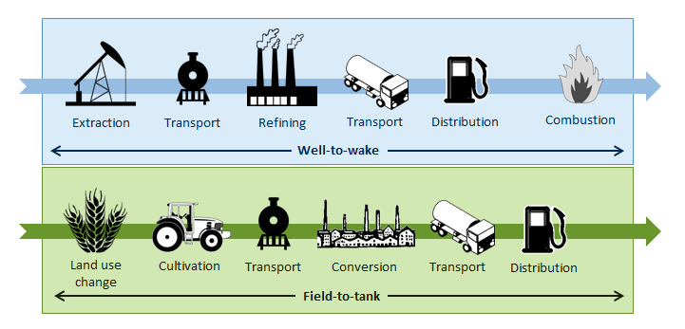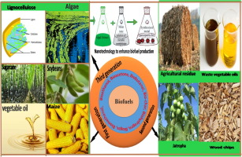G
H

tps://letstalkscience.ca/sites/default/files/2023-01/what_are_biofuels_made_of.png

Greenhouse gas accumulation in the atmosphere, caused by the large consumption of fossil-derived fuels, coupled with the reduction of the world's supply of these fuels, has lead to increased interest in identifying novel sources of energy. Biofuels, produced from crops such as corn, represent an alternative energy source, however, their competition with food production results in an ethical dilemma. Fortunately, a solution is offered by second-generation biofuels, which can be produced from plant cell wall polysaccharides derived from agricultural waste, or biomass. Over the years, several technologies have been developed for the conversion of biomass to fermentable sugars, and future efforts aim to make this process cost-competitive in the present-day market.
The Union Cabinet headed by the Prime Minister Shri Narendra Modi approved National Policy on Biofuels, 2018 (“Policy”) on Wednesday, 16th May 2018. Biofuels allow the use of surplus food grains, sugar beet and starch for production of ethanol to blend with petrol to cut oil imports by ₹4,000 crore in 2018. Therefore, the Policy expands the scope of raw material for ethanol production by allowing use of sugarcane juice, sugar containing materials like sugar beet, sweet sorghum, starch containing materials like corn, cassava, damaged food grains like wheat, broken rice, rotten potatoes unfit for human consumption for production of ethanol.

References

AFDC (2019). Alternative Fuels Data Center, Biodiesel Production and Distribution https://afdc.energy.gov/fuels/biodiesel_production.html.

BP Statistical Review of world energy June 2018" (PDF). Retrieved 6 January 2019.

Choi, J.H., Woo, H.C., and Suh, D.J. (2014). Pyrolysis of seaweeds for bio oil and biochar production. Chem. Eng. Trans. 37, 121–126.

CSS (2018). Center for Sustainable Systems, University of Michigan.“Biofuels Factsheet.” Pub. No. CSS08-09.http://css.umich.edu/sites/default/files/Biofuels_Factsheet_CSS08-09_e2018.pdf.

Dutta K, DavereyA, Lin JG. Evolution retrospective for alternative fuels: First to the fourth generation. Renew Energy 2014; 69:114–22.

Eggert, H., & Greaker, M. (2014). Promoting second generation biofuels: does the first generation pave the road?. Energies, 7(7), 4430-4445.

Kim, G.V., Choi, W.Y., Kang, D.H., Lee, S.Y., and Lee, H.Y. (2014). Enhancement of biodiesel production from a marine alga, Scenedesmus sp.Through in situ transesterification process associated with acidic catalyst. Bio Med. Res. Int. 2014:391542.

