Overview of recently developed Materials and their Processing

Chandra kant¹, Krishana Priya² , Ali Alsuraifi³, K.P. Tiwari¹
¹Department of Physics, Agra College Agra, India
²Department of Botany, School of Life Sciences, Dr. B.R.Ambedkar University, Agra,India
³College of Dentistry,University of Basrah, Basrah(61004), Iraq

Email: cksharma4050@gmail.com

CHAPTER OUTLINES
- Introduction
- Classification of nanomaterials
  - Zero Dimensional
  - One-Dimensional
  - Two-Dimensional
  - Three-Dimensional
  - Carbon-based
  - Metal-based
  - Semiconducter nanomaterial
  - Nanocomposites
- Properties of nanomaterials
  - Chemical Properties
  - Physical Properties
  - Mechanical Properties
  - Optical Properties
- Synthesis techniques
  - Top-Down approaches
    - Ball milling
    - Thermal evaporation
    - Laser ablation
    - Sputtering
  - Bottom-Up approaches
    - CVD
    - Hydrothermal
    - Co-precipitation
    - Sol-gel
5. Conclusions
6. References

- Introduction
The prefix “nano,”is derived from the Greek for “dwarf” (which means “one billionth”). It is used to describeextremely small sizes. One nanometer (nm) is equivalent to one billionth of a meter (Alsuraifi, 2020). Because everything is now measured on a nanoscale, nanoscience and nanotechnology have become increasingly relevant in today's technological world.Nanoscience and Nanotechnology have gained significant attention due to the emergence of Quantum phenomena at the nanoscale level. This has led to revolutionary developments in science and technology. The advancement in nanotechnology has made it possible to solve various issues in industrial, electronic, national security, medicine delivery, and environmental domains at the nano level.(Hulla et al., 2015; Nasrollahzadeh et al., 2019;Bhushan, 2017).
In the past decade, scientists have shown a lot of interest in nanoparticles, also known as NMs, which are between1 to 100 nm in size.NMs possess unique properties, such as catalytic, magnetic, optical,mechanical, and electronic capabilities (Thanh et al., 2014; Titus et al., 2019), making them highly sought afterin various industries. As the surface area increases and particle size decreases, the melting point of the surface atom also increases,, which impacts the physical and chemical propertiesof nanoscale materials (Ali, 2020).
There are different effective methods for controlling the size of NMs, such as limiting concentration, arranging micelle development, and functionalizing the particle’s surface. Typically, NMs cover the surface ofmetal ions, polymers, and tiny molecules. Because of their ability to make covalent bonds with particles on the surface and their incorporation of charge-carrying groups, tiny molecules are frequently employed. The outermost layer of inorganic NMs, or shell, contains material that is chemically distinct from the NMs’core., The core is anessential part of NMs, and its composition determines the NM features that are expressed. Although the toxicity of NMs depends on the core composition, it does not necessarily predict how NMs behave in the environment. (Christian et al., 2008)Nanomaterialscan be grouped into three categories based on their origin (i) incidental, (ii) engineered, or (iii) naturally produced (Jeevanandam et al., 2018). One can approach nanotechnology usingeither the top- down or the bottom-up method. The top-down method involves progressively reducing the size ofthe structure to achieve a nanoscale form. Conversely, the bottom-up strategy involves the assembling more complex nanostructures from more smallerbuilding blocks, such as atoms and molecules. This chapter aims to explore the different types of nanomaterials, their categorization, and how they can be synthesized using both top-down and bottom-up approaches.
- Classification of nanomaterials
Dimension-based
A crucial factor in identifying different structures of NMs is their dimensionality. Every NM has at least one dimension that falls in the range of 1-100 nm (Vaseghi et al., 2018).
  - Zero-dimensional (0D)
NMs’ x, y, and z dimensions are all inside the nanometer scale. Nanoparticles, quantum dots, nanospheres, and nanoclusters are all included here.
  - One-dimensional (1D)
Two dimensions are close to the nanoscale, but the third is not. This category includesnanorods (NRs), nanotubes (NTs), and nanowires (NWs).
  - Two-dimensional (2D)
Even if one of the dimensions is on the nanoscale, the other two will be completely outside. Nanostructures (NSs) include nanofilms and nanolayers.
  - Three-dimensional (3D)
Three-dimensional NMs are bulk NMs with diameters greater than the nanoscale range (1-100 nm). Composed of 0D, 1D, 2D, and 3D NMs is a more complex structure. Nanocrystals (NCs), core-shell structures, bundled nanowires and nanotubes, and multi-nanolayer structures are all examples.(Vaseghi et al., 2018; Kolahalam et al., 2019; Singh et al., 2020)

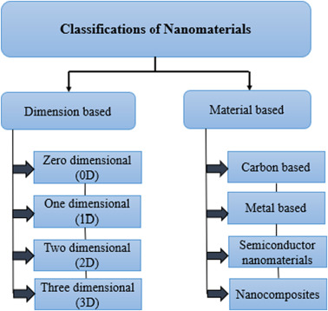
Fig. 1.Schematic representation the basicclassifications of nanomaterials

Nano-Materials Development
  - Carbon-based
CarbonNMs come invarious shapes and sizes, such as carbon nanotubes (CNTs), fullerenes, carbon nanofibers (CFs),graphene (GR), and carbon black.(Anu Mary Ealia&Saravanakumar, 2017)

  - Metal-based
In order to produce metal-based NMs in the nanometer range, both destructive and constructive techniques are used to reduce the size of metal atoms. To achieve this, divalent and trivalent metal ions are necessary for the creation of metal nanostructures. By usingreductants, these metal ions are reduced to metal NPs, which are highly effective due to their high surface area and ability to adsorb small molecules.They have wide-ranging applications in various scientific fields, as well as environmental studies, and other disciplines (Kolahalam et al., 2019; Singh et al., 2020; Anu Mary Ealia&Saravanakumar, 2017).

  - Semiconductor nanomaterials
Nanostructures in semiconductors exhibit both metallic and non-metallic features. When modified, they can produce broadband gaps and other changes commonly used in electronic devices and photocatalysis(Kolahalam et al., 2019).
  - Nanocomposites
A nanocomposite is a solid material that has more than one phase and at least one dimension that isless than 100 nm. These materials are often referred to as “materials of the 21st century”due to their exceptional performance, unique design options, and ability to combinedifferent properties..(Kolahalam et al., 2019, Hadef, 2018)
3.0. Properties of nanomaterials
3.1. Chemical properties
In order to achieve the intended function, the composition and chemical structure of NMsplay a crucial role. The chemical characteristics of NMs, including their surface energy, chemical potential, oxidation process, and catalytic activity, have a significant influenceimpact on their composition.

3.2. Physical properties
The physical properties of NMs are influenced by various factors, including the size, shape, colour, and morphology of particles. The size effect, degree of crystallinity, lattice parameter, and appearance of NMs are all interrelated effects that are determined by the size, shape, and arrangement of the particles.
3.3. Mechanical properties
Nanomaterials (NMs) are known for their exceptional strength in high-speed plasticitysituations due to their unique mechanical nature. The mechanical properties of NMs are influenced by various factors, such as particle sizes, material structure, hardness, the impact of permeability, elastic modulus, adherence, and resistance. These factors have been extensively studied by researchers (Mohan et al., 2018; Thorat& Bauer, 2020; Guo et al., 2013; Alagarasi, 2017; Abdullaeva, 2017; Alexandru Mihai Grumezescu, 2016; RavinNarain, 2020)and play a significant role in determining the mechanical properties of NMs.

3.4. Optical properties
The optical properties of nanomaterials NMs are influenced by the atoms present on their surface due to their electronic structure. , These properties include absorption, light emission, reflection, and transmission. As the size of the particle decreases to less than 10 nanometers, the optical characteristics become more pronounced and can be used to observe the size effect.
4.0. Synthesis techniques
4.1. Top-down approaches
With this technique, it's possible to decrease large amounts of material to generate particles at the nanoscale.. Whiletop-down methods are simple to execute, they are not effective for producting of irregularly shaped or extremely small particles due to their imprecision. One major drawback of this approach is the difficulty in achieving the desiredparticle size and form
    - Ball milling
The process of ball milling is a mechanical method used inthe top-down approach’s to generate NPs through attrition. The material being reduced undergoes a process known as “grinding,” which transfer kinetic energy from the grinding media to the material. The interaction between the balls generates heatand pressure,which can cause significant phase transformation., in addition to the impact of the balls against the vessel wall, might lead to severe phase transformation. This process is used for various applications,includingchange in particle size, change in the crystalline structure and agglomeration.
    - Thermal evaporation
When heat is applied, chemical reactions are initiated, which is an endothermic process. As a result of this heat, one chemical bond in the molecule is broken (Ijaz et al., 2020). Among the several methods for producinginorganic NPs, thermal evaporation is a popular choice as it creates solid, uniform suspensions that can self-assemble. It is also used to create thin films on a range of substrates.
    - Laser ablation
A laser is a powerful source of electromagnetic radiation that emits a coherent beam. This technologywas first proposed by Einstein and has since been widely used in various industries such as communication, medicine, manufacturing, and defense. Laser ablation synthesis in solution is a technique that simplifies the creation of NPs in different solvents (Ijaz et al., 2020).
    - Sputtering
Sputtering is a popular bottom-up methodbecause it uses a non-thermal vaporization process.A vacuum pumps used to achieveand maintain a low pressure of 0.67 Pa (atm) during the sputtering process. This method is used todeposit NMs on a substrate by evacuating nanoparticles with the help of rising ions. Sputtering can be used for surface etching, sputtering, and thin-layer deposition.

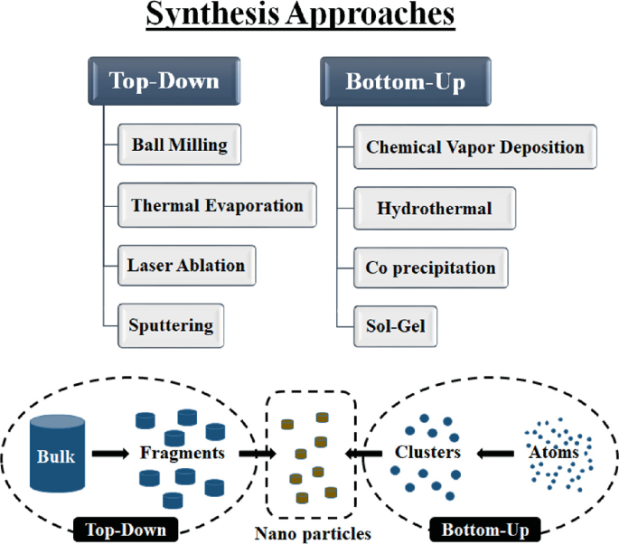
Fig. 2.Schematic representation of synthesis approaches

4.2. Bottom-up approaches
The constructive technique, also known as bottom-up strategy, involves NMs self-assembling from smaller atoms and molecules to form a certain size, shape, and chemical content.(Vaseghi et al., 2018; Kolahalam et al., 2019; Ijaz et al., 2020).
4.2.1. CVD
When it comes to fabricating nanostructures, CVD is a versatile and effective technique. CVD has been widely used in the microelectronics industry for decades and it is still a popular option for overcoming the challenges new technologies. CVD allows for the fabrication of nanostructures with affordable and easily obtainable components. When gas itroducedinto a reactor vessel and comes into contact with a hot surface,a chemical reaction takes place, resulting in a thin layer being deposited onto the surface of the substrateThis layer can then be used as a thin film. For successful operation, it is important to have controlled gaseous phase chemical delivery, an enclosed reactivity chamber, gas outlet, reaction pressure control, energy source distribution, safe and non-toxic exhaust gas cleansing, and automated process monitoring to improve deposition process stability. (Sun et al., 2021)
4.2.2. Hydrothermal
When solid materials react with acidic suspensions in high temperature and pressure reaction chambers, they undergo hydrothermal synthesis resulting in the deposition of tiny particles..This process is also known as a solution reaction, which relies on water as a solvent.In hydrothermal synthesis, water is heated over its boiling point until its vapor phase is entirely saturated. The method is cost-effective, eco-friendly, and produces a pure end product, making significant contributions to modern science and technology through its homogeneous precipitation and ease of upgrading.
Hydrothermal synthesis is used to create luminescence phosphors, superionic conductors, microporous crystals, gels, nanoscopic particles, and ultrathin films. (Jamkhande et al., 2019;; Gan et al., 2020)
4.2.3. Co-precipitation
A common and fundamental for producingvarious NMs is co-precipitation. This process involves the precipitation of impurities along with the resulting mix, which can be easily removed through subsequent filtration and washing. During Co-precipitation, two or more cations are precipitated out of a solution to form a uniform mixture. Once the precipitates have matured, larger particles can be collected throughfiltration or centrifugation.However, to obtainhigh-purity NPs, further washing in ethanol, distilled water, or another solvent is necessary to eliminate impurities. Post-treatment methods such asheating, grinding, and calcination may also be used to achieve the desired crystal structures and morphologiesof the NMs.
4.2.4. Sol-gel
The sol-gel technique is a popular bottom-up approach due toits simplicity. The term "sol-gel"comes from the combination of “soil” and “jelly.”Essentially, a colloidal solution known as a "sol" contains solid particles suspended in liquid, while the gel is a larger molecule that can disintegrate into smaller pieces when exposed to water. The process involves several stages, including hydrolysis, polycondensation, aging, drying, and calcination.
The final product’s morphology, permeability, crystallinity, and densification are significantly affected by factors such as pH, stirring speed and duration, reaction temperature, and reaction time. This method is ideal for fine-tuning the feel and appearance of materials. Heat treatment is required to achieve NPs with the desired crystalline structure, particle size, and crystallinity.
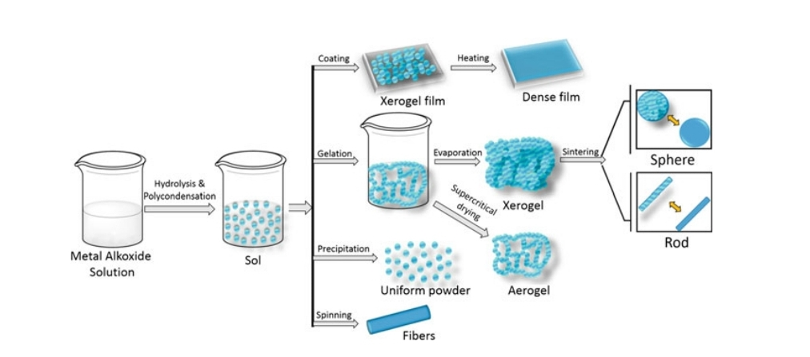
Fig. 3. Schematic representation of Sol-Gel method

Advantages of sol-gel
- Its pricing is reasonable.
- It’s consistent in quality and has a high degree of uniformity.
- Low-temperature processing environment.
- This method is an easy way to create composites and advanced nanostructures.
- Higher product purity is achieved with the ability to introduce even small amounts of dopants into the sol, which are then distributed uniformly throughout the final product.
Disadvantages of sol-gel
- The time to react is somewhat slower.
- There is a danger to human health from organic compounds.
- To get a clean sample, some further processing is needed.(Vaseghi et al., 2018; Kolahalam et al., 2019; Ijaz et al., 2020; Rane et al., 2018; Wang et al., 2021; Su and Chang, 2018;Parashar et al., 2020; Baig et al., 2021)

- Conclusion
Nanotechnology is widely acknowledged by the world’s scientific community as the mostsignificant technological development of the 21st century. It involvesthe study, management, and control ofmaterials with diameters between one and one hundred nanometers, which fallsoutside the scope of standard physics. NanomaterialsNMs are finding increasingapplications in various fields, including physics, chemistry, material science, and healthcare, around the world. The synthesis of NMs can be accomplished via various top-down and bottom-up methods, each with its own pros and cons. The techniques of synthesis that are used for various nanomaterials are selected with consideration given to the main materials that are readily available, the facilities that are available, the prospective applications of the nanomaterials, and other environmental and economic constraints. It is possible to find answers to the problems that modern society will face in the not-too-distant future by gaining a deeper grasp of and making rapid progress in, nanotechnology.

- References
- Abdullaeva, Z. (2017). Introduction into Nano- and Biomaterials. Wiley-VCH.
- Alagarasi, A. (2017). Chapter-INTRODUCTION TO NANOMATERIALS.
- Alsuraifi, A. Metallic nanoparticles in dental biomaterials: A review. AAJMS 2020, 3, 27–37. [Google Scholar]
- AlexandruMihaiGrumezescu. (2016). Nanobiomaterials in drug delivery : applications of nanobiomaterials. Elsevier/William Andrew.
- Ali, A. S. (2020). Application of Nanomaterials in Environmental Improvement. Nanotechnology and the Environment. https://doi.org/10.5772/intechopen.91438
- Anu Mary Ealia, S., &Saravanakumar, M. P. (2017). A review on the classification, characterisation, synthesis of nanoparticles and their application. IOP Conference Series: Materials Science and Engineering, 263(3), 032019. https://doi.org/10.1088/1757-899x/263/3/032019
- Baig, N., Kammakakam, I., &Falath, W. (2021). Nanomaterials: a review of synthesis methods, properties, recent progress, and challenges. Materials Advances, 2(6), 1821–1871. https://doi.org/10.1039/d0ma00807a
- Bhushan, B. (2017). Introduction to Nanotechnology. Springer Handbook of Nanotechnology, 1–19. https://doi.org/10.1007/978-3-662-54357-3_1
- Christian, P., Von der Kammer, F., Baalousha, M., & Hofmann, Th. (2008). Nanoparticles: structure, properties, preparation and behaviour in environmental media. Ecotoxicology, 17(5), 326–343. https://doi.org/10.1007/s10646-008-0213-1
- Guo, D., Xie, G., &Luo, J. (2013). Mechanical properties of nanoparticles: basics and applications. Journal of Physics D: Applied Physics, 47(1), 013001. https://doi.org/10.1088/0022-3727/47/1/013001
- Hadef, F. (2018). An Introduction to Nanomaterials. Environmental Nanotechnology, 1–58. https://doi.org/10.1007/978-3-319-76090-2_1
- Hulla, J., Sahu, S., & Hayes, A. (2015). Nanotechnology. Human & Experimental Toxicology, 34(12), 1318–1321.https://doi.org/10.1177/0960327115603588
- Jamkhande, P. G., Ghule, N. W., Bamer, A. H., &Kalaskar, M. (2019). Metal nanoparticles synthesis: An overview on methods of preparation, advantages and disadvantages, and applications. Journal of Drug Delivery Science and Technology, 53, 101174. https://doi.org/10.1016/j.jddst.2019.101174
- Ijaz, I., Gilani, E., Nazir, A., &Bukhari, A. (2020). Detail review on chemical, physical and green synthesis, classification, characterizations and applications of nanoparticles. Green Chemistry Letters and Reviews, 13(3), 223–245. https://doi.org/10.1080/17518253.2020.1802517
- Jeevanandam, J., Barhoum, A., Chan, Y. S., Dufresne, A., &Danquah, M. K. (2018). Review on nanoparticles and nanostructured materials: history, sources, toxicity and regulations. Beilstein Journal of Nanotechnology, 9, 1050–1074. https://doi.org/10.3762/bjnano.9.98
- Kolahalam, L. A., KasiViswanath, I. V., Diwakar, B. S., Govindh, B., Reddy, V., & Murthy, Y. L. N. (2019). Review on nanomaterials: Synthesis and applications. Materials Today: Proceedings, 18, 2182–2190. https://doi.org/10.1016/j.matpr.2019.07.371
- Mohan, S., Samuel OluwatobiOluwafemi, NandakumarKalarikkal, & Thomas, S. (2018). Characterization of Nanomaterials. Woodhead Publishing.
- Nasrollahzadeh, M., Sajadi, S. M., Sajjadi, M., &Issaabadi, Z. (2019). An Introduction to Nanotechnology. Interface Science and Technology, 28, 1–27. https://doi.org/10.1016/b978-0-12-813586-0.00001-8
- Parashar, M., Shukla, V. K., & Singh, R. (2020). Metal oxides nanoparticles via sol–gel method: a review on synthesis, characterization and applications. Journal of Materials Science: Materials in Electronics, 31(5), 3729–3749. https://doi.org/10.1007/s10854-020-02994-8
- Rane, A. V., Kanny, K., Abitha, V. K., & Thomas, S. (2018). Methods for Synthesis of Nanoparticles and Fabrication of Nanocomposites. Synthesis of Inorganic Nanomaterials, 121–139. https://doi.org/10.1016/b978-0-08-101975-7.00005-1
- RavinNarain. (2020). Polymer science and nanotechnology : fundamentals and applications. Amsterdam ; Kidlington, Oxford ; Cambridge, Massachusetts Elsevier.
- Singh, V., Yadav, P., & Mishra, V. (2020). Recent Advances on Classification, Properties, Synthesis, and Characterization of Nanomaterials. Green Synthesis of Nanomaterials for Bioenergy Applications, 83–97. https://doi.org/10.1002/9781119576785.ch3
- Su, S. S., & Chang, I. (2018). Review of Production Routes of Nanomaterials. In Commercialization of Nanotechnologies–A Case Study Approach. Springer International Publishing.
- Thanh, N. T. K., Maclean, N., &Mahiddine, S. (2014). Mechanisms of Nucleation and Growth of Nanoparticles in Solution. Chemical Reviews, 114(15), 7610–7630. https://doi.org/10.1021/cr400544s
- Thorat, N. D., & Bauer, J. (2020). Nanomedicines for Breast Cancer Theranostics. Elsevier.
- Titus, D., James Jebaseelan Samuel, E., &Roopan, S. M. (2019). Nanoparticle characterization techniques. Green Synthesis, Characterization and Applications of Nanoparticles, 303–319.https://doi.org/10.1016/b978-0-08-102579-6.00012-5
- Sun, L., Yuan, G., Gao, L., Yang, J., Chhowalla, M., Gharahcheshmeh, M. H., Gleason, K. K., Choi, Y. S., Hong, B. H., & Liu, Z. (2021). Chemical vapour deposition. Nature Reviews Methods Primers, 1(1). https://doi.org/10.1038/s43586-020-00005-y
- Vaseghi, Z., Nematollahzadeh, A., &Tavakoli, O. (2018). Green methods for the synthesis of metal nanoparticles using biogenic reducing agents: a review. Reviews in Chemical Engineering, 34(4), 529–559. https://doi.org/10.1515/revce-2017-0005
- Wang, N., Fuh, J. Y. H., Dheen, S. T., &Senthil Kumar, A. (2021). Synthesis methods of functionalized nanoparticles: a review. Bio-Design and Manufacturing. https://doi.org/10.1007/s42242-020-00106-3
- Gan, Y. X., Jayatissa, A. H., Yu, Z., Chen, X., & Li, M. (2020). Hydrothermal Synthesis of Nanomaterials. Journal of Nanomaterials, 2020, 1–3. https://doi.org/10.1155/2020/8917013

