COMPARATIVE ANALYSIS OF BIOACTIVE COMPOUNDS IN DRY BLACK AND GREEN GRAPES Vitis Vinifera (L.) by GC-MS

¹S. Vasantha, ²A. Subramaniyan, ³S. V. Bakiya Lakshmi, ⁴P. Vanathi, ⁵C. Karpaga Sundari
^{1,4, 5}Assistant Professor, Department of Botany, A.V. V. M Sri Pushpam College (Autonomous) Poondi, Thanjavur
²Assistant Professor, Department of Zoology, H. H The Rajahs College, Pudukottai
³Assistant Professor, Department of Biotechnology, Bon Secours College for Women, Thanjavur
Affiliated with Bharathidasan University, Tiruchirappalli

Corresponding : subravasanth76@gmail.com, subramanian2376@gmail.com, bakiyalakshmi.sv@gmail.com, pvanathi1979@ gmail.com, sundarikarpagam1981@gmail.com

Abstract

The study indented to examine the therapeutic potentials of V. vinifera through GC/MS characterization. The ethanolic extracts of Black and Green dry grapes were undergone qualitative analysis. The consequences of qualitative phytochemical analysis of black and green grapes extracts confirmed the occurrence of alkaloids, flavonoids, glycosides, saponins, tannins, carbohydrates, phytosterol, and triterpenoids, whereas flavonoids were absent in green grapes. The black dry grape possessed Antioxidant, hypocholesterolemic, Antiandrogenic, hemolytic, Alpha reductase inhibitor, Anti-inflammatory, Antimicrobial, and anti-cancer compounds. The black grapes have a special steroid compound namely Pregn-5-en-20-one, 3,16- bis[(trimethylsilyl)oxy]-, (3beta,16alpha) possessed Uterine endothelium activity. Similarly, the green dry grape showed fifteen bioactive compounds that possessed Anti-inflammatory, Antimicrobial, anti-cancer, Hepatoprotective and Diuretic, Anti leukemia activity, Anti cataract hypolipidemic properties, and anti-larvicidal activity. In addition, male sex hormone compounds, namely Testosterone and Androst-4-en-3-one, 17-hydroxy-, (17.beta.)-. The study shows that both green and black grapes possessed different bioactive especially omega fatty acids found in green grapes. These findings are essential and light up the position of dry grapes as a future supplement that could prevent detrimental outcomes. in this take look at, it turned into counseled that the consumption of purposeful food is beneficial in the prevention of numerous illnesses.

Keywords: V. vinifera, GCMS, Bioactive compounds, Antioxidant, Anticancer

Introduction
Grapes, (Vitis Vinifera) is an character from the Vitaceae has rich polyphenolic mixes, such as catechin, epicatechin, gallic acid, procyanidins and anthocyanin also has excessive vitamin E, linoleic acid, flavonoids and phenolic procyanidins which had more medicinal properties like hemorrhages, iron deficiency, skin problems, syphilis, bronchial asthma, jaundice, bronchitis, antidiabetic cardioprotective, hepatoprotective, anti-carcinogenic, anti-microbial, Vaso-relaxation, protection towards membrane oxidation, inhibit platelet aggregation, anti-viral activity, and anti cancers (Mohanad Jawad Kadhim et al.,2017; Chedea et al., 2010). Therefore, to investigated bioactive compounds evaluation of Dry black and green grapes Vitis Vinifera (L.).
2. MATERIALS AND METHODS
2.1 COLLECTION OF SAMPLE
The dry black and green grapes (Vitis Vinifera) were purchased from PPDS at Thanjavur. The samples had been color dried for 15 days and ground into quality powder for further studies.

2.2 Preparation of extract
The aqueous extract was prepared using 0 g of grape powder, boiled in 200mL of distilled water and then heated at 60-70°C to get a concentrated solution. The filtrate was used for qualitative analysis for the identification of diverse plant constituents through the Harborne method (1973) and GCMS study and the spectrum of the compared with NIST library.
3. RESULT AND DISCUSSION
3.1 Qualitative analysis
The end result of qualitative phytochemical analysis of the chosen fruit extracts exposed the presence of alkaloids, flavonoids, glycosides, carbohydrates, saponins, tannins, phytosterol, and triterpenoids in black grapes; whereas flavonoids had been absent in green grapes.
3.2 GC-MS analysis of Black and Green grapes (Vitis Vinifera )
Diverse bioactive compounds, inside the dry black and green Viti’s vinifera extracts, had been identified thru GC-MS analysis. The identity of some of the important phytoconstituents become primarily based on the peak place, retention time, and molecular weight and their pharmacological activity have been primary pharmaceutically vital compounds from the GC fractions of decided on samples. various compounds found in aqueous extracts of grape peel and seed have been indexed with their pharmacological activity (table 2 &3) to represent the chromatogram of aqueous extracts of decided on Vitis Vinifera .
The Diterpenoids compound particularly 2-Pentadecanone, 6,10,14-trimethyl changed into found in black grapes. in addition to that eleven-Octadecenoic acid, methyl ester, 9,12-Octadecadienoic acid (Z,Z)-, methyl ester, Hexadecanoic acid, methyl ester and Tridecanoic acid, 12-methyl-, methyl ester changed into the present which confirmed Antioxidant, hypocholesterolemic, Antiandrogenic, hemolytic, Alpha reductase inhibitor, Anti inflammatory, Antimicrobial and Anticancer hobby. The inexperienced grapes have a unique steroid compound specifically Pregn-5-en-20-one, 3,16- bis[(trimethylsilyl)oxy]-, (3beta,16alpha) possessed Uterine endothelium activity. (Table 1).
further, the green dry grape confirmed fifteen bioactive compounds specifically Gamma.-Sitosterol, nine,19-Cyclolanost-24-en-3-ol, Lanosterol, Lup-20(29)-en-3-one, Ferrocene, [(hexadecyloxy)carbonyl, 9,19-Cycloergost-24(28)-en-3-ol and Friedelan-3-one have antiinflammatory, Anti microbial, Anti most cancers, Hepato protecting and Diuretic, Anti leukemia interest, Anti cataract pastime, hypolipidemic property and anti larvicidal activity. in addition , male intercourse hormone compounds were additionally gift, namely Testosterone and Androst-4-en-3-one, 17-hydroxy-, (17.beta.)-. The a look suggests that both inexperienced and black grapes possessed one-of-a-kind bioactive especially omega fatty acids had been located in green grapes, male intercourse stimulating hormones had been present in inexperienced grapes, in which because the black grape possessed uterine enhance compound. ( Table 2).
Table 1. Compounds identified in Black Grapes
Name of the compound | Structure | Biological Activity
Tridecanoic acid, 12-methyl-, methyl ester | 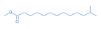 | Antifungal and antibacterial activities.
Phenol, 3-isopropoxy-5-methyl- | 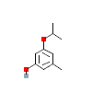 | No activity reported
2-Pentadecanone, 6,10,14-trimethyl | 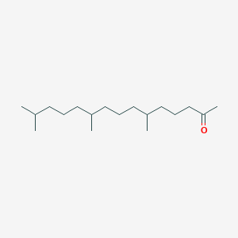 | Antimicrobial
Hexadecanoic acid, methyl ester | 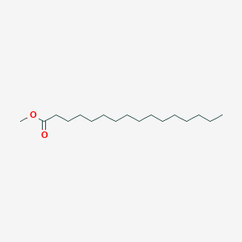 | Antioxidant, hypocholesterolemic, Antiandrogenic, hemolytic, Alpha reductase inhibitor
9,12-Octadecadienoic acid (Z, Z)-, methyl ester | 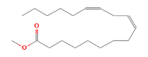 | Anticancer
11-Octadecenoic acid, methyl ester | 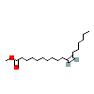 | Hypercholesterolemic, Dermatitigenic, Anti-inflammatory
l-Leucine, N-(trifluoroacetyl)-, tetradecyl ester | 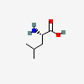 | preventing muscle loss
Benzoic acid, 2-(1-isopropyl)- | 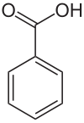 | Antimicrobial activity
Pregn-5-en-20-one, 3,16- bis[(trimethylsilyl)oxy]-, (3beta,16alpha) | 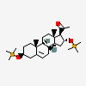 | Uterine endothelium activity
5-Methyl-2-trimethylsilyloxy-acetophenone | 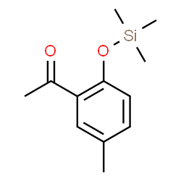 | Antioxidant and antimicrobial

Table 2: Compounds identified in Green Grapes
Name of the compound | Structure | Biological Activity
Gamma.-Sitosterol | 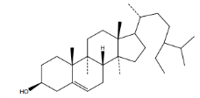 | hypolipidemic property
9,19-Cyclolanost-24-en-3-ol | 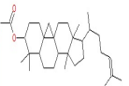 | Anti-mosquito and larvicidal
alpha.-Amyrin | 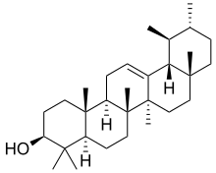 | Antimicrobial and anti-inflammatory activity
Lanosterol | 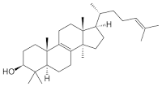 | prevent cataracts
Lup-20(29)-en-3-one | 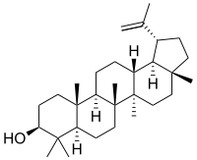 | Anti leukemia activity
9,19-Cyclolanost-23-ene-3,25-diol, | 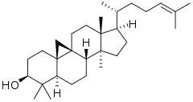 | Antibacterial activity
Phenol, 4-(2-thienylmethyl)- | 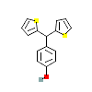 | No activity reported
Testosterone | 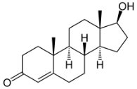 | Sex hormone
Phenol, 4,4'-methylenebis[2,6-bis 1,1-dimethyl ethyl)- | 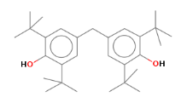 | No activity reported
Ferrocene, [(hexadecyloxy)carbonyl | 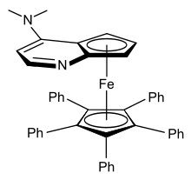 | Anticancer
9,19-Cycloergost-24(28)-en-3-ol, | 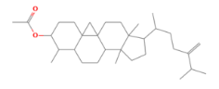 | Anti-inflammatory, Antimicrobial, Anti-cancer, Hepatoprotective, and Diuretic
Friedelan-3-one | 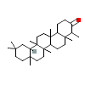 | Antimicrobial
Androst-4-en-3-one, 17-hydroxy-, (17.beta.)- | 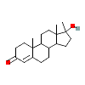 | Regulation of spermatogenesis

Conclusion
The results of the qualitative phytochemical evaluation of black grape extract confirmed the occurrence of alkaloids, flavonoids, glycosides, saponins, tannins, carbohydrates, phytosterol and triterpenoids, wherein as flavonoids become absent in green grapes. The black grapes having a unique steroid compound possessed Uterine endothelium action. Further the green dry grape showed male sex hormone compounds, specifically Testosterone and Androst-four-en-three-one, 17-hydroxy-, (17.beta.)-. The actual mechanism of identified compounds to be clarified in diverse diseases using community pharmacology to increase the Nutraceutics for a sustainable healthy life.
REFERENCE
Amerine, M.A. and Joslyn, M.A., Table wines. 2nd edition. Berkeley and Los Angeles: University of California press pp. 997, (1967).
Bupesh, G., T.S. vijayakumar, S. Manivannan, M. Beerammal, E. Manikadan, P. Shanthi and A.A. Vijaya, 2016. Identification of secondary metabolites, antimicrobial and antioxidant activity of grape fruit ( Vitis Vinifera ) skin extract. Diabetes Obesity Int. J., Vol. 1, No. 1.
Burin, V.M., N.E. Ferreira-Lima, C.P. Panceri and M.T. Bordignon-Luiz, 2014. Bioactive compounds and antioxidant activity of Vitis vinifera and Vitis labrusca grapes: Evaluation of different extraction methods. Microchem. J., 114: 155-163.
Chedea,V.S., Braicu,C. and Socaciu,C., Antioxidant/prooxidant activity of polyphenolic grape seed extract. Food Chem., 121: 132-139, (2010).
Chedea,V.S., C. Braicu and Socaciu, C. 2010. Antioxidant/prooxidant activity of polyphenolic grape seed extract. Food. Chem.121: 132-139.
Dulundu,E., Ozel,Y. and Topaloglu,U., Grape seed extract reduces oxidative stress and fibrosis in experimental biliary obstruction. J. Gastroenterol Hepatol., 22: 885-892, (2007).
Harborne, J. B. (1973). Phytochemical methods: A guide to modern techniques of plant analysis. Chapman and Hall Ltd, London.; Pp. 279.
Kadhim, M.J., A.B. Al-Rubaye and I.H. Hameed, 2017. Determination of bioactive compounds of methanolic extract of Vitis vinifera using GC-MS. Int. J. Toxicol. Pharmacol. Res., 9: 113-126.
Maier,T., Schieber,A., Kammerer,D. and Carle,R., Residues of grape (Vitis Vinifera L.) seed oil production as a valuable source of phenolic antioxidants. Food Chemistry, 112: 551-559, (2009).
Mohanad Jawad Kadhim, Abeer Fauzi Al-Rubaye. Determination of Bioactive Compounds of Methanolic Extract of Vitis Vinifera Using GC-MS. International Journal of Toxicological and Pharmacological Research. 2017; 9(2): 113 – 126.
Shenoy,S.F., Keen,C.L.,Kalgaonkar,S. and Polagruto,J.A., Effects of grape seed extract consumption on platelet function in postmenopausal women. Thromb. Res., 121: 431-432, (2007).
Yilmaz Y, Toledo R.T. Health aspects of functional grape seed constituents. Trends Food Sci Tech. 2004; 15: 422 – 433.

