Sustainable Technologies for EV Charging Infrastructure
K. Jeykishan Kumar, Energy Efficiency and Renewable Energy Division, Central Power Research Institute, Bengaluru-560012, India (jeykishan@cpri.in)
Abstract
This study provides the different sustainable technologies that could be used for EV charging infrastructure. With the increasing adoption of e-vehicles globally, the importance of adhering to sustainable developmental goals while adopting newer technologies is imminent for the automotive sector.
- Introduction
Fast adaptation to electric mobility is necessary to have a sustainable future for all. Electric vehicles (EV) are considered a sustainable or green technology compared to the existing Internal Combustion (IC) engine-based transportation sector. Similarly, the EV chargers and EV charging infrastructure should be too. EVs do not generate unnecessary emissions such as CO₂, NO_{x}, CO, etc. Like IC engine-based vehicles while driving, they are not completely emission-free considering the complete EV ecosystem. Some emissions are generated in the process of manufacturing, powering, and producing the infrastructure to charge the EVs. Still, e-mobility will help promote cleaner transport and sustainability efficiency.
Recently, the automobile sector is evolving with increased use and sales of pure EVs. Governments are also providing incentives and subsidies for EVs. This is one of the major ways to limit CO₂ emissions.
The government of India (GoI) has supported accelerating the adoption of electric vehicles through several policy initiatives such as the National Electric Mobility Mission Plan (NEMMP), Faster Adoption and Manufacturing of (Hybrid) and Electric Vehicles (FAME) Scheme, etc. With the demand for EVs increasing accordingly, there is also an equal increase in the requirement for supporting infrastructure.
To meet this increasing demand, the GoI is actively formulating policies at various levels, such as Energy guidelines for setting up EV charging infrastructure, Modification of the model building regulations (MBBL-2016) for the charging infrastructure for electric vehicles by the Ministry of Housing and Urban Development, etc.

The private sector also supports government initiatives with technological innovations, improving battery density, reducing operation and maintenance (O&M) costs, improving charging time, etc. Therefore, efforts such as incentivizing EVs and introducing new policies, campaigns, and initiatives by private companies are playing a catalytic role in boosting the adoption of electric vehicles and associated infrastructure.
Electric vehicles (EVs) are the upcoming transition in the transportation sector, which are sustainably better than conventional vehicles that run on fossil fuels such as petrol, diesel, natural gas, etc.
The major advantages of using EVs are the non-usage of fossil fuels, low running cost, zero-emission (no pollution), reduced emission of greenhouse gases (GHGs), use of fewer components, low noise while running, and use of a recyclable battery. The scope of this paper is limited to battery-based EVs but could be extended to fuel cell-based EVs and other technologies in the coming future.
One of the most pre-requisite items for using EVs is the EV charging infrastructure (EVCI). EVCI is a set of individual components such as EV supply equipment (EVSE), power supply source with/without a transformer, communication technology, and installation location.
EVCI is defined as a system that is used to charge the EVs safely when the batteries inside the EVs get depleted, using intelligent communication and protection technology.
In this case of EVCI, the essential technology in place is the EVSE, and other technologies involved are electrical power supply, installation and commissioning aspect, software and communication factors, type of EV charger, services offered, the material used, type of semiconductor technology used, type of ownership, area/location of stakeholders, governance, and supporting institutions.
Sustainable technology is defined as the system of knowledge, techniques, skill, ability, processes, and organization that will transform the resources effectively into a usable form of goods and services considering the economic, social, and environmental outcomes that are sustainable. Figure 1 shows the multi-dimensional aspects of sustainability.
Under the context of sustainability, the technologies help transform the available natural capital into useable goods and services adhering to sustainability norms. Both soft and hard technologies are important for sustainable economic development by contributing to economic growth, meeting the social needs and equitable distribution of resources, improving the quality of life, balancing ecological growth, meeting lifestyle and livelihood needs, etc. Example- Software help in reducing the manpower work in automated car manufacturing by using controlled robots. Hardware, such as instruments and equipment, are used to measure and analyze the efficiency of a product. These make the life of humans easy, the quality of life is improved, etc. For example, plant-based solar power is a sustainable technology for EV charging infrastructure.
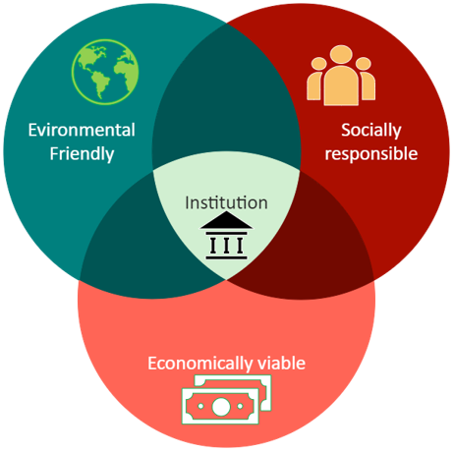
Figure 1. The four pillars of sustainability dimensions

To enable the decarbonization of the automotive sector and support the global EV30 campaign, sustainable, accessible, and robust charging infrastructure for EVs is an essential prerequisite. To encourage EV adoption, the availability of charging infrastructure is a key requirement, and it is reported that EV adoption in India would require 4,000 charging stations by 2026. The government has also planned to set up charging stations every 3km in cities every 25km on both sides of the highways to improve accessibility.

- The objective of Sustainable mobility
The idea of sustainable mobility involves the need to move freely, helping build relationships without sacrificing environmental and human values ​​(current or future). It also aims to improve the quality of the environment, not only by reducing harmful emissions from transport but also by protecting pedestrians, cyclists, and people with reduced mobility. It also provides universal access to important places through public transport and internalizes the socio-economic costs of transport.
Sustainable mobility is created to counteract the negative effects of a transport model that pollutes the air, consumes excessive energy, and harms citizens' health. It is an energy and environmental challenge that will help improve social, economic, and transport well-being in cities. It's about being transported in the most environmentally friendly way possible, apart from fossil fuels (responsible for the largest emission of CO₂ into the atmosphere and responsible for 4.5 million deaths a year, according to the latest reports). To combine mobility and sustainability, investing in electric cars, car sharing, and public transport is necessary. For this to be possible, green mobility policies are required, as well as implementing a mobility plan that supports the green fleet, restrictions on polluting vehicles in urban areas, and constructing roads and circuits for non-motorized vehicles. Promoting and using public transport, non-motorized vehicles (bicycles, mopeds, scooters, etc.), and reducing private cars can be more environmentally friendly and sustainable for the automotive sector.
With the increasing use of EVs across the country and globally, the efficient contribution to the economic, social, and environmental aspects must be considered in the EV ecosystem, especially for the EV charging infrastructure. Such infrastructures that contribute to greener economic growth are environment-friendly and socially inclusive and are called sustainable infrastructures. The EV charging infrastructures that follow sustainable norms and help contribute to climate change, efficient use of smart technologies and resources, greener economic growth, and making socially habitable and inclusiveness sustainable EV charging infrastructures. This means the infrastructure is environmentally friendly from end to end, including economic, financial, social, and institutional factors. These factors form the 4 dimensions of sustainability and sustainable development. Technology is the main factor that converts essential resources efficiently into useful outcomes for consumption. This paper discusses the sustainable technologies, advantages, disadvantages, and challenges of EV charging infrastructure (EVCI).

- The ecosystem of EV Charging Infrastructure
The infrastructure required to support battery-based EVs to charge their batteries is called EV charging infrastructure. Such infrastructure is used only for battery EVs (BEVs). In the near future, the possibility of using hydrogen as a fuel will be adopted with the integration of fuel cell systems and such infrastructure will be entirely different from battery-based electric vehicles. To understand the EVCI completely, understanding the ecosystem is required. The ecosystem of EVCI consists of the type of EV supply equipment (EVSE), type of power supply usage, land use area (location specific), installation and commissioning aspects of EVSE, type of services offered such as communication and software used, and operation and maintenance of EVCI. To enable the ecosystem of EVCI, the institutions, proper governance, and stakeholders play a significant role. There are 3 types of EVCI’s, which are detailed in Table 1. The differences mainly arise concerning the usage type, location of use, type of ownership, and operation. Public EVCI can help in faster EV adoption, followed by semi-public and private, respectively. With the adoption rate in the nascent stage, the public EVCI can help promote the use of EVCI’s and EVs, help create awareness among the society, and reach a large audience as most people use public transport systems, etc. The technologies related to different types of EVCI may be common or different with respect to the location of use, type of ownership, etc.
Table 1. Types of EV Charging Infrastructure
Type of EV Charging Infrastructure | Factors affecting the EV charging Infrastructure
 | Usage | Location | Ownership | Operation
Private | Dedicated charging for personal EV or EV fleet  owned by one entity | Independent homes, dedicated parking spots in apartments/offices; for fleets- any location with  land availability | Individual EV owners, EV fleet owners/ operators | Self-operated or CPO-managed (for EV fleet  charging)
Public | Open for all EV users | Public parking lots, on-street parking, charging plazas, petrol pumps, highways, metro stations | Municipal authorities, PSUs, CPOs, host properties | CPO-managed
Semi-public | Shared charging for a restricted set of EV users | Apartment complexes, office campuses, gated communities, shopping malls, hospitals, universities, government buildings, etc. | Host properties, Original Equipment  Manufacturers (OEMs) & Charge Point Operators (CPOs) | CPO-managed

For example, the technology used for private EVCI will be wall mounted type, whereas, in the case of public charging, it will be floor mounted type. The differences may be many depending on other factors such as type of usage (personal purposes or shared usage, or high-power usage) and location of the charger. Secondly, another major factor that depends on technology will be the type of services offered, such as smart charging, intelligent communication systems, fast charging, better connectivity, etc. The whole ecosystem is dependent on the type of technologies used and their influence on their operation. Thirdly, the type of EVSE and its specification is another factor of the ecosystem that is considered during the installation and commissioning process for the EVCI. The EVSE can be either conductive or non-conductive type EVSE and are of 2 types viz. DC charging (fast charging) and AC charging (slow charging).
The institutions such as the Ministry of Road Transport and Highways of India and the Department of Heavy Industries play an important role in the faster adoption of EVs and the development of EV charging infrastructure across the country. If the institutions can make proper policies, regulations, and guidelines for the public, the impact will be larger. The process of forcing the adoption of certain technology using rules and regulations are called the top-bottom approach, which is the practical way of living, rather than the bottom-top approach, which is the ideal way. Similarly, the stakeholders viz. Government, private, and public representatives are important in formulating the necessary guidelines, rules, and regulations that lead to policymaking. The common services offered by EVCI are payment options, a mobile app for connectivity between the charging points, fast charging options, security, safer energy transfer, proper and reliable energy supply, etc. The general power supply is through the normal electricity supply from state utilities or distribution companies (DISCOMS) that is supplied from fossil fuel-based generating power plants.
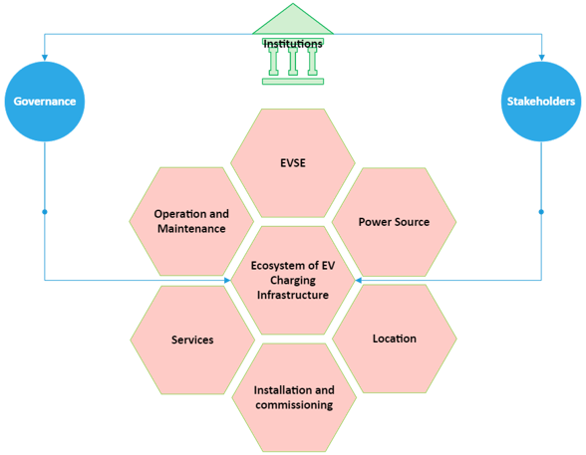
Figure 2. A typical ecosystem of EVCI

Key drivers for charging infrastructure development: -
- Location: Location is one of the critical factors when considering range anxiety and EV charging time. Therefore, a mix of home charging, public charging, and destination charging (workplace/commercial) is required to increase range and improve charging access.
- Charger Type: To increase utilization at the charging site by installing the most appropriate mix of chargers, i.e., H. Charger type (slow/fast) and charging standards, to ensure interoperability within the EV ecosystem.
- Electricity: Large-scale EV charging requires a proper power distribution system and grid infrastructure planning to ensure power availability at the charging locations.
- Technology: Applying the right technology will make the operation of the charging infrastructure ecosystem more efficient and further improve the seamless customer experience.

- Technologies involved in EVCI
Technology is driven by energy and the use of resources. Technology is a tool, skill, process, etc., that improves the system’s quality and life. The major technological factors in EVCI are the material technology, power electronic semiconductor technology, EVSE technology, software and communication technology, technologies involved in the type of electricity supply, technologies involved in the operation and maintenance, the technology used in infrastructure development, technology variations based on the ownership type and usage pattern, and the technological mechanism of the stakeholders. The complete ecosystem of EVCI depends on various technologies, and Figure 3 shows the technologies involved in the EVCI ecosystem.
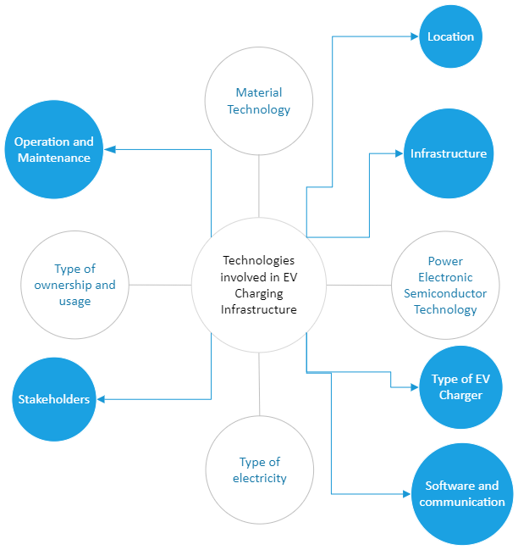
Figure 3. Typical technologies involved in EVCI

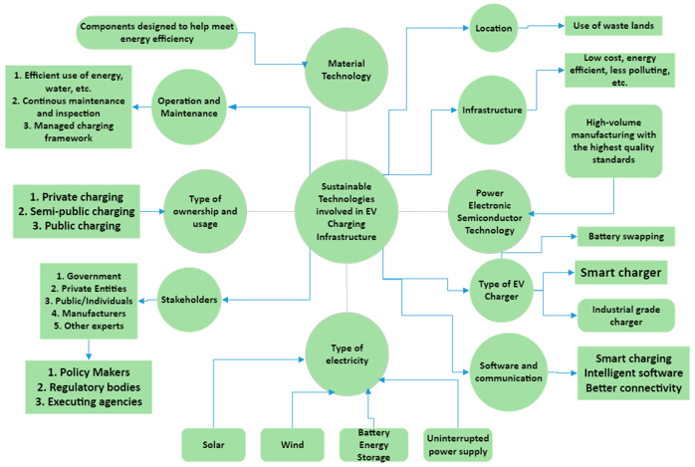Figure 4. Sustainable technologies involved in SEVCI
The following are the methods to be adopted for SEVCI to be sustainable: -
- Material technology- using less energy-intensive materials and energy-efficient components can reduce GHG emissions in manufacturing the raw materials used in EVCI.
- Power electronic semiconductor technology- good quality manufacturing with low waste output and high-volume production are more sustainable than low-quality products.
- Type of electricity used- using renewable energy resources such as solar power, wind power, biomass, etc., instead of natural gas, coal, etc., are sustainable as they contribute positively to environmental development. The use of solar or wind power-based energy supply will help reduce GHG emissions and help climate change aspects positively. To ensure a reliable power supply, using an uninterrupted power supply (UPS) and battery energy storage systems are encouraged to contribute to social-economic development.
- Location or Land use planning- using wasteland or barren land is best compared to useful land for developing the EVCI. This contributes to environmental sustainability.
- Infrastructure- Using low-cost, energy-efficient, and low polluting in nature.
- Type of EV charger or EVSE- Using an industrial-grade charger, smart charger, and battery swapping system is much better for economic, social, and environmental sustainability.
- Operation and maintenance- the efficient use of land, water, energy supply, etc., along with continuous maintenance and managed to charge network, is a sustainable system.
- Software and communication- the adoption of smart charging and intelligent communication system with better connectivity is socially sustainable but may not be economically sustainable.
- Type of ownership and usage- the public EVCI is the most preferred and needed type of ownership that should be supported by the institutions and good governance that contribute to socio-economic sustainability. Adopting shared usage instead of private usage of EVCI is sustainable but not comfortable to adopt practically.
- Stakeholder mechanism- this technological aspect comprises 5 components viz. Government organizations/entities/institutions, private entities, manufacturers, individuals, or public, and expert peoples. The outcome of partnerships between these components can help provide better policy-making decisions, proper rules, regulations, and guidelines, and better implementations. Hence, contributing to inclusive economic, social, and environmentally sustainable growth.

- Sustainable EVCI
In general, the infrastructure that focuses on and follows sustainable practices and norms is called sustainable infrastructure. Using sustainable technologies can help make the existing system into a sustainable EV charging infrastructure. The most fundamental difference between EVCI and SEVCI is the source of power supply (electricity) which is coal-based and solar-based, respectively. The other options for SEVCI are the use of wind-power-based and battery-based. The second important difference is using less energy-intensive and energy-efficient materials or components for manufacturing the various technologies involved in creating the product SEVCI, such as aluminum, silica, silver, etc.

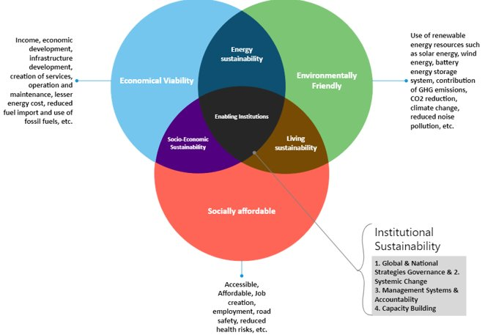
Figure 5. Dimensions of Sustainable EVCI

There are 17 Sustainable Development Goals (SDGs) detailed by the United Nations (UN) for inclusive growth in terms of economic, environmental, and social development on a global scale. Figure 6 provides the 17 SDGs. The most direct way of understanding the effect and contribution of certain technology on sustainability is by relating to the SDGs. For example, the country or city with a better sustainability index is having better sustainable mobility ecosystem. By adopting SEVCI, the following goals can be achieved directly:
- Goal 3 (SDG 3)- Adopting a sustainable mobility ecosystem can promote well-being, ensure healthy lifestyles among the community, and contribute to inclusive social development. The use of SEVCI will indirectly ensure healthy living by reducing the release of GHG emissions as they use renewable energy-based energy sources (majorly solar energy), which are much cleaner than conventional sources of electricity (from fossil fuels such as coal, hydrocarbon, and natural gas, etc.).
- Goal 7 (SDG 7)- We know that renewable energy-based power sources are not reliable with their operating characteristics. With the increased use of renewable energy-based sources of electricity such as solar power, the intermittency or fluctuations in the solar radiation during the daytime can be supported by the SEVCI wherein the option of the vehicle to grid power is possible, especially during the peak hours and fluctuating hours. This option is advanced and still in the research stage globally but has proven to be successful in certain countries. Therefore, adopting SEVCI with the vehicle-to-grid (V2G) technology option can help ensure a reliable energy supply for all, which is both sustainable and affordable.
- Goal 8 (SDG 8)- With the recent move by the Government of India (GoI) , any private entity can start setting up EVCI to encourage small-scale start-ups and business companies. The SEVCI is an existing equivalent of petrol/diesel stations that can act as a source of income and a decent employment opportunity for the owners of SEVCI. With the transition towards using EVs in the next 50 years, this business can act as a productive employment opportunity and decent work. This ensures sustainable economic growth.
- Goal 9 (SDG 9)- The use of battery swapping station (a special type of EV charging solution), adoption of solar/wind/battery/UPS integrated electricity supply, optimal use of energy resources, use of less energy intensive and energy efficient materials/components in manufacturing, use of intelligent software solutions (smart charging), sustainable charging framework (operation and maintenance), less polluting or less GHG emissions, usage of the optimal land area without compromising environmental surrounding (protecting biodiversity), etc., based EV charger is said to be SEVCI. If such an infrastructure is adopted, it can positively impact socio-economic and environmental development and lead to sustainable industrialization.
- Goal 11 (SDG 11)- The use of SEVCI in smart cities is considered safer, resilient, and sustainable. Sustainable cities adopting SEVCI are more socially sustainable.
- Goal 13 (SDG 13)- The SEVCI does not have many GHG emissions as they use a cleaner source of energy supply, thereby contributing to climate change. This positively impacts on environmental sustainability.
- Goal 15 (SDG 15)- Using efficient land for establishing SEVCI (like the use of wasteland) can help contribute to environmental sustainability.
Figure 6. Sustainable Development Goals (SDGs)
Table 2. Advantages and disadvantages of battery EV charging through BSI
Sl. No. | Advantages | Disadvantages
1 | EV recharging is completed in minutes | Lack of standardization among EV batteries
2 | Batteries can be charged away from the swapping point, allowing more freedom in setting up swap facilities | Unsuitable battery pack design to enable ease of swapping (weight, dimensions, and ergonomics)
3 | Reduction in the upfront cost of EV, as battery ownership is replaced by battery leasing | A greater number of batteries are needed to power the same number of EVs
4 | Increased predictability of battery life due to controlled charging conditions | The shorter commercial life of battery packs is due to customer preference for new batteries with higher ranges. Slow adoption of charging method by OEMs - Higher costs of battery leasing over the life of the EV - Higher GST on separate battery (18%) vs. battery sold with EV (5%).

An alternative method of charging batteries that are gaining worldwide attention is battery swapping infrastructure (BSI), in which a discharged electric vehicle battery is removed from the vehicle and replaced with a fully charged one. The technology is being trailed for various EV segments, including E-2Ws, E-3Ws, e-cars and e-buses. There are two major types of BSI’s viz. Manual BSI and autonomous BSI.
- Manual BSI: The battery charging station is a stand-alone device in which batteries are inserted and removed manually from the individual slots, mostly by hand. Manual Changing stations are modular and occupy a minimum amount of space. These are used for 2W, and 3W Battery applications as battery pack sizes are smaller, and one or two people can handle the weight.

- Autonomous BSI: A robotic arm is used in these types of exchanges Stations with battery changes are semi/fully automated. Robot exchange is used for 4W and E-bus applications as battery packs are larger, heavier, and require mechanical assistance. These Exchange stations or BSI systems are also more expensive and have higher space requirements, i.e., more land space but efficient.
Changing the battery has some distinct advantages over its Plug-in store but will also face several Challenges in its development as a mainstream Charging method (see Table 2). Changing the battery is currently considered a feasible Solution for commercial EV fleets, especially in the e-2W and e-3W segments. The Ministry of Roads Transport and Highways (MoRTH) made this possible Sale and registration of electric vehicles without batteries, thus providing a tremendous boost for battery swapping solutions and the development of BSIs across the country. In addition, industry interest groups make big Investments in the development of the battery replacement ecosystem. This indicates that battery replacement is in progress to emerge as an independent component of charging networks for electric vehicles in India in the coming years. BSI is currently the best type of SEVCI. Using batteries as part of a BSI also can be a lower-impact method of providing a vehicle with the potential to store the batteries in an optimum environment. Figure 7 shows the sustainability contribution of BSI in three dimensions.
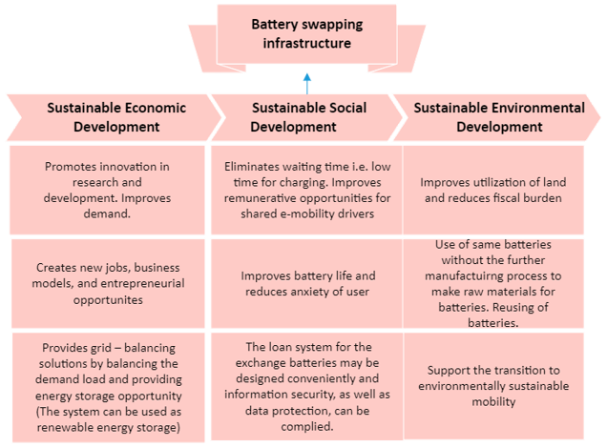
Figure 7. The sustainability aspect of BSI
- Advantages and disadvantages of SEVCI
Replacing old urban infrastructure with new, modern, and sustainable elements will make cities more livable and inclusive. This would require multi-trillion-dollar investments worldwide over the next decade. But if we do things right, it will also put us on the path of economic growth. Here is a summary of the key benefits of sustainable infrastructure: -

- Reducing our environmental and carbon footprint: According to The New Climate Economy, better urban planning with more sustainable infrastructure would save the planet 3.7 gigatons of CO2 per year over the next 15 years.
- Promote renewable energies: Decarbonizing the economy and developing a decentralized and digitized power grid could mean access to electricity for the billions of people who are currently without electricity.
- Create green jobs: In the renewable energy sector, we could see an increase from 2.3 million green jobs today to 20 million by 2030.
- Drive green economic growth: Building sustainable infrastructure is a key pillar in the new economy based on climate and sustainability policies.
- Equalize inequalities: Today's infrastructure is unprepared to meet even the most basic needs of emerging economies, such as access to running water, sanitation, transport networks, etc., while the sustainable alternative could.

Table 1. Advantages and disadvantages of SEVCI
Sl. No. | Advantages | Disadvantages
1 | Reducing our environmental and carbon footprint | Pollution due to production and manufacturing activities remains at large
2 | Fostering renewables | Capital cost is high
3 | Creating green employment | Existing jobs will be lost, and takes more time to learn new skills for the SEVCI
4 | Driving green economic growth | Very poor economic growth but a healthy version
5 | Evening out inequalities by providing Accessibility, affordability, transparency, and effectiveness | Accessibility, affordability, and effective reach to rural areas are difficult

Challenges:
- Short lifespan, high waste - Waste is also a major challenge for chargers. Many manufacturers claim that chargers will last a decade, although it's a poorly kept secret that many have a 5-7 years lifespan. This is not only wasteful and harmful to the environment but also makes no economic sense, and the infrastructure is supposed to last a long time.
- Making charging infrastructure out of recycled materials - If these chargers were our only option, it would still be worth allowing EV inclusion. But we can do better. Remember, the less CO2 the charging infrastructure produces, the faster it pays for itself. The carbon cost of manufacturing most of the materials that go into our chargers is close to zero because they have already been manufactured.​ For example, charging stations are made from recycled tires and plastics. So instead of mining new materials, we are reducing hard-to-recycle waste from the automotive industry. Scaling to millions of chargers results in significant economic and environmental benefits.
- Using charging infrastructure to encourage green behaviors- First, slow/fast chargers require cars to be plugged in for long periods (e.g., overnight or at work), enabling smart charging that can help minimize stress on the grid and batteries. This has the advantage of increasing battery life and, therefore, battery waste. Second, a vast network of vehicles connected to smart chargers for long periods creates tremendous flexibility for the grid, allowing for intelligent matching of supply and demand. This can facilitate the effective use of renewable energy (and turn off backup gas generation) if smart-charging vehicles can pick up electricity when it's plentiful and cheap. Third, charging on the street and in the workplace opens EV ownership to people without a driveway, expanding access and accelerating the transition from internal combustion engines to electric vehicles. In contrast, as analyzed by different countries, public fast chargers mostly offer additional options for existing drivers on long journeys and not for their usual daily charging needs.
- Charging should be green, too - As part of our drive to enable EV adoption, we should also make our charging infrastructure as green as possible. This means that chargers must be made from recycled and recyclable materials. It means designing chargers to minimize materials and electronics. It means providing an infrastructure that lasts for decades. It also means designing infrastructure that encourages green charging behavior. We must not overlook the environmental impact of the infrastructure required for EV adoption. In our understandable rush to enable EVs, the environmental impacts of the chargers themselves escaped scrutiny, meaning manufacturers didn't have much incentive to change. EVs are a green industry that will help save the planet. Charging infrastructure should share this claim.

- Conclusion
As the adoption of EVs develops gradually, the sustainability of the charging process will be a challenge until the scalability of EVs is achieved. Infrastructure viability can be achieved by understanding the needs of key ecosystem players, including consumers, government, and private operators. On the consumer side, the accessibility and availability of supporting infrastructure must be provided to increase user confidence in purchasing electric vehicles. When EV traffic on the road is limited, additional privileges may be offered to operators by the operator side, such as the availability of land at subsidized rates for infrastructure creation, provision of additional revenue from commercial activities, etc. Enabling policy environment and promotion of Private sector involvement by OEMs and operators to develop supporting infrastructure. The interaction of all these factors will make the infrastructure sustainable in the long term. Five key EV charging infrastructure areas that must be considered critical to sustainable development are energy, transport, waste management, land use planning, and governance. Battery swapping technology is the most sustainable technology for EVCI. Currently, over 90% of vehicles in India are 2W; 2W electric batteries can be charged from any single-phase outlet. Changing batteries on tricycles can be successful - the new business model of 3w sold without batteries and a battery leasing agency that owns and rents charged batteries in a city is worth exploring. Battery replacement is not yet feasible for cars and buses (although trials are ongoing). Innovative models for BSS must be explored to make it successful. Given the current scenario of the EV landscape in India, EV consumers will like the idea of ​​BSS as replacing the battery is much easier than charging it. However, as fast-charging technology advances every day, EV range increases and faster charging of EV batteries decreases, battery swapping could be a good idea in the long run or become obsolete over the years. Ultimately, battery swapping has the potential to become a successful business model for commercial electric vehicles. Fleet operators, such as buses, taxis, etc., would swap their battery packs at their facilities and distribute battery changes across different electric vehicles. International collaboration is essential for faster EV adoption in India.

- References:
- IEA (2020), Global EV Outlook 2020, IEA, Paris https://www.iea.org/reports/global-ev-outlook-2020
- White Paper on Electric Vehicles, Adopting Pure Electric Vehicles: Key Policy Enablers, Society of Indian Automobile Manufacturers (SIAM), December, 2017
- Kumar K, Jeykishan. (2019). INDIA’S EV CHARGING INFRASTRUCTURE-AN OVERVIEW.
- Kumar K, J, Kumar, S, V.S, N. Standards for electric vehicle charging stations in India: A review. Energy Storage. 2022; 4( 1):e261. https://doi.org/10.1002/est2.261
- G ̈onül ̈O, Duman AC, Güler ̈O. Electric vehicles and charging infrastructure in Turkey: an overview. Ren Sust Energy Rev 2021;143. https://doi.org/10.1016/jrser.2021.110913. 110913-1193.
- https://www.financialexpress.com/auto/electric-vehicles/factors-to-ensure-sustainable-ev-charging-infrastructure-location-charger-type-more/2309601/
- Chakraborty, S.; Kumar, N.M.; Jayakumar, A.; Dash, S.K.; Elangovan, D. Selected Aspects of Sustainable Mobility Reveals Implementable Approaches and Conceivable Actions. Sustainability 2021, 13, 12918. https://doi.org/10.3390/su132212918
- Schmidt, Steffen (2021): Use of battery swapping for improving environmental balance and price-performance ratio of electric vehicles. TechRxiv. Preprint. https://doi.org/10.36227/techrxiv.14224811.v1
- Guangling Zhao, Jenny Baker, Effects on environmental impacts of introducing electric vehicle batteries as storage - A case study of the United Kingdom, Energy Strategy Reviews, Volume 40, 2022, 100819, ISSN 2211-467X, https://doi.org/10.1016/j.esr.2022.100819.
- Avci, Buket, et al. “Electric Vehicles with a Battery Switching Station: Adoption and Environmental Impact.” Management Science, vol. 61, no. 4, 2015, pp. 772–94, http://www.jstor.org/stable/24550365. Accessed 19 Apr. 2022.

