Exploring Destination Resilience in Sustainable Tourism: A Bibliometric Analysis
¹Dr. Aparna Merin Mathew
Assistant Professor, Department of Commerce, All Saints’ College, Trivandrum, Ph 9495023932, Email: aparnamathew25@gmail.com

Abstract
The tourism business is thriving in the post-pandemic era. Similarly, numerous studies have attempted to ascertain the benefits of sustainable tourism on the country's economic growth. This study will give fresh insights into sustainable tourism by examining published book chapters, conference papers and articles from the Web of Science database. The findings showed that between 2020 to 2022, academic interest in this field skyrocketed. This paper shed light on studies on sustainable tourism in order to identify key themes, present state of research in sustainable tourism, and suggest how prominent works have shaped it. Using bibliometrics analysis, this study examined 951 papers published in Web of Science (WoS) database between 1990 to 2022. Academic interest in this area shows a positive trend as the annual scientific productivity shows a gradual increase over these years.
Keywords:Sustainable tourism, Bibliometric analysis, WoS

1.Introduction
Tourism is the key factor contributed to the recovery of economy after the COVID pandemic. The tourism sector establishes relations and interconnections with other sectors such as transportation,cultural exchange, education, and infrastructure. Over time, it became clear that tourism must be environmentally sustainable as well as economically and socially beneficial (Garg & Pandey, 2021). The World Tourism Organisation defines sustainable tourism as tourism that fully considers its current and future social, economic and environmental implications, while also meeting the requirements of visitors, the industry, the environment, and host communities. Sustainable tourism concepts address the socio- cultural, environmental, and economic aspects of tourism development. An appropriate balance between these three dimensions needs to be achieved to ensure long-term viability. Its importance arises from the fact that it aims to conserve resources while simultaneously expanding and preserving local cultures and customs. In other words, sustainable tourism is responsible tourism that generates employment and earnings for the current generation without compromising the needs of future generation(Thottekat Sri Guru Tegh Bahadur Khalsa et al., 2017). The concepts of sustainable tourism place a strong emphasis on local community participation at tourism locations. The active participation of local citizens is a major success factor in maintaining momentum in this scenario. Tourism development should ideally help local communities directly, as indicated by the expansion of local economic options. Training and education courses play a vital supporting role here, as they help to improve cultural heritage and natural resource management (Kaul & Gupta, 2009). The goal of sustainable tourism is to provide social and economic benefits to society while without jeopardising local community culture or environmental quality (Yadav et al., 2018). One strategy of achieving sustainable tourism in underdeveloped countries, such as India has been identified as effective community engagement (Kokkranikal et al., 2002).
Several assessments of the literature on sustainable tourism development and economic growth have been conducted in recent years. (Hussain et al., 2015) created the "the prism of sustainability" model, which is a holistic model formulated around four interconnected dimensions such as institutional sustainability, socio cultural sustainability, environmental sustainability and economic sustainability, which could lead to tourism satisfaction. Each study has offered information in the field of sustainable tourism, but further analysis of this literature through bibliometric approaches may provide additional information that has not been completely understood or analysed previously. As a result, bibliometric methods can be a strong tool for identifying emerging and established current themes, as well as finding research groups and academics to highlight how diverse fields of thought may have formed. By locating more current themes covered by these scholars, identifying the most prominent researchers within a group opens the door to identifying more developing areas of study. As a result, the current study provides a comprehensive valuation of the impact of sustainable tourism development on economic growth, beginning with a group of more than 17,000 published papers and filtering this group to locate specialised works on the suggested issue. These findings add to our understanding of current research priorities and prospective future research initiatives.
2. Methodology
2.1. Method
The bibliometric analysis method was employed to identify publishing trends and patterns in sustainable tourism literature. Bibliometrics is a quantitative/statistical tool for assessing patterns in the publication of research articles, conference papers, and other academic documents. Its capacity to review published research without directly communicating the authors is one of its most significant strengths (Saleem et al., 2021)
2.2. Database Selection
WOS is widely regarded as the most trustworthy, powerful, and dependable database in the world. Due to its multidisciplinary nature, data was collected from WoS database (Sánchez et al., 2022).
2.3. Keyword used
The search query was made in the topic field of the WOS database with the Keyword “Sustainable Tourism”.
2.4. Selection Criteria
The time period for the publication search in WOS was from1990 till 2022. All articles, review articles, proceedings, books chapters, and book review from business and management area was filtered and included.
2.5. Analysis of Data
The data for the study was obtained from the WOS database.Data analysis was carried out with the help of variety of software and tools including Rstudio, Biblioshiny and MS Excel.

3.Result and Discussion
3.1 Summary of Analysis
Table 1 presents the results of a bibliometric analysis of 951sustainable tourism-related documents published between 1990 and 2022. The summary findings from the analysis are presented in Table 1 Documents published in the WOS database during this time period received an average of 28.77citations per year. The higher average number of citations per document states that the number of scholarly works in the field of sustainable tourism is increasing promptly. During this time period, 2181 different authors contributed to the area of sustainable tourism. Furthermore, single-author documents accounted for 221 of the total. The number of co-authors per document is 2.72. This indicates that a significant amount of research studies in the development of sustainable tourism are conducted in collaboration with other authors. However, a substantial number of single-author articles are also published.

Table 1
Summary Statistics
Duration of the study | 1990 to 2022
Sources | 137
Documents | 951
Annual Growth Rate % | 15.86
Document Average Age | 7.61
Average citations per doc | 28.77
References | 1
DOCUMENT CONTENTS
Keywords Plus (ID) | 1229
Author's Keywords (DE) | 2389
AUTHORS
Authors | 2181
Authors of single-authored docs | 221
COLLABORATION OF AUTHORS
Single-authored docs | 267
Co-Authors per Doc | 2.72
International co-authorships % | 25.97
Article | 761
Article and paper proceedings | 12
biographical-item | 1
book review | 85
Correction | 1
editorial material | 53
Letter | 3
meeting abstract | 2
Review | 33

3.2 Performance Analysis
Tourism industry is a rapidly expanding and economically significant on a local and international level. From 1990 to the present, yearly scientific production in the field of sustainable tourism has shown a positive upward trend. Post pandemic period reported a high number of contributions in the field of sustainable tourism. In the year 2020, 100 studies were made in the field of sustainable tourism which increased to 111 in 2022. Figure 1 shows the yearly scientific production in the field of sustainable tourism.
Figure 1
Yearly Scientific Production in Sustainable tourism
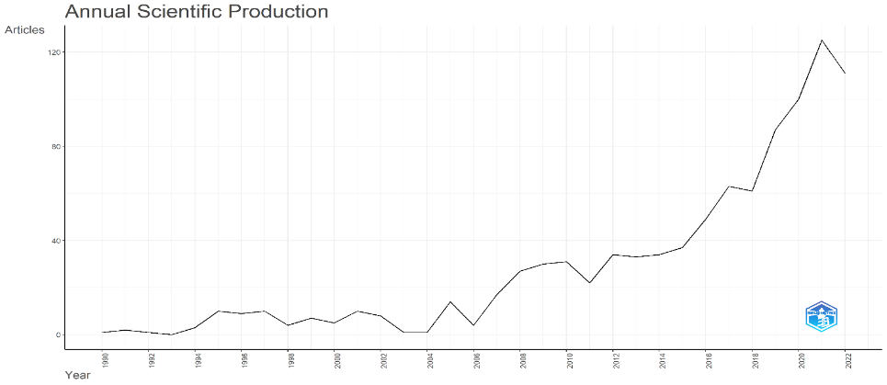

3.3Analyzing the Contribution of Journals
In order to point outthe most contributing journals, most relevant sources category has been taken it is found from Figure 2 that the journal “Sustainability” had the highest Input in this area. This journal alone contributed 219 research articles in the area of sustainable tourism. Followed by “Journal of Sustainable tourism” with 148 documents, “Tourism management” with 73, and “Annals of tourism Research” with 53 documents are the main journals in the field of sustainable tourism.

Figure 2
Most Relevant Sources
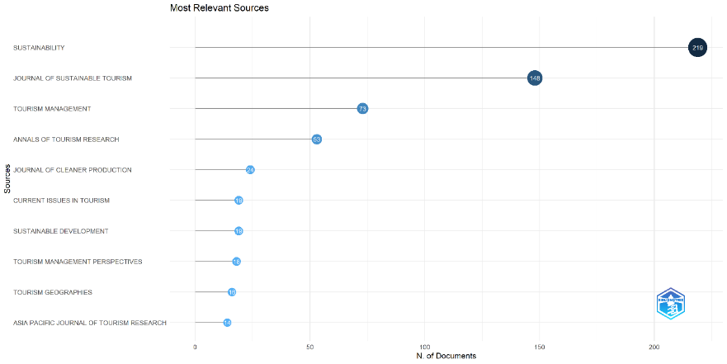

3.4 Most relevant Authors
The most relevant authors in the filed of sustainable tourism are depicted in Figure 3. Bramwell B is the top most among the ten authors with 17 publications, Lane B with 13 publications followed by Blancas F J and Lozano - Oyola M with 9 publications each.
Figure 3
Most Relevant Authors
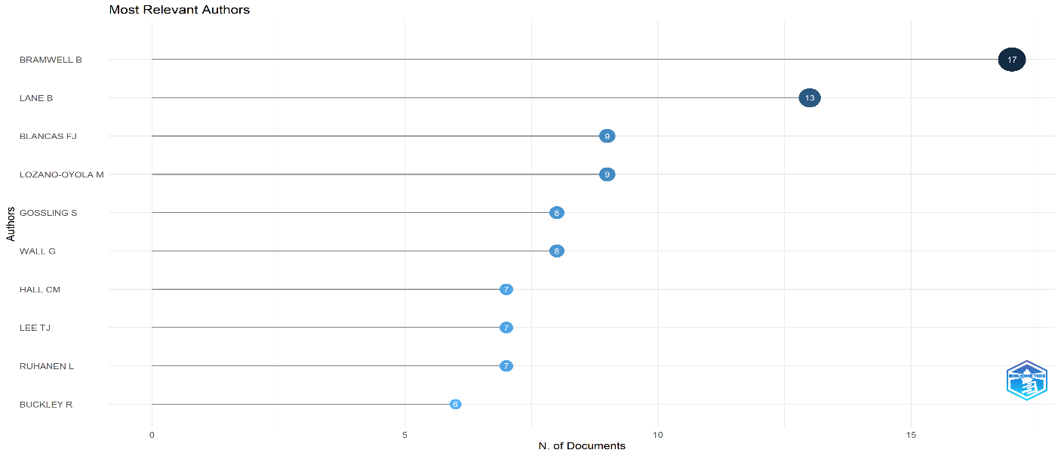

3.4Contribution by Countries
From the bibliometric analysis it is found that among various countries contribution in the aa of sustainable tourism (Figure 4), China occupies the top of the list with 269 research papers followed by Spain 277 papers, and Australia 164 papers. In case of India only 18 papers were published in field of Sustainable Tourism. Hence, there is a scope for future research in the field of sustainable tourism.
Figure 4
Countries Scientific Production
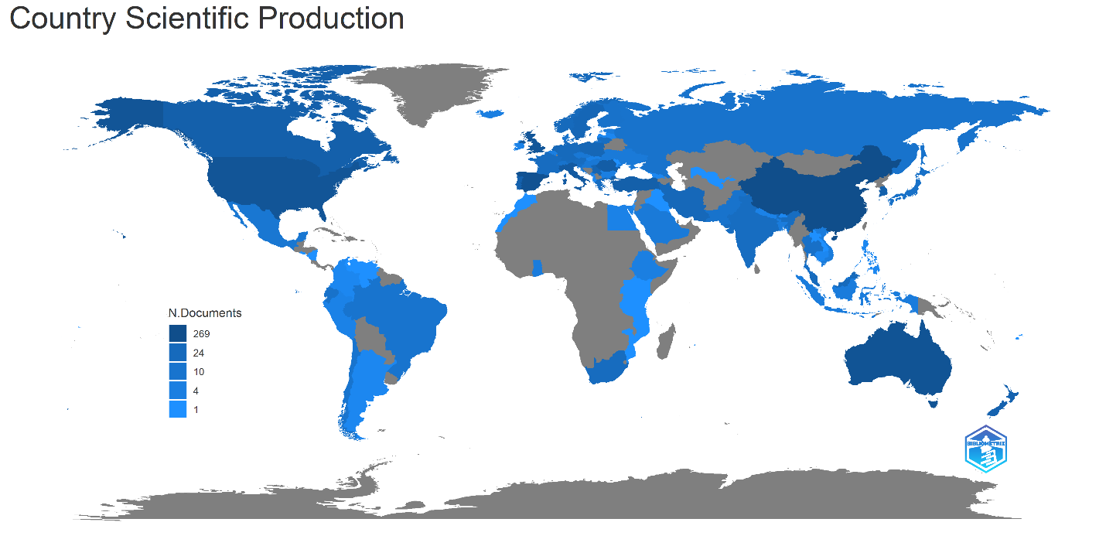

3.5Bradford’s Law
Bradford's law of dispersion describes how studies in a discipline are scattered over the universe of journals. It is revealed from Figure 5 that most articles are published in Sustainability journal followed by Journal of sustainable tourism.
Figure 5
Braford’s Law
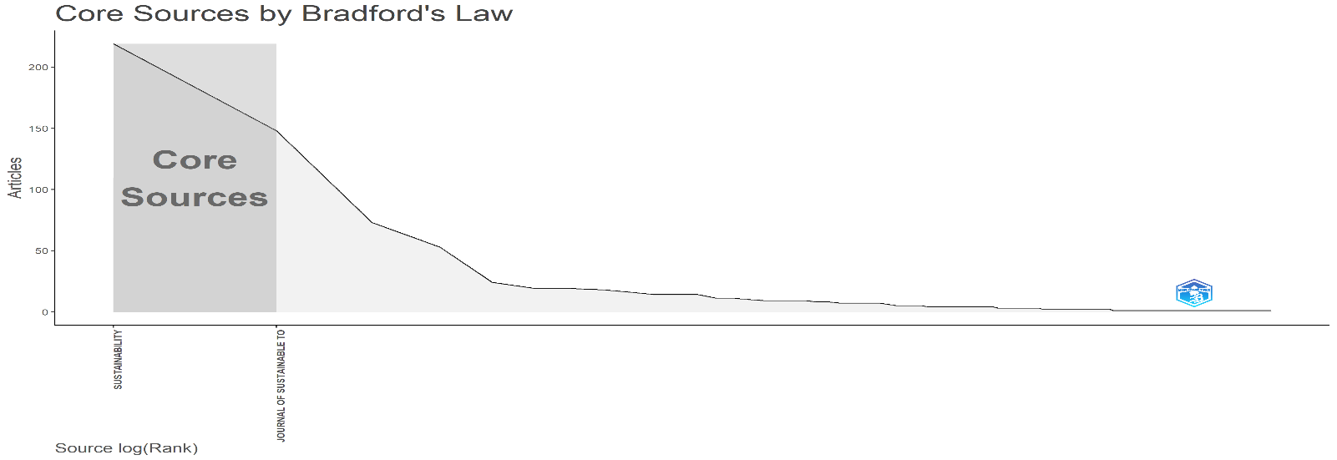

3.6 Word cloud
Word cloud shows the frequency of words used in studies related to sustainable tourism. Figure 6 shows that Management, Eco tourism, destinations, climate change, conservation and community are the frequently used key words in most of the studies.
Figure 6
Word cloud
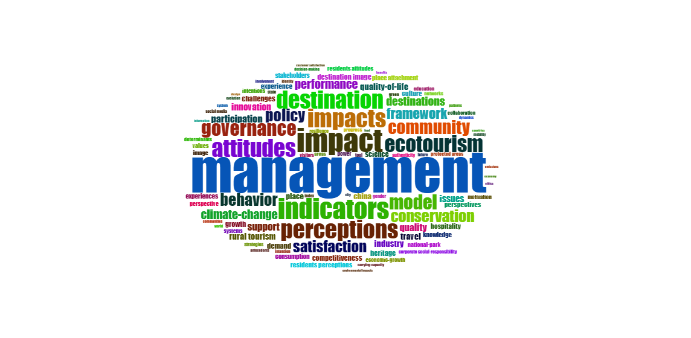
4.Conclusion
The sole objective of this study was to deliver a comphrehensive review of the research conducted in the field of sustainable tourism. Bibliometric analysis has been done on the topic sustainable tourism with keywords “Sustainable tourism” for a period from 1990 to 2022. Researchers working in the sustainable tourism field can use this study to develop strategies centered on the topics that are emerging (as evidenced by the data visualization in this study). Furthermore, they are capable of identifying the most influential journal, papers,and authors in the field of sustainable tourism. To summarize, this study has made an important contribution in expanding scope of knowledge on sustainable tourism research. The study had provided valuable inputs in the sustainable tourism research area by examining 951 studies from web of science database. According to the findings, research interest in this field has skyrocketed from 2020 to 2022.
References

Garg, P., & Pandey, A. (2021). Towards sustainable tourism: an empirical investigation. Foresight, 23(2), 188–200. https://doi.org/10.1108/FS-04-2020-0042/FULL/HTML
Hussain, K., Ali, F., Ragavan, N. A., & Manhas, P. S. (2015). Sustainable tourism and resulting resident satisfaction at Jammu and Kashmir, India. Worldwide Hospitality and Tourism Themes, 7(5), 486–499. https://doi.org/10.1108/WHATT-06-2015-0024
Kaul, H., & Gupta, S. (2009). Sustainable tourism in India. Worldwide Hospitality and Tourism Themes, 1(1), 12–18. https://doi.org/10.1108/17554210910949841
Kokkranikal, J., Hospitality, A. M.-T. and, & 2002, undefined. (2002). Entrepreneurship and sustainable tourism: The houseboats of Kerala. Journals.Sagepub.ComJ Kokkranikal, A MorrisonTourism and Hospitality Research, 2002•journals.Sagepub.Com, 4(1), 7–20. https://doi.org/10.1177/146735840200400102
Saleem, F., Khattak, A., & Rehman, S. U. (2021). Bibliometric Analysis of Green Marketing Research from 1977 to 2020 Bibliometric Analysis of Green Marketing Research from 1977 to 2020. MDPI, 9(1). https://doi.org/10.3390/publications9010001
Sánchez, J. M., Rodríguez, J. P., & Espitia, H. E. (2022). Bibliometric analysis of publications discussing the use of the artificial intelligence technique agent-based models in sustainable agriculture. Heliyon, 8(12), e12005. https://doi.org/https://doi.org/10.1016/j.heliyon.2022.e12005
Thottekat Sri Guru Tegh Bahadur Khalsa, V., Kumar Sri Guru Tegh Bahadur Khalsa, D., & Kumar, D. (2017). Sustainable development through sustainable tourism in India-A case study of Kerala tourism. Indianjournals.ComT Venugopalan, D KumarAsian Journal of Research in Business Economics and Management, 2017•indianjournals.Com, 7(12), 10–27. https://doi.org/10.5958/2249-7307.2017.00189.X
Yadav, N., Sahu, N. C., Sahoo, D., & Yadav, D. K. (2018). Analysis of barriers to sustainable tourism management in a protected area: A case from India. Benchmarking, 25(6), 1956–1976. https://doi.org/10.1108/BIJ-09-2016-0149/FULL/HTML

