Futuristic HR Trends: Reshaping Human Resource Management
Pankaj Thakur
Faculty in the Department of Management,
Rabindra Nath Tagore Government College Sarkaghat, Mandi, Himachal Pradesh, India

Abstract: An organization is a combination of physical resources (machines, technology, money, etc.) and human resources. With the ongoing changes in the business environment, it is imperative to think strategically and move forward. To move forward every organization needs to rethink and redesign its operations. This is only possible through its human resources. In the current scenario, human resource management has undergone several changes. These changes have been discussed in the form of HR trends and these trends have an impact on the HR processes in the future. Now, the HR industry is moving from a hybrid work model to a metaverse. The variable work modes differentiated manpower with varied skills, different work relationships, divergent cultures, and sub-cultures have made HR managers think strategically. There has been a change from the conventional approach to the well-being of employees to a more holistic approach to creating healthy organizations. HR leaders are rethinking and constructing new approaches to organize and utilize human resources in an organizational setup beyond the traditional boundaries of the organization. New HR trends are increasing the transformation and adding value to the industry. Here the researcher has made an attempt to highlight the HR trends that are going to reshape human resource management in the future.
Keywords: Futuristic Approach, HR Analytics, HR Trends, Hybrid Working Model, Metaverse, and Transition to Healthy Organizations

1. Introduction: Human resource management is a strategic and cohesive process for the efficient management of the workforce so that organizations have a competitive edge over their competitors. (Luthans and Youssef, 2004). There is a significant impact on human resources due to the emergence of various trends that reshape the working of organizations. In the last few years, human resources have changed very significantly. There is a paradigm shift in technology and hybrid and remote working culture has emerged globally. HR analytics and AI intelligence have a key role in HR processes. These strategies were in focus but after the pandemic, they are in mainstream. These practices are reshaping the HR and its processes. The pace at which digital transformation is going on has changed employee-employer dynamics and work processes drastically at the global as well as national level. It is causing disruptive changes in the workforce and these changes have been termed a socio-technical revolution (Ferrari et al., 2020). HR people are constantly embracing these changes but to take the lead and stay ahead they must be proactive in embracing the fundamental changes going on at the workplace. To lead the shift HR leaders are designing a work culture that engages people, and they are developing new models of leadership and career development. They are being asked to reshape the work processes, help employees manage information overload, and create a collaborative and innovative culture. They are being asked to upgrade skills in the area of digital technologies, people analytics, artificial intelligence, and metaverse and hybrid working. As the pace of transformation is accelerating, HR leaders need to take aggressive steps to address these changes. This will help them to meet the global challenges and to have a competitive advantage.

2. HR Trends
2.1 Hybrid Working Model: After a post-pandemic period the organizations are switching to a hybrid working model. The hybrid working model is considered to be employee-centric which offers a flexible working approach; a mix of working in-office and working remotely. The hybrid working model is shown below. In this 2×2 matrix, the lower left quadrant shows a traditional working culture in which the employee has to work in the office as prescribed by his organization without any flexibility. Some firms are allowing more flexible hours to work in the office as shown in the lower right quadrant. Some firms are giving their employees more flexibility to work from anywhere during office time as shown by the upper left quadrant. Very few firms are allowing their employees to work from anywhere at any time as shown in the upper right quadrant which represents a hybrid working model (Gratton,2021).
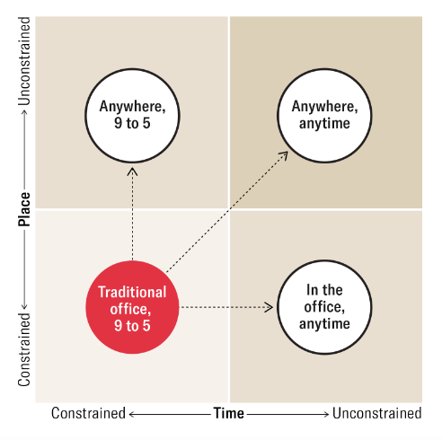
Figure 1. Hybrid Working Model Source: HBR
There are two ways in which a hybrid work model can work. One way is the discretion of the employer i.e., mandated hybrid work, and the other is left to the employee’s discretion known as employee’s choice hybrid. In the mandated hybrid the employer determines the presence of employees in the office as per the company policies. On the other hand, in the employee’s choice hybrid employee has no restrictions and enjoys full flexibility in the work. Google was the first company to introduce a hybrid working model and later on, more companies like Microsoft, Facebook, Infosys, etc. adopted this model. The HR leaders need to clarify the roles and tasks of employees to achieve the performance and productivity goals of the organizations. They need to establish co-ordination among teams and need to invest in training these teams to support and run this new work culture
2.2 Metaverse Workplace: As technology is advancing day by day the metaverse workplace is becoming an everyday reality. Neal Stephenson, a science fiction author was the first person who talked about the metaverse in his novel Snow Crash in 1992. Metaverse allows to creation of digital workstations and allows employees to interact in their physical environment with employees in virtual environments through digital avatars (Riva & Wiederhold, 2022). Metaverse reshapes the workplace in four main ways: collaborating teams in an immersive way; the emergence of new digital avatars; enhancing skill acquisition and learning by gamification and virtualization; and the emergence of a metaverse economy with new enterprises and tasks (Prudy, 2022). This is a big transformation in the working culture. The tech giants Meta (earlier known as Facebook), Apple, Google, and Microsoft are investing heavily in metaverse technology. As Metaverse is redesigning the way people work the HR leaders who are driving this transformation need to think that this transformation is designed in accordance with the people working in the organizations. They should design the metaverse in a way that enhances business performance. There is a need to redesign the working policies and train leaders to ensure a healthy metaverse working environment that leads to the development and growth of business (Vuplen,2022).
2.3 HR Analytics: HR analytics is also known as people analytics, manpower analytics, or talent analytics. HR analytics is a systematic gathering of data, analysis of data, and reporting of data related to the management of human resources. This can be done by using proper HR analytics software. This approach is fact-based and it is concerned with decision-making and action-taking to human capital (Margherita, 2022). By using different processes and applications HR analytics combines data from HR and business to analyze it to find out the performance characteristics, career ladder, and people-related risks.
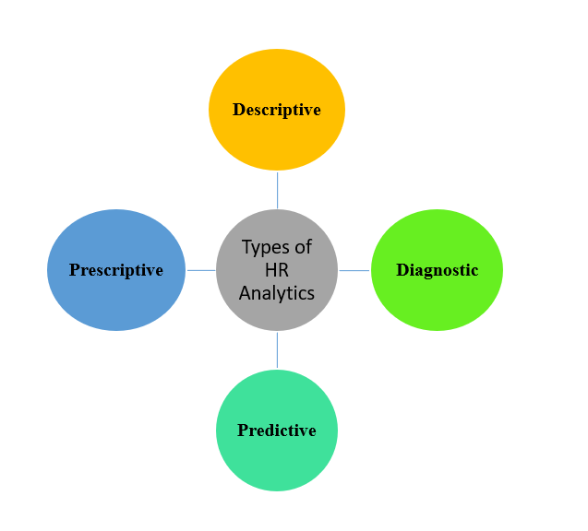
Figure 2. Types of HR Analytics As per Gartner’s Model
Descriptive: It gives the answer to “What” of HR data, interprets & and analyses historical data, and uses performance indicators and dashboards to explain it.
Diagnostic: It gives the answer to the “Why” of HR data, and it provides analysis of descriptive data.
Predictive: It answers what HR data “Will” be. By using statistical modeling, it predicts results and gives an insight into what the future trend will be.
Prescriptive: It prescribes evidence-based results to HR data by using simulation and optimization techniques.
HR analytics is useful in manpower planning. It develops insights and models that are helpful in performance management and also helpful in finding positive and negative future trends. On the broader side HR analytics is helpful in gaining a competitive advantage and fostering business growth at a pace (Tomar & Gaur, 2020).
2.4 Artificial Intelligence (AI) & HR: Artificial intelligence has entered every arena of the business landscape and HRM is not untouched by it. Most business organizations are adopting AI to enhance their productivity and the rate of adoption of AI globally stands at 35% (IBM Global AI Adoption Index, 2022, 2022). AI is a multifaceted science that has the ability to impersonate human cognitive abilities (Upadhyay & Khandelwal, 2018). Artificial Intelligence and big data analytics have the ability to automate repetitive work otherwise add monotony and it is going to help HR managers make important decisions regarding recruitment, performance appraisal, training and management, and talent management. AI adds monetary, strategic, and competitive advantages to organizations as it lowers HR costs. (Cappelli et al., 2018). However, there are some challenges when it comes to integrating AI with HR processes. These challenges include how to add AI into current systems, data privacy, security concerns, and ethical issues. These need to be addressed and there is a need to train and upskill the HR people to make effective use of AI tools so that they can use AI in HR operations and outcomes. HR managers should focus on developing AI strategies and these strategies should be aligned in such a way that they are going to accomplish the organizational objectives (“State of AI in Human Resource Management: 2023 Report| Engagedly”, 2023).
2.5 Transition to Healthy Organization : Every organization, whether big or small in structure nowadays is focusing on the holistic approach of healthy organizations rather than simply focusing on the mental health of the employees. This approach creates a work culture that is better for the overall well-being of the employees and it surpasses the traditional approach of employee well-being. This approach provides an environment that is supportive and provides opportunities for personal and professional growth. In healthy organizations, people feel supported and valued. This leads to increased productivity and reduced absenteeism. Healthy organizations can retain top talents and there is increased collaboration and teamwork among employees (Verasai, 2023).
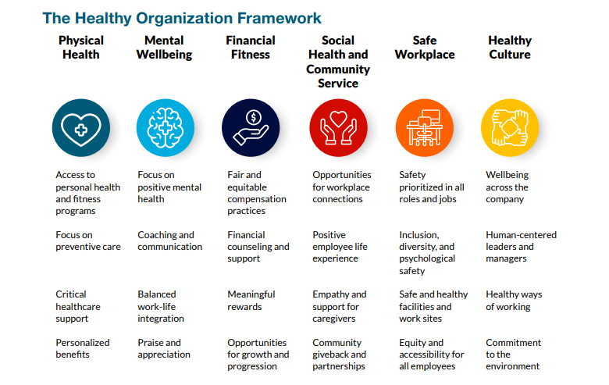
Figure 3. Source: The Healthy Organization, The Josh Bersin Company, 2021

2.6 Diversity, Equity, and Inclusion (DEI): Diversity, equity, and inclusion came into existence in organizations as a result of contemporary racism, biases, sexism, and other harmful activities. It has become a buzzword in most of the organizations and it should be. DEI refers to the inclusion and involvement of people in organizations irrespective of their race, ethnicity, culture and subculture, age groups, and sexual orientation (Ganeshan & Vethirajan, 2022). Most of the time diversity, equity, and inclusion are grouped under one umbrella because they are interconnected. But in a real sense, they are different. Diversity refers to the composition of people who represent the workplace in an organization. It may be gender diversity, age diversity, race diversity, ethnic diversity, and physical and neuro-ability diversity. Equity means fair treatment of all employees irrespective of diversity. Inclusion refers to the degree to which organizations embrace their employees and allow them to contribute. “A series of three McKinsey Reports: Why Diversity Matters (2015), Delivering Through Diversity (2018), and, Diversity Wins: How Inclusion Matters (2020) have shown the correlation between DEI and organizational performance”. DEI helps in retaining talent, and improves decision-making, enhances team culture, improves job satisfaction, and creates a global image of the company (“What is diversity, equity, and inclusion (DE&I)? | McKinsey”, 2022). HR leaders should realize different perspectives coming from different people coming from different or the same demographics. when it comes to DEI. Being proactive thinkers, they must realize the benefits of a diverse business culture.
3. Conclusion: From the viewpoint of the above explanations, these HR trends are going to affect the working culture globally in every kind of organization. In the meantime, to adopt these trends there is a need to think strategically. In the era of complexity and data-driven technology, HR leaders must work in collaboration to create values. The HR managers should redesign and reframe the policies in a holistic way so that these policies are going to achieve the overall objectives of organizations. They should come up with the person-fit and organization-fit strategies to make the transition successful. While redesigning and reshaping the organizations and organizational strategies the concern should be people-centered not institutional-centered. It largely depends upon the HR managers how creatively they adopt these changes that are much needed to have a competitive advantage. Many HR professionals envision creating a workforce of the future with more flexibility and they are using technology that can really drive them to success. HR managers must adopt a proactive approach as most of the infrastructure and technology are already with the organizations. These HR trends are surely going to benefit organizations if HR people adopt a holistic approach of having healthy organizations, hybrid working spaces, and metaverse working with the inclusion of people from diverse races, ethnicities, and cultures without any kind of abuse.

References:
Cappelli, Peter & Tambe, Prasanna & Yakubovich, Valery. (2018). Artificial Intelligence in Human Resources Management: Challenges and a Path Forward. SSRN Electronic Journal, 1-29, DOI 10.2139/ssrn.3263878
Fareri et al. (2020). Estimating Industry 4.0 Impact on job profiles and skills using text mining. Computers in Industry, 118. https://doi.org.10.1016/j.compind.2020.103222.
Ganeshan, M K & .C, Vethirajan. (2022). DIVERSITY, EQUITY, AND INCLUSION IN THE WORKPLACE IN HUMAN RESOURCE MANAGEMENT. Conference: International Congress on Social Sciences, China to Adriatic-XIV At: Kayseri, Turkey
Gratton, L. (2021, May-June). How to Do Hybrid Right. August 24, 2023. https://hbr.org/2021/05/how-to-do-hybrid-right
HW-21_10-DefGuide-The-Healthy-Organization-ExecSum.pdf. (2021). August 27, 2023. https://joshbersin.com/wp-content/uploads/2021/10/HW-21_10-DefGuide-The-Healthy-Organization-ExecSum.pdf
IBM Global AI Adoption Index 2022. (2022, May). August 26, 2023. https://www.ibm.com/downloads/cas/GVAGA3JP
Luthans, F. & Youssef, C.M. (2004). Human, social, and now positive psychological capital management: Investing in people for competitive advantage. Organizational Dynamics, 33, 143-160. https://doi.org/10.1016/j.orgdyn.2004.01.003.
Margherita, A. (2022). Human Resources Analytics: A systemization of research topics and direction for future research. Human Resource Management Review, 32(2). https://doi.org/10.1016/j.hrmr.2020.100795.
Purdy, M. (2022, April 5). How the Metaverse Could Change Work. August 24, 2023. https://hbr.org/2022/04/how-the-metaverse-could-change-work
Riva, G. & Wiederhold, B.K. (2022). What the Metaverse Is (Really) and Why We Need to Know About It. Cyberpsychology, Behaviour and Social Networking, 25(6), 355-359. https://doi.org/10.1089/cyber.2022.0124.
State of AI in Human Resource Management: 2023 Report| Engagedly. (2023). August 27, 2023. https://engagedly.com/ai-in-hr-2023-report/
Upadhyay, A. K., & Khandelwal, K. (2018). Applying artificial intelligence: implications for recruitment. Strategic HR Review, 17(5), 255-258.
Verasai, A. (2023, April 18). Transitioning From Employee Well-being To Healthy Organization. August 27, 2023. https://www.thehrdigest.com/transitioning-from-employee-well-being-to-healthy-organization/
Vuplen, E. van. (2022, June 3). Three Ways The Metaverse Could Transform HR. August 25, 2023. https://www.forbes.com/sites/forbeshumanresourcescouncil/2022/06/03/three-ways-the-metaverse-could-transform-hr/
What is diversity, equity, and inclusion (DE&I)? | McKinsey. (2022, August 17). August 28, 2023. https://www.mckinsey.com/featured-insights/mckinsey-explainers/what-is-diversity-equity-and-inclusion

