EFFECT OF HUMIC ACID AND NPK FERTILIZERS ON CROP GROWTH AND YIELD RESPONSE OF RICE (Oryza sativa L.)
R. Catherine Pockisha ª, Dr. K. Arivazhagan ª, Dr. P. Senthilvalavan ª and Dr. S. Natarajan ^{b}
a Department of Soil Science and Agricultural Chemistry, Faculty of agriculture, Annamalai university, Chidambaram.
b Department of Agronomy, Faculty of agriculture, Annamalai university, Chidambaram.

ABSTRACT
Rice (Oryza sativa L.) is a widely grown crop everywhere in the world and is taken into consideration as the “worldwide grain’’. In gift scenario the growing need for food production via sustainable cultivation practices, without lowering crop yield and producer income, is a first-rate objective because of accelerated environmental pollution, extended use of chemical fertilizers and the slow degradation of cultivated soils. To avoid such environmental degradation, to lessen use of chemical fertilizers, cost of cultivation and to attain sustainability in production, a promising and environmental-friendly innovation would be the usage of natural plant bio-stimulants (PBs) that beautify flowering, plant increase, fruit set, crop productiveness and nutrient use efficiency (NUE), and are also capable of enhance the tolerance towards a wide variety of abiotic stresses (Colla and Rouphael, 2015). Researchers have proven that bio-stimulant like humic acid which include a complicated mixture of polysaccharides, micronutrients and plant increase hormones, promote plant growth and enhance plant resistance to abiotic stresses.
Humic substances are extraordinarily versatile and critical additives of the natural soil- ecosystem, where they have got persevered for hundreds of years (Mayhew, 2004). Foliar application of humic acid could increase osmotic regulators in comparison with other fertilizer sources, reducing the damage resulting from drought strain to some useful trends of cultivars. Humic acid, in contrast with other dietary systems at higher tiers, cause increase in chlorophyll degrees. It additionally reasons photosynthetic balance with growth in yield (Jaber Mehdiniya afra et al., 2022). The humic acid has a superb effect on the effectiveness of the enzymes and vitamins plant metabolism. It improves the chemical, bodily and biological traits of the soil. Thereby, influencing the increase of roots, elongation of stem and boom in plant peak (Ragheb hadi AL-bourky et al., 2021).
Keywords: Humic acid, Rice, growth and yield

1. Introduction
1.1 What Is Humic Acid?
Humic substances are extremely versatile and critical components of the natural soil- ecosystem, where they have persisted for hundreds of years (Mayhew, 2004). Humic acid is the final break-down constituent of the natural decay of plant and animal materials. Humic matter is formed through the chemical and biological humification of plant and animal matter and through the biological activities of micro-organisms. They're the maximum broadly used allotted organic products of biosynthesis on the floor of the earth, exceeding the quantity of organic carbon contained in all dwelling organisms.
They provide a focused and reasonably priced shape of organic be counted which could replace humus depletion as a result of conventional fertilization techniques in soil. The addition of humic substances to soils can stimulate plant growth past the outcomes of mineral nutrients alone. Humic materials are drastically used all over the globe because of their benefits in agricultural soils, mainly in soils with low organic content. The sources of Humic Acid consist of coal, lignite, soils, and organic materials. Humic acid can positively have an effect on soil physical, chemical, and biological characteristics, along with texture, shape, cation exchange potential, pH, soil carbon, enzymes, nitrogen biking, and nutrient availability.
1.2 Relationship between humic acids structure and functions
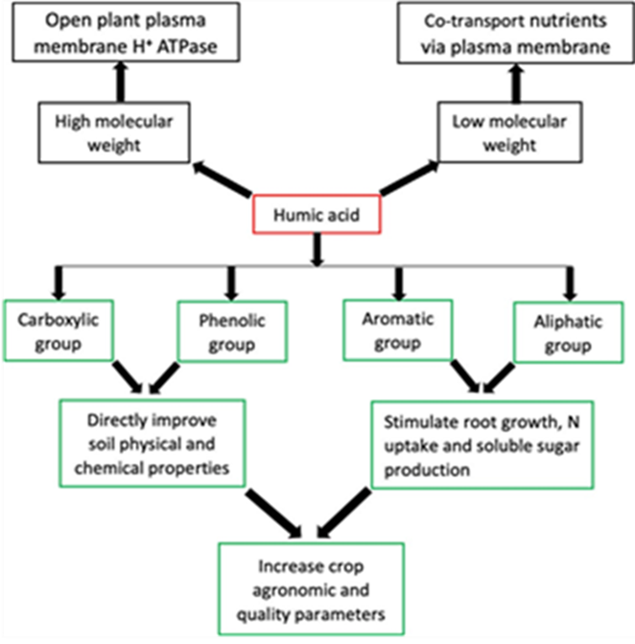
The features of HA are associated with their structures, which are source dependent (Nardi et al., 2021).
1.2.1 Aromatic and Aliphatic functional groups of HA
Recent research by van Tol de Castro et al. (2021) proved that the aromatic and aliphatic functional groups of HA were responsible for increasing N uptake and soluble sugars, which resulted in a corresponding yield increase in rice; meanwhile an earlier finding by Garciá et al. (2016) confirmed that HS aliphatic and aromatic functional groups stimulated root growth in rice seedlings.
1.2.2 Phenolic and Carboxylic groups of HA
HA structure contains many functional groups, the maximum major is phenolic (OH), and carboxylic (COOH) groups. The COOH and OH functional groups are mainly responsible for HA functions such as improving soil physical and chemical properties in addition to plant growth.
Dissociation of these functional groups creates polar and non- polar ends, which are the hydrophilic and hydrophobic parts, respectively. The hydrophilic end is mainly involved in chelating functions, while the hydrophobic end is connected with repelling purposes
1.2.3 Low and High molecular weight groups of HA
Humic acids with low molecular weight (LMW) contain more phenolic and carboxylic functional groups than HA with high molecular weight (HMW). The chelating ability of HA has also been attributed to LMW, which is efficacious in altering the biochemical characteristics of the soil.
The HMW is efficient in enhancing the soil physical conditions. HA with HMW have also been observed to stimulate plasma membrane H+ ATPase, allowing LMW HA to co-transport nutrients and perform different biological activities in plants.
1.3 Formation of Humic substances
Humification is a natural system of changing organic matter such as leaves into humic substances by using geo- microbiological mechanisms. This process starts whilst organic residues from flora and animals come in touch with microbial existence in the soil. At some point of humification, microbes make use of carbon compounds for its personal metabolism with the undigested part of residue gathering as humus.
However, regardless of the degree at which the pathway is favored, all pathways considered are feasible for the synthesis of humic substances in nature. Nevertheless, their contribution may differ from one environment to another. The assimilation of nutrients from the organic residues with the aid of microorganisms constitutes the first stage of forming humus. This procedure ends in the formation of complex chemical systems, which are extra stable than the chemical structures of the beginning materials. When the decomposed organic matter reaches a certain degree of humification, it can be referred to as humus (humic substances) that is an aggregate of complex natural compounds (humic acid, fulvic acid and humins). Numerous pathways were postulated to give an explanation for the genesis/formation of humic substances all through the decay of plant and animal matter in soil.
But, irrespective of the degree at which the pathway is desired, all pathways considered are possible for the synthesis of humic substances in nature. Despite the fact that, their contribution might also fluctuate from one environment to some other.
1.3.1 The lignin theory (pathway 1)
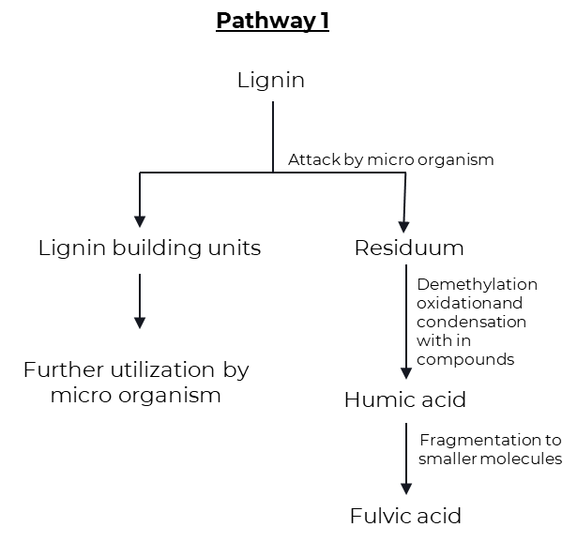
This theory assumes that lignin is incompletely utilized by the microorganisms and the residue becomes part of the soil humus. The amendment of lignin includes the loss of methoxy groups (-OCH3) with the generation of o-hydroxyphenols (C6H5OH) and carboxyl groups (-COOH). This m material is what has humic and fulvic acids.

The subsequent evidence was cited through Waksman (1932) in assist of the lignin principle of humic acid formation:
- Both lignin and humic acid are decomposed with extensive difficulty by the great majority of fungi and bacteria.
- Both lignin and humic acid are partly soluble in alcohol and pyridine.
- Both lignin and humic acid are soluble in alkali and precipitated by acids.
- Both lignin and humic acid are acidic in nature.
- When Lignins are warmed with aqueous alkali, they are converted into methoxyl-containing humic acids.
- Humic acids have properties similar to oxidized Lignins.
1.3.2 The polyphenol theory (Pathway 2 and 3)
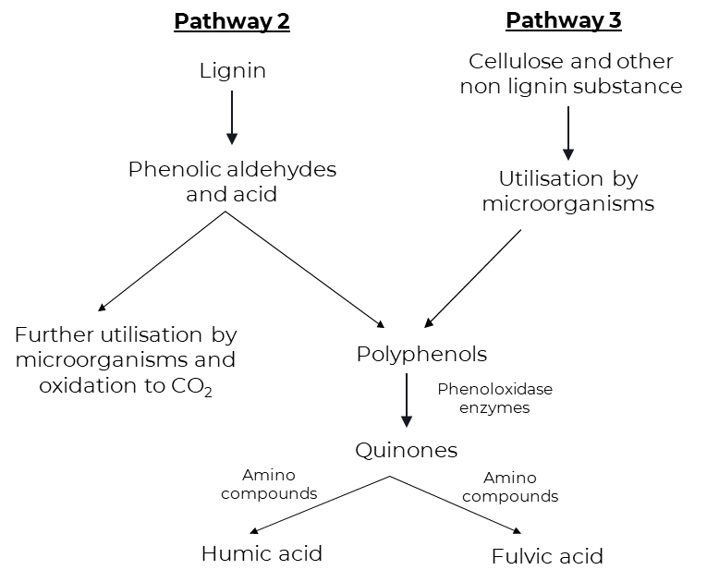
Pathways 2 and 3 are truly similar besides that polyphenols in pathway 2 are synthesized by microorganisms from non-lignin carbon (C) sources like cellulose. Polyphenols are then enzymatically oxidized to quinones and converted to humic substances. Quinones of lignin origin, collectively with those synthesized by means of microorganisms are assumed to be the main building blocks from which humic substances (humic and fulvic acids) are shaped in pathway 3, cellulose and different non-lignin substances are the starting substances.
In this pathway lignin still plays an crucial function inside the humus synthesis, but in a exclusive way from the lignin concept. Phenols, aldehydes, and acid launched from lignin (beginning cloth for pathway 2) all through microbial attack undergo enzymatic conversion to quinones. Those quinones in turn polymerize within the presence or absence of amino compounds to form humic-like micromolecules (Stevenson, 1982). Lignin is freed of its linkage with cellulose in the course of the decomposition of plant residues and subjected to oxidative splitting with the formation of primary structural units along with derivatives of phenyl propane.
The side chains of lignin-constructing units are then oxidized and demethylation happens. The ensuing polyphenols are transformed into quinones with the aid of polyphenoloxidase enzymes. These quinones arising from lignin and possibly from different sources react with nitrogen-containing compounds to form dark-coloured polymer humic materials, that is a combination of humic and fulvic acids.
1.3.3 Sugar amine condensation (Pathway 4)
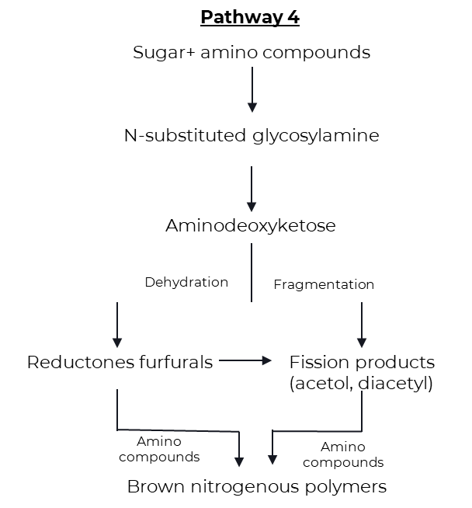
According to pathway 4, reducing sugars and amino acids, which are formed as by-products of microbial metabolism, undergo nonenzymatic polymerization to form brown nitrogenous polymers of the kind produced throughout dehydration of certain food products at moderate temperatures. Drastic and frequent adjustments inside the soil surroundings (freezing and thawing, wetting and drying) coupled with the intermixing of reactants and mineral substances having catalytic residences can also facilitate condensation.
An appealing feature about this theory is that the reactants (sugars, amino acid, etc.) are produced in abundance through the activities of microorganisms. Throughout the preliminary sugar amine condensation, amine is added to the aldehyde group of the sugar to shape n-substituted glycosylamine. Glycosylamine is in turn oxidized to form n-substituted-1-amino-deoxy-2- ketose. This is subjected to fragmentation and dehydration processes. Fragmentation results in the formation of 3-carbon chain aldehydes and ketones inclusive of acetol, diacetyl, and so on., whilst dehydration ends in the formation of reductones and hydroxymethyl furfurals. These compounds with ease polymerize within the presence of amino compounds to shape brown-colored products, in particular humic and fulvic acids (Stevenson, 1982).
1.4 Sources of humic acid
Humic substances can also originate from litters, roots, dead organisms and excrements of dwelling organisms determined in both soil or water. Traditional researchers have been keeping apart humic materials from soils and water. These humic substances had been re-generated within the soil via practices consisting of crop rotation, planting legumes, plowing beneath green manure and alertness of compost.
1.4.1 Different sources of humic substances with different concentrations
Natural Source | % Humic/Fulvic acid
Leonardite | 25 to 90
Compost | 5 to 25
Peat | 5 to 20
Lignite | 5 to 15
Manure | 1 to 3
Soft coal | 2 to 5
Hard coal | 0 to 1

1.5 Extraction of humic acid
1.5.1 Extraction of Humic acid from lignite by fractionation procedure by Stevenson (1982)
The Lignite is ground and passed through 0.25mm sieve.

The sieved lignite powder is dissolved in 0.5N sodium hydroxide solution (lignite: NaOH in 1:10)

The dark brown liquid is filtered through Whatman No.1 filter paper.

The filtrate is collected, the pH of the solution was adjusted to 1.0 with con. HCl and the precipitate (HA) is allowed to settle.

The supernatant is siphoned off (FA) and the suspension is filtered.

The precipitate is purified by redissolving in 0.5N NaOH and reprecipitating with con. HCl. This is repeated five times.

Then the humic acid is washed with distilled water till free of chloride, dried and ground to a fine powder.
1.5.2 Extraction of Humic Acid from Lignite by KOH-Hydrothermal Method
The air-dried sample of lignite powder (20 g) is treated with potassium hydroxide (KOH) and distilled water.

Then, the mixture is placed into oven (130–190 ◦C) and its naturally cooled to room temperature.

The supernatant is separated from residues by centrifugation. The residue is washed with distilled water until almost reaching neutral pH.

Then, the residue is filtered and dried in a vacuum oven at 105 ◦C.

The pH of supernatant is brought to pH < 2 with HCl, further separated by centrifugation, and dried in a vacuum oven at 60 ◦C.

The obtained dried material is the Humic Acid
1.5.3 Extraction of Humic Acid from Lignite by Ion Exchange Method
The humic acid is extracted from the lignite by combining the method of nitric acid peroxidation and the method of alkali solution and acid eduction.

Lignite is crushed and sieved using 80 mesh sieves.

The lignite (10 g) along with 0.5M NaOH is centrifuged for an hour.

The extracted solution was filtered using a Whatman paper.

The filtrate is treated with resin cation in order to obtain a humic acid solid.

1.6 Benefits of Humic acid
1.6.1 Physical benefits
- Improved structure of soil: Prevents excessive water and nutrient losses in sandy soils, simultaneously changing them into productive soils with the aid of way of decomposition.
- Prevents soil cracking, surface water runoff and soil erosion by the using growing ability of colloids to mix.
- Enables the soil loosen and disintegrate, and accordingly will increase aeration of soil in addition to soil workability. Increases water holding capacity of soil and thus helps resist drought.
- Darkens the colour of the soil and thus helps absorption of the sun’s energy.
1.6.2 Chemical benefits
- Increases buffering properties of soil.
- Acts as natural chelator for metal ions underneath alkaline situations and promote their uptake by means of the roots.
- Possesses extremely high cation-trade capacities.
- Promotes the conversion of nutrient elements (N, P, k + Fe, Zn and other hint factors) into forms available to vegetation.
- Complements the uptake of nitrogen by using vegetation.
- Reduces the response of phosphorus with Ca, Fe, Mg and Al and liberates it into a form that is available and beneficial to plants.
- Liberates carbon dioxide from soil calcium carbonate and allows its use in photosynthesis.
- Reduces the provision of poisonous substances in soils.
1.6.3 Biological benefits
- Acts as an organic catalyst in lots of biological techniques.
- Stimulates growth and proliferation of suited micro-organisms in soil
- Complements plant’s natural resistance against diseases and pests.
- Stimulates root increase, specifically vertically and allow better uptake of nutrients.
- Increases root respiration and root formation.
- Promotes the development of chlorophyll, sugars and amino acids in plants and resource in photosynthesis.
- Stimulates plant growth (higher biomass production) by accelerating cell division, increasing the rate of development in root systems and increasing the yield of dry matter.
- Increases the quality of yields; improves their physical appearance and nutritional value.

2. Review of literature
2.1 Effect of humic acid on growth and yield of rice
The study on the effect of humic-acid based bio-stimulant on growth, yield and yield attributing characters of kharif rice (oryza sativa L.) concluded that, soil application (broadcasting) of bio-stimulant (humic acid) @ 20 kg ha-1 (at 2-3 weeks of transplanting and at panicle initiation of rice) had higher crop growth parameters viz., plant height, number of leaves per hill, tillers per hill and dry weight and yield parameters viz., panicle length, no. of panicles per hill, no. of grains per panicle and grain yield and straw yield. The rice grain yield was also increased by 30.5 per cent over control treatment. (Karennavar et al., 2022)
Mitkar et al., (2022) concluded that the application of bio-stimulants showed positive effect on growth, yield and yield attributing characters of kharif rice. Significantly higher values of growth parameters were recorded at 60 DAT, 90 DAT and at harvest with the application of humic acid @ 0.5 per cent.
Humic acid at 2 g/mL with half of the recommended NPK can produce better vegetative growth and yield of Tadong upland rice. Also, it can reduce chemical fertilizer usage in rice cultivation. (Armeylee Joneer and Lum Mok Sam, 2022)
Kalyanasundaram et al., (2021) in the study of Yield maximization of direct sown rice (Oryza sativa l.) under water constraint situation concluded that the Tensiometer based irrigation with soil application of humic granules @ 2.5 kg ha-1 can be a feasible approach for increasing grain yield and conserve water in north eastern region of Tamil Nadu, by promoting water use efficiency method in direct rice cultivation areas.
The positive role acid humic which has a positive impact on the effectiveness of the enzymes and nutrients plant metabolism and this leads to a high amount of carbohydrates for most plants, which has impact on plant production and increase yield, as well as the impact of Humic acid in some metabolic processes of the plant, such as respiration and photosynthesis as well as the increase of antioxidants due keeps on securities content of chlorophyll from the demolition process.( Ragheb hadi AL-bourky et al., 2021)
2.2 Effect of humic acid on growth of rice
The application of Humic acid 12% @ 12.5 l ha-1 (T5) increased the growth attributes. Therefore, this experiment concluded that the application of humic acid 12% @ 12.5 L ha-1 was found to be agronomical superior, economically sustainable and ecologically viable practice for cultivation of rice. (Kumaravel et al., 2022)
The amino group and carboxylic group attached to natural buffering group for the ion exchanged in soil agriculture. The composition of humic acid consists of C, O, Al, Si and KCl. Humic substances were used to condition soils either by applying it directly to the soil as soil fertilizer. This research on the impact of short-term humic acid application on rice growth. HA and leonardite was beneficial to leaf and root growth of rice compared with the control. (Buntita jomhataikool et al., 2019)
2.3 Effect of humic acid on yield of rice
Yield contributing characters were significantly influenced by different treatment combinations of HA and PM along with chemical fertilizers and became maximum when humic acid and poultry manure were applied @ 6 L ha-1 and 3 t ha-1, respectively (Saha et al., 2013)
The results of experiment on Efficiency of Various Sources and Doses of Humic Acid on Physical and Chemical Properties of Saline Soil and Growth and Yield of Rice by Wanti Mindari et al., (2018) showed that humic acid from peat increased plant biomass weight, plant roots, grain number of tillers and chlorophyll content more than others. Humic acid efficiently can improve rice yields 10–20% supported by the suitability of soil pH, nutrient availability and soil salinity.
2.4 Effect of humic acid under drought stress condition
Foliar application of humic acid could increase osmotic regulators compared with other fertilizer resources, reducing the damage caused by drought stress to some functional traits of cultivars. Humic acid, in comparison with other nutritional systems at higher levels, led to an increase in chlorophyll levels. It also caused photosynthetic stability with increased yield. (Jaber Mehdiniya Afra et al., 2022)
2.5 Effect of humic acid on growth of rice under saline condition
Foliar spray with mixture of humic acid and K+ at panicle initiation and mid booting stages was significantly the most efficient treatment in improving rice grain quality, growth and yields. The mixture of humic and K+ could be recommended for improving rice quality and productivity of Giza 179 under salt stress.( Amira M. Okasha et al., 2019)
Application of Gypsum, Farmyard manure and Humic acid helped in improvement of soil properties and leaching of excessive ions to the deeper layer. Thus, concentration of salts was decreased in the upper layers which favoured the growth of plant and ultimately a significant increase in rice grain was observed. (M. Shaaban et al., 2013)
2.6 Effect of humic acid on nutrient uptake of rice
Humic substances (humic acid) attract positive ions, forms chelate with micronutrients and releases them slowly when required by plants and act as chelating agents there by prevents formation of precipitation, fixation, leaching and oxidation of micronutrients in soil. Humic substances (humic acid and fulvic acid) with its auxin activity induce hormonal effect on catalytic activity cell permeability and increases nutrient uptake and dry matter yield. (M Eshwar et al., 2017)
In the study of Differential responses of rice (Oryza sativa L.) to foliar fertilization of organic potassium salts, the potassium humate performed best among the different potassium salts used and significantly enhanced the number of leaves, root biomass, and nutrient uptake. This study confirmed the growth promoting attributes of organic potassium salts by improving yield and nutrient uptake of submerged rice. (Arnab Kundu et al., 2020)
Spraying humic acid or compost extract led to significant increases in most parameters of yield and its components as well as N, p & K content of grains and straw compared to no addition of such organic compounds in both seasons (El-Gohary et al., 2010)
2.7 Effect of humic acid on nutrient availability
The experimental results showed that humic acid from peat increased plant biomass weight, plant roots, grain number of tillers and chlorophyll content more than others. Humic acid efficiently can improve rice yields 10–20% supported by the suitability of soil pH, nutrient availability and soil salinity. (Wanti Mindari et al., 2019)
From the experiment on Effect of Lime, Humic Acid and Moisture Regime on the Availability of Zinc in Alfisol, Sushanta Kumar Naik and Dilip Kumar Das (2007) concluded that the humic acid application have favorable effect on the Zn availability at saturated condition.

3. Research evidences:
Table 1- Effect of humic acid with and without urea on the growth, yield of paddy IR 20
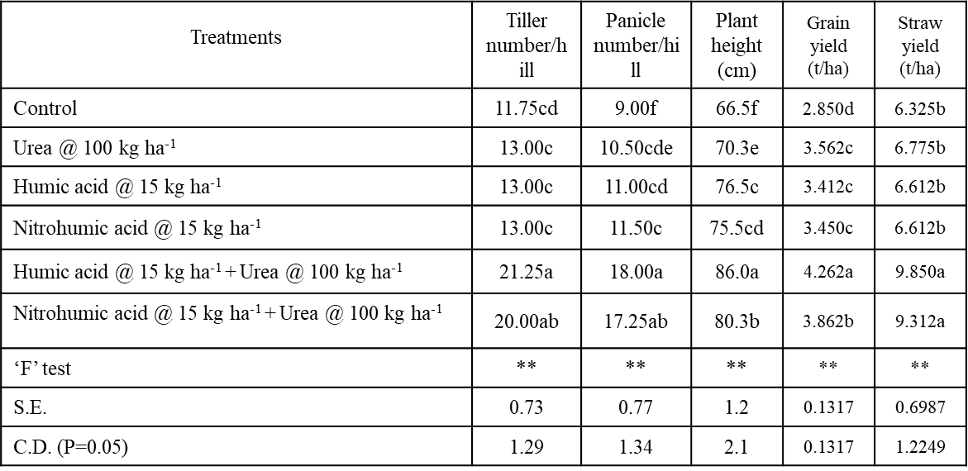

a, b, c, d, e, f denotes decreasing order of significance
Mean value of four replications
** Highly significant
Ravindra prasad (1988, M.Sc. Agri. Thesis)
Place: Annamalai Nagar, Tamil Nadu

Discussion:
The tiller number was significantly increased due to the application of humic and nitrohumic acid with urea. They were on par with each other and excelled all the other treatments in increasing the tiller number. The treatments humic and nitro humic acids equalled urea alone and check treatments in their effect on tiller number.
The panicle number was significantly increased when the humic acid and nitrohumic acid were applied with and without urea. The treatments humic and nitrohumic acids with urea were on par with each other and surpassed all the other treatments in their effect in increasing the panicle number. These were followed by the treatments humic and nitro humic acid without urea and urea alone. The control recorded minimum panicle number. The slow release of humic acids adsorbed nutrients might be released more periodically, which in turn would have satiated periodical crop demands throughout.
The plant height was affected significantly when humic and nitrohumic acids were applied with and without urea. The humic acid with urea excelled all the other treatments in its influence in increasing the plant height. This was followed by nitrohumic acid with urea treatment. These acids were on par in their effect on plant height they were effective than the treatments urea and control.
The grain yield of paddy IR 20 was significantly increased when the humic and nitrohumic acids were applied with and without urea. The huic acid excelled all the other treatments in its effect in increasing grain yield. This was followed by the treatment nitrohumic acid with urea which was significantly higher than the treatments humic and nitrohumic acids without urea. The treatments humic and nitrohumic acids without urea were on par with the urea alone treatment in this aspect. Urea was significant in increasing grain yield over control.
The application of humic and nitrohumic acids with urea increased the straw yield of paddy IR 20 to a significant level, these were on par and not significant in increasing the straw yield.

Table 2- Effect of humic acid with and without urea on the nutrient uptake of paddy IR 20
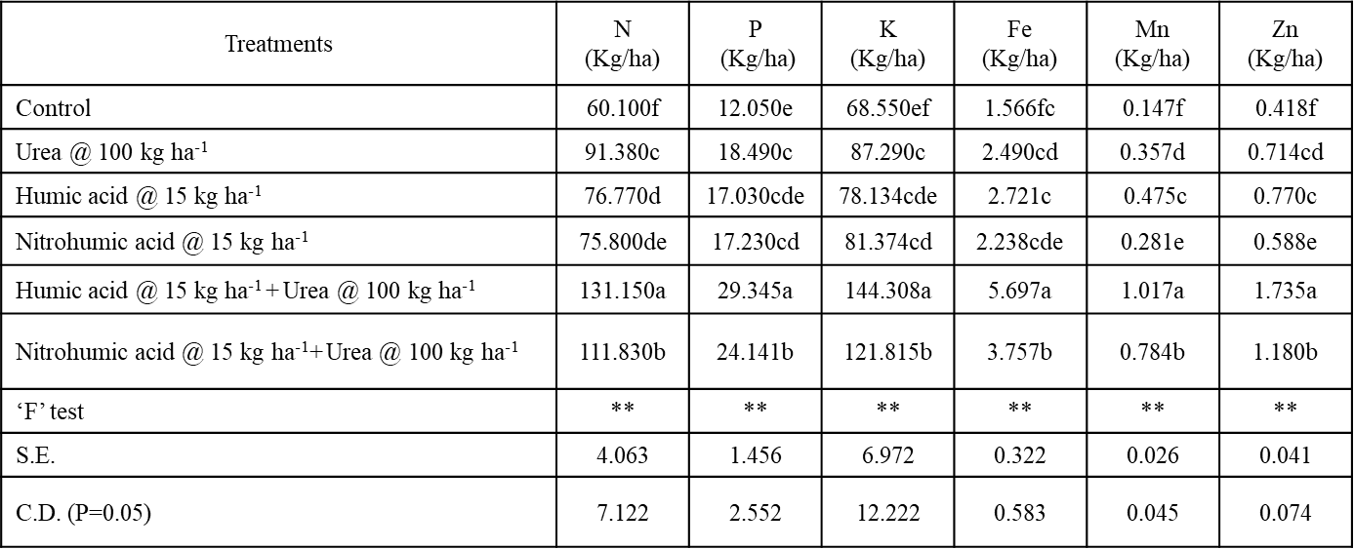

a, b, c, d, e, f denotes decreasing order of significance
Mean value of four replications
** Highly significant
Ravindra prasad (1988, M.Sc. Agri. Thesis)
Place: Annamalai Nagar, Tamil Nadu

Discussion:
The N uptake was greatly influence by the humic and nitrohumic acids when applied with and without urea. Humic and nitrohumic acids with urea recorded a maximum uptake of 131.50 and 111.83 Kg ha-1 respectively, but when they were applied without urea did not surpass the urea alone, but did the control, which recorded ad uptake of 60.10 Kg ha-1.
The P uptake was significantly increased when humic and nitrohumic acids were applied with urea. They recorded a maximum P uptake of 29.435 and 24.141 Kg ha-1 respectively. The humic and nitrohumic acids when applied without urea were on par with urea alone. The control recorded the minimum P uptake of 12.05 Kg ha-1.
The K uptake was significantly increased over control and urea alone when humic and nitrohumic acids were applied with urea. Humic and nitrohumic acids recorded a K uptake of 144.308 and 121.815 Kg ha-1 respectively in contrast with 68.550 and 87.290 Kg ha-1 in control and urea alone. The urea alone was on par with humic and nitrohumic acids alone.
The Fe uptake by paddy plants was significantly influenced over control when humic and nitrohumic acids were applied with urea. Urea alone, humic and nitrohumic acids without urea were on par within and excelled the control. Humic and nitrohumic acids with urea recorded a maximum uptake of 5.697 and 3.757 Kg ha-1 respectively. The control recorded a Fe uptake of 1.560 Kg ha-1.
The Mn uptake was significantly influenced when humic and nitrohumic acids were applied with urea. These without urea excelled the control and urea alone. The humic and nitrohumic acids showed a Mn uptake of 1.017 and 0.784 Kg ha-1 respectively and these with and without urea showed a Mn uptake of 0.475 and 0.281 Kg ha-1 respectively. The control showed a Mn uptake of 0.147 Kg ha-1.
The Zn uptake is greatly significant over control when humic and nitrohumic acids were applied with and without urea. The urea alone was on par with humic acid alone and superior to nitrohumic acid alone. Humic and nitrohumic acids with urea showed 1.725 Kg ha-1 and 1.180 Kg ha-1 of Zn. The control recorded a Zn uptake of 0.418 Kg ha-1.
Result:
The humic acid when added to soil at optimum levels increased the yield of paddy. The humic and nitrohumic acids increased the crop yield and uptake of nutrients by paddy IR 20. This may be due to the direct absorption of humic acid by plants, the auxin activity of humic acids, the humic acid activated active ion uptake or protein synthesis, the slow release of nitrogen due to humic acid and the chelation of micronutrients by humic acid and thereby rendering these available to plants.

Table 3- Effect of humic acid on root: shoot ratio of rice var. IR 20 (gm)
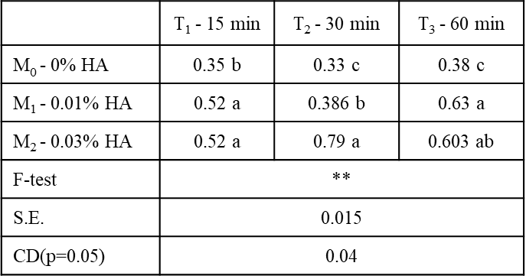
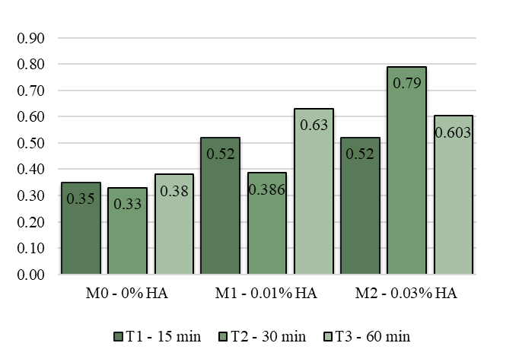

Nethala nivalini ushasree (1988, M.Sc. Agri. Thesis)
Place: Annamalai Nagar, Tamil Nadu
Discussion & Result:
The effect due to humic acid treatments on root: shoot ratio was significant. It is evident from the results that increasing root: shoot ratio was obtained due to humic acid. In this respect rice seedlings dipped in 0.03% HA concentration for 30 min gave the highest root: shoot ratio over the control and roots dipped in 0.01% HA concentration for 60 Min also gave significantly higher values comparatively.

Table 4- Influence of bio-stimulant on yield attributing characteristics
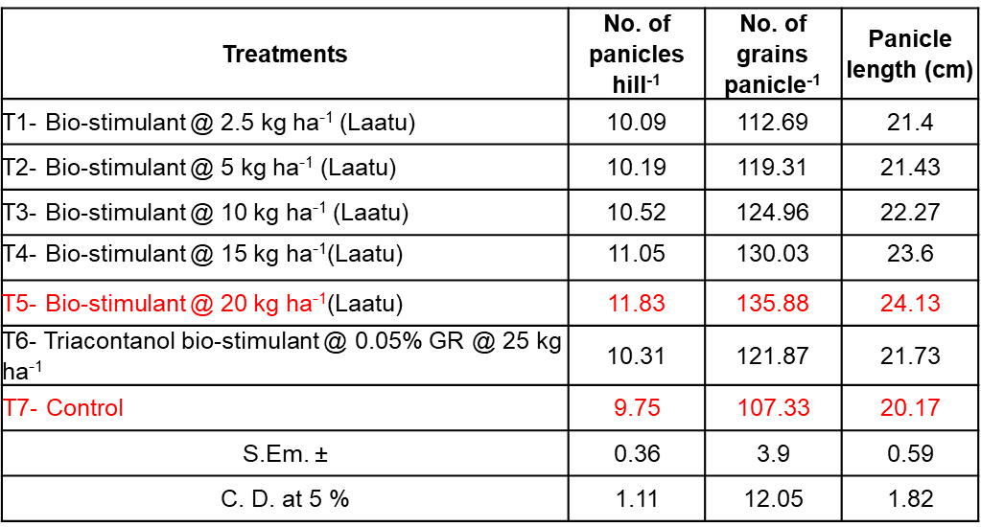
Karennavar et al. (2022)
Place: Maharastra
Discussion:
Substantially higher yield attributes had been recorded under T5 (bio-stimulant @ 20 kg ha-1) viz., No. of panicles hill-1 (11.83), No. of grains panicle1 (135.88) and Panicle length (24.13 cm) while T3 and T4 treatments had been located at par with T5. Numerically lesser no. of panicles (9.75), number of grains per panicle (107.33) and panicle length (20.17 cm) observed for T7.

Graph 2 - Influence of bio-stimulant on yield (grain and straw) characteristics (Kg ha-1)
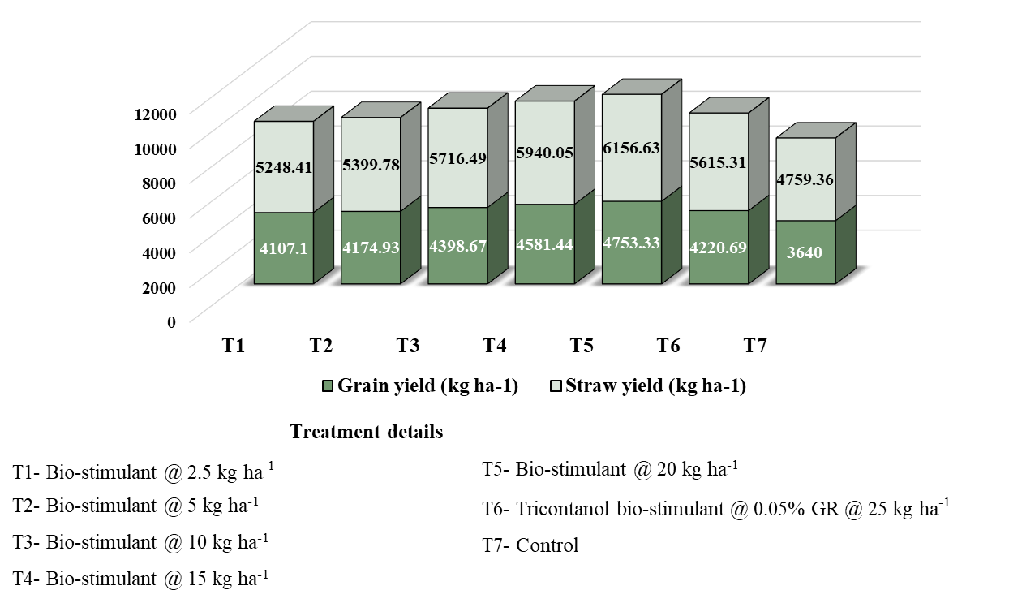
Karennavar et al. (2022)
Place: Dapoli, Maharashtra
Discussion:
All the yield attributing characters contributed definitely toward the mean grain, straw yield and biological yield. biostimulant @ 20 kg ha-1 (T5) recorded highest grain yield and straw yield whereas T3 and T4 were determined at par with T5 treatment. T5 produced 30.5 percentage higher grain yield and 29.35% straw yield than control (T7). Lower values of grain and straw yield are recorded with T7. The application of bio stimulant received higher yield and yield attributes because of effective utilization of native in addition to implemented nutrients.

Table 5- Effects of different levels of irrigation and water conservation practices on yield and yield parameters ha-1 of direct-sown CO 51 rice
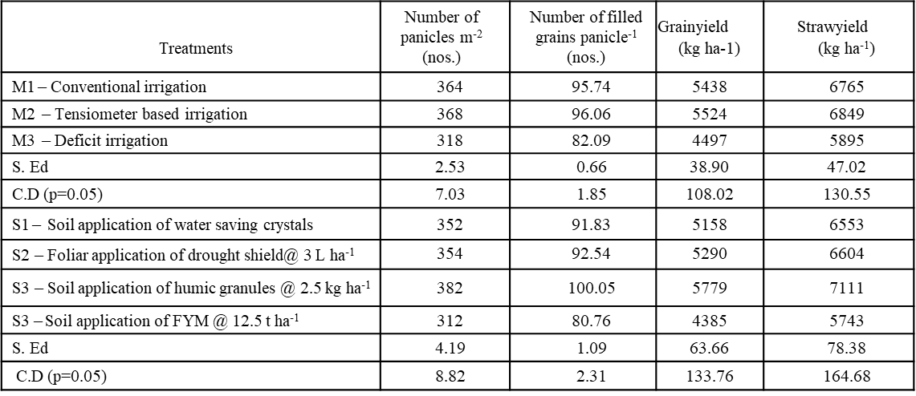
Kalyanasundaram et al. (2021)
Place: Annamalai Nagar, Tamil Nadu
Discussion & Result:
Tensiometer-based irrigation -M2, maximum number of ears m-2 (368) and number of ears of filled grain -1 (96.06) were recorded for the most common irrigation practices. Yield-related traits were maximized with sufficient water available to the crop and adequate aeration at critical growth levels in unseeded rice. This is probably due to the higher intake of nutrients, especially phosphorus, and improved grain fertility in direct-seeded rice. Treatment mixture M3S (FYM 12.5 tha-1 deficient irrigation) recorded the lowest yield. This is probably due to water stress in the flora during grain filling. Water management practices played an important role in influencing grain and straw yields of direct-seeded rice. M2 tensiometer-based irrigation recorded the highest grain yield (5,52 kg ha-1) and straw yield (6,89 kg ha-1). The doubling of yield is likely due to the efficient use of water throughout plant growth, especially during critical growth stages. With most moisture protection measures, humus grains recorded maximum grain yields of 5779 kg ha-1 and straw yields of 7111 kg ha-1 at 2.5 kg ha-1 at 30 and 45 DAS. This is probably due to increased absorption of vitamins by the humic acid-treated material and improved soil aeration and water retention. It was found that better uptake of nutrients should positively affect the growth and yield factors of unseeded rice.
Table 6 - Impact of gypsum, farm manure and humic acid on paddy yield (kg/ha)
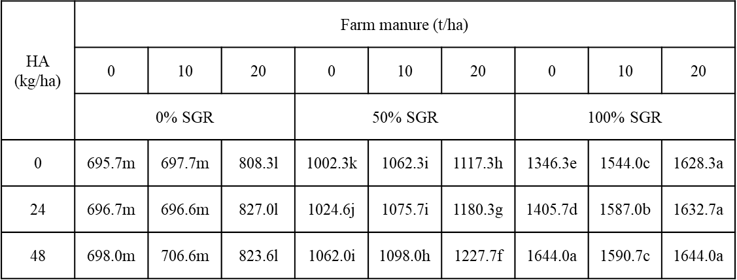
HA – commercial humic acid; SGR – soil gypsum requirement.
Means having the same letters are statistically nonsignificant at P ≤ 0.05 (n = 3)
Shaaban et al. (2013)
Place: Pakistan
Discussion and Result:
A significant (P ≤ 0.05) impact of Gypsum, FYM, Humic acid, G × FYM, G × HA, FYM × HA, and G × FYM × HA on paddy yield was observed. There was higher paddy yield with higher rates of G, FYM and HA compared with low rates and the control plot. Paddy yield (1644 kg/ha) was higher from 100% SGR + 20 t FM/ha + 48 kg HA/ha treatment compared to control (695.7 kg/ha). The application of G, FYM and HA contributed to the development of bottom retention and leaching of ions into deeper layers. This resulted in a decline in the awareness of salt in the upper layers, encouraging plant dissemination and ultimately leading to a sizeable boom in rice grains.

Graph 3 - Effect of plant growth regulators on DMP of rice

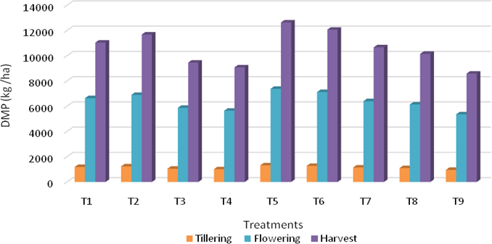
Treatment details

T1 - Gibberellic acid 40% WSG @ 10 gm ha-1
T2 - Gibberellic acid 40% WSG @ 20 gm ha-1
T3 - Abscisic acid 20% SG @ 60 gm ha-1
T4 - Abscisic acid 20% SG @ 30 gm ha-1
T5 - Humic acid 12% @ 12.5 l ha-1
T6 - Humic acid 12% @ 10 l ha-1
T7 - Triacontanol 0.05% EC @ 250 ml ha-1
T8 - Triacontanol 0.05% EC @ 150 ml ha-1
T9 - Untreated control
Kumaravel et al. (2022)
Place: Annamalai Nagar, Tamil Nadu
Discussion & Result:
A review of the data showed that, among other growth regulators, foliar application of humic acid 12% at 12.5 l ha-1 (T5) yielded 1319 kg ha-1 during tillering and 7381 kg ha-1 during flowering. 1, revealing the highest DMP production of 12636 kg ha-1 during flowering. kg ha recorded -1 at the rice harvesting stage. The highest DMP was the result of increased efficiency of the photosynthetic apparatus, expressed as (1) increased leaf area, (2) increased photosynthetic intensity, and (3) increased chlorophyll content. The overall function of the plant eventually leads to a gradual accumulation of dry matter within the plant body. All physiological processes lead to the accumulation of dry matter.
Table 7 - Effect of plant growth regulators on yield of rice
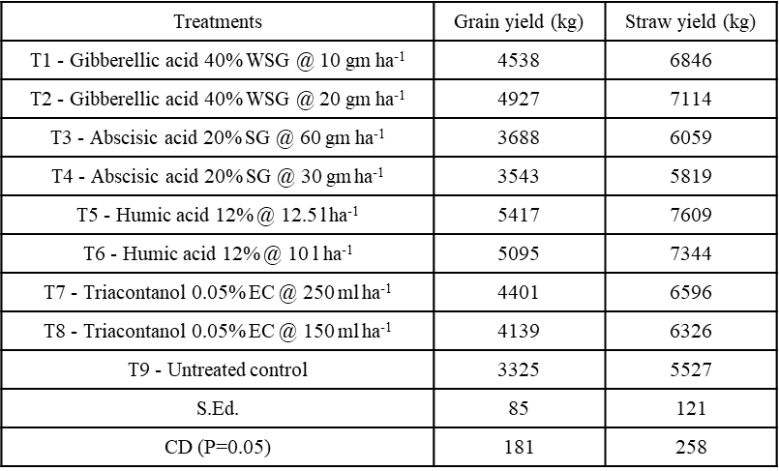
Kumaravel et al. (2022)
Place: Annamalai Nagar, Tamil Nadu
Discussion & Result:
Among the various growth regulators, foliar application of Humic acid 12% @ 12.5 l ha-1 (T5) recorded the highest grain yield of 5417 kg ha-1. The positive impact of traits related to crop yield reflected remarkable results on rice crop yield. Yield increased due to increased biomass. Among the various growth regulators, the treatment with 12.5 L ha-1 foliar application of humic acid 12% (T5) recorded a significantly higher straw yield of 7609 kg ha-1, outperforming the other treatments. Straw was affected by the accumulation of dry matter. Foliar application of humic and fulvic acids significantly increases grain and straw yields.

Table 8- Effect of foliar spraying of some substances on No. of filled grains, No. of unfilled grains of Giza179 rice variety during 2017 and 2018 seasons
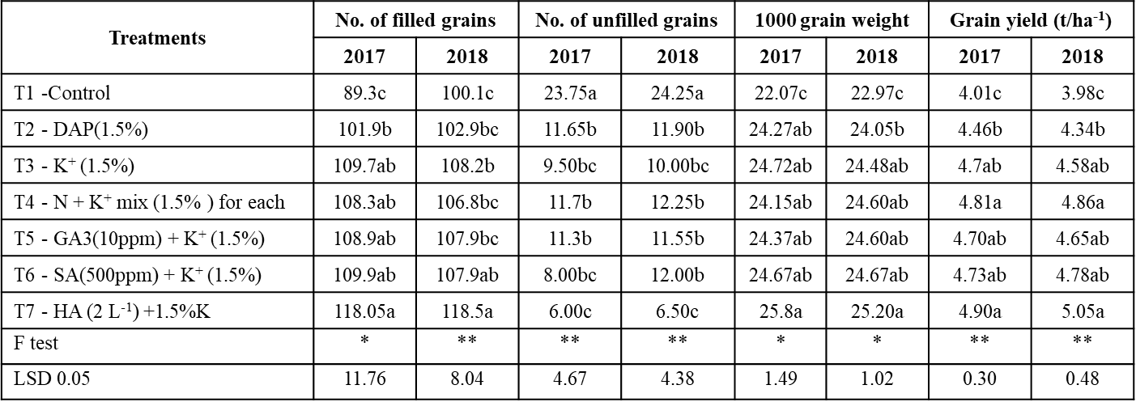
Amira M. Okasha et al. (2019)
Place: Egypt
Discussion:
Foliar application of Humic acid + K significantly reduced the number of unfilled panicle-1 seeds compared to the control treatment and gave the highest number of unfilled panicle-1 seeds in two seasons. The 1000-grain weight was significantly improved by foliar application of several chemicals in both seasons compared to the control treatment. Salinity effect is because of the reduced growth due to less water uptake, Na+ and Cl toxicity and less photosynthesis and salicylic, humic acids, Gibberellic acid and di ammonium phosphate with potassium enhanced the salt stress resistance of plants.
Result:
The beneficial effects of these substances, including humic acids, are attributed to their beneficial effects on improved salt tolerance in rice growth, increased photosynthesis before and during rice cultivation, net assimilation rate and transfer to rice grain. It is possible humic+ K and/ or mixture of N+K may be recommended to improve the quality and productivity of Giza 179 rice under salt stress.

Graph 4 - Rice plant height and Yield parameters impacted by soil organic amendments
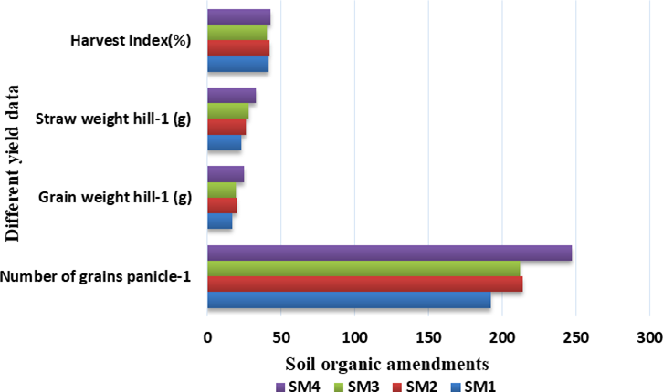
SM1 = Soil + inorganic fertilizer (control)
SM2 = Soil + cow dung + inorganic fertilizer
SM3 = Soil + inorganic fertilizer + humic acid
SM4 = Soil + inorganic fertilizer + cow dung + humic acid

Samar Barai et al. (2022)
Place: Bangladesh
Discussion & Result:
According to the above results, organic soil amendments such as humic acid and cow dung resulted in significant increases in rice growth and yield. SM4 (Soil + inorganic fertiliser + cow manure + humic acid) showed the fastest rice swelling and yield. Humic acids are essential for nutrient transfer from soil to plants as they can retain ionized nutrients and prevent runoff. Cow dung for plants is a high-quality organic fertilizer that promotes aeration and loosens compacted soil.

Table 9 - Effect of bio-stimulants on growth parameters
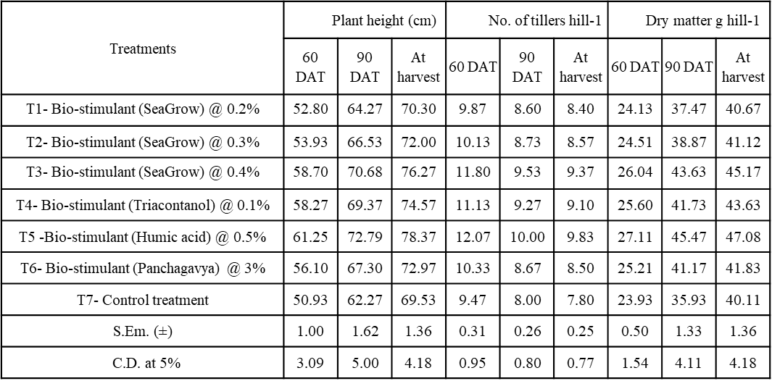
Mitkar et al. (2022)
Place: Dapoli, Maharashtra
Discussion & Result:
Foliar application of biostimulant showed significant positive effects on growth parameters such as 60 DAT, 90 DAT and height at harvest (cm), number of shoot Hill-1 and dry matter Ghill-1 . Application of 0.5% (T5) humic acid resulted in significantly higher plant heights at 60, 90 DAT and harvest. The increase in plant height with humic acid application was due to the improvement of the crop root zone, resulting in improved nutrient availability. Treatment with 0.5% humic acid (T5) was found to produce the highest number of hillock-1 tillers. It is a natural phenomenon that a productive cultivator stabilizes as the crop ages. Humic acid increases the supply of nitrogen, which is essential for vegetative growth, resulting in increased number of tillers per hill. Dry matter produced showed an increasing trend throughout the crop growth stages and was highest at harvest. Application of 0.5% humic acid (T5) significantly increased the dry matter accumulation. This is likely due to improved root growth, increased nutrient uptake, and enhanced bioactivity.

Graph 5 – Efficiency of nitrogen fertilizer on various doses of humic acid
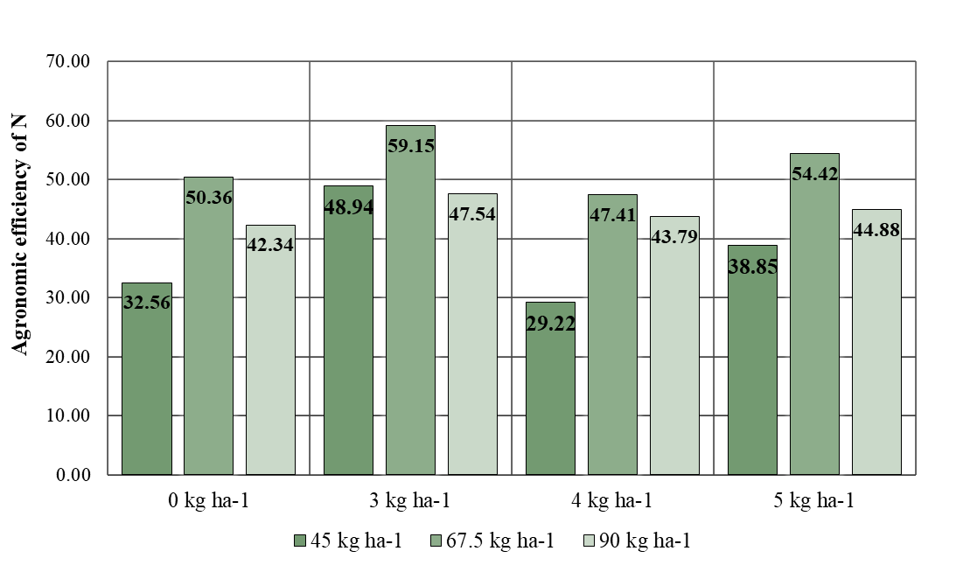
Suhardjadinata et al. (2015)
Place: Indonesia
Discussion & Result :
When treated with humic acid, the grain yield obtained with each unit of N fertilizer is higher than that without humic acid. The application of humic acid increased the efficiency of nitrogen fertilization, with the highest values ​​achieved at a dosage of 3 kg ha-1 humic acid and 67.5 kg ha-1 nitrogen fertilizer. The figure above shows that the use of humic acid can improve agricultural efficiency when using nitrogen fertilizers on rice, as humic acid delays the release of nitrogen fertilizers, allowing plants to utilize nitrogen more efficiently. Nitrates are slow nitrogen releasers, so less fertilizer is lost through evaporation and leaching, giving rice plants an opportunity to absorb more nitrogen. This means that humic acid can improve the efficiency of nitrogen fertilizers.

Graph 6&7 - Effect of potassium humate on length of (a) root and (b) shoot of rice growth
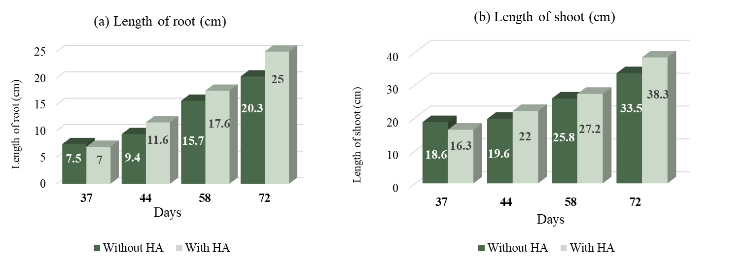
Buntita jomhataikool et al. (2019)
Place: Thailand

Discussion & Result:
Leonardite-derived potassium humate (K-HA) was administered to rice fruit every 7 days after 30-day-old seedlings, and plantlets were collected every 1 days. There was a significant difference between the control and the effect of potassium humate on rice berry plant height. The length of roots and shoots of treated rice fruits was longer in seedlings aged days or more than in untreated ones. However, application of potassium humate increased root and shoot length compared to untreated plants. Potassium humate uptake in rice berry seedlings positively affects plant germination and development. As a result, the plant grows faster.

Graph 8&9 - Effect of potassium humate on weight of (a) root and (b) shoot of rice growth
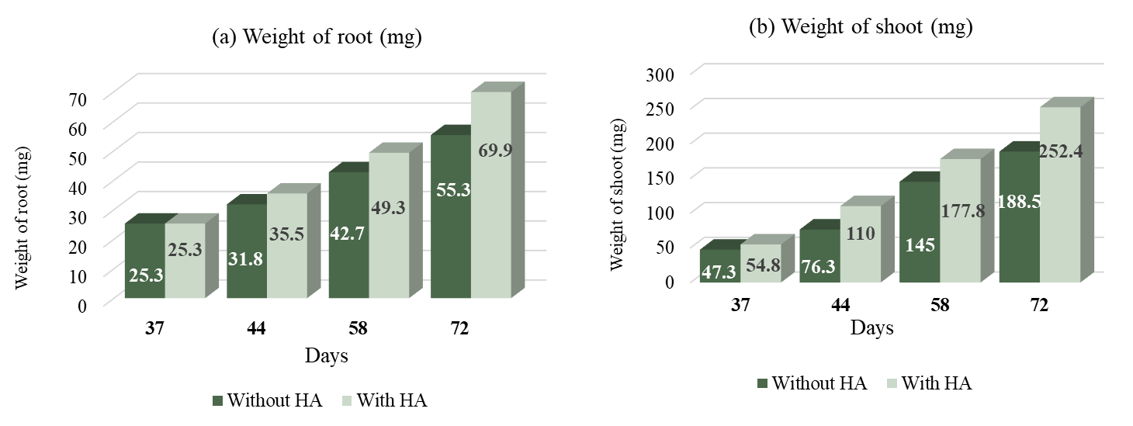
Buntita jomhataikool et al. (2019)
Place: Thailand
Discussion & Result:
The root and shoot weights of the treated rice fruits were higher in the day-old seedlings than in the untreated ones. Therefore, potassium humate intake has a positive effect on biomass production by rice berry growth. Potassium humate intake had a positive effect on leaf and body growth of rice fruit compared to controls, because humic substances improve water uptake and stimulate biomass accumulation. Humic substances promote plant growth by improving water uptake, but indirectly affect soil structure, the release of plant nutrients from soft minerals, increased availability of trace elements, and overall soil fertility. have a significant impact.

Table 10- Effect of humic acid and fertilizers on total NPK uptake (kg ha-1) of rice
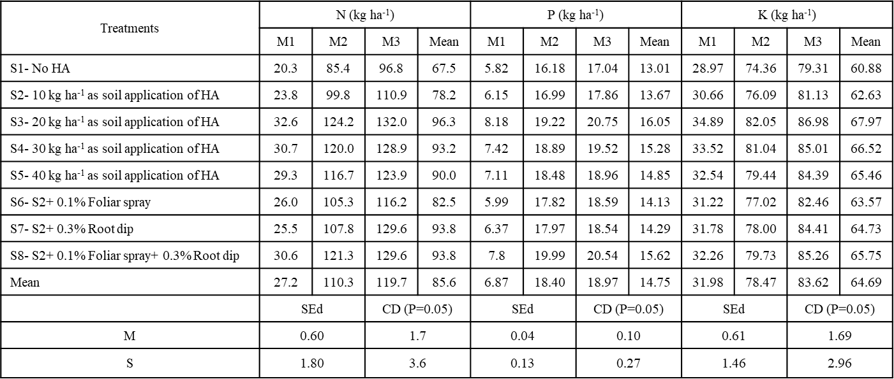
M1- Control, M2- 112:35.7:35.7, M3- 150:50:50
Siva Kumar et al. (2007)
Place: Killikulam, Tamil Nadu
Discussion & Result:
Fertilizer level significantly increase the uptake of N 27.2 (M1) to 119.7 (M3) Kg ha -1. The treatment receiving 0.1% HA+FS or 0.3% HA+RD alone or in combination recorded higher total N uptake of 82.5, 83.6 and 93.8 kg ha-1 in S6, S7 and S8 separately. The interaction of fertilizer and humic acid was also significant with regard to N uptake. The increase in nitrogen uptake by humic acid application was noticed up to 20 Kg ha-1. Humic acid might have influenced the plant growth directly through its effect on ion uptake or by the effects on the plant growth regulators.
The perusal of the data on P uptake showed that the fertilizer application significantly increased the P uptake front 6.87 to 18.97 kg ha-1. The highest P uptake of 16.05 Kg ha -1 proved the superiority of treatment receiving 20 Kg HA ha-1 as soil application. The uptake of P in the presence of organic and inorganic sourced of nutrients.
The fertilizer application excelled a significant increase in total K uptake from 31.98 (M1) to 83.62 (M3) Kg ha-1. The soil application of humic acid @ 20 Kg ha -1 proved to be most effective than in rest of the treatments with regard to K uptake (67.97 Kg ha-1) in M3S3.
Table 11 & 12 - Changes in total N (g kg–1) and available N (kg ha–1) in soil treated with FYM and humic acid in rice
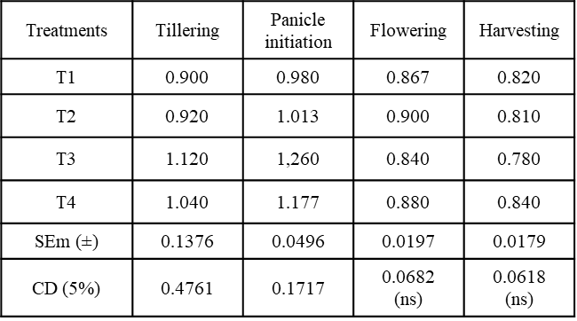
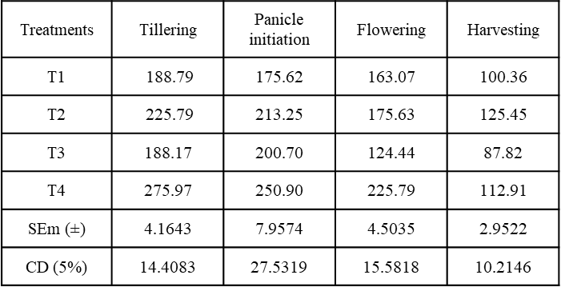
T1- NPK @ RDF
T2- T1+ FYM @5 tons ha–1 at basal
T3- T1+ Commercial HA @ 0.5 kg ha –1 @ basal
T4- T1+ HA from FYM @ 0.5 kg ha–1 @ basal
Niladri Paul et al. (2016)
Place: West Bengal, India
Discussion:
After plants and microorganisms have basically utilized urea (an inorganic nitrogen source), a serious demand for nitrogen produced in microbial communities can arise. It accelerated the microbial degradation rate of FYM and the activity of free-living nitrogen-fixing bacteria that fix atmospheric nitrogen. Both activities occurred simultaneously and significantly increased total soil nitrogen content at the panicle (PI) stage. The highest increase in PI stage was found in CHA (28.6%), followed by him in EHA (20.1%), FYM (3. %). Due to high microbial activity, organic nitrogen present in the soil is mineralized and utilized by plants, and TN tends to decrease towards the harvest stage. No significant effects were found on the IN content in the soil compared to the control during both the flowering and harvesting stages of paddy fields. Changes in available nitrogen concentration actually depend on changes in TN and other physico-chemical and biological factors. Base application of EHA and urea together increased available nitrogen towards the highest crop (6.7%) followed by FYM (20.0%) compared to control in soils at tillering stage Did. Microbial calcification was mainly responsible for increasing the amount of available nitrogen and also affected the TN content in the soil. During the growing season, available nitrogen tended to decrease with increasing crop age. Judicious use of EHA by the microorganisms themselves through plant roots showed the highest levels at both PI (2.9%) and flowering stage (38.5%), with FYMs of 21.4 % And 7.7 % respectively, compared to controls. was 0.7%. in the soil.
Result:
The basal application of EHA and the recommended fertilizer dose increase soil nitrogen availability and MBN content, which indicates nitrogen uptake within the plant, resulting in significantly increased rice grain yield. The residual effect of FYM resulted in the highest plant biomass yield.

Table 13 - Content of soil fertility elements under different fertilization treatments
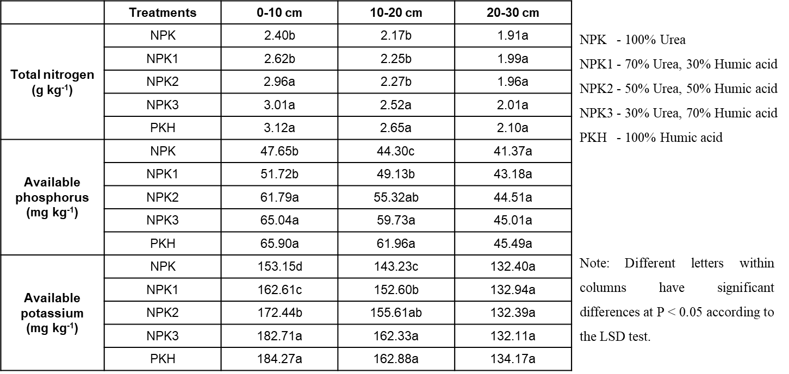
Zheng Ennan et al. (2022)
Place: China
Discussion & Result:
The application of humic acid organic fertilizers to black soil had a positive effect on improving the impact on the soil environment. Total nitrogen, available phosphorus, and available potassium were all elevated. In 0–10 cm soil thickness, NPKH3 and PKH treatments significantly increased soil microbes. Total nitrogen, available phosphorus, and available potassium increased with increasing application rates of humic acid organic fertilizers and reached maximum values ​​with PKH treatment. As a result of principal component analysis, it was found that the application of humic acid-based organic fertilizer had a positive effect on improving the impact on the soil environment, and PKH treatment was the best.

Table 14 - Effect of different levels of Humic acid and inorganic nitrogen on Available NPK (kg ha-1) in soil at different growth stages of direct sown rice
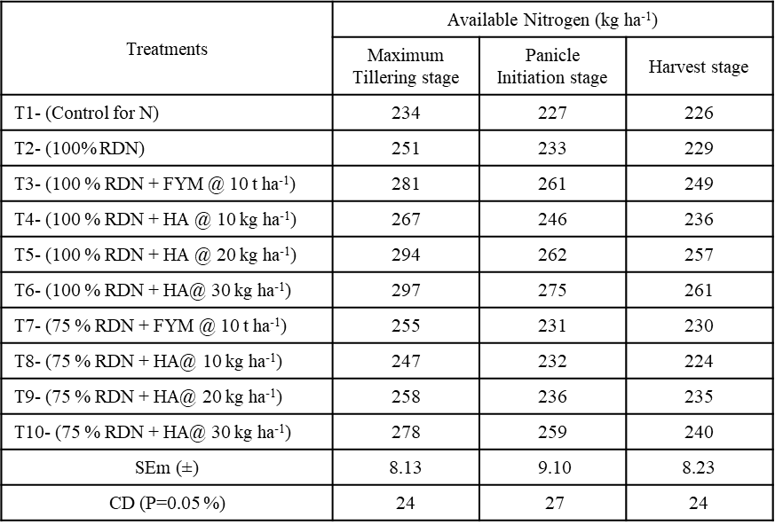
Sai Manjeera et al. (2021)
Place: Andhra Pradesh
Discussion & Result:
Maximum available nitrogen contents (297, 275, 261 kg ha-1) were recorded in T6 (100% RDN HA at 30 kg ha-1). Under humic acid treatment, the available nitrogen content increased to a dose of 30 kg ha-1. However, a significant increase was only observed up to 20 kg ha when combined with 100% RDN. The increased nitrogen availability could be due to the N contribution of natural nitrogen due to the increased microbial activity induced by HA. Also, ammonia not absorbed by plants is quickly oxidized, so urea alone can result in significant volatile losses. This chemoautotrophic oxidation of ammonia to NO2 is limited by the availability of NH3. The increased availability of N may be due to the decrease of No. Nitrifying microorganisms.

Table 15 - Soil fertility status after harvest of rice crop
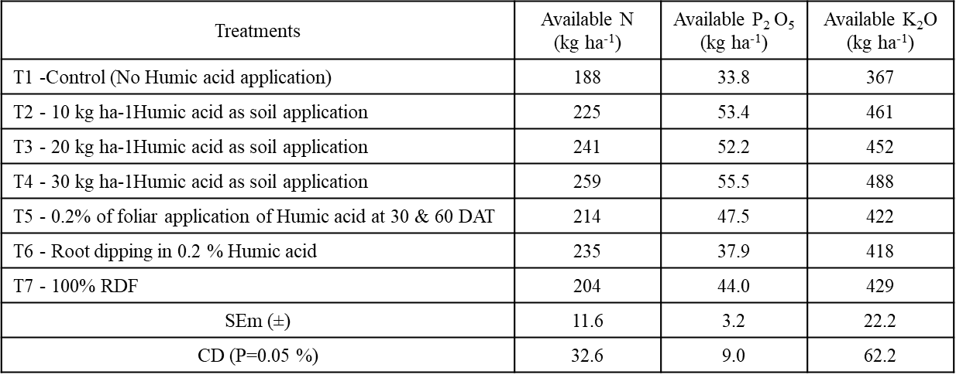
Satish Kumar et al. (2022)
Place: Andhra Pradesh
Discussion & Result:
Post-harvest soil fertility status data showed that soil available nitrogen, phosphorus, and potassium (259, 55.5 and 488 kg N, P2 O5 and K2 O ha-1) increased at the time of treatment and showed to be significantly the best. The increase in available nitrogen could also be due to the addition of nitrogen through the mineralization of natural nitrogen through increased microbial activity. The increased availability of phosphorus may be due to the beneficial effects of humic acid on the chemical and biochemical processes involved. Humic acid may have helped to solubilize phosphorus from insoluble to soluble forms, leading to increased phosphorus. The combined application of 100% NPK and 20 kg ha-1 of potassium humate significantly increased the availability of potassium in the soil. At all three years, the minimum macronutrient and micronutrient levels available in the soil were recorded in the control plots.

Table 16 - Effect of Humic Acid (HA) on the availability of the DTPA extractable Zinc (mg/kg) in an Alfisols
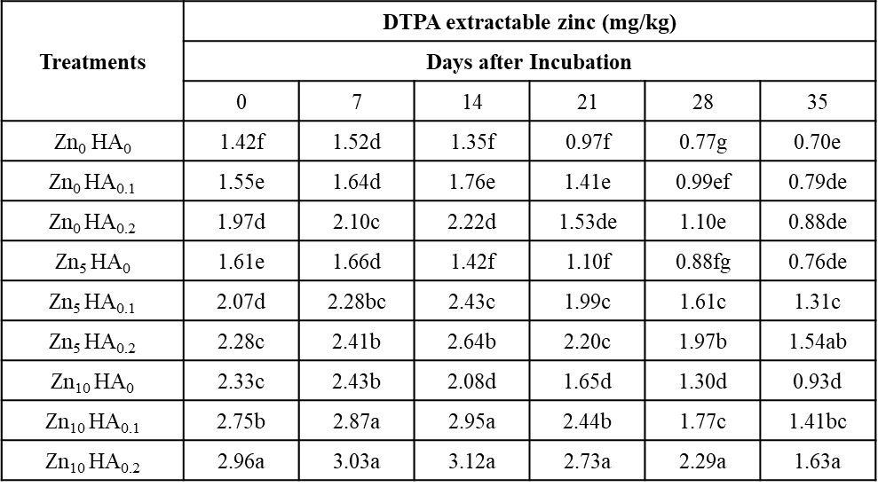
Within a column, data followed by the same letter are not significantly different at the 0.05 level of probability by DMRT.
Sushanta Kumar Naik et al. (2007)
Place: West Bengal, India
Discussion & Result:
The effect of humic acid on the availability of DTPA-extractable Zn showed that the application of humic acid increased the content of extractable Zn compared to the absence of humic acid. The beneficial effect of humic acid in increasing micronutrient availability may be due to its priming effect, which increases the number of water-soluble micronutrients, leading to chelation and subsequent release of micronutrients.

4. Conclusion:
The humic acid utility has potential vast impact on crop agronomic overall performance and soil parameters. The humic acid chemical shape, solubility and application rate, soil crop type also have an effect on the Humic acid effects on crop performance. From the above findings the humic acid showed the higher crop response, yield and yield attributing characters. Nutrient uptake and nutrient availability had been additionally considerably elevated. Currently there's a growth in the use of natural material as fertilizer or soil amendments. This can be attributed to reduction within the use of chemical fertilizers, problem for ability polluting effects of chemical in soil, a need for power conservation. Therefore, humic materials is one of the natural sources with the capacity for meeting a number of those needs.

5. References:
Alan B., Hurst, H. M., Walkden, S. B., Dean, F. M., and Hirst, M. (1963). Nature of humic acids. Nature, 199(4894): 696-697.
Amira, M.O., Abbelhameed, M.M., and Elshayb, O.M. (2019). Improving rice grain quality and yield of Giza 179 rice cultivar using some chemical foliar spray at late growth stages under salt stress. Journal of Plant Production, 10(9): 769-775.
Ampong, K., Thilakaranthna, M.S., and Gorim, L.Y. (2022). Understanding the role of humic acids on crop performance and soil health. Frontiers Agronomy, 4: 848621.
Arnab, K., Raha, P., Dubey, A.N., Rani, M., Paul, A., and Patel, R. (2020). Differential responses of rice (Oryza sativa L.) to foliar fertilization of organic potassium salts. Journal of Plant Nutrition, 44(9): 1330-1348.
Barai, S., Islam, M.M., Parvin, S., Nizam, R., and Bithy, P.A. (2018). Influence of humic acid on morpho-physiology and yield of rice. Journal of Bioscience and Agriculture Research, 29(01): 2407-2415.
Beckley, V.A. (1921). The preparation and fractionation of humic acid. Journal of Agricultural Science, 11(1): 66-68.
Brattebø, H., Ødegaard, H., and Halle, O. (1987). Ion exchange for the removal of humic acids in water treatment. Water Research, 21(9): 1045-1052.
Bruna, A. G., Motta, F. L., and Santana, M. H. A. (2016). Humic acids: Structural properties and multiple functionalities for novel technological developments. Materials Science and Engineering, 62: 967-974.
Cheng, G., Niu, Z., Zhang, C., Zhang, X., and Li, X. (2019). Extraction of humic acid from lignite by KOH-hydrothermal method. Appl. Sci., 9(7): 1356.
Colla, G. and Rouphael, Y. (2015). Biostimulants in horticulture. Scientia Horticulturae, 196: 1-2.
Cornelius, S. (1963). What is humic acid?. Proceedings of the California associaton of chemistry teachers, 40(7): 379-384.
Davies, G., Ghabbour, E. A., and Steelink, C. (2001). Humic acids: Marvelous products of soil chemistry. Journal of Chemical Education, 78(12): 1609.
El-Gohary, A.A., Osman, E.A.M., and Khatab, K.A. (2010). Effect of nitrogen fertilization, humic acid and compost extract on yield and quality of rice plants. Journal of Soil Sciences and Agricultural Engineering, 1(1): 77-91.
Eshwar, M., Srilatha, M., Rekha, K.B., and Sharma, S.H.K. (2017). Effect of humic substances (humic, fulvic acid) and chemical fertilizers on nutrient uptake, dry matter production of aerobic rice (Oryza sativa L.). Journal of Pharmacognosy and Phytochemistry, 6(5): 1063-1066.
García, A.C., Berbara, R.L.L., Farías, L.P., Izquierdo, F.G., Hernández, O.L., Campos, R.H., and Castro, R.N. (2012). Humic acids of vermicompost as an ecological pathway to increase resistance of rice seedlings to water stress. African Journal of Biotechnology, 11(13): 3125-3134.
García, A.C., Santos, L.A., Izquierdo, F.G., Rumjanek, V.M., Castro, R.N., Dos, F.S. and Berbara, R.L.L. (2014). Potentialities of vermicompost humic acids to alleviate water stress in rice plants (Oryza sativa L.). Journal of Geochemical Exploration, 136: 48-54.
Herviyanti, Teguh, B.P., Fachri A. and Darmawan. (2018). The Properties of Humic Acids Extracted from Four Sources of Organic Matters and Their Ability to Bind Fe2+ at New Established Rice Field. Journal of Tropical Agriculture, 15(3): 237-244.
Jaber, M.A.Y., Niknejad, H., Fallah Amoli and Barari Tari. (2020). Effects of drought stress on some phytochemical characteristics of rice cultivars under different chemical and organic nutritional sources. Journal of Plant Nutrition, 44(8): 1193-1206.
Jomhataikool, B., Faungnawakij, K., Kuboon, S., Kraithong, W., Chutipaichit, S., Fuji, M., and Eiad-Ua, A. (2019). Effect of humic acid extracted from Thailand’s leonardite on rice growth. Journal of Metals, Materials and Minerals, 29(1): 1-7.
Kalyanasundaram, D., Arthi, E., Kumar, K.S., and Sri. S. H. (2021). Yield maximization of direct sown rice (Oryza sativa l.) under water constraint situation. Journal of Applied and Natural Science, 13(1): 373-376.
Karennavar, S.S., Chavan, V.G., More, V.G., Dhopavkar, R.V., Desai, S.S. and Bodake, P.S. (2022). Effect of humic acid-based bio-stimulant on growth, yield and yield attributing characters of kharif rice (Oryza sativa L.). The Pharma Innovation, 11(11):319-322.
Kononova, M. M., and Alexandrova, I. V. (1973). Formation of humic acids during plant residue humification and their nature. Geoderma, 9(3): 157-164.
Kumaravel, S., Nandakumar, P., and Maheshwaran, M.M.K. (2022). Effect of different plant growth regulators on the growth of transplanted rice (Oryza sativa L.). The Pharma Innovation, 11(12): 1461-1464.
Kumaravel, S., Nandakumar, P., and Maheshwaran, M.M.K. (2022). Effect of different plant growth regulators on the yield of transplanted rice (Oryza sativa L.). The Pharma Innovation, 11(12): 4005- 4008.
Kurniati, E., Muljani, S., Virgani, D. G., and Neno, B. P. (2018). Humic acid isolations from lignite by ion exchange method. In Journal of Physics: Conference Series, 953(1):012234. IOP Publishing.
Mayhew, L. (2004). Humic substances in biological agriculture. Acres, 34: 54-61.
Mikkelsen, R.L. (2005). Humic materials for agriculture. Better crops, 89(3): 6-10.
Mitkar, G.V., Sagvekar, V.V., Bodake, P.S., Thorat, T.N., Mahadik, S.G., Khobragade, N.H. and Ghodake, S.S. (2022). Effect of foliar application of bio stimulants on growth, yield attributing characters and yield of Kharif rice (Oryza sativa L.) under lateritic soils of Konkan. The Pharma Innovation, 11(11): 1788- 1791.
Mohammad, F., Moradi, H., Noori, M., Sobhkhizi, A., Adibian, M., Abdollahi, S., & Rigi, K. (2014). Influence of humic acid on increase yield of plants and soil properties. International Journal of Farming and Allied Sciences, 3(3): 339-341.
Moskalenko, T., Mikheev, V., and Vorsina, E. (2020). Intensification of humic acid extraction from lignites. EDP Sciences, 192: 02024.
Nagamitsu, M., Watanabe, A., and Kimura, M. (1997). Origin and properties of humus in the subsoil of irrigated rice paddies: I. Leaching of organic matter from plow layer soil and accumulation in subsoil. Soil science and plant nutrition, 43(4): 901-910.
Nethala nivalini ushadhree (1988). Humic acid and its influence on crop plants. M.Sc. (Agri.), Thesis, Annamalai University.
Niladri, P., Debarata, D., Ashin, D., Dipankar, S. (2017). Comparative Study of Organic Matter Vis-a-Vis Humic Acid on Change in Nutrients Availability in Rice-Mustard Cropping Sequence. International Journal of Agriculture Environment and Biotechnology, 10(3): 303-314.
Perumal, P., Ahmed, O.H., Majid, N.M., Jalloh, M.B., and Susilawati, K. (2015). Improving lowland rice (O. sativa L. cv. MR219) plant growth variables, nutrients uptake, and nutrients recovery using crude humic substances. The Scientific World Journal, 2015(906094):14.
Ravindra Prasad G. (1988). The influence of lignite humic acids in the growth, yield and nutrient content and uptake of paddy IR 20. M.Sc. (Agri.) Thesis, Annamalai university.
Ragheb, H.M.A. Manshood, M.R. Mahmoud, S.T. and Al-mousawy. (2021). Effect of Humic Acid on Growth and Yield of Several Genotypes of Rice (Oryza Sativa L.). Environmental Earth Sciences, 923(1): 012-059.
Ronald, L.M., and MacCarthy, P. (1986). Limitations in the use of commercial humic acids in water and soil research. Environmental Science & Technology, 20(9): 904-911.
Sai, M. K., Subbaiah, P.V., Prasad, P.R.K. and Rekha, M.S. (2021). Available Nutrient Status of Soil as Influenced by Combined Application of Humic Acid and Inorganic Nitrogen. International Journal of Plant and Soil Science, 33(22): 209-217.
Samir, P. and Sengupta, M. B. (1985). Nature and properties of humic acid prepared from different sources and its effect on nutrient availability. Plant and Soil, 88: 71-91.
Satish, Y.S., Nayak, S.B., Reddy, C.V.C.M., Arun, K.A., Vishnuvardhan, K.M., Kiranmayi, J. and Narayana, E.N. (2022). Effect of Potassium humate fertilizers on soil nutrients and productivity of Rice crop in vertisols of Southern India. Ecology, Environment and Conservation, 29(1): 43-48.
Senn, T.L., and Kingman, A.R. (1973). A review of humus and humic acids. Research series, 145: 1-5.
Senthil Kumar K. (1995). Studies on the effect of lignite derived humic substances and nitrogen on low land rice. M.Sc. (Agri.) Thesis, Annamalai university.
Shaaban, M., Abid, M., and Shanab, R.A.I. (2013). Amelioration of salt affected soils in rice paddy system by application of organic and inorganic amendments. Plant, Soil and Environment, 59(5): 227-233.
Shozo, K., Tsutsuki, K., and Kumada, K. (1978). Chemical studies on soil humic acids: 1. Elementary composition of humic acids. Soil Science and Plant Nutrition, 24(3): 337-347.
Sivakumar, K., Devarajan, L., Dhanasekaran, K., Venkatakrishnan, D., and Surendran, U. (2007). Effect of humic acid on the yield and nutrient uptake of rice. Oryza, 44(3): 277-279.
Suhardjadinata, Sunarya, Y., and Tedjaningsih, T., (2016). Increasing Nitrogen Fertilizer Efficiency on Wetland Rice by Using Humic Acid. Journal of Tropical Soils, 20(3): 143-148.
Sushanta, K.N. and Dilip, K.D. (2007). Effect of lime, humic acid and moisture regime on the availability of zinc in alfisol. The Scientific World Journal, 7: 1198-1206.
Tadeu, A.T.C., Ricardo, L. L.B., Orlando, C.H.T., Debora, F.G.M., Erinaldo, G.P., Camila, C.B.S., Luis, M.E. and Andres, C.G. (2021). Humic acids induce a eustress state via photosynthesis and nitrogen metabolism leading to a root growth improvement in rice plants. Plant Physiology and Biochemistry,162: 171-184.
Wanti, M., Sasongko, P.E., Kusuma, Z., Syekhfani, S., and Aini, N. (2018). Efficiency of various sources and doses of humic acid on physical and chemical properties of saline soil and growth and yield of rice. AIP Conference Proceedings, 2019(1):03000- 030008.
Zheng, E., Yinhao, Z., Jianyu, H. and Tiamyu, X. (2022). Effects of humic acid organic fertilizer on soil environment in black soil for paddy field under water saving irrigation. Nature Environment and Pollution Technology, 21(3): 1243-1249.

