International Research Journal of Engineering and Technology (IRJET)
www.irjet.net

Volume: 09 Issue: 01 | Jan 2022 p-ISSN: 2395-0072 e-ISSN: 2395-0056

Optical Non-Contact Fuel Level Indicator For Automotive Application

Manvantar R Girimaji
Student, Dept. of Electronics and Instrumentation, Malnad College of Engineering, Hassan, Karnataka, India

***************************************************************************************

Abstract:
Fuel indicator is an integral part of any automotive instrument cluster. Measurement of the fuel remaining in the reservoir is an important factor in order to calculate the distance which can be travelled with the remaining fuel. Different types of fuel indicator systems are available in the market which are prone to non linearity and mechanical loading. In India, the percentage of people using mopeds are comparatively high and replacement of the fuel tank if damaged demands a very big-budget affair. therefore it calls for a solution. Consequently, the paper proposes to design and fabricate low-cost fuel indicator system which overcomes these vulnerabilities. The system addresses the problem of non-linear behaviour of fuel level indicator typically employing a float and a potentiometer. The system uses an LED as a source of light and a number of LDR’s as receivers. As the light passes through the optical opening in the tank it gets diffused, absorbed and reflected through the fuel. The amount of light received on the other side is a function of fuel present in the reservoir. Since there is multiple receiving points (LDRs) whose readings are averaged, the readings have negligible effect from the turbulence within the reservoir due to the shaking of vehicle itself. In the fabrication of the a signal condition circuit is used in order to convert resistance in voltage and is assembled with an Arduino that quantifies and presents the volume on an LCD.

Introduction:
Fuel indicator is used to convey the information regarding the volume of the fuel remaining in the reservoir of the vehicle along with other critical data such as speed of the vehicle, odometric reading. Various methods are employed in order to achieve the same feat. These principles include, but are not limited to Pressure sensing[5], magneto-metric Floats, Weight sensing[5]. The most widely used technique consists of a Float with a signal conditioning circuit(fig. 1). In case of critical fuel sensing applications like aviation and aerospace, weight of the fuel is considered since the volume of the fuel changes with respect to temperature.

Majority of vehicles worldwide use float in their system. Fuel sensors consist of two main components: the sensing system itself (also known as the sender) and the indicator (also commonly referred to as the gauge). Fuel sensors work by measuring the voltage across a variable resistor within the sensing system, to determine the amount of fuel in the vehicle, which is then relayed to the driver via the indicating system. The proposed fuel sensor system is relatively simple compared to other sensors currently produced, although newer fuel sensor systems can also utilize microprocessors for faster and more accurate measurements. The fuel sensor is located in the fuel tank and consists of a float—usually made of foam and connected to an actuating metal rod—attached to a variable resistor. The variable resistors used in fuel level sensors are often composed of a resistive material, where one end is attached to the ground, with a wiper that moves over the resistive material as the float moves. When the float moves due to changing fuel levels, the wiper moves across the resistor, causing a change in voltage. The orientation of the wiper means that the highest resistance is experienced across the resistor when the tank is empty. At this point, the wiper is also as far away as possible from the ground end of the resistor. The change in voltage is then passed on to the indicator which in turn changes the reading.
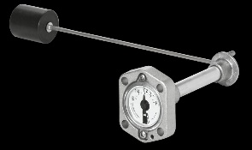
By using the proposed system, we can find out accurate volume (in litter) of fuel in fuel tank. Nowadays the fuel indicator system is digital but they use conventional floats. They might tend to display extrapolated mileage, but this is based on minimal hardware inputs and highly dependent on software (for computation) and graphics (for representation). The Proposed system fundamentally focusses on the development of the sensing method. The previous techniques use analog strip or capacitive sensor which is either inefficient to measure or too costly to install. It actively keeps the record of the fuel entering the tank and the fuel present in the tank at any given time in the dynamic memory of the Arduino. The device has to be cost efficient without compromising on the accuracy of measurement. The sensor fitted has to be passive in nature(meaning it should have no active power supply), should not vary with physical orientation, independent of shape and size of the tank. Basic methodological errors of liquid level measurement are caused by changes in physical orientation and mechanical forces, when liquid level does not correspond to fuel volume.
Figure 1 Float type fuel level indicator

1.3 Literature survey:
To ensure the research work involved in the design of an optical absorbance-based fuel indicator system with enhanced features, a literature survey is carried out.
The following are the learnings from the following sources.

In[1]the point esteem value measurement check whether it is above or below the particular point by the point level sensor this paper proposes different changes to existing float meter and pressure transducer sensor by making them segmented and using LTCC[ low-temperature coffered ceramic] innovations by which they become durable and can be more effectively used on a large scale furthermore this paper talks about the transmission of techniques to remote areas while the float is in the measuring medium
[2] Proposes the principle of buoyancy that states that a float immersed in a liquid is buoyed in an upwards direction by an applied force equal to the weight of the displaced liquid The principle of radar level detector is similar to that of the ultrasonic sensor; that is, measuring the time require for a microwave pulse and its reflected echo to make a complete return trip between the non-contacting transducer and the liquid level. It uses monochromatic light; because monochromatic light is dispersed when reflected from the surface of a liquid. The main goal of the study was achieved by using the LDR which operates on the principle that states that the voltage across an LDR is a function of the luminance incident on it, as a sensor.
In [3] LDR sensor resistance will change according to changes in light intensity. The amount of resistance will be greater according to the magnitude of the distance between the LDR sensor and the light source. This difference in the intensity and resistance of visible light can illustrate to students that polychromatic light consists of several monochromatic light with different wavelengths.
In [4] the article explains the various methods of liquid level measurement since its inception. From the working basic glass level gauges and floats, to hydrostatic methods like displacers, bubblers and differential pressure transmitters have been explained in brief. Then it throws light on the principle of working of advanced technics like magneto strictive level transmission, and ultra-sonic level transmitters. This article gives a surface idea of all the current level measurement technics and their draw backs in brief.

Proposed System:
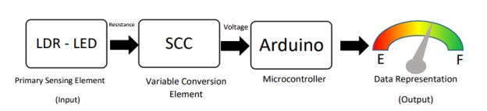
Figure 2 Block Diagram of the proposed system
The paper proposes a low cost, contactless system, that could potentially replace the conventional float system. As shown in the diagram, LDRs and LEDs are placed at the top and the bottom respectively (Converse is also possible). The intensity of light being transmitted at bottom by the LED is, by logic, higher than the intensity of light being received at the top by the LDR. It was chosen as a source of light as it low cost, small and has a longer life compared to florescent or other forms of light. The amount of light that is lost, in other words, absorbed by the fluid in between is proportional to the “path length” or the height if the fluid. If the cross section of the container is known, the volume of the fluid can be computed with acceptable levels of accuracy.

Design and Methodology:
LED
Figure 3 Schematic diagram of the System
The initial developmental trials were carried out using a transparent PET bottle as shown in the figure. The level of fluid was systematically varied, and resistance values of the LDR was recorded. Here are some factors that were considered during the process.
- The intensity of LED greatly affected the result. The supply voltage was kept constant throughout the development.
- The testing was initially done with water, then water – ink combination, water - food colour, and finally with petrol. The system was developed with a petrol level measuring system. Critical elements would have be redesigned for a diesel measuring system.
- The Transparency of the container was also an issue. Initially a transparent PET bottles, then an semi transparent malt box and finally an actually a tank from an old moped was used in the final stage demonstration..
- The colour of the LED was chosen in accordance with linearity of the change in resistance of the LDR. As shown in figure, green LED had the most linear performance. Usage of red LED was ruled out as the colour of the fluid under measurement was near to red. A red fluid would not absorb any amount of red colour.

The probes of the LDR were fed to a signal condition circuit that would proportionally convert resistance to voltage. This was required as microcontroller would need voltage as an input and resistance would not do the job. The microcontroller was programmed to take average of 3 resistance values in case of a tilt in the tank. It would then compute the volume of the fuel by multiplying the level of the fuel with the cross sectional area of the tank at that point. This was then printed on the LCD through I2C protocol.

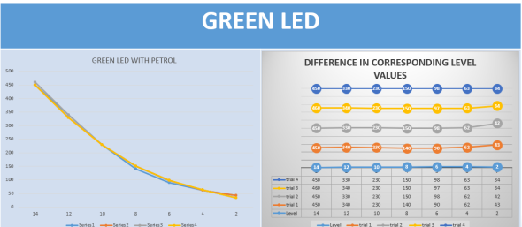
Figure 4 Level v/s Resistance readings with x axis level in CMs and resistance Y in Kilo Ohms
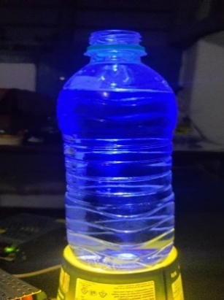
Figure 5 Initial iteration of the model with PET bottle

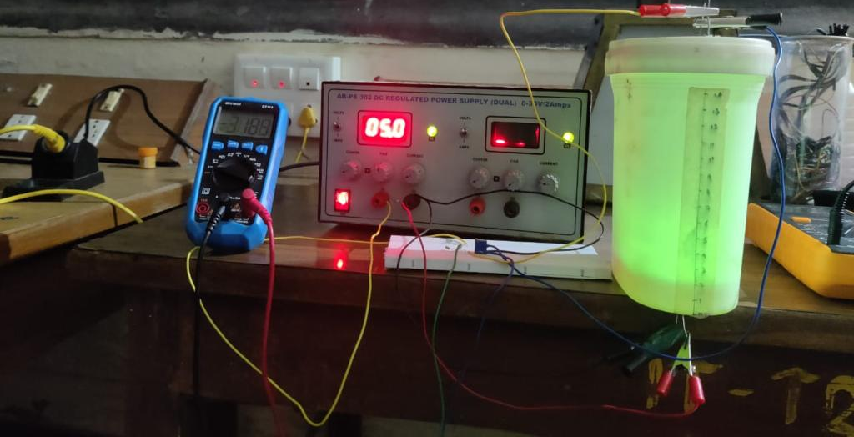
Figure 6 Intermediate iteration of the model with semi transparent Malt BOX

.
Figure 7 Final Stages of the model with Actual Petrol tank from a vehicle

References:
- G. N. Popa, I. Popa, C. M. Diniş, and A. Iagăr, “Resistive stepped transducer used for water level measurement,” in Proceedings of the 1st WSEAS International Conference on Sensors and signals, 2008, pp. 66–71.
- Bera, S.C., Mandal, H., Saha, S., and Dutta, A.A. 2014. Study of A Modified Capacitance-Type Level Transducer for Any Type of Liquid. IEEE Transactions on Instrumentation and Measurement. 46(2): 641-649. doi:10.1109/TIM.2013.2282194
- Marinho, F., Carvalho, C.M., Apolinario, T.R., and L. Paulucci, L. 2019. Measuring Light with Light Dependent Resistors: An Easy Approach for Optics Experiments. European Journal of Physics, 40(3): 035801
- https://new.abb.com/products/measurement-products/level/a-dozen-ways-to-measure-fluid-level
- N. I. Klyuev, Measurement of the Liquid Level in the Fuel Tank of Rocket, January 2016, American Journal of Aerospace Engineering
- Brajesh Kumar, G Rajita, and Nirupama Mandal Review on Capacitive-Type Sensor for Measurement of Height of Liquid Level, Volume 47, Issue 7, SGage Journals.

