PROTECTED CULTIVATION IN AGRICULTURE
D.Swathi, Shanthi.B, T.Jyotsna, Y.DurgaVenkat Hemu
M.Sc Student,Department of Agronomy,School of Agricutural sciences Malla Reddy University,Hyderabad.
PROTECTED CULTIVATION IN AGRICULTURE
Abstract:
A significant challenge has been presented by the green revolution, various biotics, biotic stress, too. By offering fully regulated environment, protected cultivation techniques lessen these pressures. Thinking about protected farming is necessary given the rising food need. The most effective way for meeting the goals of protected horticulture is the greenhouse. The cultivation of many houses has become an important Indian agricultural policy.
Keywords: Green house, regulated atmosphere, nutrient film technology
INTRODUCTION
protected agriculture is defined for cropping strategy a plant's growth and development are influenced by a regulated microclimate. As agriculture has developed, many protected cultivation techniques have been widely employed in industrial farming. Greenhouse farming is one of these protective cultivation techniques. It is useful to have plastic, artefact, internet, and shade houses, among other things. A green house is a framed or inflatable building that is lined with a clear or semi-transparent material, allowing crops to grow to full maturity within in an environment that is at least partially regulated. Crop production affected by the genetics of the cultivar, the environment environment of a plant. in which it grows, and management techniques. The five fundamental elements of light, temperature, humidity, carbon dioxide, and nutrients can be used to describe the
How does protected cultivation work?
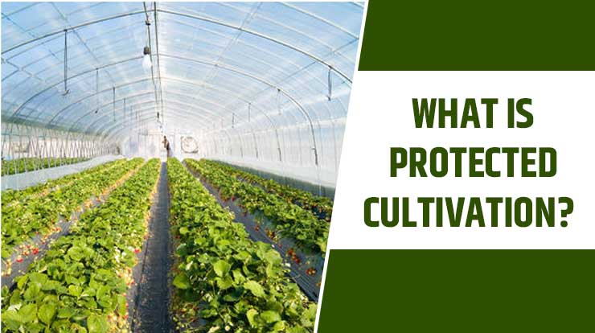
Protected agriculture is a farming technique when crops grow in a regulated environment. That is farming system, every critical factor—including temperature, humidity, light, and others—is controlled in accordance with the needs of the crop's growth. All of the necessary farming conditions are only adjusted as necessary. The agricultural technique is safer and produces a lot of food under uniform conditions. To protect the crop from bad weather, protected agriculture methods are totally, partially, or modified. Protected agriculture can take many various forms, such as mulching, raised beds, trellising, drip irrigation, insect-proof net houses, greenhouses with forced ventilation, polyhouses with natural ventilation, insect-proof net houses, and shade net homes. Two processes are offered by these protected cultivation types: an independent process, and an integrated process.
Importance of protected cultivation
• Because of controlled environmental factors, plant growth and crop maturation are higher. Long-term improvements in manufacturing quality and output
• Water use is optimized, with a 40–50% reduction in consumption• Inputs are used effectively;
• The prevalence of disease and pests is decreased or eliminated
The entire year will see the crops reach full maturity.
• Crop is shielded from cold, wind
• Due to controlled conditions there's higher consumption is reduced by 40–50%.• Inputs are used effectively • Illness and pest incidence is decreased or eliminated The entire year will see the crops reach full maturity. • Can be utilized for star drying of farm products. • Best technology for industrial production of high value commodities like flowers, medicinal plants, etc. crop cultivation in adverse weather conditions Some crops are grown continuously to meet market demands. Full-grown crops of high value and excellent quality, even organic, for export markets Income from modest land holdings was greatly inflated. Successful Due to controlled circumstances, crops are protected from cold, wind, storm, rain, and frost, resulting in faster crop maturation. Improved quantity and quality of production over a long period of nurseries, prepared as and when needed from seeds or vegetative propagation More Opportunities for educated youth to work for themselves on farms The greenhouse's ability to control the microclimate and keep bugs out allows for the breeding of plants, which helps to create new types and seeds. Cold and water are kept away from the crop
• There is higher efficiency because of the controlled conditions. Due to controlled conditions, crops are protected from cold, wind, storm, rain, and frost. As a result, plants grow faster and reach maturity sooner. longer period of time with improved quantity & quality of manufacture Utilization of water is maximized, and consumption is reduced by 40–50%.Utilizing inputs effectively
• Reducing or eliminating the prevalence of disease and pests All year long, crops will reach full maturity. Best technology for drying farm products in the star method, which is used to produce high-value crops like flowers and medicinal plants. Agricultural production in adverse weather To meet the demands of the market, some crops are grown continuously .crops that are fully grown and of
exceptional value, even those that are organic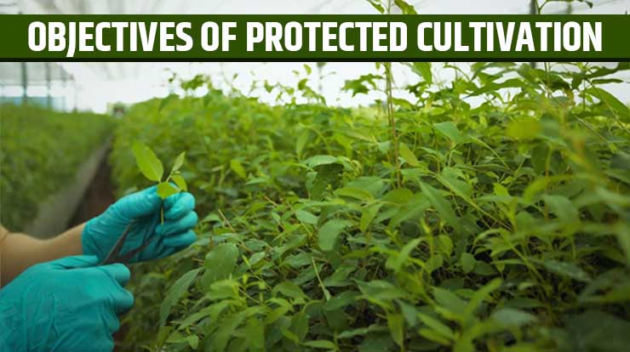
- Look at the objectives of protected cultivation, which are listed below, to see why it is now a popular farming technique in India. • The primary objective of the farming approach is to shield the plants from abiotic stress, which includes both physical and non-living variables like temperature, excess or inadequate water, hot and cold waves, and biotic factors like the occurrence of pests and diseases, among other things. The use of pesticides in agricultural production is maintained to a minimal using this method, keeping the quality of the crops. Protected farming in India easily adapts to all the natural conditions.
• The method emphasizes the high value and quality of horticulture crops. Protected farming propagates the healthy, consistent, and disease-free planting material, which raises germination percentages and enhances hardening, to create a disease-free yield and genetically better transplants.
• By increasing production areas, yields, and quality while extending the effective harvest season, protected cultivation aims to change the natural environment and achieve optimal crop productivity.
• There are also specific objectives and benefits in certain geographic locations for limiting rainfall and hail damage as well as reducing high sun radiation by shading.
• This approach preserves the quality of crops by using fewer pesticides during crop production.
• The approach highlights the superior worth and standard of horticulture produce.
The healthy, uniform, and disease-free planting material is multiplied. protected farming produces disease-free yield and genetically superior transplants which increases germination percentages and improves hardening. • Protected cultivation aims to change the natural environment and achieve optimal crop productivity by boosting production areas, raising quality, prolonging the actual harvest season, and increasing yields.
• In certain geographical areas, there are also specific goals and advantages for limiting hail and rain damage as well as lowering high sun radiation through shading.
Type of Protected structure
1. Net houses
2. Plastic low tunnels/row covers
3 Plastic mulch
4. Trench mulch
5. Floating plastic covers
6. Green houses
7. Poly houses
8 Shade houses
9. Rain shelters
1.Net houses
→ Shade nets and insect-proof nets are examples of these simple framed structure types. Perforated plastic shade nets are used to block solar radiation and prevent scorching and wilting of plants. These nets are offered in three colors black, green, and white—as well as various shading levels—from 25 to 75 percent. When compared to plants that aren't shaded, leafy vegetables and ornamental greens grow much faster under shade nets, especially when the sun is strong. There are various intensities of perforations for insect-proof nylon nets, ranging from 25 to 60 mesh.

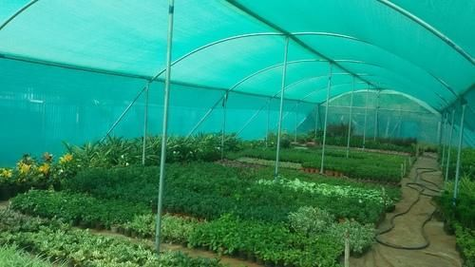
2. Plastic row coverings and low tunnels
To cover plant rows with translucent plastic film stretched over steel hoops, these structures are installed in an open field. that are spaced appropriately along the TOWS and are about 50 cm high. It is made of 30–40 micron thick polyethylene film without UV stabilization, which is in situ perforated as the temperature rises. In temperate and tropical regions, row covers used in vegetable production serve different purposes. The primary benefit of these covers in northern India is the ability to grow vegetables, particularly cucurbitaceous crops, earlier than usual during the winter. The crop continued to grow despite the cold weather.

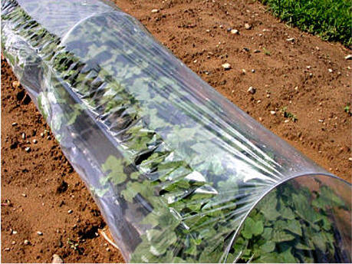
3 Artificial mulch
Covering the area around a plant with plastic mulch is a procedure that enhances growing conditions. by weed control, better CO exchange, in situ moisture conservation, and soil moisture maintenance. By preventing fruit contact with the soil, it enables the production of cleaner crop products. It is skilled in insect management techniques, such as the use silver and yellow colored film to effectively ward off aphids and whiteflies, respectively. Plastic films made of linear low density polyethylene (1.1.DPE) and low density polyethylene (LDPE) are frequently used for mulching.
4. Trench mulch
A simple and inexpensive growing method is the trench. in the coldest winter conditions, even at 15°C. Utilizing the heat of the sun and the soil, trench cultivation creates an environment conducive to the growth of specific leafy vegetables. Trenches can be constructed in a variety of lengths for large-scale production. Metal pipes or wooden poles are used to hold plastic sheets. Trench cultivation has been discovered to be a sustainable method for year-round vegetable production in cold climates.
5. Floating plastic covers
o protect vegetables from frost, snow, and cold temperatures, a large open field is covered with transparent plastic sheeting.
6. Green houses
According to the framed structure, transparent Vegetable plants absorb a significant amount of sunlight due to their substance and transparency. In polyhouses, vegetable plants also emit long wave thermal radiations, for which the covering material has a lesser transparency. This causes solar energy to be trapped and the temperature to rise of 10-12°C. This phenomenon is commonly referred to as the "green house effect." The forcing of vegetables in cold climates is caused by the increase in greenhouse temperature. By supplying cooling equipment, the temperature in the polyhouse will be lowered during the summer. Commercial polyhouses use carefully monitored The year-round production of desired vegetables is made possible by factors such as temperature, relative humidity, CO, photoperiod, soil temperature, plant nutrients, etc. The greenhouses are fully climate-controlled.
7. Poly houses
In contrast to the poly house, which offers a more stable environment, crops grown in open fields are subject to the world's environmental conditions as well as insect and pest attack. There are two categories of polyhouses: a) naturally ventilated polyhouses
Except for the provision of adequate ventilation and a logger system to essentially prevent damage from weather aberration and other natural agents, these polyhouses lack any environmental control systems.
By regulating the type of lighting, temperature, humidity, carbon dioxide levels, and root medium, an environmental controlled polyhouse can help to extend the growing season or allow Meson production.
8. Shade houses
A shade house is a building that is covered in agro nets or another type of woven a substance that allows sunlight, moisture, and air to enter through the cracks as needed. It develops a suitable microclimate that is beneficial to plant growth. Net house or shade net house are other names for it. Shade house applications
aids in the cultivation of vegetables, spices, medicinal plants, flower and foliage plants, and flowering plants. used for raising forest species, as well as fruit and vegetable nurseries and other uses. improves the quality of drying various agricultural products. used to ward off pest attacks. safeguards against climatic disturbances like wind, rain, hail, and frost. used to produce graft saplings and lower mortality rates during the hot summer months. used to make tissue harder
9.RainShelters

In an effort to boost domestic vegetable production and support the idea of family farming, the Department of Agriculture has launched an initiative to promote rain shelter farming as a cheap alternative to polyhouse farming. 200 rain shelters are intended to be built as part of the project, which is estimated to cost Rs 1 crore. The partially covered low-cost construction is made of transparent UV-stabilized polythene film for the ceiling and G1 pipes or wooden or bamboo poles for the framework.to shield the plants from harsh weather conditions like sweltering summers and torrential rain. When it comes to installing foggers and sprinklers to control the temperature, a greenhouse with covered sides will cost more than one with open sides.

Safeguarded Cultivation Structures
In protected cultivation practices, the microenvironment around the plant body is either totally or partially controlled in accordance with the requirements of the plant during its growth phase. in order to maximize yield and conserve resources. Due to factors like a growing population, climate change, shrinking land holdings, increased demand for high-quality fresh horticultural produce, and increased pressure on land and water resources, we are compelled to use modern crop production techniques like protected cultivation. To increase national productivity and produce quality, it is necessary to convert at least an amount of the approximately 9.2 million ha of land currently used for vegetable cultivation to protected cultivation. Only about 40,000 ha of horticultural crops are currently grown in protected areas, and out of those 40,000 ha, The country's major cities' specialist markets frequently draw the attention of vegetable and flower growers, encouraging them to switch from conventional methods of crop growth to such contemporary ones. Even educated youths without jobs who are not drawn to or interested in conventional agriculture are displaying a strong interest in these modern agricultural technology and may be further inspired by them.
Techniques for Safer Cultivation

There is only one remedy for every significant farming problem, and that is protected agriculture. With this approach, farmers can address issues like unpredictable and changing weather, climate change, incorrect usage and low productivity of natural resources, nutritional security in unfavorable topographical and climatic regions, polluted environments as a result of pesticide use, etc. The term "farming method" often refers to artificially boosting production levels and creating favorable conditions for plant development. This technique regulates the climate by covering the plant so that it cannot survive lower or higher temperatures, humidity, and other harmful farming elements. But make sure you get adequate light for photosynthesis, ideal watering and fertilization, and other crucial growth and production aspects.

India's status of protected cultivation

Protected agriculture is a relatively indian novel method, as we all know, but it quickly gained popularity there due to its straightforward methodology. he project between India and Israel, which started in 1998 This high-tech protected farming of vegetables and high-value horticulture crops is carried out at the Indian Agricultural Research Institute (IARI) in New Delhi. in agriculture has been refined and upgraded using this technique over the last ten years to lower costs and better suit local conditions. These days, almost all farmers accept this method of farming and use it extensively. Protected cultivation gradually expanded its presence within Indian agricultural industry.

India's Protected Cultivation Area

India has embraced this new farming method in the last ten years, and today almost all Indian states use it. According to the report, there were over 275,000 hectares worldwide and approximately 110 ha in India under protected cultivation by the 20th century's end. Over time, this area increased by 10%. The states that continually increased the amount of land under protected farming from 2007 to 2012 are Gujarat, Andhra Pradesh, West Bengal, Tamil Nadu, Punjab, Haryana, and Maharashtra. A significant area of 5,730.23 hectares in Gujarat and 4,720.72 hectares in Maharashtra was permitted for protected cultivation up till 2012.

Benefits of Protected Cultivation
Protected cultivation has some advantages, which are listed in the following section:
• With the help of environmental control, plants can grow throughout the year. This means that crops can be grown in hot climates even though they cannot be grown in open fields.
The high-quality yield that is free from infections, chemical residue, and insect attack is made possible by this method's microcosm methodology. It offers production or yield depending on the greatest level per unit area, per unit input, and per unit volume.
• The agricultural industry's educated rural farmers can also generate self-employment using this method.
• These are some important aspects of protected cultivations that can help you learn more about them.
Benefits of protected agriculture
in contrast to an open field conditions, cultivation of protected vegetables can use less water and chemicals to produce high-value vegetables. The following are the comparative benefits: Vegetable production all year long. It is possible to grow different crops on the same plot of land. Vegetable production in unfavorable climates can be overcome using a different protected manufacturing types techniques. the creation of superior, healthful sprouts of vegetables for sowing outside in fields in order to support early crop, robust, and resistant crops. Producing vegetables out of season will increase growers' profits. When protected vegetable cultivation is used, production and It is possible to increase production per unit of land, water, energy, and labor. It promotes the production of spotless, superior items. It allows for the production of vegetables.
Under protected buildings, the cultivation of expensive vegetables from disease-free seeds becomes simple.
It is possible to fully utilize the potential of polyhouse production technology to meet the demand for generating high-quality, pesticide-free vegetables and foods that are nutritious and healthy.
For the off-season production of vegetables, the development of their seeds, and the protection of the priceless germplasm, controlled environmental conditions are used.
Vegetable crops can be cultivated in inclement weather all year long including during the off-season.
It is simpler to manage and control weeds, illnesses, and pest insects
Restrictions on protected agriculture
The manually pollinating or by hand of parthenocarpic hybrids or varieties of cross-pollinated vegetables like cucurbits .Expensive, short-lived, and inaccessible cladding materials. Inadequate access to tools and equipment, common PHM procedures, and power in rural areas. The price of the structure initially seems prohibitive. Farmers with zero risk budgets are reluctant to take it on. the lack of insurance policies. Lack of market connectivity, cooperative strategy, and clustering
Conclusion:
For commercial purposes, greenhouses are used to grow exotic (non-native) and off-season vegetables, export-grade cut flowers, and quality seedlings. The economic benefits from high-value agricultural crops can be greatly increased when cultivated in a greenhouse.
References
- Chandra, P. 2001. Protected cultivation in vegetable crops: current status, problems and future strategies. In: Emerging Scenario in Vegetable Research and Development (Eds.
G. Kalloo and Kirti Singh). Research Periodicals and Book Publishing House (India). Pp. 242-249.
Choudhary, B.R., Sharma, S.K. and Janakiram, T. 2015. Cultivation of cucurbits in arid Rajasthan fetches more. Indian Horticulture (May-June), 60(3):22-24.
- Hickman, G.W. 2011. A review of current data on international production of vegetables in greenhouses.
www.cuestaroble.com.
- Kalia, P. and Yadav, R.K. 2015. Enhancing small farmers’ income through off-season vegetable production under temporary low height polyhouse protections. New Age Protected Cultivation (July-Dec. issue). Pp. 30-33. More, T.A. 2010. Arid Horticulture-Making greater strides. Agricultural Spectrum, I(X): 26-29. Sabir, N. and Singh, B. 2013. Protected cultivation of vegetables in global arena: A review. Indian Journal of Agricultural Sciences, 83(2):123-135.
- Samadia, D.K. 2008. Hi-tech approaches for vegetable and seed production under Hot Arid region of India. In: Hi-tech Production of Arid Horticulture, More et al. (ed.). ICAR-CIAH, Bikaner. Pp. 1-10.
- Singh, B. 2014. Protected cultivation of horticultural crops in India: Challenges and opportunities. In: 3rd International Conference on Agriculture and Horticulture held at Hyderabad from 27-29 Oct., 2014.
- Singh, B. and Kumar, M. 2009. Evaluation of summer squash varieties under plastic low tunnels during their off season cultivation. Indian Journal of Horticulture, 66(1):135-136.
- Singh, B. and Sirohi, N.P.S. 2006. Protected cultivation of vegetables in India: Problems and future prospects. Acta Horticulture, 710:339-342.
- Singh, B. and Solanki, R. 2014. Protected cultivation technologies for vegetable cultivation .

