Robotics an indispensable arm for smart agriculture

V P Sethi
Head, Department of Mechanical Engineering, Punjab Agricultural University, Ludhiana

S S Gosal
Vice Chancellor, Punjab Agricultural University, Ludhiana

Agriculturists predict that global population is expected to reach 9 billion by 2025. The innovators dealing in agriculture have to think of new ways to maintain the food supply chain for their people using smart agricultural technologies. In order to cater to the needs of next-generation farming, now is the high time to infuse human brains with intelligent machine technologies (created by super human brains) called artificial intelligence (AI). Robotics in agriculture (RIA) is one such indispensible arm of AI.

Robotics has already shown its impact in several commercial areas like customer service, manufacturing, shipping, and transportation. The technologically advanced countries such as United States, Australia, Japan, and European nations have already adopted RIA to successfully sort out their production challenges. In country like India, where more than 65% of the population is actively involved in agriculture and allied fields, RIA is going to be the best suited application of AI for its adoption to convert the conventional agriculture practices into the smart-agriculture. The reason is because robotics can fill the gap between manpower needs and production needs.

The most important use of agricultural robotic machines is to automate the repetitive tasks with precise accuracy using machine learning/vision based on an algorithm programmed by humans. These machines can vary in function, size, cost, and other characteristics based on the type of work to be executed. GPS technology also helps some robots to accomplish several complex tasks during field operations. The important tasks an agricultural robot can perform for farmers with ease are; harvesting and picking, weed control, autonomous mowing, pruning, seeding, spraying and thinning etc. and allowing them to focus more on improving overall production yields.

The working mechanism of robotics involves machine or computer vision having a camera or multiple cameras feeding information to the robot which makes it capable to locate and access the crops around it. Several robots are already working successfully in fields operations and helping to improve the productivity in several agricultural operations mostly abroad such as; autonomous precision seeding, multi-talented robots for harvesting, micro-spraying robots, robotic automation process (RPA), robots to remove weeds, LiDAR-powered robots to collect data, bots & drones, autonomous agricultural robots, robot-assisted precision irrigation, sorting and packing robots. Before discussing about the above mentioned applications it is important to know about the major components of any robotic design which are; (a) End effectors-hands of robots, (b) Manipulators-arms of robot (3) Actuators-robots muscles and joints (d) Controller-brain of Robot (e) Sensors. Once the robot is designed and accordingly an algorithm is written and fed to the system to perform certain task either in general repetitive or specific in agricultural application (manually or automated command based). Robotics has already shown its impact in several commercial spaces. Several types and applications of robots till date are; military robots, industrial robots, cobots (collaborative robots), construction robots, agricultural robots (AgRobots), medical robots, robot combat for sport, cleanup robots (toxic waste or nuclear facilities), domestic robot etc. Here we will discuss important applications of AgRobots.
Conventional way of sowing by sprinkling seeds in the field were replaced by modern machinery like broadcast spreader and seed drills which work at slow pace, need human estimation and depends upon manual work capacity. Now, autonomous precision seeding with a combination of robotics and geo-mapping mechanism can place the seeds exactly maintaining the row-to-row and seed-to-seed distance at a much faster rate at optimum depth for better germination, growth and yield. Repetitive tasks of harvesting and picking at much faster rate and accuracy can be replaced by Robots to relieve humans from these tedious tasks.
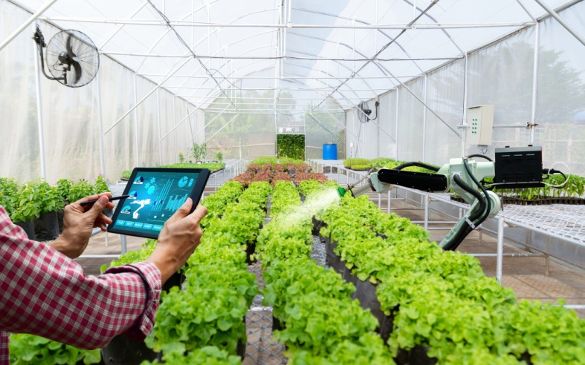
Fig. 1 (Courtesy: HDI Global)
With futuristic computer vision technology, micro-spraying robots can detect weeds and then spray a targeted drop of pesticide/herbicide onto them thereby saving money, human, environmental and soil health (Fig. 1). Planting and harvesting of basic food grains like wheat, maize and barley can easily be performed by robots while harvesting of other fruits and vegetables need multi-talented robots (Fig. 2). Conventional way of watering at regular intervals and plucking of ripened fruits and vegetables can be easily replaced with robotic process automation which takes care of all these process with hassle-free operation.
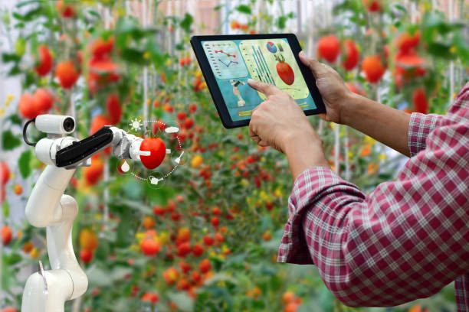
Fig. 2 Robotic harvesting (Courtsey: DMAXO & iSTOCK)
Weeding is one of the rigorous time-consuming and repetitive activities for the farmer which not only consumes time but also involves huge labour and weedicide. Farmers have started using autonomous robots, powered with computer vision technology to exactly identify the weeds and removing them out before they could pose any threat to the crop yield. Conventional methods of soil or plant analysis are time consuming. The development of LiDAR (Light detection and ranging) powered robots have made the data collection and analysis process so simplified that data on plants’ health, physiology, and stress response can be collected on real-time basis and use it to improve the condition for timely action. Use of drones in agriculture has gradually expanded from aerial photography of fields to spraying activities to latest generation AI powered drones that are being effectively used to capture 3D imaging, map-building, and crop monitoring.
The latest development is Agricultural Autonomous Robot (AAR) loaded with various features of multi-tasking such as cloud seeding, planting seeds, doing weed control, harvesting, soil analysis, soil moisture and weather monitoring. New addition in smart farming is the robot-assisted precision irrigation & fertigation as water saving alternate by targeting specific plants. AAR can take up all end-to-end agricultural activities and replace the tough manual tasks with automatic actions through AI, Machine Vision/Learning, IoT and Robotic machines as tools. Sorting and packing robots have also been introduced to streamline the tasks without breaking using coordination capability and line tracking technology, these robots can fast-track the packing process.
It can finally be ascertained that robotic revolution in the world has already started as a giant step towards smart-agriculture. It is high time to implement robotics applications in agriculture in India too to increase crop productivity and as a substitute solution to critical food chain transformation in the coming years.

